Single Quote login and result  
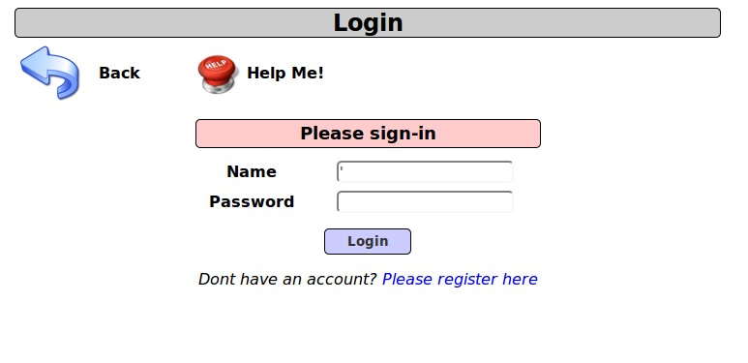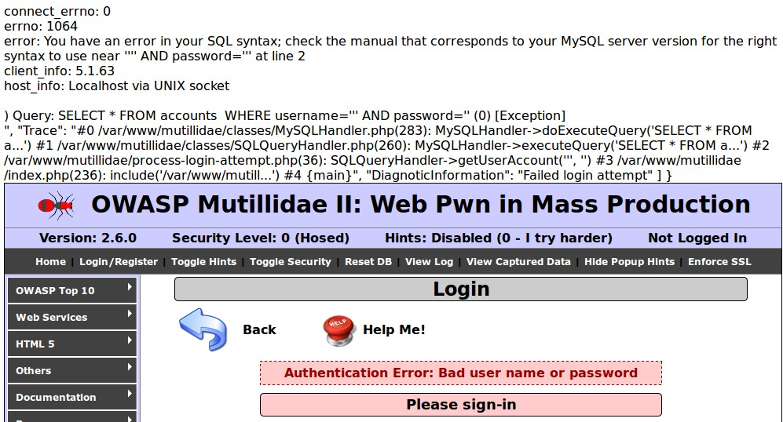

Login as first user  
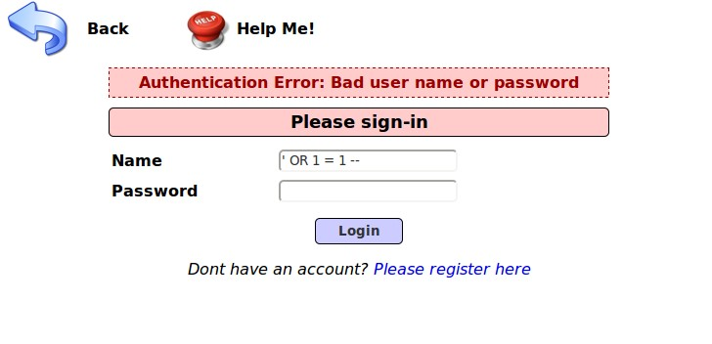  
FirstUser.jpg

Getting table info

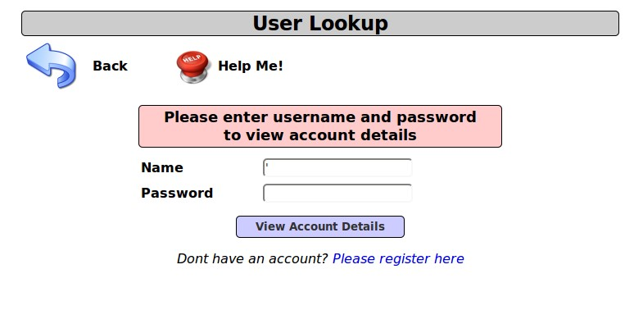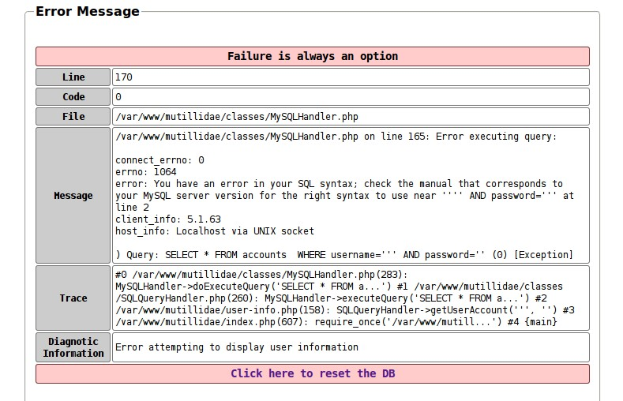

Column Count Match

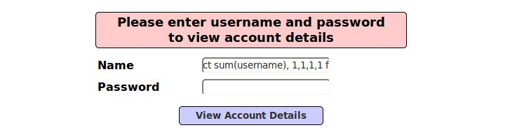

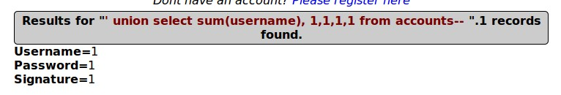

Last Username

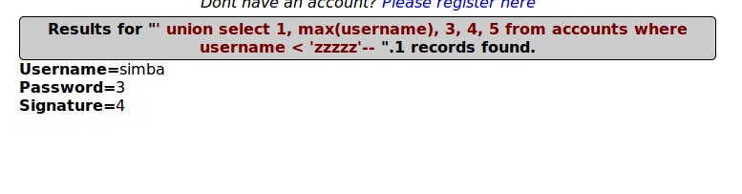

Harvest Password

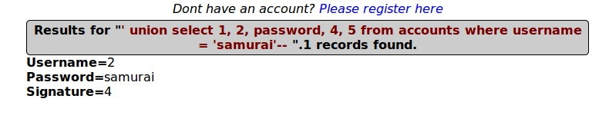

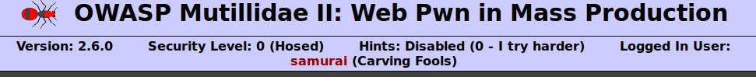

Not Needing a Password

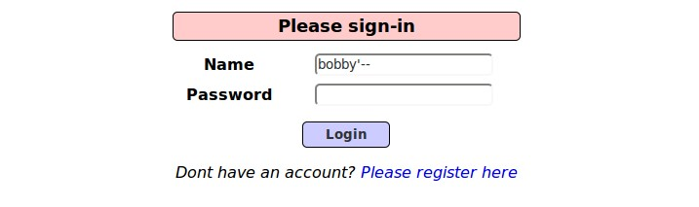  
LoggedInAsBobby.jpg