Alec Austin - J00501671

Lab 6

Part 1: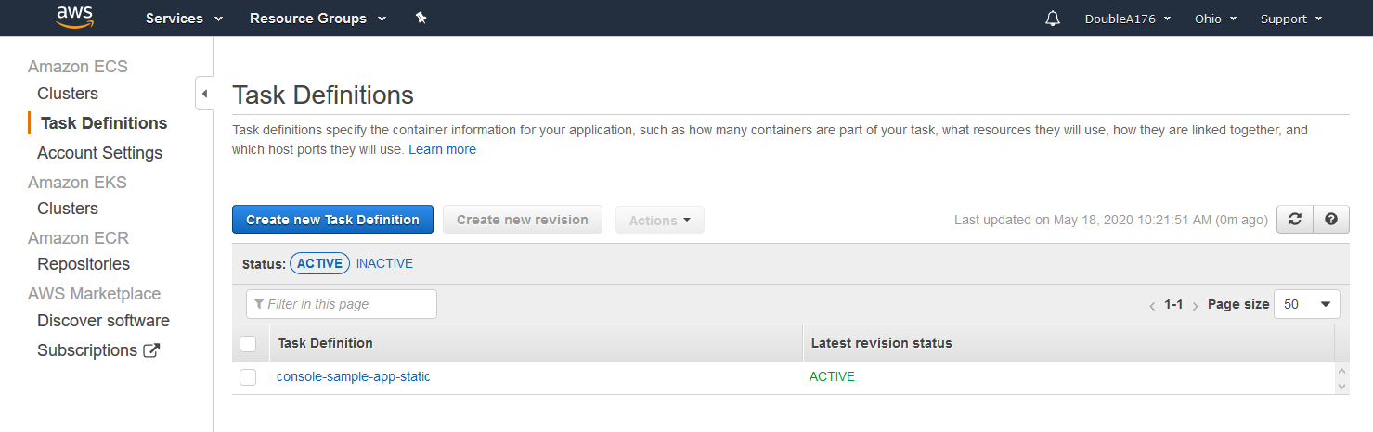

Part 2: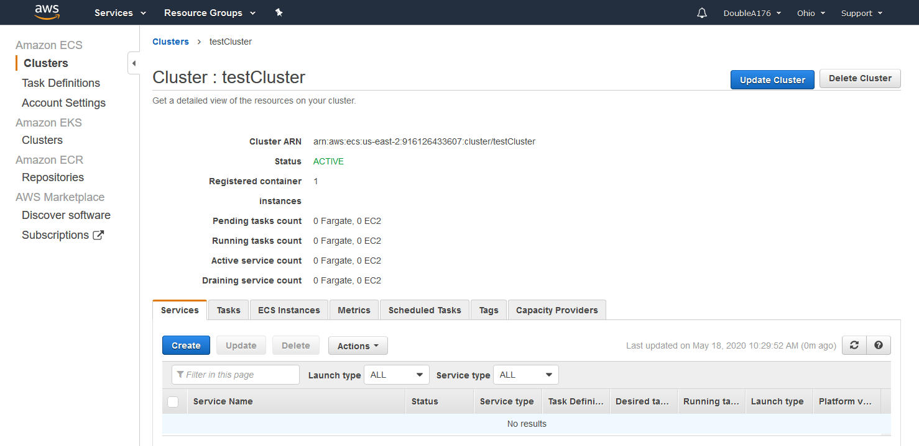

Part 3: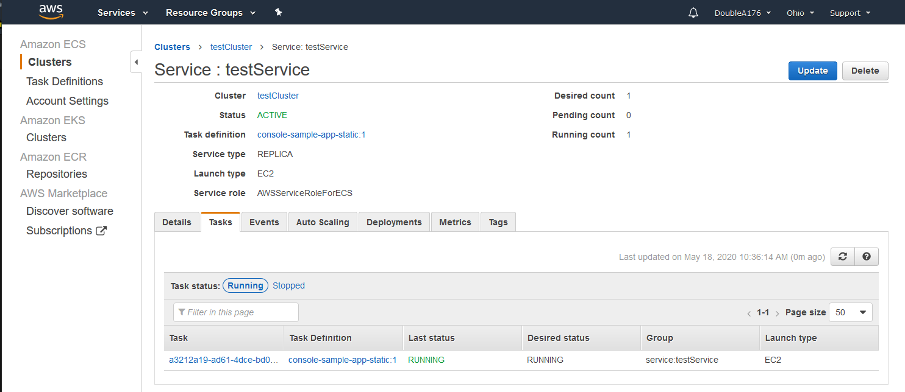

Part 4: