Alec Austin - J00501671

Lab 9

Part 1:

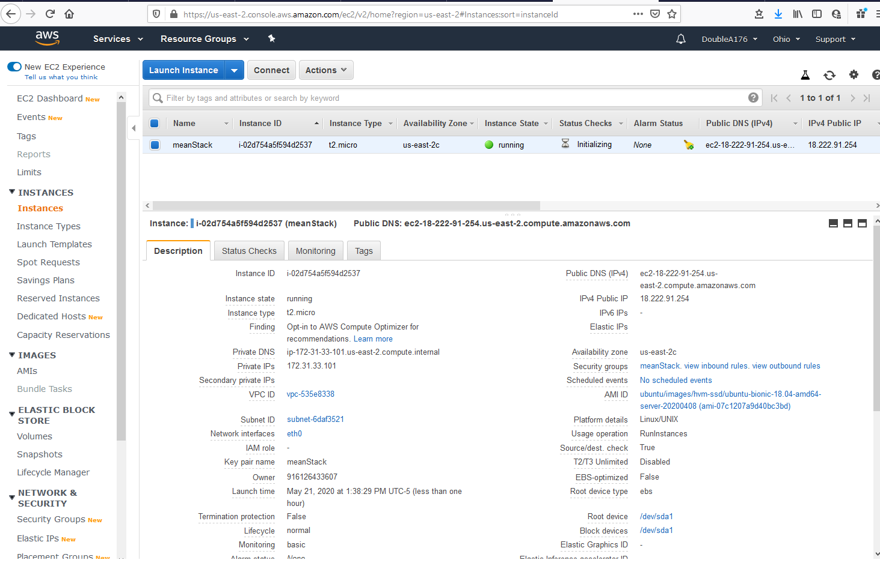

Part 2:

Part 3:

Part 4:

