

**CAA 900**Resource Plan – v1

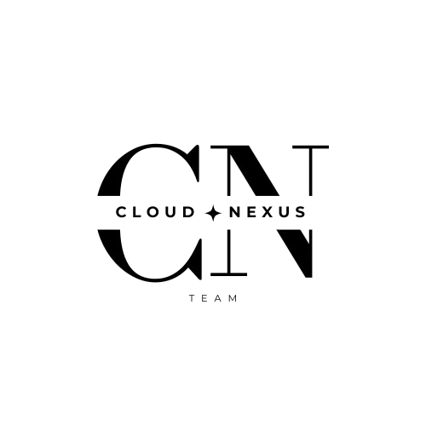

*Drafted by*,

Group Name : **CLOUD NEXUS**

Date : 13/02/2025

#### **Project Overview**

**Project Name:** Multi-Cloud Resource Insights & Cost Projection Platform (MCRP)

**Cloud Provider:** AWS (Hosting), Sample Analysis (AWS, Azure, GCP)

**Tech Stack:**

* Frontend: React.js (3 developers)
* Backend: Node.js with Express (2 developers)
* Cloud: AWS with Terraform for (Infrastructure as Code)IaC, GitHub Actions for CI/CD, Docker for containerization, Kubernetes for orchestration (1 Developer)

1. Compute and Container Management

* **Amazon EC2**
  + *Specification:* 2 t3.medium instances (2 vCPUs, 4GB RAM each).
  + *Purpose:* Provides virtual machines for Docker containers hosting frontend and backend, acting as the backbone for running workloads efficiently.
* **Amazon EKS**
  + *Specification:* 1 Kubernetes cluster with 2 nodes.
  + *Purpose:* Manages deployment, scaling, and maintenance of containerized applications, ensuring high availability and scaling.

2. Storage and Content Delivery

* **Amazon S3**
  + *Specification:* 50GB storage.
  + *Purpose:* Stores static files (images, CSS, JS) with reliable storage and high availability.
* **Amazon CloudFront**
  + *Specification:* 1 CDN distribution.
  + *Purpose:* Delivers content globally with low latency, enhancing user experience with fast delivery.

3. Database and API Management

* **Amazon RDS**
  + *Specification:* db.t3.medium (2 vCPUs, 4GB RAM, 100GB SSD).
  + *Purpose:* Manages secure database operations with scalable and reliable data storage.
* **Amazon API Gateway**
  + *Specification:* Handles up to 1000 requests/second.
  + *Purpose:* Manages and secures API communications efficiently.

4. Infrastructure Provisioning and Configuration

* **Terraform**
  + *Specification:* 10+ infrastructure modules.
  + *Purpose:* Automates cloud resource provisioning, reducing manual setup time.
* **Ansible**
  + *Specification:* 5+ server configurations.
  + *Purpose:* Automates deployment and server management, ensuring consistent configurations.

5. CI/CD Pipeline and Image Management

* **GitHub Actions**
  + *Specification:* 5 workflows.
  + *Purpose:* Automates testing, building, and deployment for continuous integration and delivery.
* **Amazon ECR**
  + *Specification:* 2 Docker image repositories.
  + *Purpose:* Stores container images, facilitating deployment.

6. Security and Secrets Management

* **AWS IAM**
  + *Specification:* 10 managed policies.
  + *Purpose:* Controls AWS resource access, ensuring secure access.
* **AWS Secrets Manager**
  + *Specification:* 5 managed secrets.
  + *Purpose:* Stores sensitive data securely, protecting API keys and credentials.

7. Monitoring, Cost, and Optimization

* **Amazon CloudWatch**
  + *Specification:* 5 dashboards, 10 alarms.
  + *Purpose:* Monitors app performance and provides proactive issue resolution.
* **AWS Cost Explorer**
  + *Specification:* Monthly usage reports.
  + *Purpose:* Tracks cloud expenses and assists in cost management.
* **AWS Trusted Advisor**
  + *Specification:* Weekly scans.
  + *Purpose:* Provides optimization recommendations and ensures best practices.

8. Development and Collaboration Tools

* **Docker Desktop**
  + *Specification:* 4 vCPUs, 8GB RAM.
  + *Purpose:* Enables local container development and testing.
* **Kubernetes CLI (kubectl)**
  + *Specification:* Installed locally and on Cloud9.
  + *Purpose:* Manages Kubernetes clusters and provides container orchestration control.
* **Postman**
  + *Specification:* 20+ saved API requests.
  + *Purpose:* Tests and debugs APIs, ensuring reliability.
* **Visual Studio Code**
  + *Specification:* Installed with AWS, Docker, Kubernetes extensions.
  + *Purpose:* Provides essential cloud development features as a code editor.
* **Jira**
  + *Specification:* 1 project board with 5 epics, 20+ user stories.
  + *Purpose:* Manages project tasks, tracks progress, and enhances collaboration.
* **Microsoft Teams**
  + *Specification:* For chat, video, and file sharing.
  + *Purpose:* Facilitates communication and team collaboration.

#### 9. **Future Development and Uncertainties**

The plan also advocates the reservations of additional resources for potential future development and unforeseen project needs:

* Reserve of 1 EC2 t3.medium instance for scaling or new microservices.
* Additional 20GB storage in Amazon S3 for new data or assets.
* 2 more GitHub Actions workflows reserved for future pipelines.
* IAM policies designed to accommodate new roles or services.
* Room for up to 3 more Docker containers if needed for new features.
* Monitoring with CloudWatch can be extended with 5 more alarms for new services.