**esm15_rad**

Changes in code (CABLE3-ESM): cbl_radiation.F90

! Define fraction of SW beam tranmitted through canopy:

IF( cable_runtime%esm15_rad) THEN

dummy2 = -rad%extkb * canopy%vlaiw

dummy = EXP(dummy2)

ELSE

dummy2 = MIN(rad%extkb * canopy%vlaiw,30.) ! vh version to avoid floating underflow !

dummy = EXP(-dummy2)

ENDIF

IF( cable_runtime%esm15_rad) THEN

VegTemp = met%tk

ELSE

VegTemp = met%tvrad

ENDIF

IF( cable_runtime%esm15_rad) THEN

WHERE (sunlit_veg_mask) ! i.e. vegetation and sunlight are present

CanopyExtincion_beam = EXP( -rad%extkbm(:,1) * canopy%vlaiw )

CanopyExtincion_dif = EXP( -rad%extkdm(:,1) * canopy%vlaiw )

END WHERE

ELSE

WHERE (sunlit_veg_mask) ! i.e. vegetation and sunlight are present

CanopyExtincion_beam = EXP( -MIN(rad%extkbm(:,1) * canopy%vlaiw,20.) )

CanopyExtincion_dif = EXP( -MIN(rad%extkdm(:,1) * canopy%vlaiw,20.) )

END WHERE

ENDIF

Effect on climate:

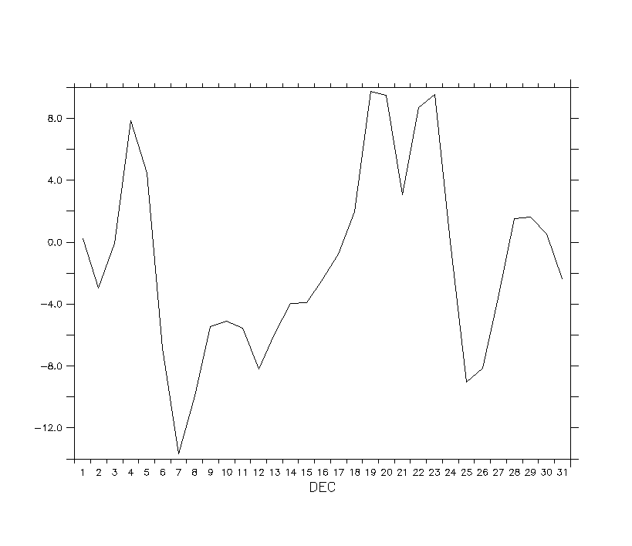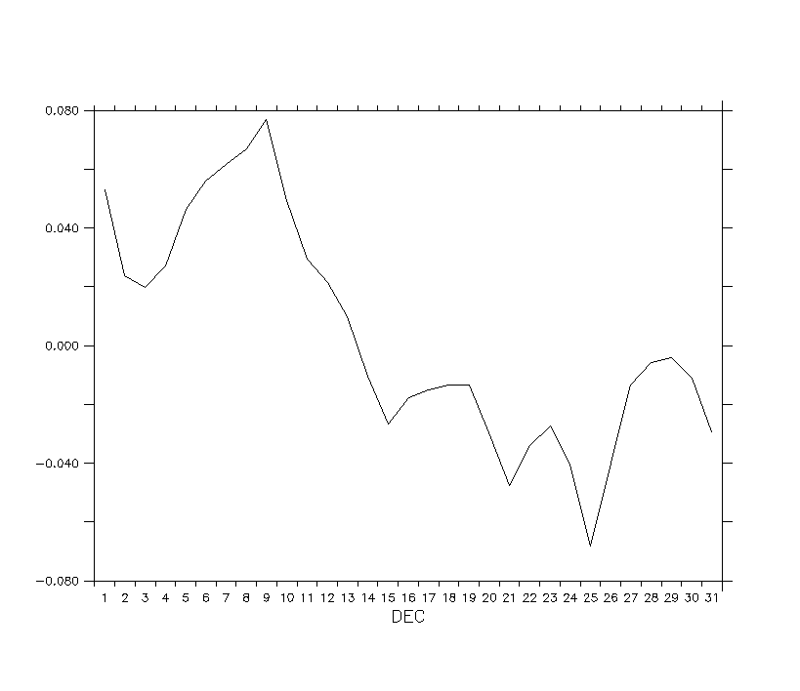

Effect on carbon:

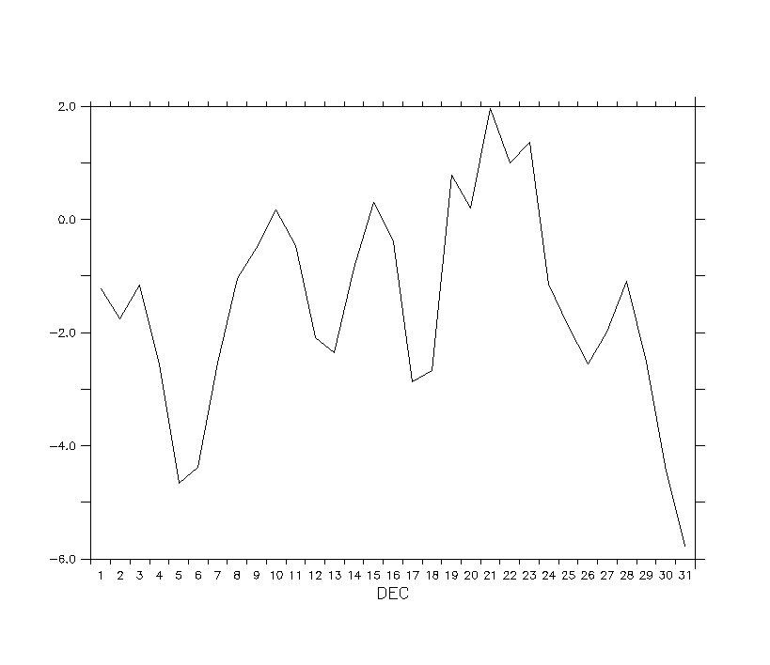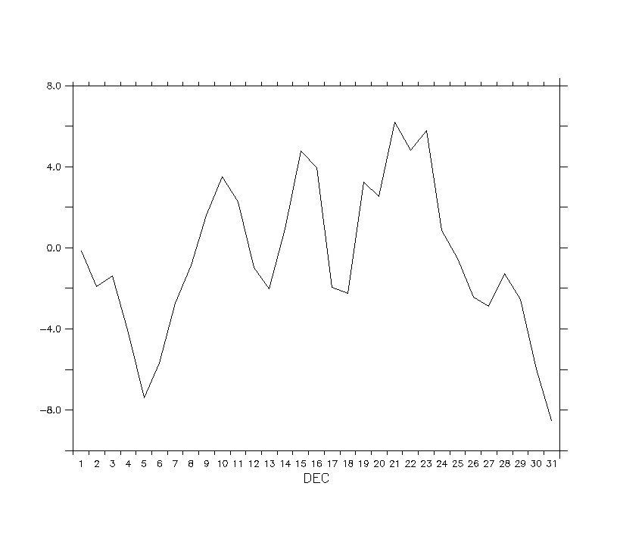

Recommendation: