**esm15_** **friction**

Changes in code (CABLE3-ESM): cbl_friction_vel.F90

IF( cable_runtime%esm15_friction ) THEN

psim_1 = psim( zetar(:,iter), mp, CPI_C )

ELSE

psim_1 = psim( zetar(:,iter) * zref_uv/zref_tq, mp, CPI_C )

ENDIF

IF( cable_runtime%esm15_friction ) THEN

psim_arg = zetar(:,iter) / z_eff

ELSE

psim_arg = zetar(:,iter) * z0m / zref_tq

ENDIF

IF( cable_runtime%esm15_friction ) THEN

friction_vel = MAX(1.e-6, lower_limit )

ELSE

friction_vel= MIN( MAX(1.e-6, lower_limit), 10.0 )

ENDIF

Effect on friction:

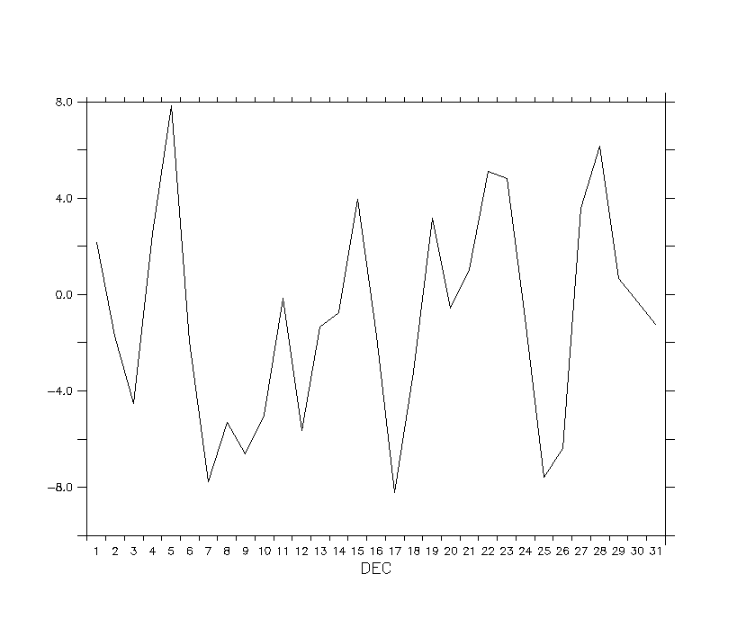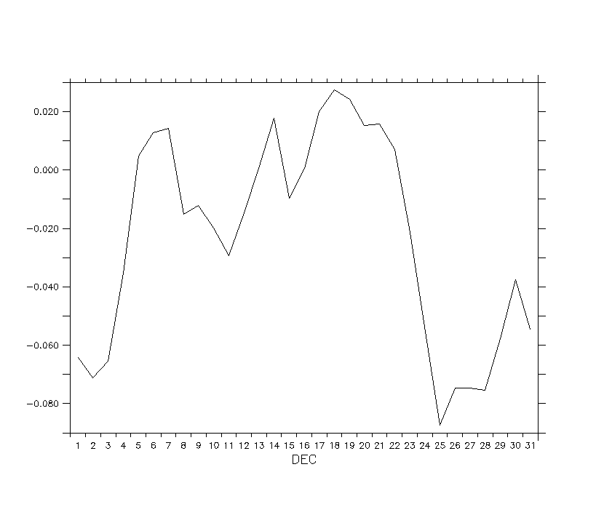

Effect on carbon:

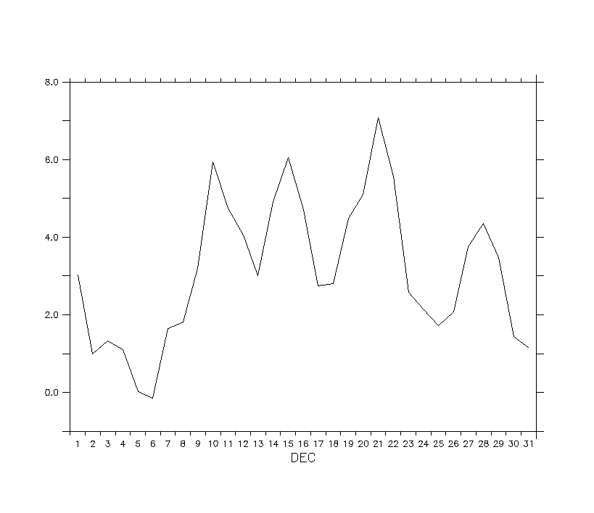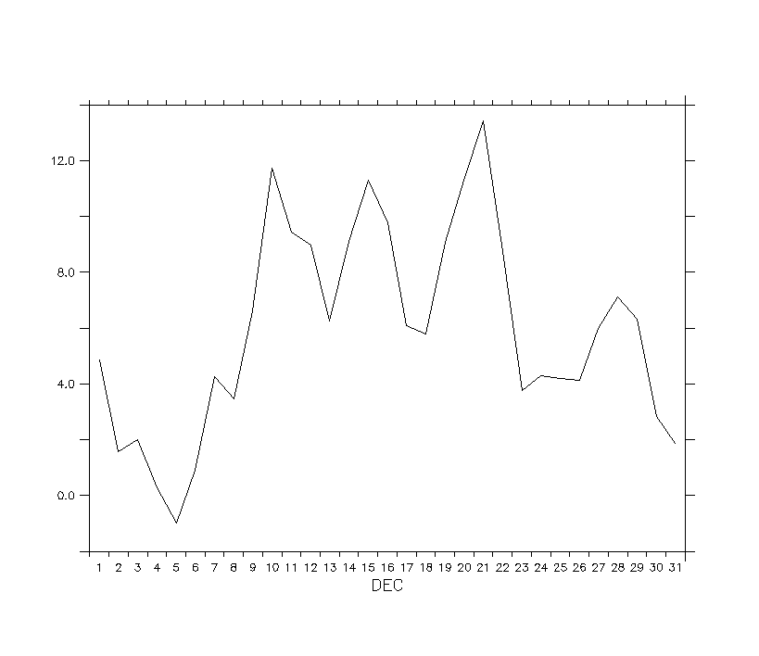

Recommendation: Discussion