**esm15_canopy**

Changes in code (CABLE3-ESM): cable_canopy.F90

Multiple Lines

Effect on climate: : (left: precipitation; right: temperature (kelvin), Unit: percentage relative change )

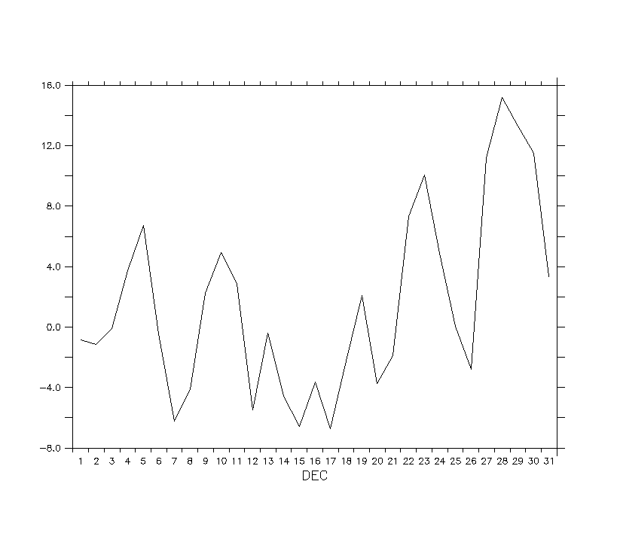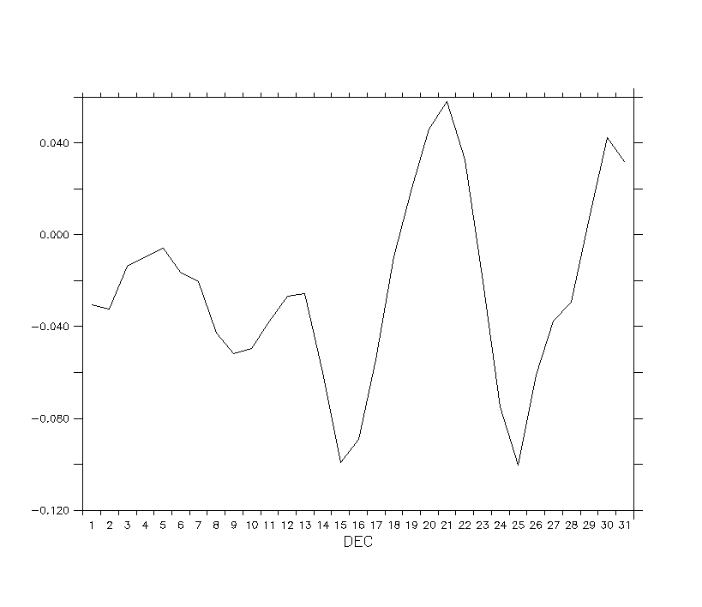

Effect on carbon: (left: GPP; right: NPP, Unit: percentage relative change)

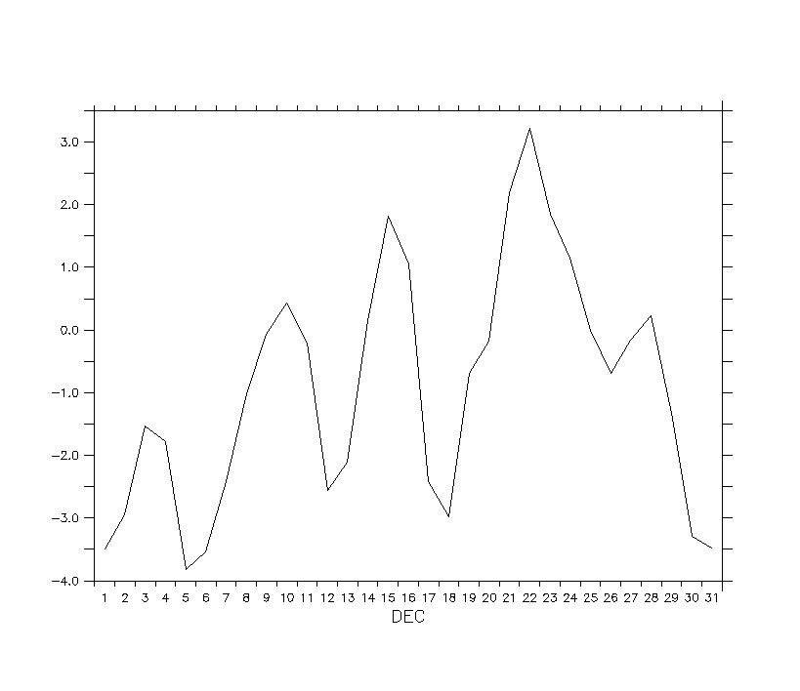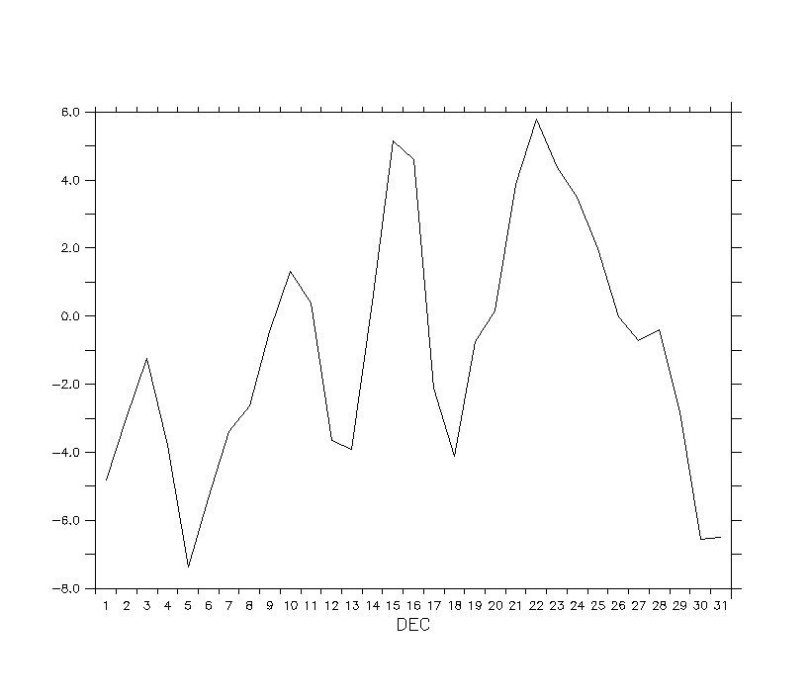

Recommendation: Discussion