**esm15_** **latentH**

Changes in code (CABLE3-ESM): cbl_latent_heat.F90

IF( cable_runtime%esm15_latentH ) THEN

canopy_fess= ssnow_wetfac * ssnow_potev

WHERE (ssnow_potev < 0. ) canopy_fess = ssnow_potev

ELSE

WHERE (ssnow_potev < 0. ) ssnow_wetfac(:) = 1.0

canopy_fess= ssnow_wetfac * ssnow_potev

END IF

IF( cable_runtime%esm15_latentH ) THEN

fupper_limit(j) = REAL(ssnow_wb(j)-ssnow_wbice(j)) * frescale(j)

ELSE

fupper_limit(j) = REAL(ssnow_wb(j)-ssnow_wbice(j)/0.85)*frescale(j)

fupper_limit(j) = MAX(REAL(fupper_limit(j),r_2),0.)

END IF

IF( .NOT. cable_runtime%esm15_latentH ) THEN

!Ticket 137 - case ii) deposition of frost onto snow

! case of sublimation of snow overwrites later

IF (ssnow_snowd(j) >=0.1 ) THEN

ssnow_cls(j) = 1.1335

canopy_fess(j) = ssnow_cls(j)*ssnow_potev(j)

ENDIF

!Ticket 137 - case iv) deposition of frost onto frozen soil, no snow

IF (ssnow_snowd(j) < 0.1 .AND. ssnow_potev(j) < 0. .AND. &

ssnow_tss(j)<CTFRZ) THEN

ssnow_cls(j)=1.1335

canopy_fess(j) = ssnow_cls(j)*ssnow_potev(j)

ENDIF

END IF

Effect on climate: (left: precipitation; right: temperature (kelvin), Unit: percentage relative change, ):

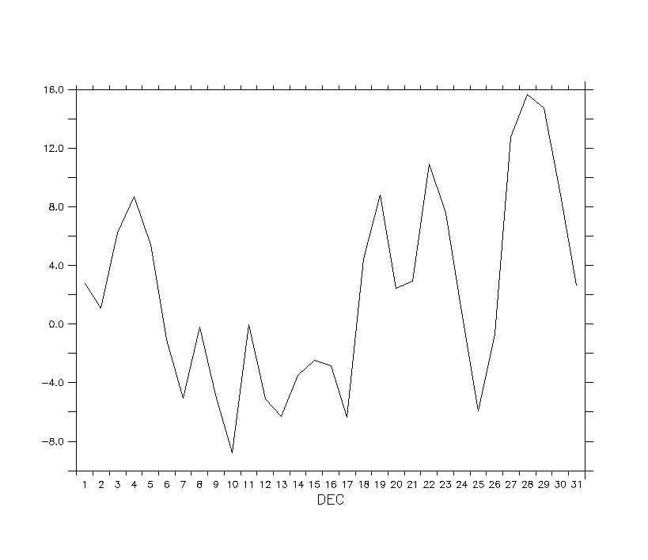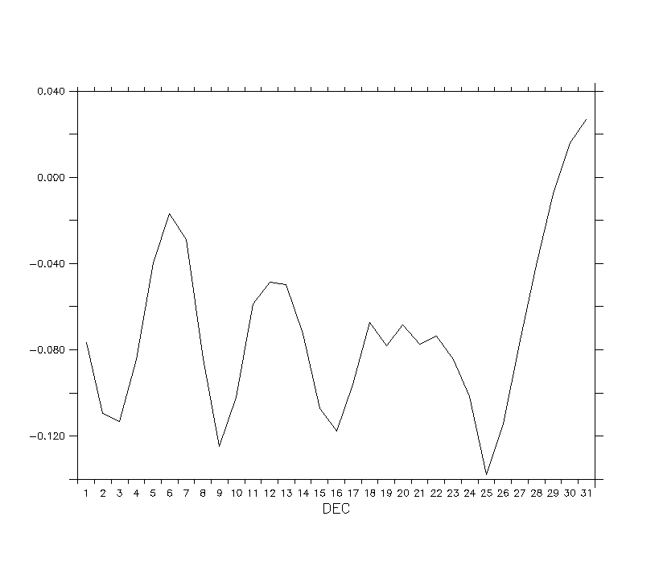

Effect on carbon: (left: GPP; right: NPP, Unit: percentage relative change)

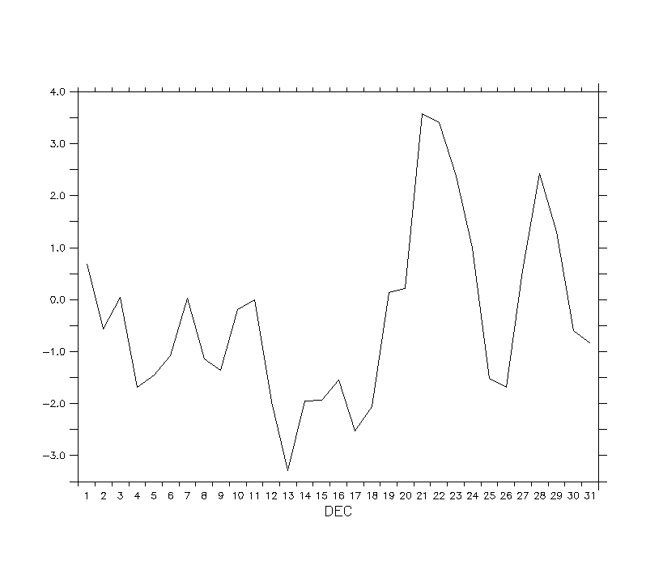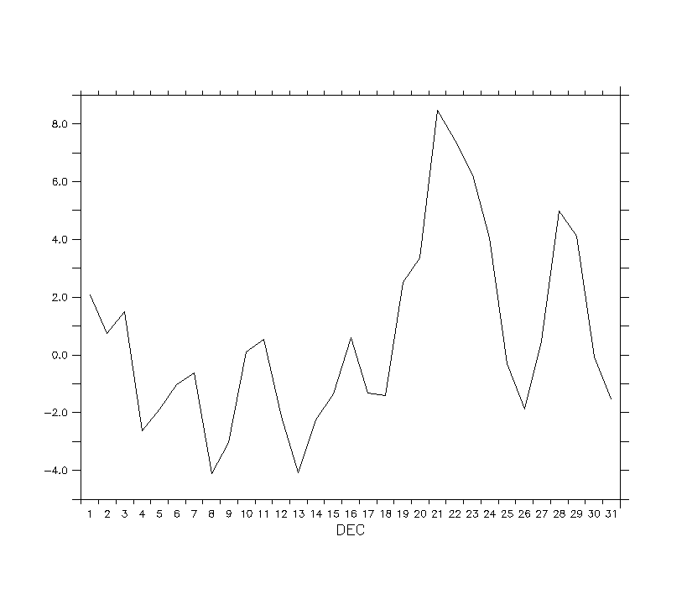

Recommendation: Discussion