**esm15_dryLeaf**

Changes in code (CABLE3-ESM): cbl_dryLeaf.F90 cbl_SurfaceWetness.F90

* weight min stomatal conductance by C3 an C4 plant fractions?
* fraction of canopy which is wet, min-max equation
* stomate conductance xleuning
* leaf respiration

After 2-year simulation

Effect on climate: (left: precipitation; right: temperature (kelvin), Unit: percentage relative change):

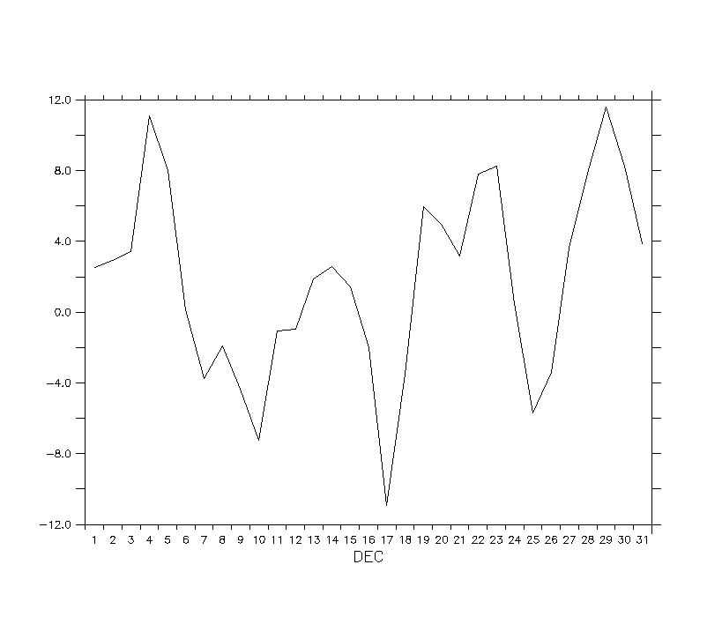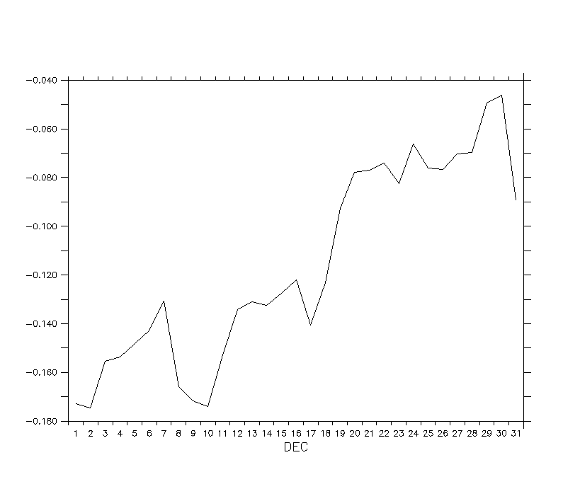

Effect on carbon: (left: GPP; right: NPP, Unit: percentage relative change)

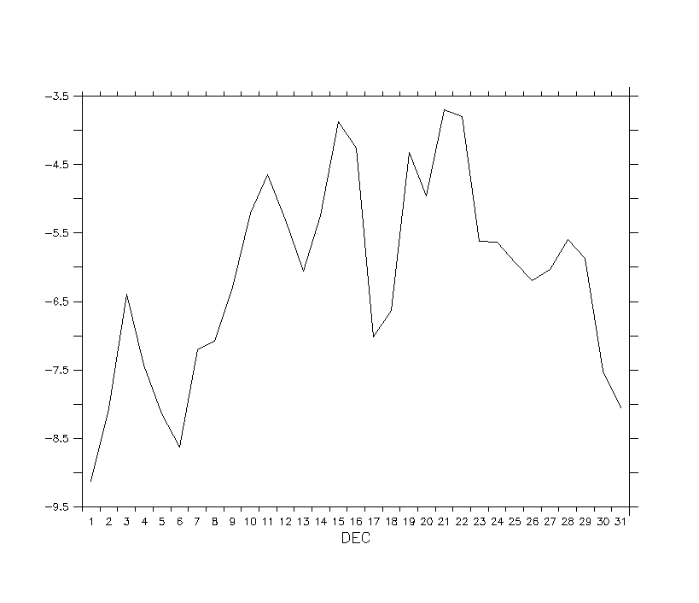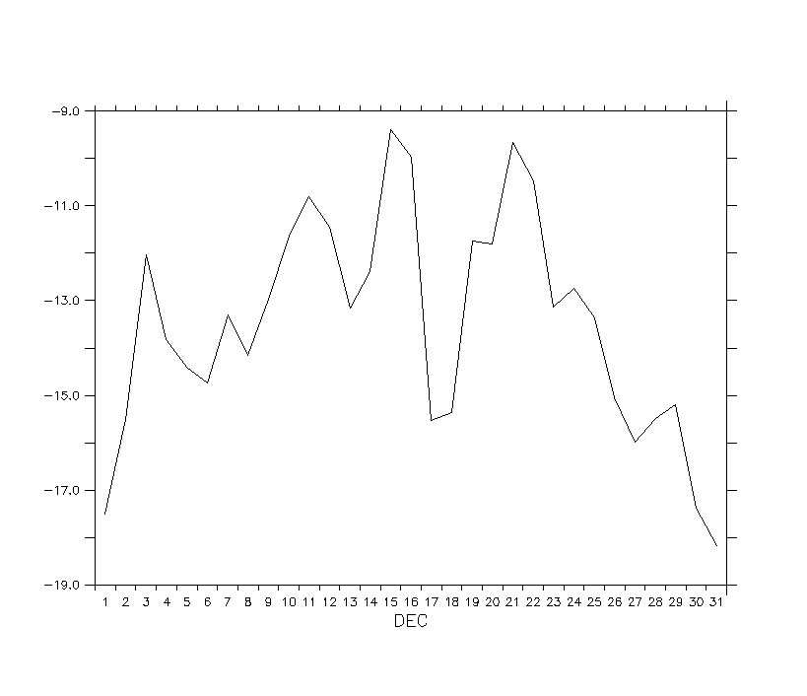

Recommendation: Discuss