**esm15**

Changes in code (CABLE3-ESM): cbl_soilfreeze.F90 cbl_snowAccum.F90 cbl_soilsnow_main.F90

cbl_init_radiation.F90 cbl_stempv.F90 cable_roughness.F90 cbl_lai_eff.F90 cbl_surfbv.F90

Effect on climate: (left: precipitation; right: temperature (kelvin), Unit: percentage relative change, ):

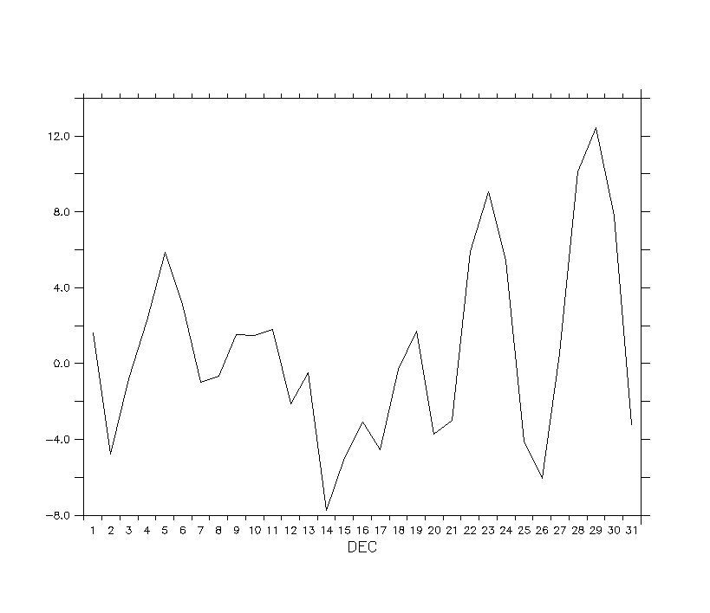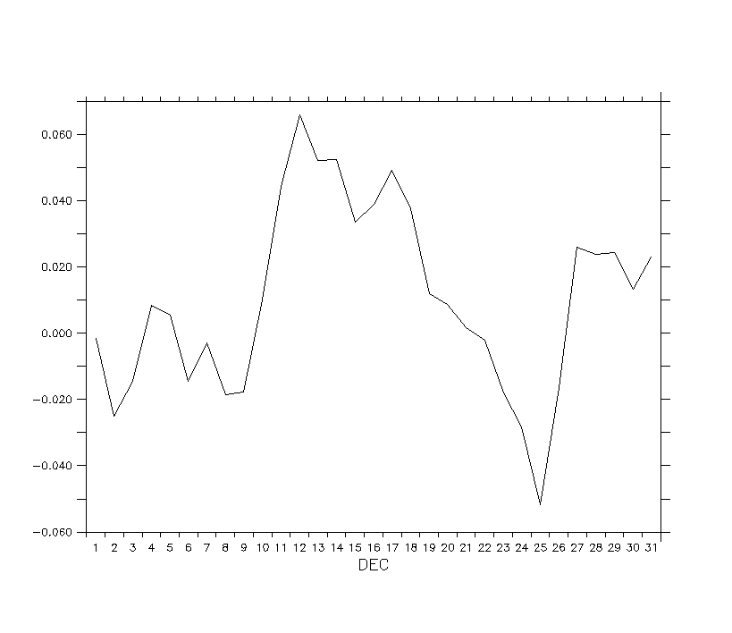

Effect on carbon:

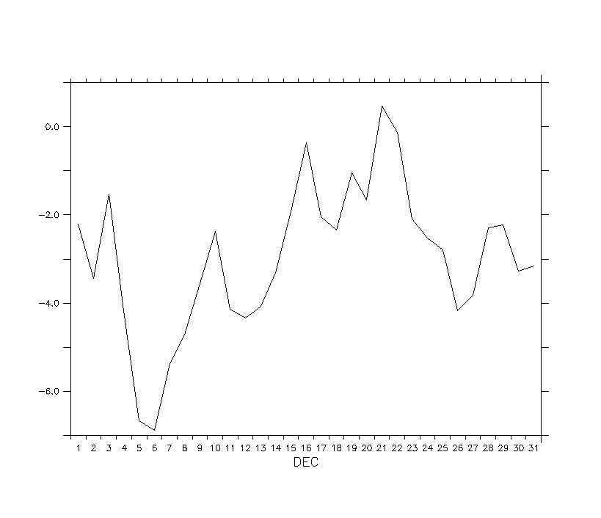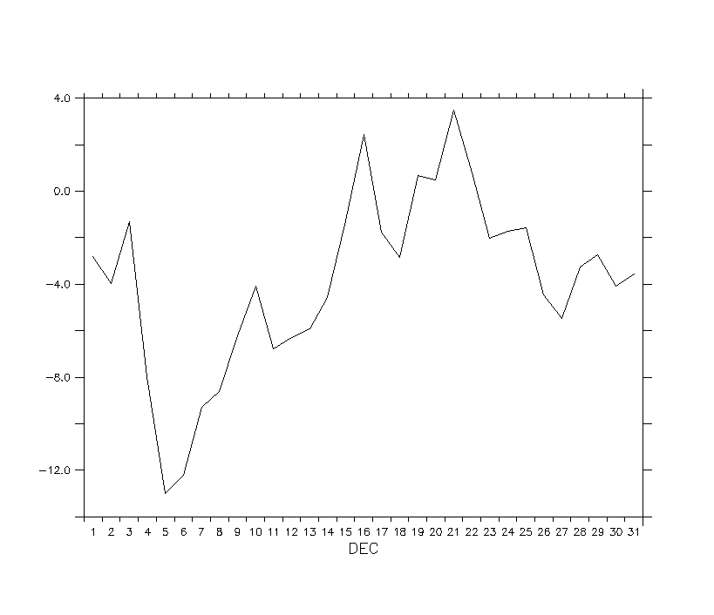

Recommendation: Discuss