# Cable Ticket: Drought Response and Root Water Extraction

*Vanessa Haverd, 8/10/15*

The improved model is enabled when cable_user%FWSOIL_SWITCH is set to ’Haverd2013’ in cable.nml.

The improvements resolve the long-standing water-use efficiency problem in CABLE 2.0, in which transpiration is decoupled from photosynthesis when the transpiration rate that emerges from the solution of the coupled photosynthesis/stomatal conducatance equations causes the demand for soil water extraction to be larger than the extractible soil water.

Model equations for the default model and the improved code are presented below, along with comparisons to global fluxnet data (PLUMBER sites, Best et al. 2015) illustrating a significant improvement.

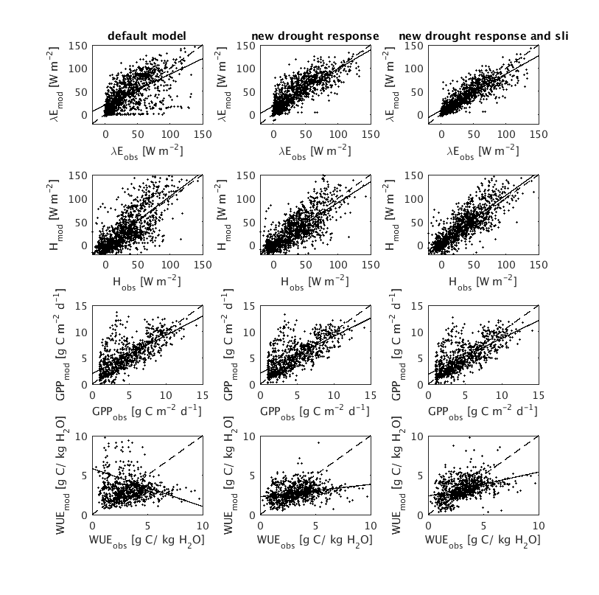

**Figure 1:** monthly fluxes (latent heat, sensible heat and GPP) and total water use efficiency (GPP/ET) for the default model (left); the default model with the new formulation for coupled root water extraction/ drought response (middle); as for (middle), but with the SLI soil module in place of the default soil module. Dotted lines (1:1); solid lines are linear fits.

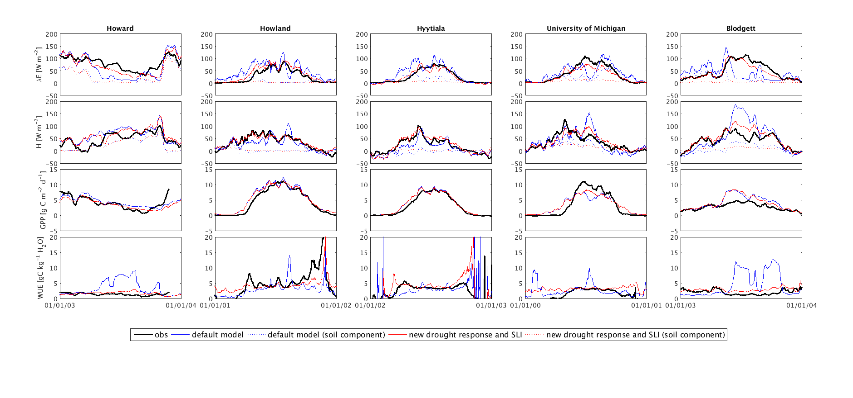

Figure 2 : Examples of times series (14-day running mean) (latent heat, sensible heat, GPP, water use efficiency). The default model often overpredicts WUE, and that the improved model does not.

### 1 Default Model

#### Drought Response

As described in Wang et al. 2011, canopy photosynthesis and transpiration ate coupled via stomatal conductance, modeled for each of sunlit and shaded leaves as:



where *G0* is residual conductance [molm-2s-1], *Ds*, *Cs* and *Ac* are the water vapour pressure deficit at the leaf surface, CO2 concentration at the leaf surface and net photosynthesis respectively; Γ is the CO2 compensation point of photosynthesis [mol m-1] (a function of canopy temperature), a1 and D0 are two model parameters, and *fw,soil* is the stomatal conductance drought response factor, calculated as:



where *βv* is a model parameter, *gj* is the fraction of root mass in the *jth* layer, *θj* is the volumetric soil moisture content of the *jth* soil layer, *θw* and *θfc* are volumetric soil water contents at wilting point and field capacity respectively.

#### Coupled Transpiration and Photosynthesis

Coupled equations for net photosynthesis and energy balance (Wang and Leuning 1998) are solved iteratively, as described by Kowalczyk et al. (2006), providing a solution for the transpiration flux, qtrans0 [m s-1], which is consistent with the stomatal conductance and net photosynthesis.

#### Actual Transpiration

This value of transpiration may then be adjusted down according to soil water availability, giving an actual transpiration flux:



The surface energy balance is calculated with this adjusted value of transpiration, but net photosynthesis is not, which leads to a decoupling of carbon and water fluxes whenever the demand for root water extraction exceeds availability.

#### Root Water Extraction

Demand for root water extraction in the *jth* layer is set to *gjqtransdt* , where *qtrans* is the transpiration rate [m s-1] and *dt* is the model time step. Actual root extraction in each layer, *rex,j*[m] is the lesser of the extractible water, and the demand for root water extraction, augmented by the demand from layers above, which is in excess of the extractible water:



### 2 Improved Model

#### Coupled drought response and root water extraction

The rate of root-water uptake from level *j* is modelled as:



where *gj* is the fraction of fine root mass in the *jth* layer and *qtrans* is the actual transpiration rate [m s-1], here equal to the transpiration rate *qtrans,0* that is determined from the coupled equations for leaf energy balance and net photosynthesis.  is the volumetric soil moisture content after root water extraction, and  is proportional to the root “shut-down” function of Lai and Katul (2000):



where ** is an empirical parameter controlling the rate at which  approaches 0. is rescaled from  such that  :



Equations - are computed initially with  and a second time with



to ensure that over-extraction does not occur in any layer.

The stomatal drought response function is defined as:



where ** when roots are presentand otherwise , and *n* is the total number of soil layers. Equation is an attempt to capture the ecological optimality hypothesis, that evolutionary selection pressures drive ecosystems towards maximal utilization of available resources (Raupach, 2005), without imposing an optimal carbon allocation scheme.

Equations - are evaluated after each call to the subroutine that solves the coupled equations for stomatal conductance, photosynthesis and leaf energy balance, which includes the calculation of the transpiration rate. Since this subroutine is called 4 times within a loop in which atmospheric stability is iteratively updated, updates to *fw,soil* feed back to coupled transpiration and photosynthesis. In the extreme case where the initial transpiration estimate leads to *fw,soil* = 0, the subsequently calculated transpiration and photosynthesis are zero, and all net radiation absorbed by the leaf is converted to sensible heat. This is in contrast to the default model where photosynthesis may proceed in the absence of extractible water.