Show how in CM a single point is very high – only looked at for one CASA-pool, BUT behaviour is not there in analgous AMIP run.

Total Carbon, Leaf pool over all PFTs. (Weighted by tile fraction) Plot shows most of globe 0-10 XX.

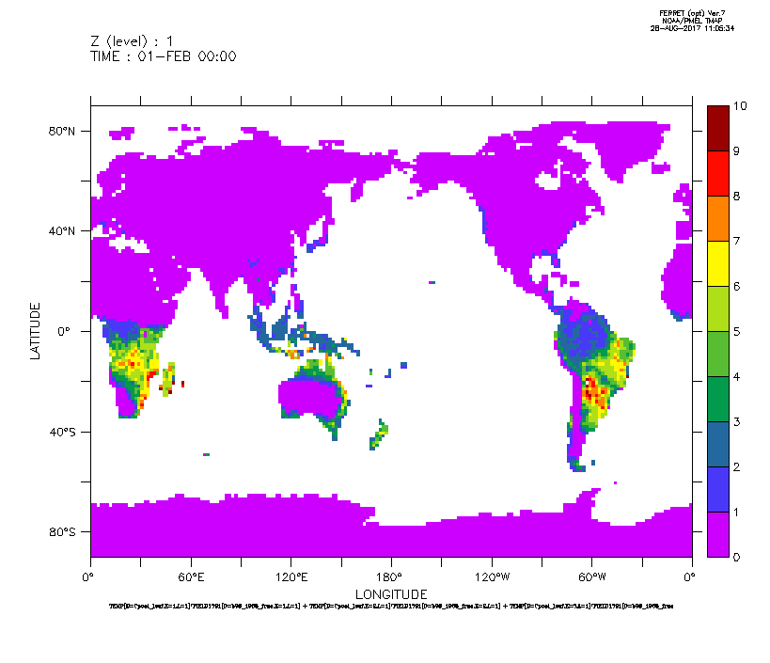

Plot shows same as above for 10-20. Note there are a few points.

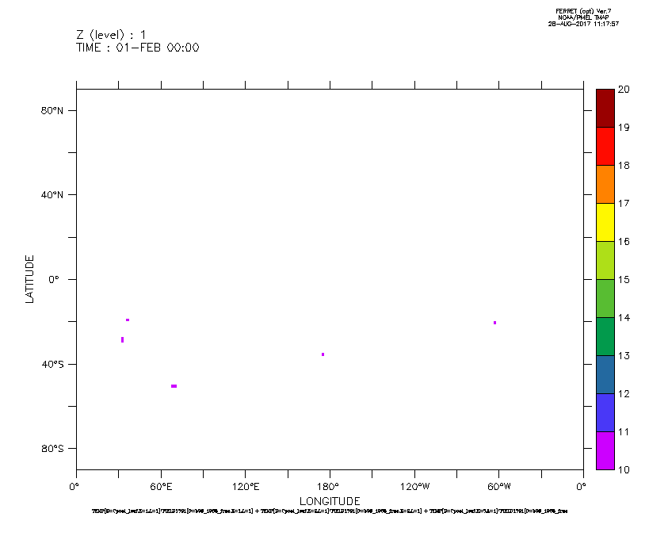

Plot shows same as above for 20-35. Note there are a two points.
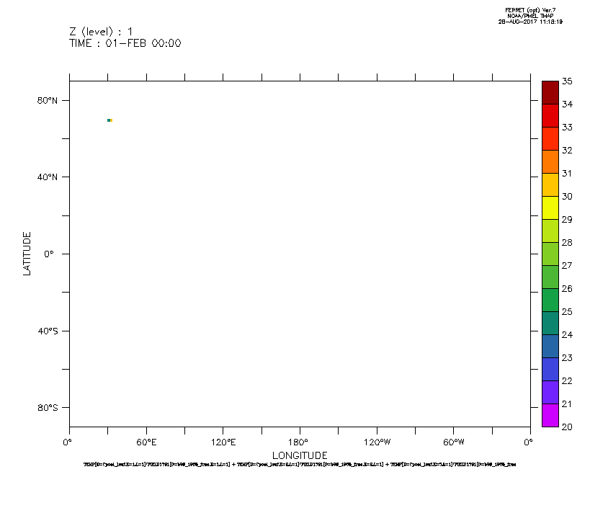
Bringing up land

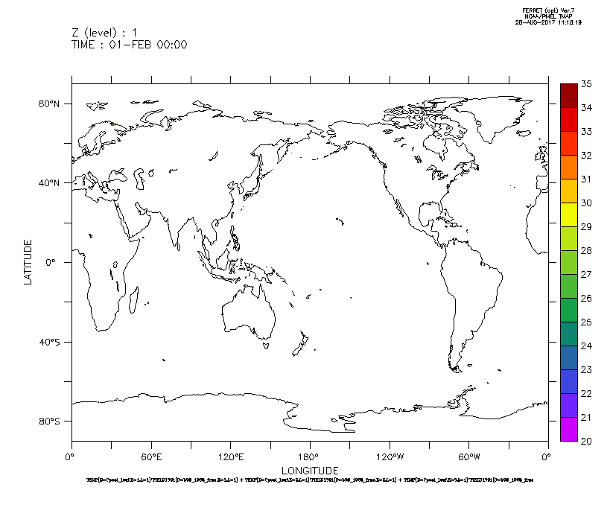

and narrowing region

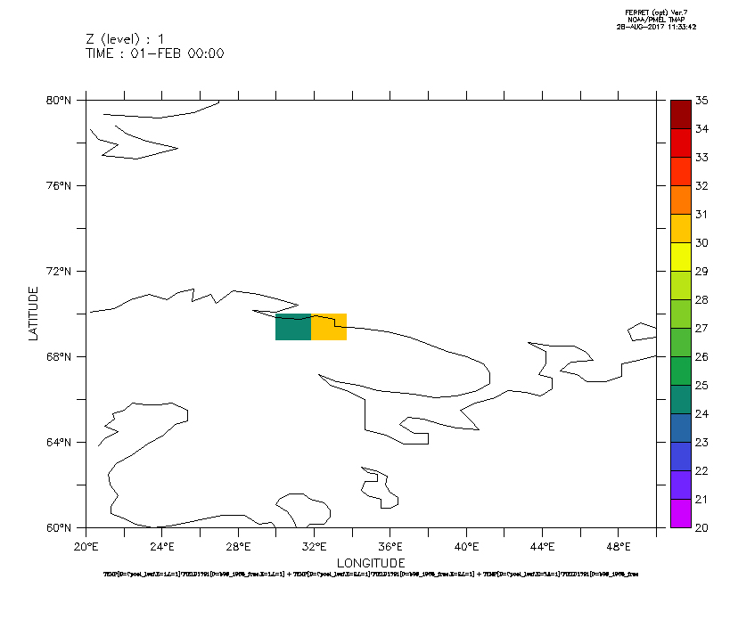

same region Surface Temperature
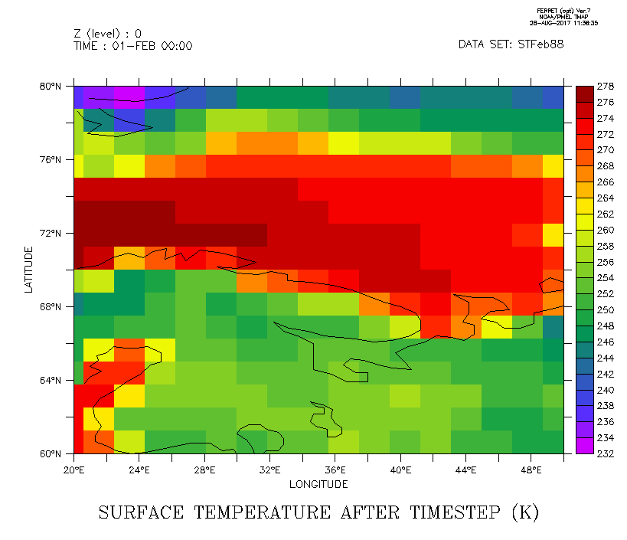
same region Soil temp over all PFTS

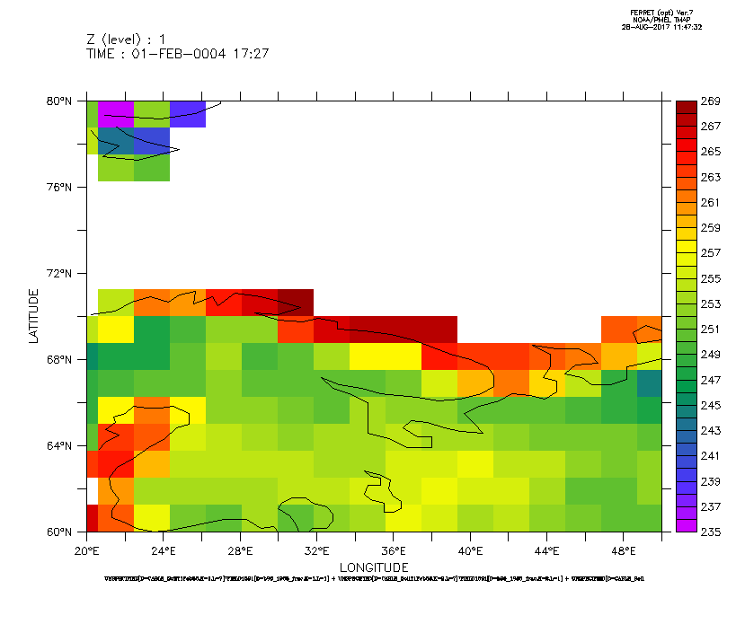
Global plots of Surface Temperature and soil temperature on top level
