Modifications to Cable Canopy-Module: Vanessa Haverd and Matthias Cuntz, Oct-Nov 2009

CABLE-canopy has been condensed to remove:
- Restriction on transpiration due to extractible water which led to decoupling of photosynthesis/transpiration under water-limited conditions
- Recalculation of energy-balance following wet-canopy calculation which gave incorrect energy flux partition between sunlit and shaded leaves

This was achieved by:
(Note here there are two iteration loops:
- the outer “T_{air} loop” which iterates until convergence of in-canopy air-temperature and absolute-humidity are achieved
- the inner “T_{leaf} loop” which iterates until convergence of leaf temperature is achieved)

- Moving the dispersion calculation to the top of the T_{air} loop.
- introduced tolerances for q_{vair} and T_{vair} to reduce number of iterations
- Removed modification to transpiration based on extractible water
- Root extraction in layer i set to : 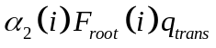, where q_{trans} is the total transpiration rate; F_{root} is the fraction of root density in layer i and 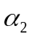 is the ramp function of Lai and Katul (2000): 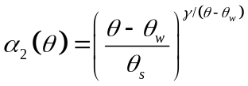
- The function of soil moisture which multiplies stomatal conductance is set to: 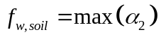 and this is applied to the entire stomatal conductance (not just the second term as was previously done, to eliminate the possibility of finite transpiration when there is no extractible water): 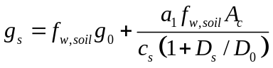
- Included wet-canopy evaporation into T_{leaf} loop, so that there is a single energy balance for a partially wet leaf
- Coupled stomatal conductance/photosynthesis equations are unchanged, but it is assumed that these apply only to the dry fraction of the leaf. Thus the resulting net photosynthesis for the partially wet leaf is scaled after the T_{leaf} loop: 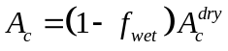
- Latent heat flux and 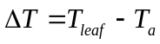 are obtained as before by combining: 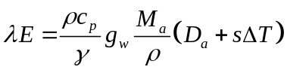 and
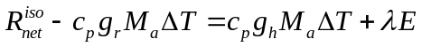, giving
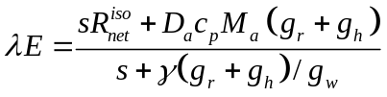
However g_{w} is modified to reflect the enhanced conductance for the wet fraction of the leaf: 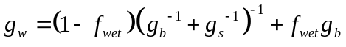
- Boundary layer conductance assumed the same for wet and dry parts of leaf (Previously g_{b} for wet leaf did not include forced component. Why not?)
- Introduced Flag_fwet. Wherever wet canopy evaporation (f_{wet}E_{can}) exceeds supply-limited rate (E_{cansto}, based on interception store), f_{wet} is reset to E_{cansto}/E_{can}, Flag_fwet is set to 1, which causes at least one more iteration of the T_{leaf} loop.

