Instructions for Completion:

Organisations requesting a licence must complete Part 1.
Users from that organisation requiring access to the CABLE code repository need to individually complete Part 2.

Individuals can apply for their own licence by completing Part 2 only, provided that they can warrant the use of their Improvements as stated in clause 6.3 of the licence.

Part 2 – User to complete:
Name of user: Albert Van Dijk
Address: Fenner School of Environment & Society
Linnaeus way
ANU Canberra 0200 ACT
Email: albert.vandijk@anu.edu.au
Telephone number: (02) 612 52197
(Please note that the above details may be posted on the list of CABLE users page and used by CSIRO in accordance with the Software Licence Agreement.)
NCI login (if you already have a NCI user account): avd652
Please select one of the following:
- X I am requesting an individual CABLE licence
- I am requesting a User account under my Organisation’s CABLE licence
From where or whom did you hear about the CABLE model?
Cannot remember. Probably from one of the early developers and/or contributors in CMAR.

Please provide a short description of your intended use of CABLE and anticipated intended research results (including proposed publication time frames, if any).

Evaluation against hydrological observations, comparison of water and carbon simulations against those from other models, potentially data assimilation experiments.

I have read and will comply with the Software Licence Agreement and the Guidelines for users and developers of CABLE:

Signed: 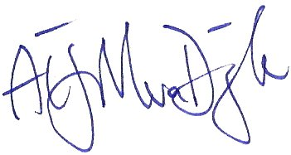 Date: 19/11/2013

Send the completed registration form via email to cable_help@nf.nci.org.au

