Instructions for Completion:

Organisations requesting a licence must complete Part 1.
Users from that organisation requiring access to the CABLE code repository need to individually complete Part 2.

Individuals can apply for their own licence by completing Part 2 only, provided that they can warrant the use of their Improvements as stated in clause 6.3 of the licence.

Part 1 – Organisation to complete:

Name of Licensee organisation:

ABN:

Name of contact: _______________________________________________________
(Title) (First name) (Last name)
E-mail: _______________________________________
Telephone number: _____________________________
Postal Address for notices: ____________________________________________________________ ____________________________________________________________________

By submitting this signed Form, the Licensee represents that:
- it has read and accepted the current Software Licence Terms for CABLE located at http://www.cawcr.gov.au/projects/access/cable/index.php and
- its Permitted Users are those users who have completed Part 2 of this Form and anyone else to whom the Licensee and/or the Licensee contact has granted CABLE access pursuant to the Software Licence Terms.

.....................................................  Signed by an authorised representative  for the Licensee | .........................................................  Witness
.........................................................  Name and title | .........................................................  Name

.........................................................
Date

Part 2 – User to complete:
Name of user: Li Deqin
Address: Changbainan street 388#, Heping of Shenyang, Liaoning, China.
Email: lewen05@hotmail.com
Telephone number: 086-13898861307
(Please note that the above details may be posted on the list of CABLE users page and used by CSIRO in accordance with the Software Licence Agreement.)
NCI login (if you already have a NCI user account):
Please select one of the following:
- ■ I am requesting an individual CABLE licence
- I am requesting a User account under my Organisation’s CABLE licence
If you have selected (b), please state which Organisation:
Student Employee Other (please state)
If you are a student, please provide supervisor contact information (these would not appear in the list of users page). Your supervisor’s signature is also required to indicate that they approve your registration.
Name of supervisor:
Position in organisation:
Address:
Email: Telephone number:
Supervisor’s signature: Date:

****************************************************
From where or whom did you hear about the CABLE model?
I am a old user of CABLE, I have supplied the version 1.3. I have validated the finite-difference techniques of solving 1-D Richards equation in CABLE1.3.
Please provide a short description of your intended use of CABLE and anticipated intended research results (including proposed publication time frames, if any).
I am mainly focus the hydraulic process in LSMs, and I have validated the finite-difference techniques of solving 1-D Richards equation in CABLE1.3. and compared it with Noah and CLM.
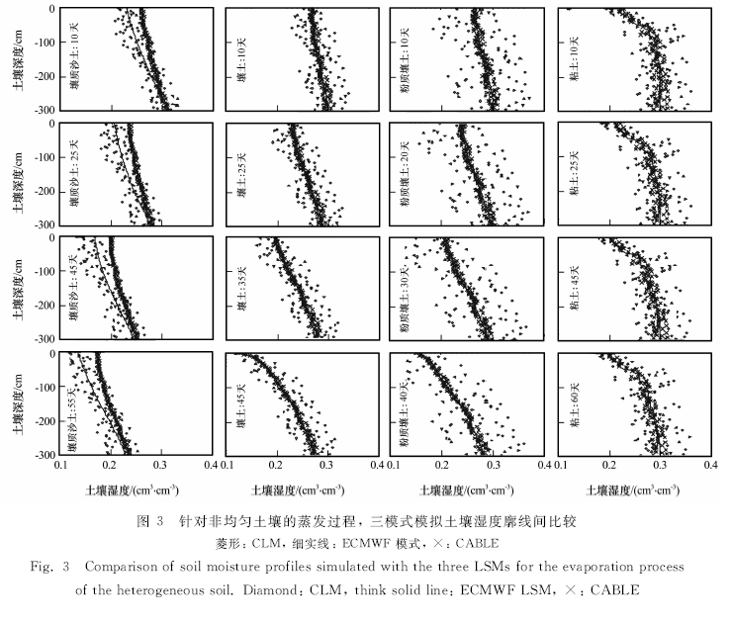

I have read and will comply with the Software Licence Agreement and the Guidelines for users and developers of CABLE:

Signed: Date:

Send the completed registration form via email to cable_help@nf.nci.org.au

