Device Characterization Platform v1.0.0

User Guide (Mobile App)

DCP-User-Guide-Mobile-App-v1.0.0

October 4, 2019

Revision history

|  |  |  |
| --- | --- | --- |
| Revision | Date | Description |
| A | October 2019 | Initial release |

# **Contents**

1. **Introduction** 5

**1.1.** **Purpose** 5

**1.2.** **Supported OS Versions** 5

**1.3.** **Definitions, Acronyms, and Abbreviations** 5

2. **App Description** 6

3. **App Navigation** 7

**3.1.** **Log-in Screen** 7

**3.2.** **Search IMEI** 8

**3.3.** **Verify IMEI** 9

**3.4.** **Device Details** 10

**3.5.** **Report Device** 11

**3.6.** **Scan IMEI** 13

**3.7.** **Device Details of Scanned IMEI** 15

**3.8.** **Report IMEI** 16

**3.9.** **IMEI not found** 16

**3.10.** **History** 17

**3.11.** **User Profile** 19

**3.12.**  **Feedback** 20

**3.13.** **Logout** 23

**Figures**

Figure 1- Login Screen 7

Figure 2- Search IMEI 8

Figure 3- Verify IMEI 9

Figure 4- Device Details 10

Figure 5- Report Details 11

Figure 6- Submit 12

Figure 7- Scan IMEI 13

Figure 8- Verify Scanned IMEI 14

Figure 9- Device Details of Scanned IMEI 15

Figure 10- IMEI not Found 16

Figure 11- View History 17

Figure 12- Display History 18

Figure 13- User Profile 19

Figure 14-Feedback 20

Figure 15-Feedback 21

Figure 16-Feedback 22

Figure 17- Logout 23

**Tables**

Table 1-Supported OS Versions 5

Table 2-Definitions, Acronyms, and Abbreviations 5

Table 3-System Description 6

|  |
| --- |
|  |

# **Introduction**

Device Characterization Platform (DCP) is a platform for authorized users to characterize devices based on their IMEI by querying GSMA IMEI database. It fetches information associated with an IMEI from GSMA IMEI database and displays to user. It gives option to user to report counterfeit device if its TAC part of IMEI is not approved by GSMA or characteristics retrieved from GSMA IMEI database does not match with physical device.

## **Purpose**

This document is projected to give assistance to the user of DCP mobile app.

## **Supported OS Versions**

Table 1-Supported OS Versions

|  |  |
| --- | --- |
| OS | Version |
| Android | 4.1 |

## 

## **Definitions, Acronyms, and Abbreviations**

Table 2-Definitions, Acronyms, and Abbreviations

|  |  |
| --- | --- |
| **Term** | **Definition** |
| DCP | Device Characterization Platform |
| MSISDN | Mobile Subscriber Integrated Services Directory Number |
| IMEI | International Mobile Equipment Identity |

# **App Description**

Table 3-System Description

|  |  |
| --- | --- |
| ****Feature /Sections**** | ****Purpose**** |
| **Login Screen** | * To access the app, authorized user(s) first needs to enter his/her credentials on login page |
| Type IMEI | * Takes the IMEI as input. Enter IMEI of device to be verified |
| Scan IMEI | Allows user to scan IMEI of the device |
| View History | Displays a complete history of activity(ies) performed by the user within the system i.e. searched IMEI, Date & Time, User Name, Results, Medium, IP address |
| Change Language | Allows user to change app language i.e. Vietnamese, English.  English is default language |
| Logout | Allows user to logout from app |

# **App Navigation**

## **Log-in Screen**

To access the app, authorized user first needs to register his/her account via [web portal](http://vietnam.dcp.smartforum.org/en/register).

1. Enter user credentials i.e. email and password
2. Tap on “Login” button.

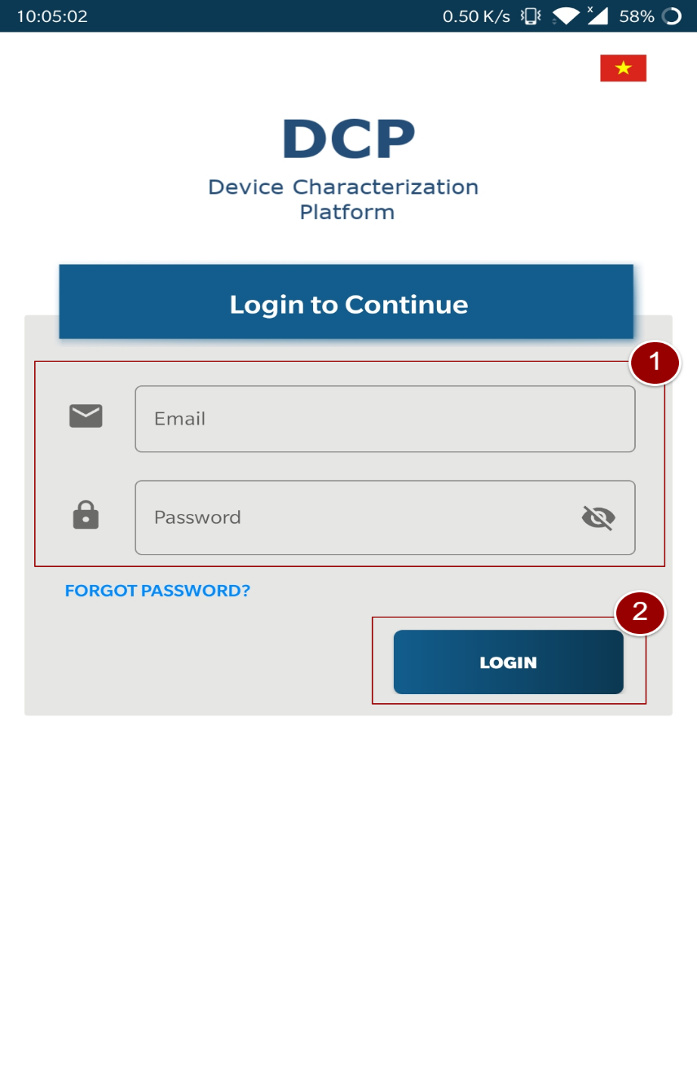

Figure 1- Login Screen

## **Search IMEI**

Read the instructions.

1. Enter IMEI to verify the status of IMEI.

**Note**: *IMEI should be 14-16 digits long.*

1. Tap on “Check” button.

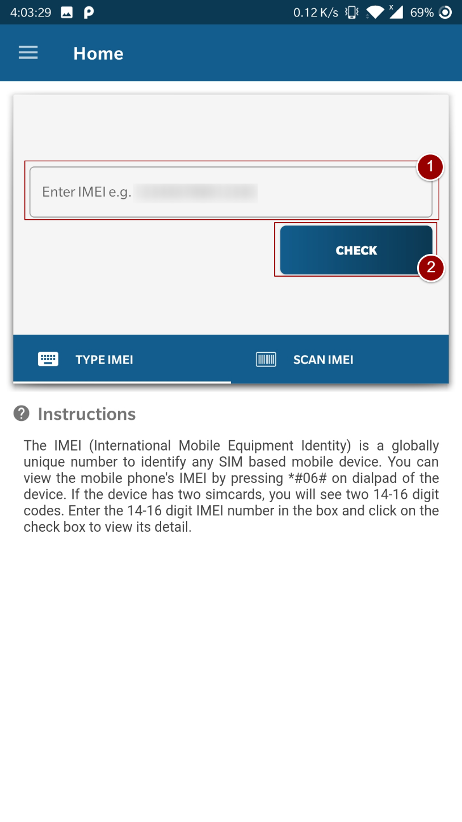

Figure 2- Search IMEI

## **Verify IMEI**

After tapping on “check button” a popup will appear to verify the IMEI.

1. Verify IMEI and tap on “OK” button.

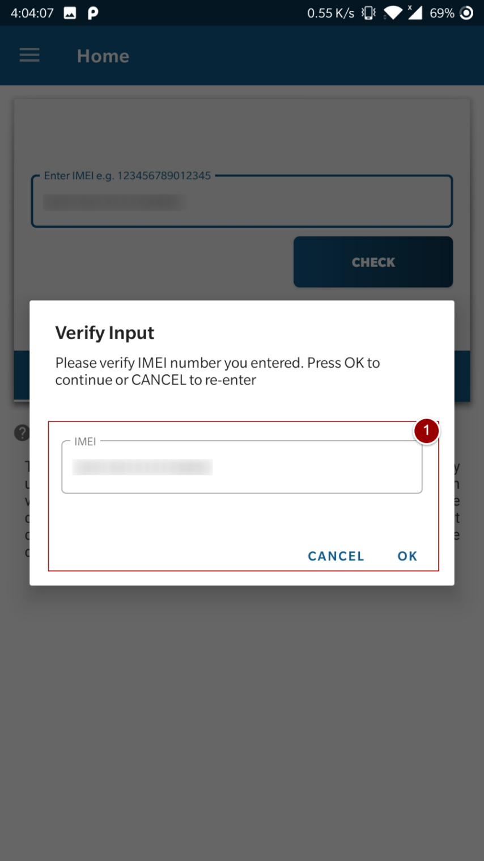

Figure 3- Verify IMEI

## **Device Details**

After confirming IMEI, device details (Device ID, Manufacturer, Equipment Type, Brand Name etc.) will be displayed on the screen.

1. Tap on “YES” button, if the displayed details are same as mentioned on device/device box, otherwise tap on “NO, Report” button to report device.

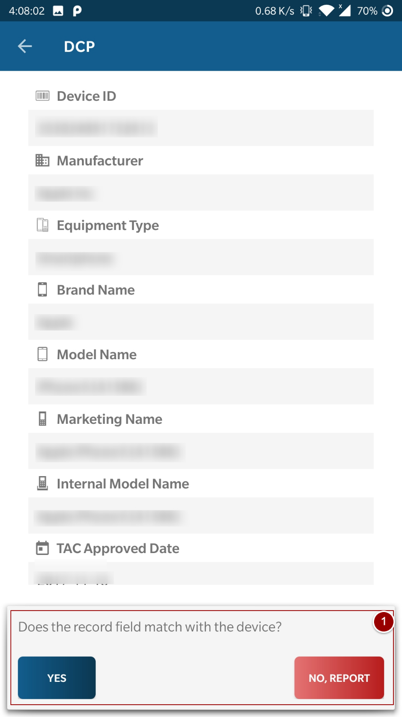

Figure 4- Device Details

## **Report Device**

User needs to report the device if the displayed details do not match with the device.

After tapping on “NO, Report” button, a form will appear to get actual device details.

1. Enter device details (Mobile Phone Brand, Model Name, Store Name, Address, Description and Images of the device).

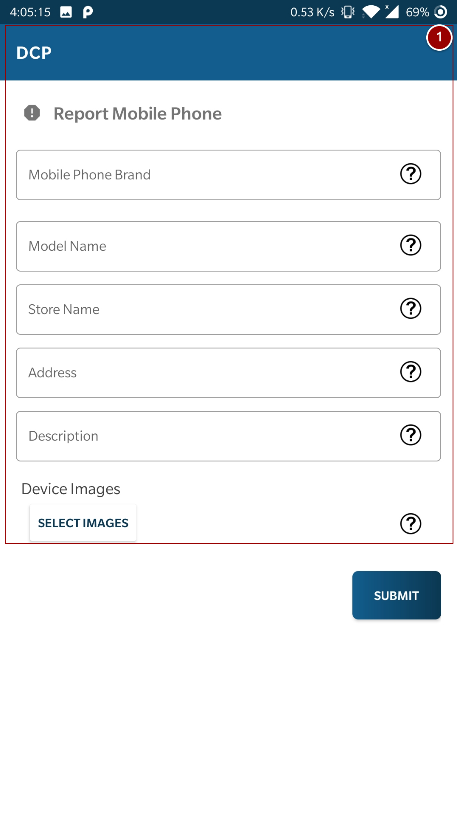

Figure 5- Report Details

**Note**: *Upto 5 images can be added.*

1. Tap on “Submit” button.

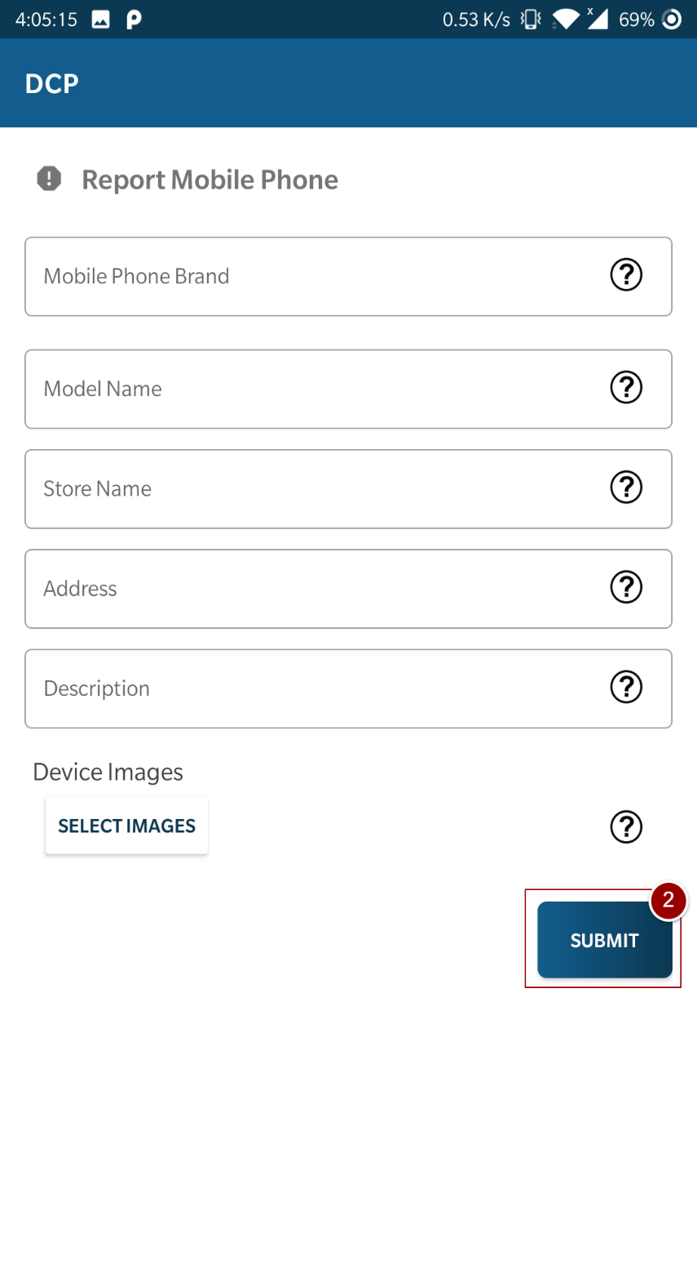

Figure 6- Submit

## **Scan IMEI**

1. To scan IMEI, tap on “Scan IMEI” and place the scan box on IMEI. After placing the IMEI in scan box tap within the box to fetch IMEI.

**Note**: *IMEI should be 14-16 digits long.*

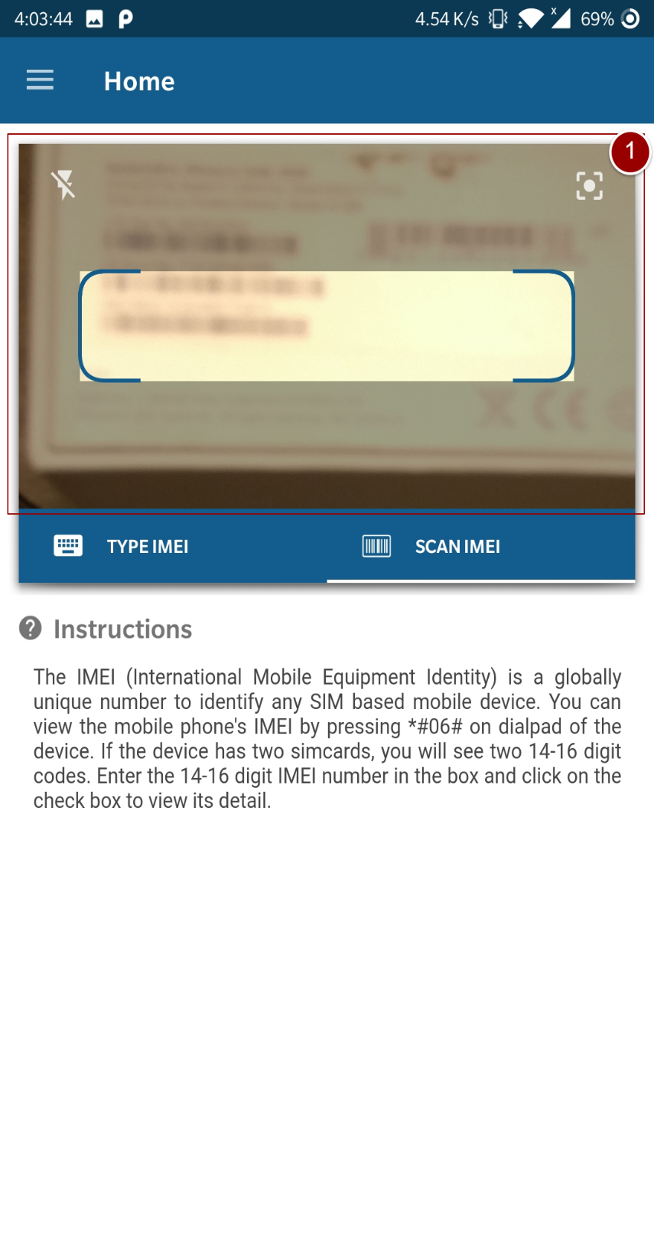

Figure 7- Scan IMEI

1. A popup will appear to verify IMEI. Verify IMEI and tap on “OK” button.

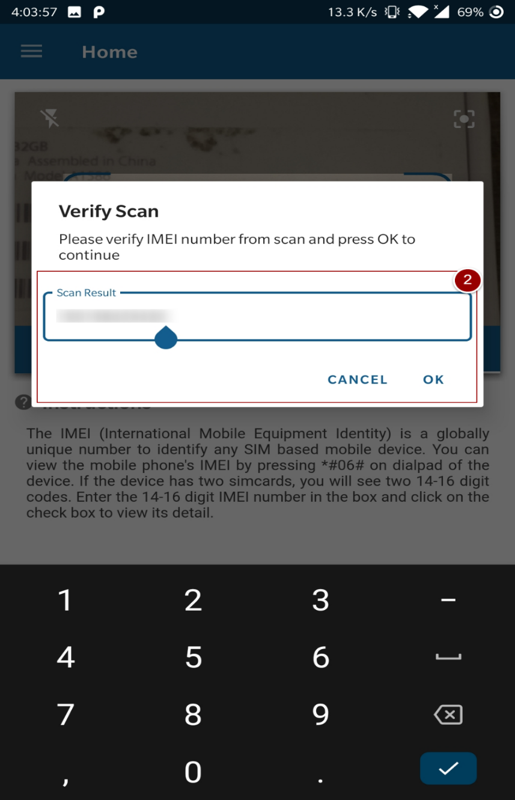

Figure 8- Verify Scanned IMEI

## **Device Details of Scanned IMEI**

After confirming IMEI, device details (Device ID, Manufacturer, Equipment Type, Brand Name etc.) will be displayed on the screen.

1. Tap on “YES” button, if the displayed details are same as mentioned on device/device box, otherwise tap on “NO, Report” button to report device.



Figure 9- Device Details of Scanned IMEI

## **Report IMEI**

User needs to report the device if the displayed details do not match with the device.

To report the device, perform steps mention in Section 3.5.

## **IMEI not found**

A popup will appear if the IMEI is not found in GSMA database. This device may be a counterfeit or illegal device.

1. To report this device tap on “Report Mobile Phone” button.

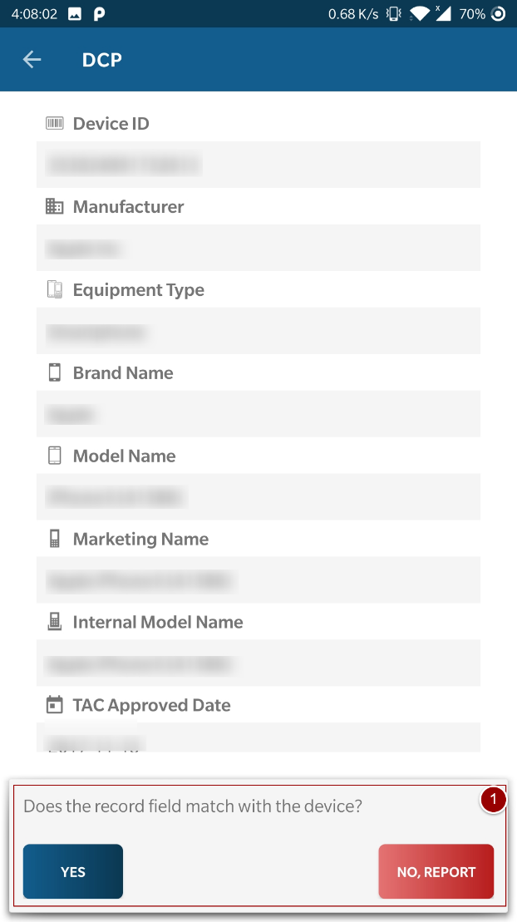

Figure 10- IMEI not Found

To report the device, follow steps mention in Section 3.5.

## **History**

1. To view history, tap on icon on top left side of the screen.
2. A menu will appear, tap on “History”.

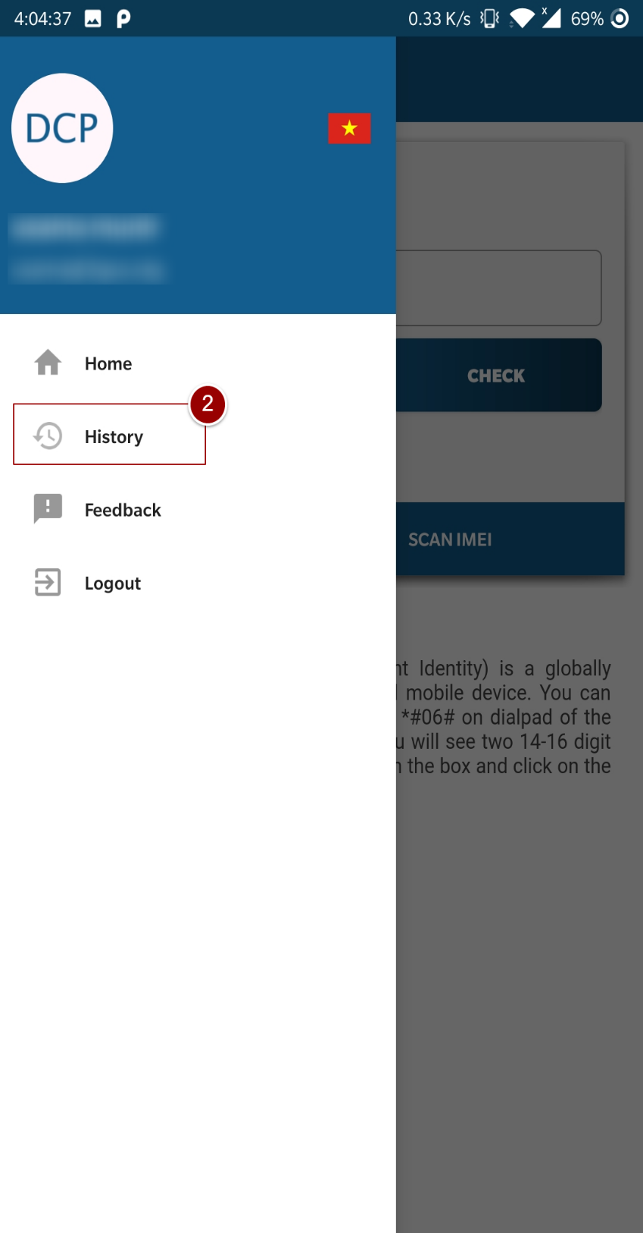

Figure 11- View History

1. History will display with complete details i.e. Searched IMEI, Date & Time, User Name, Results, Medium, and IP Address.

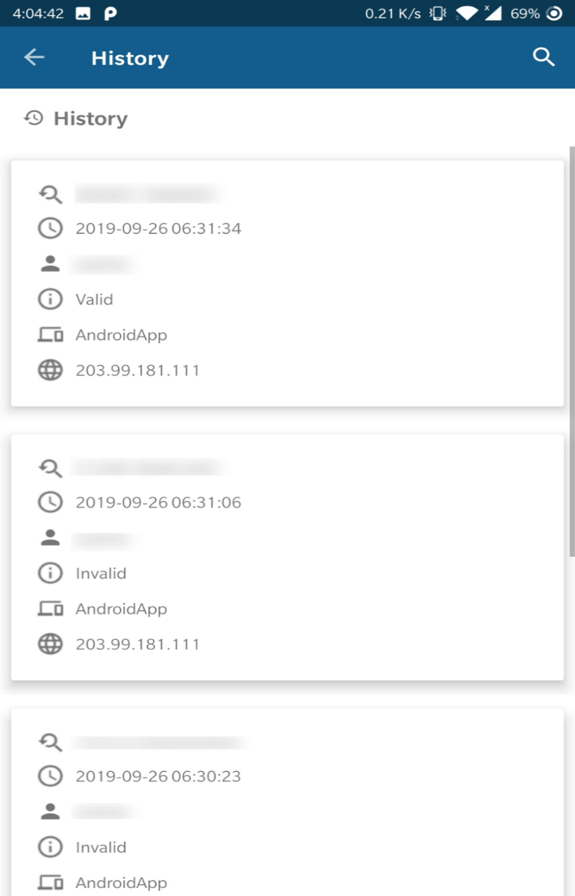

Figure 12- Display History

## **User Profile**

To view username or email address, tap on icon.

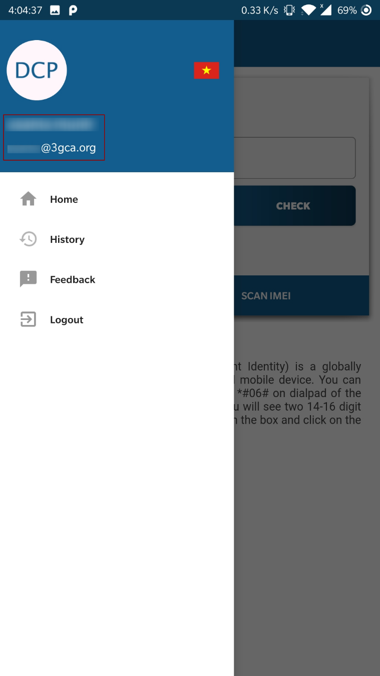

Figure - User Profile

## **Feedback**

1. To give feedback, tap on icon on left top of the screen
2. A menu will appear, tap on “Feedback”

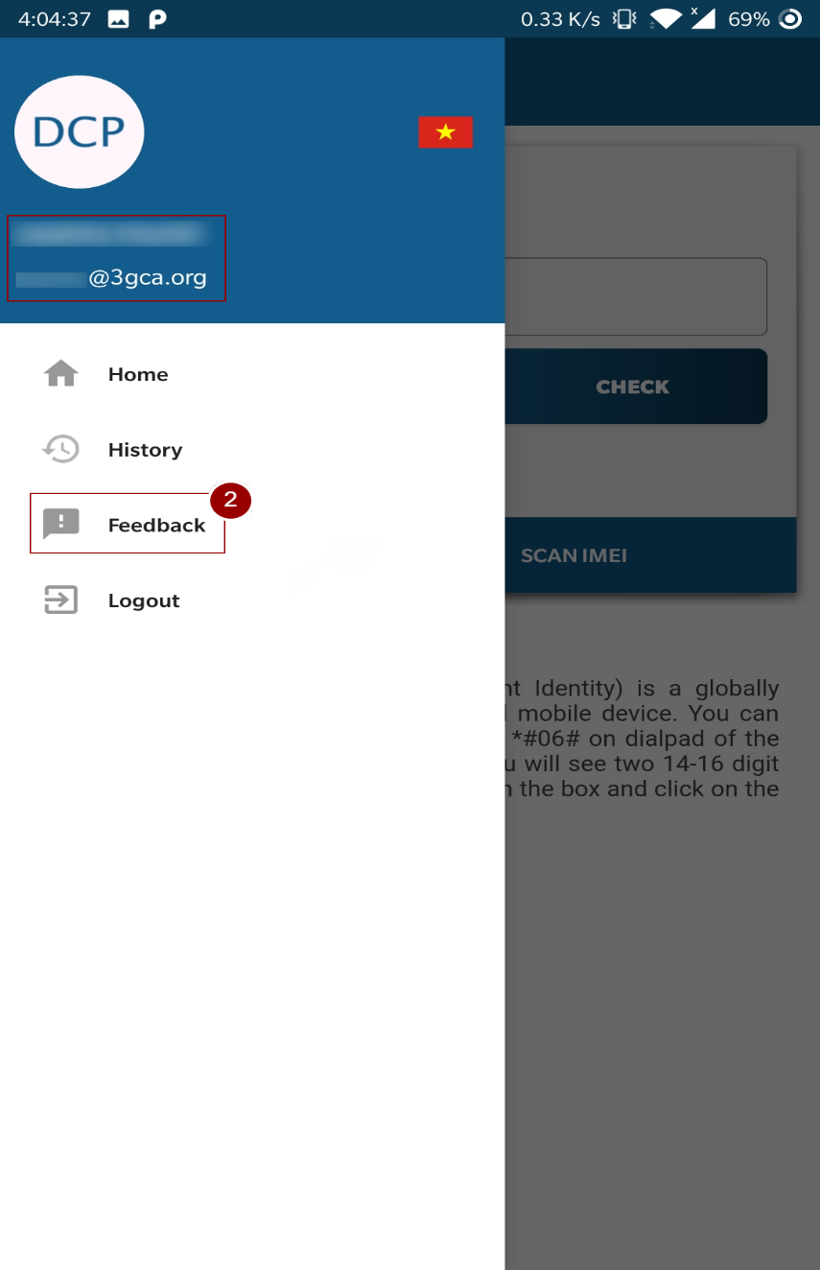

Figure 14-Feedback

1. Write down your comments/suggestions in comment box
2. Tap on “Submit Feedback” button

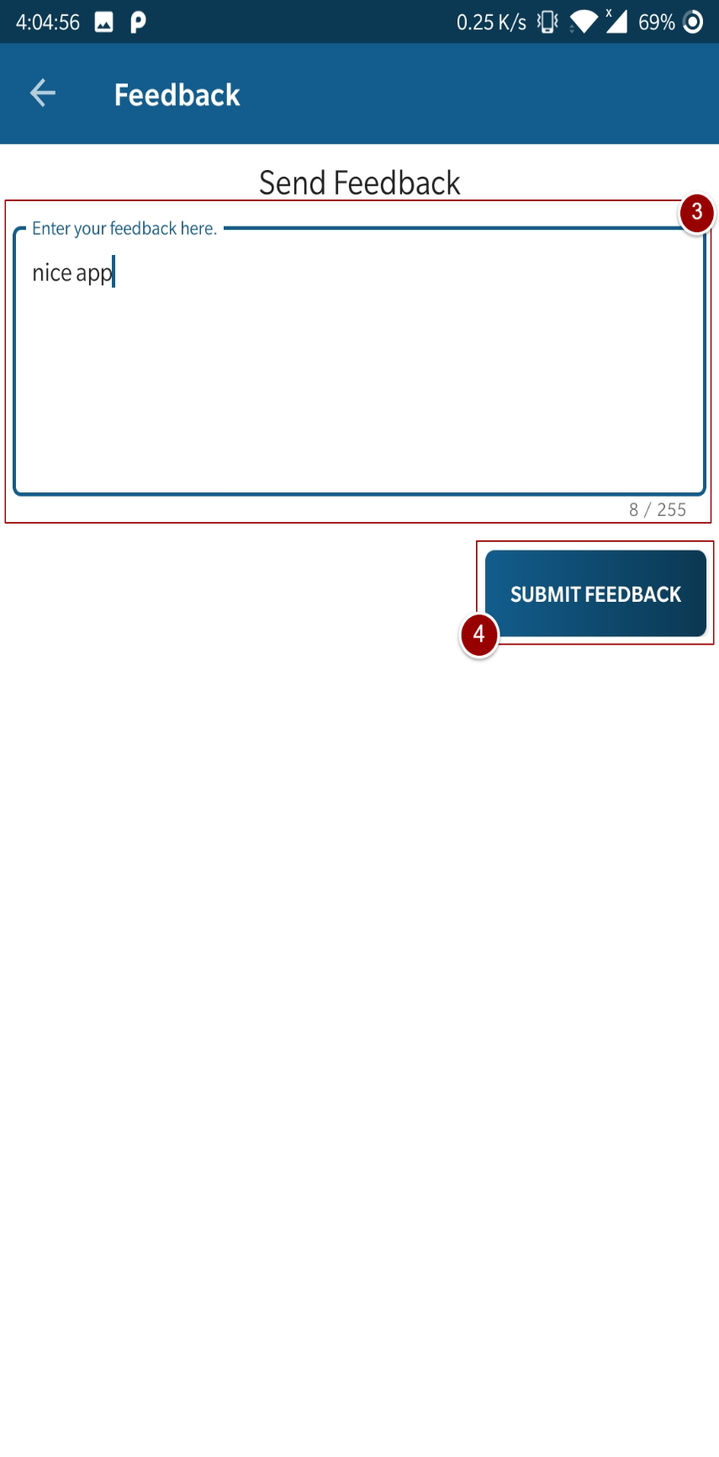

Figure 15-Feedback

A confirmation message will pop-up after tapping the “Submit Feedback” button

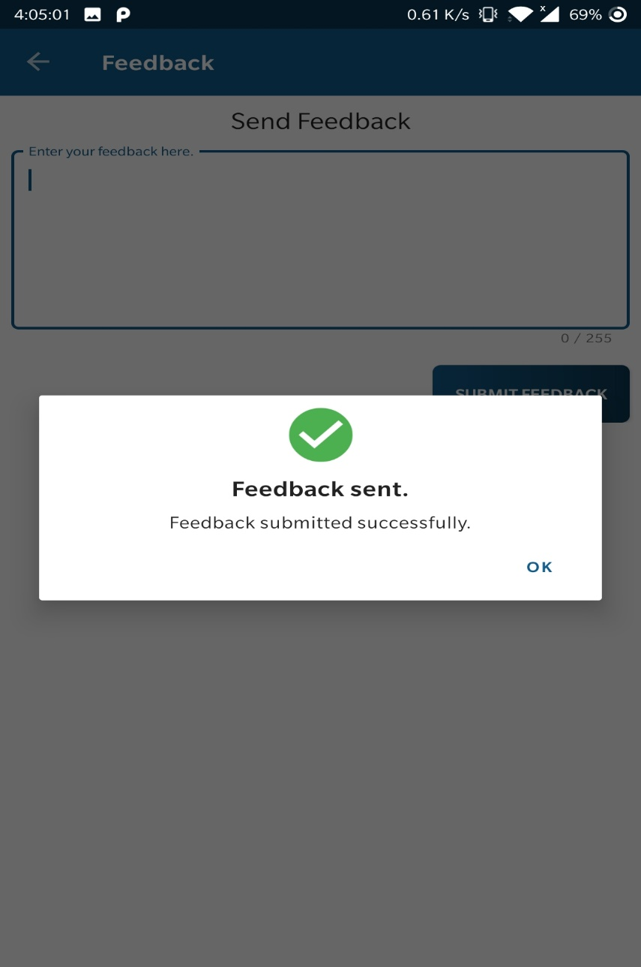

Figure 16-Feedback

## **Logout**

1. To logout app, tap on icon on left top of the screen.
2. A menu will appear, tap on “Logout”.

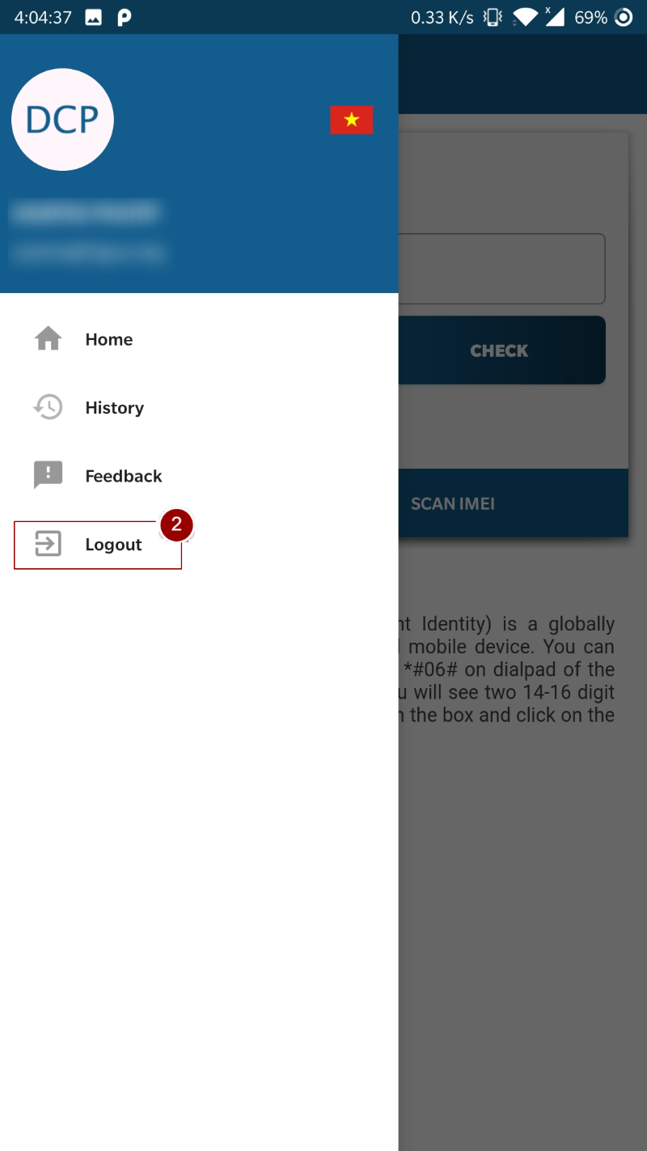

Figure 17- Logout