Device Characterization Platform v1.0.0

User Guide

DCP- Public-User-Guide-v1.0.0

October 10, 2019

Revision history

|  |  |  |
| --- | --- | --- |
| Revision | Date | Description |
| A | October 2019 | Initial release |

# **Contents**

1. Introduction 5

1.1. Purpose 5

1.2. Supported Desktop Browsers 5

1.3. Supported Mobile Browsers 5

1.4. Definitions, Acronyms, and Abbreviations 6

2. System Description 7

3. System Navigation 9

3.1. Registration 9

3.2. Login Screen 11

3.3. Portal Sections 13

3.4. Edit Profile 14

3.5. IMEI Search 18

3.5.1.Matched Devices 21

3.5.2.Counterfeit Devices 23

3.6. My Activity 26

3.7. App download 27

3.8. Feedback 29

**Figures**

Figure 1-Registration Link 9

Figure 2-Registration Form 10

Figure 3-Login Screen 11

Figure 4-License Agreement for New Users 12

Figure 5-Portal Sections 13

Figure 6-Edit Profile 14

Figure 7-Edit Profile 15

Figure 8-Change Password 16

Figure 9-Change Password 17

Figure 10-IMEI Search 18

Figure 11-IMEI Search 19

Figure 12-Searched Results 20

Figure 13-Matched Devices 21

Figure 14-Confirmation Message 22

Figure 15-Counterfeit Devices 23

Figure 16-Counterfeit Device Details 24

Figure 17-Confirmation Message 25

Figure 18-My Activity 26

Figure 19-Download App 27

Figure 20-Download App 28

Figure 21-Feedbacks 29

**Tables**

Table 1- Supported Desktop Browsers 5

Table 2- Supported Mobile Browsers 5

Table 3- Definitions, Acronyms, and Abbreviations 6

Table 4-System Description 7

# **Introductio****n**

Device Characterization Platform (DCP) is a platform for authorized users to characterize devices based on their IMEI by querying GSMA IMEI database. It fetches information associated with an IMEI from GSMA IMEI database and displays to user. It gives option to user to report counterfeit device if its TAC part of IMEI is not approved by GSMA or characteristics retrieved from GSMA IMEI database does not match with physical device.

## Purpose

This document is intended to give assistance to the user(s) to use the Device Characterization Platform (DCP).

## Supported Desktop Browsers

**Table 1- Supported Desktop Browsers**

|  |  |
| --- | --- |
| **Name** | **Version** |
| Internet Explorer | 11.0 |
| Firefox 52.5 ESR | 57.0 |
| Chrome | 63.0 |
| Safari | 11.0 |
| Edge | 41.16299 |

## Supported Mobile Browsers

**Table 2- Supported Mobile Browsers**

|  |  |
| --- | --- |
| **Name** | **Version** |
| Chrome | 63.0 |
| UC Browser | 11.5 |
| Opera(Android) | 44.1 |
| Opera(iOS) | 16.0.7 |
| Safari | 11.1 |
| Samsung Internet | 6.2 |
| Android | 4.1.x - 4.3 |

## Definitions, Acronyms, and Abbreviations

**Table 3- Definitions, Acronyms, and Abbreviations**

|  |  |
| --- | --- |
| ****Term**** | ****Definition**** |
| **DCP** | **Device Characterization Platform** |
| **TAC** | **Type Allocation Code** |
| **IMEI** | International Mobile Equipment Identity |

# **System Description**

**Table 4-System Description**

|  |  |
| --- | --- |
| Feature****/Sections**** | ****Description**** |
| **Login Screen** | * In order to gain access to information and functionality, user first needs to enter his/her credentials on login screen. |
| Portal Sections | **The portal is divided into following sections.**   * **Header**   Header section displays name of the system, and language change option with logout functionality     * **Navigation Panel**   Navigation Panel contains main navigation menu through which user can navigate the whole system   * **Main Content Area**   Main Content Area contains all the content to be displayed and actions to be performed for respective feature   * **Footer**   Footer contains the copyright statement |
| Profile Screen | Display details (i.e. First Name, Last Name and Email Address), of the user and allows user to edit/change the information and password. |
| IMEI Search | Allows user to enter IMEI to fetch details from GSMA IMEI database |
| Searched Results | * Displays the following information (i.e. Device ID, Manufacturer, Equipment Type, Brand Name, Model Name, Marketing Name, Internal Model Name, TAC Approved Date, Device Certify Body, Radio Interface, Operating System, SIM Support, Bluetooth Support, and WLAN Support) of the device in a table. |
| Counterfeit Device Details Form | Takes the details of the actual device as input. Form contains the following input fields.   * **Mobile Phone Brand**   Takes the brand name of the device as input.   * **Store Name**   Takes the name of the store (i.e. From where the user purchased the device) as input.   * **Model Name**   Takes the model number of the device as input.   * **Address**   Takes the user’s address as input.     * **Description**   Takes the description of the device (i.e. color, size etc.) as input.     * **Choose file**   Allows user to upload the images of the device. |
| My Activity | * Allows user to view his/her own activity logs (i.e. User Device (web, mobile), Checking Method(auto, manual), IMEI Number, Result Status(found/not found),Results Matched(yes/no), User Name, Created At). |
| App Download | * Allows user to download the mobile app by accepting end user license agreement. |
| Feedbacks | * Allows user to submit feedback. |
| Language Change | * Facilitates user to select any language (English, Vietnamese) for the system. |

# System Navigation

# **Registration**

1. To access the system a new user first needs to sign up, click on the “Register Now” link.

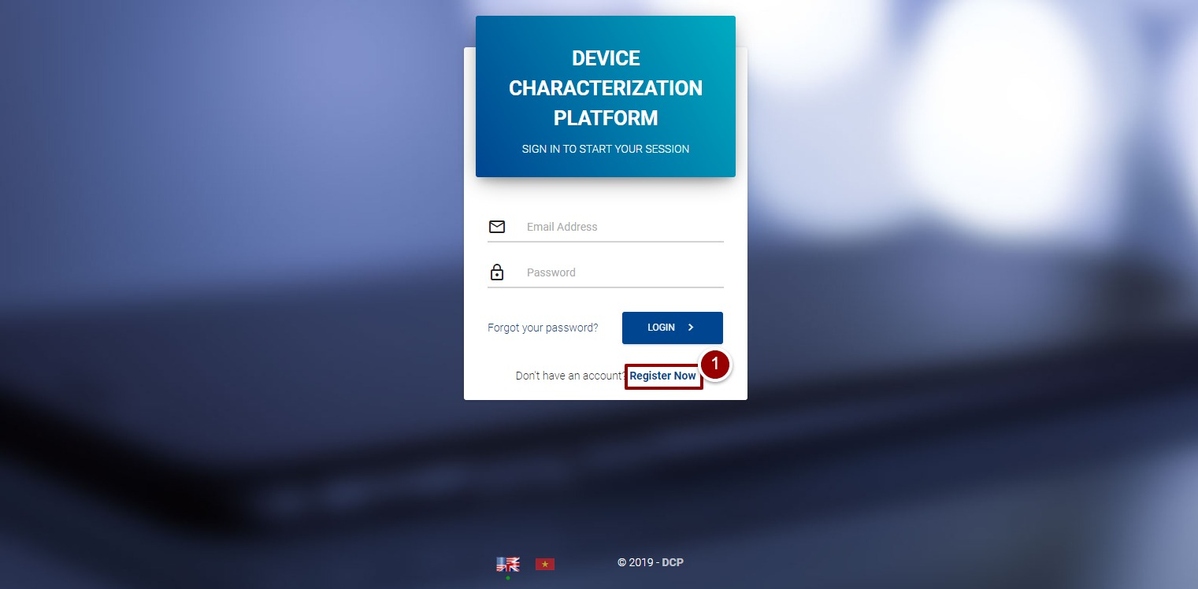

**Figure 1-Registration Link**

A new page will appear that displays the registration form.

1. Enter required information (i.e. First Name, Last Name, Email, and Password) in respective fields.
2. Click on “Register” button.

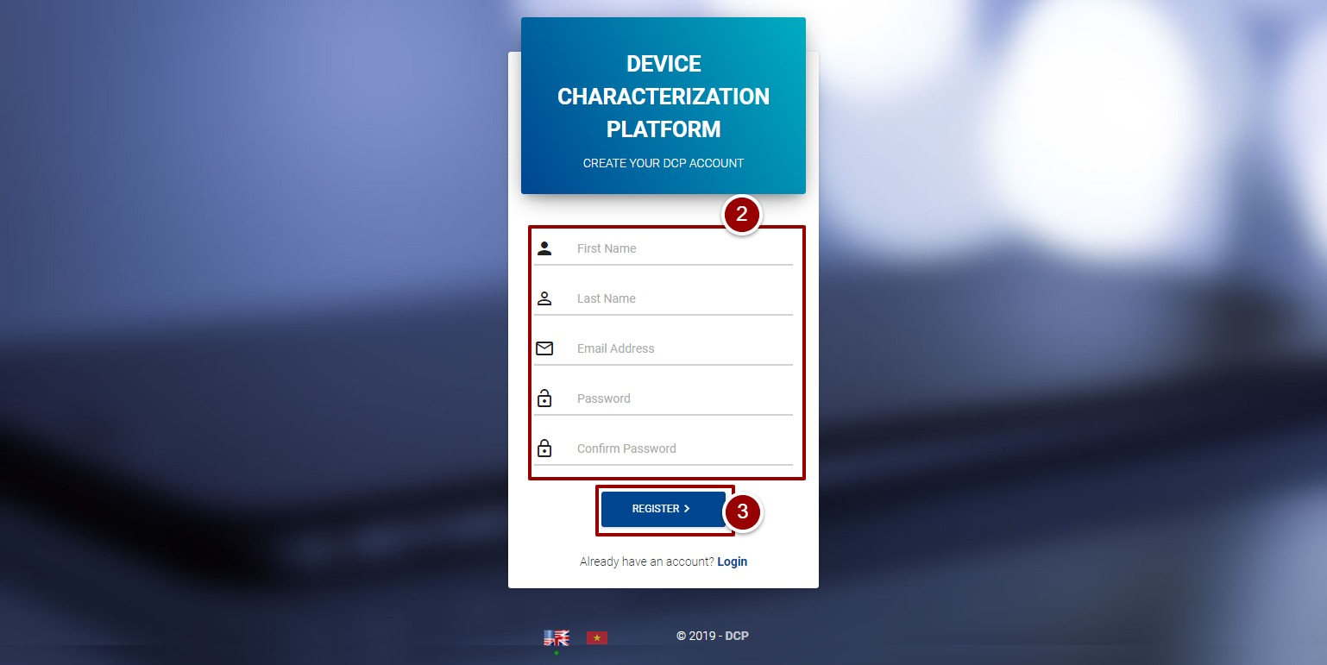

**Figure 2-Registration Form**

**Note:** New user cannot access the system until admin user will approve registration request.

# Login Screen

1. Enter username and password in respective fields.
2. Click on “Log in” button.

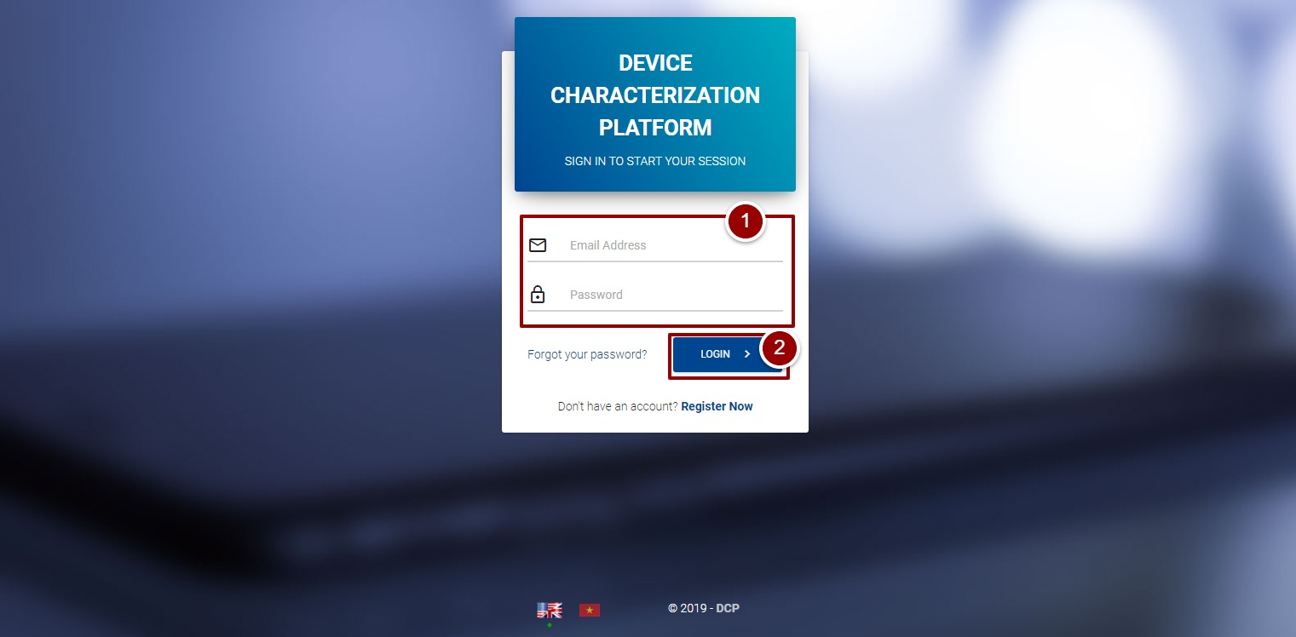

**Figure 3-Login Screen**

By clicking on “login” button, a welcoming popup will appear on the screen click on “Close” button and then a license agreement will appear for the new user(s). After accepting the license agreement user will able to navigate the system.

1. To accept the license, click on checkbox.
2. Click on “Continue” button.

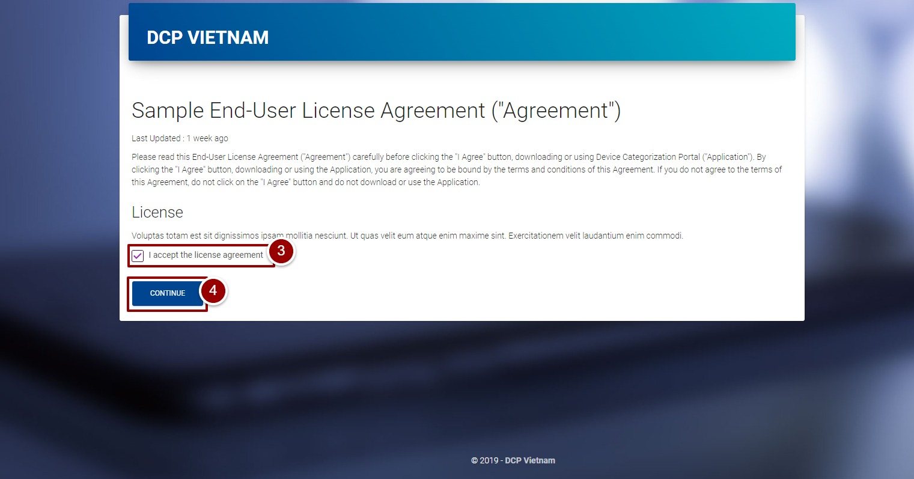

**Figure 4-License Agreement for New Users**

**Note**: This license agreement will appear only for once when the user sign in for first time.

# **Portal Sections**

The portal screen is divided into following sections.

1. **Header** section displays the name of the system, name of the logged in user with logout functionality.
2. **Main Navigation Panel** helps user to navigate through system.
3. **Main Content Area** contains all relevant information related to the respective feature/option.
4. **Footer** contains the version and copyrights statement.

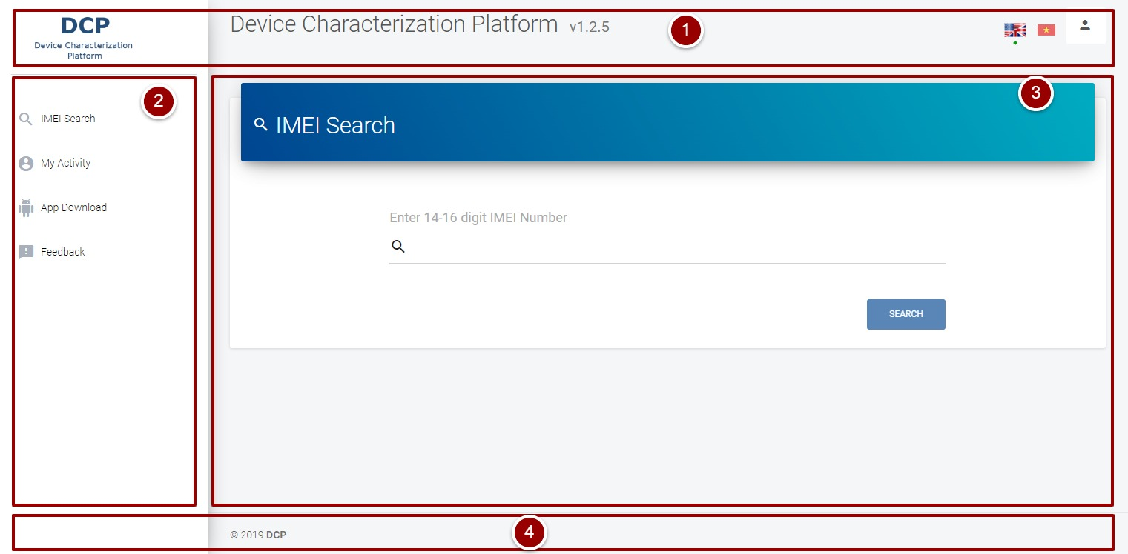

**Figure 5-Portal Sections**

# **Edit Profile**

1. To edit his/her own profile, click on the profile icon on top right side of screen and select “Profile” option.

A page will appear that contains user information (i.e. First Name, Last Name, and Email Address).

1. Click on “Edit Details” button.

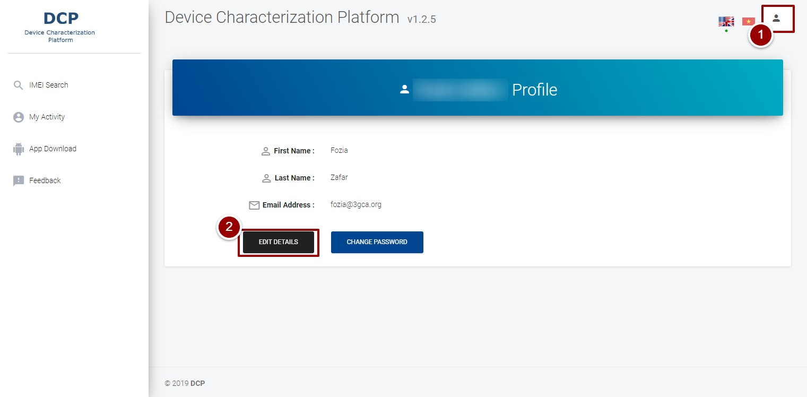

**Figure 6-Edit Profile**

By clicking on “Edit Details” button a page will appear that display details of the user.

1. Edit the details and click on “Update” button.

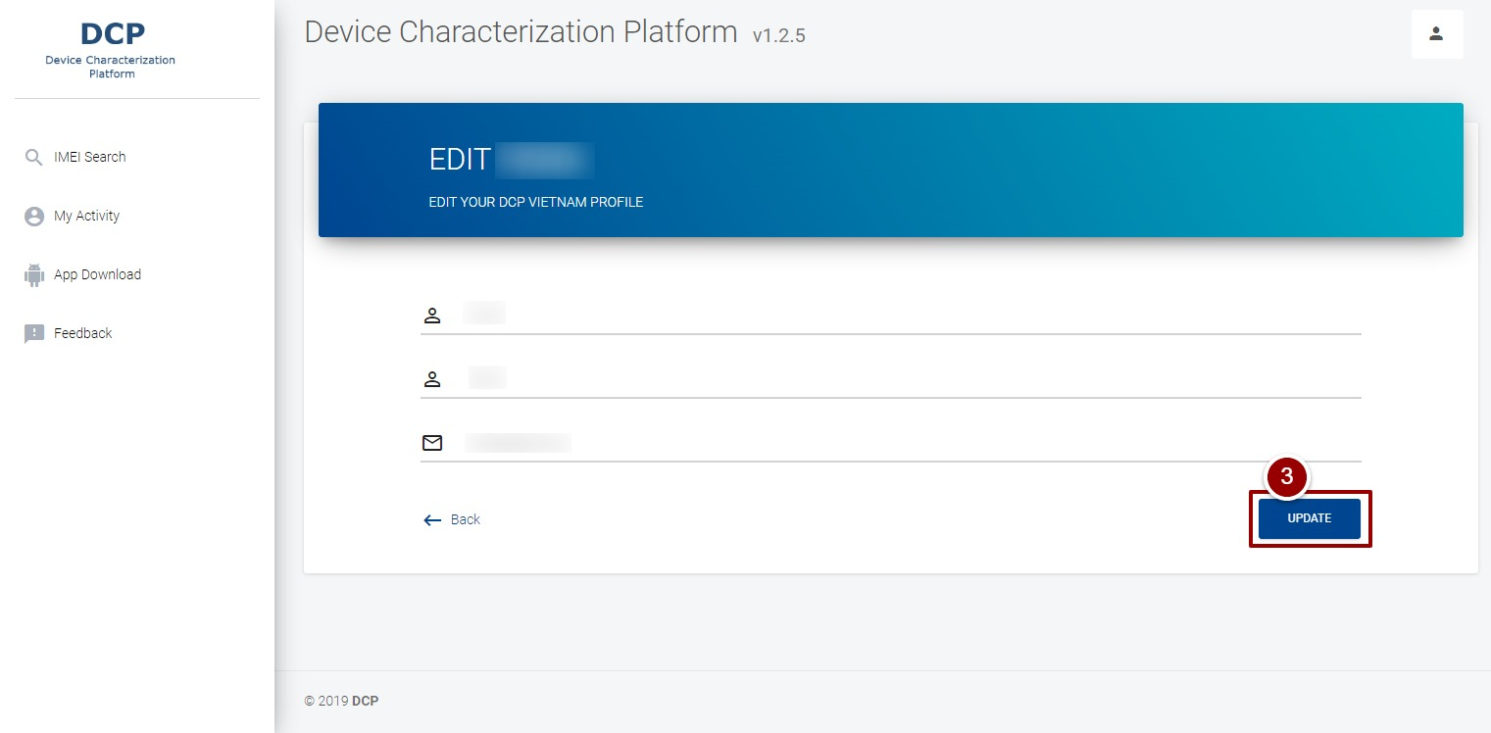

**Figure 7-Edit Profile**

1. To change the password, click on “Change Password” button.

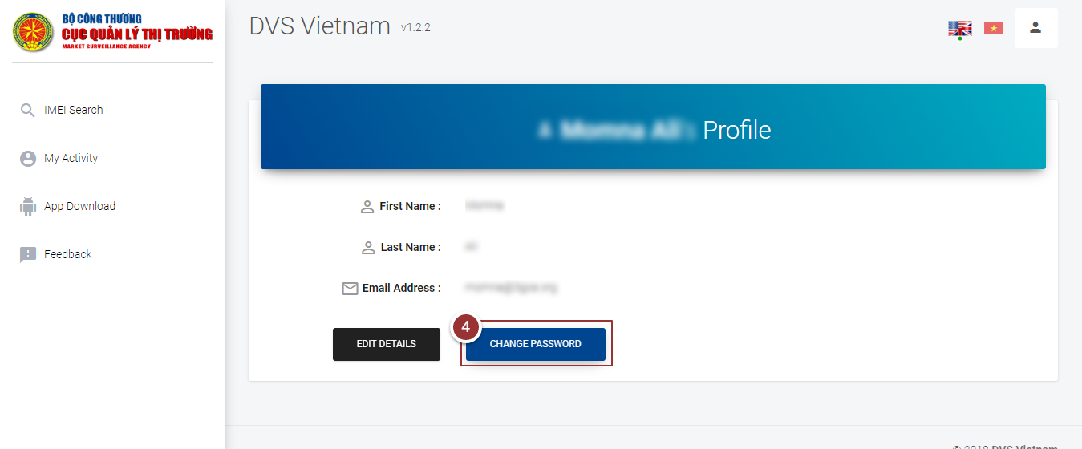

**Figure 8-Change Password**

By clicking on “Change Password” button, a page willappear that contains input fields.

1. Enter the old and new password in the respective fields.
2. Click on “Update” button.

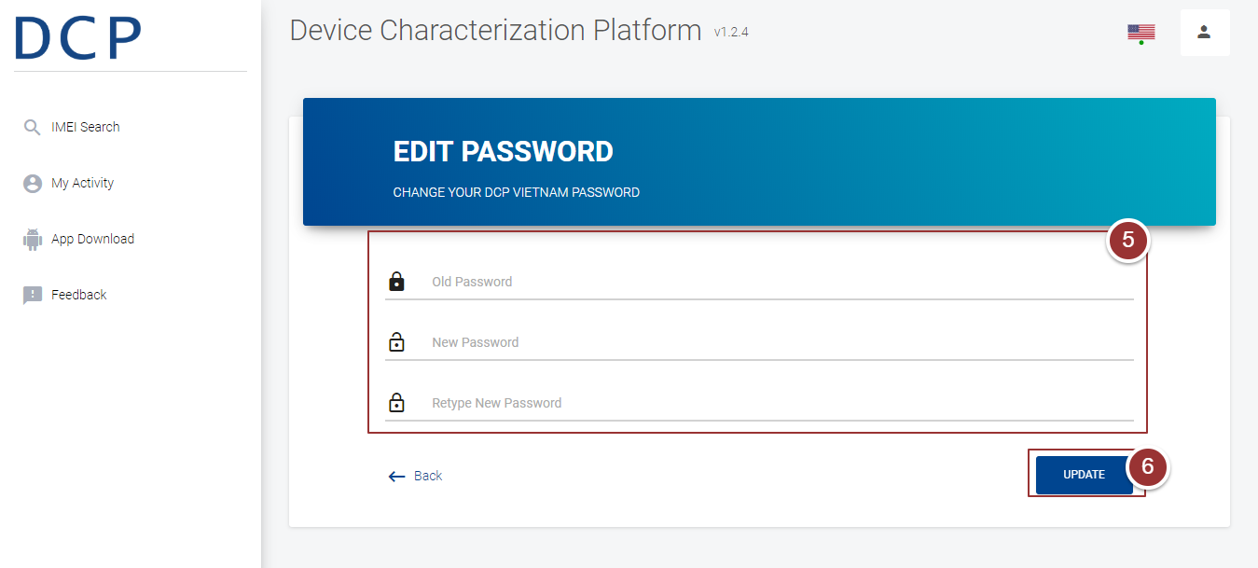

**Figure 9-Change Password**

# **IMEI Search**

1. To search a particular IMEI, click on “IMEI Search” link.
2. Enter IMEI in the respective field.

**Note**: The length of the IMEI should be between 14-16 characters.

1. Click on “Search” button.

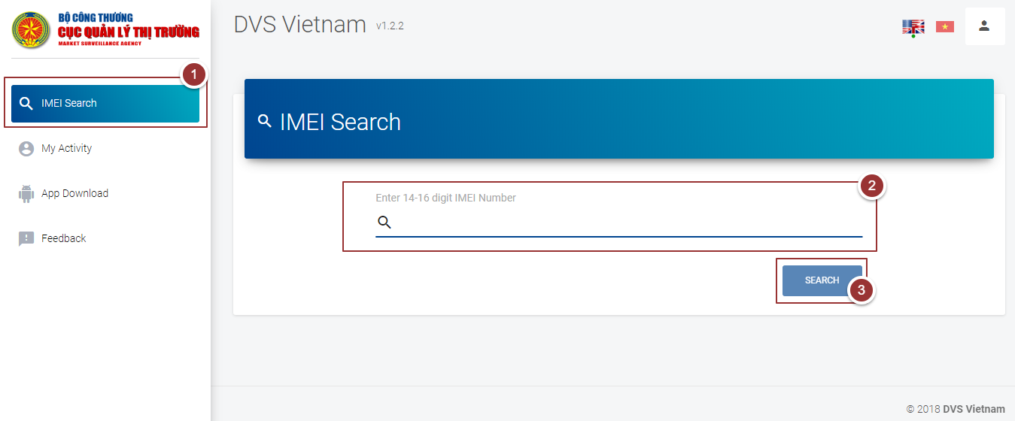

**Figure 10-IMEI Search**

By clicking on “Search” button a, popup will appear that contain entered IMEI to be verified.

1. Verify the IMEI and click on “OK” button.

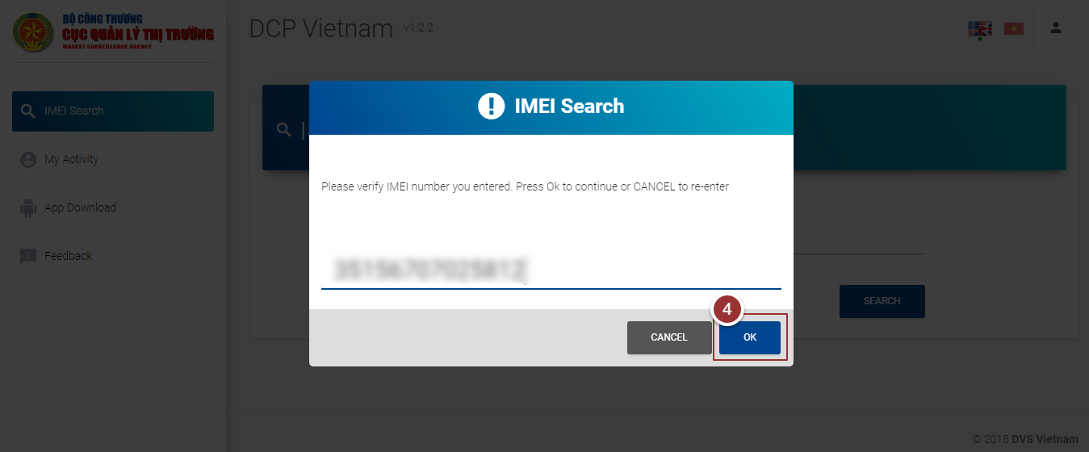

**Figure 11-IMEI Search**

‘

The details of the searched IMEI (i.e. Device ID, Manufacturer, Equipment Type etc.) will display in a table.

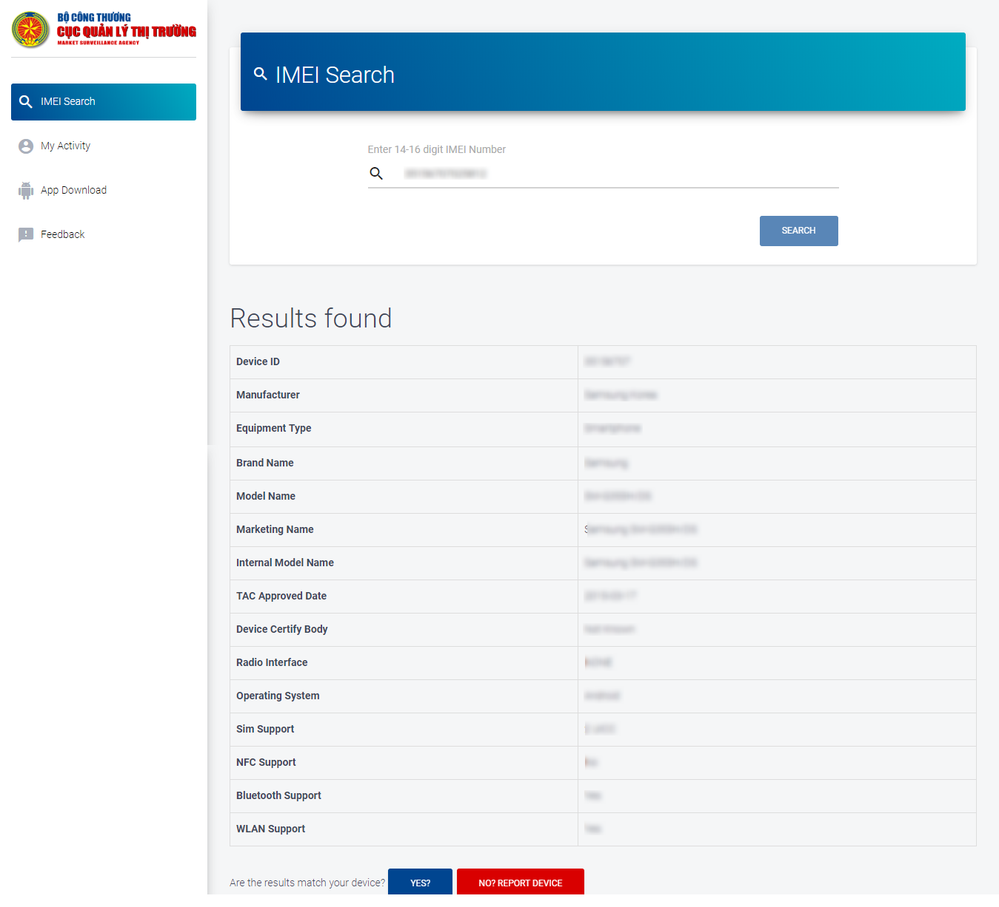

**Figure 12-Searched Results**

# **Matched Devices**

**Note**: Repeat steps 1-4 as per section 3.5

If the searched details of the device are matched with user’s device then user can mark the device as matched device.

1. To mark the device as matched, click on “Yes” button

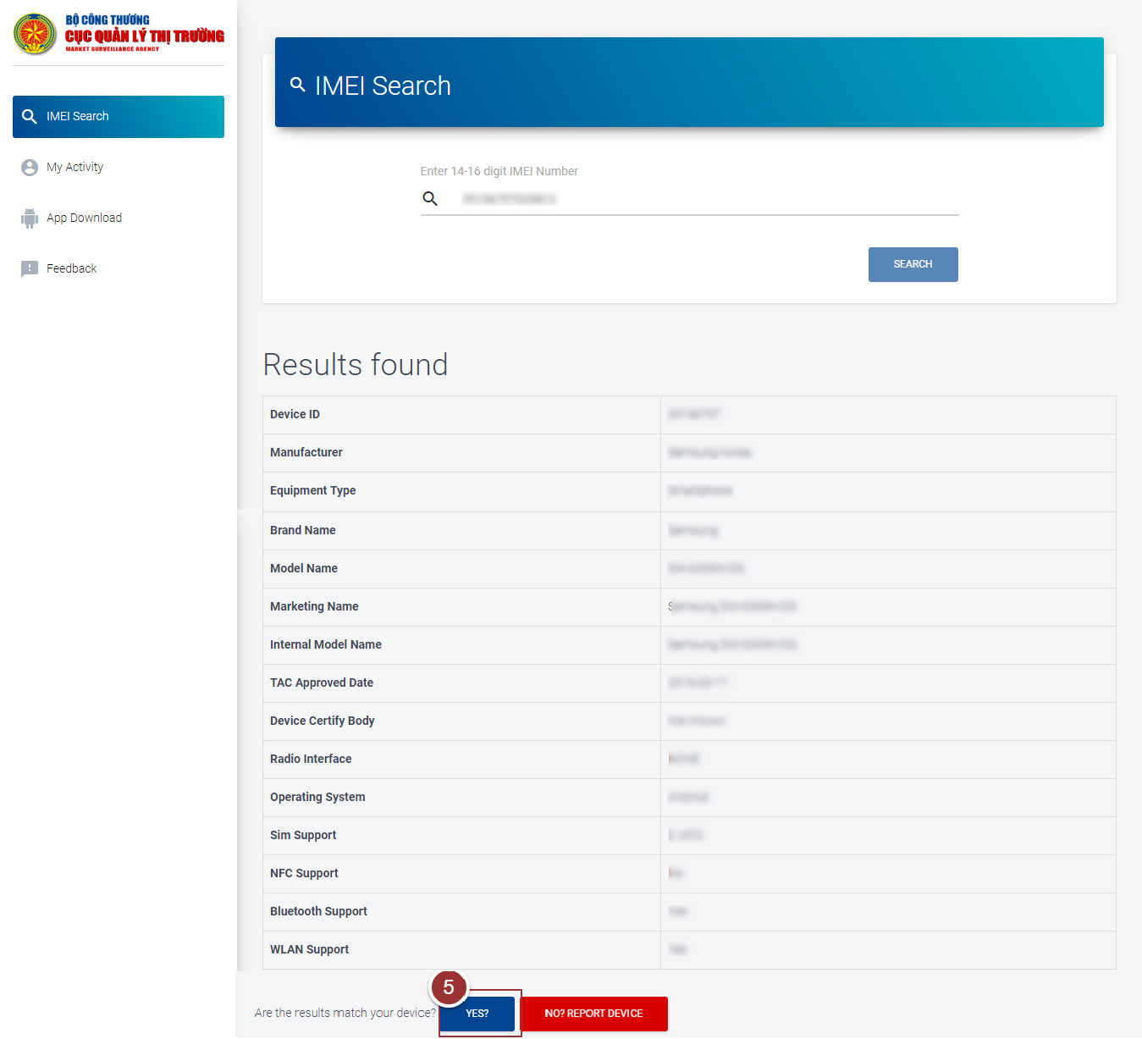

**Figure 13-Matched Devices**

By clicking on “Yes” button, a popup window will appear that displays the confirmation massage.

1. Click on “OK” button to proceed further

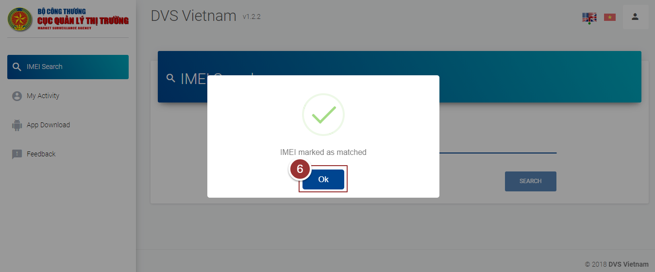

**Figure 14-Confirmation Message**

# **Counterfeit Devices**

**Note:** repeat steps 1-4 as per section 3.5

If the searched details of device are not found/not matched with user’s device then user can report the device as counterfeit device.

1. To report IMEI as counterfeit, click on “Report Now” button

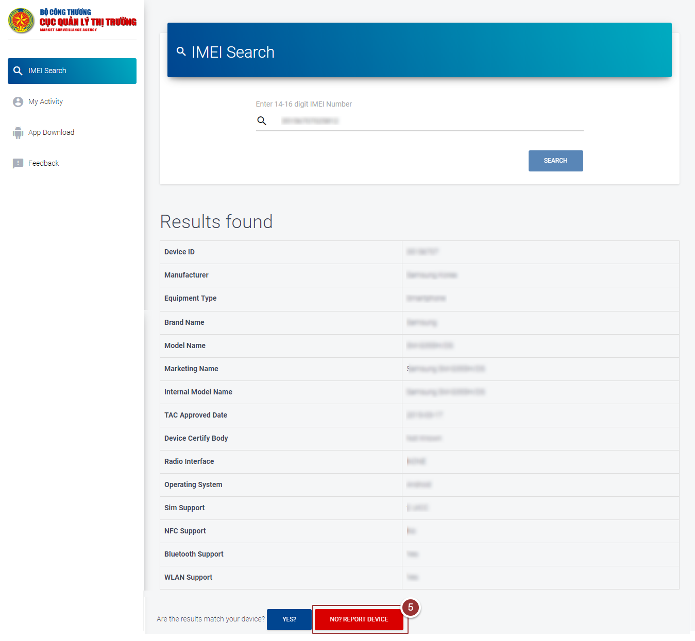

**Figure 15-Counterfeit Devices**

By clicking on “Report Now” button, a form will appear to get actual details of the device.

1. Enter the required information (i.e. Mobile Phone Brand, Model Name, Store Name, Address(user’s address), Description and images) in the respective fields

**Note**: User can upload maximum 5 images in (.png, .jpg, .gif .jpeg) format.

1. Click on “Submit” button

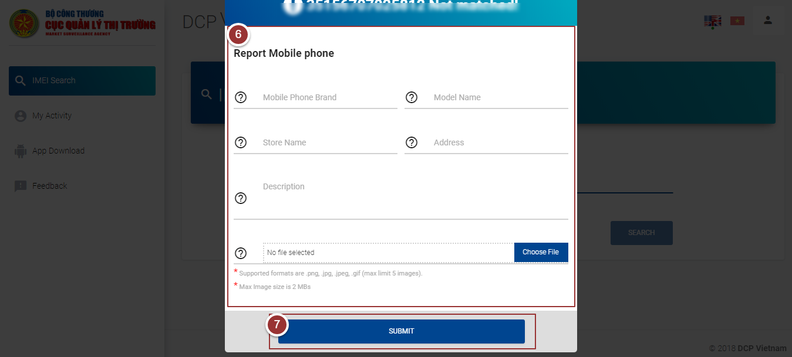

**Figure 16-Counterfeit Device Details**

By clicking on “Submit” button, a popup window will appear that displays the confirmation massage.

1. Click on “OK” button to proceed further

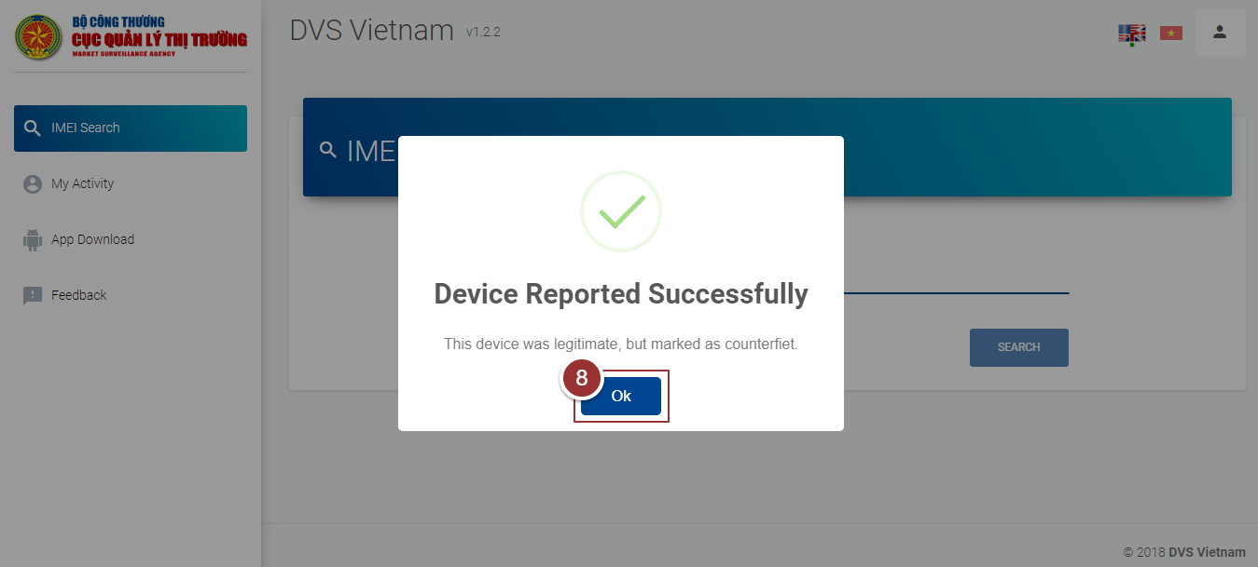

**Figure 17-Confirmation Message**

# **My Activity**

1. To view activity logs (i.e. total number of IMEIs searched by the user), click on the “My Activity” link

A page will appear in the right content area that displays all activity details (i.e. User Device (web, mobile), Checking Method (auto, manual), IMEI Number, Result Status (found/not found), Results Matched(yes/no), User Name, Created At).

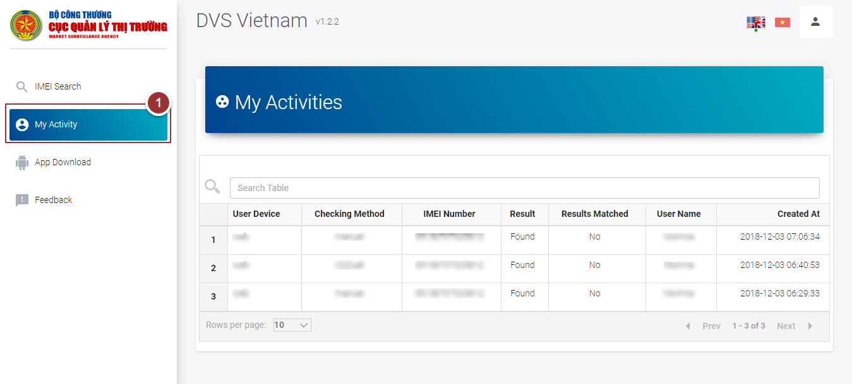

**Figure 18-My Activity**

# **App download**

1. To download mobile app, click on “App download” link

A license agreement will appear in right content area. After accepting the license agreement user will be able to download the mobile app.

1. To accept the license agreement, click on checkbox

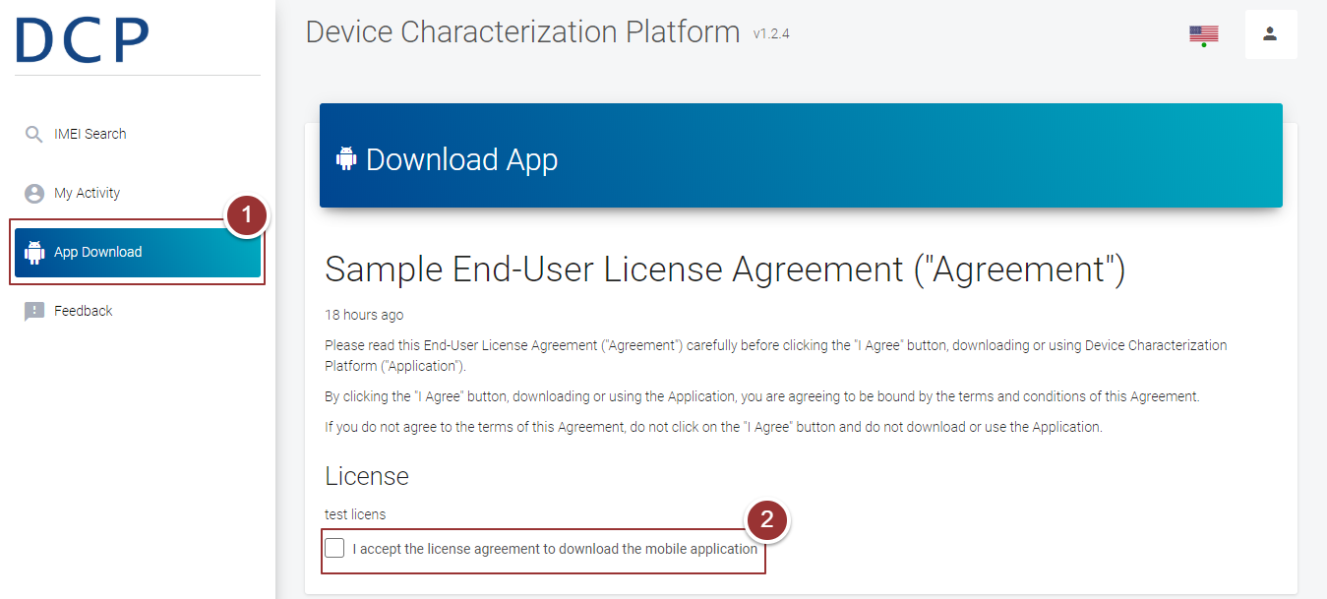

**Figure 19-Download App**

By clicking on checkbox, a button will appear on the page.

1. Click on “Download” button

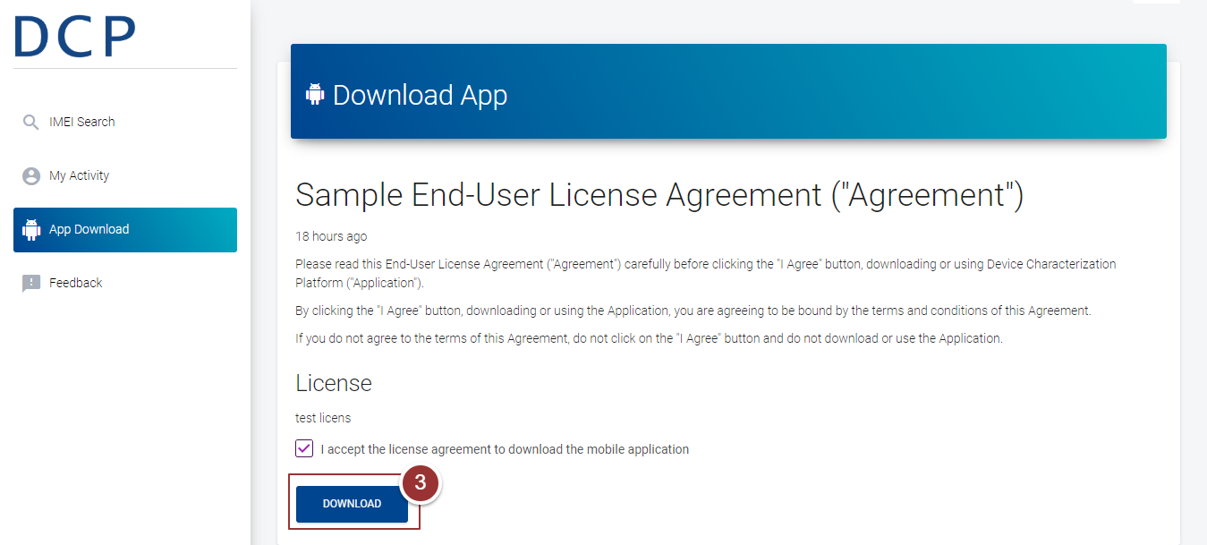

**Figure 20-Download App**

# **Feedback**

1. To give feedback, click on “Feedbacks” link

A page will appear in right content area that contains the comment box.

1. Write down your comments/suggestions in comment box
2. Click on “Submit Feedback” button

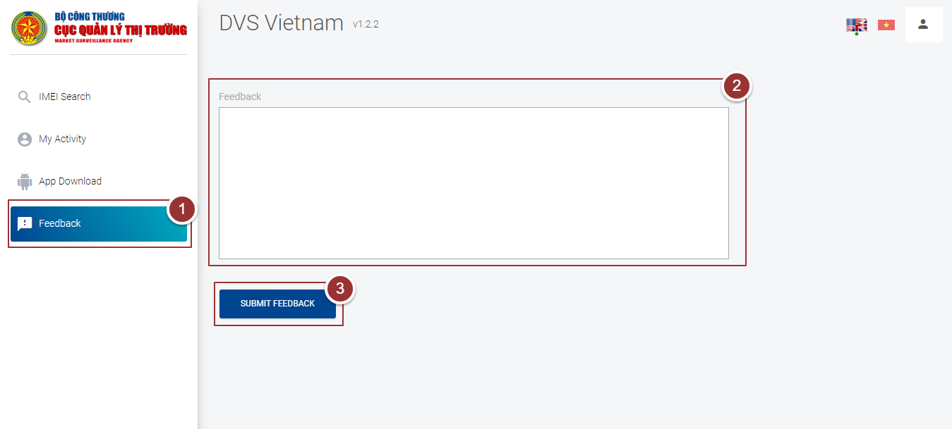

**Figure 21-Feedbacks**