Device Pairing Subsystem 1.0.0

User Guide (Authority)

DPS-Authority-User-Guide-1.0.0

Oct 15, 2018

**Revision history**

| **Revision** | **Date** | **Description** |
| --- | --- | --- |
| **A** |  | **Initial release** |

**Contents**

1. Introduction 4

1.1. Purpose 4

1.2. Supported Desktop Browsers 4

1.3. Supported Mobile Browsers 4

1.4. Definitions, Acronyms, and Abbreviations 5

2. System Description 6

3. System Navigation 8

3.1. Log-In Screen 8

3.2. Portal Sections 9

3.3. Generate Pair Code 10

3.4. Search Request 12

4. SMS Help 13

4.1. Request First Pair 13

4.2. Verify Pair Code 13

4.3. Request Additional Pair 13

4.4. Confirm Additional Pair 13

4.5. Find Pair 13

4.6. Release Existing Pair 14

4.6.1.Release Single Additional Pair 14

4.6.2.Release All Pairs 14

4.7. SIM Replacement 14

4.8. Request Help Text 14

**Figures**

Figure 1- login Screen 8

Figure 2- Portal Overview 9

Figure 3- Generate Pair Code 10

Figure 4- Search Request 12

**Tables**

Table 1- Supported Desktop Browser 4

Table 2- Supported Mobile Browser 4

Table 3- Definitions, Acronyms, and Abbreviations 5

Table 4- System Description 6

# **Introduction**

The Device Pairing Subsystem (DPS) is the subsystem of Device Identification, Registration and Blocking System (DIRBS). The main purpose of DPS is to facilitate the pairing of user’s devices with their SIMs (IMSIs) over the SMS service. It also generates Pairing-list for DIRBS-Core through which it generates exception lists and black list for MNOs to implement on their EIR.

The Device Identification, Registration & Blocking System (DIRBS) is a country-wide system that is developed to check, identify and discourage non-compliant devices by verifying the installed base of devices currently active in a market. It continuously monitors the mobile eco system as new devices are activated. It can be deployed in collaboration with country’s regulatory bodies, Mobile operators and other technology partners.

DIRBS can verify that:

* Devices have properly allocated identifiers and type approval
* Devices are not duplicated or stolen
* Device importation takes place through legal channels

## Purpose

This document is intended to give assistance to the user to use the Device Pairing Subsystem (DPS).

## Supported Desktop Browsers

**Table 1- Supported Desktop Browsers**

|  |  |
| --- | --- |
| **Name** | **Version** |
| Internet Explorer | 11.0 |
| Firefox 52.5 ESR | 57.0 |
| Chrome | 63.0 |
| Safari | 11.0 |
| Edge | 41.16299 |

## Supported Mobile Browsers

**Table 2- Supported Mobile Browsers**

|  |  |
| --- | --- |
| **Name** | **Version** |
| Chrome | 63.0 |
| UC Browser | 11.5 |
| Opera(Android) | 44.1 |
| Opera(iOS) | 16.0.7 |
| Safari | 11.1 |
| Samsung Internet | 6.2 |
| Android | 4.1.x - 4.3 |

## 

## Definitions, Acronyms, and Abbreviations

**Table 3- Definitions, Acronyms, and Abbreviations**

|  |  |
| --- | --- |
| ****Term**** | ****Definition**** |
| **DIRBS** | **Device Identification Registration and Blocking System** |
| IAM | Identity Access Management |
| DPS | Device Pairing Subsystem |
| MSISDN | Mobile Subscriber Integrated Services Digital Network Number |
| IMEI | International Mobile Equipment Identity |
| MAC | Media Access Control |
| SMS | Short Message Service |

# **System Description**

**Table 4- System Description**

|  |  |
| --- | --- |
| Feature****/Sections**** | ****Description**** |
| **Login Screen** | * To access the system, authorized user first needs to enter his/her credentials on login page, this login page authenticates user from the IAM and redirects user to the DPS |
| Portal Sections | **The portal is divided into following sections.**   * **Header**   Header section displays the name of the system, name of the logged in user with logout functionality.     * **Navigation Panel**   Navigation Panel contains main navigation menu through which user can navigate the whole system.   * **Main Content Area**   Main Content Area contains all the content to be displayed and actions to be performed for respective feature.   * **Breadcrumbs**   Breadcrumbs allows user to keep track of their location within the system.   * **Footer**   Footer contains the software version and copyright statement. |
| Generate Pair Code | Allows user to enter device details to generate pair code.  **Device IMEI**  Enter IMEI number for which you want to get a pair code, for multiple number of IMEIs click on “Add IMEIs” button.  **Device Identifiers**  **Serial Number**  Enter serial number of the device.  **Brand**  Enter brand name of the device.  **Model Name**  Enter model name of the device.  **MAC (Wi-Fi) address**  Enter MAC address of the device in below formats:  A2:C9:66:F8:47:C5  A2-C9-66-F8-47-C5  A2C.966.F84.7C5  00:25:96:FF:FE:12:34:56  0025:96FF:FE12:3456  **Radio Access Technology**  Select radio access technology of the system i.e. 2G, 3G, 4G, 5G etc.  **Reference MSISDN**  Enter MSISDN number as a reference contact number. |
| Search Request | Allows user to search particular request by applying different filters i.e. IMEI, Serial Number, MAC Address, Reference MSISDN |

# **System Navigation**

## Log-In Screen

1. **Enter user credentials i.e. username and password**
2. **Click on the “Log-In” button**

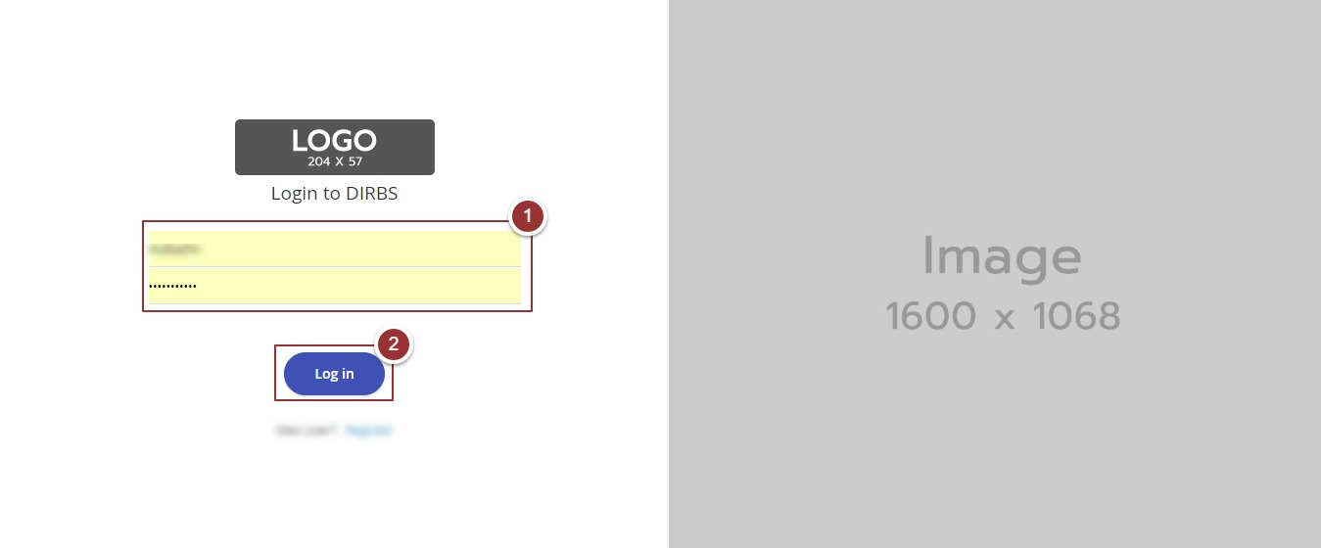

Figure 1- login Screen

## Portal Sections

The portal screen is divided into following sections.

1. **Header** section displays the name of the system, name of the logged-in user with logout functionality
2. **Main Navigation Panel** helps user to navigate through system
3. **Breadcrumbs** is a navigational aid in UI
4. **Main Content Area** contains all relevant information related to the respective feature/option
5. **Footer** contains the version and copyrights of the system

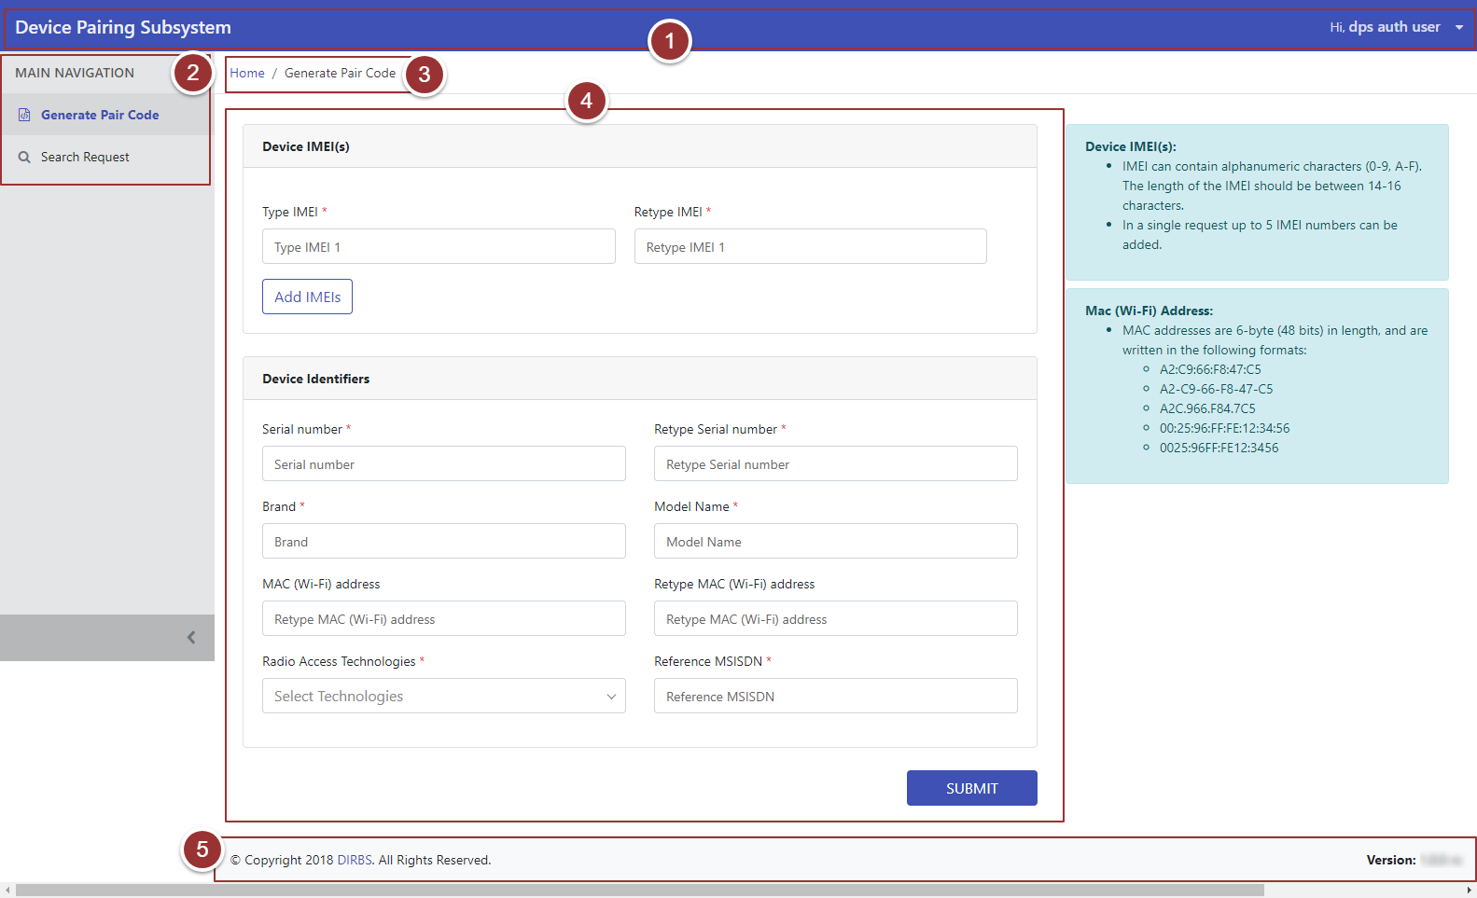

Figure 2- Portal Overview

## Generate Pair Code

1. Click on the “Generate Pair Code” tab under the “Main Navigation” heading
2. Type and Retype IMEI number in the respective field

**Note**: IMEI can contain alphanumeric characters (0-9, A-F, a-f). The length of the IMEI should be between 14-16 characters

1. For more IMEIs click on “Add IMEIs” button

**Note:** Maximum5 IMEIs numbers can be added

1. Enter Device Identifiers (Serial Number, Brand, Model Name, MAC address, Radio Access Technology and Reference MSISDN) in the respective fields

**Note:** Other than MAC address, all identifiers are mandatory.

1. Click on the “Submit” button

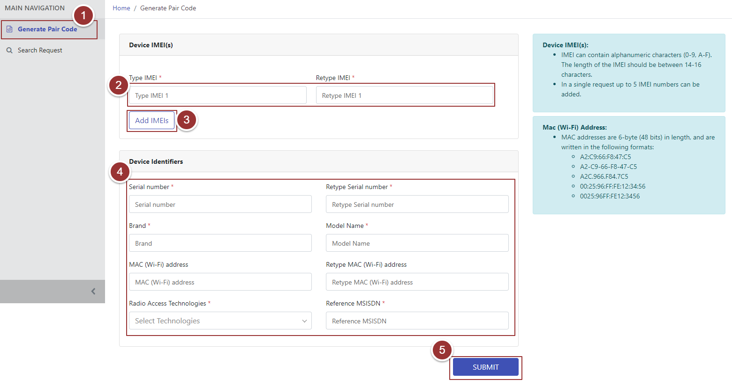

Figure 3- Generate Pair Code

On the submission of request, a page will displays the details of the request i.e. Confirmation Status, Pairing Code.

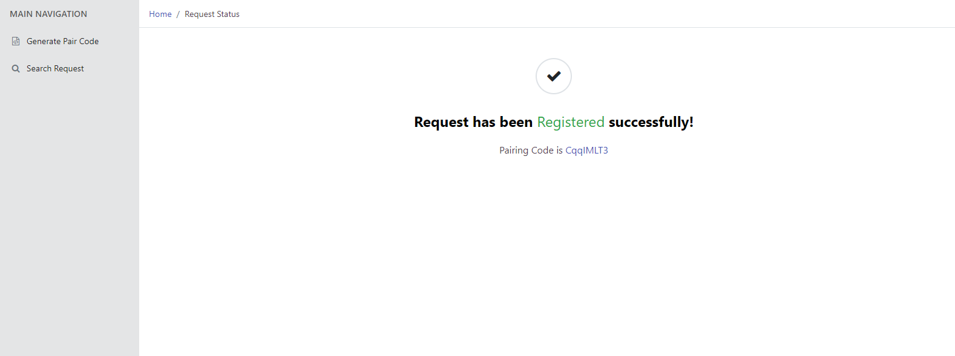

Figure 4- Request Registered Successfully

## Search Request

1. To search any particular request(s) click on “Search Request” tab
2. Enter any known information (i.e. IMEI Number, Serial Number, MAC Address, Reference MSISDN) of required request
3. To clear search filters click on “Clear Search” button
4. Click on the “Search Request” button to view the searched items

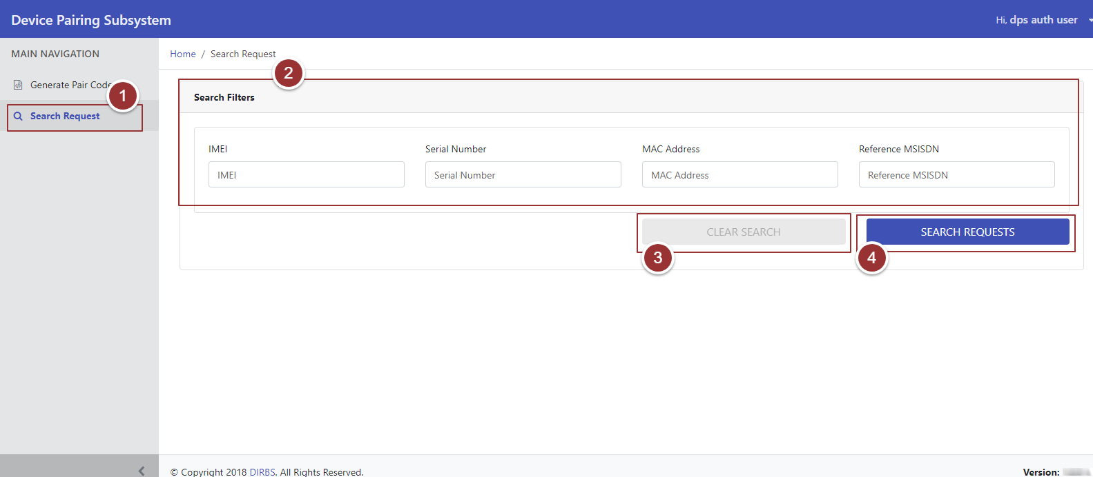

Figure 5- Search Request

# **SMS Help**

## Request First Pair

To request for Primary Pair send SMS to xxxx short code from MSISDN which you want to set as Primary Pair with the particular device.

**Note**: Make sure that the MSISDN must not be paired already with any other device as Primary Pair.

SMS Text ➔ First [Pairing Code]

## Verify Pair Code

To verify the status of a pairing code for particular IMEI.

SMS Text ➔ VERIFY [Pairing Code] [IMEI]

## Request Additional Pair

To request for Additional MSISDN to be paired with the device, send SMS to xxxx short code from Primary MSISDN.

SMS Text ➔ ADD [new MSISDN]

**Note:** Primary MSISDN can only add X Additional Pairs for a single device separately.

New MSISDN will receive below SMS to confirm the request of pairing with a device as additional pair. Here primary MSISDN is also provided to differentiate the device as the new MSISDN may pair with more than one device.

SMS Text ➔ CONFIRM [Primary MSISDN]

## Confirm Additional Pair

The new MSISDN will send a confirmation SMS to allow the additional pairing.

SMS Text ➔ YES/NO [Primary MSISDN]

## Find Pair

To check Additional Pairs, send SMS to xxxx short code from Primary MSISDN.

SMS Text ➔ FIND PAIRS

## Release Existing Pair

## Release Single Additional Pair

To release or remove an additional pair.

SMS Text ➔ RELEASE [MSISDN]

**NOTE**: Only Primary MSISDN can request for removal of additional pairs.

## Release All Pairs

To release or remove all additional and primary pair.

SMS Text ➔ RELEASE ALL

## SIM Replacement

To continue using the paired-device for Primary and Additional pairs after SIM replacement.

SMS Text ➔ SIM CHANGE

## Request Help Text

To get complete information on how to use SMS function of the DPS by sending “HELP” to xxxx short code.

SMS Text ➔ HELP