Device Pairing Subsystem 3.0.0

User Guide (MNO)

DPS-User-Guide-MNO-3.0.0

November 23, 2020

**Revision history**

| **Revision** | **Date** | **Description** |
| --- | --- | --- |
| A |  | Initial release |
| B | November | Release 3.0.0 |

Contents

1. Introduction 4

1.1 Purpose 4

1.2 Supported Desktop Browsers 4

1.3 Supported Mobile Browsers 5

1.4 Definitions, Acronyms, and Abbreviations 5

2. System Description 6

3. System Navigation 7

3.1 Log-In Screen 7

3.2 Portal Sections 8

3.3 IMSI Requests 9

3.4 Bulk Upload 11

**Figures**

Figure 1 - Login Screen 7

Figure 2 - Portal Overview 8

Figure 3 - IMSI Requests 9

Figure 4 - Add IMSI 9

Figure 5 - Download All Requests 10

Figure 6 - Bulk Upload 11

Figure 7 - Confirmation Message 12

**Tables**

Table 1 - Supported Desktop Browsers 4

Table 2 - Supported Mobile Browsers 5

Table 3 - Definitions, Acronyms, and Abbreviations 5

Table 4 - System Description 6

# **Introduction**

The Device Pairing Subsystem (DPS) is the subsystem of Device Identification, Registration and Blocking System (DIRBS). The main purpose of DPS is to facilitate the pairing of user’s devices with their SIMs (IMSIs) over the SMS service. It also generates Pairing-list for DIRBS-Core through which it generates exception list and black list for MNOs to implement on their EIR.

The Device Identification, Registration & Blocking System (DIRBS) is a country-wide system that is developed to check, identify and discourage non-compliant devices by verifying the installed base of devices currently active in a market. It continuously monitors the mobile eco system as new devices are activated. It can be deployed in collaboration with country’s regulatory bodies, Mobile operators and other technology partners.

DIRBS can verify that:

* Devices have properly allocated identifiers and type approval
* Devices are not duplicated or stolen
* Device importation takes place through legal channels

## Purpose

This document is intended for mobile operators to provide IMSIs and other important information that can help DPS in pairing their subscribers.

## Supported Desktop Browsers

Table 1 - Supported Desktop Browsers

|  |  |
| --- | --- |
| **Name** | **Version** |
| Internet Explorer | 11.0 |
| Firefox | 82.0.3 |
| Chrome | 86.0 |
| Safari | 13.1.2 |
| Edge | 86.0 |

## Supported Mobile Browsers

Table 2 - Supported Mobile Browsers

|  |  |
| --- | --- |
| **Name** | **Version** |
| Chrome | 86.0.4 |
| UC Browser | 13.3.3 |
| Opera (Android) | 60.3 |
| Opera Touch (iOS) | 2.5.1 |
| Safari | 13.1.2 |
| Samsung Internet | 13.0.1 |
| Android | 10 |

## Definitions, Acronyms, and Abbreviations

Table 3 - Definitions, Acronyms, and Abbreviations

|  |  |
| --- | --- |
| ****Term**** | ****Definition**** |
| **DIRBS** | **Device Identification Registration and Blocking System** |
| IAM | Identity Access Management |
| DPS | Device Pairing Subsystem |
| MSISDN | Mobile Subscriber Integrated Services Digital Network Number |
| IMSI | International Mobile Subscriber Identity |
| MNO | Mobile Network Operator |

# **System Description**

Table 4 - System Description

|  |  |
| --- | --- |
| Feature/Sections | Description |
| Login Screen | To access the system, authorized user first needs to enter his/her credentials on login page. This login page authenticates user from IAM and redirects user to DPS |
| Portal Sections | The portal is divided into following sections.   * Header   Header section displays name of the system, name of the logged in user with logout functionality.   * Navigation Panel   Navigation Panel contains main navigation menu through which user can navigate the whole system.   * Main Content Area   Main Content Area contains all the content to be displayed and actions to be performed for respective feature.   * Breadcrumbs   Breadcrumbs allow user to keep track of their location within the system.   * Footer   Footer contains the software version and copyright statement. |
| IMSI Request | Allows user to enter IMSI for respective MSISDN one by one.  User can also download all requests in .csv file format. |
| Bulk Upload | Allows user to upload .csv and .txt file containing MSISDNs with respective IMSIs. |

# **System Navigation**

## Log-In Screen

1. **Enter user credentials i.e. username and password**
2. **Click on the “Log-In” button**

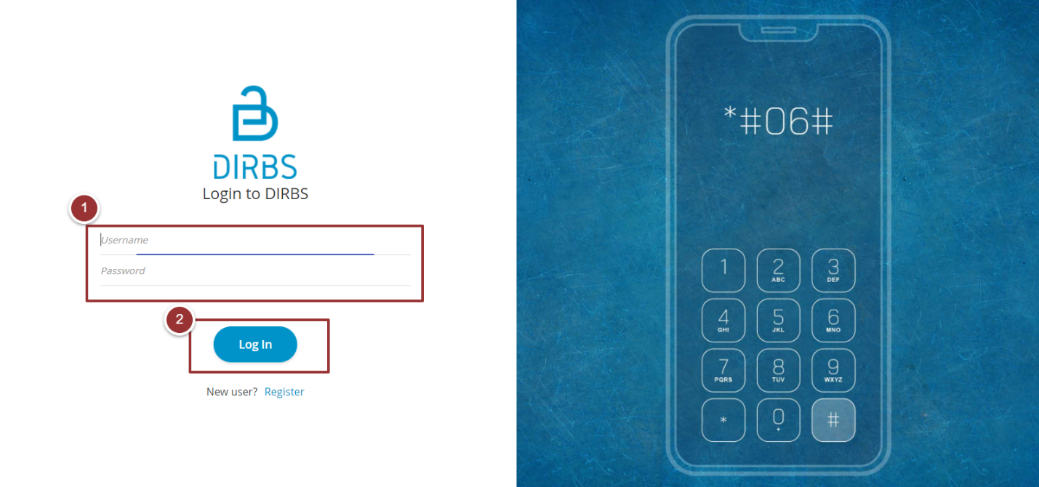

Figure 1 - Login Screen

## 

## Portal Sections

The portal screen is divided into following sections.

1. **Header** section displays name of the system, name of the logged-in user with logout functionality.
2. **Main Navigation Panel** helps user to navigate through system.
3. **Breadcrumbs** is a navigational aid in UI.
4. **Main Content Area** contains all relevant information related to the respective feature/option.
5. **Footer** contains the version and copyrights of the system.

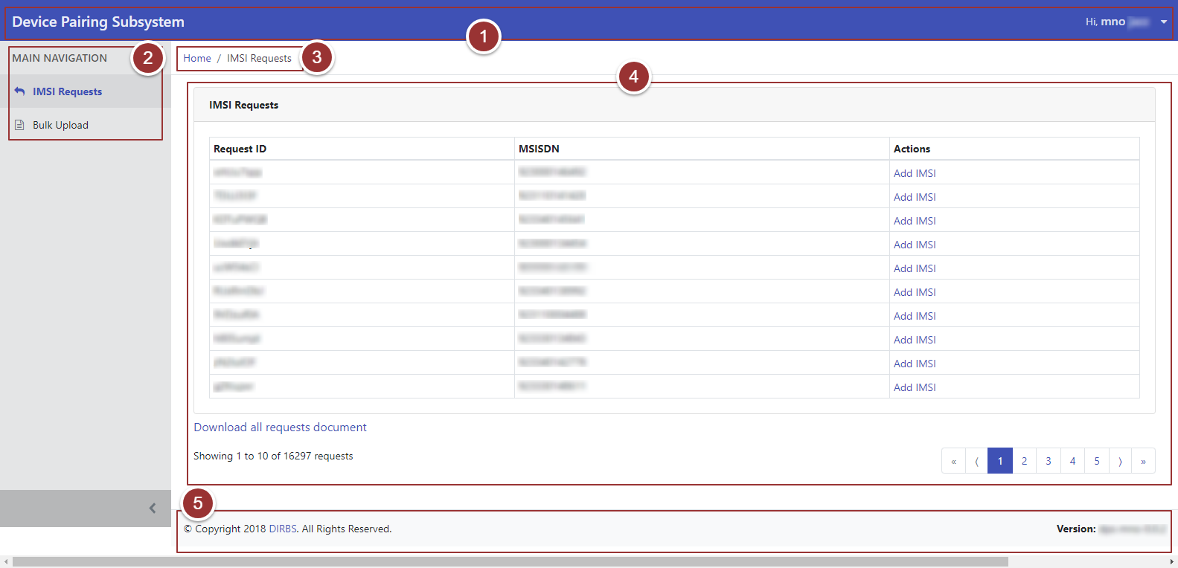

Figure 2 - Portal Overview

## 

## IMSI Requests

1. Click on the “IMSI Requests” tab under “Main Navigation” heading.
2. To add IMSI for each MSISDN from portal, click on “Add IMSI” link against respective MSISDN/Request ID.

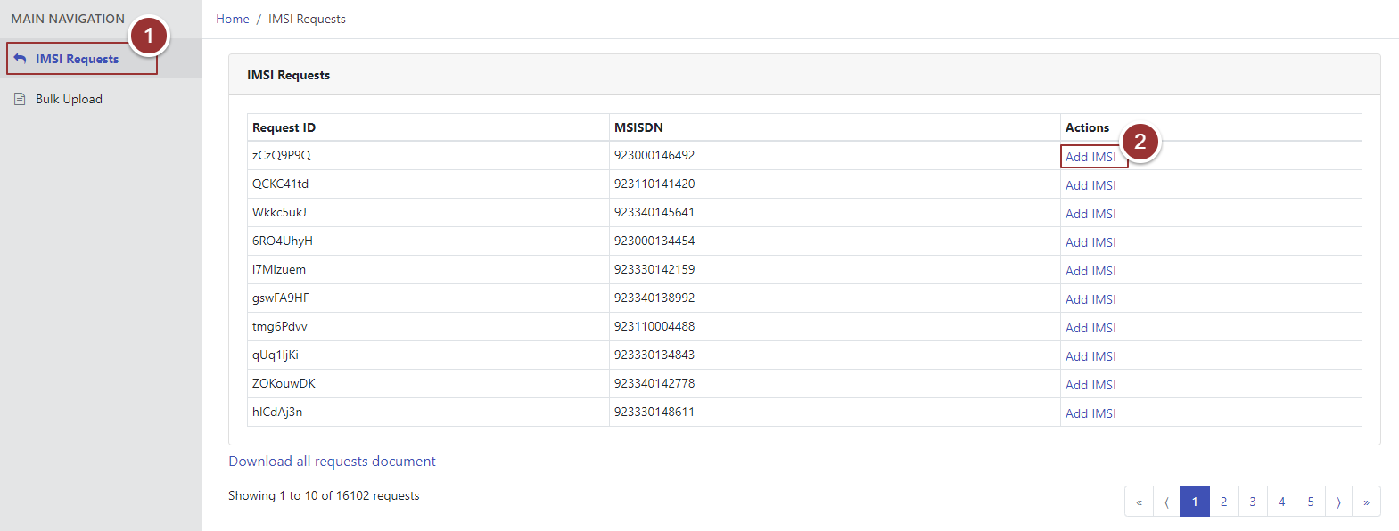

Figure 3 - IMSI Requests

1. A popup will appear where user type and retype IMSI for the particular MSISDN.
2. Click on “Submit” button.

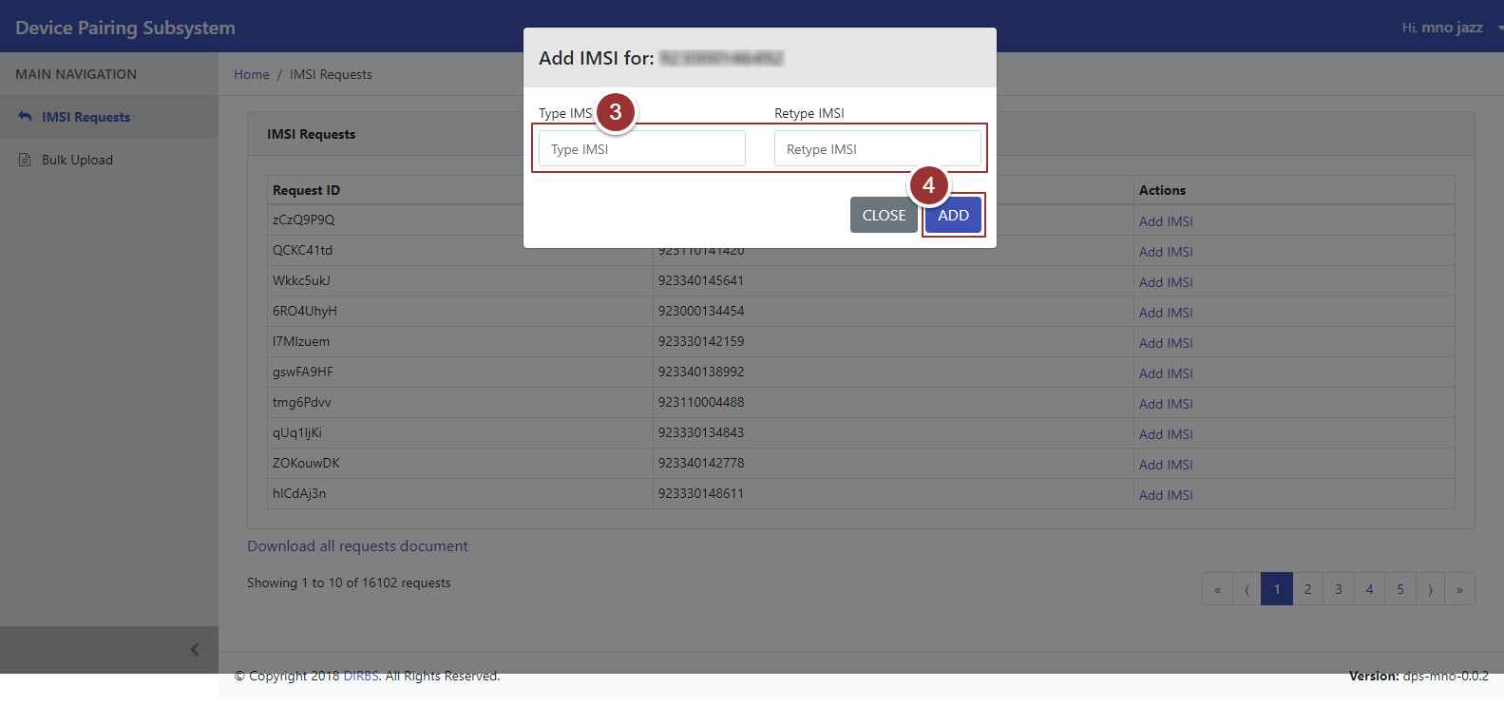

Figure 4 - Add IMSI

1. To download all IMSI Requests in a file, click on “Download all requests document” link.

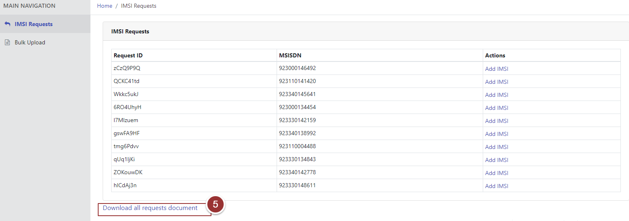

Figure 5 - Download All Requests

## 

## Bulk Upload

1. To submit IMSIs in bulk, click on “Bulk Upload” tab under “Main Navigation” heading.
2. To upload a file, click on “Choose File” button and select the required file.

**Note:** The uploaded file should be .csv or .txt file. It is preferable to use the same downloaded file in **Section 2.3** and update it with IMSIs.

1. Click on “Submit” button.

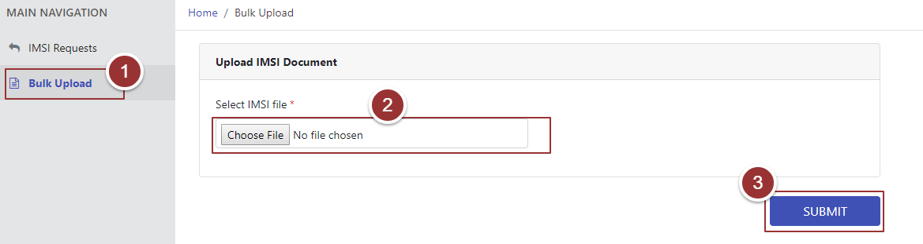Figure 6 - Bulk Upload

Upon successful submission of file, a confirmation message will be displayed with the count of Total, Invalid and Valid MSISDNs/IMSIs.

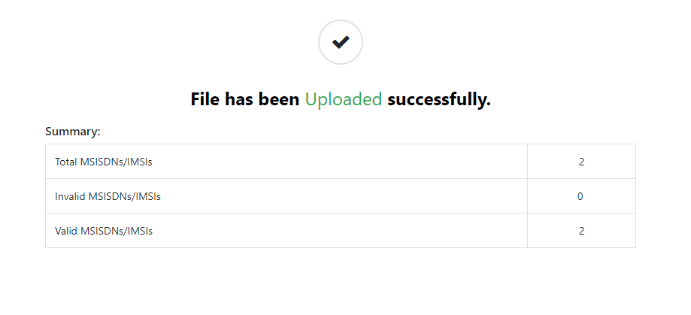

Figure 7 - Confirmation Message

1. 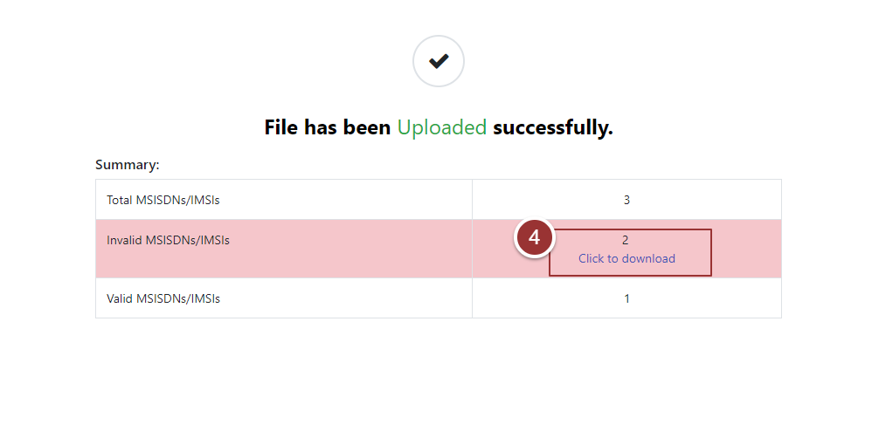In case of any Invalid MSISDNs/IMSIs are found in the file, a separate downloadable file will be generated by the system.

Figure 8 - Download Invalid MSISDNs/IMSIs

1. If the uploaded file is not in the correct format (.csv or .txt), an error message will be displayed.

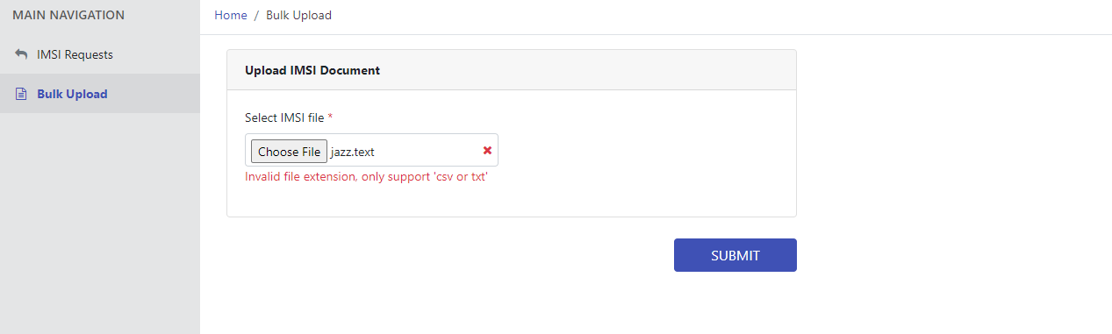

Figure 9 - File Format

An Error Message will be displayed if file content is not in correct format i.e. MSISDN, IMSI.

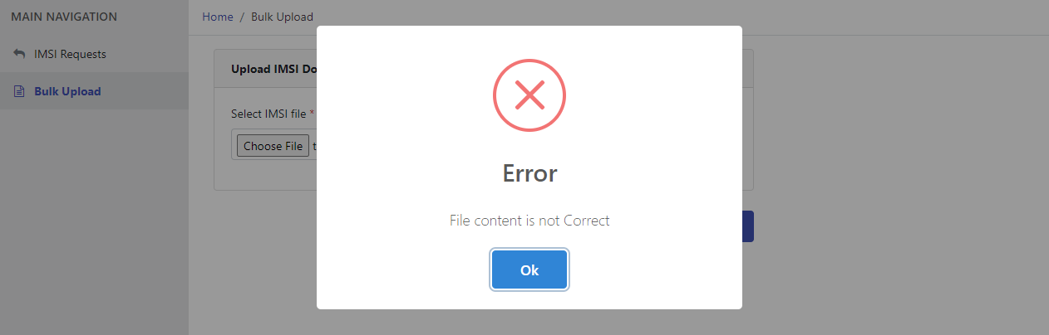

Figure 10 - Incorrect format