Device Registration Subsystem 1.0.0

User Guide (Exporter)

DRS-User-Guide-Exporter-1.0.0

June 19, 2018

Revision history

|  |  |  |
| --- | --- | --- |
| Revision | Date | Description |
| A |  | Initial release |

# **Contents**

**1. Introduction 4**

1.1. Purpose 4

1.2. Supported Desktop Browsers 4

1.3. Supported Mobile Browsers 5

1.4. Definitions, Acronyms, and Abbreviations 5

**2. System Description 6**

**3. System Navigation 9**

3.1. Login Screen 9

3.2. Dashboard Overview 10

3.3. De-Registration 11

3.3.1. Approve Request 13

3.3.2.Close Request 16

3.4.Search Request 18

**Figures**

Figure 1-Login Screen 9

Figure 2-Dashboard Screen 10

Figure 3-De-Registration 11

Figure 4-Device Model Information 12

Figure 5-Approve Request 13

Figure 6-Approval Documents 14

Figure 7-View Your Request 15

Figure 8-Close Request 16

Figure 9-View Your Request 17

Figure 10-Search Request 18

Figure 11-Action Tab(s) 19

Figure 12-Search Filter(s) 20

**Tables**

Table 1-Supported Desktop Browsers 4

Table 2-Supported Mobile Browsers 5

Table 3-Definition, Acronyms, and Abbreviations 5

Table 4-System Description 6

# **Introduction**

Device Registration Subsystem (DRS) is the subsystem of Device Identification, Registration & Blocking System (DIRBS). It provides a platform for an exporter to request their IMEIs to be deregistered.

Exporters are people who are licensed to export devices out of the country e.g. they could be, refurbishes etc.

The Device Identification, Registration & Blocking System (DIRBS) is a country-wide system deployed in cooperation between the country regulator, operators in that country, and a technology partner that supports deployment. The system checks, identifies, and discourages non-compliant devices by verifying the installed base of devices currently active in a market and continuing to monitor as new devices are activated.

DIRBS can verify that:

* Devices have properly allocated identifiers and type approval
* Devices are not duplicated or stolen
* Device importation takes place through legal channels

## **Purpose**

This document is intended to give assistance to the user to use the Device Registration Subsystem (DRS).

## **Supported Desktop Browsers**

Table -Supported Desktop Browsers

|  |  |
| --- | --- |
| **Name** | **Version** |
| Internet Explorer | 11.0 |
| Firefox 52.5 ESR | 57.0 |
| Chrome | 63.0 |
| Safari | 11.0 |
| Edge | 41.16299 |

## **Supported Mobile Browsers**

Table -Supported Mobile Browsers

|  |  |
| --- | --- |
| **Name** | **Version** |
| Chrome | 63.0 |
| UC Browser | 11.5 |
| Opera(Android) | 44.1 |
| Opera(iOS) | 16.0.7 |
| Safari | 11.1 |
| Samsung Internet | 6.2 |
| Android | 4.1.x - 4.3 |

## 

## **Definitions, Acronyms, and Abbreviations**

Table -Definition, Acronyms, and Abbreviations

|  |  |
| --- | --- |
| ****Term**** | ****Definition**** |
| **DIRBS** | **Device Identification Registration and Blocking System** |
| IAM | Identity Access Management System |
| DRS | Device Registration Subsystem |
| MSISDN | Mobile Subscriber Integrated Services Directory Number |
| IMEI | International Mobile Equipment Identity |
| IMSI | International mobile subscriber identity |
| TAC | Type Allocation Code |

# **System Description**

Table -System Description

|  |  |
| --- | --- |
| Feature/Sections | ****Explanation**** |
| Login Screen | * To access the system, authorized user first needs to enter his/her credentials on login page, this login page authenticate user from the IAM and redirects user to DRS |
| Dashboard Screen | The dashboard screen displays the instructions for the user which has following sections   * **Header**   Header section displays the name of the system, name of the logged in user with logout functionality   * **Navigation Panel**   Navigation Panel contains main navigation menu through which user can navigate the whole system.   * **Main Content Area**   Main Content Area contains all the content to be displayed and actions to be performed for respective feature   * **Breadcrumbs**   Breadcrumbs allows user to keep track of their location within the system   * **Footer**   Footer contains the software version and copyright text |
| Deregistration | Facilitate user to de-register their device IMEIs by completing following two steps  Basic Deregistration Details  Approval Documents |
| Required Input(s) for Basic De-Registration | **Device Count**  Takes the total number of devices as input  **Device IMEIs**  Takes the file that contains the valid IMEI as input |
| Device Model Information | Displays the complete information of the device model in a table.  **Device Model Information**  **Brand**  Displays the brand name of the device  **Model Name**  Displays the model name of the device  **Model Number**  Displays the model number of the device  **Device Type**  Displays the device type i.e. smartphone, tablet etc.  **Operating System**  Displays the operating system of the device i.e. Android or iOS  **Radio access technology**  Displays the radio access technologies of that device i.e. 2G, 3G, 4G, 5G etc.  **Device Count**  Takes the total number of devices as input |
| Approval Documents | Takes three types of document of the device as input  Shipment Document  Authorization Document  Certificate Document |
| Search Requests | * Allows user to search a particular request by applying different filters i.e. request ID, request status, device IMEI, create date, last updated, brand, model name, model number, device type, operating system, technologies, device count |
| Request Status | * **New Request**   Verify the details of the device model   * **Awaiting Documents**   Request is still awaited for approval documents to upload   * **Pending Review**   Request is not yet assigned to any authorized entity   * **In Review**   Request has assigned to authorized entity   * **Information Requested**   Request has some missing information   * **Approved**   Request has been approved by authorized entity   * **Rejected**   Request has been rejected by authorized entity due to invalid information   * **Closed**   Request has been closed by the user |

# **System Navigation**

# **Login Screen**

1. **Enter your credentials i.e. Username and Password.**
2. **Click on the “Log in” button**

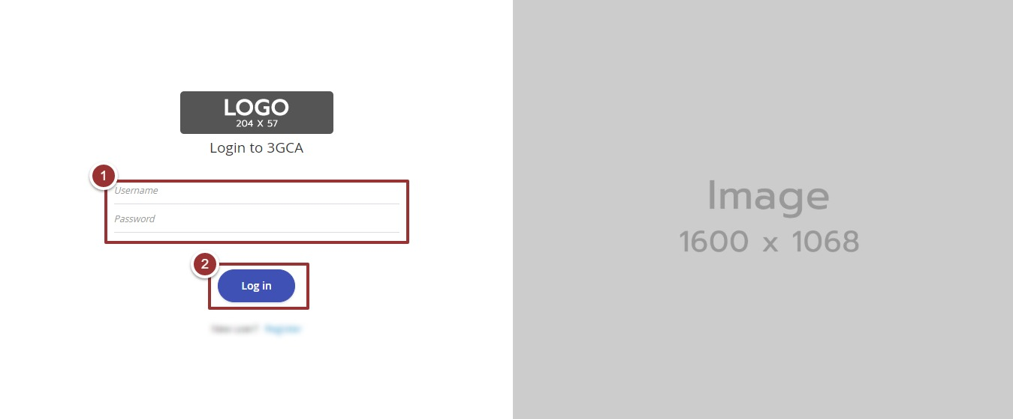

Figure -Login Screen

# **Dashboard Overview**

The dashboard screen is divided into following sections

1. **Header** section displays the name of the system, name of the logged in user with logout functionality
2. **Main Navigation Panel** helps user to navigate the system
3. **Breadcrumbs** is a navigational aid in UI
4. **Main Content Area** contains all relevant information related to the respective feature/option
5. **Footer** contains the version and copyrights statement

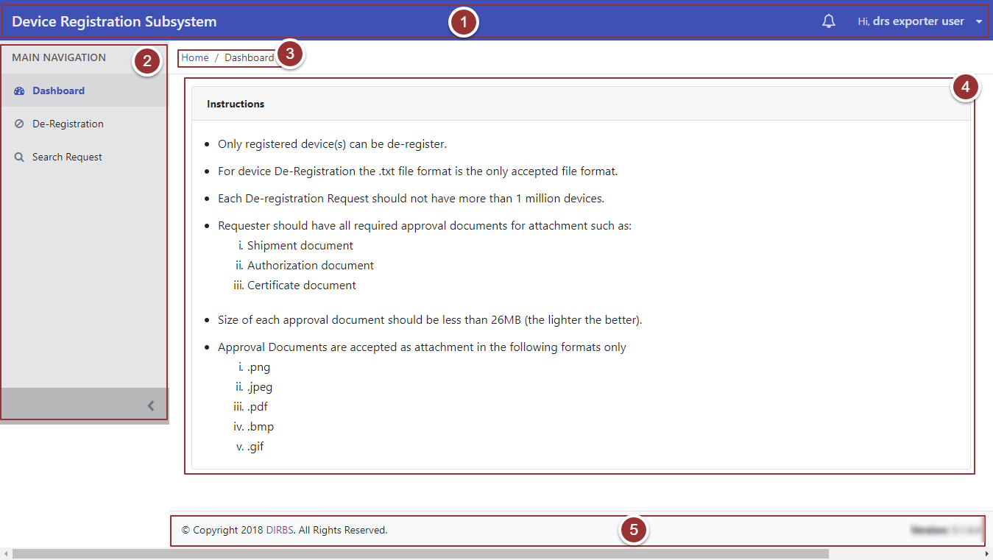

Figure -Dashboard Screen

# **De-Registration**

1. Click on the “De-Registration” tab under the “Main Navigation” heading
2. Enter the basic deregistration details i.e. Device IMEIs (“.txt” file extension), Device Count, Reason for De-registration
3. Click on the “Next” button

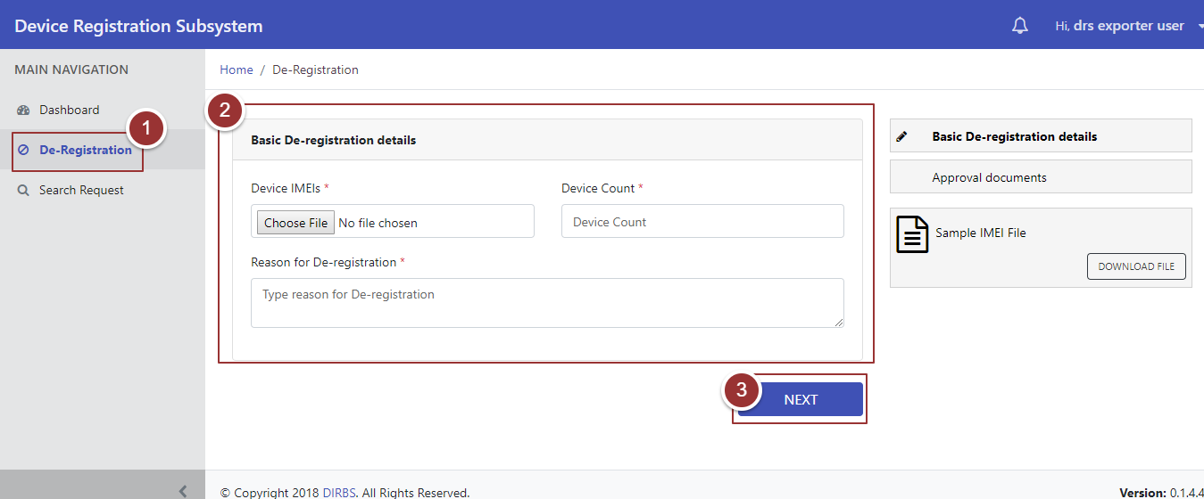

Figure -Deregistration

A popup will appear that contains the details of the device model.

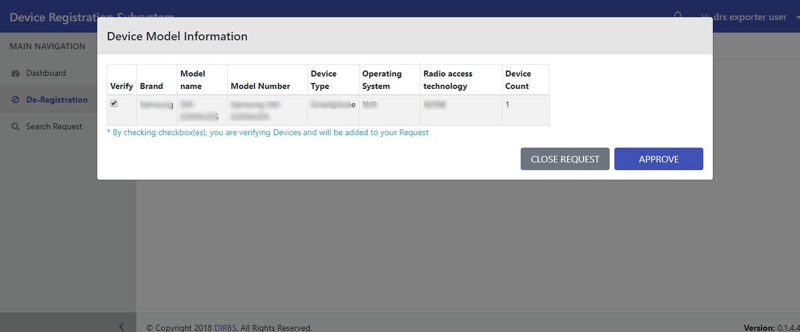

Figure -Device Model Information

# **Approve Request**

Perform steps 1-3

1. To approve the request, verify the information and check the checkbox(es) against the registered device
2. Click on the “Approve” button

**Note**: Only registered IMEIs can be approved

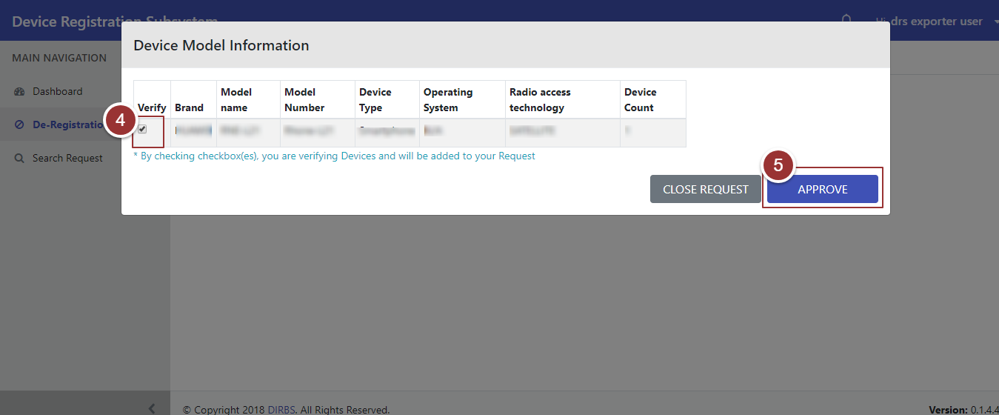

Figure -Approve Request

After clicking on the “Approve” button it will redirect to a page where user upload approval documents i.e. Shipment Document, Authorization Document, and Certificate Document

1. To upload the file, click on the “Choose File” button and select the file containing required information

**Note**: File should be inpre-defined format.

1. To view the previous entered details i.e. Basic Deregistration Details and Device Model Information, click on the “Previous Details” tab
2. Click on the “Submit” Button

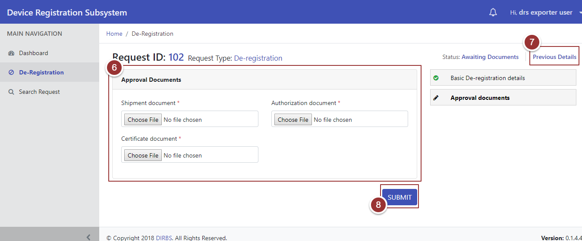

Figure -Approval Documents

On submission of the request, a page will appear that displays the details (Confirmation Message, Tracking ID, and Status)

1. To view the submitted request, click on the “View Your Request” button

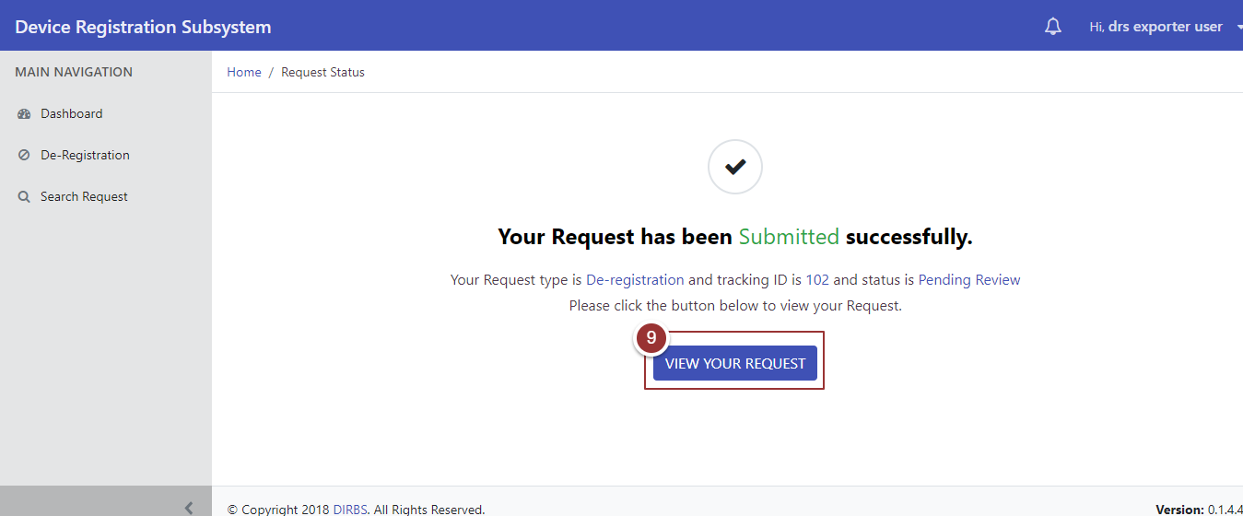

Figure -View Your Request

# **Close Request**

Perform steps 1-3

1. To close the request, verify the details and check the checkbox(es) against the correct device information
2. Click on the “Close Request” button

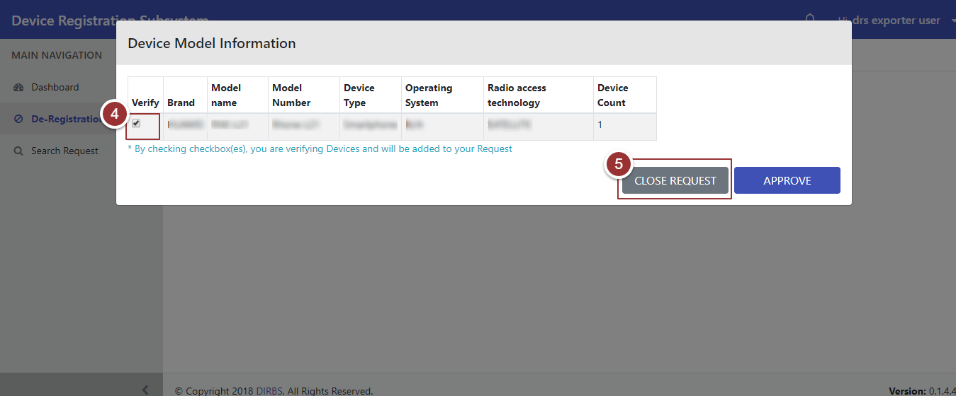

Figure -Close Request

On clicking the button, a page will appear that displays the details (Confirmation Message, Tracking ID, and Status)

1. To view the closed request, click on the “View Your Request” button

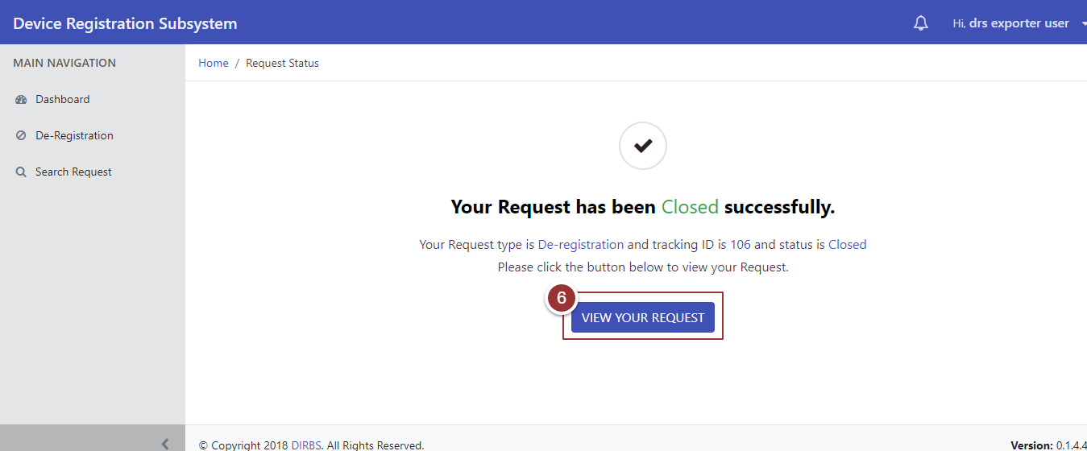

Figure -View Your Request

# **Search Request**

1. To search any request(s) click on “Search Request ” tab
2. To view all request(s) click on the “Search Requests” tab

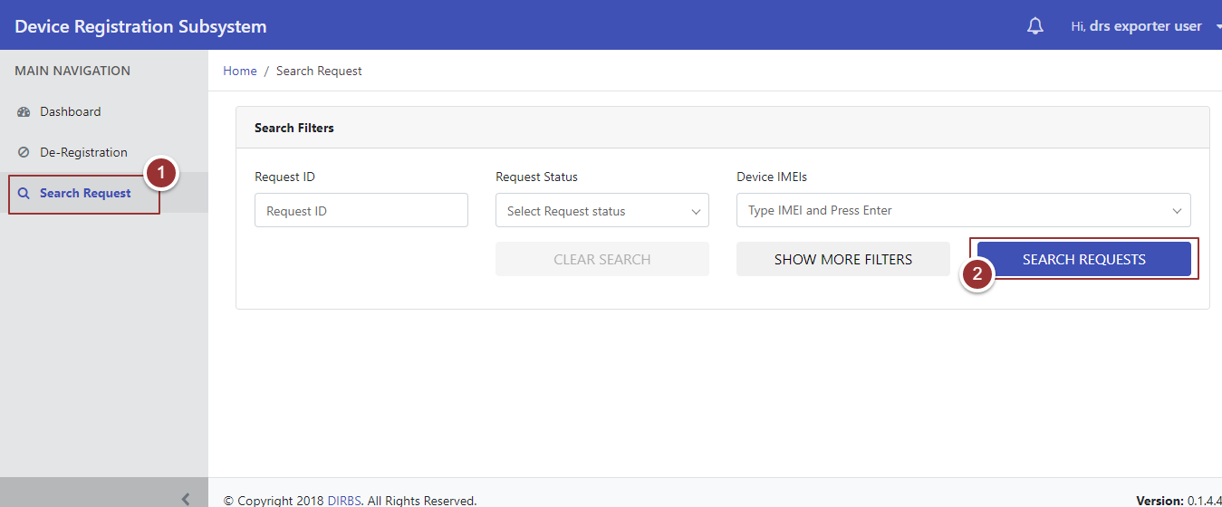

Figure -Search Request

On clicking the button, system will display all requests that contain (Request ID, Request Type, Device Count, Date Created, Date Last Updated, Request Status, and Actions)

1. To update the request, click on the required action(s) (Complete, Modify, and Close)

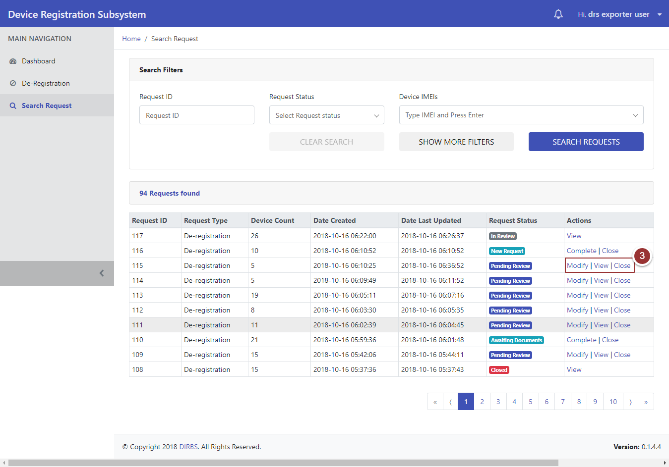

Figure -Action Tab(s)

1. To search the particular request enter any known information (i.e. Request ID, Request Status, Device IMEIs etc.). For more search filters click on “Show More Filters” button and enter known information related to the request
2. Click on “Search Requests” button

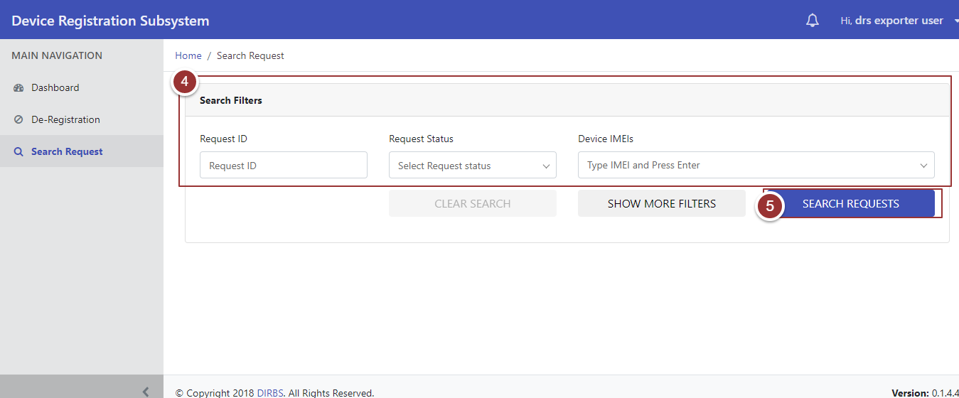

Figure -Search Filter(s)