Device Registration Subsystem 1.0.0

User Guide (Importer)

DRS-User-Guide-Importer-1.0.0

June 19, 2018

|  |
| --- |
|  |

Revision history

|  |  |  |
| --- | --- | --- |
| Revision | Date | Description |
| A |  | Initial release |

# **Contents**

1. Introduction 4

1.1. Purpose 4

1.2. Supported Desktop Browsers 4

1.3. Supported Mobile Browsers 5

1.4. Definitions, Acronyms, and Abbreviations 5

2. System Description 6

3. System Navigation 9

3.1. Login Screen 9

3.2. Dashboard Overview 10

3.3. Device Registration 11

3.4. Search Request 17

**Figures**

Figure 1-Login Screen 9

Figure 2-Dashboard Screen 10

Figure 3-Device Registration 11

Figure 4-Add Device 12

Figure 5-Type IMEI 13

Figure 6-Device Model Description 14

Figure 7-Approval Documents 15

Figure 8-Request Status 16

Figure 9- Search Request 17

Figure 10-Action Tab(s) 18

Figure 11-Search Filters 19

**Tables**

Table 1-Supported Desktop Browsers 4

Table 2-Supported Mobile Browsers 5

Table 3-Definition, Acronyms, and Abbreviations 5

Table 4-System Description 6

# **Introduction**

Device Registration Subsystem (DRS) is the subsystem of Device Identification, Registration & Blocking System (DIRBS). It provides a platform for individual(s) and importer(s) to request for device registration.

Individuals are people who are not licensed to import devices into the country, but are allowed to import a small number of devices via personal import exceptions.

Importers are people who are licensed to import devices into the country e.g. they could be manufacturers, retailer’s etc.

The Device Identification, Registration & Blocking System (DIRBS) is a country-wide system deployed in cooperation between the country regulator, operators in that country, and a technology partner that supports deployment. The system checks, identifies, and discourages non-compliant devices by verifying the installed base of devices currently active in a market and continuing to monitor as new devices are activated.

DIRBS can verify that:

* Devices have properly allocated identifiers and type approval
* Devices are not duplicated or stolen
* Device importation takes place through legal channels

## **Purpose**

This document is intended to give assistance to the user to use the Device Registration Subsystem (DRS).

## **Supported Desktop Browsers**

Table 1-Supported Desktop Browsers

|  |  |
| --- | --- |
| **Name** | **Version** |
| Internet Explorer | 11.0 |
| Firefox 52.5 ESR | 57.0 |
| Chrome | 63.0 |
| Safari | 11.0 |
| Edge | 41.16299 |

## **Supported Mobile Browsers**

Table 2-Supported Mobile Browsers

|  |  |
| --- | --- |
| **Name** | **Version** |
| Chrome | 63.0 |
| UC Browser | 11.5 |
| Opera(Android) | 44.1 |
| Opera(iOS) | 16.0.7 |
| Safari | 11.1 |
| Samsung Internet | 6.2 |
| Android | 4.1.x - 4.3 |

## 

## **Definitions, Acronyms, and Abbreviations**

Table 3-Definition, Acronyms, and Abbreviations

|  |  |
| --- | --- |
| ****Term**** | ****Definition**** |
| **DIRBS** | **Device Identification Registration and Blocking System** |
| IAM | Identity Access Management System |
| DRS | Device Registration Subsystem |
| MSISDN | Mobile Subscriber Integrated Services Directory Number |
| IMEI | International Mobile Equipment Identity |
| IMSI | International mobile subscriber identity |
| TAC | Type Allocation Code |

# **System Description**

Table 4-System Description

|  |  |
| --- | --- |
| Feature/Sections | ****Explanation**** |
| Login Screen | * To access the system, authorized user first needs to enter his/her credentials on login page, this login page authenticate user from the IAM and redirects user to DRS |
| Dashboard Screen | The dashboard screen displays the instruction for the user (individual and importer) which has following sections   * **Header**   Header section displays the name of the system, name of the logged in user with logout functionality   * **Navigation Panel**   Navigation Panel contains main navigation menu through which user can navigate the whole system.   * **Main Content Area**   Main Content Area contains all the content to be displayed and actions to be performed for respective feature   * **Breadcrumbs**   Breadcrumbs allows user to keep track of their location within the system   * **Footer**   Footer contains the software version and copyrights statement |
| Device Registration | Facilitate user to register their device(s) by completing following three steps  Basic Registration Details  Device Model Description  Approval Documents |
| Required Input(s) for Basic Registration | **Device Count**  Takes the total number of devices as input  **Number of IMEIs per Device**  Takes total number of IMEIs that entered for per device as input  **Device IMEIs**  **Tab-delimited File**  User can add up to 10,000,000 devices with 5 IMEIs per device  **Webpage input**  User can add up to 10 devices with 5 IMEI per device  **Manufacturing Details**  Allows user to select the manufacture location of the device (i.e. local or overseas) |
| Required Inputs for Device Model description | **Brand**  Takes brand name of the device as input. Enter the brand name of the device to be registered  **Model Name**  Takes the Model name of the device as input. Enter model name of the device to be registered  **Model Number**  Takes the Model name of the device as input. Enter model name of the device to be registered    **Device Type**  Allows user to select the type (i.e. smart phone, tablet, dongle, router, Feature phone etc.) of the device from the drop-down menu  **Operating System**  Takes the operating system (i.e. android, IOS) of the device as input. Enter the operating system of the device to be registered  **Radio Access Technology**  Allows user to select the radio based technologies i.e. 2G, 3G, 4G that your device supports |
| Approval Documents | Takes three types of document of the device as input  Shipment Document  Authorization Document  Certificate Document |
| Search Requests | * Allows user to search a particular request by applying different filters i.e. request ID, request status, device IMEI, create date, last updated, brand, model name, model number, device type, operating system, technologies, device count, number of IMEIs per device, manufacturing location |
| Request Status | * **New Request**   Add/Verify the details of the device model   * **Awaiting Documents**   Request is still awaited for approval documents to upload   * **Pending Review**   Request is not yet assigned to any authorized entity   * **In Review**   Request has assigned to authorized entity   * **Information Requested**   Request has some missing information   * **Approved**   Request has been approved by authorized entity   * **Rejected**   Request has been rejected by authorized entity due to invalid information     * **Closed**   Request has been closed by the user |

# **System Navigation**

# **Login Screen**

1. **Enter your credentials i.e. Username and Password.**
2. **Click on the “Log in” button**

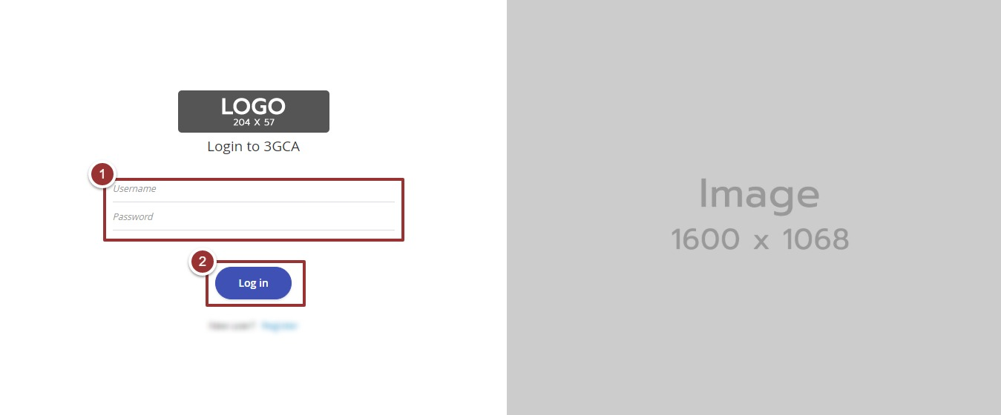

Figure 1-Login Screen

# **Dashboard Overview**

The dashboard screen is divided into following sections

1. **Header** section displays the name of the system, name of the logged in user with logout functionality
2. **Main Navigation Panel** helps user to navigate the system
3. **Breadcrumbs** is a navigational aid in UI
4. **Main Content Area** contains all relevant information related to the respective feature/option
5. **Footer** contains the version and copyrights of the system

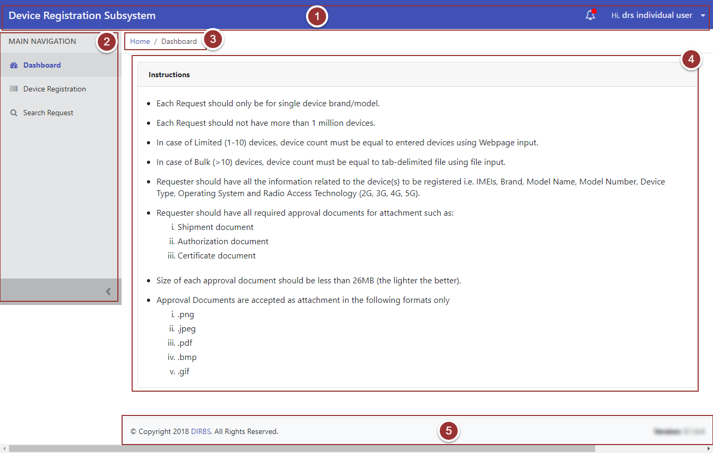

Figure 2-Dashboard Screen

# **Device Registration**

1. Click on the “Device Registration” tab under the “Main Navigation” heading
2. Enter the basic registration details (i.e. Device Count, Number of IMEIs per Device, Device IMEIs and Manufacturing location)

**Note**: All the field(s) are mandatory.

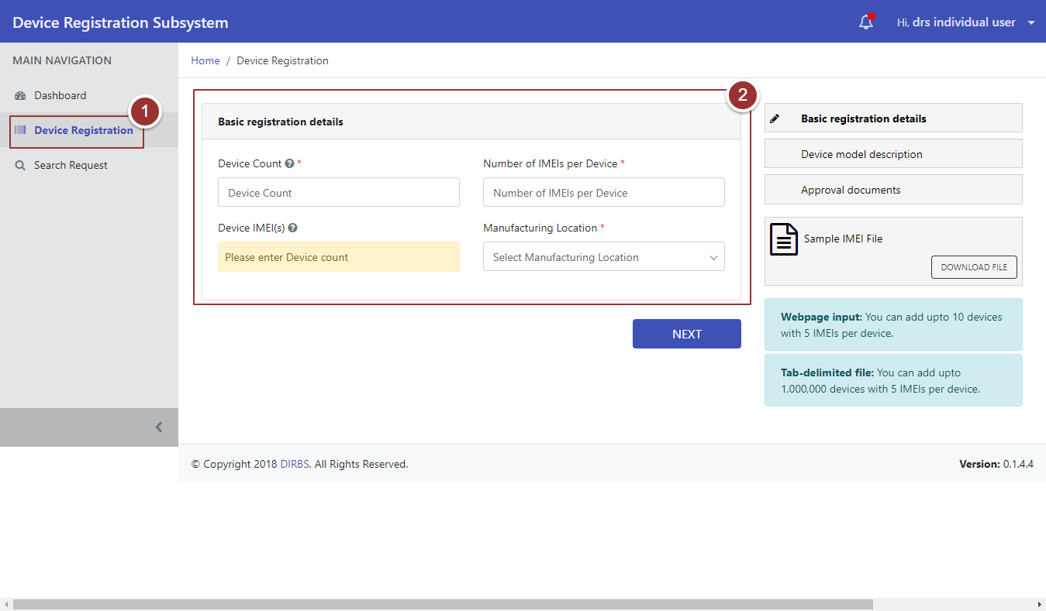

Figure 3-Device Registration

1. Click on the “Add Device” Button

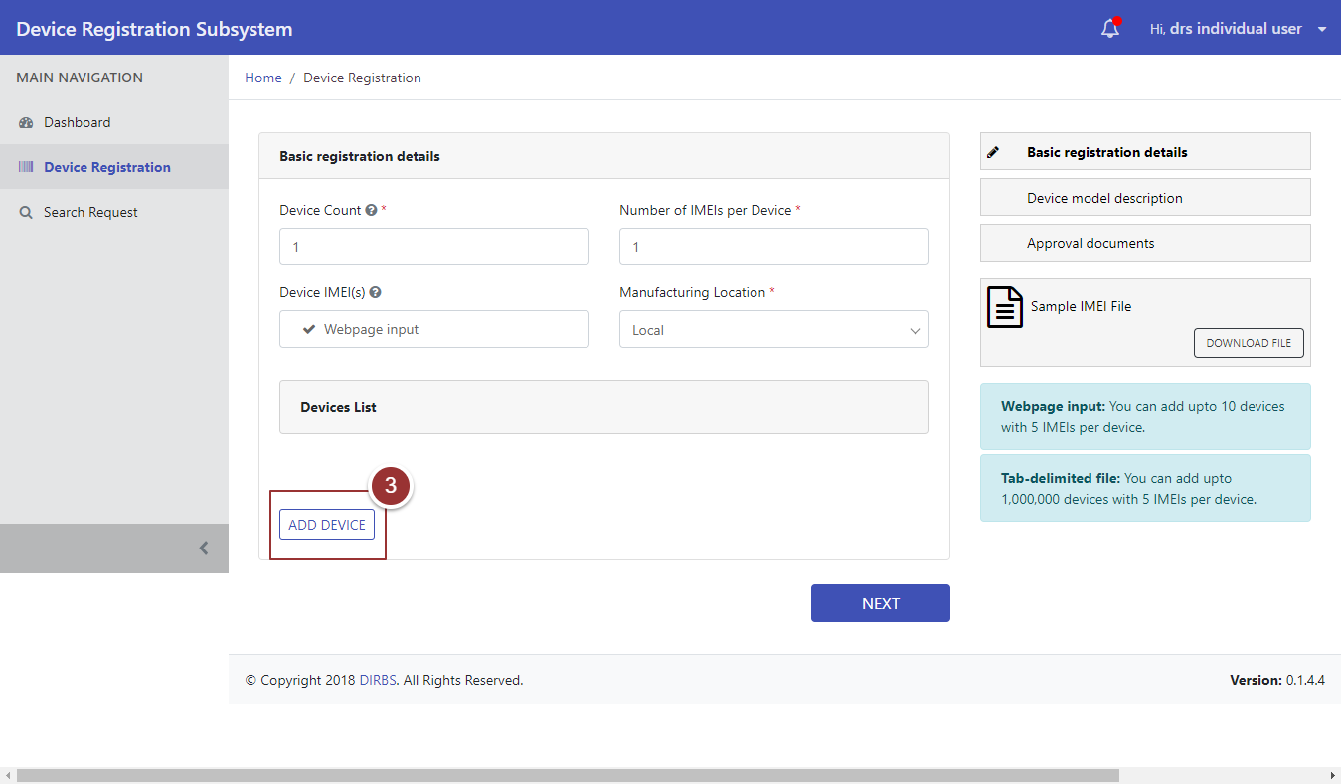

Figure 4-Add Device

1. Now, Type and re-type the IMEI in the respective fields
2. Click on the “Next” Button

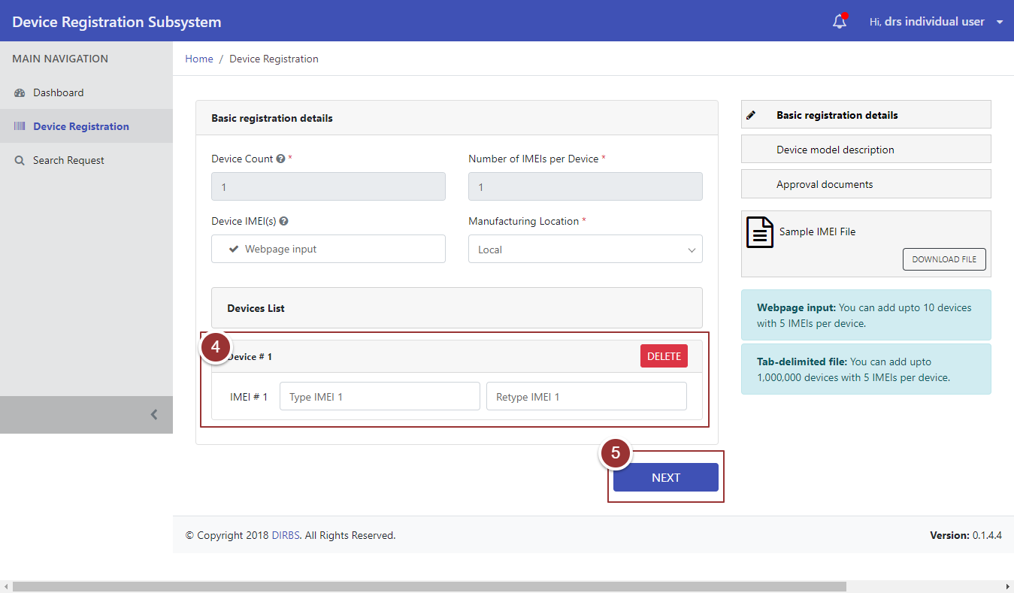

Figure 5-Type IMEI

After clicking on the “Next” button, it will redirect to a page where user enters the device model description.

1. Enter the device model description i.e. Brand Name, Model Name, Model Number, Device Type, Operating System, and Radio Access Technology in the respective field(s)
2. To view the previous entered details i.e. Basic Registration Details, click on the “Previous Details” tab
3. Click on the “Next” button

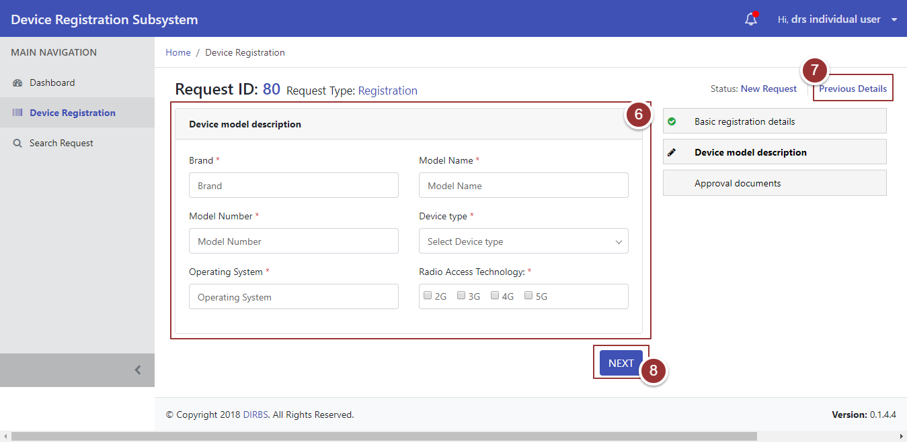

Figure 6-Device Model Description

After clicking on the “Next” button it will redirect to a page where user upload approval documents i.e. Shipment Document, Authorization Document, and Certificate Document

1. To upload the file, click on the “Choose File” button and select the file containing required information.

**Note**: File should be inpre-defined format.

1. To view the previous entered details i.e. Basic Registration Details and Device Model Description, click on the “Previous Details” tab
2. Click on the “Submit” Button

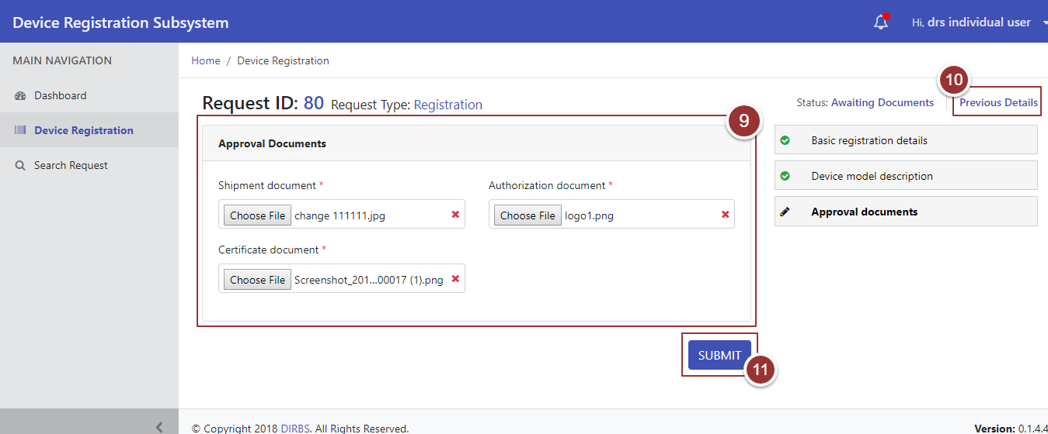

Figure 7-Approval Documents

On submission of the request, a page will appear that display the details (Confirmation Message, Tracking ID, Status of the Request)

1. To view the request, click on the “View Your Request” button

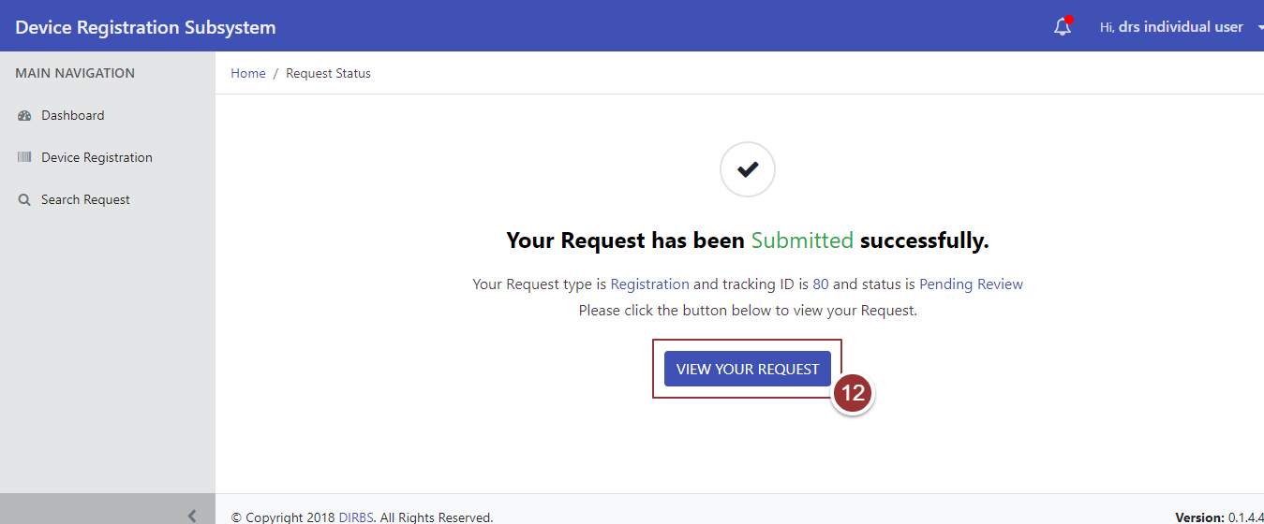

Figure 8-Request Status

# **Search Request**

1. To search any request, click on “Search Request ” tab
2. To view all request(s), click on the “Search Requests” button

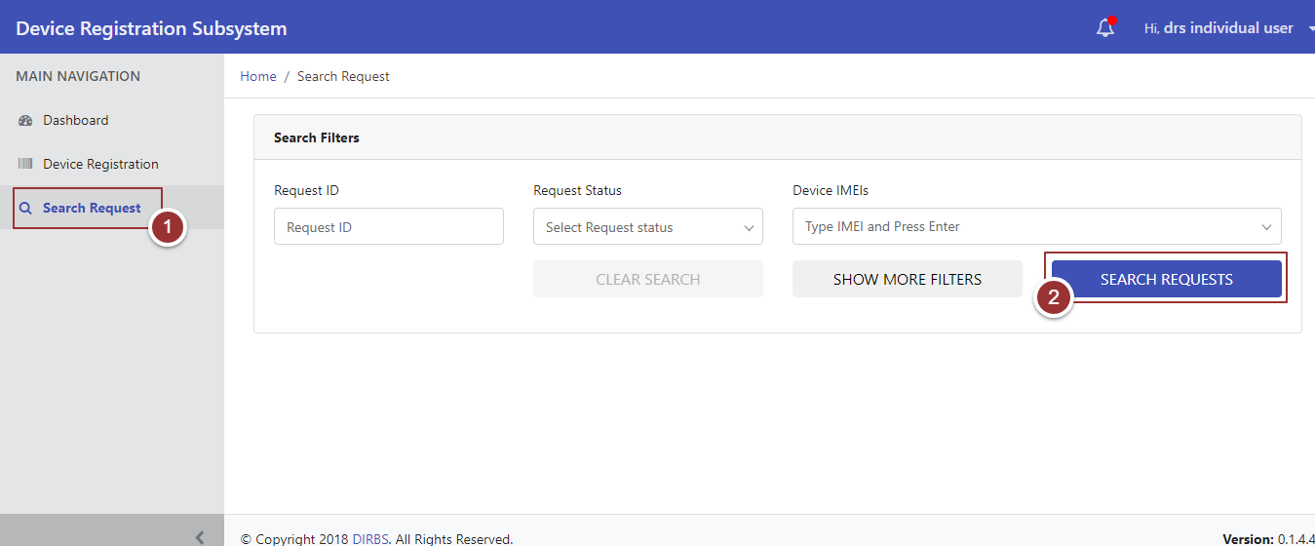

Figure 9- Search Request

On clicking the button, system will display all requests that contain (Request ID, Request Type, Device Count, Date Created, Date Last Updated, Request Status, and Actions)

1. To update the request, click on the required action (Complete, Modify, and Close)

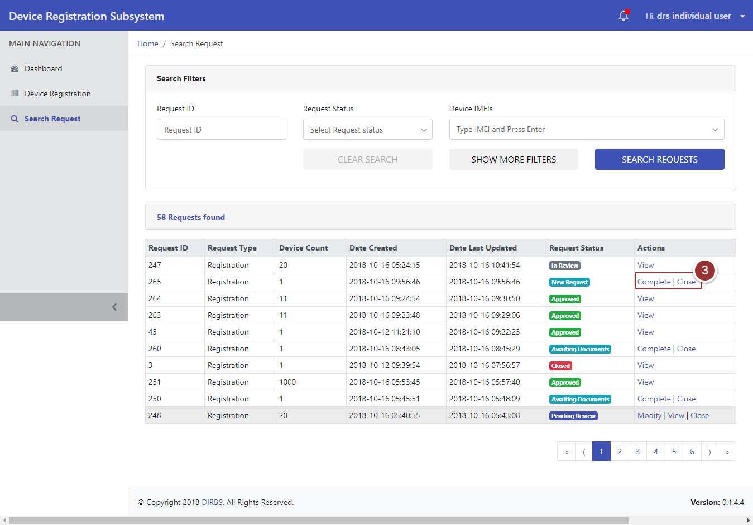

Figure 10-Action Tab(s)

1. To search particular requests enter any known information (i.e. Request ID, Request Status, Device IMEIs etc.) .For more search filters click on “Show More Filters” button and enter known information related to the request
2. Click on “Search Requests” button

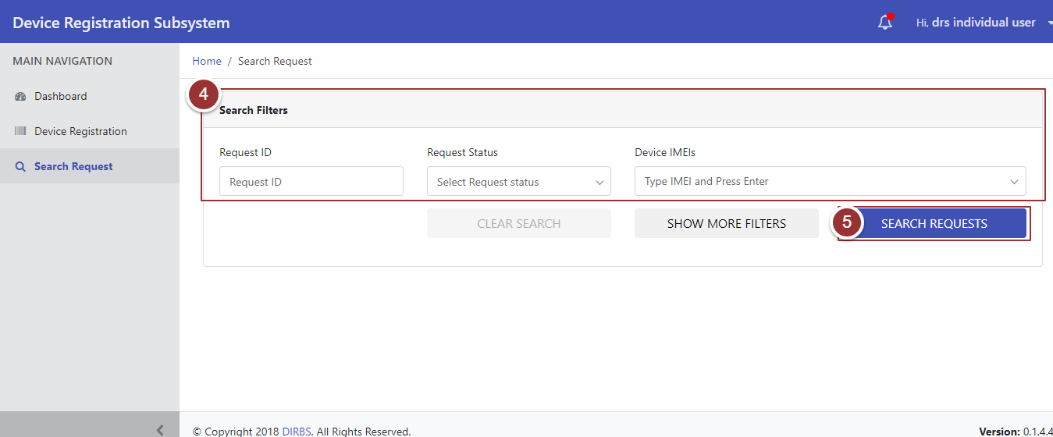

Figure 11-Search Filters