Device Registration Subsystem 1.0.0

User Guide (Authority)

DRS-User-Guide-Authority-1.0.0

June 19, 2018

Revision history

|  |  |  |
| --- | --- | --- |
| Revision | Date | Description |
| A |  | Initial release |

# **Contents**

1. Introduction 4

1.1. Purpose 4

1.2. Supported Desktop Browsers 4

1.3. Supported Mobile Browsers 5

1.4. Definitions, Acronyms, and Abbreviations 5

2. System Description 6

3. System Navigation 11

3.1. Login Screen 11

3.2. Dashboard Overview 12

3.3. Search Request 13

3.3.1. View Request 15

3.3.2. Assign Request 16

**Figures**

Figure 1-Login Screen 11

Figure 2-Dashboard Overview 12

Figure 3-Search Requests 13

Figure 4-View Requests 14

Figure 5-View Request Sections 15

Figure 6-Assign Request 16

Figure 7-Review Status 17

Figure 8-Review Status 2 18

Figure 9-Search Filters 19

**Tables**

Table 1-Supported Desktop Browsers 4

Table 2-Supported Mobile Browsers 5

Table 3-Definition, Acronyms, and Abbreviations 5

Table 4-System Description 6

# **Introduction**

Device Registration Subsystem (DRS) is the subsystem of Device Identification, Registration & Blocking System (DIRBS). It provides a platform for authorized user(s) to review and approve device registration and deregistration requests.

The Device Identification, Registration & Blocking System (DIRBS) is a country-wide system deployed in cooperation between the country regulator, operators in that country, and a technology partner that supports deployment. The system checks, identifies, and discourages non-compliant devices by verifying the installed base of devices currently active in a market and continuing to monitor as new devices are activated.

DIRBS can verify that:

* Devices have properly allocated identifiers and type approval
* Devices are not duplicated or stolen
* Device importation takes place through legal channels

## **Purpose**

This document is intended to give assistance to the user to use the Device Registration Subsystem (DRS).

## **Supported Desktop Browsers**

Table 1-Supported Desktop Browsers

|  |  |
| --- | --- |
| **Name** | **Version** |
| Internet Explorer | 11.0 |
| Firefox 52.5 ESR | 57.0 |
| Chrome | 63.0 |
| Safari | 11.0 |
| Edge | 41.16299 |

## **Supported Mobile Browsers**

Table 2-Supported Mobile Browsers

|  |  |
| --- | --- |
| **Name** | **Version** |
| Chrome | 63.0 |
| UC Browser | 11.5 |
| Opera(Android) | 44.1 |
| Opera(iOS) | 16.0.7 |
| Safari | 11.1 |
| Samsung Internet | 6.2 |
| Android | 4.1.x - 4.3 |

## 

## **Definitions, Acronyms, and Abbreviations**

Table 3-Definition, Acronyms, and Abbreviations

|  |  |
| --- | --- |
| **Term** | **Definition** |
| **DIRBS** | **Device Identification Registration and Blocking System** |
| IAM | Identity Access Management System |
| DRS | Device Registration Subsystem |
| MSISDN | Mobile Subscriber Integrated Services Directory Number |
| IMEI | International Mobile Equipment Identity |
| IMSI | International mobile subscriber identity |
| TAC | Type Allocation Code |

# **System Description**

Table 4-System Description

|  |  |
| --- | --- |
| Feature/Sections | ****Explanation**** |
| Login Screen | * To access the system, authorized user first needs to enter his/her credentials on login page, this login page authenticate user from the IAM and redirects user to DRS |
| Dashboard Screen | The dashboard screen displays the instructions for the user which has the following sections   * **Header**   Header section displays the name of the system, name of the logged in user with logout functionality   * **Navigation Panel**   Navigation Panel contains main navigation menu through which user can navigate the whole system.   * **Main Content Area**   Main Content Area contains all the content to be displayed and actions to be performed for respective feature   * **Breadcrumbs**   Breadcrumbs allows user to keep track of their location within the system   * **Footer**   Footer contains the software version and copyrights statement |
| Search Requests | * Allows user to search a particular request by applying different filters i.e. request ID, request status, device IMEI, create date, last updated, brand, model name, model number, device type, operating system, technologies, device count, number of IMEIs per device, manufacturing location |
| Request Sections | * Request contains the following sections to review such that * Device Quota * Device Description * IMEI Classification Result * IMEI Registration Status * Approval Documents |
| Device Quota | * **Allowed Device Quota**   Displays the total count of devices that a user can register   * **Used Device Quota**   Displays the total number of devices registered by user     * **Request Device Count**   Displays the number of devices user is requesting for   * **Remaining Device Quota**   Displays the total number of remaining devices |
| Device Description | Displays both user and GSMA device descriptions  **Brand**  Displays the brand name of the device  **Model Name**  Displays the model name of the device  **Model Number**  Displays the model number of the device  **Manufacturer**  Displays the name of the company/country where the device is manufactured  **Device Type**  Displays the device type i.e. smartphone, tablet etc.  **Operating System**  Displays the operating system of the device i.e. Android or iOS  **Radio access technology**  Displays the radio access technologies of that device i.e. 2G, 3G, 4G, 5G etc. |
| IMEI Classification Results | * Displays the below classified results based on particular request of a user * IMEI Compliance Status * Pre-Condition Classification State * Lost/Stolen Status * Seen On Network * Download Report Link |
| IMEI Compliance State | * **Non-compliant**   Displays the total count of IMEIs that are not registered with regulatory authority   * **Compliant**   Displays the total count of IMEIs that are registered with regulatory authority   * **Provisional non-complaint**   Displays the total count of the IMEIs that are reported as lost/stolen but not blocked yet   * **Provisional complaint**   Displays the total count of the IMEIs that are requested for registration but not approved yet |
| Pre-Condition Classification State | * **Duplicate**   Displays the total count of duplicate IMEIs   * **GSMA Not Found**   Displays the total count of IMEIs that are not registered in GSMA database   * **Local Stolen**   Displays the total count of IMEIs that are reported as lost/stolen   * **Malformed**   Displays the total count of IMEIs that contains the character other than hexadecimal number   * **Not on registration list**   Displays the total count of the IMEIs that are not being requested for registration |
| Lost/Stolen Status | * **Stolen status**   Displays the total count of IMEIs that are reported as stolen   * **Provisional stolen**   Displays the total count of the IMEIs that are reported as lost/stolen but not blocked yet |
| Seen On Network | * Displays the total count of IMEIs seen on network |
| Download Report Link | * Allows user to download the report to view the non-compliant IMEIs |
| IMEI Registration Status | Displays the registration status based on the total requests of a user   * **Duplicate IMEIs**   Displays the total count of duplicate IMEIs   * **Pending Registration**   Displays the total count of IMEIs that have been requested for registration but no action is performed yet by the authorized entity     * **Registered**   Displays the total count of IMEIs that are registered   * **Not Registered**   Displays the total count of IMEIs that have been rejected by the authorized entity |
| Approval Documents | * Allows user to download and verify the approval documents such that   Shipment Document  Authorization Document  Certificate Document |
| Request Status | |  |  |  | | --- | --- | --- | | **Previous**  **request**  **status** | **Action** | **New**  **request**  **status** | | Pending  Review | Authorized entity assigns  request | In Review | | In Review | Authorized entity approves all  sections | Approved | | In Review | Authorized entity marks a  section as incomplete/missing | Information  Requested | | In Review | Authorized entity marks a  section as rejected | Rejected | | In Review | Authorized entity un-assigns  request | Pending  Review | | In process | System generates the reports | Pending review | | In complete | Authorized entity can view the request | Incomplete | | Failed | Authorized entity re-initiate the request | In process |   The previous and new statuses with required actions are mention in the below table |

# **System Navigation**

# **Login Screen**

1. **Enter your credentials i.e. Username and Password.**
2. **Click on the “Log in” button**

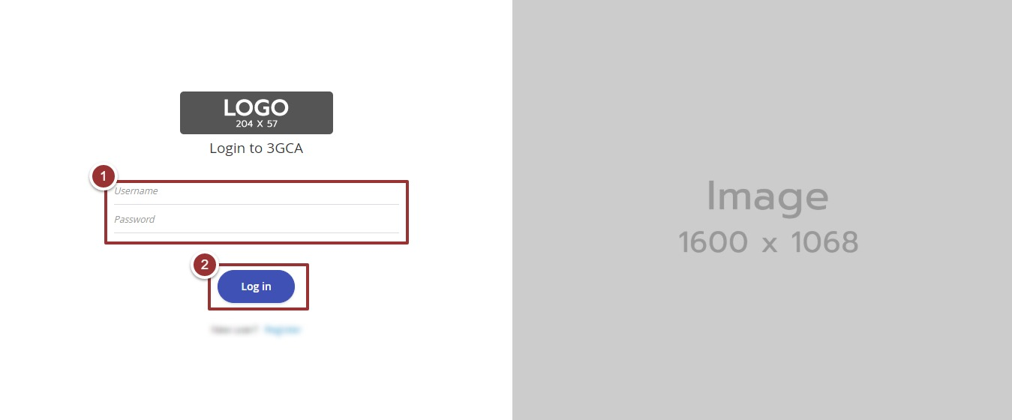

Figure 1-Login Screen

# **Dashboard Overview**

The dashboard screen is divided into following sections

1. **Header** section displays the name of the system, name of the logged in user with logout functionality
2. **Main Navigation Panel** helps user to navigate the system
3. **Breadcrumbs** is a navigational aid in UI
4. **Main Content Area** contains all relevant information related to the respective feature/option
5. **Footer** contains the version and copyrights statement

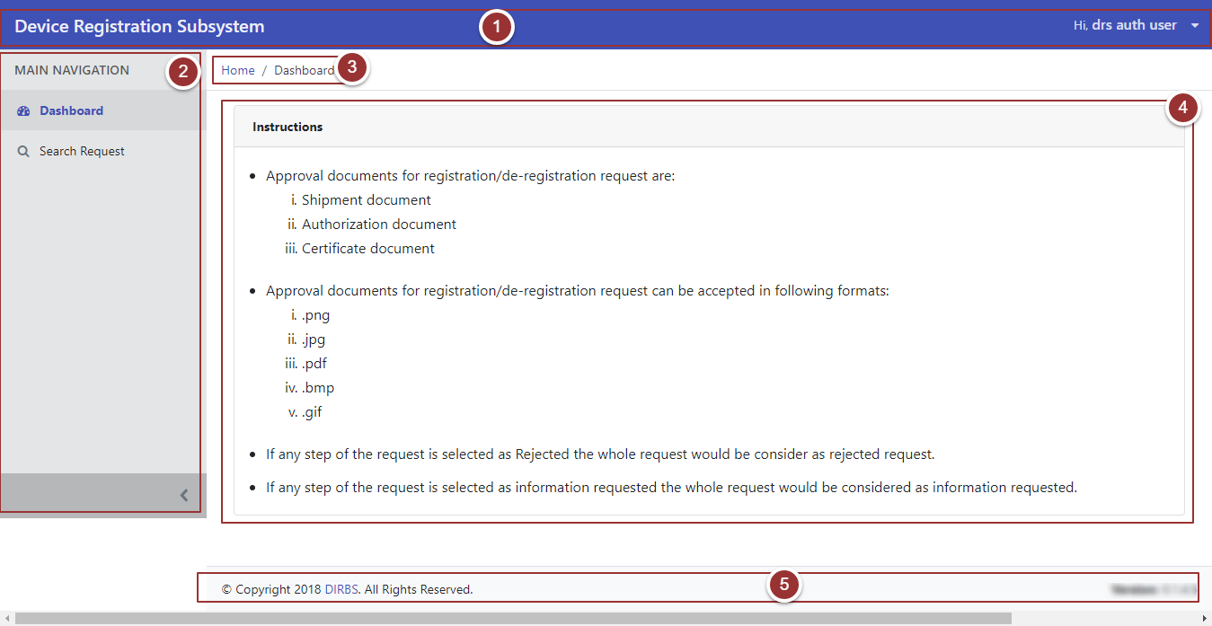

Figure 2-Dashboard Overview

# **Search Request**

1. To search any request, click on “Search Request ” tab
2. To view all requests, click on the “Search Requests” button

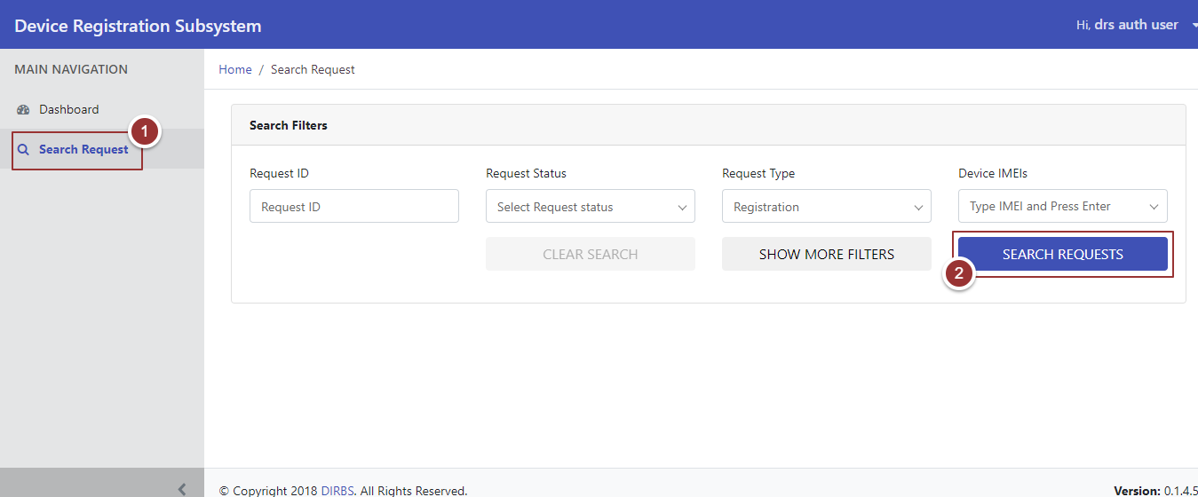

Figure 3-Search Requests

On clicking the button, system will display all requests that contain (Request ID, Request Type, Device Count, Date Created, Date Last Updated, Request Status, and Actions)

1. To view the request, click on the “View” Link against the respective request

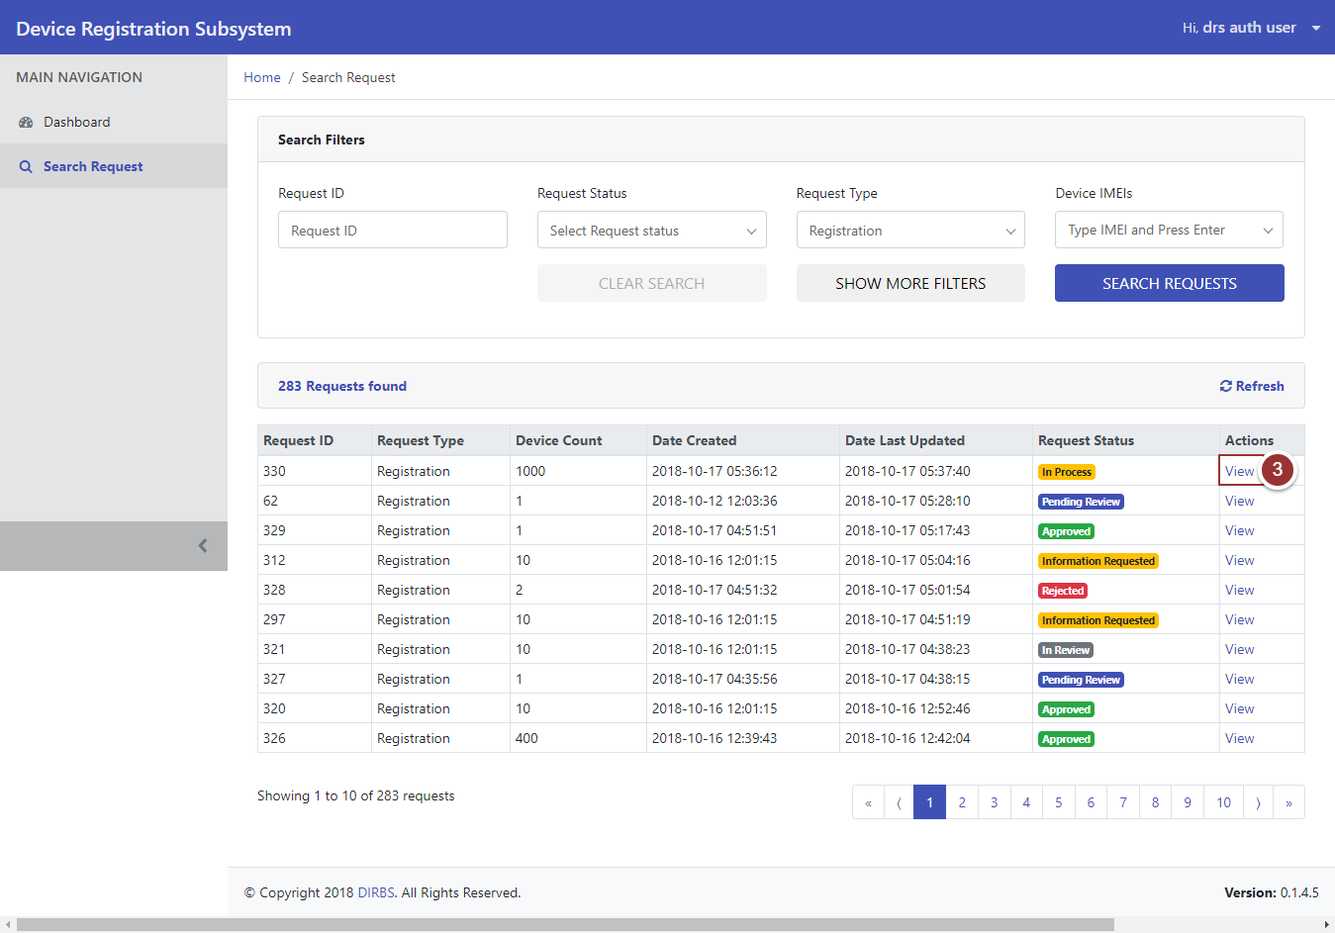

Figure 4-View Requests

# **View Request**

Perform steps 1-3 as per section3.3

1. The “View” link will redirect to the request details page, click on the “Next” button to view the other sections of the request

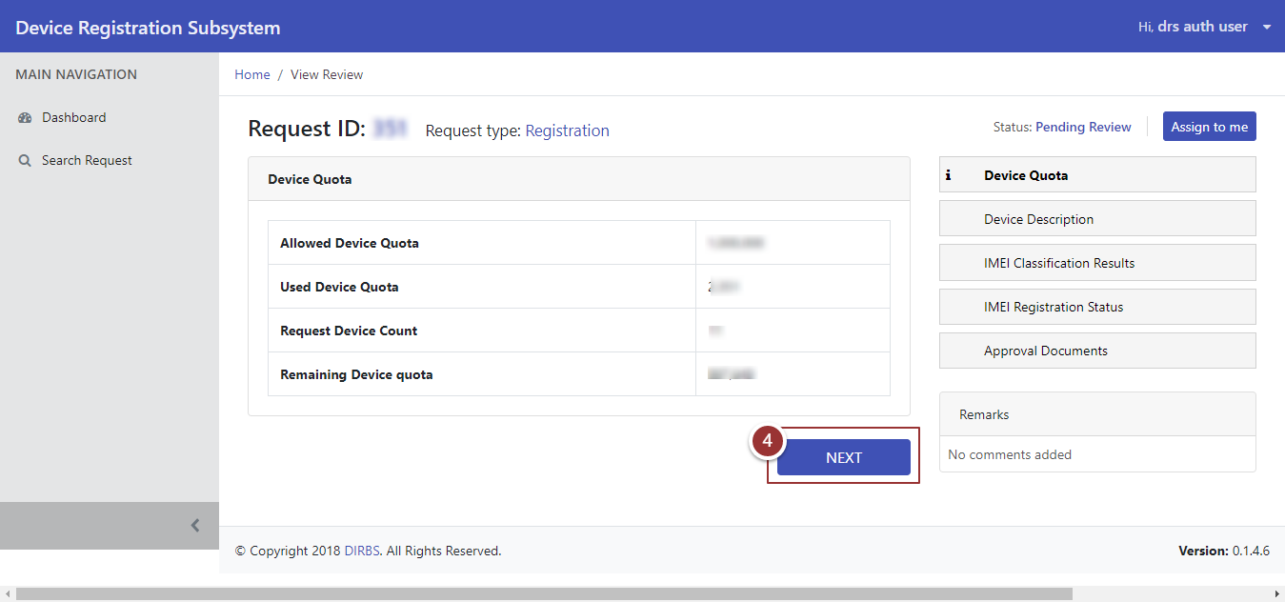

Figure 5-View Request Sections

Perform step 4 to view all sections of the request

# **Assign Request**

Perform steps 1-3 as per section 3.3

The “View” link will redirect to the request details page while viewing the request, user can assign/unassign the request with “Pending Review” status

1. To assign the request, click on “Assign to me” button

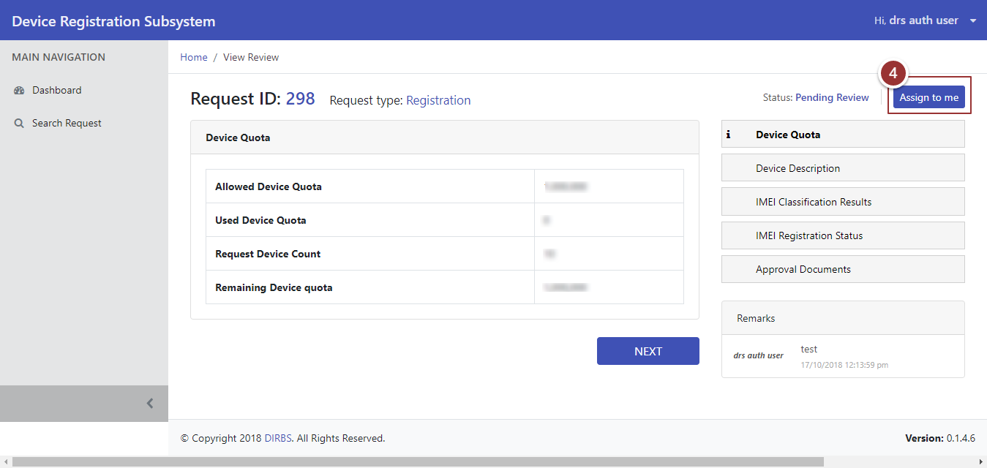

Figure 6-Assign Request

1. To change the status of the reviewed section of the request, select the status (Approve, Information Requested, and Rejected) from the drop-down menu accordingly
2. Enter the feedback in the respective comment box
3. Click on the Next button

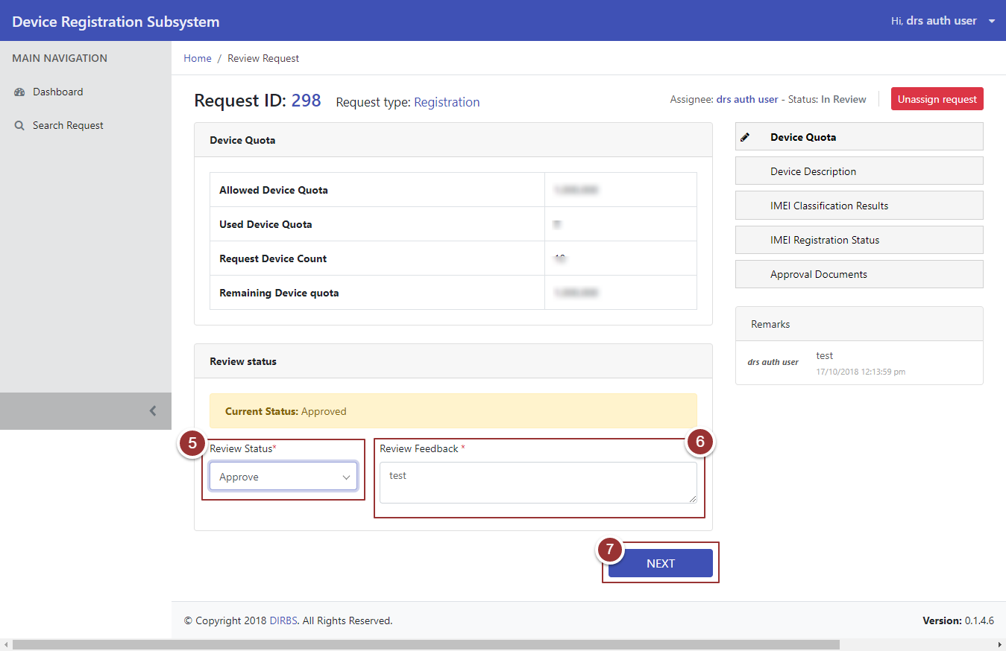

Figure 7-Review Status

To change the status accordingly for every reviewed section of the request perform the steps 5 -7

1. After changing the status of the last reviewed section (i.e. Approval Documents) of the request, click on the “Finish” button

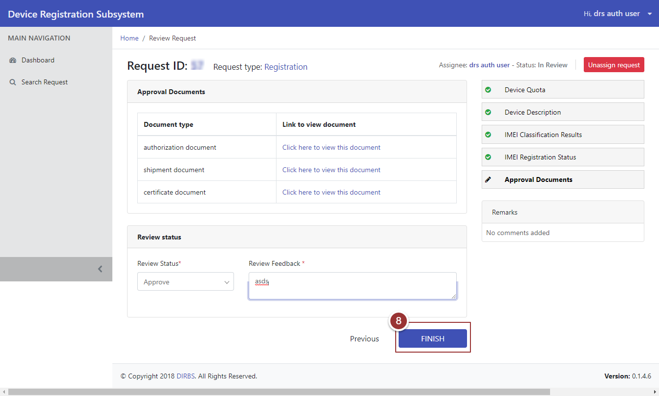

Figure 8-Review Status 2

1. To search the particular request enter any known information (i.e. Request ID, Request Status, Device IMEIs etc.).For more search filters click on “Show More Filters” button and enter known information related to the request
2. Click on “Search Requests” button

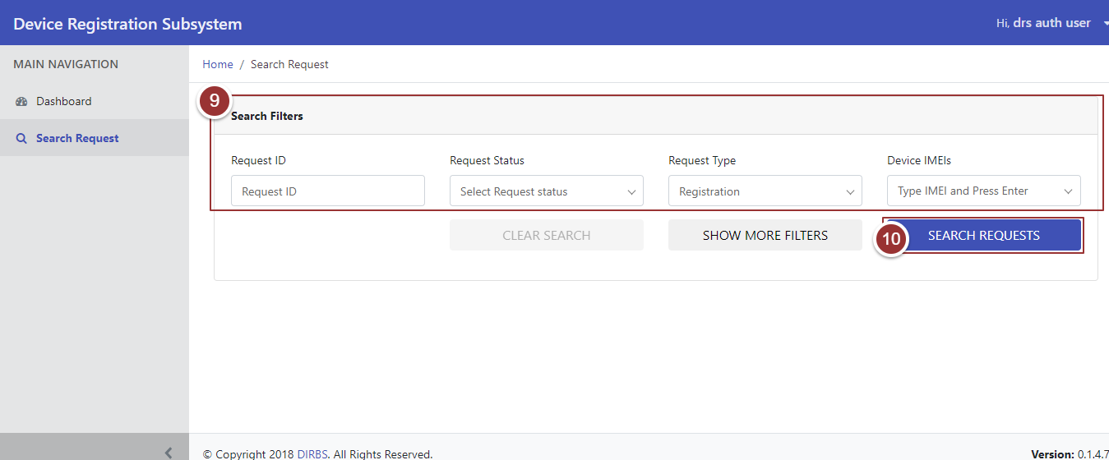

Figure 9-Search Filters