Device Registration Subsystem 2.0.0

User Guide (Exporter)

DRS-User-Guide-Exporter-2.0.0

March 5, 2019

Revision history

|  |  |  |
| --- | --- | --- |
| Revision | Date | Description |
| A |  | Second Release |

# **Contents**

1. Introduction 5

1.1. Purpose 5

1.2. Supported Desktop Browsers 5

1.3. Supported Mobile Browsers 6

1.4. Definitions, Acronyms, and Abbreviations 6

2. System Description 7

3. System Navigation 10

3.1. Login Screen 10

3.2. Portal Sections 11

3.2.1.Language Menu 12

3.2.2.Notification Alerts 13

3.3. Dashboard 14

3.3.1.System Instructions 15

3.4. De-Registration 17

3.4.1.Approve Request 19

3.4.2.Close Request 22

3.5. Search Request 24

3.5.1.Search Particular Request 29

**Figures**

Figure 1-Login Screen 10

Figure 2-Portal Sections 11

Figure 3-Language Menu 12

Figure 4-Notification Alert Icon 13

Figure 5-Dashboard 14

Figure 6-System Instructions 15

Figure 7-System Instructions 2 16

Figure 8-Deregistration 17

Figure 9-Device Model Information 18

Figure 10-Approve Request 19

Figure 11-Approval Documents 20

Figure 12-View Your Request 21

Figure 13-Close Request 22

Figure 14-View Your Request 23

Figure 15-Search Request 24

Figure 16-Action Tab(s) 25

Figure 17-View Request 26

Figure 18-View Request 2 27

Figure 19-Download Report Button 28

Figure 20-Search Filter(s) 29

Figure 21-Search Filters 2 30

**Tables**

Table 1-Supported Desktop Browsers 5

Table 2-Supported Mobile Browsers 6

Table 3-Definition, Acronyms, and Abbreviations 6

Table 4-System Description 7

# **Introduction**

Device Registration Subsystem (DRS) is the subsystem of Device Identification, Registration & Blocking System (DIRBS). It provides a platform for an exporter to request their IMEIs to be deregistered.

Exporters are people who are licensed to export devices out of the country e.g. they could be, refurbishes etc.

The Device Identification, Registration & Blocking System (DIRBS) is a country-wide system deployed in cooperation between the country regulator, operators in that country, and a technology partner that supports deployment. The system checks, identifies, and discourages non-compliant devices by verifying the installed base of devices currently active in a market and continuing to monitor as new devices are activated.

DIRBS can verify that:

* Devices have properly allocated identifiers and type approval
* Devices are not duplicated or stolen
* Device importation takes place through legal channels

## **Purpose**

This document is intended to give assistance to user to use the Device Registration Subsystem (DRS).

## **Supported Desktop Browsers**

Table 1-Supported Desktop Browsers

|  |  |
| --- | --- |
| **Name** | **Version** |
| Internet Explorer | 11.0 |
| Firefox 52.5 ESR | 57.0 |
| Chrome | 63.0 |
| Safari | 11.0 |
| Edge | 41.16299 |

## **Supported Mobile Browsers**

Table 2-Supported Mobile Browsers

|  |  |
| --- | --- |
| **Name** | **Version** |
| Chrome | 63.0 |
| UC Browser | 11.5 |
| Opera (Android) | 44.1 |
| Opera(iOS) | 16.0.7 |
| Safari | 11.1 |
| Samsung Internet | 6.2 |
| Android | 4.1.x - 4.3 |

## 

## **Definitions, Acronyms, and Abbreviations**

Table 3-Definition, Acronyms, and Abbreviations

|  |  |
| --- | --- |
| ****Term**** | ****Definition**** |
| **DIRBS** | **Device Identification Registration and Blocking System** |
| IAM | Identity Access Management System |
| DRS | Device Registration Subsystem |
| MSISDN | Mobile Subscriber Integrated Services Directory Number |
| IMEI | International Mobile Equipment Identity |
| IMSI | International mobile subscriber identity |
| TAC | Type Allocation Code |

# **System Description**

Table 4-System Description

|  |  |
| --- | --- |
| Feature/Sections | ****Explanation**** |
| Login Screen | * To access the system, authorized user first needs to enter his/her credentials on login page, this login page authenticate user from the IAM and redirects user to DRS |
| Portal Sections | **The portal is divided into the following sections.**   * **Header**   **Header section displays name of the system and it contains following features.**   * **Language selection Drop-Down**   **Allows user to change the language of system in English, Spanish and Indonesian.**   * **User profile Drop-down**   **Displays the user name with logout functionality.**   * **Notification Alert Icon**   **Generates the notification whenever the user(reviewer) Updates/modifies status of the request (i.e. Approved, Information Requested, Rejected).**   * **Navigation Panel**   Navigation Panel contains main navigation menu through which user can navigate the whole system.   * **Main Content Area**   Main Content Area contains all the content to be displayed and actions to be performed for respective feature.   * **Breadcrumbs**   Breadcrumbs allows user to keep track of their location within the system.   * **Footer**   Footer contains the software version and copyright text. |
| Dashboard | * The dashboard displays the total count of pending reviews, awaited documents, in-review requests and information requested requests. Also, it displays the recent pending requests along with their details |
| Deregistration | Facilitate user to deregister their device IMEIs by completing following two steps  Basic Deregistration Details  Approval Documents |
| Required Input(s) for Basic De-Registration | **Device Count**  Takes the total number of devices as input.  **Device IMEIs**  Takes the file that contains valid IMEI as input. |
| Device Model Information | Displays complete information of device model in a table.  **Device Model Information**  **Brand**  Displays the brand name of device.  **Model Name**  Displays the model name of device.  **Model Number**  Displays the model number of device.  **Device Type**  Displays the device type i.e. smartphone, tablet etc.  **Operating System**  Displays the operating system of device i.e. Android or iOS.  **Radio access technology**  Displays the radio access technologies of that device i.e. 2G, 3G, 4G, 5G etc.  **Device Count**  Takes the total number of devices as input. |
| Approval Documents | Three types of approval documents are required for deregistration of the device  Shipment Document  Authorization Document  Certificate Document |
| Search Requests | * Allows user to search a particular request by applying different filters i.e. request ID, request status, device IMEI, create date, last updated, brand, model name, model number, device type, operating system, technologies, device count |
| Request Status | * **New Request**   Verify details of the device model.   * **Awaiting Documents**   Approval documents are required to be uploaded.   * **Pending Review**   Request is not yet assigned to any authorized entity.   * **In Review**   Request has assigned to authorized entity.   * **Information Requested**   Request has some missing information.   * **Approved**   Request has been approved by authorized entity.   * **Rejected**   Request has been rejected by authorized entity due to invalid information.   * **Closed**   Request has been closed by the user. |

# **System Navigation**

# **Login Screen**

1. **Enter your credentials i.e. Username and Password.**
2. **Click on the “Log in” button.**

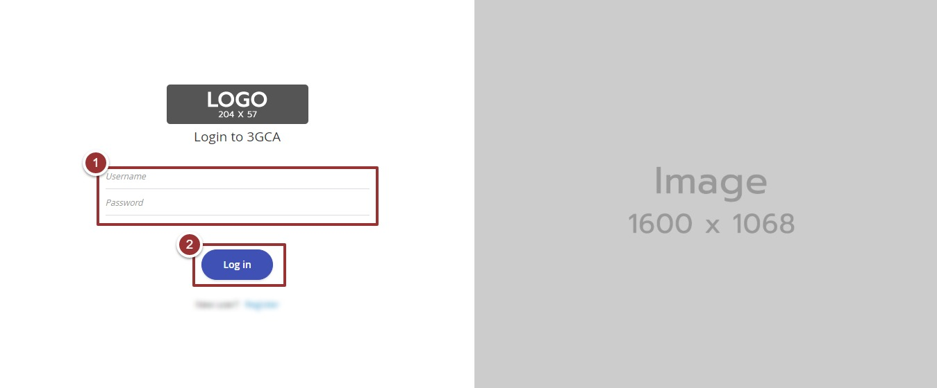

Figure 1-Login Screen

# **Portal Sections**

The portal is divided into following sections.

1. **Header** section displays name of system, a dropdown menu for language selection, notification alert icon and name of logged in user with logout functionality.
2. **Main Navigation Panel** helps user to navigate system.
3. **Breadcrumbs** is a navigational aid in UI.
4. **Main Content Area** contains all relevant information related to respective feature/option.
5. **Footer** contains version and copyrights statement.

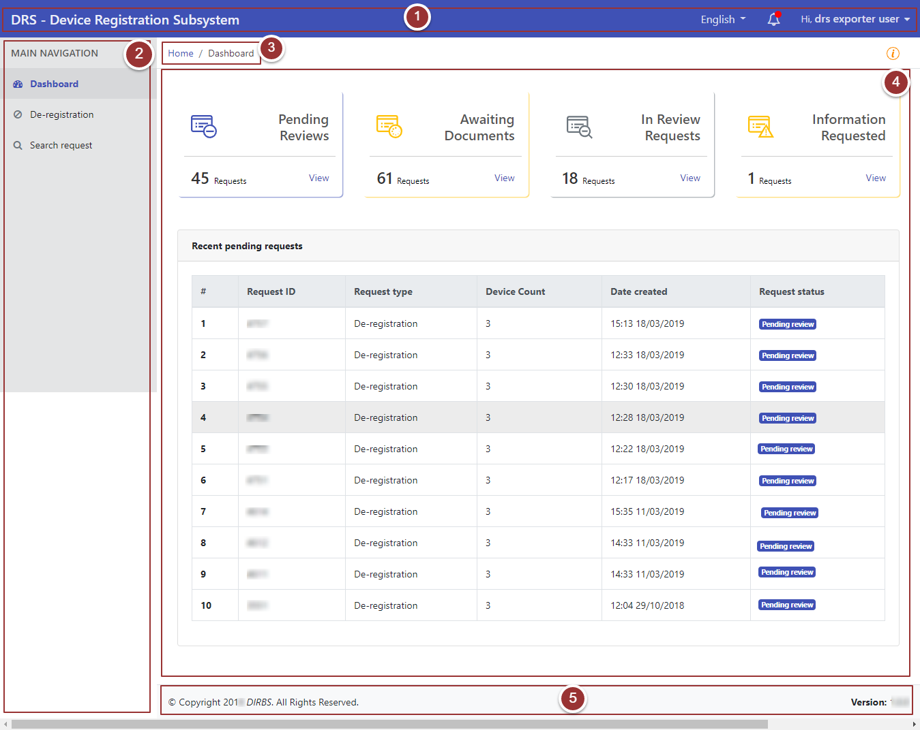

Figure 2-Portal Sections

# **Language Menu**

1. To select the required language, click on language drop-down menu.

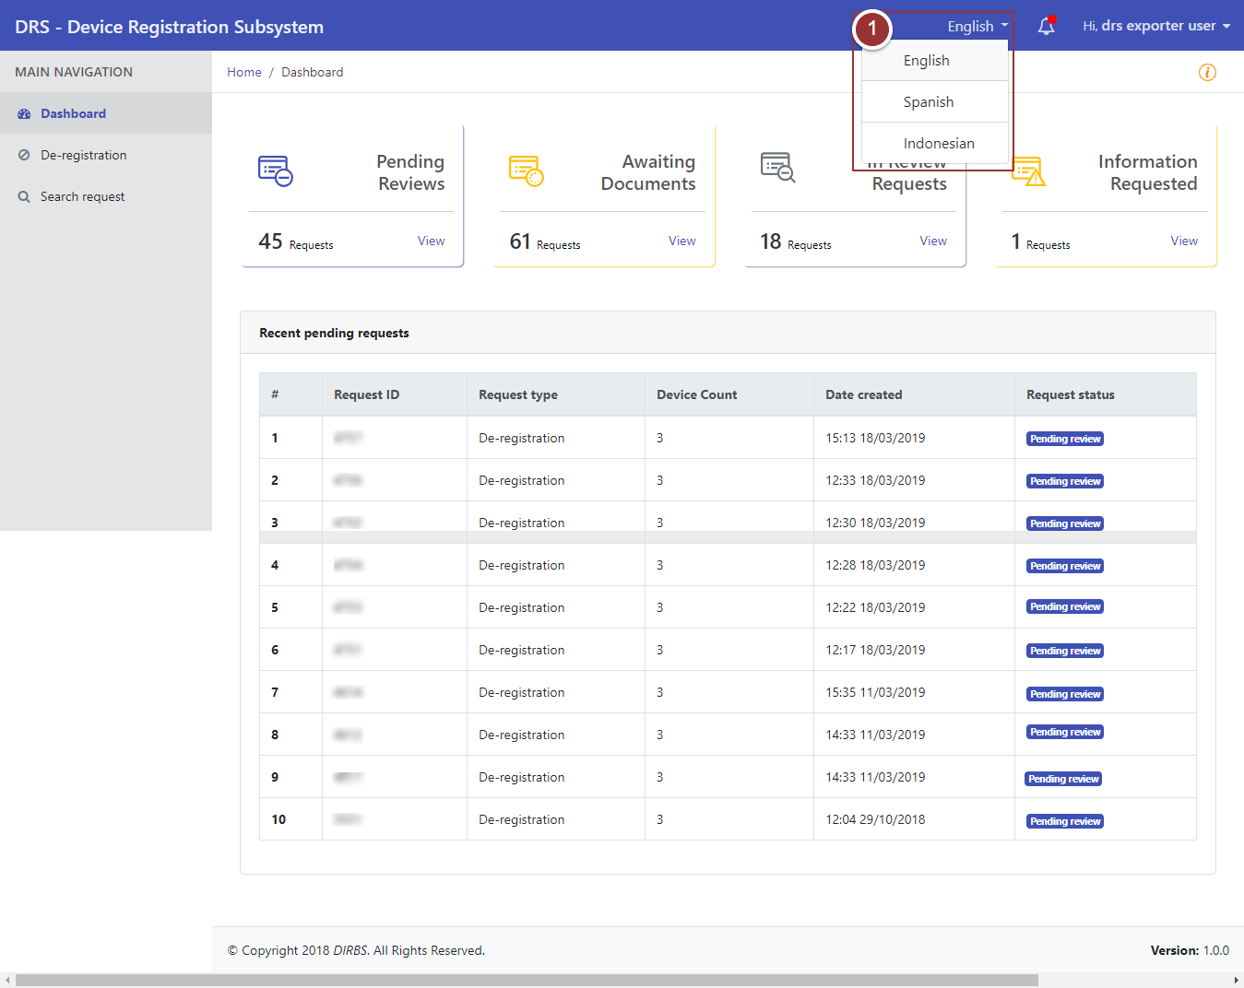

**Figure 3-Language Menu**

# **Notification Alerts**

1. To view notification(s), click on notification alert icon 

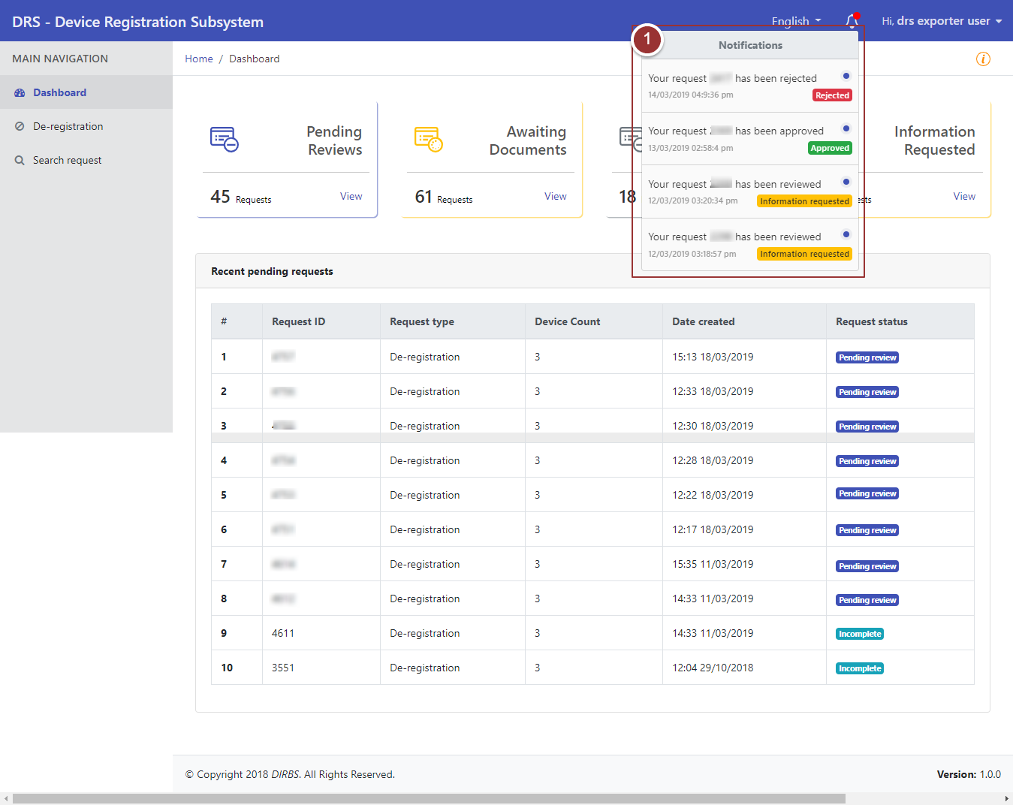

**Figure 4-Notification Alert Icon**

# **Dashboard**

By clicking on “login” button, user will be redirected to dashboard screen that displays total count of "Pending Reviews”, “Awaited Documents”, “In-Review Requests” and “Information Requested” requests. Also, it displays recent pending requests along with their details.

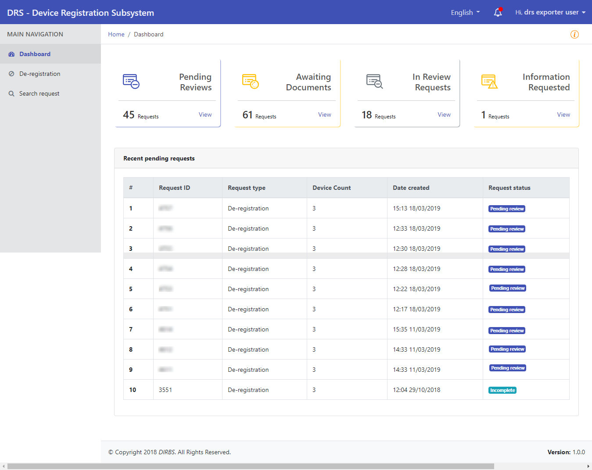

**Figure 5-Dashboard**

# **System Instructions**

1. To view instructions, click on icon

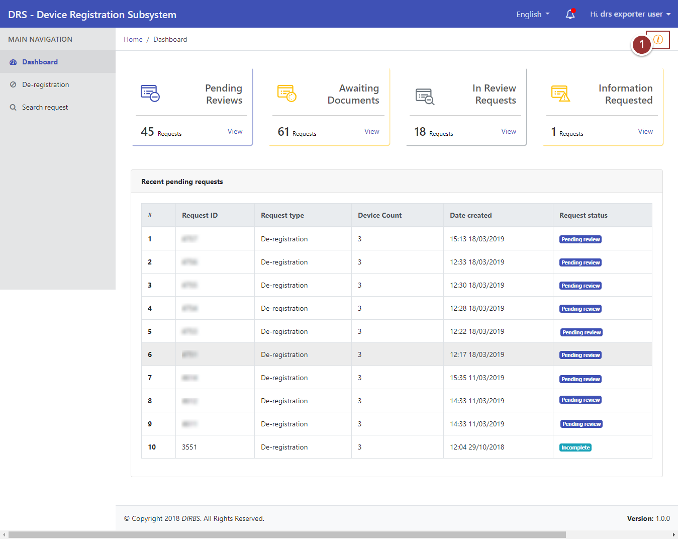

**Figure 6-System Instructions**



By clicking on instructions icon a pop up will appear that displays instructions for user.

1. Click on “Close” button to proceed further.

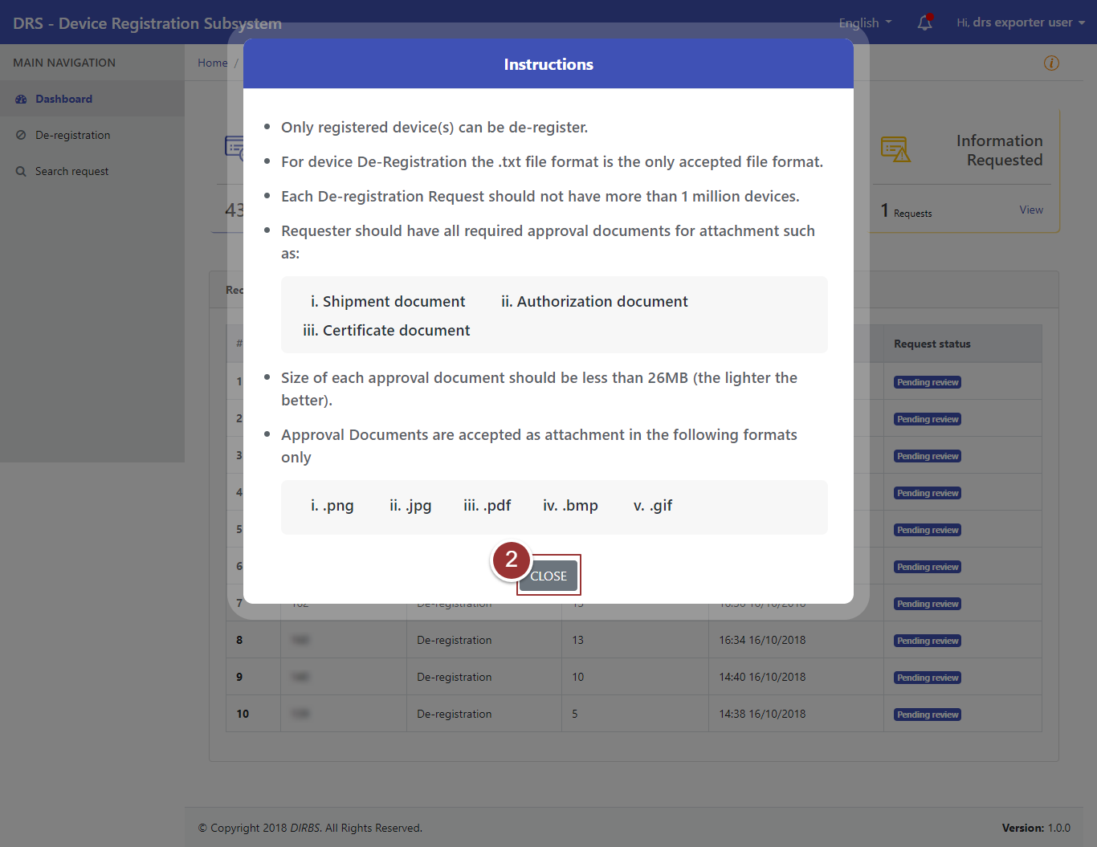

**Figure 7-System Instructions 2**

# **De-Registration**

1. To request for device deregistration, click on “De-Registration” tab under “Main Navigation” heading.
2. Enter basic deregistration details i.e. Device IMEIs (“.txt” file extension), Device Count, Reason for De-registration.
3. Click on “Next” button.

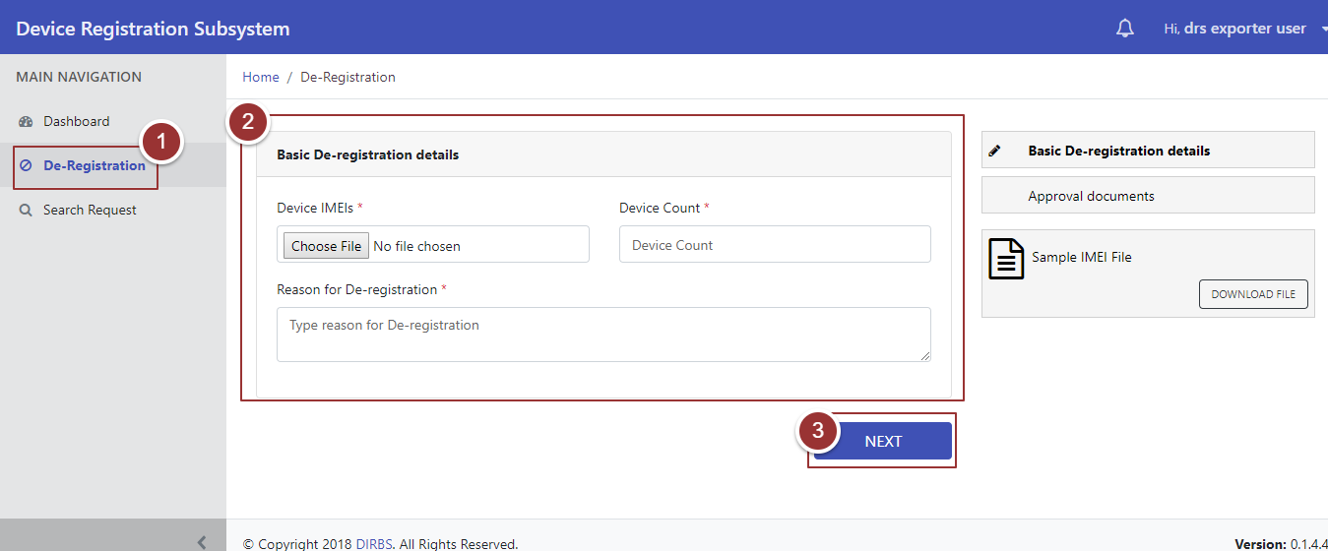

Figure 8-Deregistration

A popup will appear that contains details of device model.

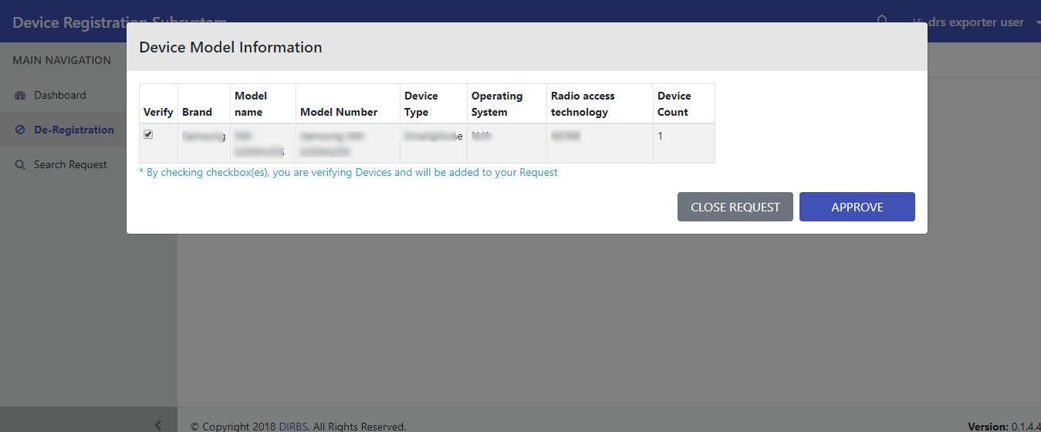

Figure 9-Device Model Information

# **Approve Request**

Perform steps 1-3 as per section 3.4

1. To approve request, verify information and check checkbox(es) against registered device.
2. Click on “Approve” button.

**Note**: Only registered IMEIs can be approved.

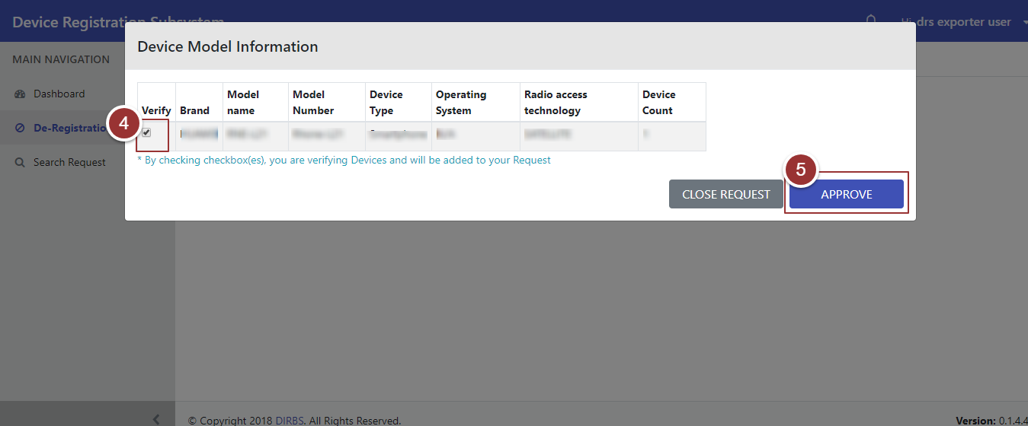

Figure 10-Approve Request

After clicking on “Approve” button it will redirect to a page where user upload approval documents i.e. Shipment Document, Authorization Document, and Certificate Document.

1. To upload file, click on “Choose File” button and select file containing required information.

**Note**: File should be inpre-defined format i.e. .png, .pdf, .jpeg, .bmp.

1. To view previous entered details i.e. Basic Deregistration Details and Device Model Information, click on “Previous Details” tab.
2. Click on “Submit” Button.

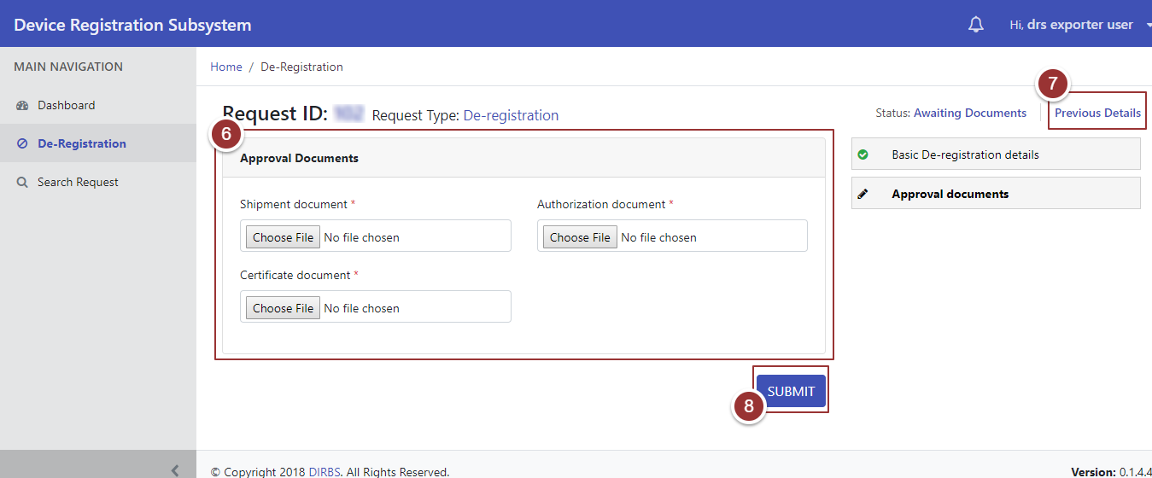

Figure 11-Approval Documents

On submission of request, a page will appear that displays details (Confirmation Message, Tracking ID, and Status).

1. To view submitted request, click on “View Your Request” button.

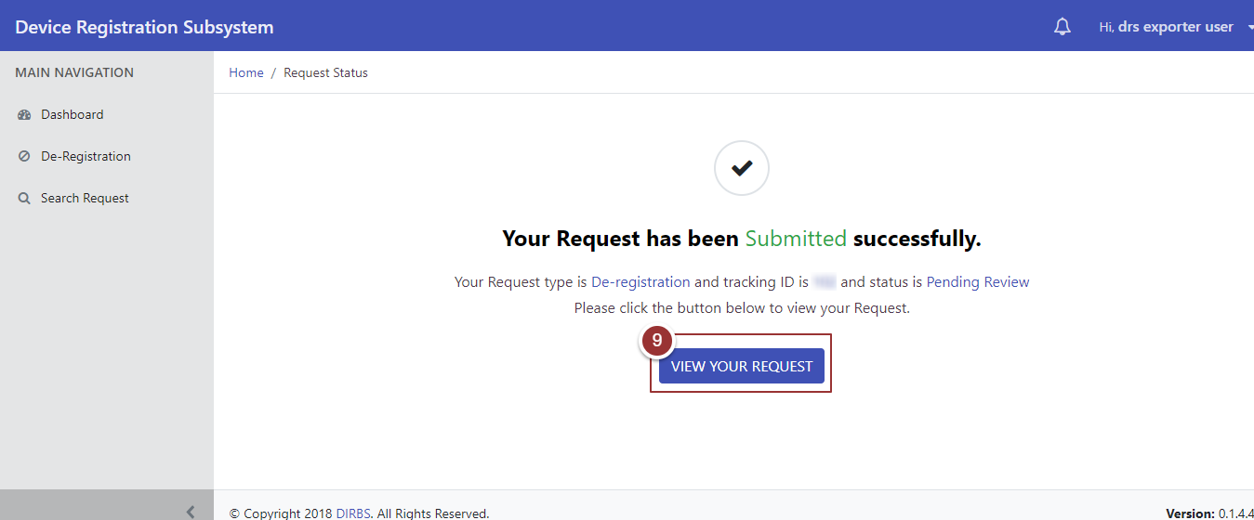

Figure 12-View Your Request

# **Close Request**

Perform steps 1-3 as per section 3.4

1. To close request, verify details and check checkbox(es) against correct device information.
2. Click on “Close Request” button.

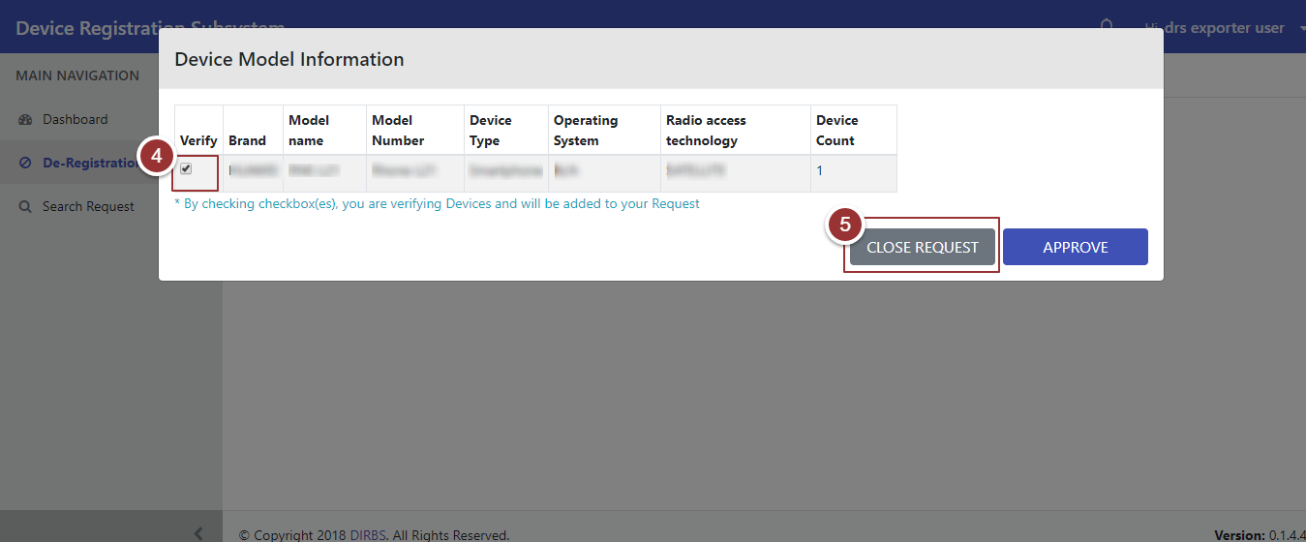

Figure 13-Close Request

On clicking “Closed Request” button, a page will appear that displays details (Confirmation Message, Tracking ID, and Status).

1. To view closed request, click on “View Your Request” button.

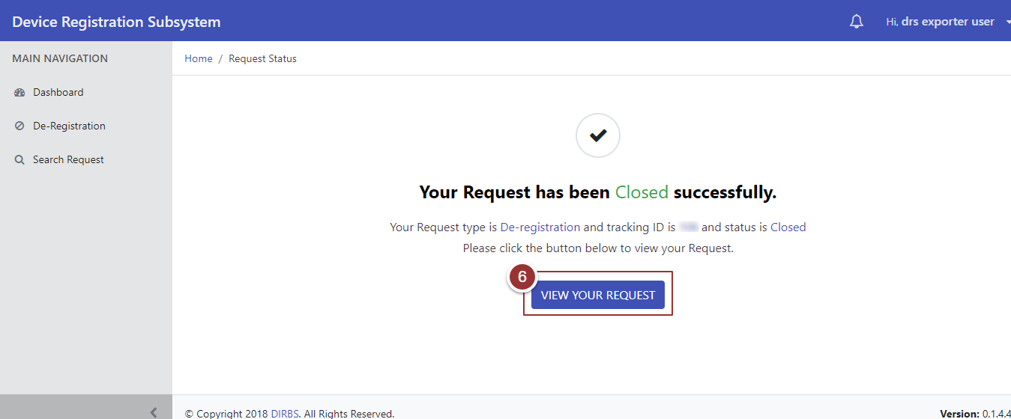

Figure 14-View Your Request

# **Search Request**

1. To search any request(s) click on “Search Request” tab.
2. To view all request(s) click on “Search Requests” button.

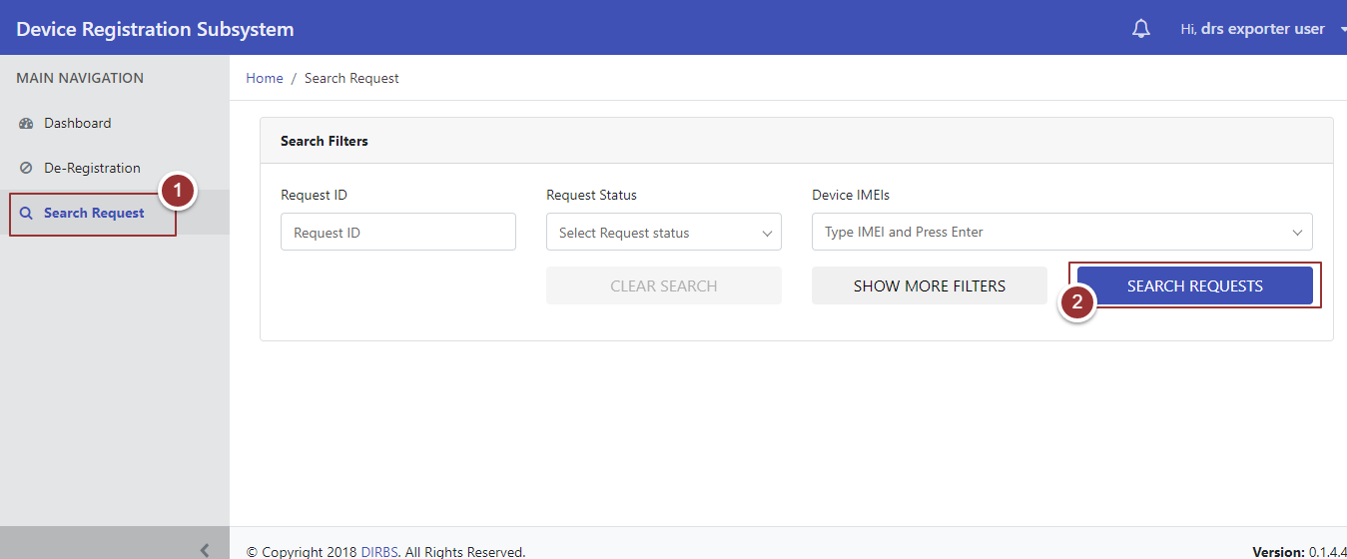

Figure 15-Search Request

On clicking “Search Requests” button, system will display all requests that contain (Request ID, Request Type, Device Count, Date Created, Date Last Updated, Request Status, and Actions). To manage number of found requests to be displayed on a page, click on drop-down menu “Show Requests” and select required number.

1. To update request, click on required action(s) (Complete, Modify, and Close).

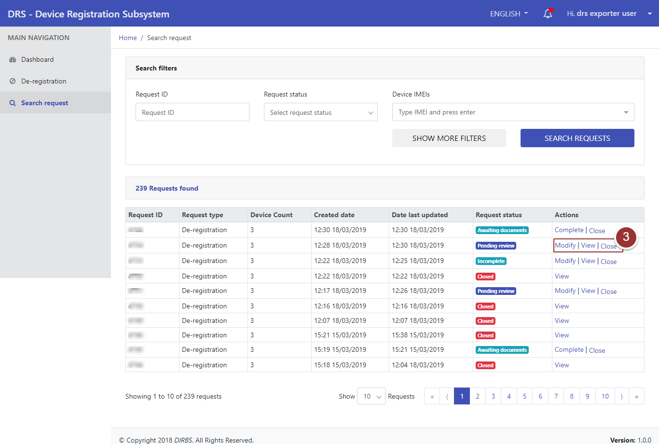

Figure 16-Action Tab(s)

1. To view request, click on “View” link.

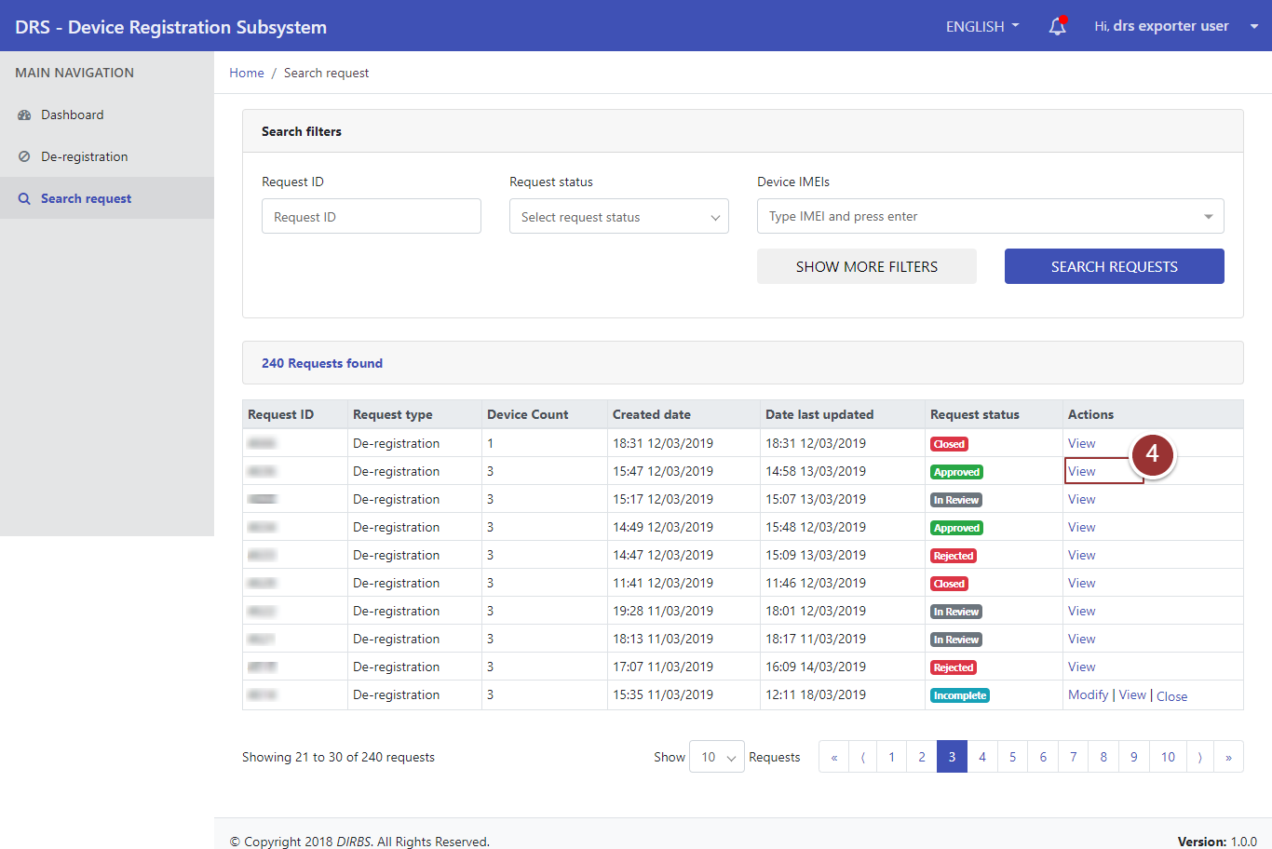

**Figure 17-View Request**

A page will appear that displays basic deregistration details of device.

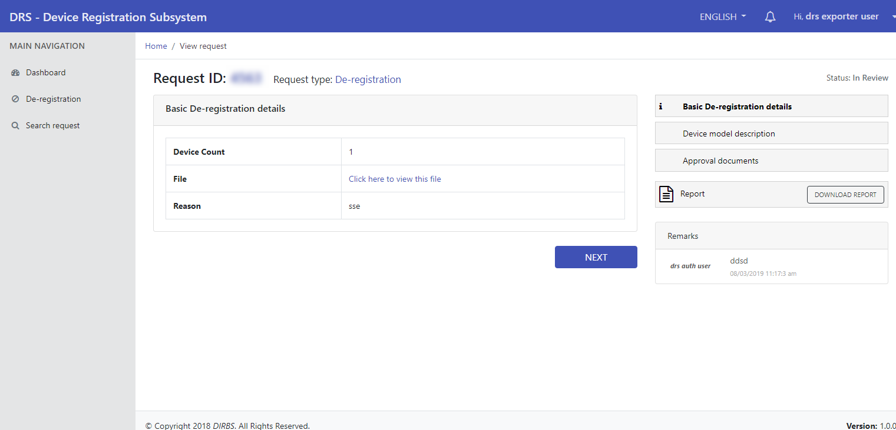

**Figure 18-View Request 2**

1. To download report shared by reviewer, click on “Download Report” button.

**Note**: Download Report button will be visible when reviewer enables “Share Report with User” option.

1. To view other sections of request, click on “Next” button.

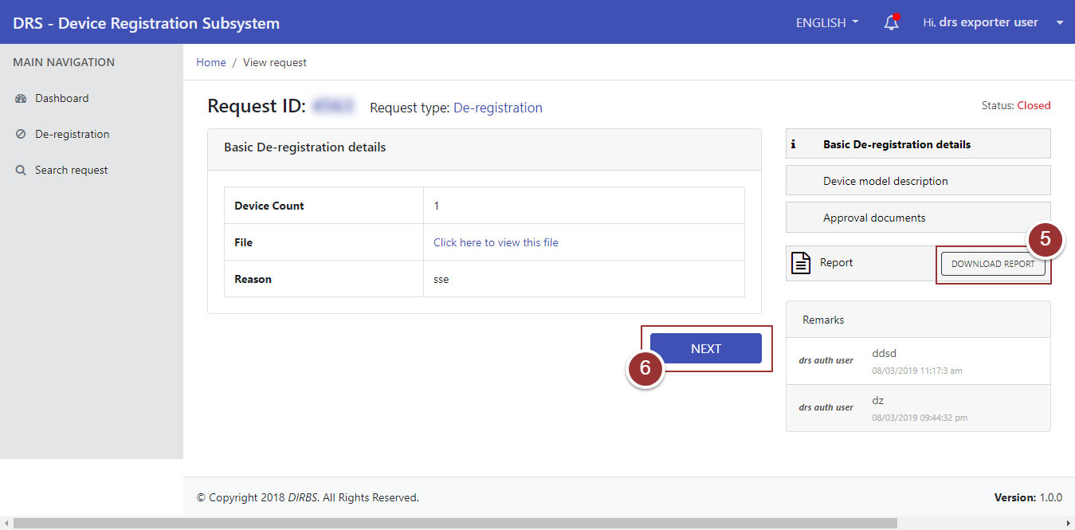

**Figure 19-Download Report Button**

# **Search Particular Request**

1. To search any particular request(s), click on “Search Request” tab.
2. Enter any known information (i.e. Request ID, Request Status, Device IMEIs etc.). For more search filters click on “Show More Filters” button and enter known information related to request.
3. Click on “Search Requests” button.

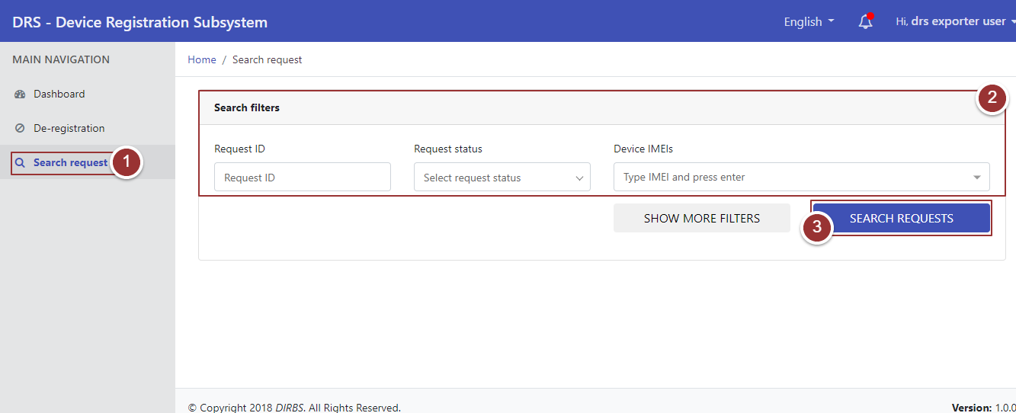

**Figure 20-Search Filter(s)**

By clicking on “Search Requests” button, it will display request(s) with applied search filters.

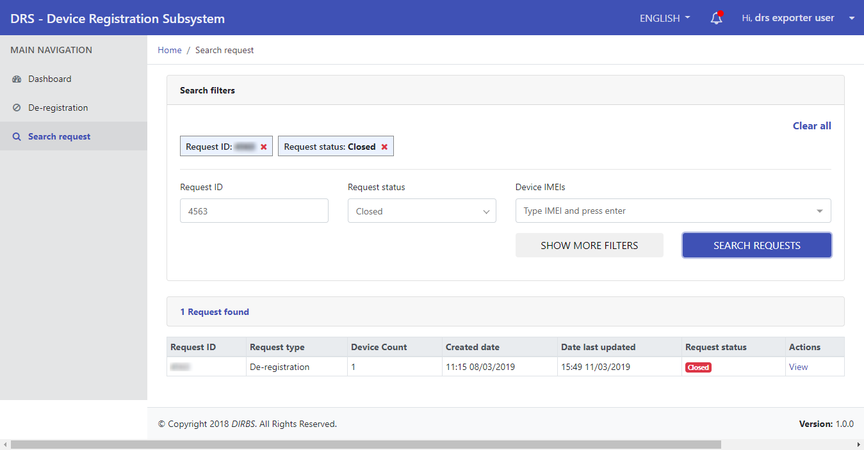

**Figure 21-Search Filters 2**