Device Registration Subsystem 2.0.0

User Guide (Importer)

DRS-User-Guide-Importer-2.0.0

March 1, 2019

|  |
| --- |
|  |

Revision history

|  |  |  |
| --- | --- | --- |
| Revision | Date | Description |
| A |  | Second Release |

# **Contents**

1. Introduction 5

1.1. Purpose 5

1.2. Supported Desktop Browsers 5

1.3. Supported Mobile Browsers 6

1.4. Definitions, Acronyms, and Abbreviations 6

2. System Description 7

3. System Navigation 10

3.1. Login Screen 10

3.2. Portal Sections 11

3.2.1.Language Menu 12

3.2.2.Notification Alerts 13

3.3. Dashboard 14

3.3.1.System Instructions 15

3.4. Device Registration 17

3.5. Search Request 26

3.5.1.Search Particular Request 31

**Figures**

Figure 1-Login Screen 10

Figure 2-Portal Sections 11

Figure 3-Language Menu 12

Figure 4-Notification Alert Icon 13

Figure 5-Dashboard Screen 14

Figure 6-System Instructions 15

Figure 7-System Instruction 2 16

Figure 8-Device Registration 17

Figure 9-Add Device 18

Figure 10-Add Device 2 19

Figure 11-Delete Device 20

Figure 12-Delete Device 2 21

Figure 13-Type IMEI 22

Figure 14-Device Model Description 23

Figure 15-Approval Documents 24

Figure 16-Request Status 25

Figure 17-Search Request(s) 26

Figure 18-Action Tab(s) 27

Figure 19-View Request 28

Figure 20-View Request 2 29

Figure 21-Download Report Button 30

Figure 22-Search Filters 31

Figure 23-Search Filters 2 32

**Tables**

Table 1-Supported Desktop Browsers 5

Table 2-Supported Mobile Browsers 6

Table 3-Definition, Acronyms, and Abbreviations 6

Table 4-System Description 7

# **Introduction**

Device Registration Subsystem (DRS) is the subsystem of Device Identification, Registration & Blocking System (DIRBS). It provides a platform for individual(s) and importer(s) to request for device registration.

Individuals are people who are not licensed to import devices into the country, but are allowed to import a small number of devices via personal import exceptions.

Importers are people who are licensed to import devices into the country e.g. they could be manufacturers, retailer’s etc.

The Device Identification, Registration & Blocking System (DIRBS) is a country-wide system deployed in cooperation between the country regulator, operators in that country, and a technology partner that supports deployment. The system checks, identifies, and discourages non-compliant devices by verifying the installed base of devices currently active in a market and continuing to monitor as new devices are activated.

DIRBS can verify that:

* Devices have properly allocated identifiers and type approval
* Devices are not duplicated or stolen
* Device importation takes place through legal channels

## **Purpose**

This document is intended to give assistance to the user to use the Device Registration Subsystem (DRS).

## **Supported Desktop Browsers**

Table 1-Supported Desktop Browsers

|  |  |
| --- | --- |
| **Name** | **Version** |
| Internet Explorer | 11.0 |
| Firefox 52.5 ESR | 57.0 |
| Chrome | 63.0 |
| Safari | 11.0 |
| Edge | 41.16299 |

## **Supported Mobile Browsers**

Table 2-Supported Mobile Browsers

|  |  |
| --- | --- |
| **Name** | **Version** |
| Chrome | 63.0 |
| UC Browser | 11.5 |
| Opera (Android) | 44.1 |
| Opera(iOS) | 16.0.7 |
| Safari | 11.1 |
| Samsung Internet | 6.2 |
| Android | 4.1.x - 4.3 |

## 

## **Definitions, Acronyms, and Abbreviations**

Table 3-Definition, Acronyms, and Abbreviations

|  |  |
| --- | --- |
| ****Term**** | ****Definition**** |
| **DIRBS** | **Device Identification Registration and Blocking System** |
| IAM | Identity Access Management System |
| DRS | Device Registration Subsystem |
| MSISDN | Mobile Subscriber Integrated Services Directory Number |
| IMEI | International Mobile Equipment Identity |
| IMSI | International mobile subscriber identity |
| TAC | Type Allocation Code |

# **System Description**

Table 4-System Description

|  |  |
| --- | --- |
| Feature/Sections | ****Explanation**** |
| Login Screen | * To access the system, authorized user first needs to enter his/her credentials on login page, this login page authenticate user from the IAM and redirects user to DRS |
| Portal Sections | The portal is divided into the following sections.   * **Header**   **Header section displays name of the system and it contains following features.**   * **Language Selection Drop-Down**   **Allows user to change the language of system in English, Spanish and Indonesian.**     * **User Profile Drop-down**   **Displays the user name with logout functionality.**   * **Notification Alert Icon**   **Generates the notification whenever user(reviewer) Updates/modifies status of the request (i.e. Approved, Information Requested, Rejected).**   * **Navigation Panel**   Navigation Panel contains main navigation menu through which user can navigate the whole system.   * **Main Content Area**   Main Content Area contains all the content to be displayed and actions to be performed for respective feature.   * **Breadcrumbs**   Breadcrumbs allows user to keep track of their location within the system.   * **Footer**   Footer contains the software version and copyrights statement. |
| Dashboard | * The dashboard displays the total count of Pending Reviews, Awaited Documents, In-Review Requests and Information Requested requests. Also, it displays the recent pending requests along with their details |
| Device Registration | Facilitate user to register their device(s) by completing following three steps  Basic Registration Details  Device Model Description  Approval Documents |
| Required Input(s) for Basic Registration | **Device Count**  Takes the total number of devices as input.  **Number of IMEIs per Device**  Takes total number of IMEIs that entered for per device as input.  **Device IMEIs**  **Tab-delimited File**  User can add up to 10,000,000 devices with 5 IMEIs per device.  **Webpage input**  User can add up to 10 devices with 5 IMEI per device.  **Manufacturing Details**  Allows user to select the manufacture location of the device (i.e. local or overseas). |
| Required Inputs for Device Model description | **Brand**  Takes brand name of the device as input. Enter the brand name of device to be registered.  **Model Name**  Takes the model name of device as input. Enter model name of device to be registered.  **Model Number**  Takes the Model name of the device as input. Enter model name of the device to be registered.    **Device Type**  Allows user to select type of the device (i.e. smart phone, tablet, dongle, router, Feature phone etc.) from drop-down menu.  **Operating System**  Takes the operating system (i.e. android, IOS) of device as input. Enter the operating system of device to be registered.  **Radio Access Technology**  Allows user to select the radio-based technologies i.e. 2G, 3G, 4G that your device supports. |
| Approval Documents | Three types of approval documents are required for registration of the device  Shipment Document  Authorization Document  Certificate Document |
| Search Requests | * Allows user to search a particular request by applying different filters i.e. request ID, request status, device IMEI, create date, last updated, brand, model name, model number, device type, operating system, technologies, device count, number of IMEIs per device, manufacturing location |
| Request Status | * **New Request**   Add/Verify details of the device model.   * **Awaiting Documents**   Approval documents are required to be uploaded.   * **Pending Review**   Request is not yet assigned to any authorized entity.   * **In Review**   Request has assigned to authorized entity.   * **Information Requested**   Request has some missing information.   * **Approved**   Request has been approved by authorized entity.   * **Rejected**   Request has been rejected by authorized entity due to invalid information.     * **Closed**   Request has been closed by the user(importer). |

# **System Navigation**

# **Login Screen**

1. **Enter your credentials i.e. Username and Password.**
2. **Click on the “Log in” button.**

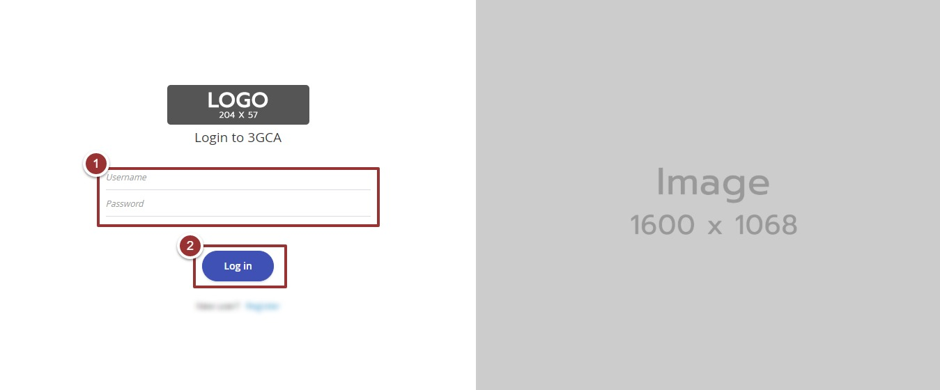

Figure 1-Login Screen

# **Portal Sections**

The portal screen is divided into following sections.

1. **Header** section displays name of the system, a dropdown menu for language selection, notification alert icon and name of logged in user with logout functionality.
2. **Main Navigation Panel** helps user to navigate the system.
3. **Breadcrumbs** is a navigational aid in UI.
4. **Main Content Area** contains all relevant information related to the respective feature/option.
5. **Footer** contains version and copyrights of the system.

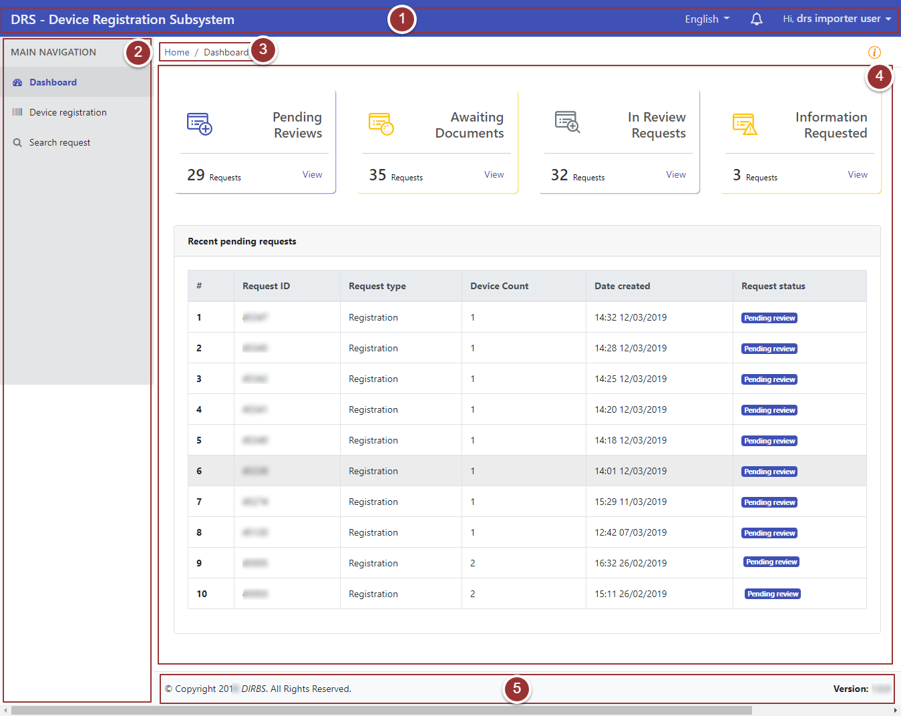

Figure 2-Portal Sections

# **Language Menu**

1. To select the required language, click on language drop-down menu.

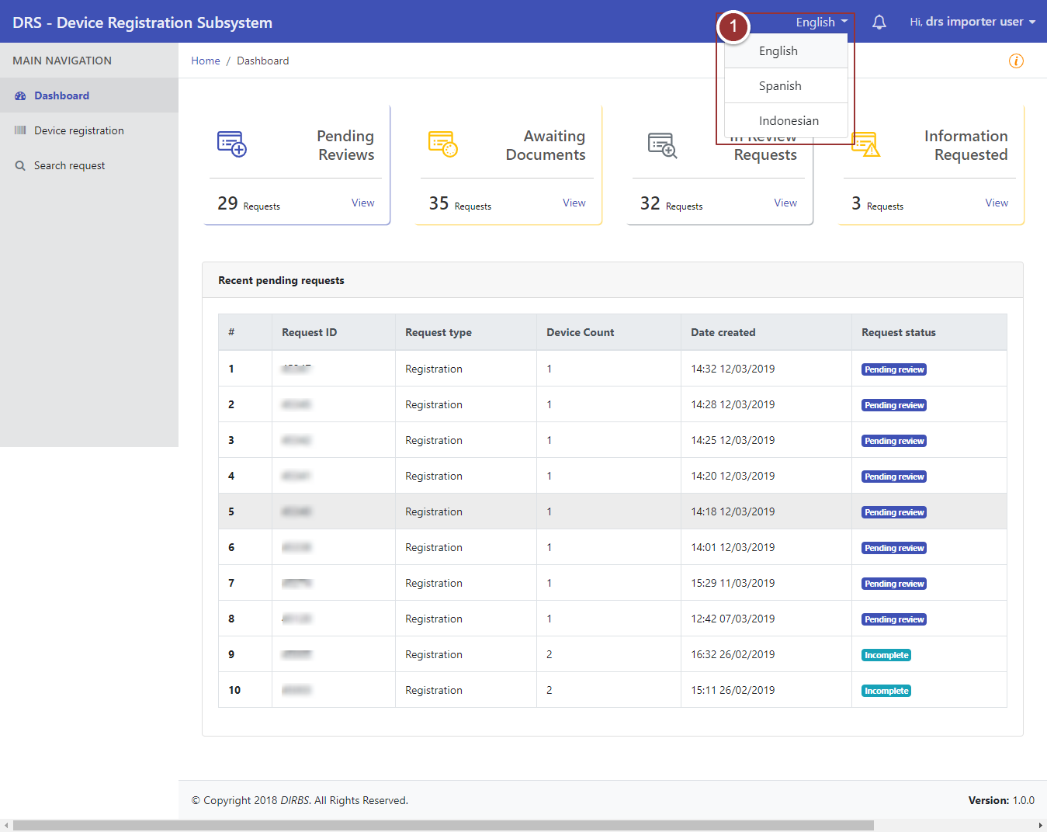

**Figure 3-Language Menu**

# **Notification Alerts**

1. To view notification(s), click on the notification alert icon 

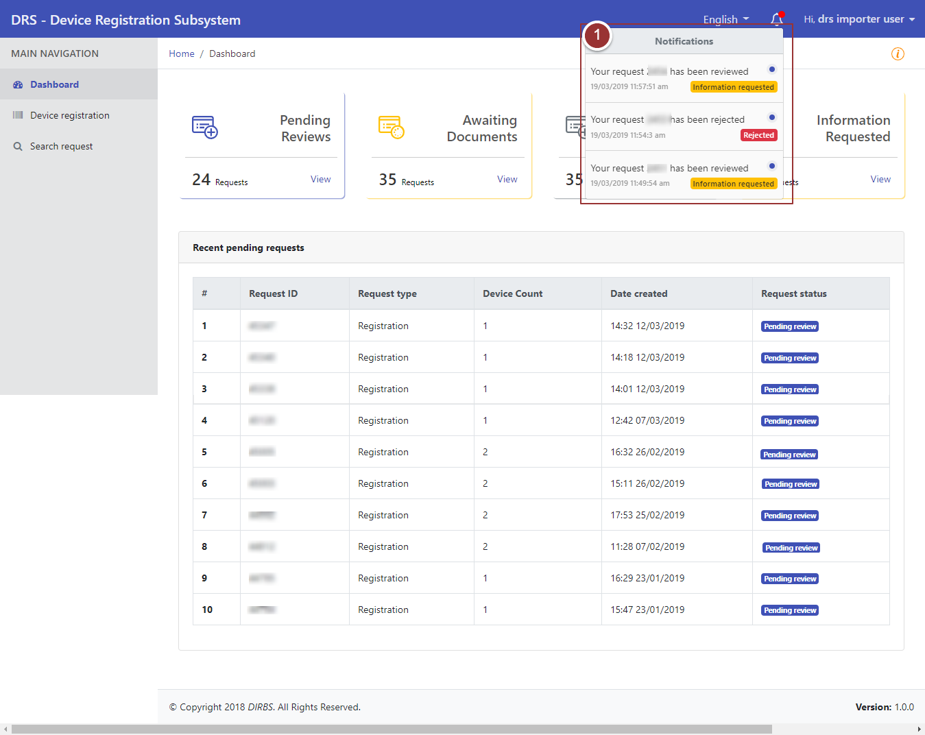

**Figure 4-Notification Alert Icon**

# **Dashboard**

By clicking on “login” button, user will be redirected to dashboard screen that displays the total count of “Pending Reviews”, “Awaited Documents”, “In-Review Requests” and “Information Requested” requests. Also, it displays recent pending requests along with their details.

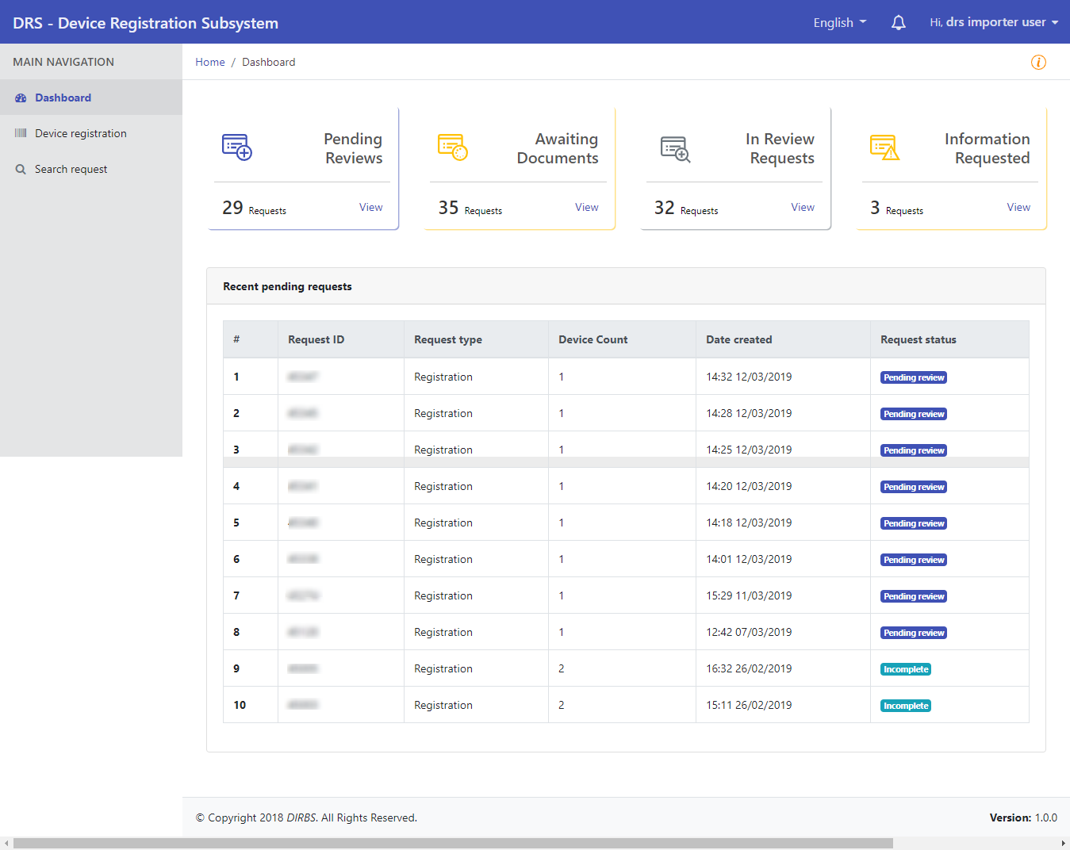

**Figure 5-Dashboard Screen**

By clicking on any recent pending request, user will be redirected to that particular request.

# **System Instructions**

1. To view instructions of the system, click on icon

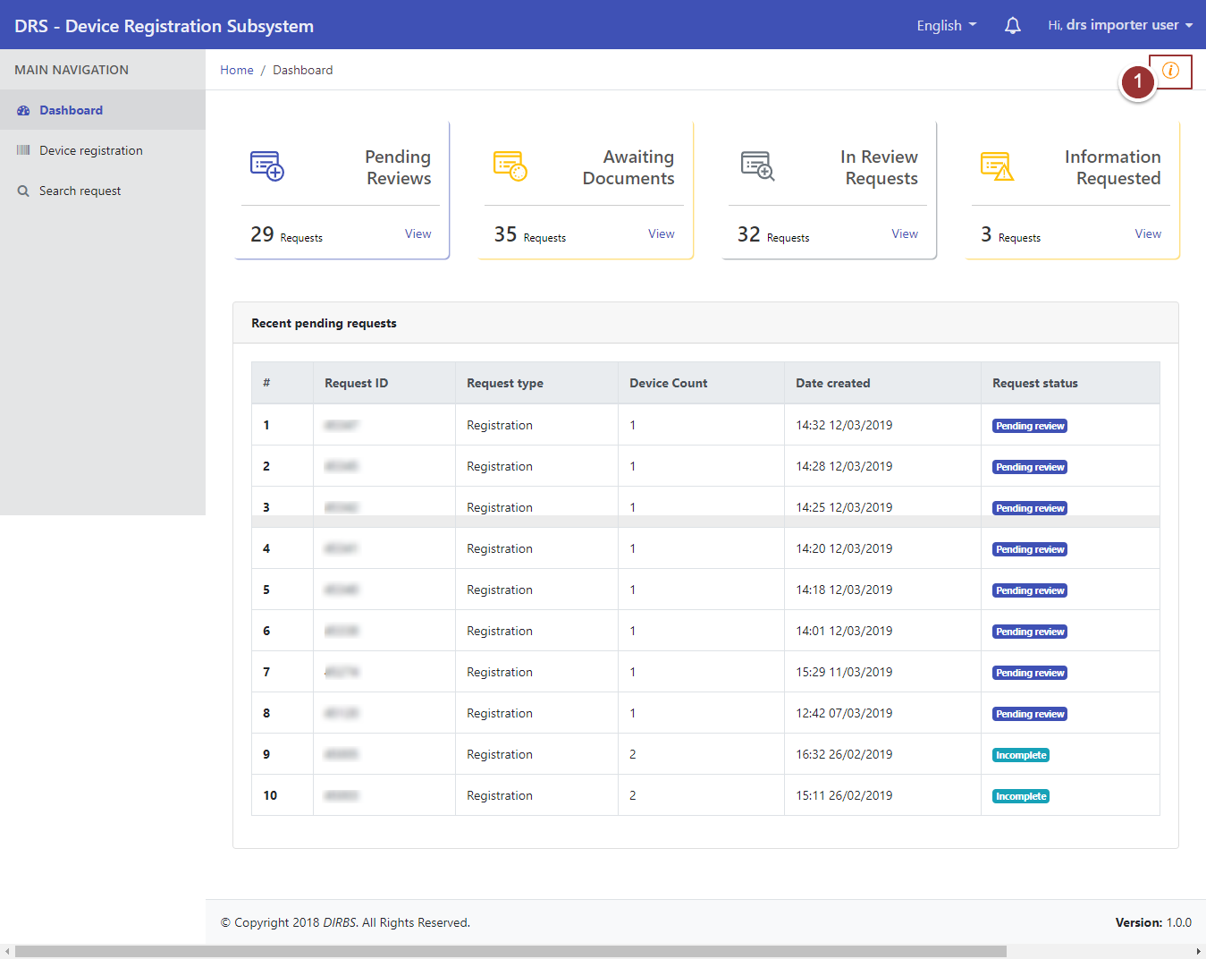

**Figure 6-System Instructions**



By clicking on instructions icon a pop up will appear that displays instructions for user.

1. Click on “Close” button to proceed further.

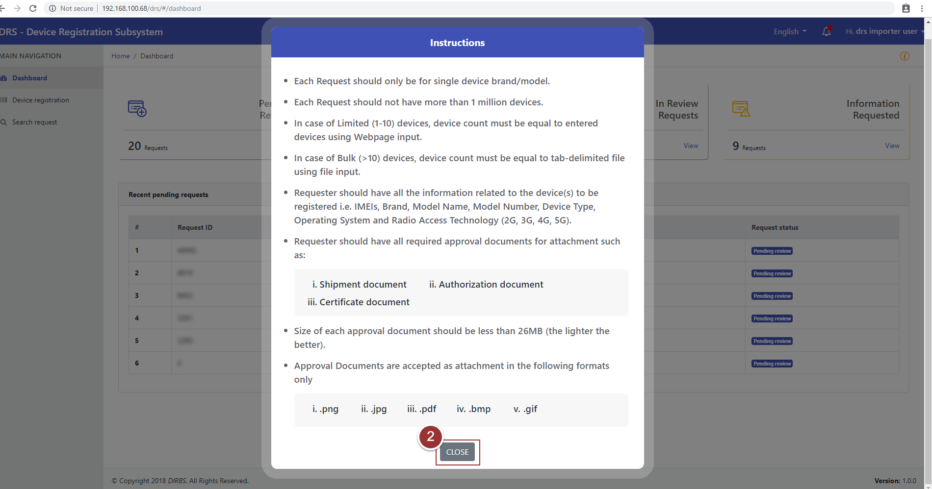

**Figure 7-System Instruction 2**

# **Device Registration**

1. To request for device registration, click on “Device Registration” tab under “Main Navigation” heading.
2. Enter basic registration details (i.e. Device Count, Number of IMEIs per Device, Device IMEIs and Manufacturing location).

**Note**: All field(s) are mandatory.

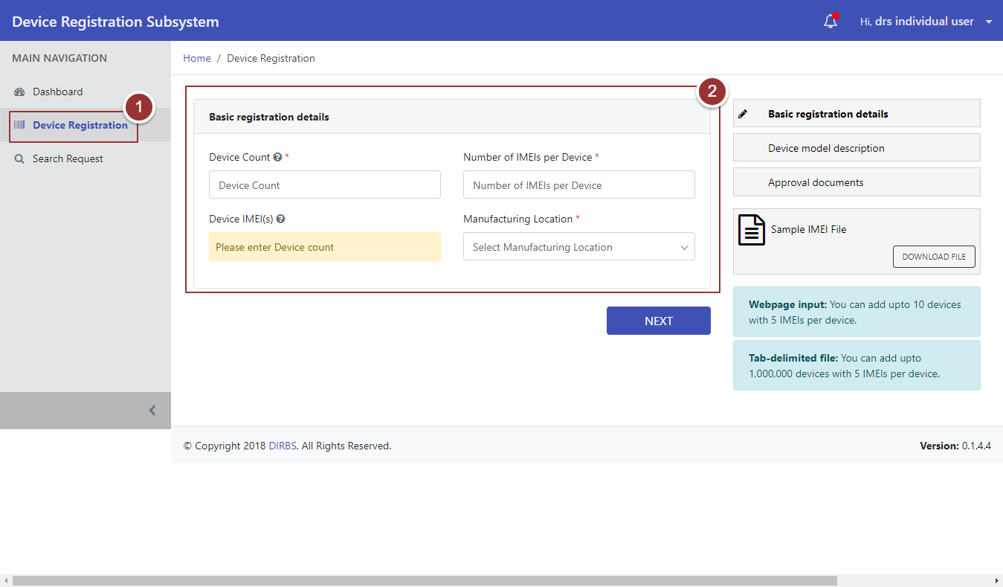

**Figure 8-Device Registration**

1. To add IMEI of the device, click on “Add Device” button.

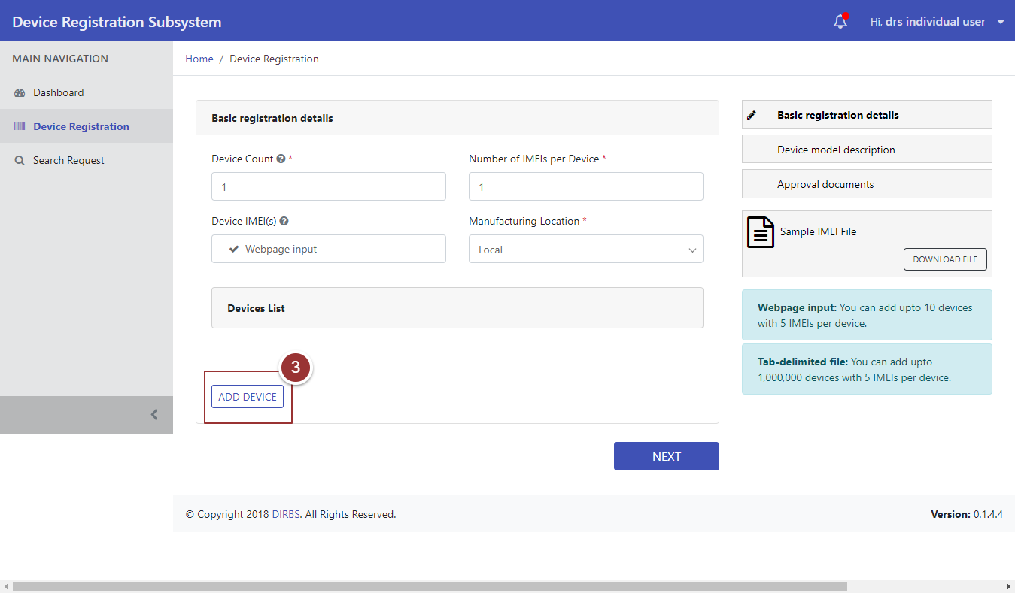

**Figure 9-Add Device**

1. Now, type and re-type IMEI in respective fields.

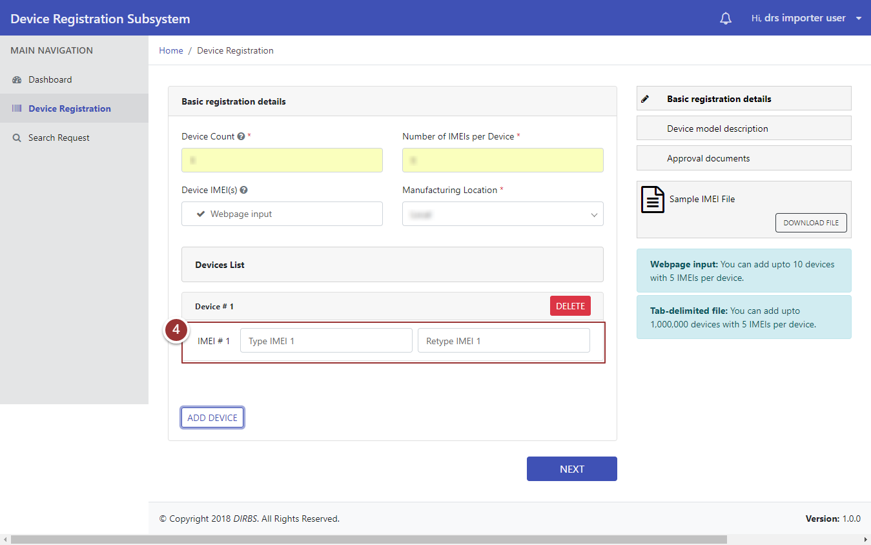

**Figure 10-Add Device 2**

1. To delete entered IMEI, click on “Delete” button.

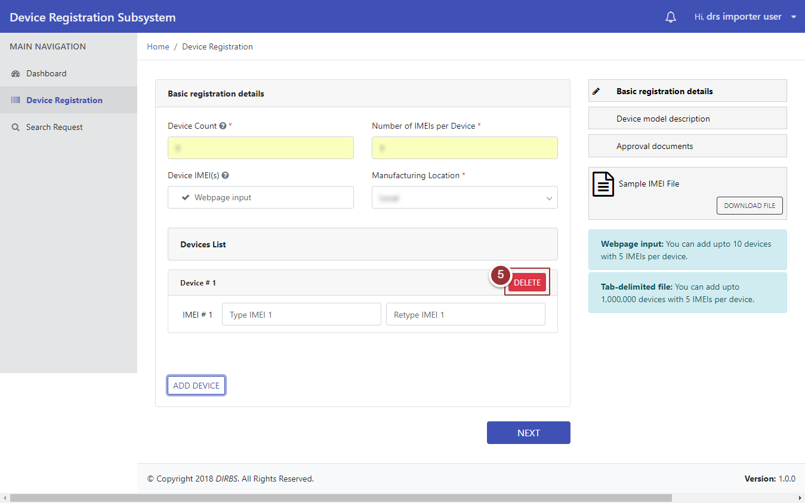

**Figure 11-Delete Device**

1. A popup will appear, click on “OK” button for confirmation.

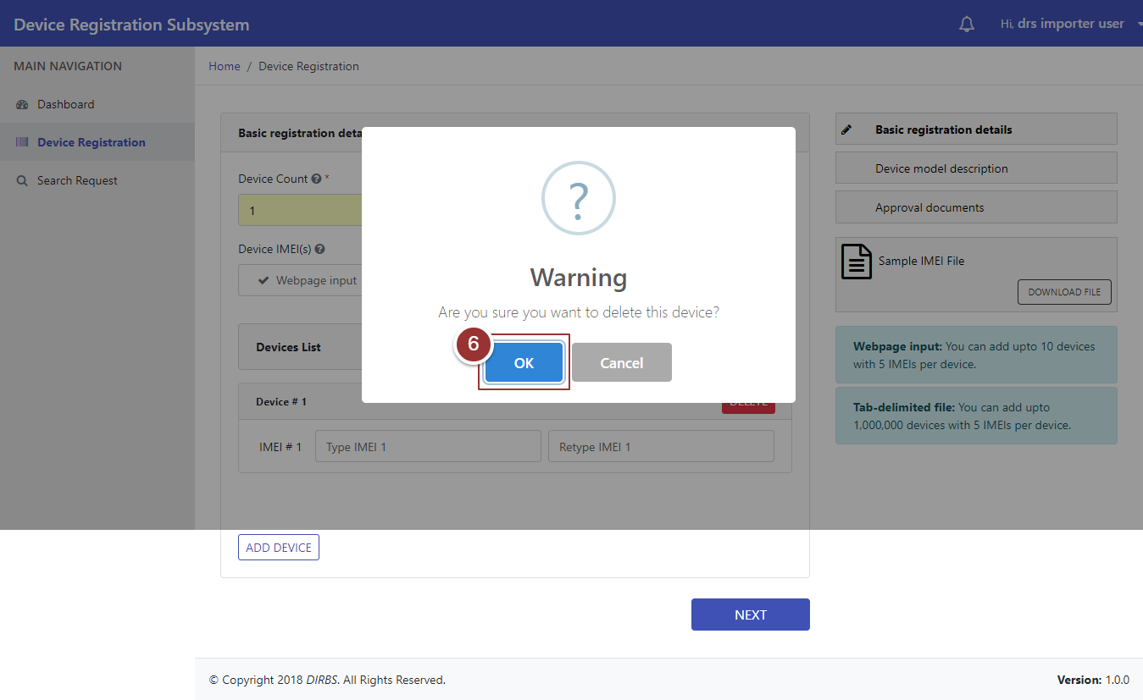

**Figure 12-Delete Device 2**

1. Repeat the steps 3 and 4 to enter IMEI again, then click on “Next” button.

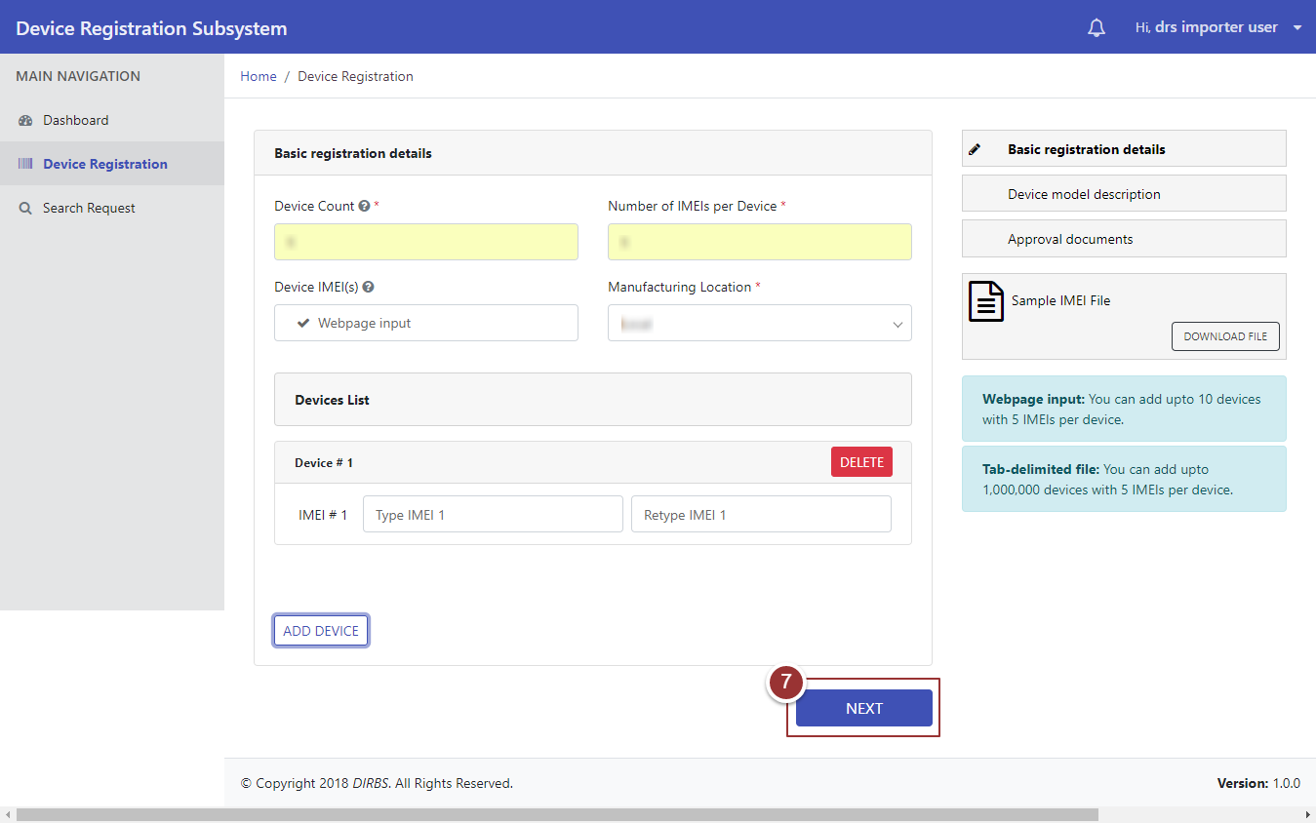

**Figure 13-Type IMEI**

After clicking on “Next” button, user will be redirected to “Device Model Description” section.

1. Enter details of device model (i.e. Brand Name, Model Name, Model Number, Device Type, Operating System, and Radio Access Technology) in respective field(s).
2. To view previous entered details (i.e. Basic Registration Details), click on “Previous Details” tab.
3. Click on “Next” button.

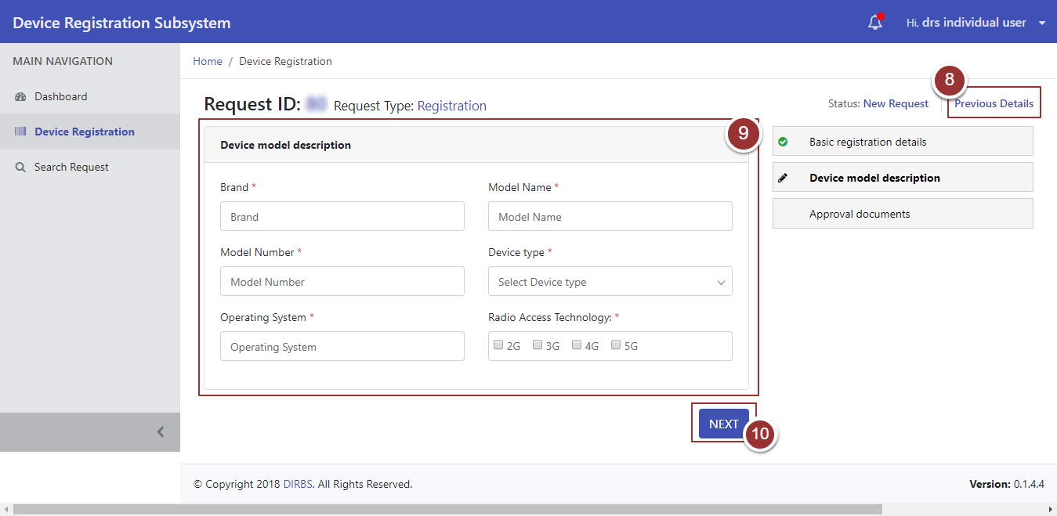

**Figure 14-Device Model Description**

After clicking on “Next” button it will redirect to a page where user upload approval documents i.e. Shipment Document, Authorization Document, and Certificate Document.

1. To upload file, click on “Choose File” button and select file containing required information.

**Note**: File should be inpre-defined format i.e. .pdf .jpeg .png .bmp.

1. To view previous entered details i.e. Basic Registration Details and Device Model Description, click on “Previous Details” tab.
2. Click on “Submit” Button.

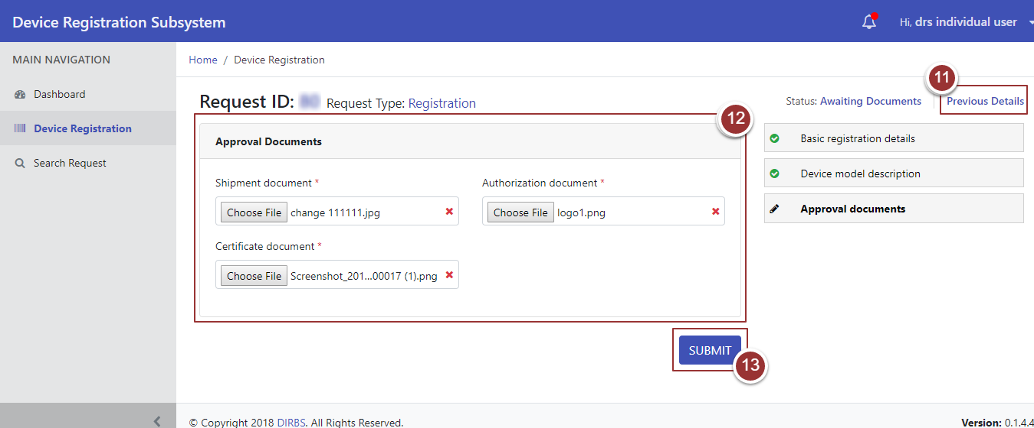

**Figure 15-Approval Documents**

On submission of request, a page will appear that display the details (Confirmation Message, Tracking ID, Status of the Request).

1. To view request, click on “View Your Request” button.

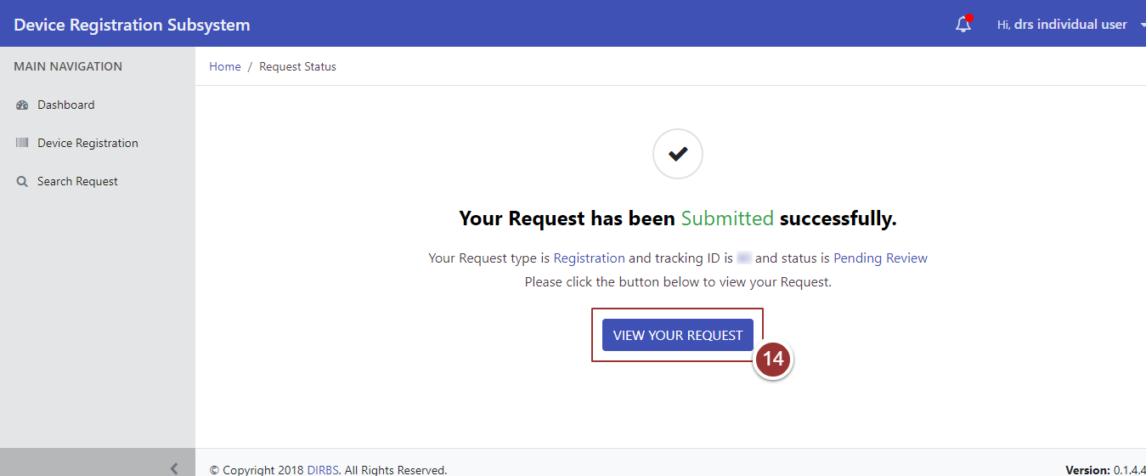

**Figure 16-Request Status**

# **Search Request**

1. To search any request, click on “Search Request” tab.
2. To view all requests, click on “Search Requests” button.

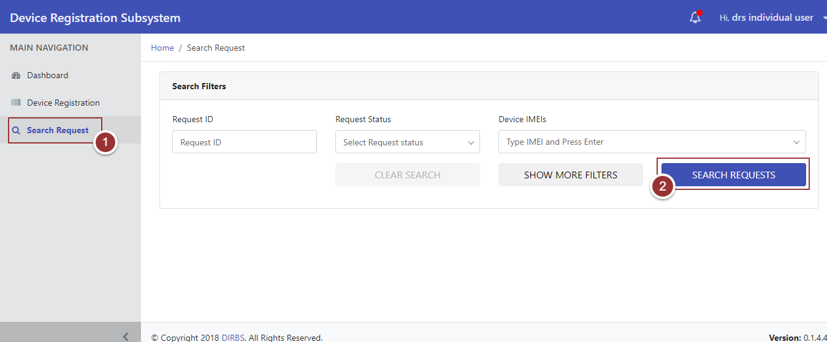

**Figure 17-Search Request(s)**

On clicking “Search Requests” button, system will display all requests that contain (Request ID, Request Type, Device Count, Date Created, Date Last Updated, Request Status, and Actions). To manage number of found requests to be displayed on a page, click on drop-down menu “Show Requests” and select required number.

1. To update request, click on required action (Complete, Modify, and Close).

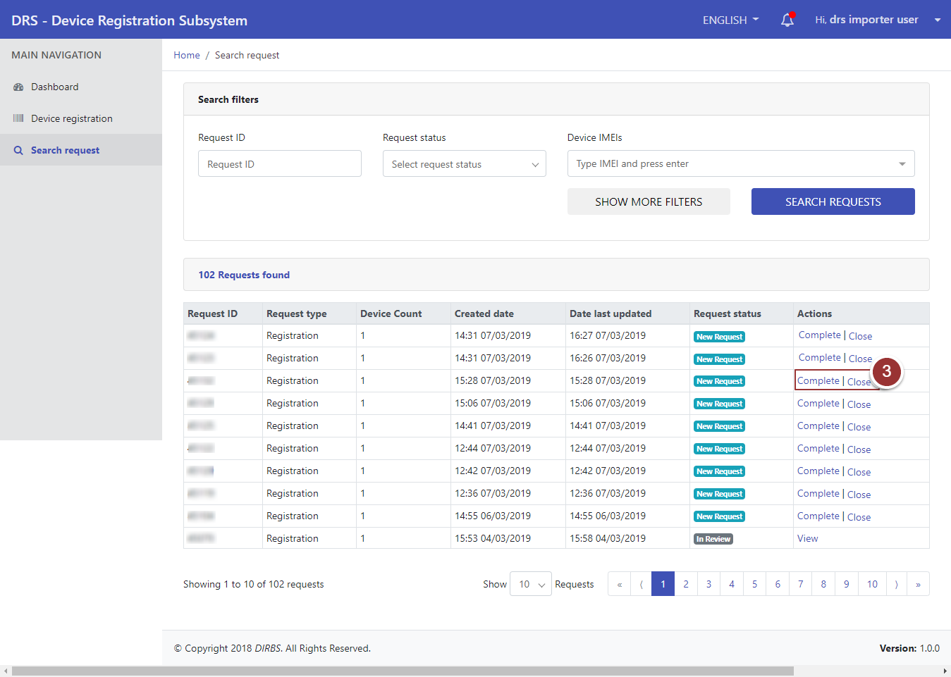

**Figure 18-Action Tab(s)**

1. To view request, click on “View” link.

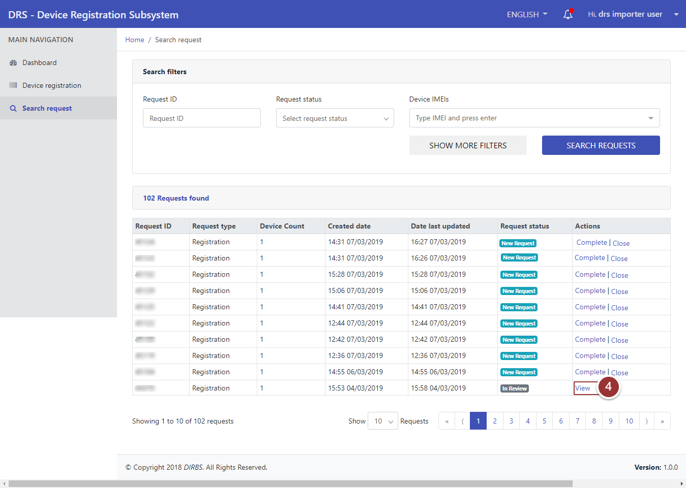

**Figure 19-View Request**

A page will appear that displays basic registration details of device.

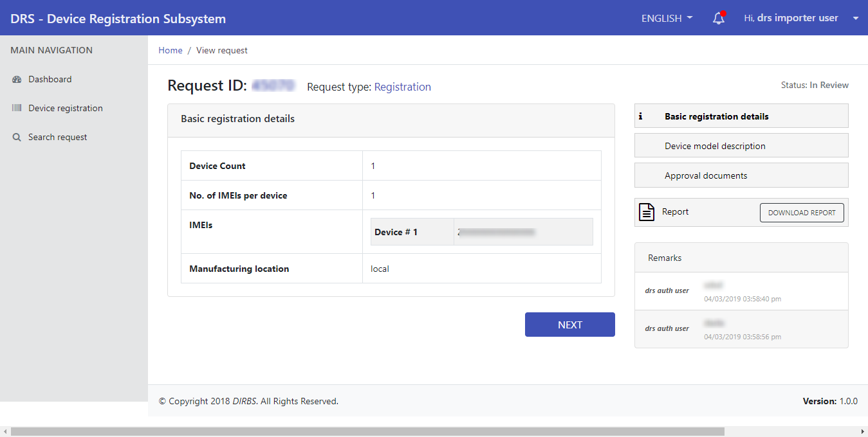

**Figure 20-View Request 2**

1. To download report shared by reviewer, click on “Download Report” button.

**Note**: Download Report button will be visible when reviewer enables “Share Report with User” option.

1. To view other sections of request, click on “Next” button.

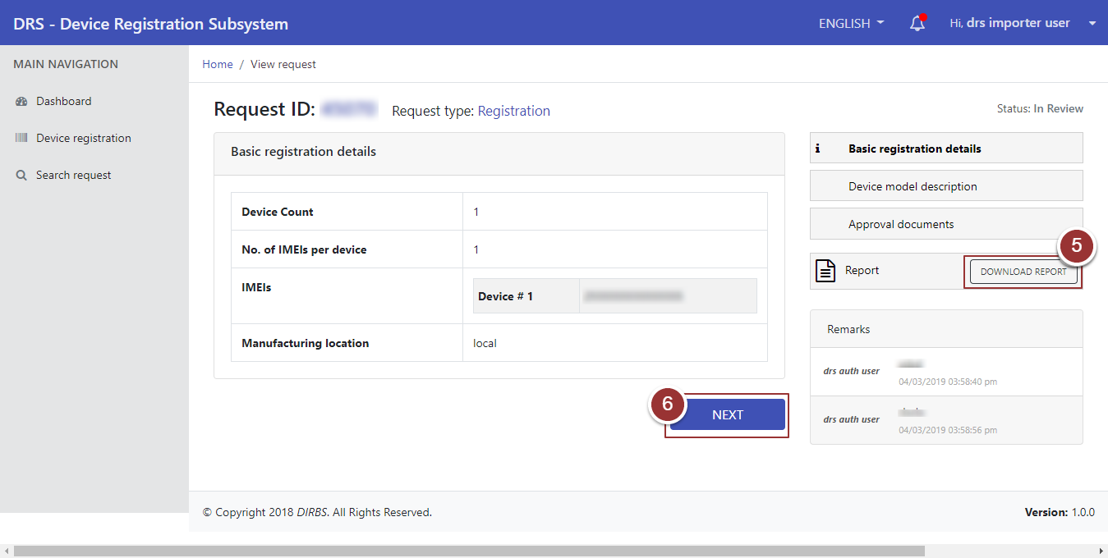

**Figure 21-Download Report Button**

.

# **Search Particular Request**

1. To search any particular request(s), click on “Search Request” tab.
2. Enter any known information about request (i.e. Request ID, Request Status, Device IMEIs etc.). For more search filters click on “Show More Filters” button and enter known information related to the request.
3. Click on “Search Requests” button.

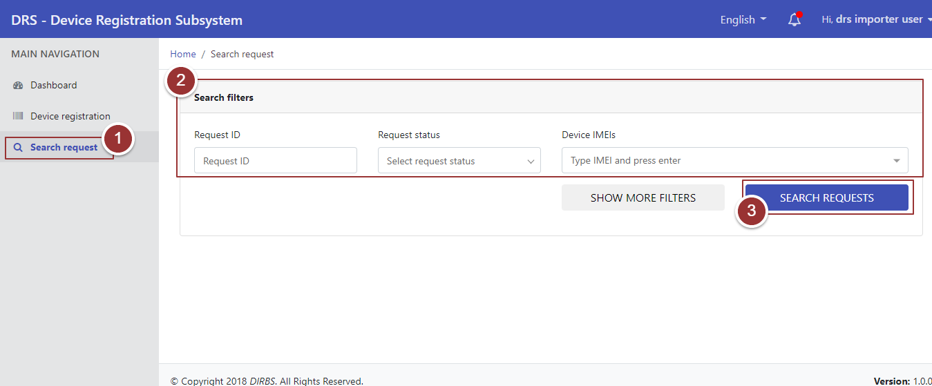

**Figure 22-Search Filters**

By clicking on “Search Requests” button, it will display request with applied search filters.

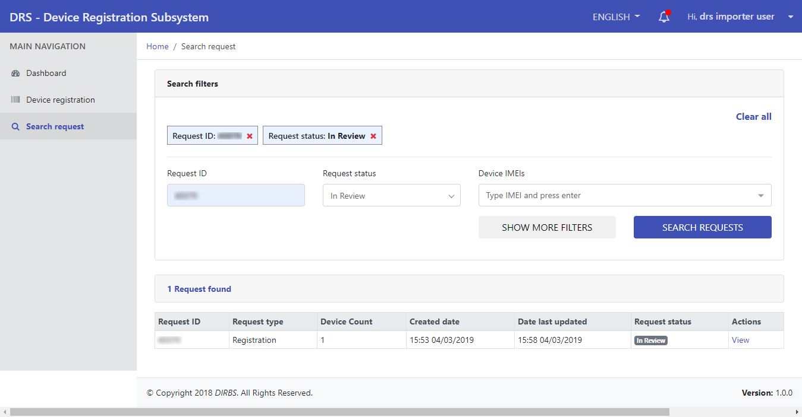

**Figure 23-Search Filters 2**