Device Registration Subsystem 3.0.0

User Guide (Authority)

DRS-User-Guide-Authority-3.0.0

November 23, 2020

Revision history

|  |  |  |
| --- | --- | --- |
| Revision | Date | Description |
| A |  | Initial Release |
| B | November 2020 | Release 3.0.0 |

# Contents

1. Introduction 5

1.1. Purpose 5

1.2. Supported Desktop Browsers 5

1.3. Supported Mobile Browsers 6

1.4. Definitions, Acronyms, and Abbreviations 6

2. System Description 7

3. System Navigation 13

3.1. Login Screen 13

3.2. Portal Sections 14

3.3. Dashboard 17

3.4. Search Request 20

3.5. Search Particular Request 29

**Figures**

Figure 1 - Login Screen 13

Figure 2 - Portal Sections 14

Figure 3 - Language Menu 15

Figure 4 - Notification Alert Icon 16

Figure 5 - Dashboard 17

Figure 6 - System Instructions (i) 18

Figure 7 - System Instructions (ii) 19

Figure 8 - Search Requests 20

Figure 9 - View Requests 21

Figure 10 - View Request Sections 22

Figure 11 - Assign Request 23

Figure 12 - Review Status (i) 24

Figure 13 - Review Status (ii) 25

Figure 14 - Review Status (iii) 26

Figure 15 - Review Status (iv) 27

Figure 16 - Review Status (v) 28

Figure 17 - Search Filters (i) 29

Figure 18 - Search Filters (ii) 30

**Tables**

Table 1 - Supported Desktop Browsers 5

Table 2 - Supported Mobile Browsers 6

Table 3 - Definition, Acronyms, and Abbreviations 6

Table 4 - System Description 7

# **Introduction**

Device Registration Subsystem (DRS) is the subsystem of Device Identification, Registration & Blocking System (DIRBS). It provides a platform for authorized user(s) to review and approve device registration and deregistration requests.

The Device Identification, Registration & Blocking System (DIRBS) is a country-wide system deployed in cooperation between the country regulator, operators in that country, and a technology partner that supports deployment. The system checks, identifies, and discourages non-compliant devices by verifying the installed base of devices currently active in a market and continuing to monitor as new devices are activated.

DIRBS can verify that:

* Devices have properly allocated identifiers and type approval
* Devices are not duplicated or stolen
* Device importation takes place through legal channels

## **Purpose**

This document is intended to give assistance to the user to use the Device Registration Subsystem (DRS).

## **Supported Desktop Browsers**

Table 1 - Supported Desktop Browsers

|  |  |
| --- | --- |
| **Name** | **Version** |
| Internet Explorer | 11.719 |
| Firefox | 82.0.2 |
| Chrome | 86.0 |
| Safari | 13.1.2 |
| Edge | 87.0 |

## **Supported Mobile Browsers**

Table 2 - Supported Mobile Browsers

|  |  |
| --- | --- |
| **Name** | **Version** |
| Chrome | 86.0.4 |
| UC Browser | 13.3.2 |
| Opera (Android) | 60.3 |
| Opera Touch (iOS) | 2.5.1 |
| Safari | 13.1.2 |
| Samsung Internet | 13.0.1 |
| Android | 10 |

## 

## **Definitions, Acronyms, and Abbreviations**

Table 3 - Definition, Acronyms, and Abbreviations

|  |  |
| --- | --- |
| **Term** | **Definition** |
| **DIRBS** | **Device Identification Registration and Blocking System** |
| IAM | Identity Access Management System |
| DRS | Device Registration Subsystem |
| MSISDN | Mobile Subscriber Integrated Services Directory Number |
| IMEI | International Mobile Equipment Identity |
| IMSI | International mobile subscriber identity |
| TAC | Type Allocation Code |

# 

# **System Description**

Table 4 - System Description

|  |  |
| --- | --- |
| Feature/Sections | ****Explanation**** |
| Login Screen | * To access the system, authorized user first needs to enter his/her credentials on login page This login page authenticate user from the IAM and redirects user to DRS |
| Portal Sections | **The portal is divided in to following sections.**   * **Header**   **Header section displays the name of the system and it contains following features.**   * **Language selection Drop-Down**   **Allows user to change the language of system in English, Spanish and Indonesian.**   * **User profile Drop-down**   **Displays the user name with logout functionality.**   * **Notification Alert Icon**   **System notifies reviewer whenever importer/exporter updates/modifies request while being in information requested state.**   * **Navigation Panel**   Navigation Panel contains main navigation menu through which user can navigate the whole system.   * **Main Content Area**   Main Content Area contains all the content to be displayed and actions to be performed for respective feature.   * **Breadcrumbs**   Breadcrumbs allow user to keep track of their location within the system.   * **Footer**   Footer contains the software version and copyrights statement. |
| Dashboard | * **The dashboard displays the total count of the pending requests and in-review requests. It also displays recent pending requests along with their details** |

|  |  |
| --- | --- |
| **Feature/Sections** | ****Explanation**** |
| Search Requests | * Allows user to search a particular request by applying different filters i.e. request ID, request status, device IMEI, create date, last updated, brand, model name, model number, device type, operating system, technologies, device count, number of IMEIs per device, manufacturing location |
| Request Sections | * Request contains the following sections to review such that * Device Quota * Device Description * IMEI Classification Result * IMEI Registration Status * Approval Documents |
| Device Quota | * **Allowed Device Quota**   Displays the total count of devices that a user can register.   * **Used Device Quota**   Displays the total number of devices registered by user.   * **Request Device Count**   Displays the number of devices user is requesting for.   * **Remaining Device Quota**   Displays the total number of remaining devices. |
| Device Description | Displays both user and GSMA device descriptions.  **Brand**  Displays the brand name of device.  **Model Name**  Displays the model name of device.  **Model Number**  Displays the model number of a device.  **Manufacturer**  Displays name of the company/country where the device is manufactured.  **Device Type**  Displays the device type i.e. smartphone, tablet etc.  **Operating System**  Displays the operating system of device i.e. Android or iOS.  **Radio access technology**  Displays the radio access technologies of that device i.e. 2G, 3G, 4G, 5G etc. |
| IMEI Classification Results | * Displays the below classified results based on particular request of a user * IMEI Compliance Status * Pre-Condition Classification State * Lost/Stolen Status * Seen on Network * Download Report Link * Show Report to the User |
| IMEI Compliance State | * **Non-compliant**   Displays the total count of IMEIs that are not registered with regulatory authority.   * **Compliant**   Displays the total count of IMEIs that are registered with regulatory authority.   * **Provisional non-compliant**   Displays total count of the IMEIs that have been reported as lost/stolen but not blocked yet.   * **Provisional compliant**   Displays total count of the IMEIs that are requested for registration but are not approved yet. |
| Pre-Condition Classification State | * **Duplicate**   Displays the total count of duplicate IMEIs.   * **GSMA Not Found**   Displays the total count of IMEIs that are not registered in GSMA database.   * **Local Stolen**   Displays the total count of IMEIs that are reported as lost/stolen.   * **Malformed**   Displays the total count of IMEIs that contains the character other than hexadecimal number.   * **Not on registration list**   Displays total count of the IMEIs that are not being requested for registration. |
| Lost/Stolen Status | * **Stolen status**   Displays the total count of IMEIs that are reported as stolen.   * **Provisional stolen**   Displays total count of the IMEIs that are reported as lost/stolen but not blocked yet. |
| Seen on Network | * Displays the total count of IMEIs seen on network. |
| Download Report Link | * Allows user to download the report to view non-compliant IMEIs. |
| Show Report to the user | * Allows user to share the report with requester(importer/exporter). |
| IMEI Registration Status | Displays the registration status based on total requests of a user.   * **Duplicate IMEIs**   Displays the total count of duplicate IMEIs.   * **Pending Registration**   Displays the total count of IMEIs that have been requested for registration but no action is performed yet by the authorized entity.   * **Registered**   Displays the total count of IMEIs that are registered.   * **Not Registered**   Displays the total count of IMEIs that have been rejected by the authorized entity. |
| Approval Documents | * Allows user to download and verify the approval documents such that   Shipment Document  Authorization Document  Certificate Document |
| Request Status | Displays the status of the request. The previous and new statuses with required actions are mention in the below table.   |  |  |  | | --- | --- | --- | | **Previous**  **request**  **status** | **Action** | **New**  **request**  **status** | | Pending  Review | Authorized entity assigns  request | In Review | | In Review | Authorized entity approves all  sections | Approved | | In Review | Authorized entity marks a  section as incomplete/missing | Information  Requested | | In Review | Authorized entity marks a  section as rejected | Rejected | | In Review | Authorized entity un-assigns  request | Pending  Review | | In process | System generates the reports | Pending review | | In complete | Authorized entity can view the request | Incomplete | | Failed | Authorized entity re-initiates the request | In process | |

# **System Navigation**

## **Login Screen**

1. **Enter your credentials i.e. Username and Password.**
2. **Click on the “Log in” button.**

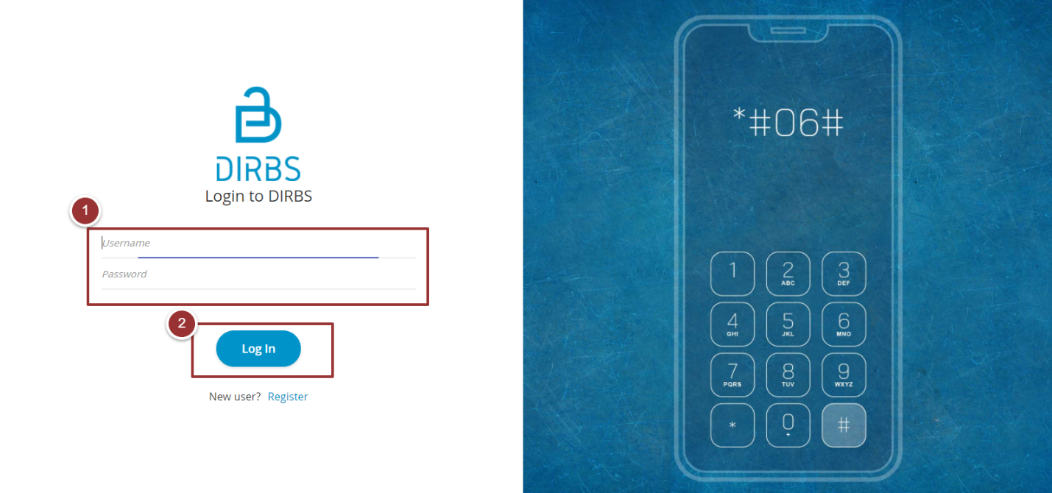

Figure 1 - Login Screen

## 

## **Portal Sections**

The portal screen is divided into following sections.

1. **Header** section displays the name of the system, a drop-down menu for language selection, notification alert icon and name of the logged in user with logout functionality.
2. **Main Navigation Panel** helps user to navigate the system.
3. **Breadcrumbs** is a navigational aid in UI.
4. **Main Content Area** contains all relevant information related to the respective feature/option.
5. **Footer** contains the version and copyrights statement.

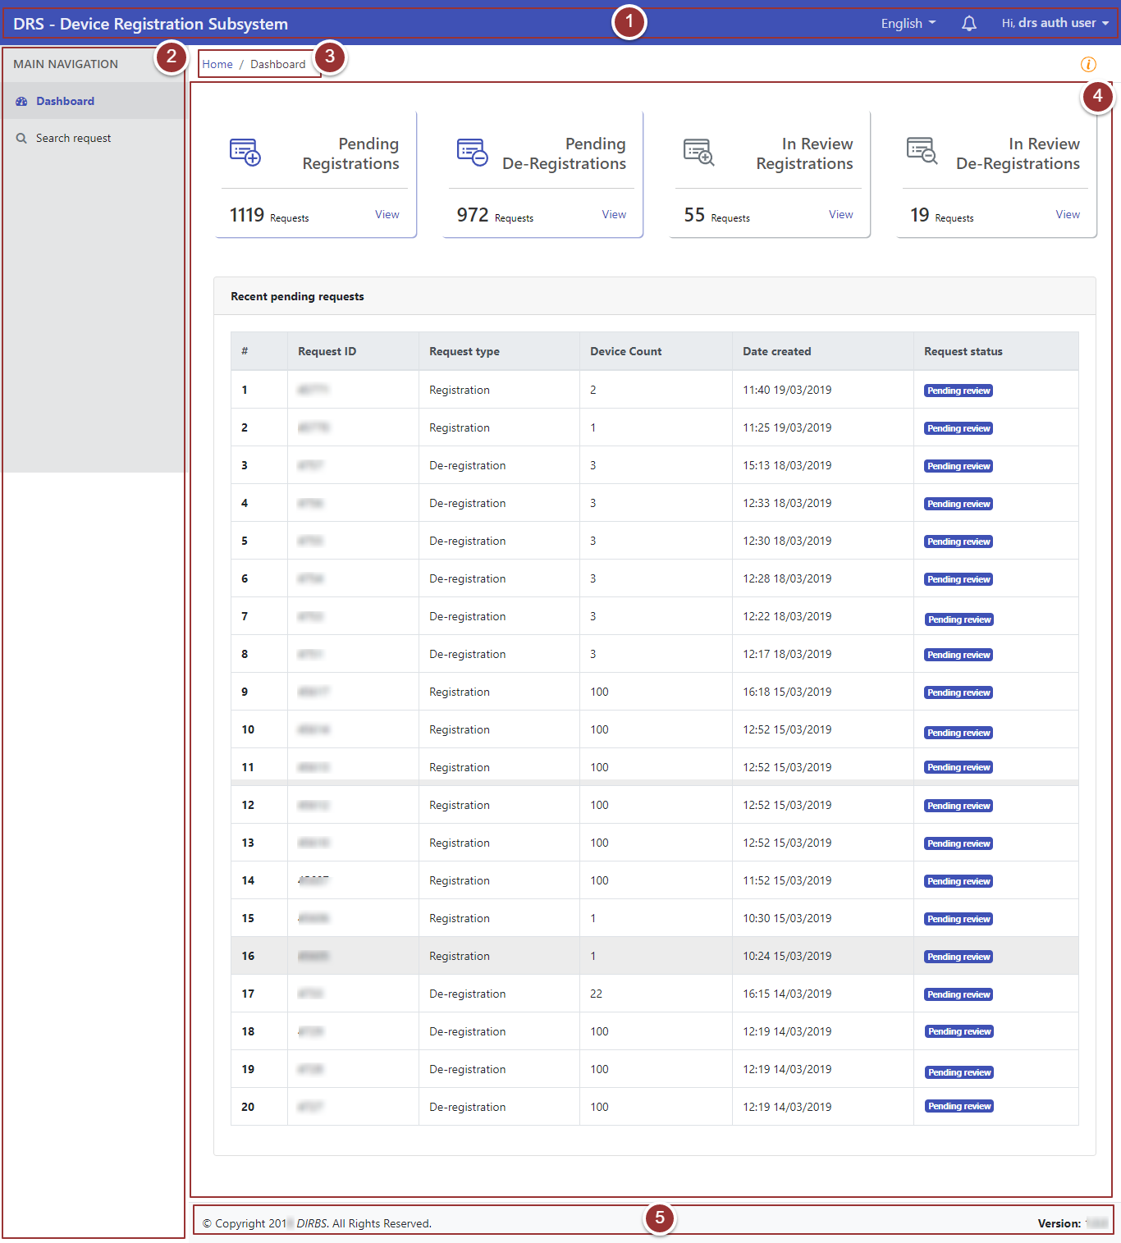

Figure 2 - Portal Sections

**Language Menu**

1. To select the required language, click on language drop-down menu.

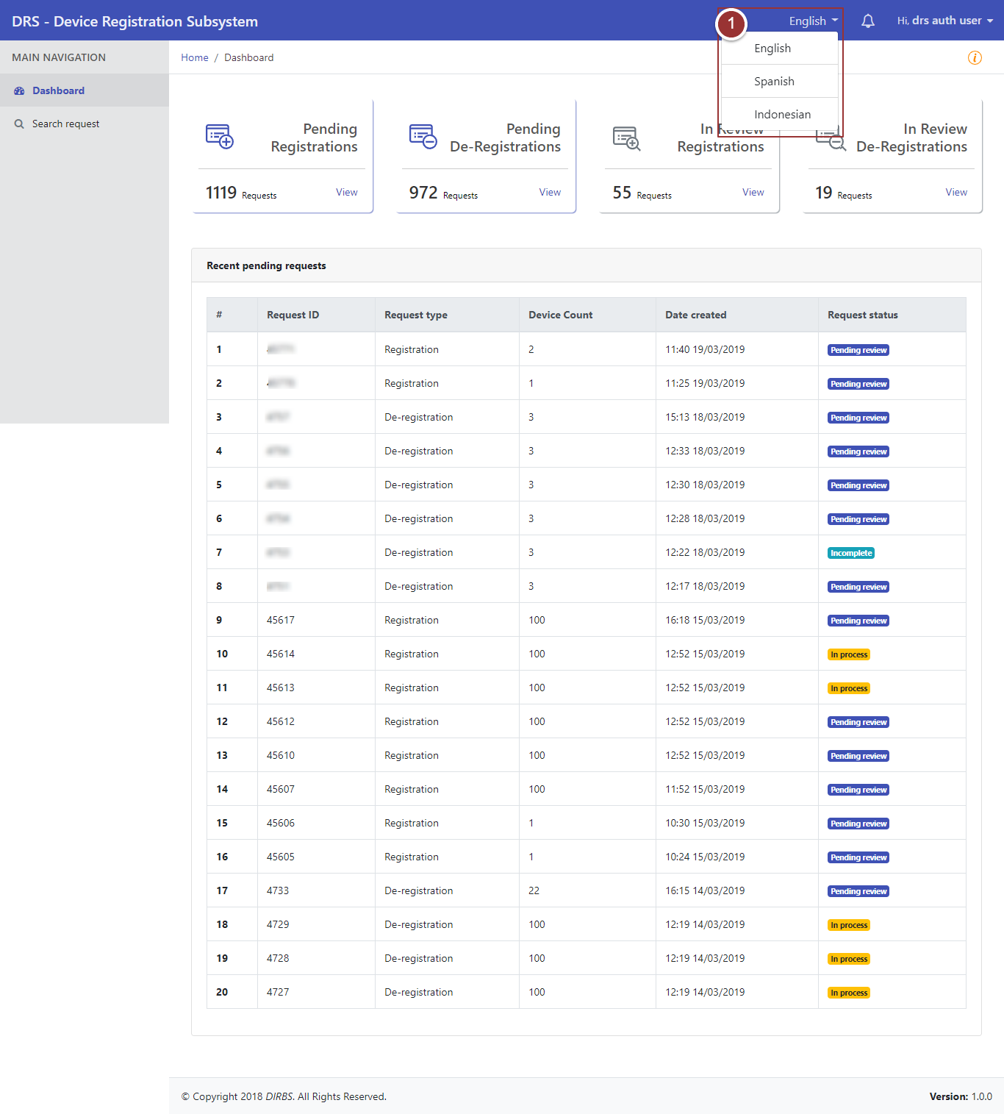

Figure 3 - Language Menu

**Notification Alert**

1. To view notification(s), click on notification alert icon 

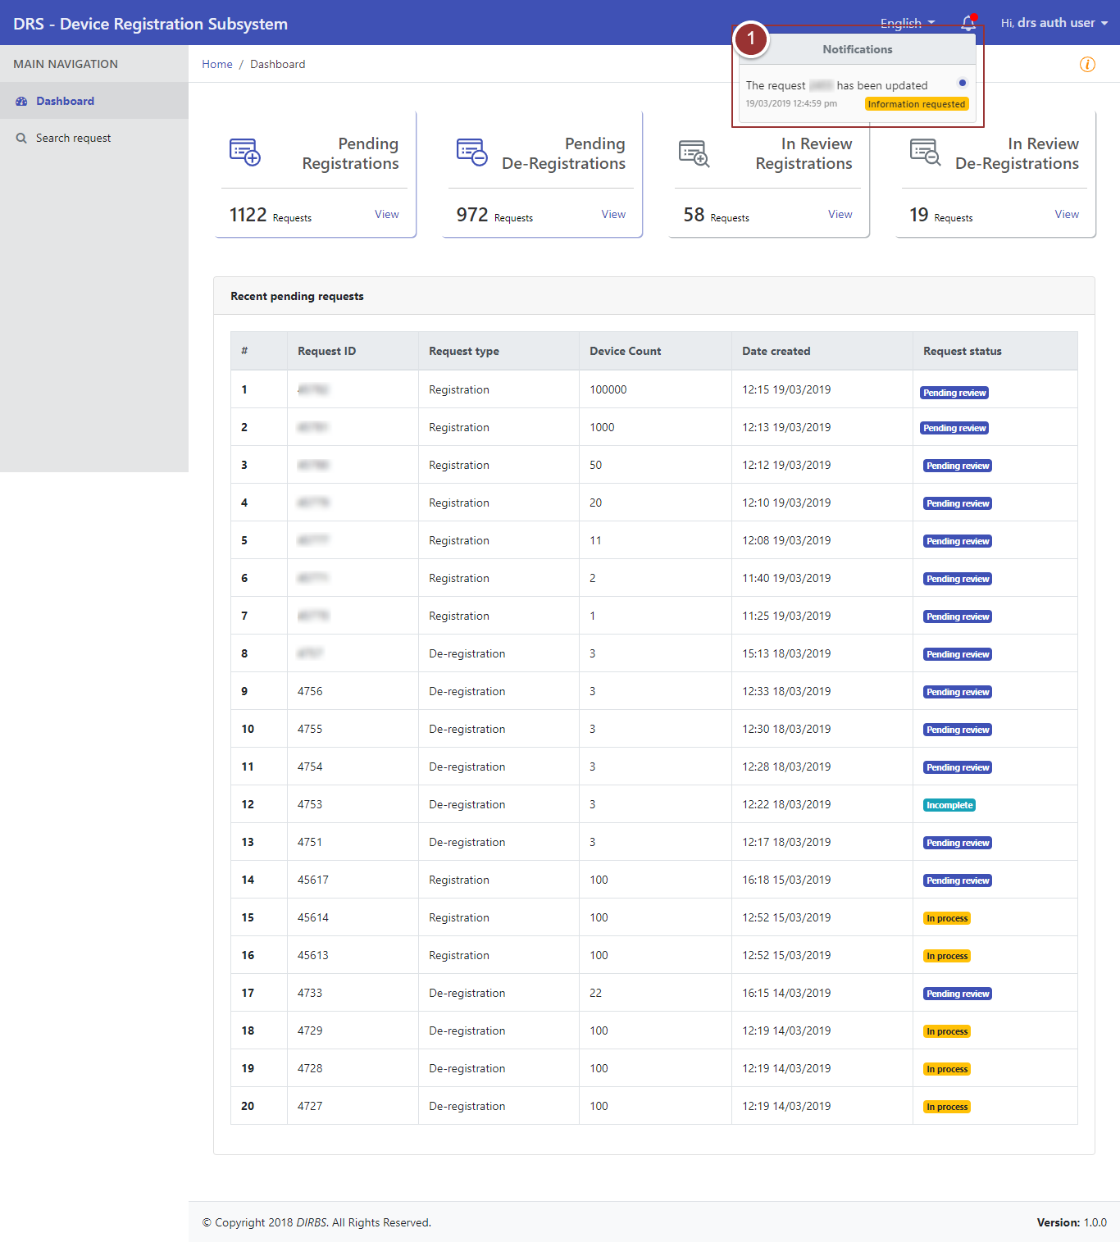

Figure 4 - Notification Alert Icon

## **Dashboard**

By clicking on “Login” button, user will be redirected to the dashboard screen that displays the total count of pending requests and in-review requests. It also displays the recent pending requests along with their details.

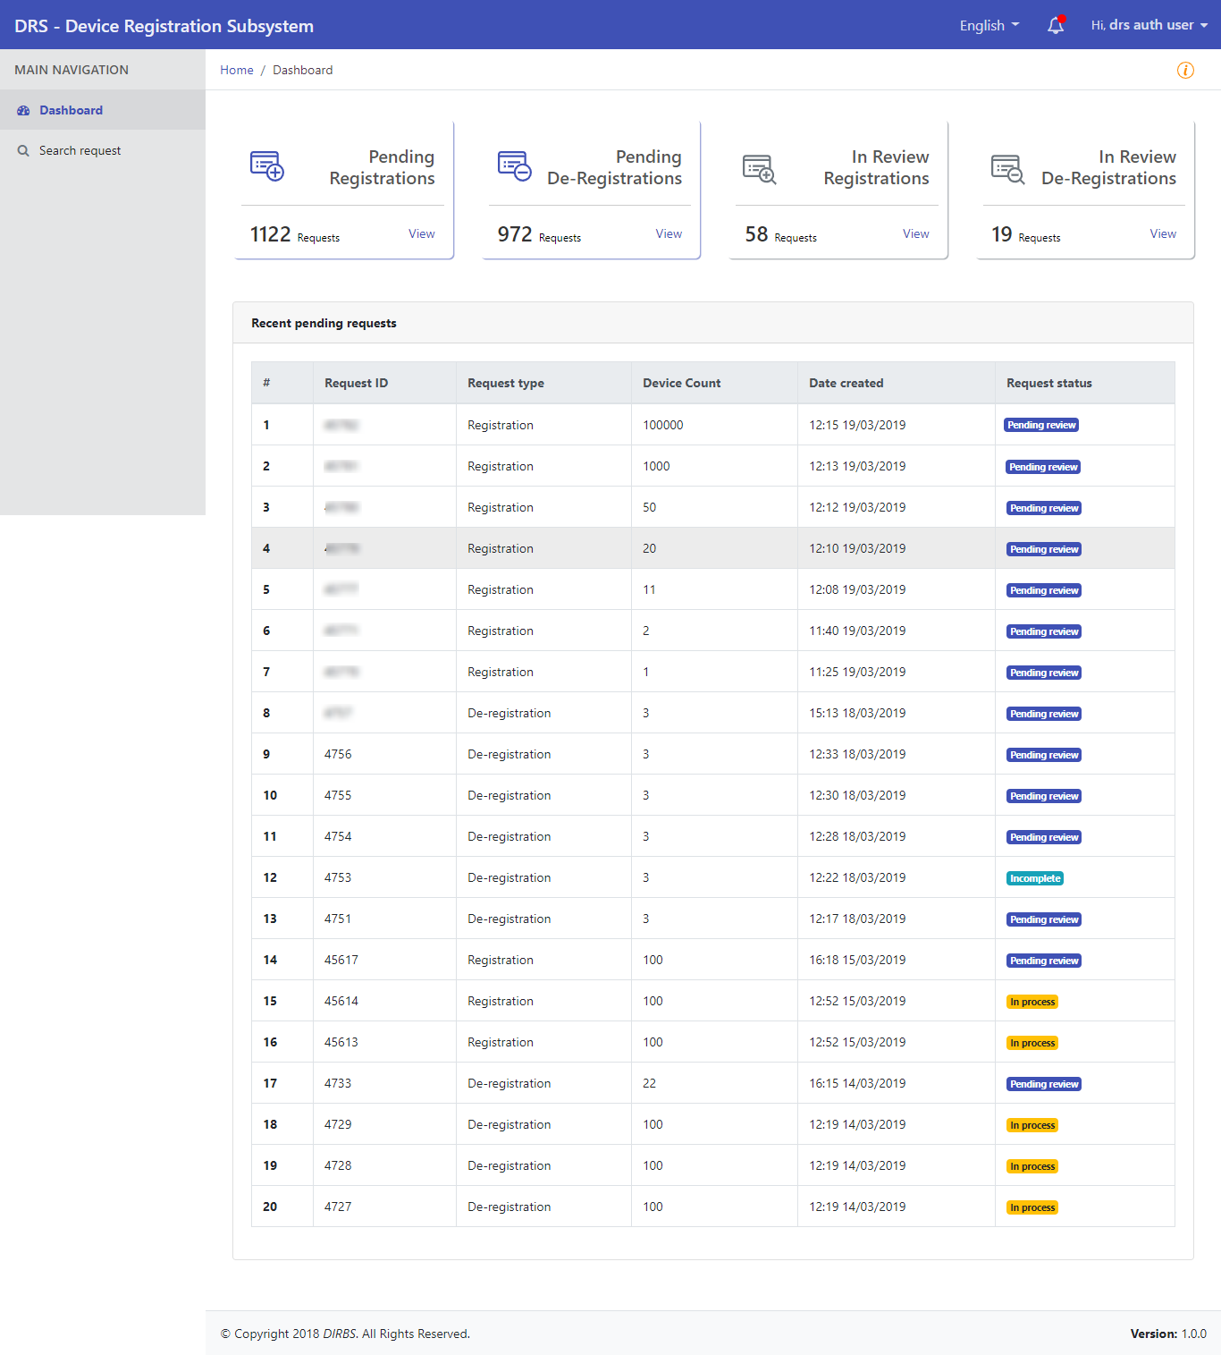

Figure 5 - Dashboard

By clicking on any recent pending request, user will be redirected to that particular request.

**System Instructions**



1. To view instructions of system, click on icon

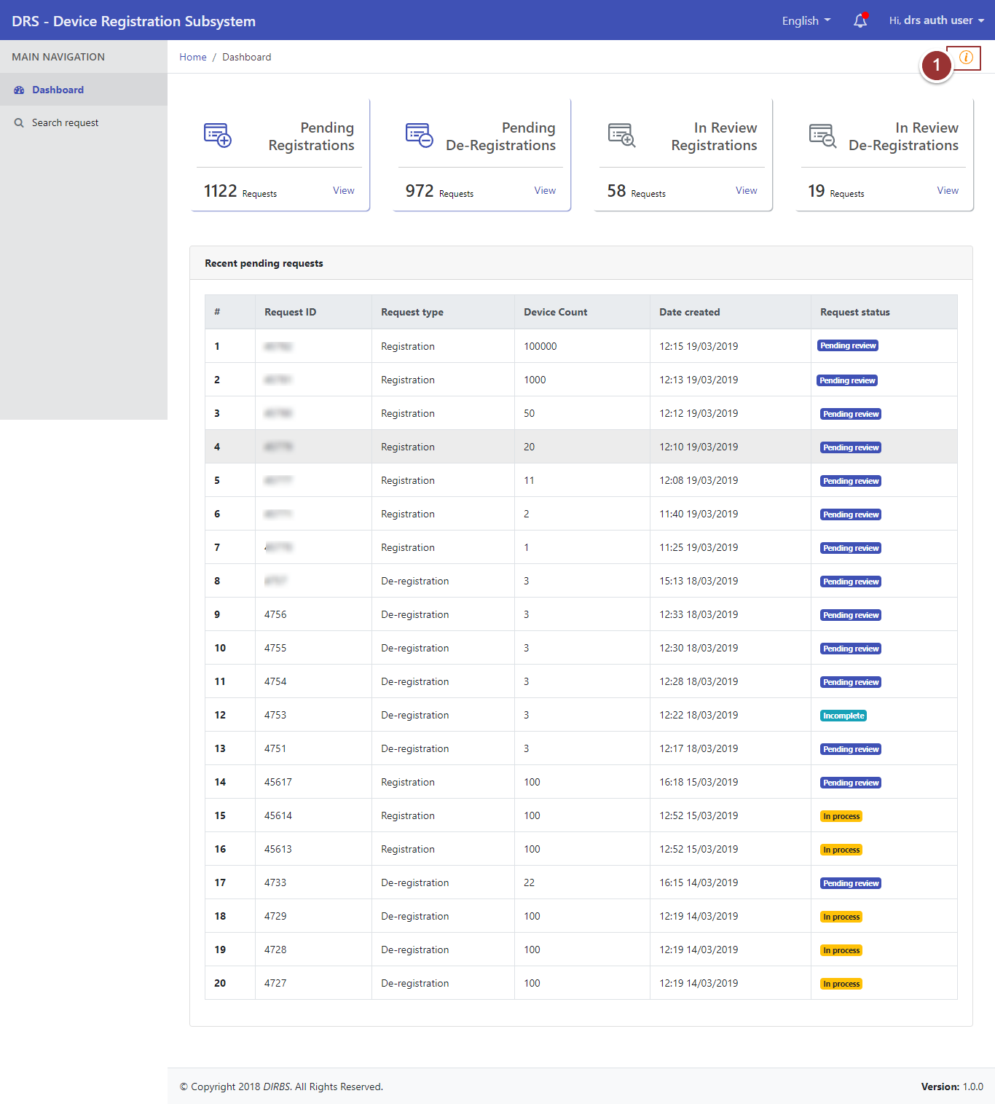

Figure 6 - System Instructions (i)



By clicking on instructions icon, a pop up will appear that displays the instructions for the user.

1. Click on “Close” button to proceed further.

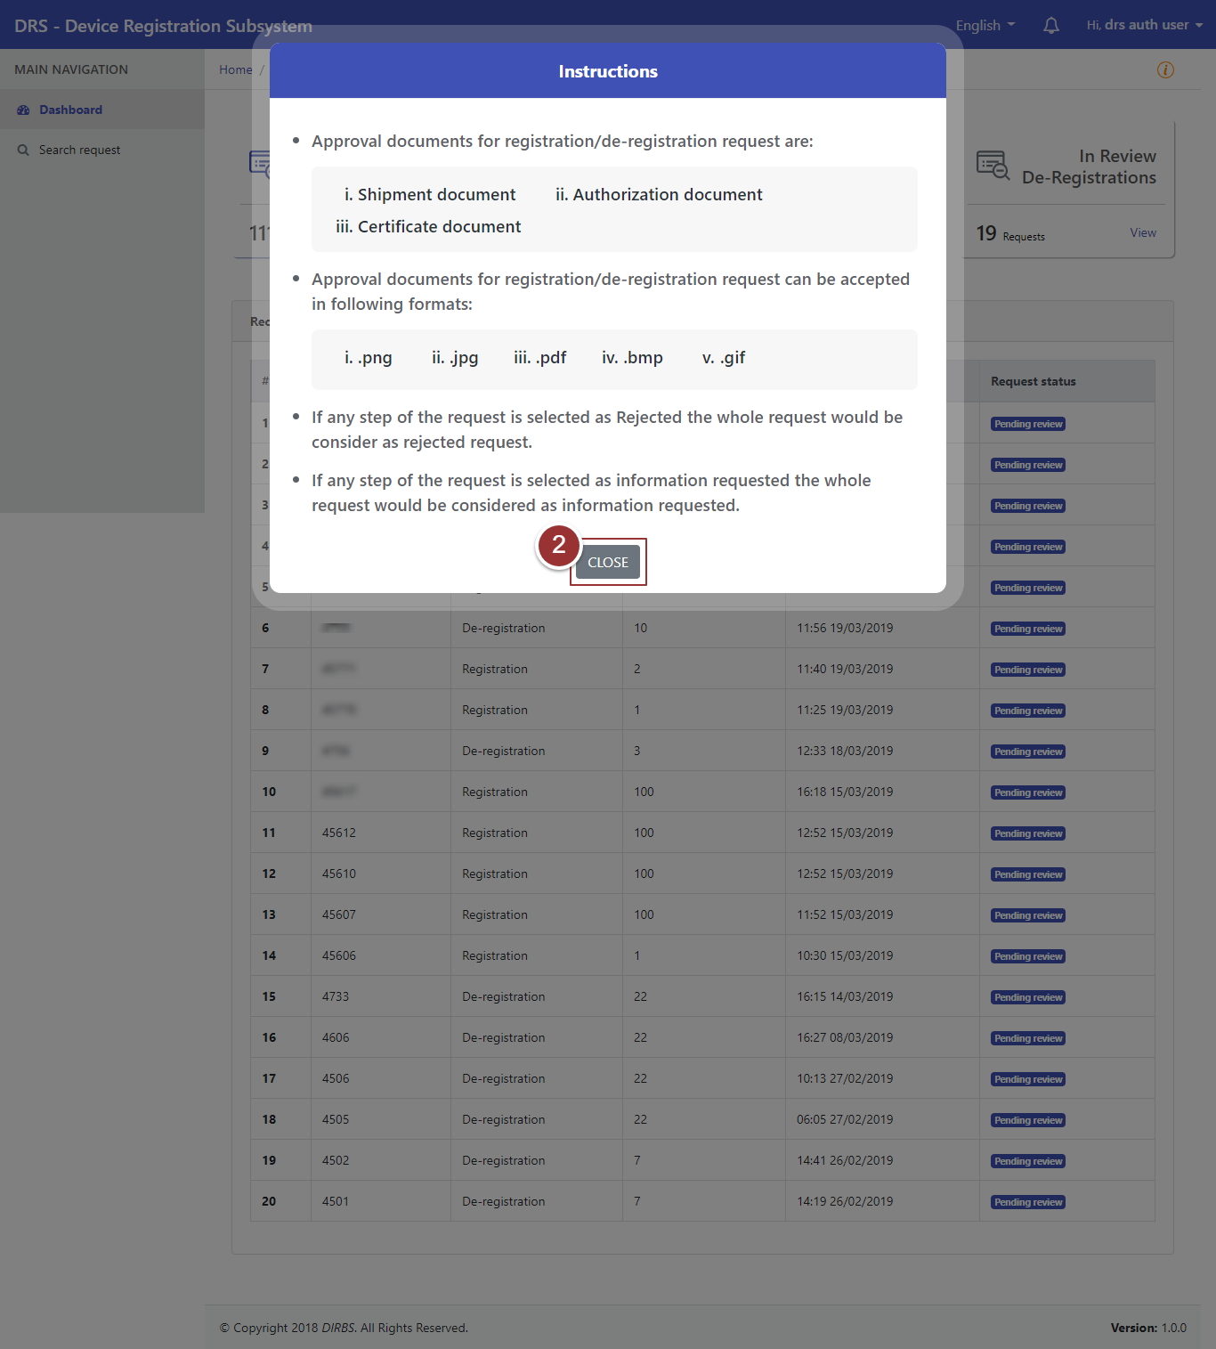

Figure 7 - System Instructions (ii)

## **Search Request**

1. To search any request, click on “Search Request” tab.
2. To view all requests, click on “Search Requests” button.

**Note**: By default, request type is set as “Registration”. To search requests for deregistration, user must have to change request type to “Deregistration”.

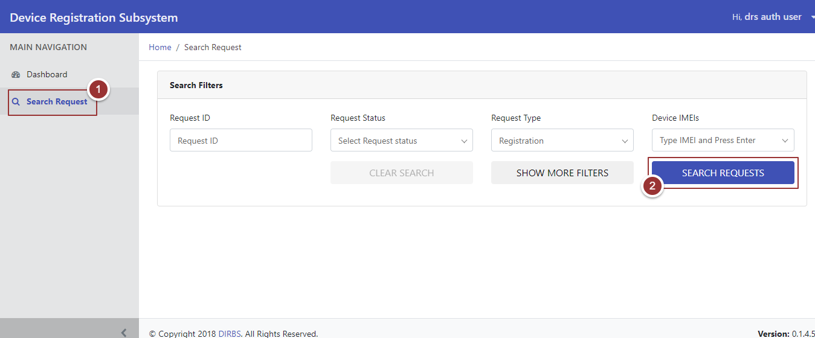

Figure 8 - Search Requests

By clicking” Search Requests” button, system will display all requests that contain Request ID, Request Type, Device Count, Date Created, Date Last Updated, Request Status, and Actions. To manage number of found requests to be displayed on a page, click on the drop-down menu “Show Requests” and select required number.

1. To view the request, click on the “View” Link against respective request.

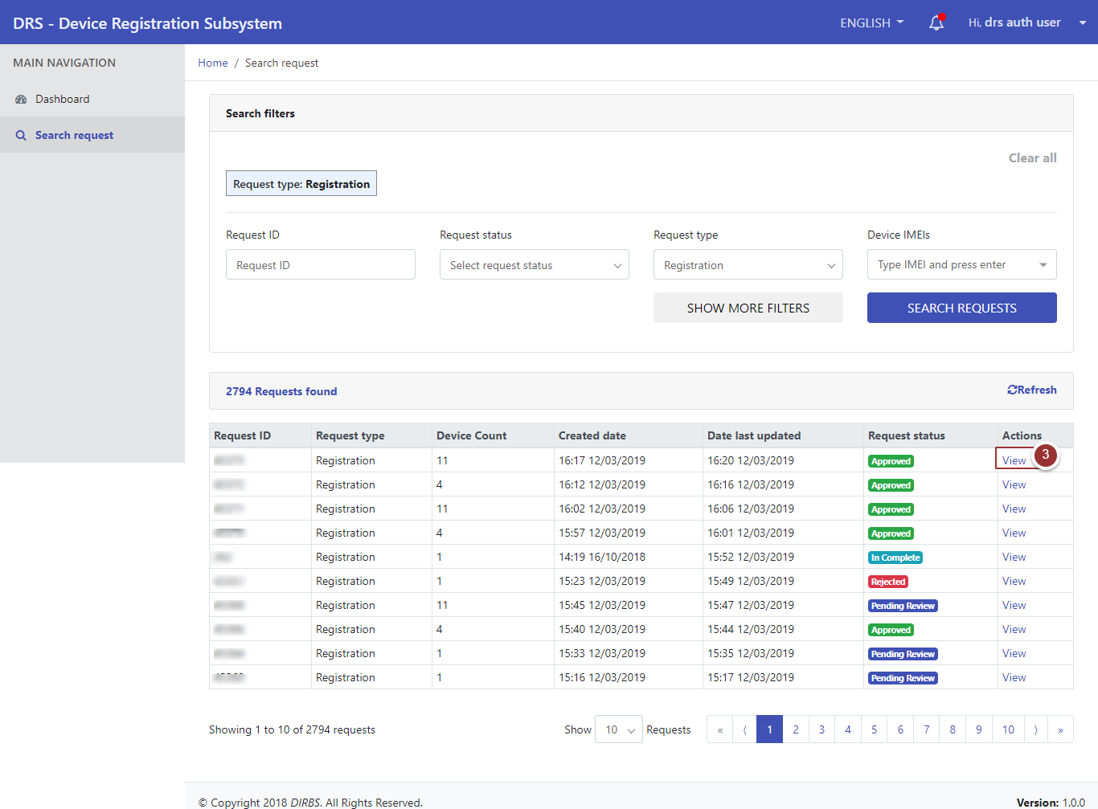

Figure 9 - View Requests

**View Request**

Perform steps 1-3 as per section 3.4

1. The “View” link will redirect to request details page, click on “Next” button to view the other sections of the request.

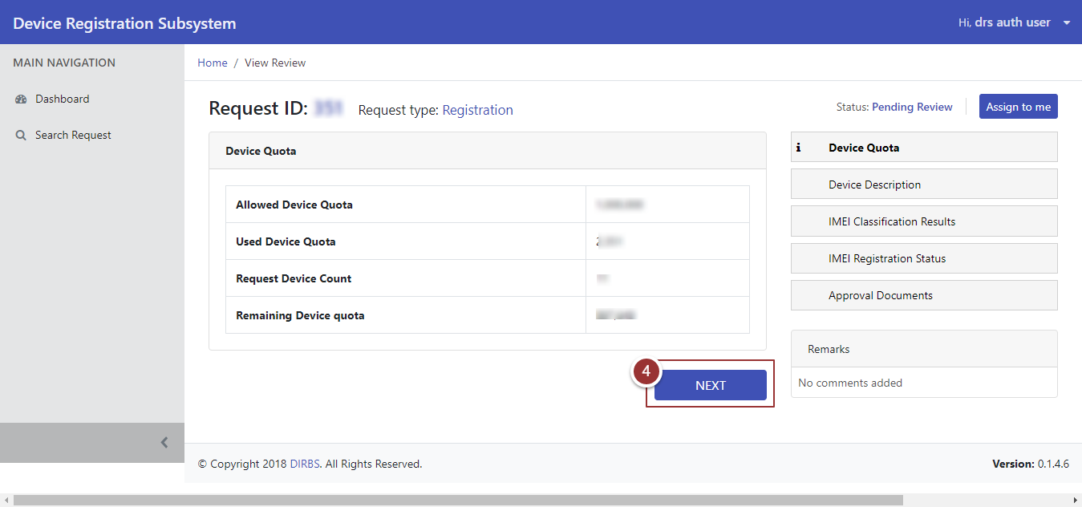

Figure 10 - View Request Sections

Perform step 4 to view all sections of the request.

**Assign Request**

Perform steps 1-3 as per section 3.4

The “View” link will redirect to request details page while viewing the request, user can assign/unassign “Pending Review” requests.

1. To assign the request, click on “Assign to me” button.

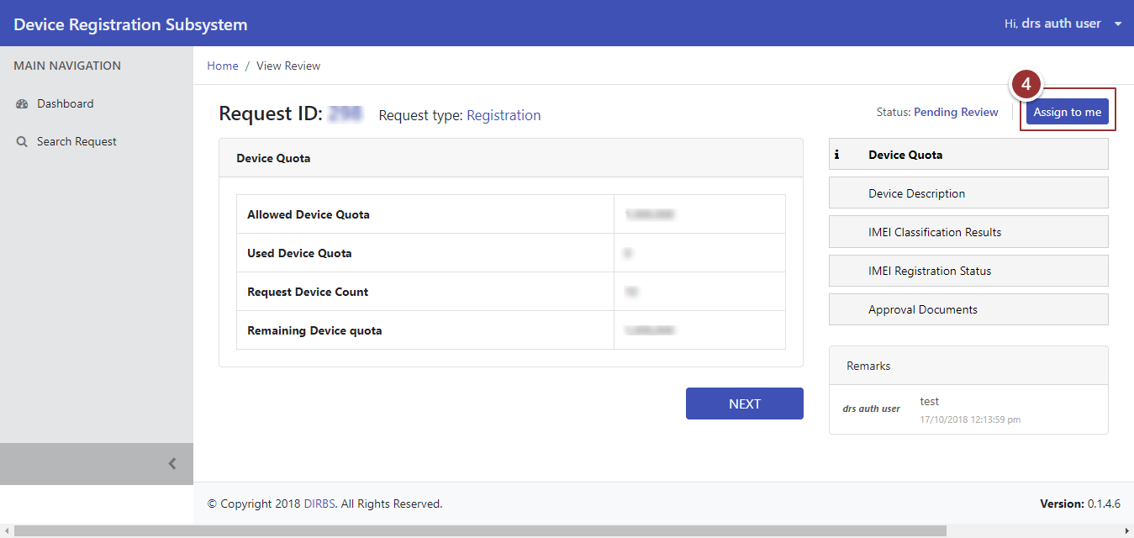

Figure 11 - Assign Request

1. To change status of reviewed section of request, select the status (Approve, Information Requested, or Rejected) from drop-down menu accordingly.
2. Enter the feedback in respective comment box.
3. Click on “Next” button.

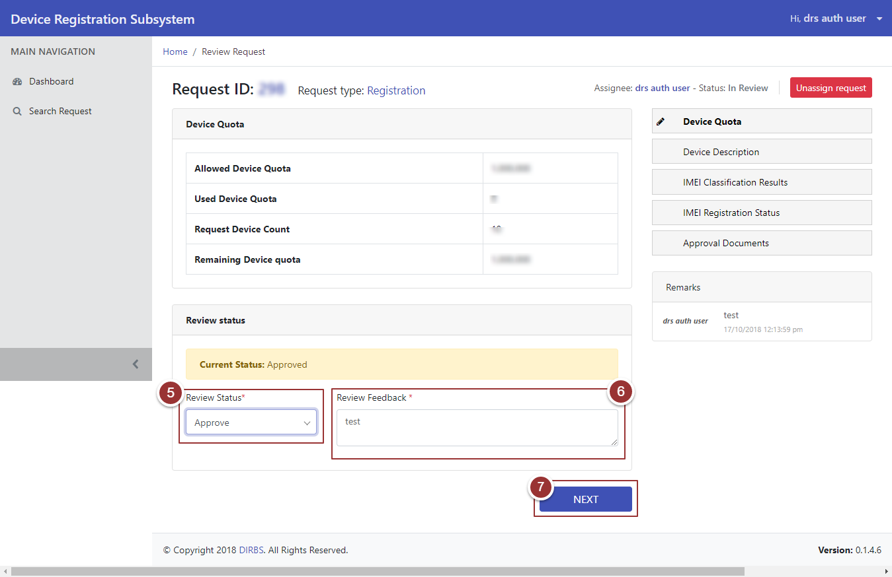

Figure 12 - Review Status (i)

By clicking on “Next” button, a page will appear that displays details of request under “Device Description” section.

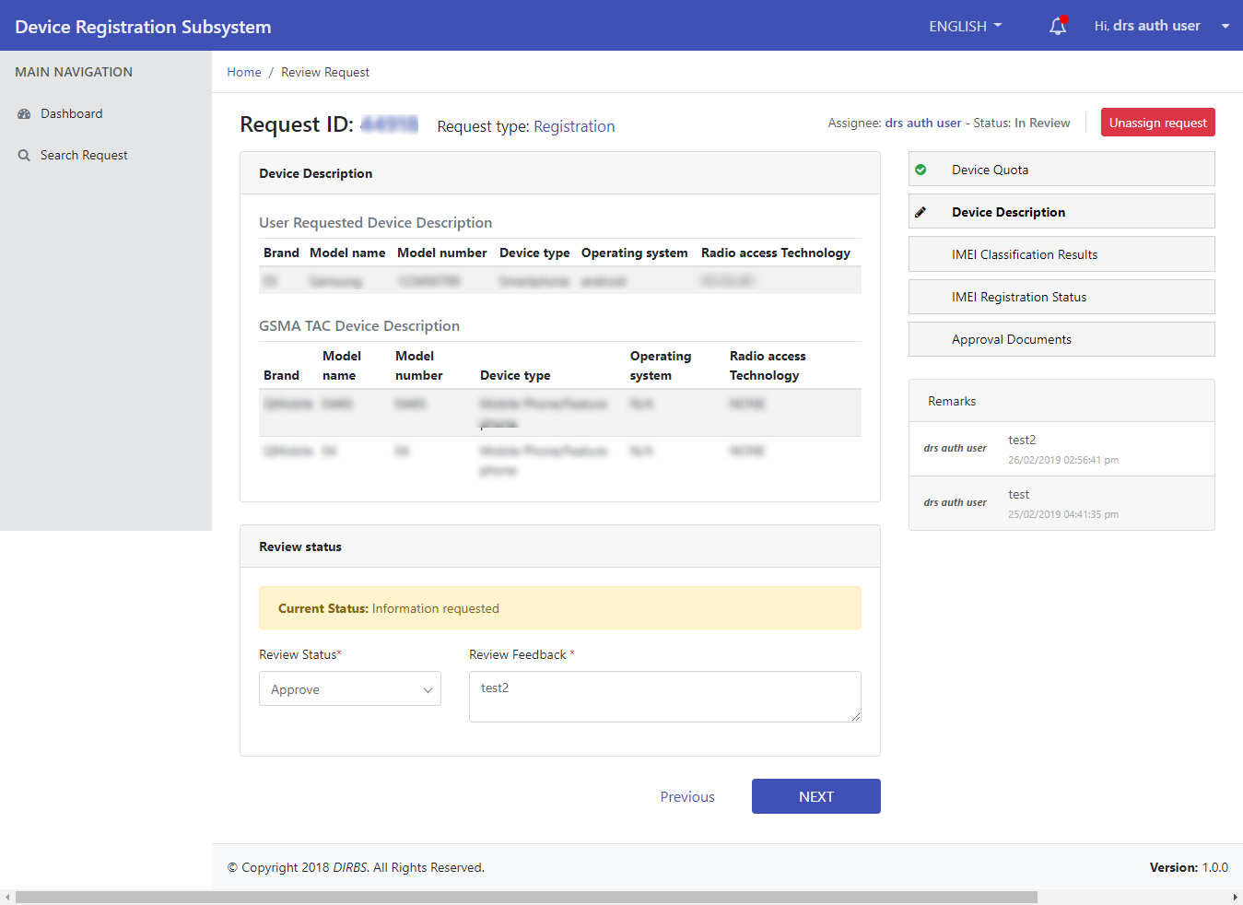

Figure 13 - Review Status (ii)

Perform steps 5-7 to change status of the above section.

After changing status of “Device Description”, next section that user will review is “IMEI Classification Results”.

1. To share report with particular requester i.e. Importer/Exporter, check the check box against the “Show Report to User” field.

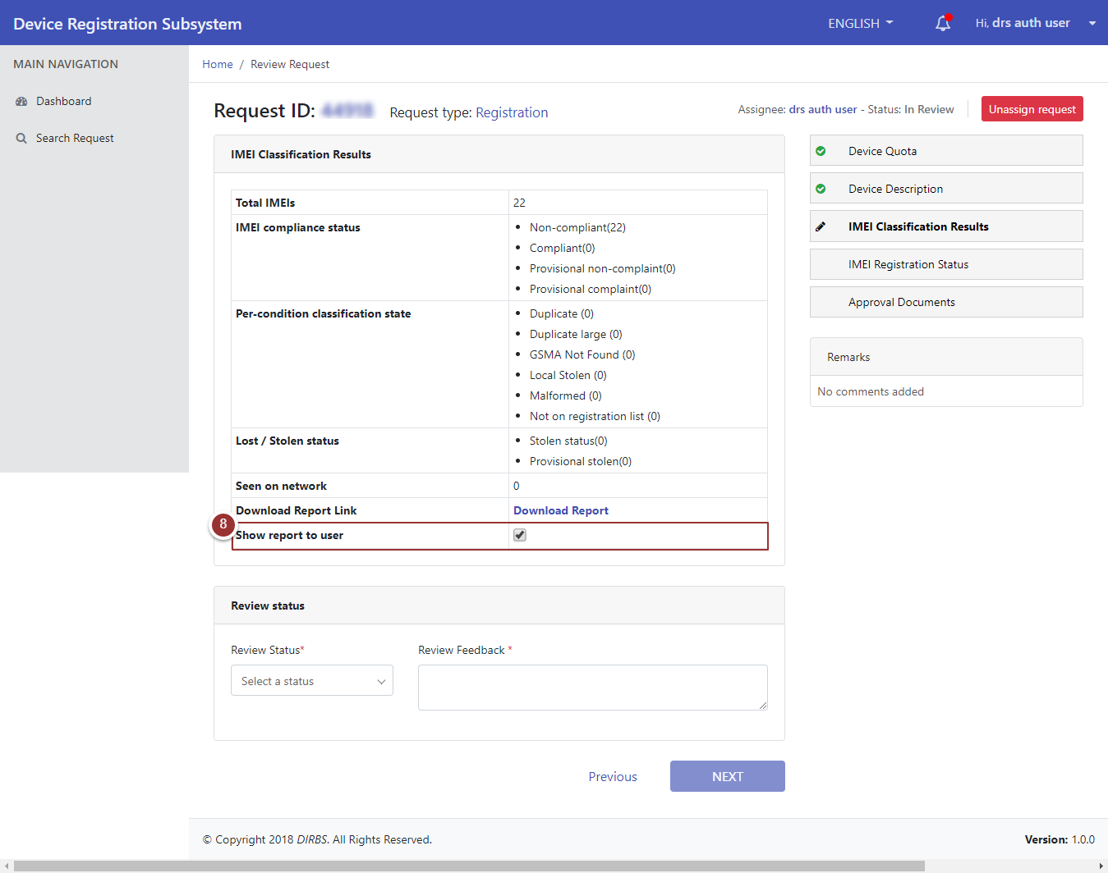

Figure 14 - Review Status (iii)

Perform steps 5-7 to change status of the above section.

After reviewing “IMEI Classification Results” section, a page will appear that displays “IMEI Registration Status” section.

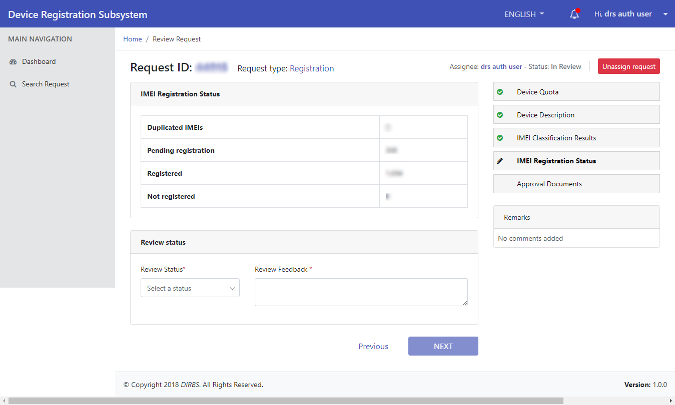

Figure 15 - Review Status (iv)

To change status for every section of the request, perform steps 5 -7.

1. After changing the status of last section i.e. Approval Documents of the request, click on “Finish” button.

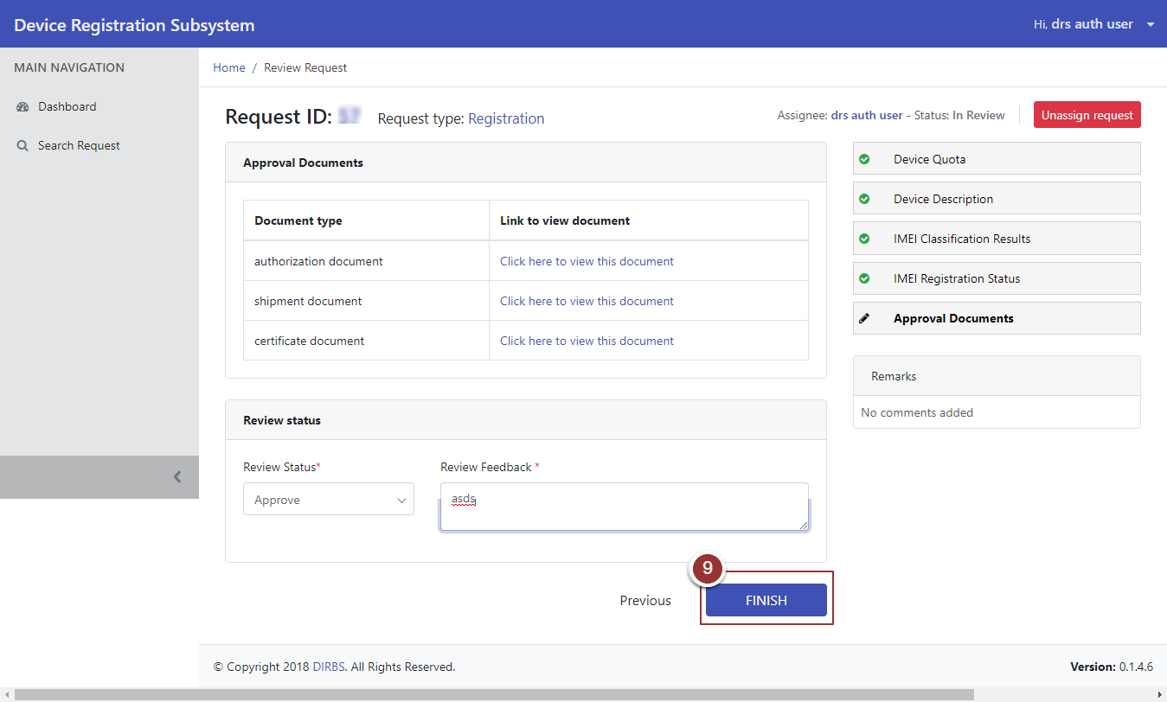

Figure 16 - Review Status (v)

## **Search Particular Request**

1. To search any particular request, click on “Search Request” tab.
2. Enter any known information about the request i.e. Request ID, Request Status, Device IMEIs etc. For more search filters, click on “Show More Filters” button and enter known information related to the request.

**Note**: By default, request type is set as “Registration”. To search requests for deregistration user must have to change request type to “Deregistration”.

1. Click on “Search Requests” button.

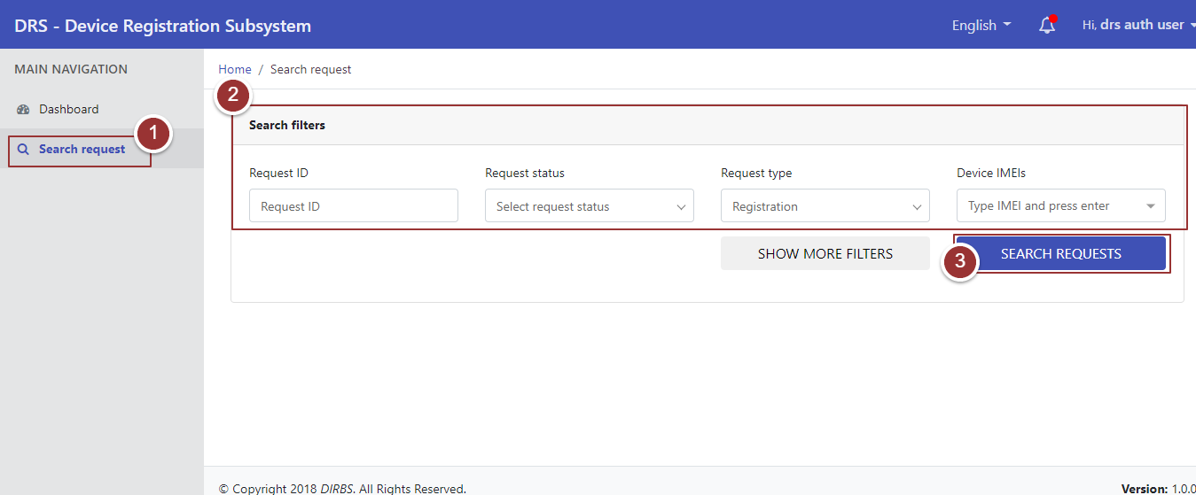

Figure 17 - Search Filters (i)

By clicking on “Search Requests” button, it will display the request with applied search filters.

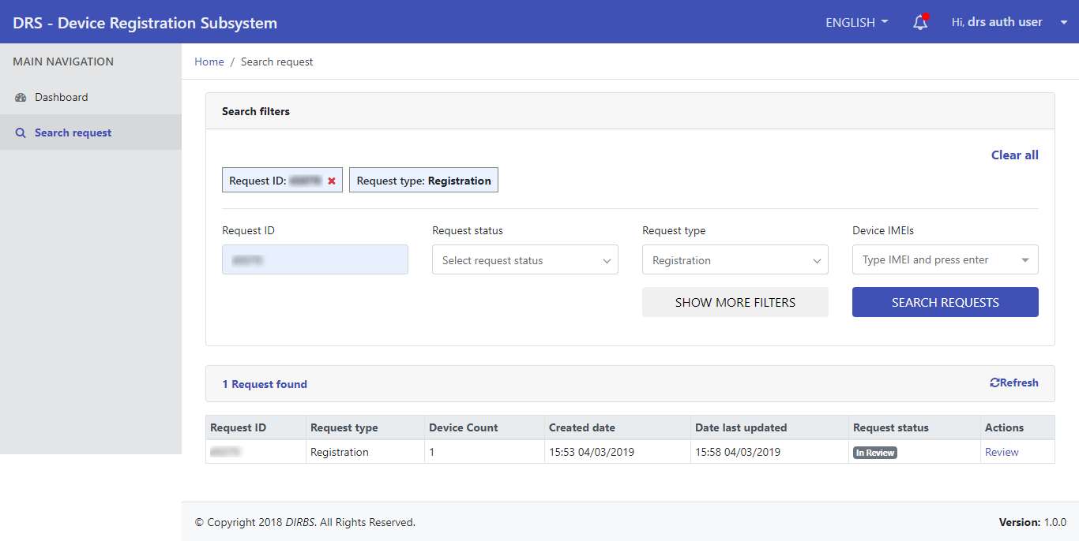

Figure 18 - Search Filters (ii)