Device Verification Subsystem 1.0.0

User Guide (Authority Web App)

DVS-User-Guide-Authority-Web-App-1.0.0

June 19, 2018

Revision history

|  |  |  |
| --- | --- | --- |
| Revision | Date | Description |
| A |  | Initial release |

# **Contents**

1. Introduction 5

1.1. Purpose 5

1.2. Supported Desktop Browsers 5

1.3. Supported Mobile Browsers 6

1.4. Definitions, Acronyms, and Abbreviations 6

2. System Description 7

3. System Navigation 10

3.1. Log-In Screen 10

3.2. Portal Sections 11

3.3. Verify IMEI 12

3.4. Bulk IMEI 14

3.4.1. Tab-delimited File Method 14

3.4.2. Enter the TAC Method 19

3.5. Check Status 22

Figures

Figure 1-login Screen 10

Figure 2-Portal Overview 11

Figure 3-Verify IMEI 12

Figure 4-Device Status Table 13

Figure 5-Bulk IMEI Verification Methods 14

Figure 6-Select Tab-Delimited file 15

Figure 7-Tracking ID 16

Figure 8-Check Status Button 17

Figure 9-Download link 18

Figure 10- TAC Verification Method 19

Figure 11-Enter the TAC Number 20

Figure 12-Tracking ID 21

Figure 13-Check Status Tab 22

Figure 14-Check Status Button 23

Figure 15-Check Status Information Table 24

Tables

Table 1-Supported Desktop Browsers 5

Table 2-Supported Mobile Browsers 6

Table 3-Definitions, Acronyms, and Abbreviations 6

Table 4-System Description 9

# **Introduction**

The Device Verification Subsystem (DVS) is the subsystem of Device Identification, Registration and Blocking System (DIRBS) .It provides platform for Authorized entity(s) to check and verify the status of IMEI(s).

The Device Identification, Registration & Blocking System (DIRBS) is a country-wide system deployed in cooperation between the country regulator, operators in that country, and a technology partner that supports deployment. The system checks, identifies, and discourages non-compliant devices by verifying the installed base of devices currently active in a market and continuing to monitor as new devices are activated.

DIRBS can verify that:

* Devices have properly allocated identifiers and type approval
* Devices are not duplicated or stolen
* Device importation takes place through legal channels

## **Purpose**

This document is intended to give assistance to the user to use the Device Verification Subsystem (DVS).

## **Supported Desktop Browsers**

1

|  |  |
| --- | --- |
| **Name** | **Version** |
| Internet Explorer | 11.0 |
| Firefox 52.5 ESR | 57.0 |
| Chrome | 63.0 |
| Safari | 11.0 |
| Edge | 41.16299 |

## **Supported Mobile Browsers**

2

|  |  |
| --- | --- |
| **Name** | **Version** |
| Chrome | 63.0 |
| UC Browser | 11.5 |
| Opera(Android) | 44.1 |
| Opera(iOS) | 16.0.7 |
| Safari | 11.1 |
| Samsung Internet | 6.2 |
| Android | 4.1.x - 4.3 |

## **Definitions, Acronyms, and Abbreviations**

Table 3-Definitions, Acronyms, and Abbreviations

|  |  |
| --- | --- |
| ****Term**** | ****Definition**** |
| **DIRBS** | **Device Identification Registration and Blocking System** |
| IAM | Identity Access Management |
| DVS | Device Verification Subsystem |
| MSISDN | Mobile Subscriber Integrated Services Directory Number |
| IMEI | International Mobile Equipment Identity |

# **System Description**

4

|  |  |
| --- | --- |
| Feature ****/Sections**** | ****Description**** |
| **Login Screen** | * To access the system, authorized user(s) first needs to enter his/her credentials on login page, this login page authenticate(s) user from the IAM and redirects user to the DVS |
| Portal Sections | **The portal is divided into following sections**   * **Header**   Header section displays the name of the system, name of the logged in user with logout functionality     * **Navigation Panel**   Navigation Panel contains main navigation menu through which user can navigate the whole system   * **Main Content Area**   Main Content Area contains all the content to be displayed and actions to be performed for respective feature   * **Breadcrumbs**   Breadcrumbs allows user to keep track of their location within the system   * **Footer**   Footer contains the software version and copyright text |
| Verify IMEI | Allows user to enter the valid IMEI to check and verify the status of device |
| Subscribers Seen with IMEI table | Displays list of IMSIs and MSISDNs seen on the network with particular IMEI |
| Paired Subscribers table | Displays list of last seen paired IMSIs with particular IMEI |
| Bulk IMEI | To check the status of larger number of IMEIs (bulk of IMEIs) either by submitting a tab delimited file or by TAC |
| Tab-Delimited File Method | This method allows user, to check and verify the status of all IMEIs, that are submitted in the form of tab-delimited file |
| Enter the TAC Method | This method allows user to enter the TAC to check and verify the status of all associated IMEIs |
| Device Status | Displays the complete status of the device in a table.  **IMEI Status**  **Normalized IMEI**  Displays the entered IMEI  **IMEI Compliance Status**  Displays the status of IMEIs i.e. Compliant, Non-Compliant  **Registration Status**  Displays the status of IMEI i.e. Registered, Pending registration, Not registered  **Lost/stolen Status**  Displays the status of IMEI i.e. Lost/ stolen (if applicable )  **Block as of Date**  Displays the block date of the device  **Device Information**  **Brand**  Displays the brand name of the device  **Model Name**  Displays the model name of the device  **Model Number**  Displays the model number of the device  **Manufacturer**  Displays the name of the company/country where the device is manufactured  **Device Type**  Displays the device type i.e. smartphone, tablet etc.  **Operating System**  Displays the operating system of the device i.e. Android or iOS  **Radio access technology**  Displays the radio access technologies of that device i.e. 2G, 3G, 4G, 5G etc.  **Per-Condition Classification States:**  All classification states are configurable parameters that are coming from the core such that GSMA not found, Duplicate, Local Stolen, Duplicate Compound |
| Check Status | Display the status of all IMEIs requested to be verified either by TAC or list of IMEIs in tab delimited file.    **Tracking Ids**  Displays the tracking id of the request  **Current Status**  Displays the status of request i.e. Success or pending  **Created At**  Displays date and time of the request submission  **Verification Method**  Displays the name of verification method through which the request has submitted i.e. Tab delimited file or TAC  **Check Status**  Displays the “Check Status” button, by clicking on this button, a table will display Total Number of IMEIs Verified, Invalid IMEIs, Non-Compliant IMEIs (not registered with regulatory authority), Per-Condition Classification States (GSMA not found, Duplicate, Local stolen, Duplicate Compound ), IMEIs Pending Registration, IMEIs Pending Lost/Stolen Report Verification |
| Non-compliant IMEIs report | This report shows the information related to the IMEIs such that   * Non-compliant IMEI * Reasons for non-compliance   Block as of date |

# **System Navigation**

## **Log-In Screen**

1. **Enter user credentials i.e. username, password**
2. **Click on the “Log-In” button**

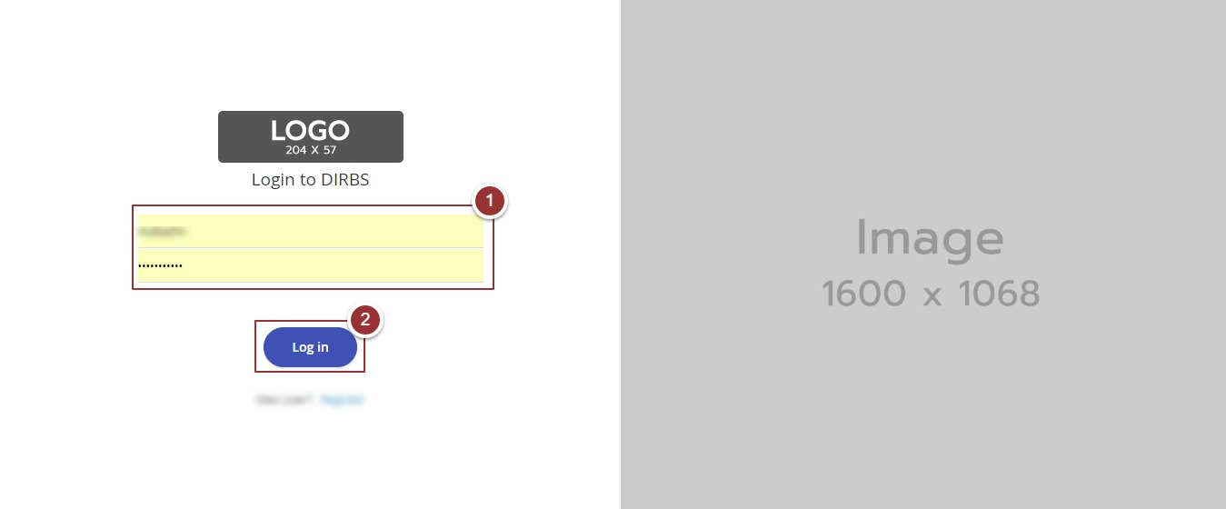

Figure 1-login Screen

## **Portal Sections**

The portal screen is divided into following sections.

1. **Header** section displays the name of the system, name of the logged in user with logout functionality
2. **Main Navigation Panel** helps user to navigate through system
3. **Breadcrumbs** is a navigational aid in UI
4. **Main Content Area** contains all relevant information related to the respective feature/option
5. **Footer** contains the version and copyrights of the system

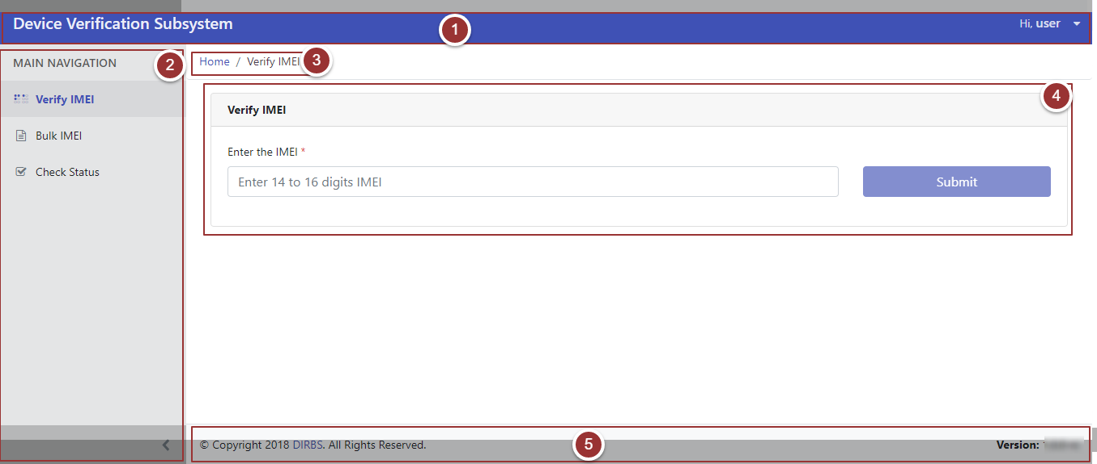Figure 2-Portal Overview

## **Verify IMEI**

1. Click on the “Verify IMEI” tab under the “Main Navigation” heading
2. Enter the IMEI in the respective field

**Note**: IMEI can contain alphanumeric characters (0-9, A-F, a-f). The length of the IMEI should be between 14-16 characters

1. Click on the “Submit” button

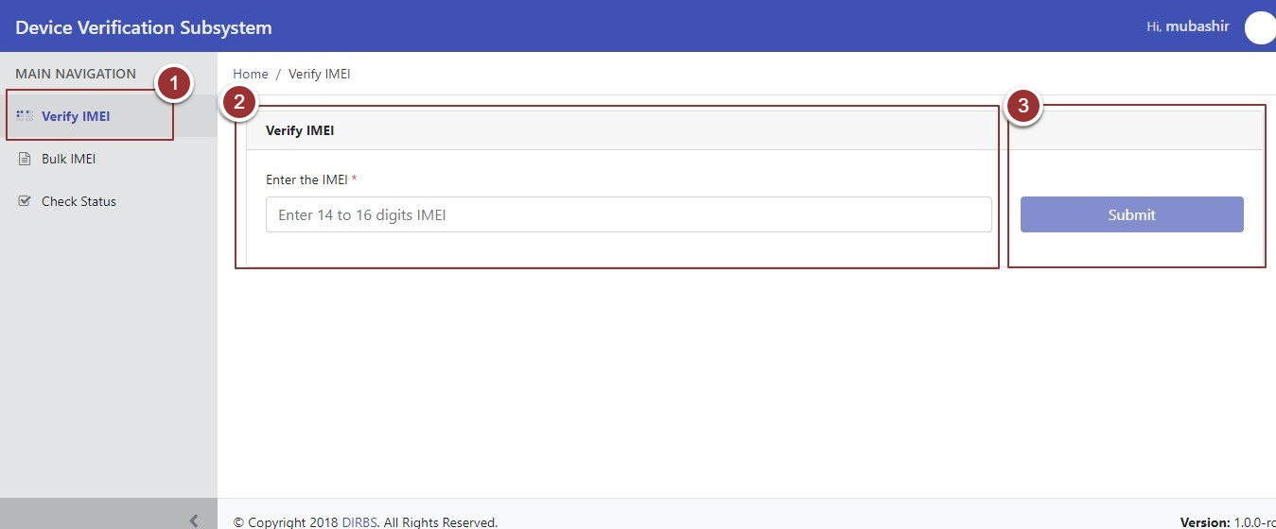

Figure 3-Verify IMEI

A page will display maximum information related to the IMEI in three different tables:

* Device Status
* Subscribers seen with IMEI
* Paired Subscribers

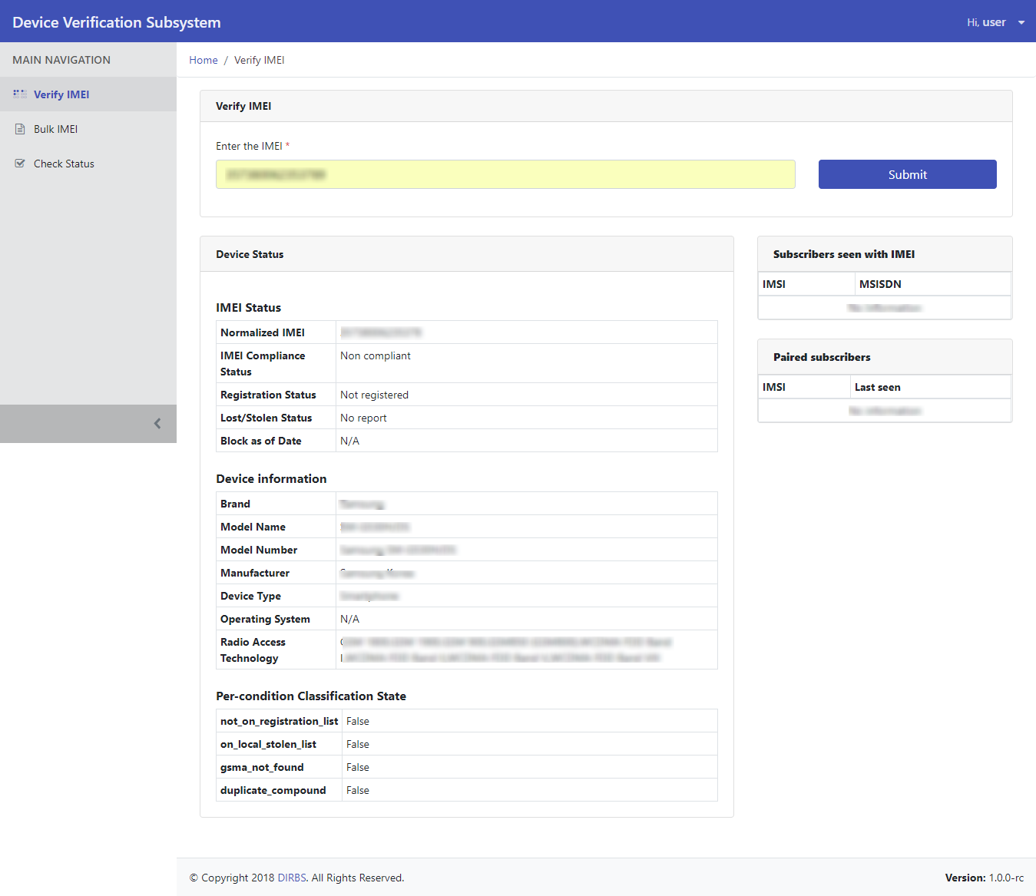Figure 4-Device Status Table

## **Bulk IMEI**

## **Tab-delimited File Method**

1. To submit IMEIs in bulk, click on the “Bulk IMEI” tab under the “Main Navigation” heading
2. To check the status of a large number of IMEIs through tab delimited file, select “Tab-delimited file” option

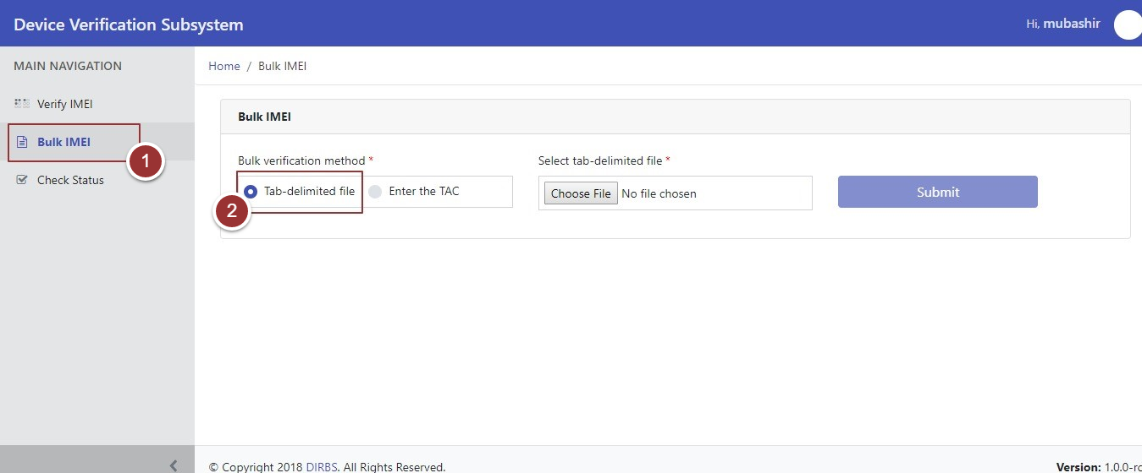 Figure 5-Bulk IMEI Verification Methods

1. Upload tab delimited file, click on the “Choose File” button and select the required file

**Note**: File should be in **“.TSV”** format

1. Click on the “Submit” button

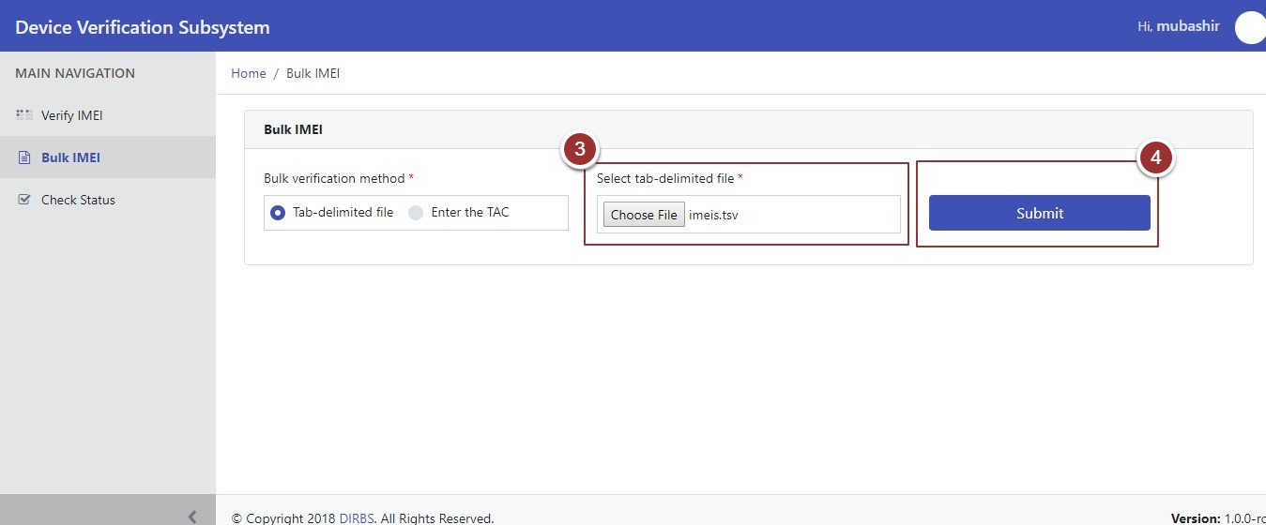

Figure 6-Select Tab-Delimited file

1. The system will generate a unique tracking id for the request, click on the id to check the status of your request

**Note**: Perform steps 1-4 to submit more IMEIs in bulk through tab delimited file.

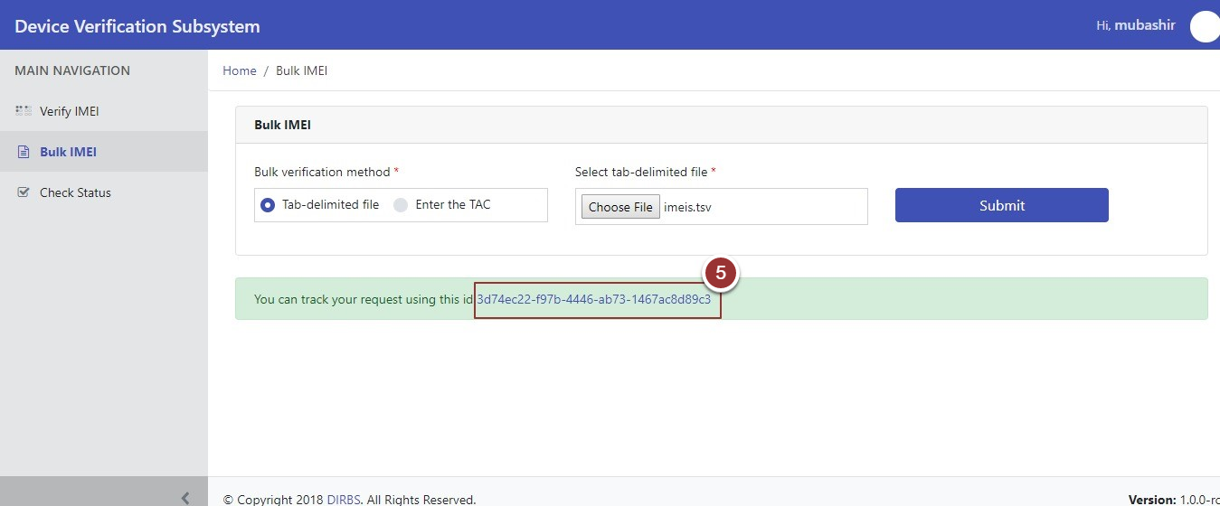

Figure 7-Tracking ID

After clicking on the tracking Id, it will redirect on a page where all the information related to the request would be displayed (Tracking Id, Current Status, Verification Method etc.)

1. To check status of your request, click on the “Check Status” button against respective request

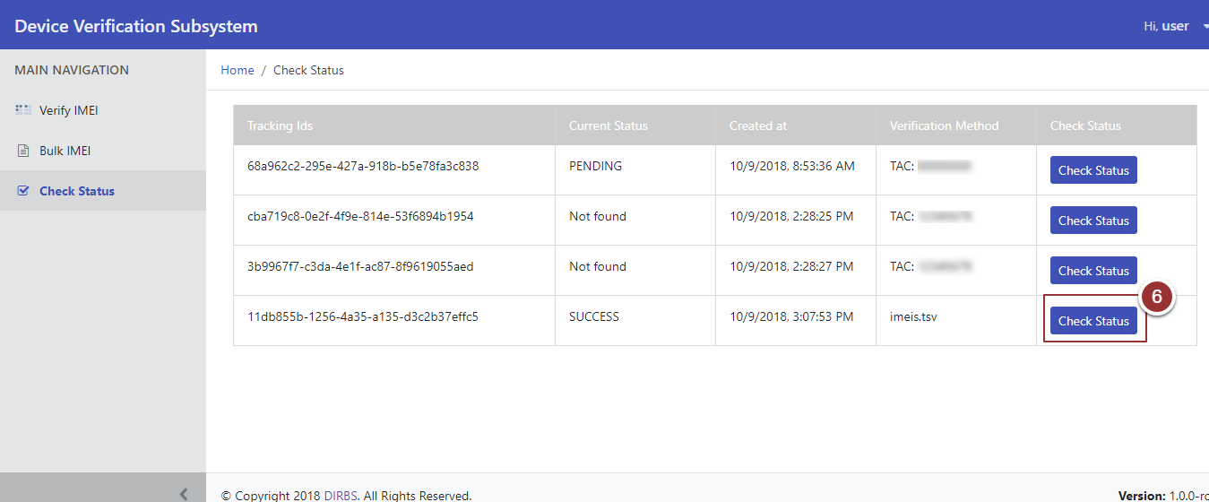

Figure 8-Check Status Button

After clicking on “Check Status” button, a table will display which contains device status information.

**Note:** Please wait for 2-3 minutes until required information being populated

1. To view the non-compliant IMEIs, click on the link to download the report for non-compliant IMEIs

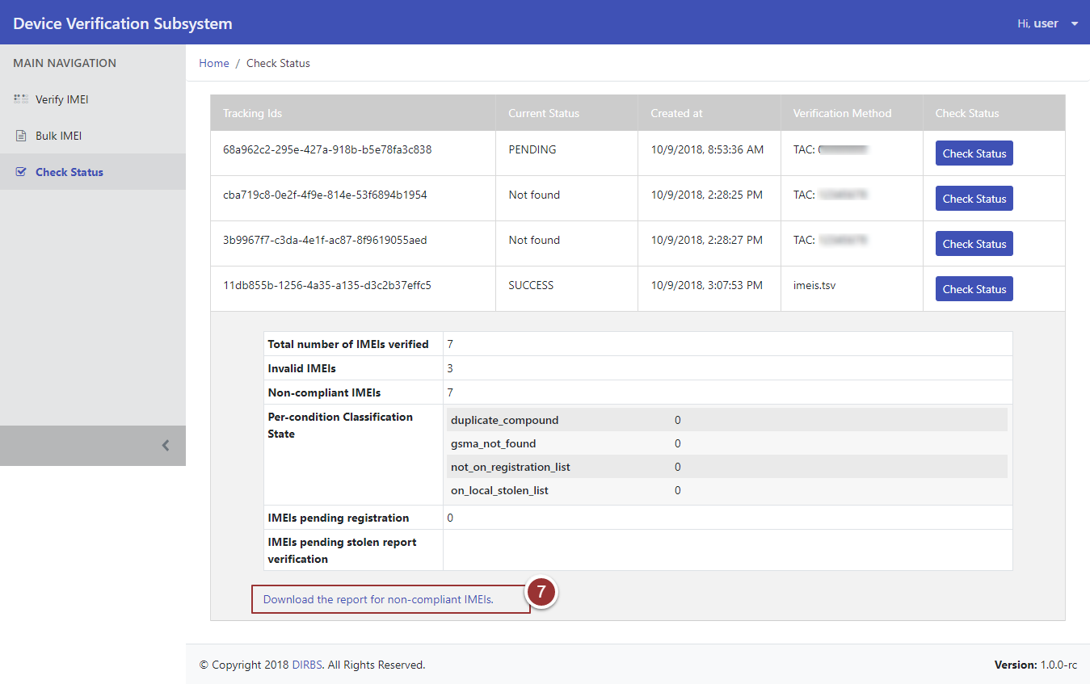

Figure 9-Download link

## **Enter the TAC Method**

Perform step 1.

1. To check the status of IMEI via TAC verification method, select “Enter the TAC” option

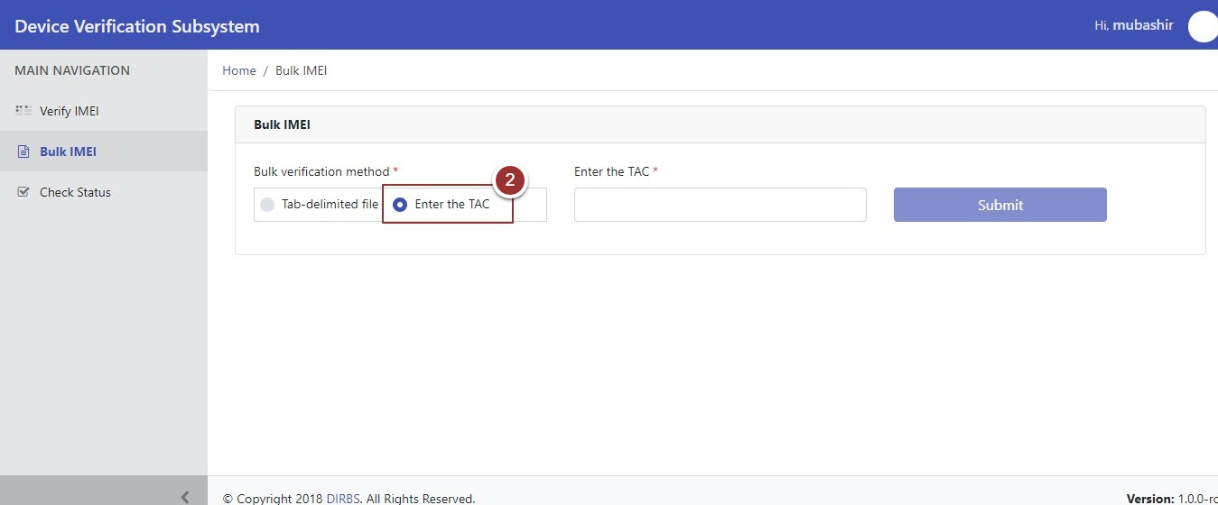

Figure 10- TAC Verification Method

1. Now, enter tac in the respective field
2. Click on the “Submit” button

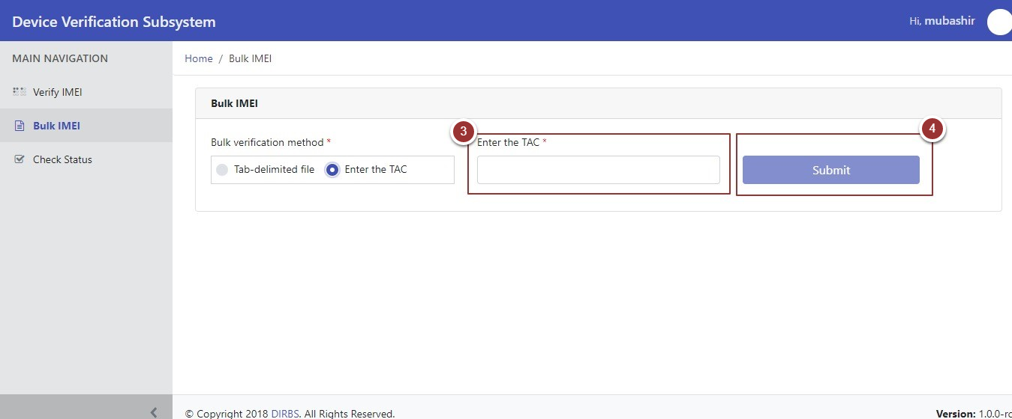

Figure 11-Enter the TAC Number

1. The system will generate a unique tracking id for the request, click on the id to check the status of your request

**Note**: Perform steps 1-4 to submit more IMEIs in bulk through TAC.

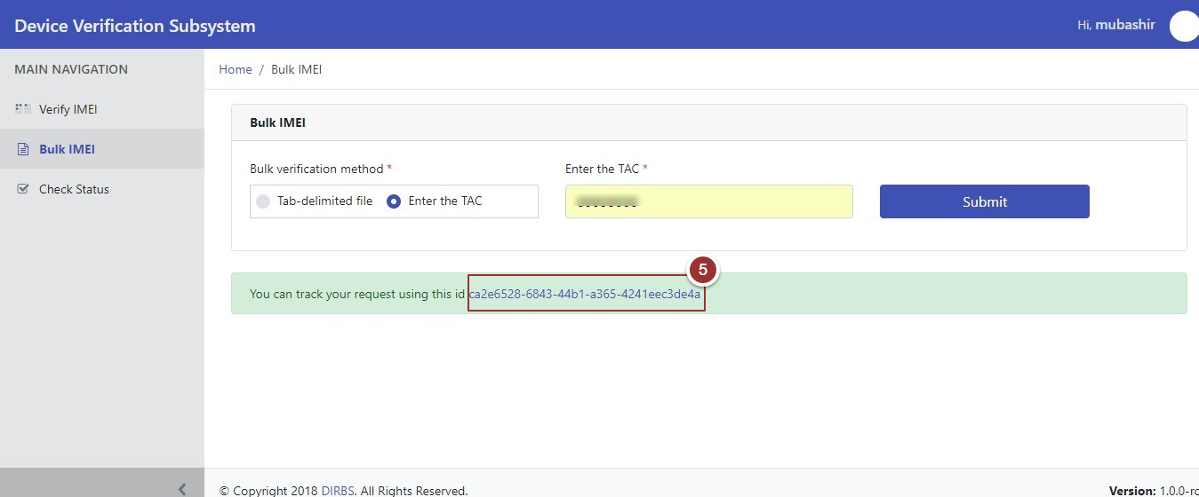

Figure 12-Tracking ID

After clicking on the tracking Id, it will redirect on a page where all the information related to the request would be displayed (Tracking Id, Current Status, Verification Method etc.)

**Note**: To check the status of the request perform steps 5-7 as per section 2.4.1.

## **Check Status**

1. To view complete device status, click on the “Check Status” tab under the “Main Navigation” heading

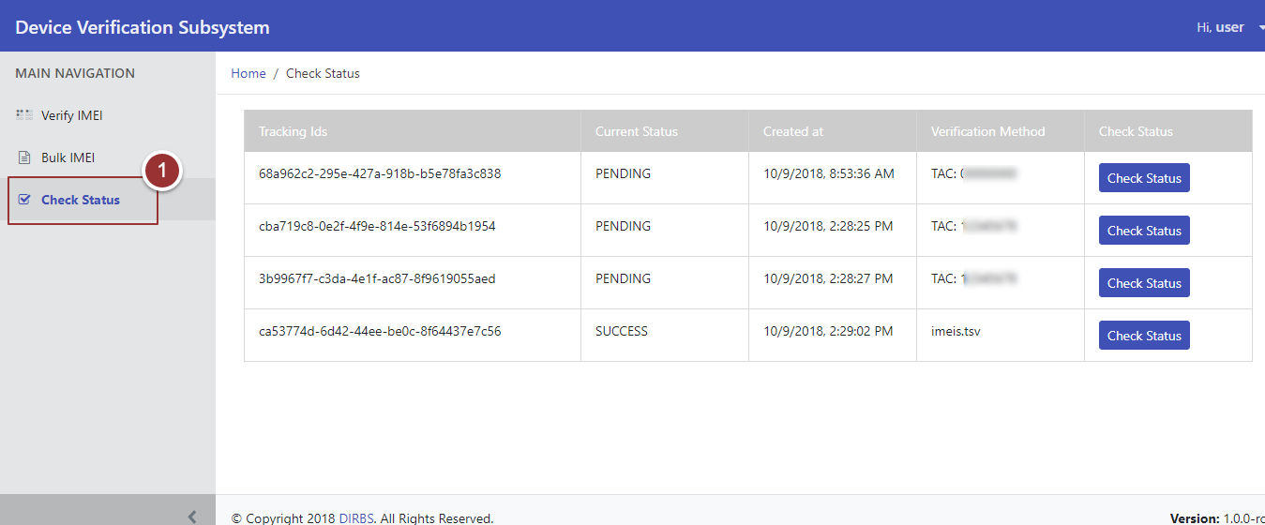Figure 13-Check Status Tab

1. Click on the “Check Status” button against particular tracking id

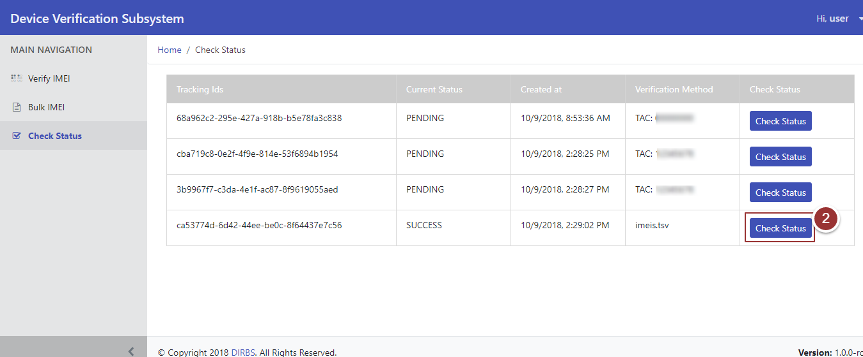Figure 14-Check Status Button

After Clicking on “Check Status” button, a table will display which contains status of the device information.

**Note:** Please wait for 2-3 minutes until required information populate.

1. To view the information of non-compliant IMEIs, click on the link to download the report

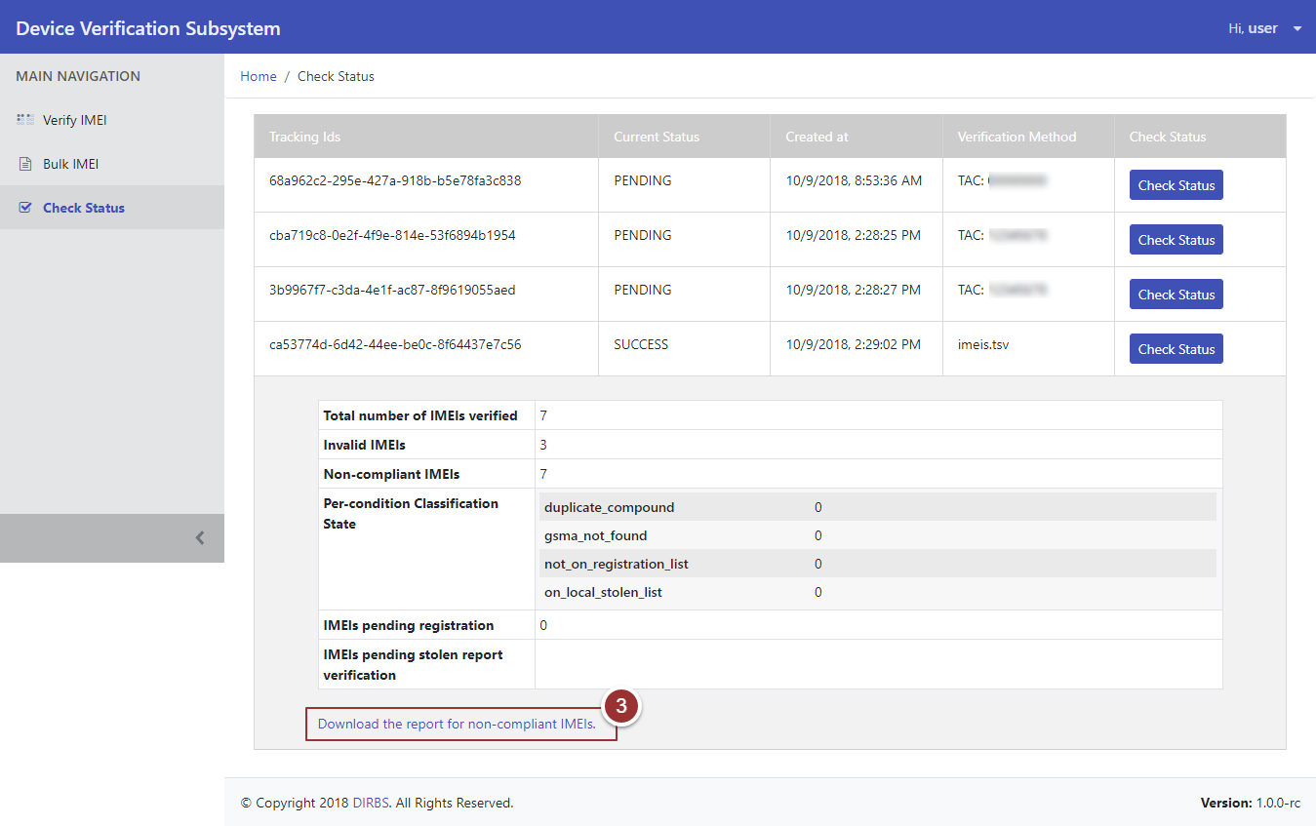Figure 15-Check Status Information Table