Device Verification Subsystem

Developer Guide

DVS-Developer-Guide-Android-App-Public

July 12, 2018

**Revision history**

| **Revision** | **Date** | **Description** |
| --- | --- | --- |
| A |  | Initial release |

Contents

1 Introduction 4

1.1 Purpose & Scope 4

1.2 Audience & Technical Stakeholder 4

1.3 Definitions, Acronyms & Abbreviations 4

1.4 References 4

1.5 Getting started 4

2 Installation 5

2.1 System Requirements 5

2.1.1 Software Requirements 5

2.1.2 Hardware Requirements 5

2.2 Operating System 5

2.3 Extracting Software Release 5

2.4 Manual Installation 6

3 Configuration 7

3.1 reCAPTCHA Configuration 7

3.2 App Configuration 8

4 Testing 9

5 Publish App 9

**Figures**

Figure 1- reCAPTCHA Configuration 7

Figure 2- Site Key 8

**Tables**

Table 1- Definitions, Acronyms & Abbreviations 4

# Introduction

## Purpose & Scope

This document provides:

* Installation instructions for the Device Verification Subsystem (DVS) Mobile app for public
* Instructions for running test commands/steps to verify DVS app installation

## Audience & Technical Stakeholder

This Installation and Deployment Guide is intended to be used by technical stakeholders of the Device Verification Subsystem Mobile app, who will be responsible for planning, performing, or maintaining the installation or deployment, such as the System Administrators and Developers.

## Definitions, Acronyms & Abbreviations

**Table 1- Definitions, Acronyms & Abbreviations**

| Term | Explanation |
| --- | --- |
| DIRBS | Device Identification, Registration & Blocking System |
| DVS | Device Verification Subsystem |
| OS | Operating System |
| URL | Universal Resource Locator |

## References

N.A.

## Getting started

The instructions provided in this document assume that the recommended equipment has been installed and configured with Ubuntu/Windows/Mac OS.

# Installation

1. The reader acknowledges and agrees that it is entirely and solely responsible for the selection and use of all third-party software modules downloaded and installed by this installation method, including securing all appropriate and proper rights of use to any of such third-party software modules and to comply fully with any terms of use that may apply to or accompany any such third-party software modules.

Qualcomm Technologies, Inc. does not undertake any obligations, duties, or other responsibilities in connection with the selection or use by the reader of any of such third-party software modules.

## System Requirements

### Software Requirements

* JDK 1.8 or more
* Android Studio 3.1.2
* Android SDK v27 (minimum)
* Minimum Android version 16
* Gradle 4.4
* Android Plugin version 3.1.2

### Hardware Requirements

Minimum hardware requirements to build DVS app using Android Studio.

* At least 3 GB of RAM
* At least 4GB of disk space
* Active Internet Connection

Minimum hardware requirements to test DVS app in Android device.

* Device’s Camera
* Active Internet Connection

## Operating System

This system can be installed and configured with Ubuntu/Windows/Mac OS.

## Extracting Software Release

The DVS software release is distributed as a tar.gz file. To extract the contents of the  
distribution, run:

tar xvzf dirbs-dvs-android-public-1.0.0.tar.gz

## Manual Installation

Import dirbs-dvs-android-public-1.0.0 in Android studio.

# Configuration

## reCAPTCHA Configuration

For reCAPTCHA configurations go to this [link](https://www.google.com/recaptcha/admin#list):

1. In Register a new site section enter label for app e.g. iOS DVS Public.
2. Select “Android” type of reCAPTCHA.
3. Enter Package Name.
4. Accept the reCAPTCHA Terms of Service
5. Click on “Register” button.

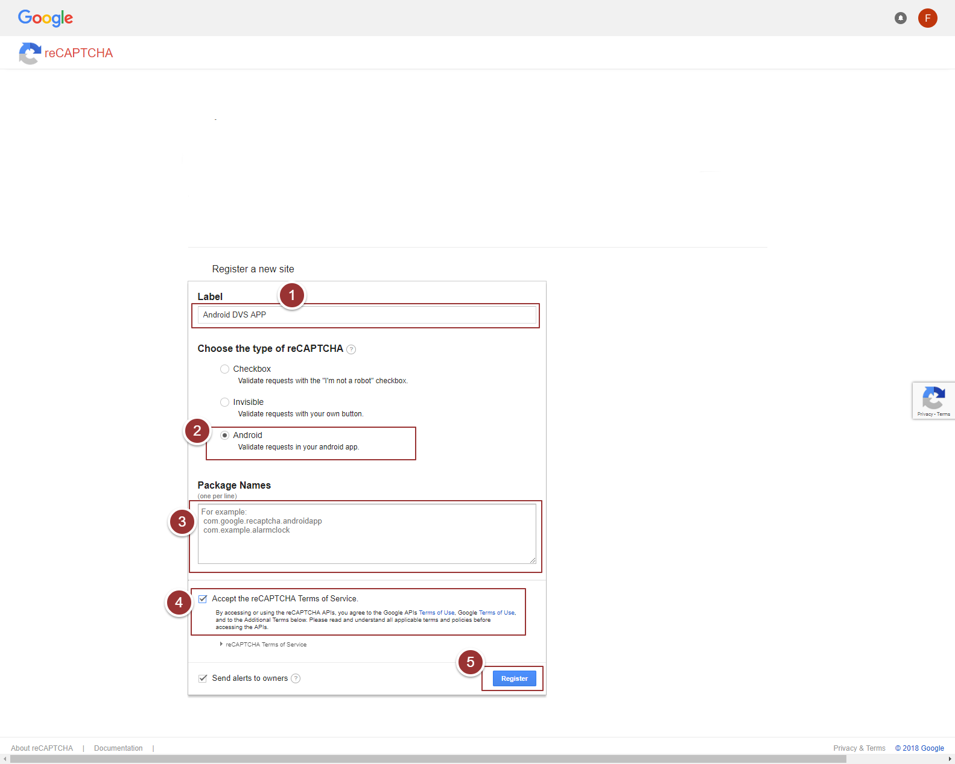

Figure 1- reCAPTCHA Configurations

1. Copy “Site Key”.

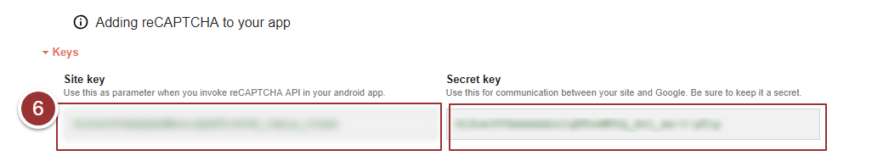

Figure 2- Site Key

**Note**: Make sure you mentioned the same “Secret Key” in DVS API Configurations.

## App Configuration

* To change the logo of app go to app/res/drawable folder and paste logo file but make sure the file name should be “company_logo.png”
* To change the colors of the app go to app/res/values/colors.xml file and mention hex color code of required color
* Open app/res/values/strings.xml file and add site key (copied in section 3.1 step 6) in value section of “reCAPTCHA_key”

<string name=”reCAPTCHA_key”>ENTER RECAPTCHA KEY HERE</string>

* Add API Gateway URL in value section of “api_gateway_url”

<string name=”api_gateway_url”>ENTER API GATEWAY URL HERE</string>

# Testing

To test the successful installation of app, run the app either on any physical device or on Android Emulator. For testing the app on physical device make sure that USB Debugging is enable. If you don’t know how to enable USB Debugging on your device visit this [link](https://www.embarcadero.com/starthere/xe5/mobdevsetup/android/en/enabling_usb_debugging_on_an_android_device.html).

# **Publish App**

To publish app on Google play store follow instruction given on this [link](https://developer.android.com/studio/publish/).