Device Verification Subsystem 1.0.0

User Guide (Authority Mobile App)

DVS-User-Guide-Authority-Mobile-App-1.0.0

June 19, 2018

Revision history

|  |  |  |
| --- | --- | --- |
| Revision | Date | Description |
| A |  | Initial release |

# **Contents**

1. **Introduction** **5**

1.1. Purpose 5

1.2. Supported OS Versions 5

1.3. Definitions, Acronyms, and Abbreviations 6

**2. App Description 7**

**3. App Navigation 10**

3.1. Log-In Screen 10

3.2. View Profile 12

3.3. Enter IMEI 14

3.4. Scan Barcode 18

**Figures**

Figure 1-Login Screen 10

Figure 2-Enter Credentials 11

Figure 3-Profile Icon 12

Figure 4-Profile Table 13

Figure 5-Enter IMEI 14

Figure 6-Device Status Table 15

Figure 7-Subscribers Seen With IMEI Table 16

Figure 8 Paired Subscribers Table 17

Figure 9-Scan Barcode 18

Figure 10-Allow Button 19

Figure 11-Scan Box 20

Figure 12-Scanned IMEI Window 21

Figure 13-Device Status table 2 22

**Tables**

Table 1-Supported OS Versions 5

Table 2-Definitions, Acronyms, and Abbreviations 6

Table 3 System Description 7

|  |
| --- |
|  |

# **Introduction**

The Device Verification Subsystem DVS mobile app is based on the subsystem of Device Identification, Registration and Blocking System (DIRBS) .It provides platform for Device Dealer(s), Mobile User(s) and Authorized User(s) to check and verify the status of IMEIs.

The Device Identification, Registration & Blocking System (DIRBS) is a country-wide system deployed in cooperation between the country regulator, operators in that country, and a technology partner that supports deployment. The system checks, identifies, and discourages non-compliant devices by verifying the installed base of devices currently active in a market and continuing to monitor as new devices are activated.

DIRBS can verify that:

* Devices have properly allocated identifiers and type approval
* Devices are not duplicated or stolen
* Device importation takes place through legal channels

## **Purpose**

This document is intended to give assistance to the user to use the DVS mobile app.

## **Supported OS Versions**

Table 1-Supported OS Versions

|  |  |
| --- | --- |
| OS | Version |
| Android | 4.1 |
| iOS | 9.0 |

## **Definitions, Acronyms, and Abbreviations**

Table 2-Definitions, Acronyms, and Abbreviations

|  |  |
| --- | --- |
| ****Term**** | ****Definition**** |
| **DIRBS** | **Device Identification Registration and Blocking System** |
| IAM | Identity Access Management |
| DVS | Device Verification Subsystem |
| MSISDN | Mobile Subscriber Integrated Services Directory Number |
| IMEI | International Mobile Equipment Identity |

# **App Description**

Table 3-System Description

|  |  |
| --- | --- |
| ****Feature /Sections**** | ****Purpose**** |
| **Login Screen** | * To access the app, authorized user first needs to enter his/her credentials on login page, this login page authenticate the user from IAM and redirects user to the DVS mobile app |
| Enter IMEI | * Takes the valid IMEI as input. Enter IMEI of device to be verified |
| Scan Barcode | Allows user to scan barcode of the device |
| Device Status | Displays the complete status of the device in a table.  **IMEI**  Displays the entered IMEI  **Brand**  Displays the brand name of the device  **Model Name**  Displays the model name of the device  **Model Number**  Displays the model number of the device  **Manufacturer**  Displays the name of the company/country where the device is manufactured  **Device Type**  Displays the device type i.e. smartphone, tablet etc.  **Operating System**  Displays the operating system of the device i.e. Android or iOS  **Radio access technology**  Displays the radio access technology(s) of the device i.e. 2G, 3G, 4G, 5G etc.  **Registration Status**  Displays the status of IMEI i.e. Registered, Pending registration, Not registered  **IMEI Compliance Status**  Displays the status of IMEI i.e. Compliant, Non-Compliant  **Lost/stolen Status**  Displays the status of IMEI i.e. Lost/ stolen (if applicable )  **Block as of Date**  Displays the block date of the device  **Per-Condition Classification States**  All classification states are configurable parameters (GSMA not found, Duplicate, Local Stolen, Duplicate Compound) are coming from the core |
| Subscribers Seen with IMEI table | Displays list of IMSI(s) and MSISDNs seen on the network with particular IMEI |
| Paired Subscribers table | Displays list of last seen paired IMSI(s) with particular IMEI |

# **App Navigation**

## **Log-In Screen**

1. Click on the “login” button

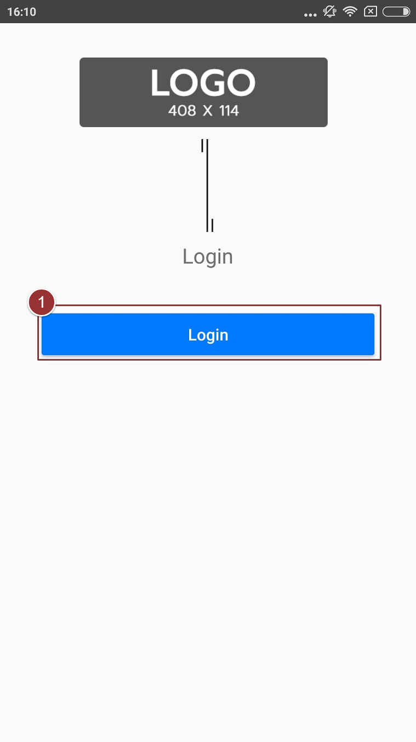

Figure 1-Login Screen

1. Now, enter the “Username” and “password”
2. Click on the “Login” button

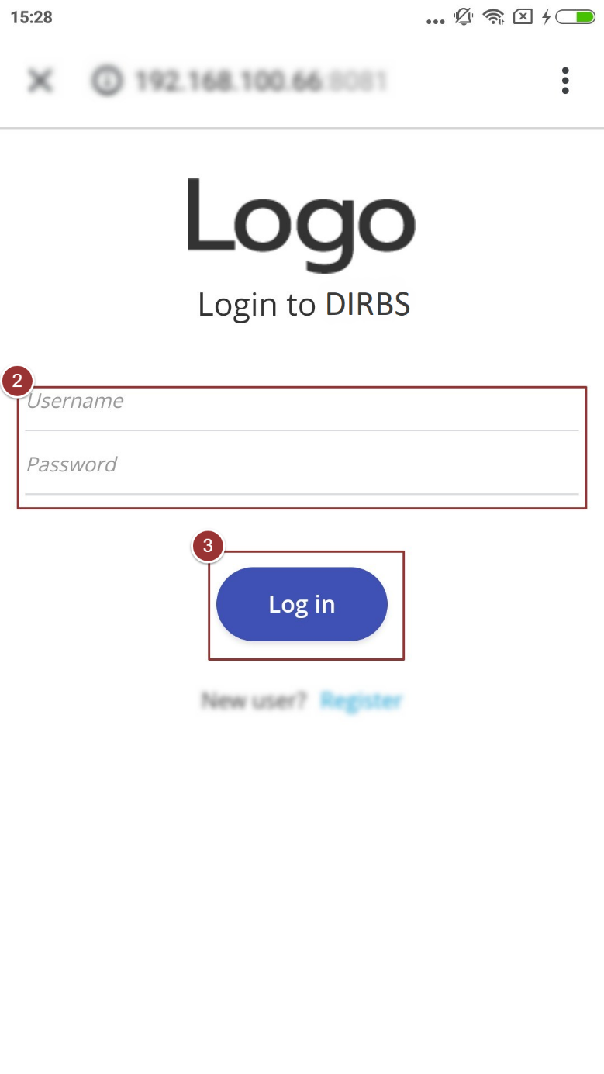

Figure 2-Enter Credentials

## **View Profile**

1. To view profile of the user tap on the “Profile “icon

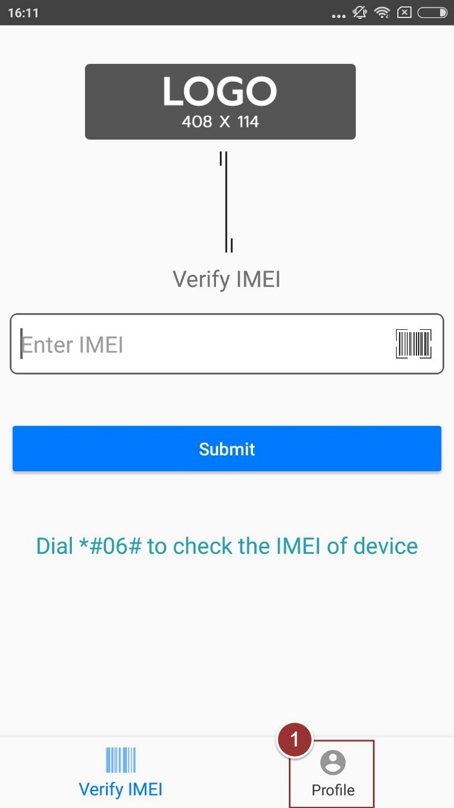

Figure 3-Profile Icon

User information (i.e. Name, Username, and Email) will display in a table

1. To logout from the app tap on the “Logout” button

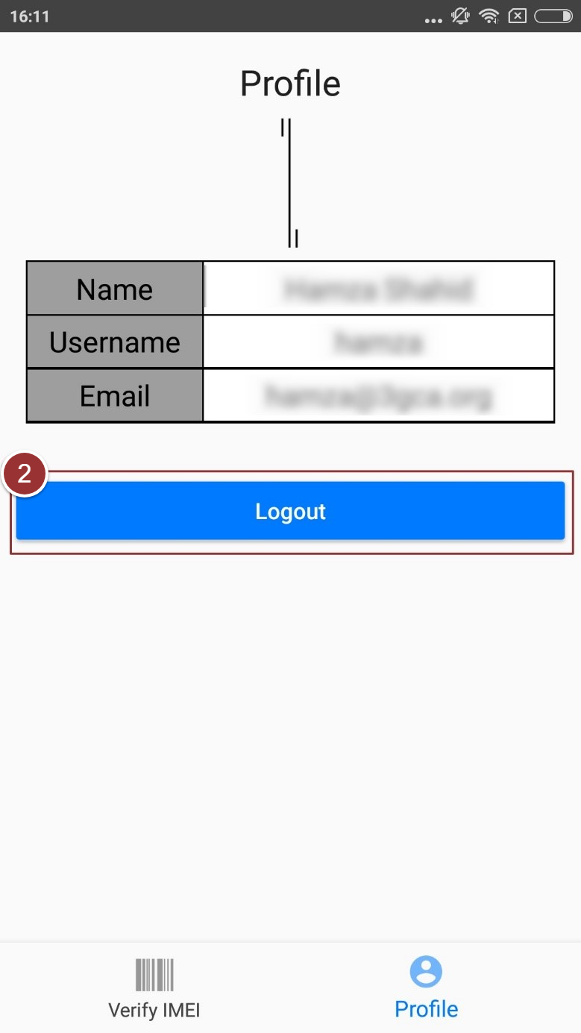

Figure 4-Profile Table

## **Enter IMEI**

1. Enter the IMEI in the respective field

**Note**: IMEI can contain alphanumeric characters (0-9, A-F, a-f). The length of the IMEI should be between 14-16 characters

1. Tap on the “Submit” button

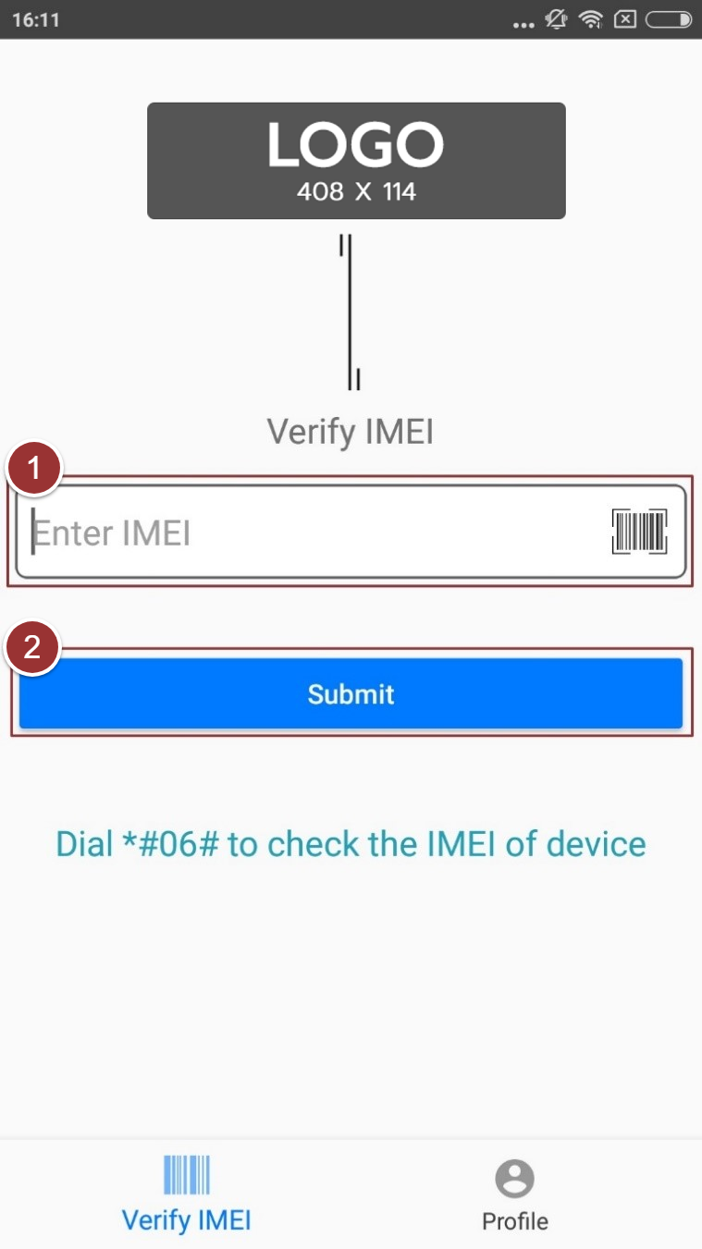

Figure 5-Enter IMEI

Status of the device will display in a table with details (i.e. IMEI, Brand, Model Name, IMEI Compliance Status etc.)

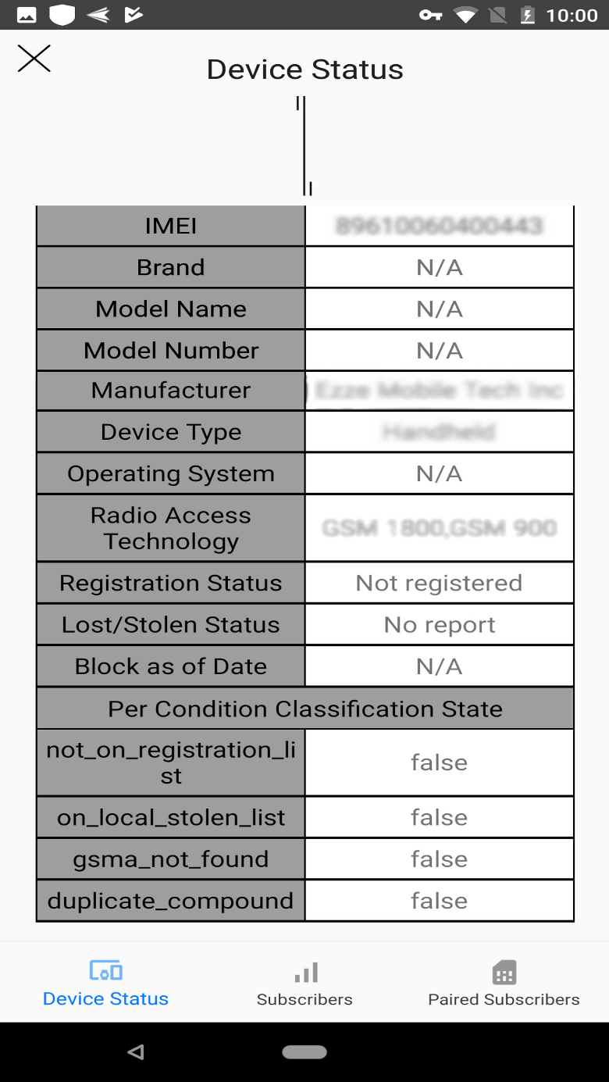

Figure 6-Device Status Table

1. To see the IMSI(s) and MSISDN(s) seen with IMEI on the network, tap on the “Subscribers” icon

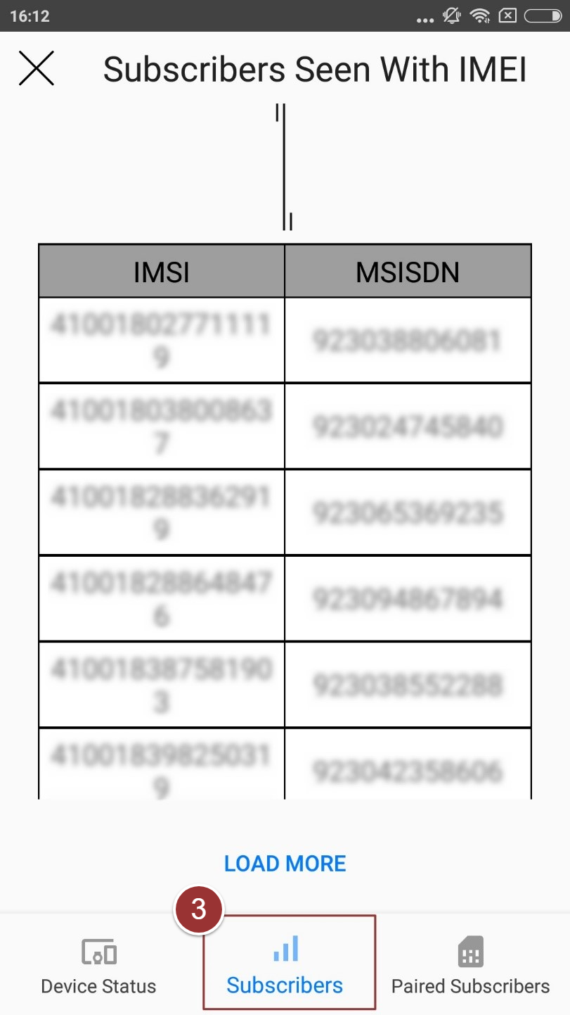

Figure 7-Subscribers Seen With IMEI Table

1. To see the last seen paired IMSI(s), tap on the “Paired Subscribers” icon

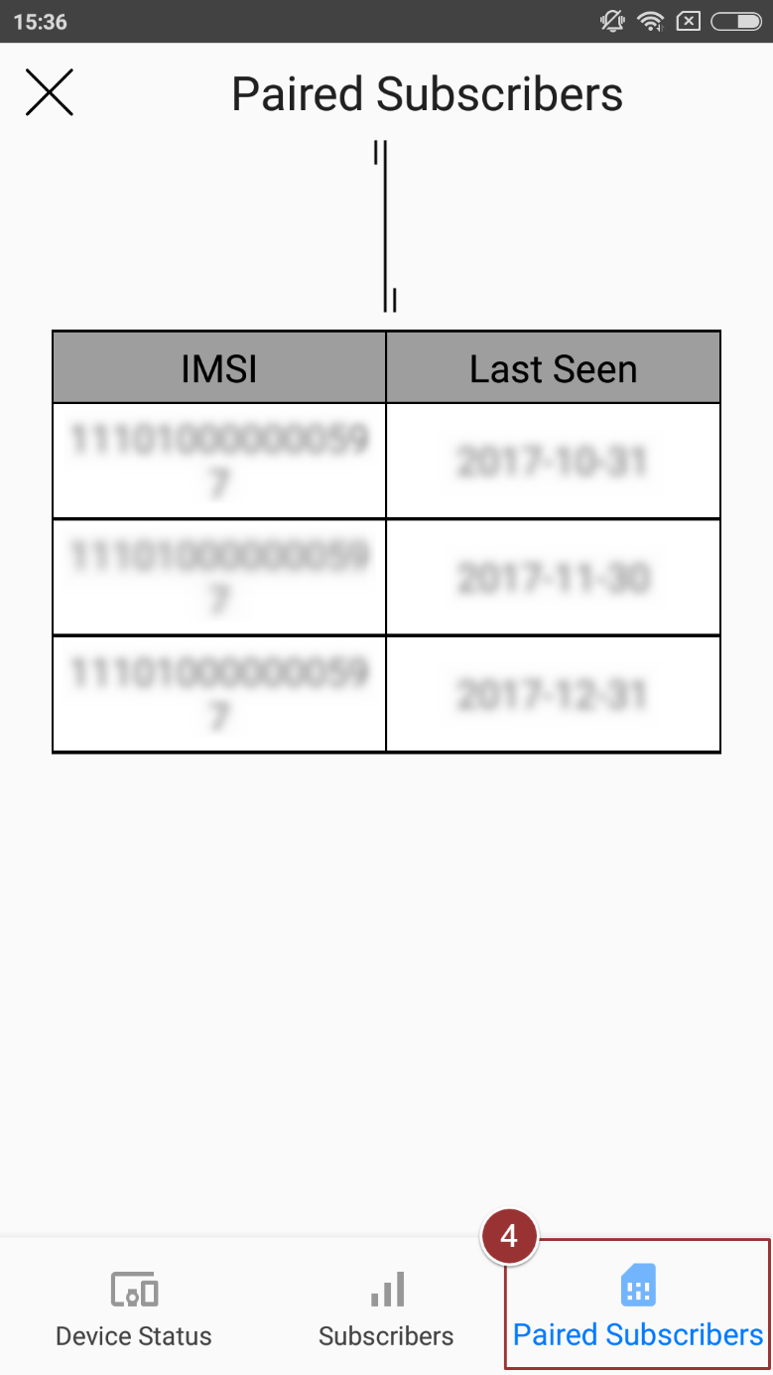

Figure 8 Paired Subscribers Table

## **Scan Barcode**

1. To scan the barcode, tap on the “Scan Barcode” icon

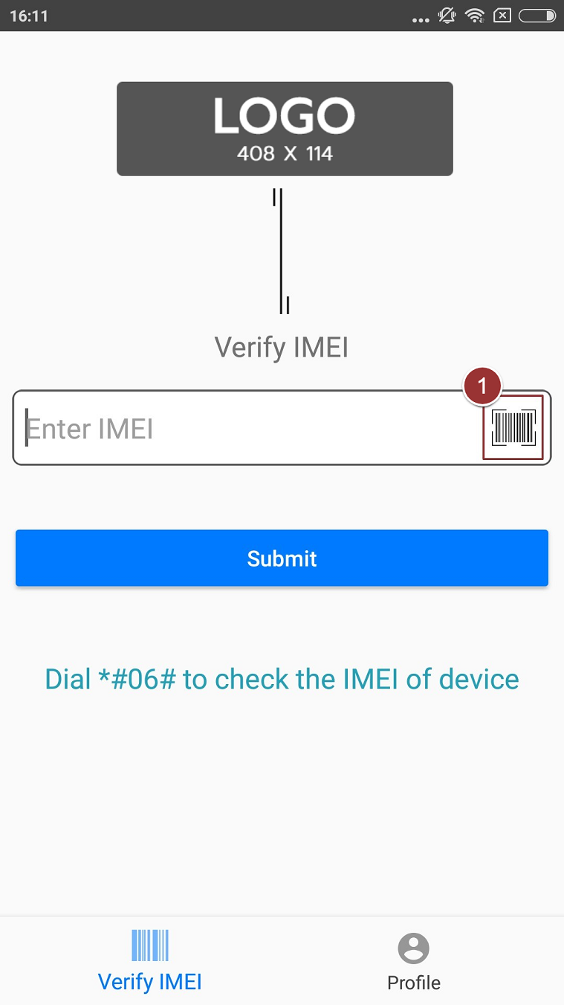

Figure 9-Scan Barcode

1. Allow the app to access device’s camera

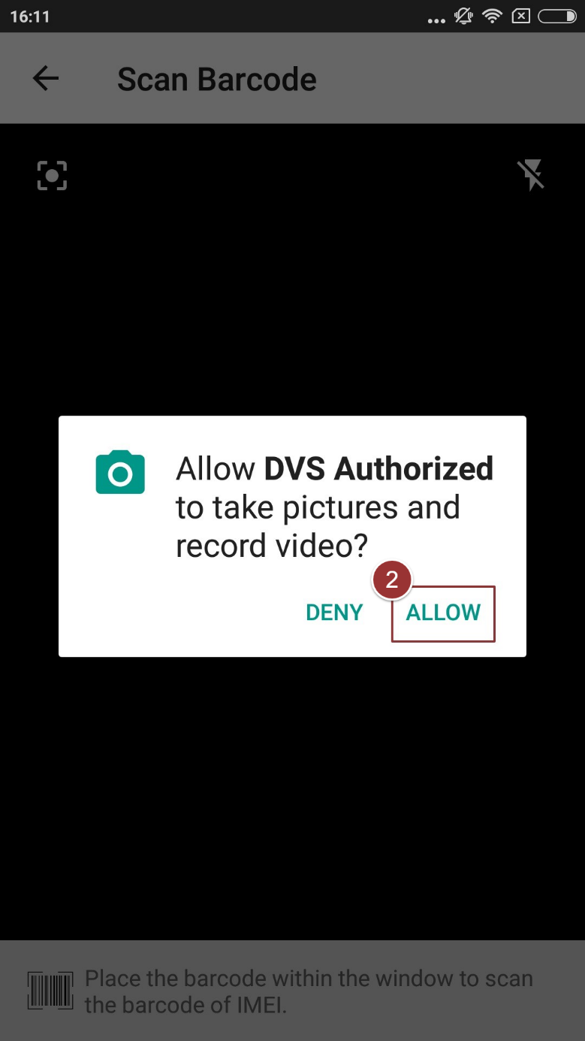

Figure 10-Allow Button

1. Place the barcode within the window to scan the barcode of the IMEI

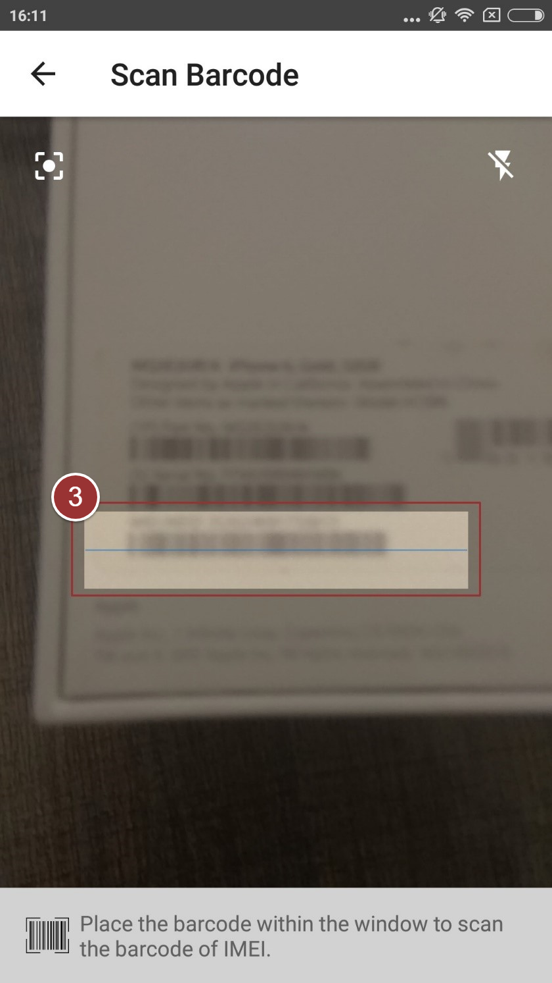

Figure 11-Scan Box

1. Tap on the “Submit ” button

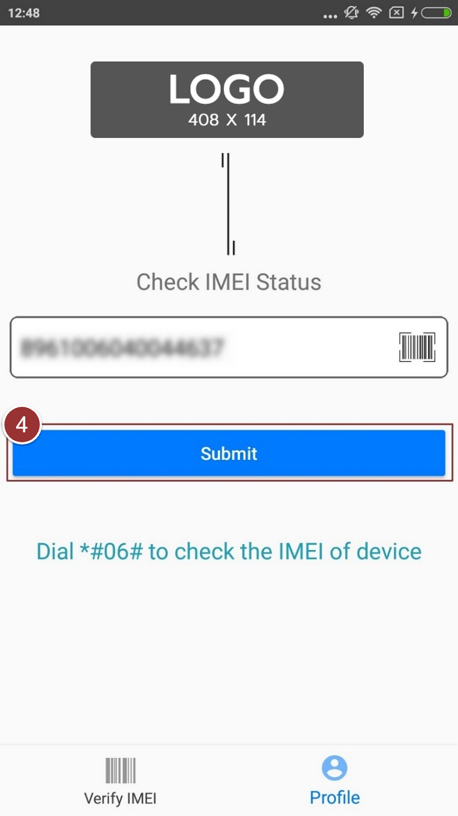

Figure 12-Scanned IMEI Window

Details of the device will display in a table i.e. IMEI, Brand, Model Name, IMEI Compliance Status etc.



Figure 13-Device Status table 2

**Note**: To see more information about the device status perform the steps 3-4 as per section 3.3