Device Verification Subsystem

Developer Guide

DVS-Developer-Guide-iOS-App-Authority

July 12, 2018

Revision history

| Revision | Date | Description |
| --- | --- | --- |
| A |  | Initial release |

Contents

1 Introduction 4

1.1 Purpose & Scope 4

1.2 Definitions, Acronyms & Abbreviations 4

1.3 References 4

1.4 Getting started 4

2 Installation 5

2.1 System Requirements 5

2.2 Software Requirements 5

2.3 Hardware Requirements 5

2.4 Operating System 5

2.5 Extracting Software Release 6

2.6 Manual Installation 6

3 Configuration 7

3.1 Keycloak Configuration 7

3.2 App Configuration 7

4 Testing 11

5 Publish App 11

**Figures**

Figure 1- Add IAM URL 7

Figure 2- Add Realm Name 8

Figure 3- Add Client ID 9

Figure 4- Add API Gateway URL 10

**Tables**

Table 1- DEfinitions, Acronyms & Abreviations 4

# Introduction

## Purpose & Scope

This document provides:

* Installation instructions for the Device Verification Subsystem iOS app 1.0.0 for authority
* Instructions for running test commands to verify DVS installation

## Audience & Technical Stakeholder

This Installation and Deployment Guide is intended to be used by technical stakeholders of the Device Verification Subsystem Mobile app, who will be responsible for planning, performing, or maintaining the installation or deployment, such as the System Administrators and Developers.

## Definitions, Acronyms & Abbreviations

**Table 1- Definitions, Acronyms & Abreviations**

| Term | Explanation |
| --- | --- |
| DIRBS | Device Identification, Registration & Blocking System |
| DVS | Device Verification Subsystem |
| OS | Operating System |

## References

N.A

## Getting started

The instructions provided in this document assume that the recommended equipment has been installed and configured with Mac OS.

# Installation

1. The reader acknowledges and agrees that it is entirely and solely responsible for the selection and use of all third-party software modules downloaded and installed by this installation method, including securing all appropriate and proper rights of use to any of such third-party software modules and to comply fully with any terms of use that may apply to or accompany any such third-party software modules.

Qualcomm Technologies, Inc. does not undertake any obligations, duties, or other responsibilities in connection with the selection or use by the reader of any of such third-party software modules.

## System Requirements

## Software Requirements

* Xcode 9.4.1
* Minimum iOS version 9.0
* Mac OS 10.13.4

## Hardware Requirements

Minimum hardware requirements to run DVS app using xcode.

* At least 8 GB of RAM
* Processor: 2.5 GHz Intel Core i5
* At least 20GB of disk space
* Internet Connection

Minimum hardware requirements to test DVS app on iOS device.

* iOS Device with Camera
* Internet Connection

## Operating System

This system can be installed and configured with Mac OS.

## Extracting Software Release

The DVS software release is distributed as a tar.gz file. To extract the contents of the  
distribution, run:

tar xvzf dirbs-dvs-ios-authority-1.0.0.tar.gz

## Manual Installation

Go to dirbs-dvs-ios-authority-1.0.0 and open DVS.xcworkspace file in xcode.

# Configuration

## Keycloak Configuration

* Loggedin in IAM
* Go to “Clients” section
* Click on “DVS-app” client
* In settings tab write callback URL “com.qualcomm.auth.entity.dvs://oauth2Callback” in “Valid Redirect URL” field

## App Configuration

* To change any icon open Assets.xcaassets file in Xcode and select required icon
* Open info.plist file and add IAM URL in “IamUrl” field

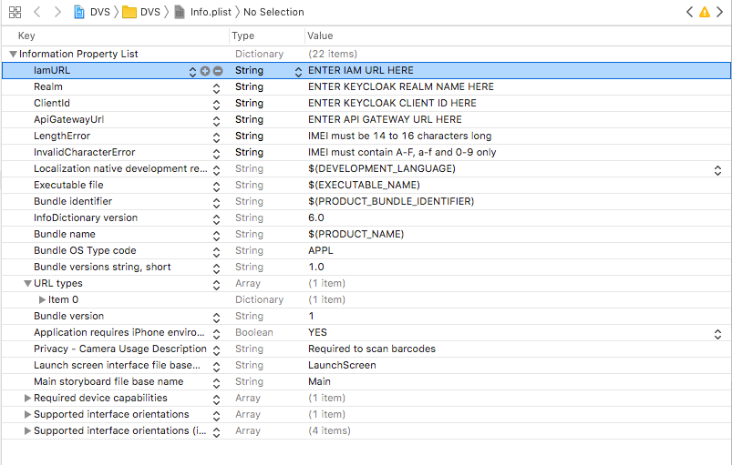**Figure 1- Add IAM URL**

* Enter Realm name in “Realm” field

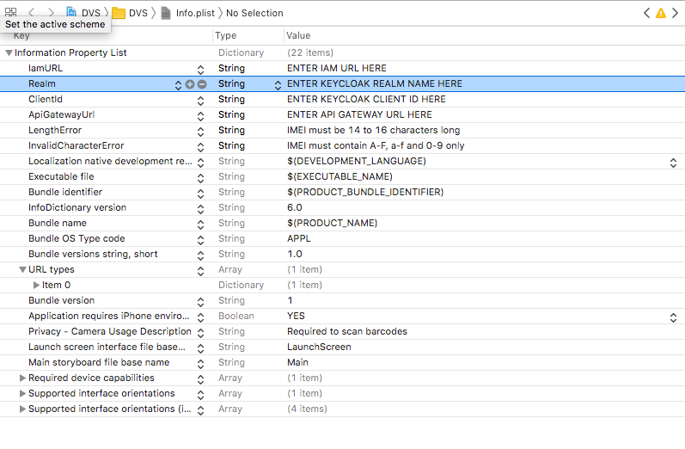

**Figure 2- Add Realm Name**

* Enter Client ID in “ClientId” field

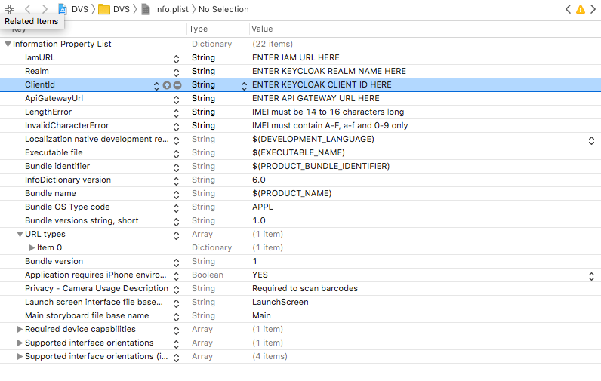**Figure 3- Add Client ID**

* Enter URL of API Gateway in “ApiGatewayUrl” field

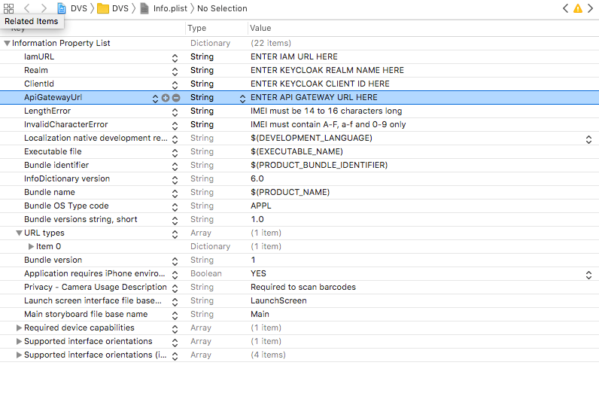**Figure 4- Add API Gateway URL**

# Testing

To test the successful installation of app, run the app either on any physical device or on iOS simulator.

# Publish App

To publish app on Apple app store visit this [link](https://help.apple.com/app-store-connect/).