Device Verification Subsystem

Developer Guide

DVS-Developer-Guide-iOS-App-Public

July 12, 2018

**Revision history**

| **Revision** | **Date** | **Description** |
| --- | --- | --- |
| A |  | Initial release |

Contents

1 Introduction 4

1.1 Purpose & Scope 4

1.2 Definitions, Acronyms & Abbreviations 4

1.3 References 4

1.4 Getting started 4

2 Installation 5

2.1 System Requirements 5

2.2 Software Requirements 5

2.3 Hardware Requirements 5

2.4 Operating System 5

2.5 Extracting Software Release 5

2.6 Manual Installation 6

3 Configuration 7

3.1 Keycloak Configuration 7

3.2 App Configuration 8

4 Testing 11

5 Publish App 11

# Introduction

## Purpose & Scope

This document provides:

* Installation instructions for the Device Verification Subsystem iOS app 1.0.0 for public
* Instructions for running test commands to verify DVS installation

## Audience & Technical Stakeholder

This Installation and Deployment Guide is intended to be used by technical stakeholders of the Device Verification Subsystem Mobile app, who will be responsible for planning, performing, or maintaining the installation or deployment, such as the System Administrators and Developers.

## Definitions, Acronyms & Abbreviations

**Table 1- Definitions, Acronyms & Abbreviations**

| Term | Explanation |
| --- | --- |
| DIRBS | Device Identification, Registration & Blocking System |
| DVS | Device Verification Subsystem |
| OS | Operating System |
| URL | Universla Recource Locator |

## References

N.A

## Getting started

The instructions provided in this document assume that the recommended equipment has been installed and configured with Mac OS.

# Installation

1. The reader acknowledges and agrees that it is entirely and solely responsible for the selection and use of all third-party software modules downloaded and installed by this installation method, including securing all appropriate and proper rights of use to any of such third-party software modules and to comply fully with any terms of use that may apply to or accompany any such third-party software modules.

Qualcomm Technologies, Inc. does not undertake any obligations, duties, or other responsibilities in connection with the selection or use by the reader of any of such third-party software modules.

## System Requirements

### Software Requirements

* Xcode 9.4.1
* Minimum iOS version 9.0
* Mac OS 10.13.4

### Hardware Requirements

Minimum hardware requirements to run DVS app using xcode.

* At least 8 GB of RAM
* Processor: 2.5 GHz Intel Core i5
* At least 20GB of disk space
* Internet Connection

Minimum hardware requirements to test DVS app on iOS device.

* iOS Device with Camera
* Internet Connection

## Operating System

This system can be installed and configured with Mac OS.

## Extracting Software Release

The DVS software release is distributed as a tar.gz file. To extract the contents of the  
distribution, run:

tar xvzf dirbs-dvs-ios-public-1.0.0.tar.gz

## Manual Installation

## Go to dirbs-dvs-ios-public-1.0.0 and open DVS.xcworkspace file in xcode.

# Configuration

## Recaptcha Configuration

For reCAPTCHA configurations go to this [link](https://www.google.com/recaptcha/admin#list):

1. In Register a new site section enter label for app e.g. iOS DVS Public
2. Select “Invisible” type of reCAPTCHA
3. Enter Domain Name.
4. Accept the reCAPTCHA Terms of Service.
5. Click on “Register” button.

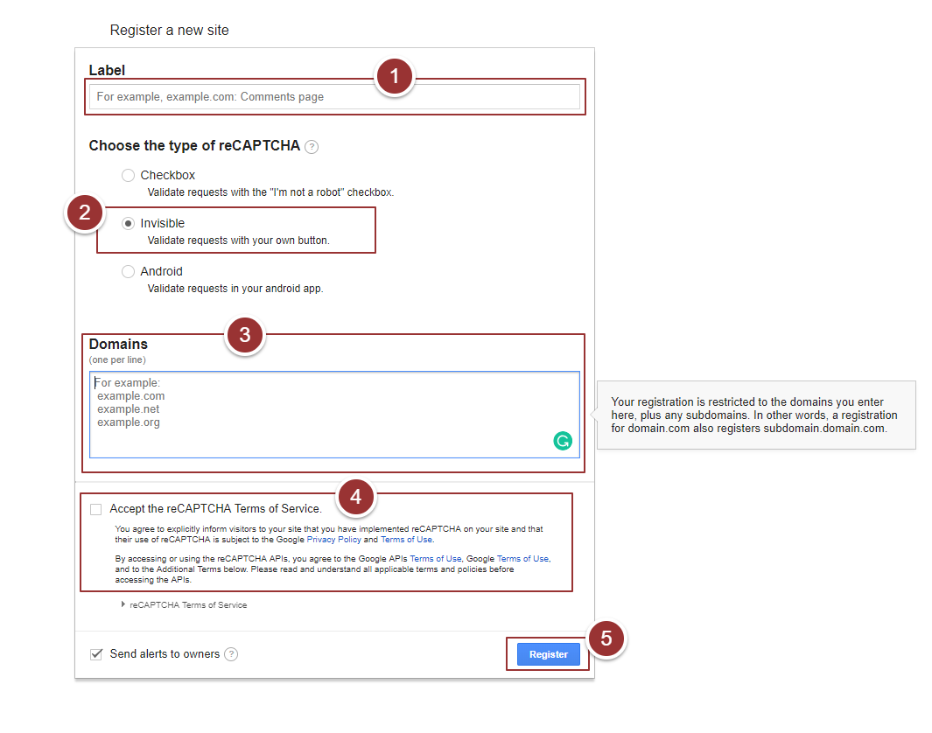

Figure 1- reCAPTCHA Configurations

1. Copy “Site Key”.

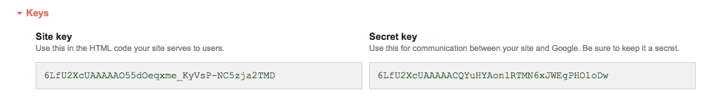

Figure 2- Site Key

**Note**: Make sure you mention the same “Secret Key” in DVS API Configurations.

## App Configuration

* To change any icon open Assets.xcaassets file in Xcode and select your required icon
* Open info.plist file and enter API Gateway URL “APIGatewayURL” field

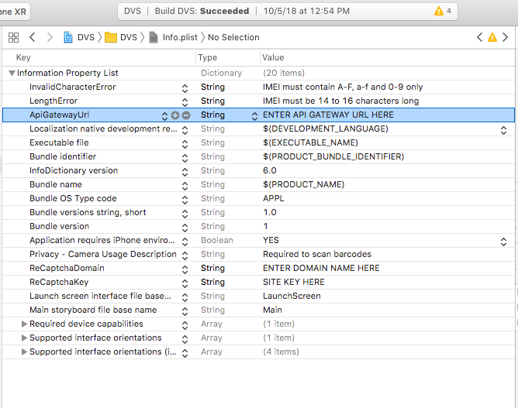

Figure 3- Add API Gateway URL

* Enter the domain name in “ReCaptchaDomain” field which you have mentioned in step 3 of Section 3.1

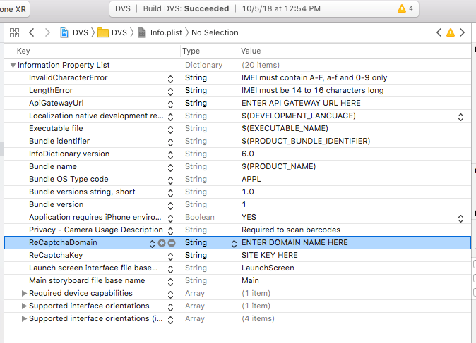

Figure 4- Add reCAPTCHA Domain

* Enter the site key (copied in Section 3.1 step 6) in value section of “ReCaptchaKey” field

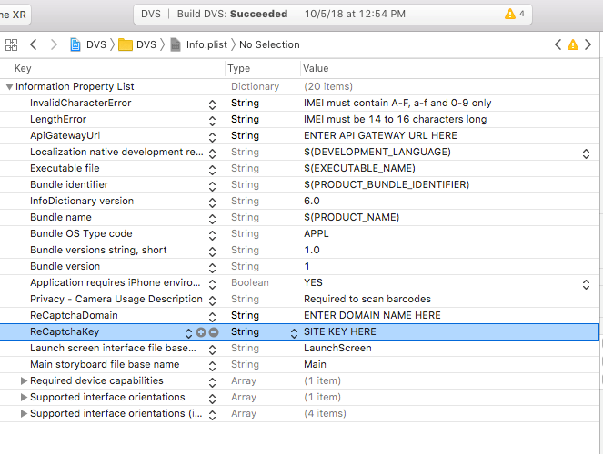

Figure 5- Add reCAPTCHA Key

# Testing

To test the successful installation of app, run the app either on any physical device or on iOS simulator.

# Publish App

To publish app on Apple app store follow instruction given on this [link](https://help.apple.com/app-store-connect/).