Date: 3-22-2013

To: Prabhjot (Nicky) Sandhu and Eli Ateljevich

From: En-Ching Hsu

Delta Modeling Section

Bay-Delta Office

Department of Water Resources

Subject: DSM2 General Transport Model compilation and packaging

This memo presents step-by-step instruction on compiling and packaging DSM2 GTM.

## Required Software

1. Visual Studio 2008
2. Intel Fortran Composer 2013
3. Subversion <http://subversion.apache.org/packages.html>
4. Tortoise SVN <http://tortoisesvn.net/downloads>
5. Flex and Bison packages in Cygwin <http://www.cygwin.com/setup.exe>

(make sure ../cywin/bin set in the environment path)

1. Inno Setup Compiler v5.2.3 <http://files.jrsoftware.org/is/5/isetup-5.2.3.exe>
2. Python <http://www.python.org/download/>
3. Java Development Kit <http://java.sun.com/javase/downloads/index.jsp>
4. Microsoft Office 2007
5. Apache ANT http://ant.apache.org/bindownload.cgi

**Checkout DSM2_GTM project**

1. DSM2 release version 8.1.1 Subversion 2146 is branched out to create desired outputs for GTM. Checkout this folder hosted on DWR SVN server and places them parallel to local DSM2 folder.

<http://dminfo:8686/svn/repository/models/branches/dsm2_v8_gtm>

1. Checkout the following folders hosted on DWR SVN server and put them in the same directory, e.g., D:\models\ (This will be moved to dsm2_v8 eventually for one step packaging?)

<http://dminfo:8686/svn/repository/models/branches/dsm2_gtm>

1. Confirm the check-out folders hierarchy and names as following (Figure 1)

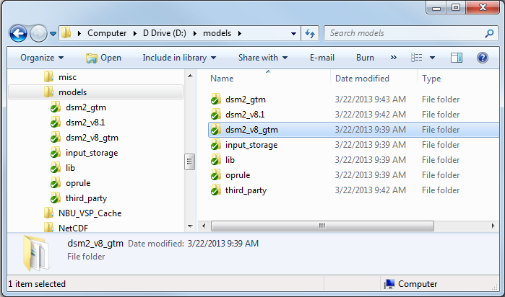

Figure 1

**Compiling DSM2_GTM**

1. Compiling DSM2: Follow this instruction under DSM2_v8.1_gtm and make sure that hydro.exe and qual.exe can be successfully created. (Details are skipped here.)
2. There are two drivers in GTM (Figure 2). One is “gtm” which is the main program to run GTM and the other is “test_driver” which is used to perform unit test for all components. Right click on those two projects and change their properties. As for now, we need to increase stack memory to keep it working (Figure 3). Bad practice! I will try to avoid this by reading data with slices.

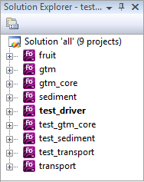

Figure 2

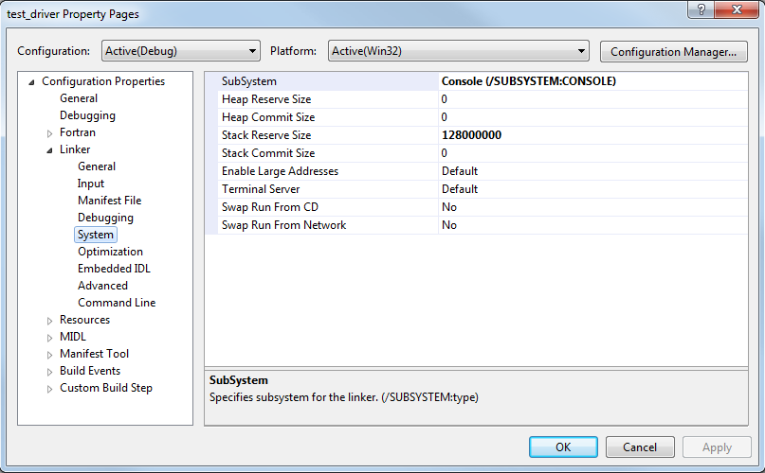

Figure 3

**Running DSM2_GTM Test**

1. Specify working directory for test_driver project and place test_hydro.h5 and test_hydro_fine.h5 those two HDF5 files under that folder.

\\delta-mod\YDrive\Projects\QUAL-GTM\testdata

1. Right click on test_driver project and run Debug/start new instance, this should return unit test results. (Only test_gtm_core is activated, test_transport and test_sediment are commented out for now.)

**Running DSM2_GTM Program**

1. Specify working directory for test_driver project and place your HDF5 files under that folder, e.g., historical.h5.
2. Right click on gtm project and run Debug/start new instance, this will run the main program. (I used this mainly to check mass balance interpolation for entire delta, so lots of hard-coded component and no cleanup.)