Date: 4/21/2010

To: Jamie Anderson

Cc: Prabhjot (Nicky) Sandhu, Tara Smith

From: Kevin Kao

Delta Modeling Section

Bay-Delta Office

Department of Water Resources

Date: 7/12/2010

Rev 1: Eli Ateljevich

Yu Zhou

Subject : DSM2 version 8 compilation and packaging assuming a minor (bug-fix) release

This memo presents step-by-step instruction on compiling and packaging DSM2 version 8 assuming a minor (bug-fix) release. Please note that DSM2 project may be reorganized and moved to an open-source server in the near future. Please consult with Nicky or Eli for more information.

**Required Software**

1. Visual Studio 2008
2. Intel Fortran Compiler 11
3. Subversion <http://subversion.apache.org/packages.html>
4. Tortoise SVN <http://tortoisesvn.net/downloads>
5. Flex and Bison packages in Cygwin <http://www.cygwin.com/setup.exe>

(make sure ../cywin/bin set in the environment path)

1. Inno Setup Compiler v5.2.3 <http://files.jrsoftware.org/is/5/isetup-5.2.3.exe>
2. Python <http://www.python.org/download/>
3. Java Development Kit <http://java.sun.com/javase/downloads/index.jsp>
4. Microsoft Office 2007

**Visual Studio Configurations**

1. Start Visual Studio 2008, go to “Tools → Options → VC++ Directories → Include Files” (See Figure 1)
2. Add paths to JDK include files (See Figure 2)
3. Go to the library section instead of the include section: “Tools → Options → VC++ Directories → Library Files”. Add the fortran library location. This will be something like C:\Program Files (x86)\Intel\Compiler\11.1\065\lib\ia32. You should find a file ifconsol.lib in this directory.

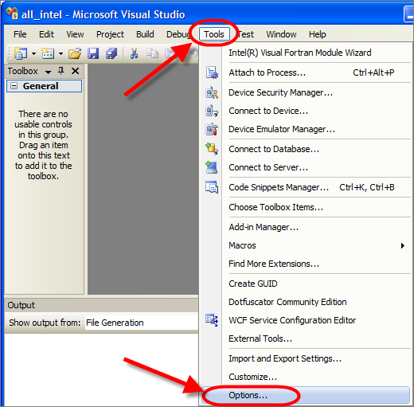

Figure

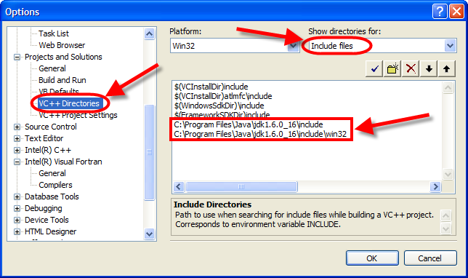

Figure

**DSM2 Versioning**

The latest DSM2 release version is 8.0.5 Subversion: 1945.

DSM2 is currently on a branch versioned as 8_0, which defines the first two digits of DSM2 version. The 3rd digit is used for minor (bug-fix) release, and it is recorded in the tag. The subversion number is embedded automatically at compilation time. To modify or increment DSM2 version number, please edit the version no in the following 3 files:

D:\delta\models\dsm2\src\common version_generate.py

D:\delta\models\dsm2_distribute\dsm2\install copy_hydro_qual_ptmDLL_notepad_style.bat

D:\delta\models\dsm2_distribute\dsm2\install\DSM2setup_Script_Generate.py

*BDO is using an ‘unstable trunk’ branching strategy in SVN for DSM2 development.

*trunk is for new module feature, while branch is for bug fix

*tag (the 3rd digit in the version number) is designed to use odd number for internal use, and even number for formal release

**Checkout DSM2 project**

1. Checkout the following folders hosted on DWR SVN server and put them in the same directory, e.g., D:\delta\models\

<http://dminfo:8686/svn/repository/models/branches/dsm2_v8_0>

<http://dminfo:8686/svn/repository/models/branches/input_storage_v1_0>

<http://dminfo:8686/svn/repository/models/branches/oprule_v1_0>

<http://dminfo:8686/svn/repository/models/branches/dsm2_distribute_v8_0>

<http://dminfo:8686/svn/repository/models/trunk/third_party>

<http://dminfo:8686/svn/repository/models/trunk/lib>

1. Rename the folder “input_storage_v1_0” to “input_storage”, “oprule_v1_0” to “oprule”, “dsm2_distribute_v8_0” to “dsm2_distribute”; “dsm2_v8_0” would be kept the same with the version number (See Figure 3)

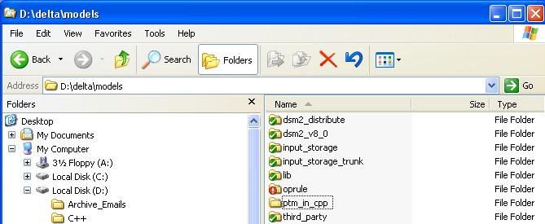

Figure

**Compiling DSM2_v8**

1. Compile Input_Storage library:

Use Visual Studio 2008 to open the following solution file and compile both Debug and Release versions:

D:\delta\models\input_storage\build_vs2008\all\input_storage_all.sln

(generate.py has been already set as automatic running before Build in different projects, no need to do the manual python compilation right now)

The compiled libraries will be automatically placed in the folder:

D:\delta\models\lib\

1. Compile Oprule library:

Use Visual Studio 2008 to open the following solution file and compile both Debug and Release versions.

D:\delta\models\oprule\build_vs2008\OpRuleAll.sln

The compiled libraries will be automatically placed in the folder

D:\delta\models\lib\

1. HEC DSS library:

HEC DSS libraries are precompiled and placed in the folder: (See Figure 4)

D:\delta\models\lib\

The Input_Storage and Oprule libraries are also contained in the folder. Steps 3 and 4 are usually conducted for version unification, to make sure the libraries are updated.

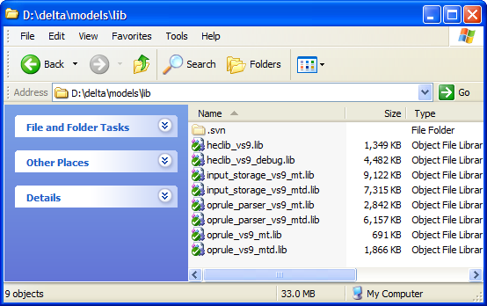

Figure

1. Compile DSM2:
2. Run “generate.py” in the folder “D:\delta\models\dsm2_v8_0\src\input_storage”.
3. Check the version number is correct in the Python script “version_generate.py“ under the folder “D:\delta\models\dsm2_v8_0\src\common”.
4. Do SVN commit and update on the two folders “D:\delta\models\dsm2_v8_0” and “D:\delta\models\dsm2_distribute”. The Python script “version_generate.py “ under the folder “D:\delta\models\dsm2\src\common” will be called automatically at compilation time to embed SVN version number into “version.inc”
5. Open the solution file “D:\delta\models\dsm2_v8_0\build_vs2008sp1_if11\all” with Visual Studio 2008 and compile using Rebuild All.
6. Double check that the svn subversion in version.fi is a single number (eg. “1945”), not something with a colon or letter in it (1940:1941 or 1942M). If you do have these, it means you either haven’t committed or updated thoroughly.
7. The release version of compiled binaries will be automatically placed in the folders:

D:\delta\models\dsm2_v8_0\build_vs2008sp1_if11\all\Release (hydro and qual.exe) D:\delta\models\dsm2_v8_0\build_vs2008sp1_if11\all\DLL\ (ptm.dll)

*ptm.jar is generated with related Java codes, which would be incorporated later

**Packaging DSM2**

1. Generate tutorial PDF files:
2. Delete all PDF files in “D:\delta\models\dsm2_distribute\dsm2\tutorials\pdf”
3. Run “doc2pdf.vbs” in “D:\delta\models\dsm2_distribute\dsm2\install\” to generate PDFs from tutorial word documents.
4. Copy compiled binaries to distribution folder:
5. Check the DSM2 version and paths to the compiled binaries are correct in the batch file “copy_hydro_qual_ptmDLL_notepad_style.bat” in the folder “D:\delta\models\dsm2_distribute\dsm2\install\”

Be aware of the version consistence for the 3 control files mentioned in ‘DSM2 Versioning’; if not, correct them and re-compile from 6-4 in the previous section

1. Run the batch file “copy_hydro_qual_ptmDLL_notepad_style.bat”
2. Generate packaging script:
3. Check the DSM2 version is correct in the Python script “DSM2setup_Script_Generate.py” in the folder “D:\delta\models\dsm2_distribute\dsm2\install\”.

Be aware of the version consistence for the 3 control files mentioned in ‘DSM2 Versioning’; if not, correct them and re-compile from 6-4 in the previous section

1. Run this Python script to generate Inno Setup script “DSM2setup_v8.iss”.
2. Create DSM2 installation file:

Run “DSM2setup_v8.iss” with Inno Setup Compiler v5.2.3

The installation file named “DSM2setup_8.X.Xrelease.XXXX.exe” will be created in the same folder, i.e., “D:\delta\models\dsm2_distribute\dsm2\install”

1. Quick-test installer:

Test installation on clean machine. Run historical hydro, qual_ec and ptm.

1. SVN Tag and version increment:

Create SVN release tag for both “dsm2” and “dsm2_distribute” folders. (See Figure 5).

Immediately increment DSM2 version number in the following three files:

D:\delta\models\dsm2\src\common\version_generate.py

D:\delta\models\dsm2_distribute\dsm2\install\copy_hydro_qual_ptmDLL_notepad_style.bat

D:\delta\models\dsm2_distribute\dsm2\install\DSM2setup_Script_Generate.py

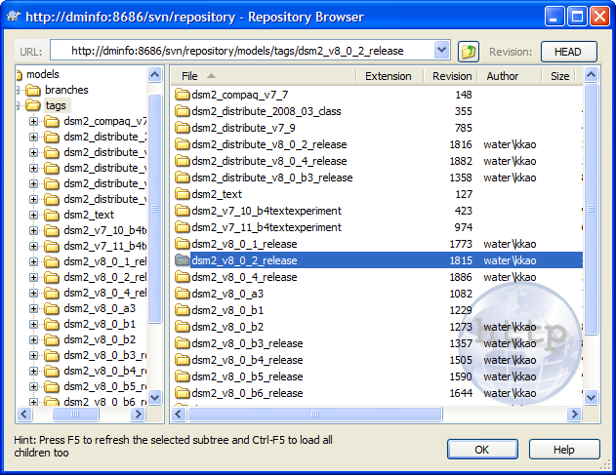

Figure