Tutorial 2: Reservoirs, Gates, Transfers
The purpose of this tutorial is to learn how to add reservoirs, gates, and transfers to the simple channel-only grid created in Tutorial 1. The grid we are going to create has the following configuration and specifications: The channel portion is identical to the simple channel model from Tutorial 1.
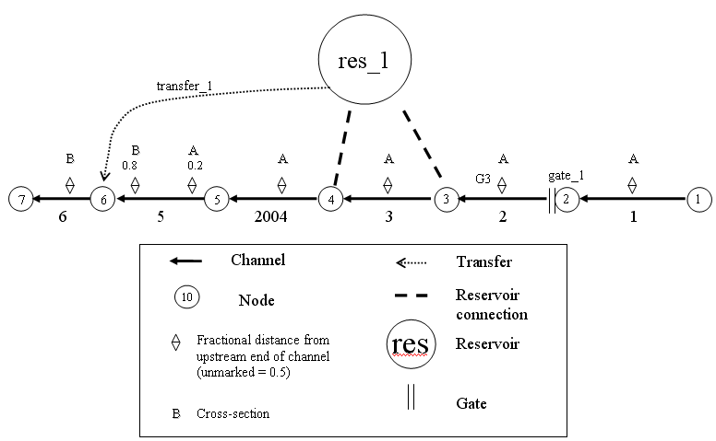
Figure 2 - Simple channel with a new reservoir, gate, and transfer.

The following steps will instruct you on how to create these new features and add them to the simple channel system.

- Create the reservoir:
  - In Windows Explorer, navigate to the directory: \{DSM2_home}\tutorial\simulations\simple\t2_reservoir_gate_transfer.
  - Open hydro.inp.
    - At the bottom of the file, Add the skeleton for the reservoir block:
RESERVOIR
NAME AREA BOT_ELEV
END
    - Enter the following values into the appropriate fields:
      - Name: res_1
      - Area (million sq ft): 40
      - Bottom elev (ft): -24
  - Note from Figure 2 that the reservoir has two connections; one at Node 3, and one at Node 4. These will go in a child table called RESERVOIR_CONNECTIONS. The header has the following form:.
RESERVOIR_CONNECTION
RES_NAME NODE COEF_IN COEF_OUT
END
    - Enter the following values into the appropriate fields for the first connection:
      - Res Name: res_1
      - Node: 3
      - Res Coef (in): 200
      - Res Coef (out): 200
    - Enter the following values into the appropriate fields for the second connection:
      - Res Name: res_1
      - Node: 4
      - Res Coef (in): 200
      - Res Coef (out): 200
  - Save the current settings.

- Create the Gate.
  - Now we are going to create the GATE table and its child table GATE_DEVICE. Note from Figure 2 that the gate is located at Node 2 of Channel 2. This gate consists of both a weir and a pipe. Therefore, two rows of information will be needed for the GATE_DEVICE table.
  - At the bottom of hydro.inp, add the skeleton for the GATE table:
GATE
NAME FROM_OBJ FROM_IDENTIFIER TO_NODE
END
  - In the Gates table:
    - Add a row and enter the following values into the appropriate fields:
      - Name: gate_1
      - Connected object: Channel
      - Name/No: 2
      - to Node: 2
    - Create a GATE_DEVICE table with the following fields:
GATE_NAME, DEVICE, STRUCTURE, NDUPLICATE. WIDTH, ELEV, HEIGHT, CF_TO_NODE, CF_FROM_NODE, DEFAULT_OP, POSITION_CONTROL
    - Enter the following values into the appropriate fields:
      - Gate Name: gate_1
      - Device: weir
      - Structure: weir
      - NDuplicate: 2
      - Width: 20
      - Elev: 2
      - Height: none (the weir is open and the gate is high)
      - CF from Node: 0.8
      - CF to Node: 0.8
      - Default Op: gate_open
      - Position Control: gated_top
  - Again, in the Gate Devices table:
    - Right-click and select Insert row.
    - Enter the following values into the appropriate fields:
      - Gate Name: gate_1
      - DeviceName: pipe
      - Structure: pipe
      - # Dupl: 2
      - Width: 20
      - Elev: 2
      - Height: none (height does not apply to pipes)
      - CF from Node: 0.8
      - CF to Node: 0.8
      - Default Op: gate_open
      - Gate Control: no_gate
  - Save the current settings.
- Create the Transfer:
A transfer is a momentum-free transfer of water from one node or reservoir to another node or reservoir. We are going to transfer water from the reservoir res_1 to node 6.
  - Below the gate input, create the TRANSFERS table
    - The headers are:
TRANSFER
NAME FROM_OBJ FROM_IDENTIFIER TO_OBJ TO_IDENTIFIER
END
    - Enter the following values into the appropriate fields:
      - Name: transfer_1
      - From Object: reservoir
      - To identifier: res_1
      - To Object: Node
      - To identifier: 6
  - Save the current settings.

- Add Initial Conditions for the Reservoir:
  - Create the Reservoir Initial Conditions table:
    - The header and data are
RESERVOIR_IC
RES_NAME STAGE
res_1 0.0
END

- Add the Transfer Flow Time Series:
We have created the transfer physically, but we have not assigned it a flow. This is done on a separate table, so that the specifications of the transfer can be used with different operations or hydrologies.
  - In hydro.inp, create the Transfer Time Series table:
    - The headers are:
INPUT_TRANSFER_FLOW
TRANSFER_NAME FILLIN FILE PATH
transfer_1 last constant 40
END
    - Enter the following values into the appropriate fields:
      - Input Name: transfer_1
      - Fillin: last
      - Input File: constant
      - Path/Value: 40
  - Save the current settings.

- Running HYDRO and QUAL
  - In Windows Explorer, navigate to the directory: \{DSM2_home}\tutorial\simulations\simple\.
  - Right-click on the directory, t2_reservoir_gate_transfer, and select Open Command Window Here.
  - In the command window, type: hydro hydro.inp.
  - In the command window, type: qual qual.inp.
  - Open the output.dss file in the t2_reservoir_gate_transfer directory, and examine the results.

