Tutorial 2: Reservoirs, Gates, Transfers
The purpose of this tutorial is to learn how to add reservoirs, gates, and transfers to the simple channel-only grid created in Tutorial 1. The grid we are going to create has the following configuration and specifications:
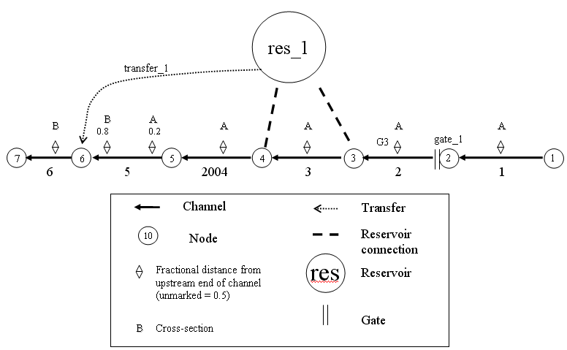
Figure 2 - Simple channel with a new reservoir, gate, and transfer.

The following steps will instruct you on how to create these new features and add them to the simple channel system.

- Create the reservoir:
  - In the Simulations Navigator:
    - Expand the model: tutorial_hydro folder.
    - Expand the Grid folder.
    - Double-click on Reservoirs.
  - In the Layers panel, right-click and select Set edit layer.
  - In the Select Layers window, double-click the tutorial_grid layer.
  - In the Reservoirs table:
    - Right-click and select Insert row.
    - Enter the following values into the appropriate fields:
      - Name: res_1
      - Area (million sq ft): 40
      - Bottom elev (ft): -24
      - Use: Make sure that the entry contains a checkmark.
  - Note from Figure 2 that the reservoir has two connections; one at Node 3, and one at Node 4. Therefore, two rows of information will be needed for the Reservoir Connections table.
  - In the Reservoir Connections table:
    - Right-click and select Insert row.
    - Enter the following values into the appropriate fields:
      - Node: 3
      - Res Coef (in): 200
      - Res Coef (out): 200
    - Again, right-click and select Insert row.
    - Enter the following values into the appropriate fields:
      - Node: 4
      - Res Coef (in): 200
      - Res Coef (out): 200
  - Save the current settings.
  - At this point, the GUI should look as follows:
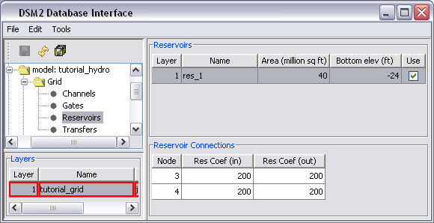
  - In the Layers Panel, right-click and select Unset edit layer [optional].

- Create the Gate.
  - Note from Figure 2 that the gate is located at Node 2 of Channel 2. This gate consists of both a weir and a pipe. Therefore, two rows of information will be needed for the Gate Devices table.
  - In the Simulations Navigator:
    - Remain in the Grid folder.
    - Double-click on Gates.
  - In the Layers panel, right-click and select Set edit layer.
  - In the Select Layers window, double-click the tutorial_grid layer.
  - In the Gates table:
    - Right-click and select Insert row.
    - Enter the following values into the appropriate fields:
      - Name: gate_1
      - Connected object: Channel
      - Name/No: 2
      - to Node: 2
      - Use: Make sure that the entry contains a checkmark.
  - In the Gate Devices table:
    - Right-click and select Insert row.
    - Enter the following values into the appropriate fields:
      - Name: weir
      - Structure: weir
      - # Dupl: 2
      - Radius/width: 20
      - Elev: 2
      - Height: NA (the weir is open and the gate is high)
      - CF from Node: 0.8
      - CF to Node: 0.8
      - Default Op: gate_open
      - Gate Control: gated_top
  - Again, in the Gate Devices table:
    - Right-click and select Insert row.
    - Enter the following values into the appropriate fields:
      - Name: pipe
      - Structure: pipe
      - # Dupl: 2
      - Radius/width: 20
      - Elev: 2
      - Height: NA (height does not apply to pipes)
      - CF from Node: 0.8
      - CF to Node: 0.8
      - Default Op: gate_open
      - Gate Control: no_gate
  - Save the current settings.
  - At this point, the GUI should look as follows (note: the GUI has been revised to say NA instead of 9,999 and Gate Control has been moved).
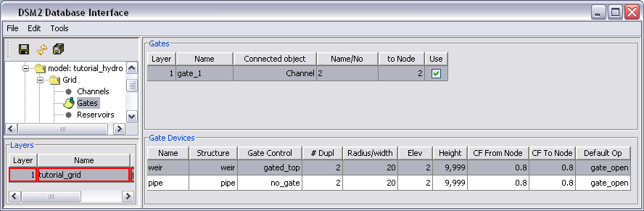
  - In the Layers Panel, right-click and select Unset edit layer [optional].

- Create the Transfer:
  - In the Simulations Navigator:
    - Remain in the Grid folder.
    - Double-click on Transfers.
  - In the Layers panel, right-click and select Set edit layer.
  - In the Select Layers window, double-click the tutorial_grid layer.
  - In the Transfers table:
    - Right-click and select Insert row.
    - Enter the following values into the appropriate fields:
      - Name: transfer_1
      - From Object: Reservoir
      - Name/Number: res_1
      - To Object: Node
      - Name/Number: 6
      - Use: Make sure that the entry contains a checkmark.
  - Save the current settings.
  - At this point, the GUI should look as follows:
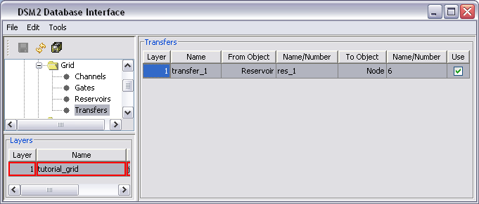
  - In the Layers Panel, right-click and select Unset edit layer [optional].

- Add Initial Conditions for the Reservoir:
  - In the Simulations Navigator:
    - Collapse the Grid folder [optional].
    - Expand the Initial Conditions folder.
    - Double-click on Reservoir IC.
  - In the Layers panel, right-click and select Set edit layer.
  - In the Select Layers window, double-click the tutorial_grid layer.
  - In the Reservoir Initial Conditions table:
    - Right-click and select Insert row.
    - Enter the following values into the appropriate fields:
      - Reservoir Name: res_1
      - Variable: stage
      - Value: 0
      - Use: Make sure that the entry contains a checkmark.
  - Save the current settings.
  - At this point, the GUI should look as follows:
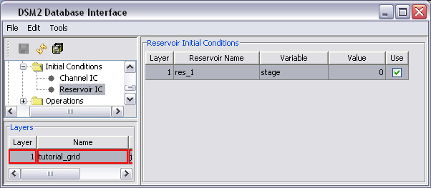
  - In the Layers panel, right-click and select Unset edit layer [optional].

- Add the Transfer Flow Time Series:
  - In the Simulations Navigator:
    - Collapse the Initial Conditins folder [optional].
    - Expand the Input Time Series folder.
    - Double-click on Transfer Flows.
  - In the Layers panel, right-click and select Set edit layer.
  - In the Select Layers window, double-click the tutorial_boundary_hydro layer.
  - In the Transfer Time Series table:
    - Right-click and select Insert row.
    - Enter the following values into the appropriate fields:
      - Input Name: transfer_1
      - Input File: constant
      - Path/Value: 40
      - Fillin: last
      - Use: Make sure that the entry contains a checkmark.
  - Save the current settings.
  - At this point, the GUI should look as follows:
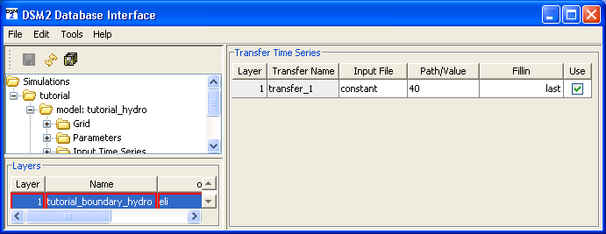
  - In the Layers panel, right-click and select Unset edit layer [optional].

- Running HYDRO and QUAL
  - In Windows Explorer, navigate to the directory: \{DSM2_home}\tutorial\simulations\simple\.
  - Right-click on the directory, t2_reservoir_gate_transfer, and select Open Command Window Here.
  - In the command window, type: hydro hydro.inp.
  - In the command window, type: qual qual.inp.
  - Open the output.dss file in the t2_reservoir_gate_transfer directory, and examine the results.

