Tutorial 6: Operating Rules
The purpose of this tutorial is to practice using Operating Rule Language (ORL) statements to set gate operations and flows. With operating rules, expressions can be crafted to make steer the model on-the-fly; e.g., a gate can be directed to automatically close when stage conditions reach a certain threshold. In this tutorial we will create operating rules to operate a gate and to regulate a source/sink inflow.

- Adding a Second Gate Where Op Rule Will Be Applied
  - In the Simulations Navigator:
    - Expand the model: tutorial_hydro folder.
    - Expand the Grid folder.
    - Double-click on Gates.
  - In the Layer panel, right-click and select Set edit layer.
  - In the Select Layers window, double-click the tutorial_grid_revision layer.
  - In the Gates table:
    - Right-click on the row with gate_1 and select Copy row to edit layer (with subtables).
    - Click on the copied row and change the following fields:
      - Name: gate_2
      - Name/No.: 5
      - to Node: 5
  - In the Gate Devices table:
    - Click on each of the weir and pipe rows and change the following field:
      - Elev: -2
  - Save the current settings.
  - At this point, the GUI should look as follows: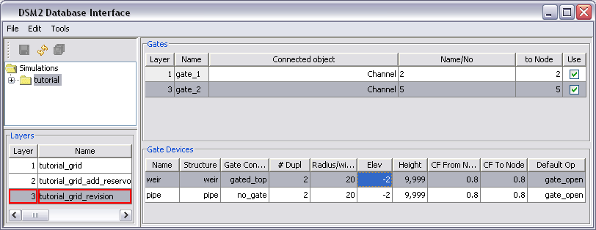

- Adding Output for the Second Gate:
  - In the Simulations Navigator:
    - Collapse the Grid folder [optional].
    - Expand the Output Time Series folder.
    - Double-click on Gate Output.
  - In the Layer panel, right-click and select Set edit layer.
  - In the Select Layers window, double-click the tutorial_output layer.
  - In the Operating Rules table:
    - Right-click and select Insert row.
    - Enter the following values into the appropriate fields:
      - Output Name: gate_2_weirop
      - Gate: gate_2
      - Device: weir
      - Variable: op-from-node
      - Output File: ${HYDROOUTDSSFILE}
      - Time Interval: 15min
      - Period Op: inst
      - Use: Make sure that the entry contains a checkmark.
  - Save the current settings.
  - At this point, the GUI should look as follows:
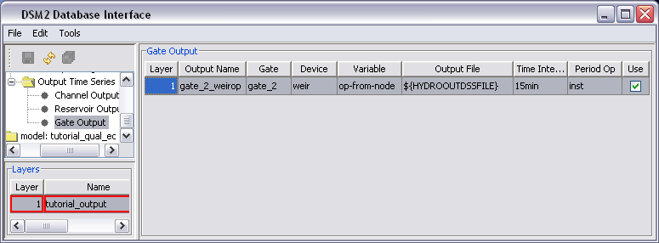
  - In Windows Explorer, navigate to the directory, \{DSM2_home}\tutorial\simulations\simple\t6_oprule.
  - Open the file, hydro.inp.
  - Add the following statements to the output paths section in order to view gate trigger locations:
trigger_loc 4 7500 stage 15min inst ${HYDROOUTDSSFILE}
ds_gate2 5 0 flow 15min inst ${HYDROOUTDSSFILE}
  - In the Layers panel, right-click and select Unset edit layer [optional].

- Create an Operating Rule to Close the Weir when Stage is Low:
This operating rule closes the new gate we created during times where stage at a monitoring point is low. First we will define the rule in terms of an expression called stage_critical (the condition where stage violates a minimum) and op_applies (a seasonal condition that is True when we are controlling the gate for stage. In a later step we will define these variables.
  - In the Simulations Navigator:
    - Collapse the Output Time Series folder [optional].
    - Expand the Operations folder.
    - Double-click on Operating Rules.
  - Add a new Operating Rules Layer:
    - In the Layer panel, right-click and select New layer.
    - Select Yes to confirm the refresh.
    - Name the new layer, tutorial_ oprule, and add a description.
    - Enter 1 for the layer number.
  - In the Layer panel, right-click and select Set edit layer.
  - In the Select Layers window, double-click the tutorial_oprule layer.
  - In the Operating Rules table:
    - Right-click and select Insert row.
    - Enter the following values into the appropriate fields:
      - Name: weir_close
      - Action Definition: SET gate_op(gate=gate_2, device=weir, direction=from_node) TO CLOSE RAMP 30MIN
      - Trigger Definition: stage_critical AND op_applies
      - Use: Make sure that the entry contains a checkmark.
  - Save the current settings.
  - At this point, the GUI should look as follows:
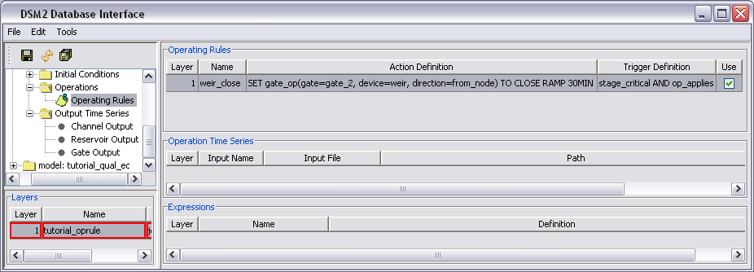
Note that the expressions stage_critical and op_applies will be created in a later step.

- Create an Operating Rule to Open the Weir when Stage is High:
As before, we will enter the rule to open the weir first in terms of the expressions stage_relax (a condition where stage is safely above a threshold where we can open the gate) and op_applies. In the next step we will define these expressions.
  - In the Operating Rules table:
    - Right-click and select Insert row.
    - Enter the following values into the appropriate fields:
      - Name: weir_open
      - Action Definition: SET gate_op(gate=gate_2, device=weir, direction=from_node) TO OPEN RAMP 30MIN
      - Trigger Definition: ( stage_relax AND op_applies) OR NOT(op_applies)
      - Use: Make sure that the entry contains a checkmark.
  - Save the current settings.
  - At this point, the GUI should look as follows: 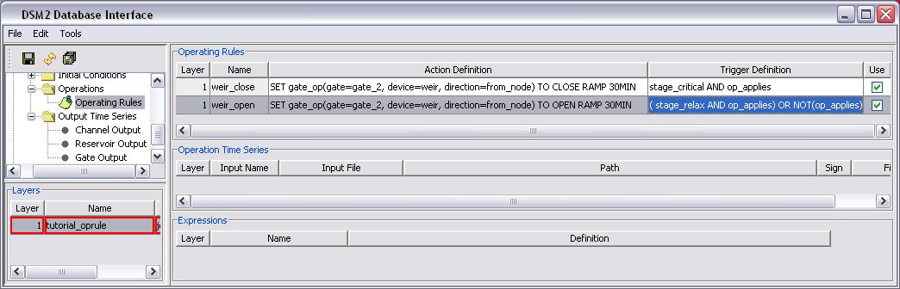

  - In the hydro.inp file, add the following environmental variables and values into the ENVVARS section:
STAGE_CRITICAL 1.4
STAGE_RELAX 1.6

- Define Expressions used in the rule
  - In the Expressions table:
    - Right-click and select Insert row.
    - Enter the following values into the appropriate fields:
      - Name: op_applies
      - Definition: SEASON < 01FEB
    - Again, right-click and select Insert row.
    - Enter the following values into the appropriate fields:
      - Name: stage_critical
      - Definition: chan_stage(channel=4, dist=7500) < ${STAGE_CRITICAL}
    - Once again, right-click and select Insert row.
    - Enter the following values into the appropriate fields:
      - Name: stage_relax
      - Definition: chan_stage(channel=4, dist=7500) > ${STAGE_RELAX}
  - Save the current settings.
  - At this point, the GUI should look as follows: 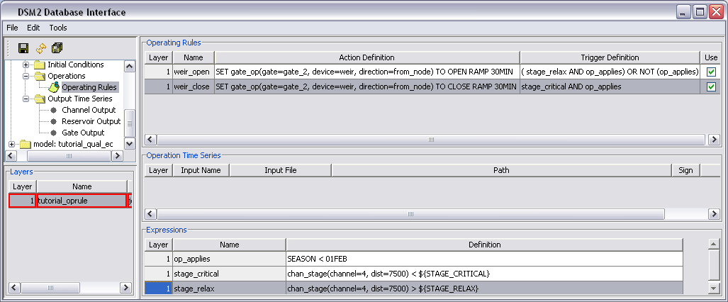

  - Now run HYDRO and QUAL:
    - Open a command window for the t6_oprule directory.
    - In the command window, type: hydro hydro.inp.
    - In the command window, type: qual qual.inp.
    - Open the output.dss file in the t6_oprule directory, and examine the results.

- Add a Reduced Flow Operating Rule:
In our next operating rule, we will control the inflow to a node by having it toggle back and forth between a larger “full flow” and a reduced flow. First we will enter the rule and then we will define the full and reduced flows.
  - In the Operating Rules table:
    - Right-click and select Insert row.
    - Enter the following values into the appropriate fields:
      - Name: flow_reduce
      - Action Definiton: SET external_flow(name=source1) TO ifelse(stage_critical,reduced_flow,full_flow)
      - Trigger Definition: TRUE
      - Make sure the Use box is checked.
  - At this point, the GUI should look as follows: 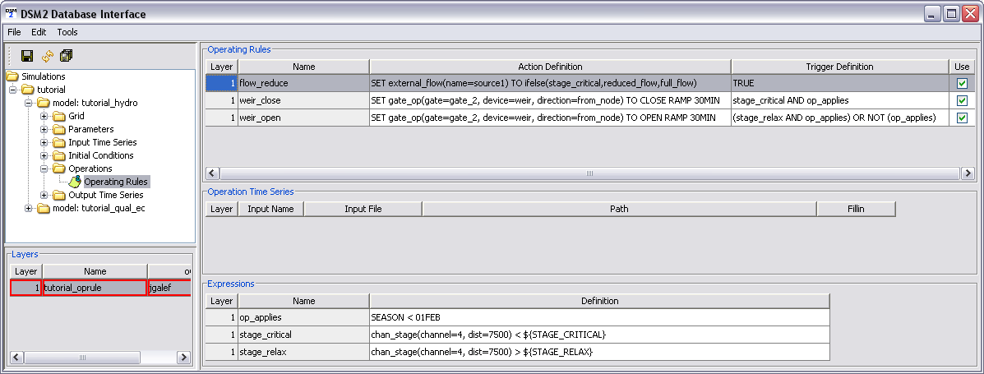
  - Save the current settings.

  - Now create the expressions that define full_flow and reduced_flow. In the Expressions table:
    - Right-click and select Insert row.
    - Enter the following values into the appropriate fields that define full_flow. This will involve the time series source_flow which we will enter later:
      - Input Name: full_flow
      - Definition: ts(name=source_flow) [note: this is a reference to a time series we haven’t defined yet].
    - Do the same for reduced_flow. Note: we are defining reduced_flow in terms of the time series. There is no guarantee of what order expressions will be evaluated, so you cannot safely define reduced_flow in terms of another expression such as full_flow. Enter the following values into the appropriate fields:
      - Input Name: reduced_flow
      - Definition: 0.5*ts(name=source_flow).
  - Save the current settings.
    - Now we will define the source_flow time series upon which the full_flow and reduced_flow expressions are based.
  - In the Layer panel, right-click and select Set edit layer.
  - In the Select Layers window, double-click the tutorial_oprule layer.
  - In the Operation Time Series table:
    - Right-click and select Insert row.
    - Enter the following values into the appropriate fields:
      - Input Name: source_flow
      - Input File: ${TUTORIALINPUT}
      - Path: /TUTORIAL/SOURCE/FLOW//15MIN/CONSTANT/ [ Note: there are two forward slashes between 15MIN and CONSTANT]
      - Sign: 1
      - Fillin: none
      - Make sure the Use box is checked.
  - Save the current settings.
  - At this point, the GUI should look as follows:
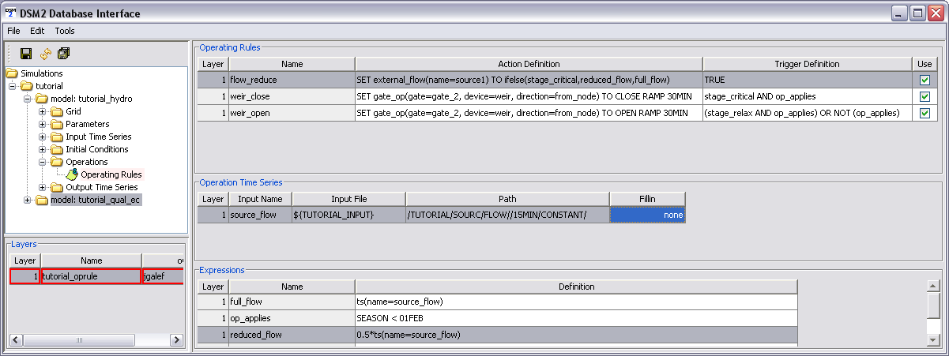

- Override the Expression op_applies:
Recall that op_applies is used to determine when the weir is operated. Previously the definition of this expression was seasonal: the expression was SEASON < 01FEB. The goal now is to make the same expression depend on a time series. Rather than change the expression, we will override it in a new layer.
  - Add a new Operating Rules Layer:
    - In the Layer panel, right-click and select New layer.
    - Select Yes to confirm the refresh.
    - Name the new layer, tutorial_ oprule_revision, and add a description.
    - Enter 2 for the layer number.
  - In the Layer panel, right-click and select Set edit layer.
  - In the Select Layers window, double-click the tutorial_oprule_revision layer.
  - Redefine the expressions that define op_applies. In the Expressions table:
    - Right-click and select Insert row.
    - Enter the following values into the appropriate fields:
      - Input Name: op_applies
      - Definition: ts(name=op_used) [note: this is a reference to a time series we will define in the next step].
  - Define the time series op_used on which the op_applies expression depends. In the Operation Time Series table:
    - Right-click and select Insert row.
    - Enter the following values into the appropriate fields:
      - Input Name: op_used
      - Input File: ${TUTORIALINPUT}
      - Path: /TUTORIAL/GATE/FLAP_OP//IR-YEAR/CONSTANT/
      - Sign: 1
      - Fillin: none
      - Make sure the Use box is checked.
  - At this point, the GUI should look as follows:

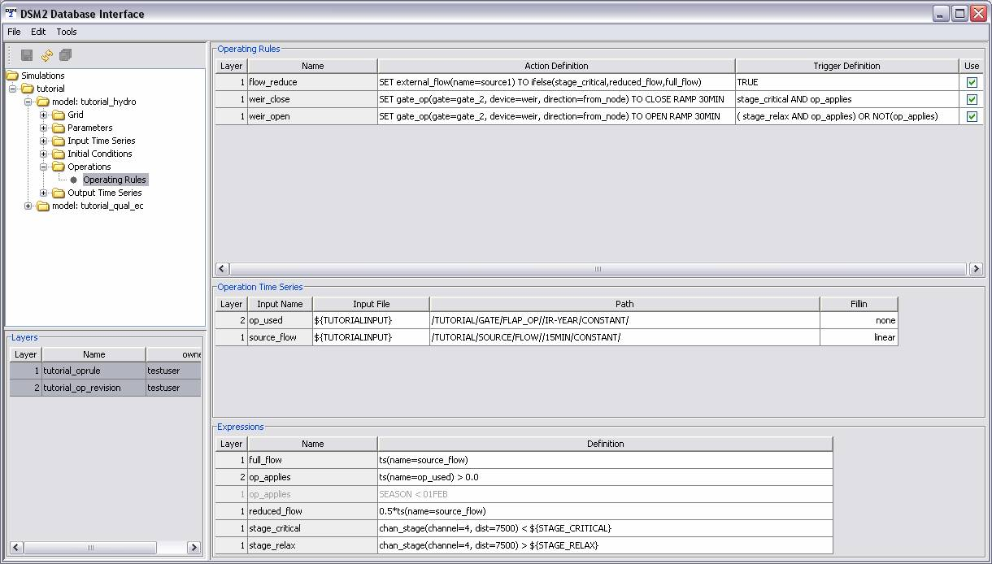
  - In the Layers panel, right-click and select Unset edit layer [optional].
  - Run HYDRO and QUAL and examine the results.

