Tutorial 1: Channels
Task
Run DSM2 for a steady boundary condition flow and salinity
(EC-electrical conductivity) simulation for a simple straight channel grid

Skills Gained
- Get started with DSM2
- Creating channels
- Establishing initial and boundary conditions
The purpose of this tutorial is twofold: to get a start with the dsm2 model and to get practice setting up channels. We will set up a simple channel-only grid with simple constant boundary conditions and run both hydro and qual. We will look at two formats for entering cross-section geometry (the new DSM2 format and CSDP) and we will familiarize ourselves with the echo output file that gives you a single-file complete record of all the input data used in a DSM2 module.

The channels have the following configuration and specifications:
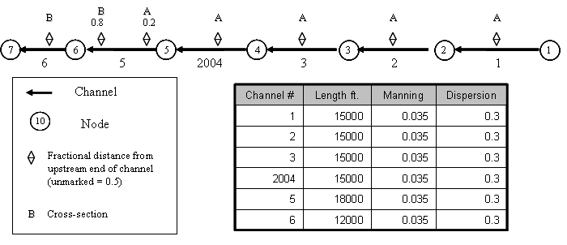
Figure 1 - Simple channel configuration and specifications.

Note that there are two cross-section geometries labeled A and B. In all the channels except Channel 5 these have been assigned at the midpoint of the channel. In Channel 5 the cross-sections are assigned at fractions 0.2 and 0.8 of the length of the channel.

DSM2 assumes a piecewise linear cross-sectional bathymetry. Width, area and wetted perimeter are tabulated according to elevation. Each elevation lists the data (width) or cumulative data (wetted perimeter and area) below the given elevation. Anything above the top elevation is extrapolated using a slope given by a global scalar called levee_slope.

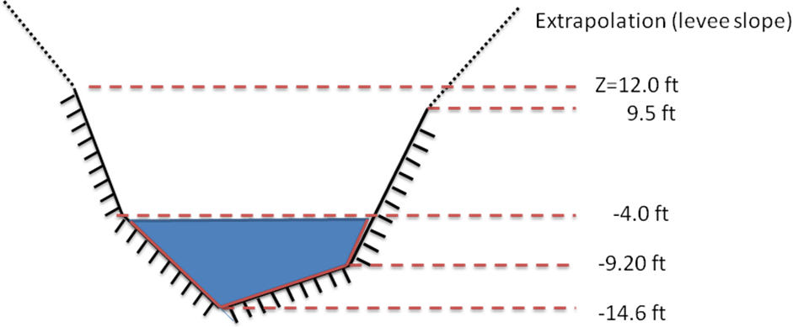
Figure 2: Piecewise linear bathymetry

For instance, for a cross section half way downstream in a fictitious channel 123. the five layers of a cross-section with elevations given by Figure 2, might be tabulated:
XSECT_LAYER
CHAN_NO DIST ELEV AREA WIDTH WET_PERIM
123 0.5 -14.6 0.0 0.0 0.0
123 0.5 -9.2 216.0 80.0 102.5
123 0.5 -4.0 736.0 120.0 111.0
123 0.5 9.5 2410.0 160.0 142.3
123 0.5 12.0 3028.5 162.0 148.0

The above table is in the single-file DSM2 cross-section format. An analogous table is produced by the Cross Section Development Program (CSDP). We will practice using both. The parameter levee_slope is seldom changed from its standard value of 0.33.

The following steps will instruct you on how to create the channels, give them very simple boundary conditions and run the model.
- Open the hydro input file and add parameters:
  - For this tutorial, you will want to use Notepad++ (recommended), Textpad or Emacs – some text editor that will not add special markup to your input.
  - Navigate to the {DSM2_home}\tutorial\simple\t1_channels directory and this directory will be referred to as the tutorial directory below.
  - Open the hydro.inp file.
- In HYDRO, add the Parameter information:
  - In the hydro.inp file, locate the SCALAR block. Scalars are name-value pairs that control the model or define constants and runtime parameters. Some scalar parameters are already defined in the sample file.
  - Add the following scalars at the top of the SCALAR table (use spaces, not tabs, to separate the input):
SCALAR
NAME VALUE
[Existing scalars]
run_start_date 01JAN1992
run_end_date 01MAR1992
run_start_time 0000
run_end_time 0000
temp_dir c:/temp
END

Note that temp_dir should be set to a location with ample disk space for production runs. This is a scratch directory where DSM2 stores cached results.

- In HYDRO, add Channel information:
Next we will add a table of channels, including connectivity, and conveyance/dispersion parameters. We are also going to add the cross-section geometry using the XSECT_LAYER section, which is introduced in Version 8. (CSDP-styled input is discussed later).
  - The CHANNEL block requires: a channel number, length, Manning’s n, dispersion coefficient, node number to identify the upstream end and node number at the downstream end. Type the table and field headers for the CHANNEL table at the bottom of the hydro,inp file:
CHANNEL
CHAN_NO LENGTH MANNING DISPERSION UPNODE DOWNNODE

  - Open the file channel_tutorial_starter.inp and copy the data from the input file CHANNEL block and paste it into your CHANNEL block.
  - Type END after the last row to end the block
  - Now create the XSECT_LAYER, table which will contain one row for every vertical layer in every user-defined cross-section. This table is new in Version 8, and is intended to allow input to be represented in a single file and using a single input style – making archives and comparisons simpler. Below the CHANNEL table, create the skeleton for the XSECT_LAYER table:
XSECT_LAYER
CHAN_NO DIST ELEV AREA WIDTH WET_PERIM
[data will go here]
END
  - In the first row, we will start defining a cross-section for channel #1. We will be entering three rows for Channel 1, each of which will have a “1” in the CHANNEL column. The data will be located midway downstream along the channel, so in the Distance (fraction) field, type 0.5. The three rows of data are given below:
XSECT_LAYER
CHAN_NO DIST ELEV AREA WIDTH WET_PERIM
1 0.5 -24.0 0.0 40.0 40.0
1 0.5 0.0 960.0 80.0 102.5
1 0.5 20.0 2640.0 160.0 192.0

  - Copy and paste the three rows of data for Channel 1 three times for Channels 2, 3 and 2004 and change the channel number. Copy one more time for Channel 5, this time changing the Channel number to 5 and the distance to 0.2.
  - There is an additional cross-section given for Channel 5, cross-section “B”. The cross section is located in Channel 5, 0.8 of the way from the upstream end to the downstream end as indicated on the schematic at the beginning of the tutorial.
XSECT_LAYER
CHAN_NO DIST ELEV AREA WIDTH WET_PERIM
5 0.8 -20.0 0.0 60.0 60.0
5 0.8 -4. 1120.0 80.0 97.74
5 0.8 2.0 1660.0 100.0 121.06
5 0.8 10.0 2700.0 160.0 183.16
  - Copy the cross section data from Channel 5 Distance 0.5 to Channel 6, Distance 0.5.
  - Make sure the block is terminated with a line with an END.

- In HYDRO, set the Boundary information:
In this section we are going assign very simple boundary conditions to the upper and lower end of the channel system. Note that if you do not set boundary conditions at the end of a channel, a “no-flow” boundary (Q=0.0) is assumed.
  - The upstream boundary will be a constant inflow.
  - Enter an input block for the inflow:
BOUNDARY_FLOW
NAME NODE SIGN FILLIN FILE PATH
upstream_flow 1 1 last constant 200.
END
This line assigns a constant inflow of 200.0cfs to the upstream boundary. The NAME column will be used 1) to associate quality inputs with inflows and 2) for prioritizing data in multiple input files. The NODE field assigns the input to Node #1. The FILLIN field is an instruction to the mode as to how to interpolate data in time, which is not relevant for a constant.
  - The downstream boundary will be a constant water surface (stage) boundary.
  - Start an input block for the downstream stage boundary:
BOUNDARY_STAGE
NAME NODE FILLIN FILE PATH
[data go here]
END
  - In the BOUNDARY_STAGE table, enter the following values into the appropriate fields:
      - Input Name: downstream_stage
      - Node: 7
      - Fillin: Last
      - Input File: constant
      - Path/Value: 0.0
- In HYDRO, set the Initial Conditions for stage and flow:
A default hydrodynamic initial condition is required for every channel in DSM2. The initial condition can be replaced using a restart file, but the default must still be entered. For each of the channels, the stage and flow will be set 0. These 0-values will be applied at both the 0 and length distances along the channel. With seven channels, and two locations to set the values, there will be a total of 14 rows.
  - Start the initial condition table:
CHANNEL_IC
CHAN_NO DISTANCE STAGE FLOW
1 0 0.0 0.0
1 length 0.0 0.0
[further data will go here]
END
Initial conditions are given above (zero flow and zero stage) for Channel 1 at the upstream (distance 0) and downstream (distance length) ends of the channel. Copy these to all the channels.

- In HYDRO, Specify the Output Locations:
Lastly, we specify the output locations. These locations will include the two boundaries, two locations along Channel 2, and the beginning of Channel 2004. The output variables will include both stage and flow.
  - Create the skeleton OUTPUT_CHANNEL table using the following header:
OUTPUT_CHANNEL
NAME CHAN_NO DISTANCE VARIABLE INTERVAL PERIOD_OP FILE
[data will go here]
END
  - The output request rows may be found in the file output_channel_tutorial.inp. Copy them into hydro.inp.

- Clean up and launch HYDRO
  - Eliminate spaces by doing a search and replace for tabs.
  - Launch hydro by typing
> hydro hydro.inp.
  - Check the output file output.dss.
  - Examine the echoed output file channel_hydro_echo.inp. Notice that it is an exact copy of your input data.

- In QUAL, add the Parameter information:
  - The file qual.inp already has a SCALAR section. Add the following SCALARS below the others:
SCALAR
NAME VALUE
run_start_date 02JAN1992
run_end_date 01MAR1992
run_start_time 0000
run_end_time 0000
temp_dir c:/temp
[Existing scalars]
END

- In QUAL, set the boundary concentration information:
  - Boundary conditions in QUAL for the constituent ec are specified in the NODE_CONCENTRATION table:
NODE_CONCENTRATION
NAME NODE_NO VARIABLE FILLIN FILE PATH
END
The names of the inputs must be EXACTLY the same as given in hydro – this is how input concentrations are matched with input flows.
  - In the Node Concentration table, add an upstream concentration row. The name for this boundary condition must match the corresponding boundary in hydro – this name-matching is how flows and concentrations are paired. In the new row, enter the following information into the appropriate fields:
      - Input Name: upstream_flow.
      - Node: 1.
      - Variable: ec
      - Fillin: last.
      - Input File: constant.
      - Path/Value: 200.

  - In the Boundary Concentration table, add a downstream concentration row. The downstream concentration is going to be higher, as we are later going to turn this into a tidal boundary. Enter the following information into the next row of the table::
      - Input Name: downstream_stage.
      - Node: 7.
      - Variable: ec.
      - Fillin: last
      - Input File: constant.
      - Path: 30000...
  - Save the current settings.

- In QUAL, Specify Output Locations:
In QUAL, you can request 1) concentration data, 2) concentration data with source tracking or 3) flow and stage data (which can be confusing if not output at the model time step. Our requests will include the two boundaries, two locations along Channel 2, and the beginning of Channel 2004. The output variable will be ec.
  - Create a QUAL Output table:
  - In the CHANNEL_OUTPUT table, add the following lines:
OUTPUT_CHANNEL
NAME CHAN_NO DISTANCE VARIABLE INTERVAL PERIOD_OP FILE
bnd_1 1 0 ec 15min inst ${QUALOUTDSSFILE}
bnd_6 6 length ec 15min inst ${QUALOUTDSSFILE}
chan2_half 2 7500 ec 15min inst ${QUALOUTDSSFILE}
chan2_length 2 length ec 15min inst ${QUALOUTDSSFILE}
chan2004 2004 0 ec 15min inst ${QUALOUTDSSFILE}
END
  - Save the current settings.

- Running HYDRO and QUAL
  - In Windows Explorer, navigate to the directory: \{DSM2_home}\tutorial\simple\.
  - Right-click on the directory, t1_channels, and select Open Command Window Here.
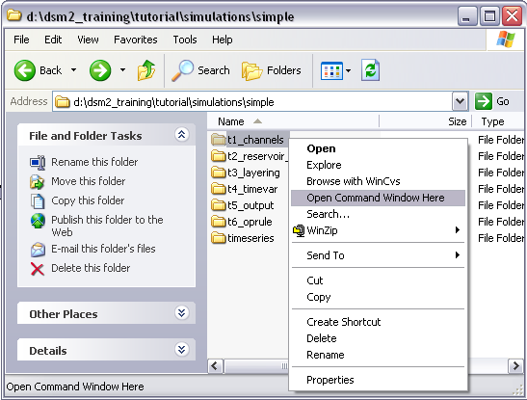

  - In the command window, type: hydro hydro.inp.
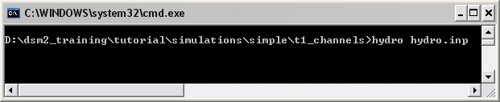

  - HYDRO will then run and create an output.dss file in the same directory.
  - In the command window, type: qual qual.inp.
  - QUAL will then run and add output to the output.dss file.
  - Open the output.dss file and examine the results.

- CSDP style cross-sections
You can also run the model using cross-sections in the CSDP format. This is the form most familiar to DSM2 users. Mixing CSDP format with other formats may produce unpredictable results.

Two caveats. First, there are no rectangular cross-sections in Version 8.. The rectangular and irregular cross-sections in Version 6 were not consistent: a regular cross-section and its equivalent representation in the irregular format did not give the same result. The discrepancy was due to different interpolation rules. In Version 8, we have dropped the “irregular” nomenclature because this is the only kind of cross section we support. The practical consequence of the change is that you are going to need a cross-section for every channel, and to get this you will need a data set targeted at Version 8.

In the tutorial, you will find that the cross sections are represented in two files: cross_section_a.txt and cross_section_b.txt.
  - Copy hydro.inp to hydro_csdp.inp (it doesn’t matter what you name it, but don’t skip this step)
  - In hydro_csdp.inp, erase the XSECT_LAYER table and type the XSECT table that will point to the cross-section files.
XSECT
CHAN_NO DIST FILE
1 0.5 xsect_a.txt
[other xsects go here]
END
  - Create the table using the same channel-distance combinations as we used before. Use cross-sections A and B as designated on the map.
  - In the IO_FILE block, change the name of the echoed output file to hydro_echo_csdp.inp. If you want you can change the environmental variables to accomplish nearly the same thing.
- Rerun HYDRO and compare cross-sections formats
Now we want to run hydro with the alternate input from CSDP. To verify that we get the same cross-sections from CSDP, we are going to scrutinize the echo input file.
  - Open the echoed input file from your first run. The file name is channel_hydro_echo.inp. Do a search for XSECT_LAYER. This file echoes the input used on your previous run, and is what we are trying to match.
  - Rerun hydro using the command:
> hydro hydro_csdp.inp
  - Compare the echoed cross-sections in to those in hydro_echo_csdp.inp Use your text editor or a “diff” tool.
- Run HYDRO using echoed input.
Now run hydro using the hydro.inp file that you were just examining.
a. Copy channel_hydro_echo.inp to hydro_echo.inp.
b. Open hydro_echo.inp Locate the IO_FILE section and change the name of the echoed input file (last entry) to echo_echo.inp.
c. Save and close hydro_echo.inp
d. Now we are going to run the model using hydro_echo.inp. At a command prompt type:
> hydro hydro_echo.inp
  - Compare the data from your first run (channel_hydro_echo.inp) to the second run (echo_echo.inp). Are they the same?.

