Tutorial 4: Time Varying Data
The purpose of this tutorial is to incorporate time-varying information to the model. In the previous sections, all boundary conditions and gate timings were set as constant, and no input files were needed. In this section, the model is set to read time-varying information stored in DSS files. The following steps will instruct you on how to add the time-varying information.

- Change the Transfer Flows:
  - In the Simulations Navigator:
    - Remain in the model: tutorial_hydro folder.
    - Expand the Input Time Series folder.
    - Double-click on Transfer Flows.
  - Add a new Transfer Flow Layer:
    - In the Layers panel, right-click and select New layer.
    - Select Yes to confirm the refresh.
    - Name the new layer, tutorial_hydro_ts, and add a description.
    - Enter 2 for the layer number.
  - In the Layers panel, right-click and select Set edit layer.
  - In the Select Layers window, double-click the tutorial_hydro_ts layer.
  - In the Transfer Time Series table:
    - Right-click and select Insert row.
    - Enter the following values into the appropriate fields:
      - Input Name: transfer_1
      - Input File: ${TUTORIALINPUT}
      - Path/Value: /TUTORIAL/TRANSFER/FLOW//15MIN/CONSTANT/
      - Fillin: linear
      - Use: Make sure that the entry contains a checkmark.
  - Save the current settings.
  - At this point, the GUI should look as follows: 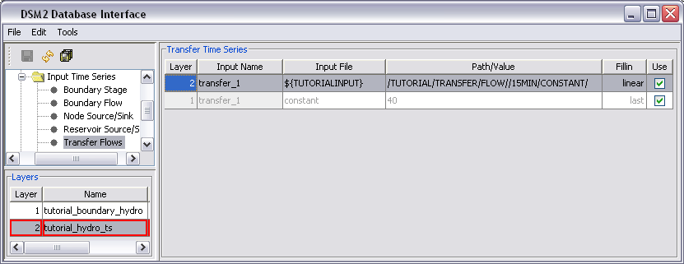

  - In the Layers panel, right-click and select Unset edit layer [optional].

- Running HYDRO and QUAL
  - In Windows Explorer, navigate to the directory: \{DSM2_home}\tutorial\simulations\simple\.
  - Right-click on the directory, t4_timevar, and select Open Command Window Here.
  - In the command window, type: hydro hydro.inp.
  - In the command window, type: qual qual.inp.
  - Open the output.dss file in the t4_timevar directory, and verify that the results are identical to the results from the previous tutorial (located in the t3_layering directory).

- Adjust the Text Input Files:
  - In Windows Explorer, navigate to the directory: \{DSM2_home}\tutorial\simulations\simple\t4_timevar
  - Open hydro.inp for editing.
  - In the ENVVARS section, change the DSM2MODIFIER environment variable from timevar_1 to timevar_2.
  - Open qual.inp for editing.
  - In the ENVVARS section, change the DSM2MODIFIER environment variable from timevar_1 to timevar_2.

- Add Source information into HYDRO:
  - In the Simulations Navigator:
    - Remain in the Input Time Series folder.
    - Double-click on Node Source/Sink.
  - In the Layers panel, right-click and select Set edit layer.
  - In the Select Layers window, double-click the tutorial_hydro_ts layer.
  - In the Node Source Time Series Input table:
    - Right-click and select Insert row.
    - Enter the following values into the appropriate fields:
      - Input Name: source1
      - Node: 5
      - Input File: ${TUTORIALINPUT}
      - Path/Value: /TUTORIAL/SOURCE/FLOW//15MIN/CONSTANT/
      - Sign: 1
      - Fillin: linear
      - Use: Make sure that the entry contains a checkmark.
  - Save the current settings.
  - At this point, the GUI should look as follows:
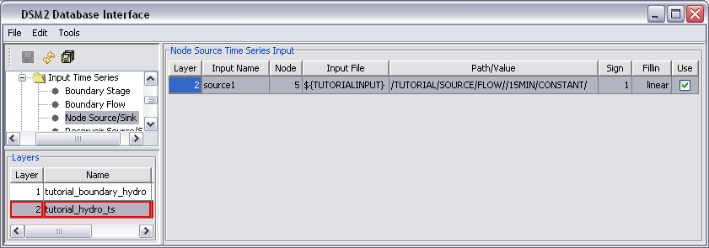
  - In the Layers panel, right-click and select Unset edit layer [optional].

- Add Source information into QUAL:
  - In the Simulations Navigator:
    - Collapse the model: tutorial_hydro folder [optional].
    - Expand the model:tutorial_qual_ec folder.
    - Expand the Input Time Series folder.
    - Double-click on Node Source/Sink.
  - Create a new QUAL Source Layer:
    - In the Layers panel, right-click and select New layer.
    - Select Yes to confirm the refresh.
    - Name the new layer, tutorial_qual_ts, and add a description.
    - Enter 2 for the layer number.
  - In the Layers panel, right-click and select Set edit layer.
  - In the Select Layers window, double-click the tutorial_qual_ts layer.
  - In the Node Source Time Series table:
    - Right-click and select Insert row.
    - Enter the following values into the appropriate fields:
      - Input Name: source1
      - Node: 5
      - Variable: ec
      - Input File: ${TUTORIALINPUT}
      - Path/Value: /TUTORIAL/SOURCE/EC//15MIN/CONSTANT/
      - Sign: 1
      - Fillin: last
      - Use: Make sure that the entry contains a checkmark.
  - Save the current settings.
  - At this point, the GUI should look as follows: 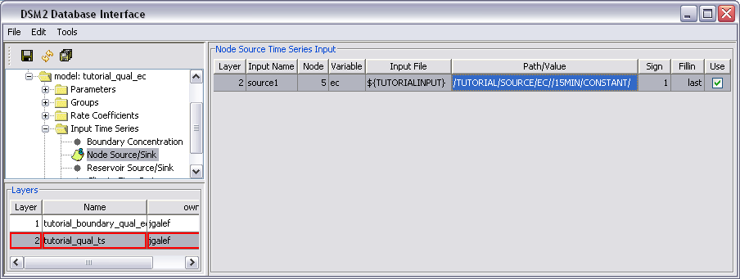

  - In the Layers panel, right-click and select Unset edit layer [optional].

- Add Tide Information for Downstream Boundary in HYDRO:
  - In the Simulations Navigator:
    - Collapse the model: tutorial_qual_ec folder [optional].
    - Expand the model: tutorial_hydro folder.
    - Expand the Input Time Series folder.
    - Double-click on Boundary Stage.
  - Create a new HYDRO Time Series Boundary:
    - In the Layers panel, right-click and select New layer.
    - Select Yes to confirm the refresh.
    - Name the new layer, tutorial_ hydro_tide, and add a description.
    - Enter 3 for the layer number.
  - In the Layers panel, right-click and select Set edit layer.
  - In the Select Layers window, double-click the tutorial_hydro_tide layer.
  - In the Boundary Stage table:
    - Right-click and select Insert row.
    - Enter the following values into the appropriate fields:
      - Input Name: downstream_stage
      - Node: 7
      - Input File: ${TUTORIALINPUT}
      - Path/Value: /TUTORIAL/DOWNSTREAM/STAGE//15MIN/REALISTIC/
      - Fillin: linear
      - Use: Make sure that the entry contains a checkmark.
  - Save the current settings.
  - At this point, the GUI should look as follows:
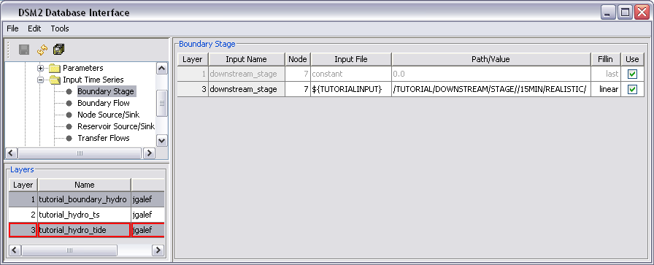
  - In the Layers panel, right-click and select Unset edit layer [optional].

- Add Tide Information for Downstream Boundary in QUAL:
  - In the Simulations Navigator:
    - Collapse the model: tutorial_hydro folder [optional].
    - Expand the model: tutorial_qual_ec folder.
    - Expand the Input Time Series folder.
    - Double-click on Boundary Concentration.
  - Add a new QUAL Time Series Boundary:
    - In the Layers panel, right-click and select New layer.
    - Select Yes to confirm the refresh.
    - Name the new layer, tutorial_ qual_tide, and add a description.
    - Enter 3 for the layer number.
  - In the Layers panel, right-click and select Set edit layer.
  - In the Select Layers window, double-click the tutorial_qual_tide layer.
  - In the Boundary Concentration table:
    - Right-click and select Insert row.
    - Enter the following values into the appropriate fields:
      - Input Name: downstream_stage
      - Node: 7
      - Input File: ${TUTORIALINPUT}
      - Path/Value: /TUTORIAL/DOWNSTREAM/EC//15MIN/REALISTIC/
      - Sign: 1
      - Fillin: last
      - Use: Make sure that the entry contains a checkmark.
  - Save the current settings.
  - At this point, the GUI should look as follows:
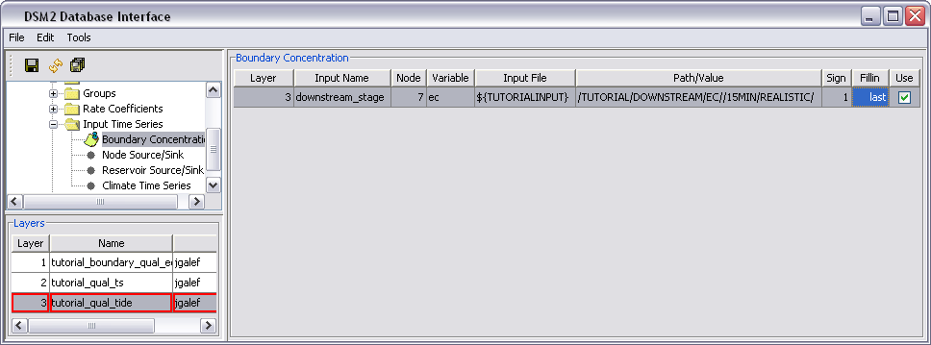
  - In the Layers panel, right-click and select Unset edit layer [optional].

- Add a Gate Time Series to HYDRO:
This gate time series will control the weir. The pipe is to be left open.
  - In the Simulations Navigator:
    - Collapse the model: tutorial_ qual_ec folder [optional].
    - Expand the model: tutorial_ hydro folder.
    - Expand the Input Time Series folder.
    - Double-click on Gate Time Series.
  - Add a Gate Time Series Layer:
    - In the Layers panel, right-click and select New layer.
    - Select Yes to confirm the refresh.
    - Name the new layer, tutorial_ gate_input, and add a description.
    - Enter 4 for the layer number.
  - In the Layers panel, right-click and select Set edit layer.
  - In the Select Layers window, double-click the tutorial_gate_input layer.
  - In the Gate Time Series table:
    - Right-click and select Insert row.
    - Enter the following values into the appropriate fields:
      - Gate: gate_1
      - Device: weir
      - Variable: op_from_node
      - Input File: ${TUTORIALINPUT}
      - Path/Value: /TUTORIAL/GATE/FLAP_OP//IR-YEAR/CONSTANT/
      - Fillin: none
      - Use: Make sure that the entry contains a checkmark.
  - Save the current settings.
  - At this point, the GUI should look as follows:
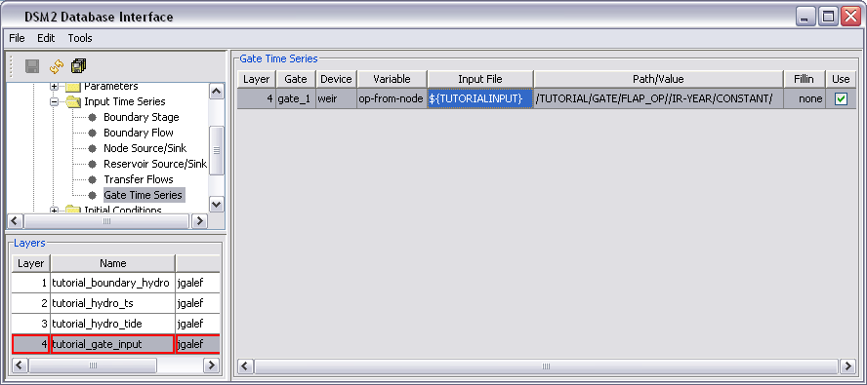
  - In the Layers panel, right-click and select Unset edit layer [optional].

- Running HYDRO and QUAL
  - In Windows Explorer, navigate to the directory: \{DSM2_home}\tutorial\simulations\simple\.
  - Right-click on the directory, t4_Timevar, and select Open Command Window Here.
  - In the command window, type: hydro hydro.inp.
  - In the command window, type: qual qual.inp.
  - Open the output.dss file in the t4_timevar directory, and examine the results.

