Tutorial 6: Operating Rules
Task
- Operate a gate based on stage criteria
- Regulate a source/sink inflow

Skills Gained Get an introduction to operating rules

The purpose of this tutorial is to practice using Operating Rule Language (ORL) statements to set gate operations and flows. With operating rules, expressions can be crafted to steer the model on-the-fly; e.g., a gate can be directed to automatically close when stage conditions reach a certain threshold. In this tutorial we will create operating rules to operate a gate and to regulate a source/sink inflow.
 Extensive documentation on the DSM2 operating rules can be found at:
START menu ⇨Programs ⇨ DSM2_v8 ⇨ DSM2_documentation⇨ Operating Rules

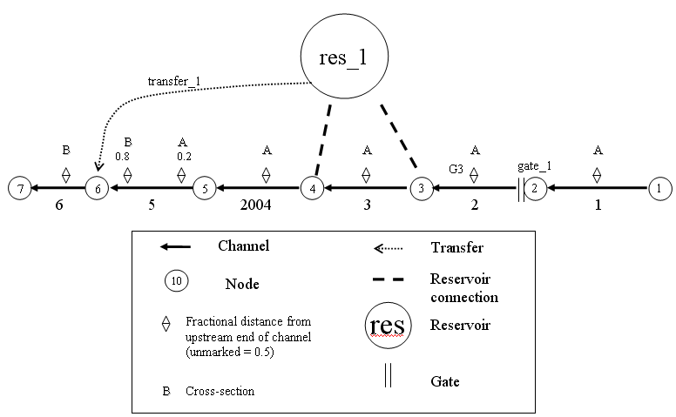
dummy_res
gate_2
Figure 1: Simple channel with a reservoir, gate, flow transfer and dummy reservoir.

- Adding a Second Gate Where Op Rule Will Be Applied
In this step of the tutorial we will prepare a new layer and add the gate that will be manipulated by the op rule.
  - In Windows Explorer, navigate to the directory, \{DSM2_home}\tutorial\simple\t6_oprule.
  - Create a file grid_tutorial_opitems.inp.
  - Open grid_tutorial_base.inp. We are going to copy items from this file into the new file with minor changes:
    - Copy the GATE table with gate_1, paste it into grid_tutorial_opitems.inp and change the following fields:
      - Name: gate_2
      - Name/No.: 5
      - to Node: 5
  - In the Gate Devices table:
    - Copy the data from gate_1 to grid_tutorial_opitems.inp, change the gate name to gate_2 and change the following fields:
      - Elev: -2
  - Save the current settings.
  - Add grid_tutorial_opitems.inp to the list of included files in hydro.inp.

- Adding Output for the Second Gate:
  - Create a file called output_oprule_tutorial.inp.
  - Create the OUTPUT_GATE table:
OUTPUT_GATE
NAME GATE_NAME DEVICE VARIABLE INTERVAL PERIOD_OP FILE
END
  - In the output table enter the following values into the appropriate fields:
      - Output Name: gate_2_weirop
      - Gate name: gate_2
      - Device: weir
      - Variable: op-from-node
      - Time Interval: 15min
      - Period Op: inst
      - File: ${HYDROOUTDSSFILE}
  - Add the following channel outputs in a new OUTPUT_CHANNEL table:
OUTPUT_CHANNEL
NAME CHAN_NO DISTANCE VARIABLE INTERVAL PERIOD_OP FILE
trigger_loc 4 7500 stage 15min inst ${HYDROOUTDSSFILE}
ds_gate2 5 0 flow 15min inst ${HYDROOUTDSSFILE}
END
  - Add the output layer to the list of include files in hydro.inp and save your work.

- Create an Operating Rule to Close the Weir when Stage is Low:
Now we are ready to write the first operating rule. This rule closes the new gate we created during times where stage at a monitoring point is low. First we will define the rule in terms of an expression called stage_critical (the condition where stage violates a minimum) and op_applies (a seasonal condition that is True when we are controlling the gate for stage. In a later step we will define these variables.
  - Create a file called oprule_tutorial.inp.
  - Create the Operating Rules table:
OPERATING_RULE
NAME ACTION TRIGGER
END
    - Enter the following values into the appropriate fields:
      - Name: weir_close
      - Action Definition: “SET gate_op(gate=gate_2, device=weir, direction=from_node) TO CLOSE RAMP 30MIN”
You must use quotes for inputs with spaces.

      - Trigger Definition: “stage_critical AND op_applies”
  - Create an OPERATION include block in hydro.inp and add the new file so that it will be used by DSM2-HYDRO.
OPERATION
oprule_tutorial.inp
END
  - Save the current settings.

Note that the expressions stage_critical and op_applies will be created in a later step.

- Create an Operating Rule to Open the Weir when Stage is High:
As before, we will enter the rule to open the weir first in terms of the expressions stage_relax (a condition where stage is safely above a threshold where we can open the gate) and op_applies. In the next step we will define these expressions.
  - In the Operating Rules table enter the following values into the appropriate fields:
      - Name: weir_open
      - Action Definition: “SET gate_op(gate=gate_2, device=weir, direction=from_node) TO OPEN RAMP 30MIN”
      - Trigger Definition: “( stage_relax AND op_applies) OR NOT(op_applies)”
  - Save the current settings.
  - In the hydro.inp file, add the following environmental variables and values into the ENVVAR section:
STAGE_CRITICAL 1.4
STAGE_RELAX 1.6

- Define Expressions used in the rule
  - In the same file, create the OPRULE_EXPRESSION table:
OPRULE_EXPRESSION
NAME DEFINITION
END
    - Enter the following values into the appropriate fields:
      - Name: op_applies
      - Definition: SEASON < 01FEB
    - Enter the following values into the appropriate fields. Don’t forget quotes!!
      - Name: stage_critical
      - Definition: chan_stage(channel=4, dist=7500) < ${STAGE_CRITICAL}
    - Enter the following values into the appropriate fields:
      - Name: stage_relax
      - Definition: chan_stage(channel=4, dist=7500) > ${STAGE_RELAX}
  - Save the current settings.
  - Now run HYDRO and QUAL:
    - Open a command window for the t6_oprule directory.
    - In the command window, type: hydro hydro.inp.
    - In the command window, type: qual qual.inp.
    - Open the output.dss file in the t6_oprule directory, and examine the results.

- Add a Reduced Flow Operating Rule:
In our next operating rule, we will control the inflow to a node by having it toggle back and forth between a larger “full flow” and a “reduced flow”. First we will enter the rule and then we will define the full and reduced flows.
  - In the Operating Rules table enter the following values into the appropriate fields:
      - Name: flow_reduce
      - Action Definiton: SET ext_flow(name=source1) TO ifelse(stage_critical,reduced_flow,full_flow)
      - Trigger Definition: TRUE
  - Now create the expressions that define full_flow and reduced_flow. In the Oprule Expressions table:
    - Enter the following values into the appropriate fields that define full_flow. This will involve the time series source_flow which we will enter later:
      - Input Name: full_flow
      - Definition: ts(name=source_flow) [note: this is a reference to a time series we haven’t defined yet].
    - Do the same for reduced_flow. Note: we are defining reduced_flow in terms of the time series. There is no guarantee of what order expressions will be evaluated, so you cannot safely define reduced_flow in terms of another expression such as full_flow. Enter the following values into the appropriate fields:
      - Input Name: reduced_flow
      - Definition: 0.5*ts(name=source_flow).
  - Save the current settings.
    - Now we will define the source_flow time series upon which the full_flow and reduced_flow expressions are based.
  - Create the Operation Time Series table:
OPRULE_TIME_SERIES
NAME FILLIN FILE PATH
    - Enter the following values into the appropriate fields:
      - Input Name: source_flow
      - Input File: ${TUTORIALINPUT}
      - Path: /TUTORIAL/SOURCE/FLOW//15MIN/CONSTANT/ [ Note: there are two forward slashes between FLOW and 15MIN]
      - Fillin: none
  - Save the current settings.

- Override the Expression op_applies:
Recall that op_applies is used to determine when the weir is operated. Previously the definition of this expression was seasonal: the expression was SEASON < 01FEB. The goal now is to make the same expression depend on a time series. Rather than change the expression, we will override it in a new layer.
  - Add a new Operating Rules Layer:
    - Create a file called oprule_ tutorial_ revision.inp
  - Redefine the expressions that define op_applies. In the Expressions table:
    - Create the OPRULE_EXPRESSIONS table.
    - Enter the following values into the appropriate fields:
      - Input Name: op_applies
      - Definition: ts(name=op_used) [note: this is a reference to a time series we will define in the next step].
  - Define the time series op_used on which the op_applies expression depends. In the Operation Time Series table:
    - Right-click and select Insert row.
    - Enter the following values into the appropriate fields:
      - Input Name: op_used
      - Input File: ${TUTORIALINPUT}
      - Path: /TUTORIAL/GATE/FLAP_OP//IR-YEAR/TIMEVAR/
      - Fillin: none
  - Add oprule_tutorial_revision.inp after oprule_tutorial.inp in the OPERATIONS block of hydro.inp so that it will be used by HYDRO.
  - Run HYDRO and QUAL and examine the results.

