Date: 4/21/2010

To: Jamie Anderson
Cc: Prabhjot (Nicky) Sandhu, Tara Smith

From: Kevin Kao
Delta Modeling Section
Bay-Delta Office
Department of Water Resources

Date: 7/12/2010
Rev 1: Eli Ateljevich
Yu Zhou
Date: 10/20/2010
Rev 2: Yu Zhou (PTM compiling addition, before 8.0.6 release)
Date: 1/14/2013
Rev 3: Yu Zhou (Updates of SVN strategy, compiler, before 8.1.2 release)

Subject : DSM2 version 8 compilation and packaging assuming a minor (bug-fix) release

This memo presents step-by-step instruction on compiling and packaging DSM2 version 8 assuming a minor (bug-fix) release. Please note that DSM2 project may be reorganized and moved to an open-source server in the near future. Please consult with Nicky or Eli or Joey for more information.

Required Software

- Visual Studio 2008
- Intel Fortran Composer 2013
- Subversion http://subversion.apache.org/packages.html
- Tortoise SVN http://tortoisesvn.net/downloads
- Flex and Bison packages in Cygwin http://www.cygwin.com/setup.exe
(make sure ../cywin/bin set in the environment path)
- Inno Setup Compiler v5.2.3 http://files.jrsoftware.org/is/5/isetup-5.2.3.exe
- Python http://www.python.org/download/
- Java Development Kit http://java.sun.com/javase/downloads/index.jsp
- Microsoft Office 2007
- Apache ANT http://ant.apache.org/bindownload.cgi

Note: make sure all software have their binary, header, or library folder set in the environment variables.

Visual Studio Configurations

- Start Visual Studio 2008, go to “Tools → Options → Projects and Solutions → VC++ Directories → Include Files” (See Figure 1)
- Add paths to JDK include files (See Figure 2)
- Go to the library files: “Tools → Options → Projects and Solutions → VC++ Directories → Library Files”. Add the fortran library location. This will be something like C:\Program Files (x86)\Intel\Compiler\11.1\065\lib\ia32. You should find a file ifconsol.lib in this directory.

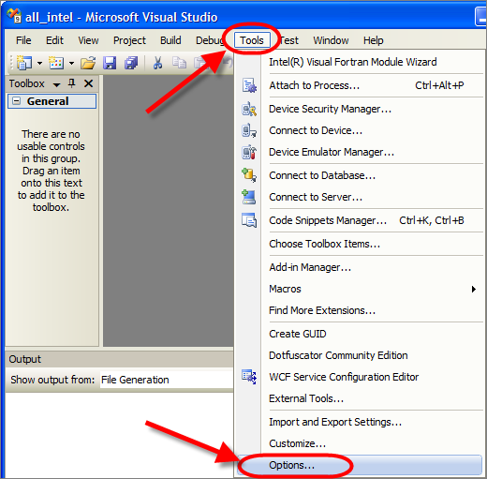
Figure 1
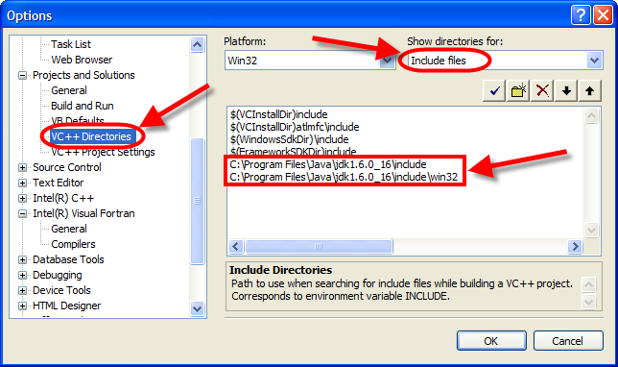
Figure 2

DSM2 Versioning

The latest DSM2 release version is 8.1.3 Subversion: 2309.

DSM2 is currently on the trunk. Its versioned is 8_1_*: the first two digits of DSM2 version; the 3rd digit is used for minor (bug-fix) releases. The subversion number is embedded automatically at compilation time. To modify or increment DSM2 version number, please confirm that the following 3 files are modified:
D:\delta\models\dsm2\src\common\version_generate.py
D:\delta\models\dsm2_distribute\dsm2\install\copy_hydro_qual_ptmDLL_notepad_style.bat
D:\delta\models\dsm2_distribute\dsm2\install\DSM2setup_Script_Generate.py

*BDO is using an ‘unstable trunk’ branching strategy in SVN for DSM2 development.
*SVN categories: Trunk is for major development and bug fix; Branches are usually for separate and time-consuming studies on old versions; Tags are the records for all release versions.
*DSM2 version tag (the 3rd digit in the version number) is designed to use odd number for internal use, and even number for formal release

Checkout DSM2 project

- Checkout the following folders hosted on DWR SVN server and put them in the same directory, e.g., D:\delta\models\

http://dminfo:8686/svn/repository/models/trunk/dsm2
http://dminfo:8686/svn/repository/models/trunk/input_storage
http://dminfo:8686/svn/repository/models/trunk/oprule
http://dminfo:8686/svn/repository/models/trunk/dsm2_distribute
http://dminfo:8686/svn/repository/models/trunk/third_party
http://dminfo:8686/svn/repository/models/trunk/lib

- Confirm the check-out folders hierarchy and names as following (Figure 3)

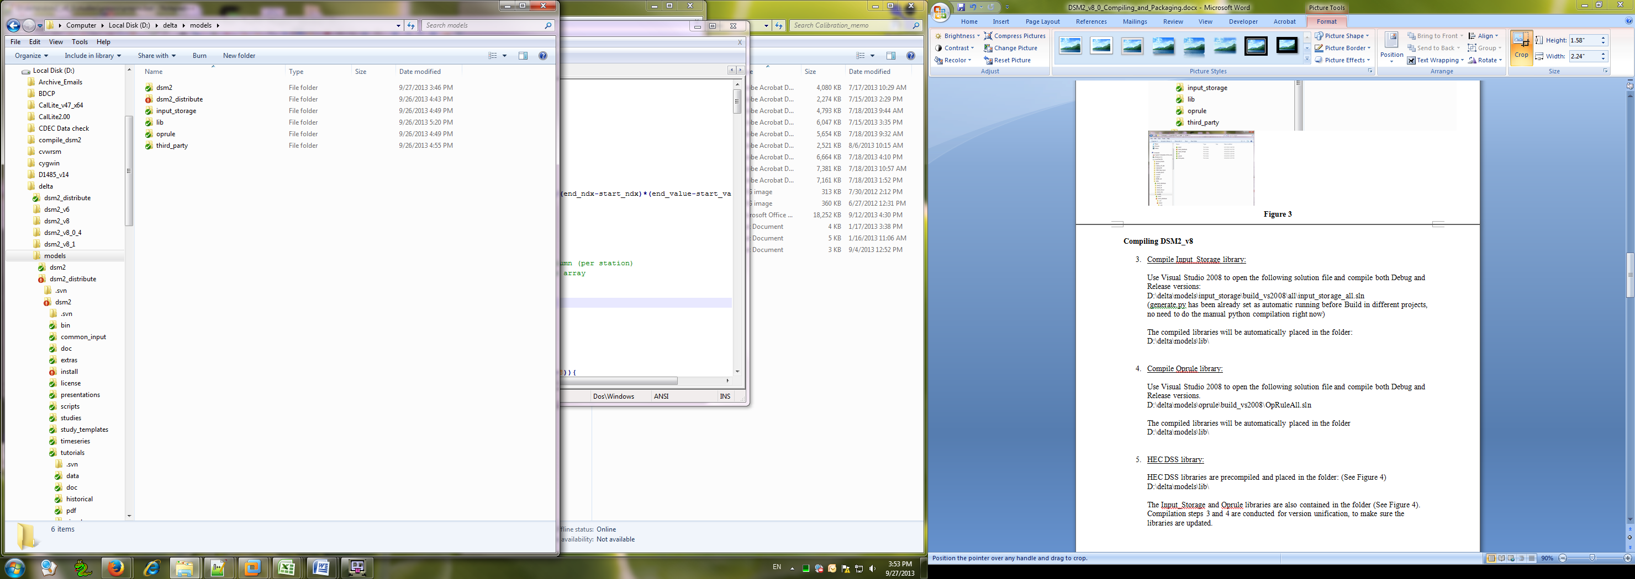
Figure 3

Compiling DSM2_v8

- Compile Input_Storage library:

Use Visual Studio 2008 to open the following solution file and compile both Debug and Release versions:
D:\delta\models\input_storage\build_vs2008\all\input_storage_all.sln
(Before projects Building, make sure generate.py been run, folder ./test and ./example with their cpp & fi files generated)

The compiled libraries will be automatically placed in the folder:
D:\delta\models\lib\

- Compile Oprule library:

Use Visual Studio 2008 to open the following solution file and compile both Debug and Release versions.
D:\delta\models\oprule\build_vs2008\OpRuleAll.sln

The compiled libraries will be automatically placed in the folder
D:\delta\models\lib\

- HEC DSS library:

HEC DSS libraries are precompiled and placed in the folder: (See Figure 4)
D:\delta\models\lib\

The Input_Storage and Oprule libraries are also contained in the folder (See Figure 4). Compilation steps 3 and 4 are conducted for version unification, to make sure the libraries are updated.
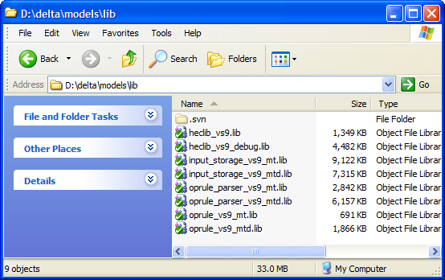
Figure 4

- Compile DSM2:

- Run “generate.py” in the folder “D:\delta\models\dsm2_v8_1\src\input_storage”, to generate 121 input storage files. (See Figure 5)

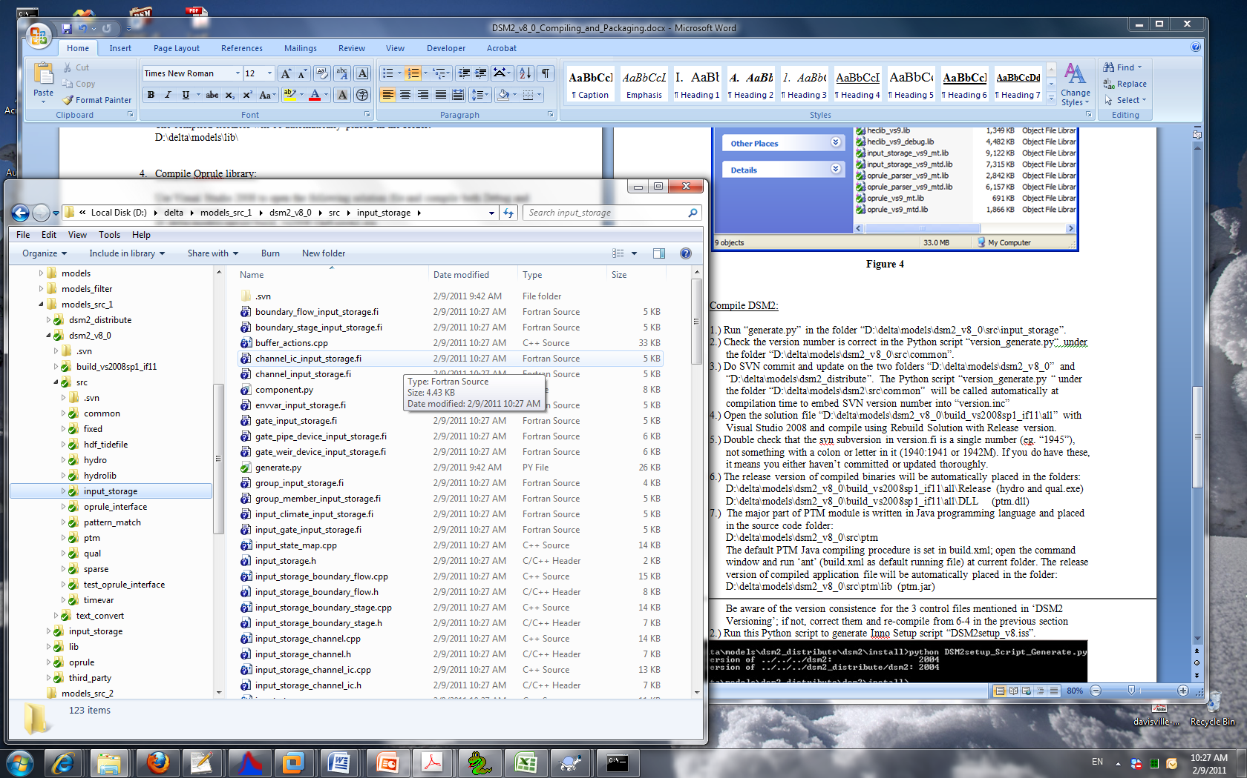
Figure 5

- Check the version number is correct (8.1.*) in the Python script “version_generate.py“ under the folder “D:\delta\models\dsm2_v8_1\src\common”.
- Do SVN commit and update on the two folders “D:\delta\models\dsm2_v8_1” and “D:\delta\models\dsm2_distribute”. The Python script “version_generate.py “ under the folder “D:\delta\models\dsm2\src\common” will be called automatically at compilation time to embed SVN version number into “version.inc”
- Open the solution file “D:\delta\models\dsm2_v8_0\build_vs2008sp1_if11\all” with Visual Studio 2008 and compile using Rebuild Solution with Release version.
- Double check that the svn subversion in version.fi is a single number (eg. “1945”), not something with a colon or letter in it (1940:1941 or 1942M). If you do have these, it means you either haven’t committed or updated thoroughly.
- The release version of compiled binaries will be automatically placed in the folders:
D:\delta\models\dsm2_v8_1\build_vs2008sp1_if11\all\Release (hydro and qual.exe) D:\delta\models\dsm2_v8_1\build_vs2008sp1_if11\all\DLL (ptm.dll)
- The major part of PTM module is written in Java programming language and placed in the source code folder:
D:\delta\models\dsm2_v8_1\src\ptm
The default PTM Java compiling procedure is set in build.xml; open the command window and run ‘ant’ (build.xml as default running file) at current folder. The release version of compiled application file will be automatically placed in the folder:
D:\delta\models\dsm2_v8_0\src\ptm\lib (ptm.jar)

Packaging DSM2

- Generate tutorial PDF files:

- Delete all PDF files in “D:\delta\models\dsm2_distribute\dsm2\tutorials\pdf”
- Run “doc2pdf.vbs” in “D:\delta\models\dsm2_distribute\dsm2\install\” to generate PDFs from tutorial word documents.

- Copy compiled binaries to distribution folder:

- Check the DSM2 version and paths to the compiled binaries are correct in the batch file “copy_hydro_qual_ptmDLL_notepad_style.bat” in the folder D:\delta\models\dsm2_distribute\dsm2\install\
Be aware of the version consistence for the 3 control files mentioned in ‘DSM2 Versioning’; if not, correct them and re-compile from 6-4 in the previous section
- Run the batch file “copy_hydro_qual_ptmDLL_notepad_style.bat”.

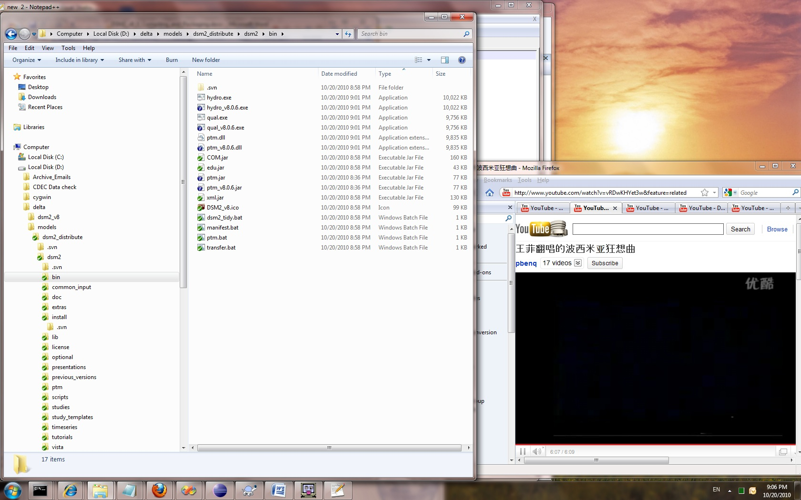
Figure 5
Manually copy hydro.exe, qual.exe, ptm.dll, ptm.jar to the folder
D:\delta\models\dsm2_distribute\dsm2\bin
- Generate packaging script:

- Check the DSM2 version is correct in the Python script “DSM2setup_Script_Generate.py” in the folder D:\delta\models\dsm2_distribute\dsm2\install\
Be aware of the version consistence for the 3 control files mentioned in ‘DSM2 Versioning’; if not, correct them and re-compile from 6-4 in the previous section
- Run this Python script to generate Inno Setup script “DSM2setup_v8.iss”. (Figure 6)

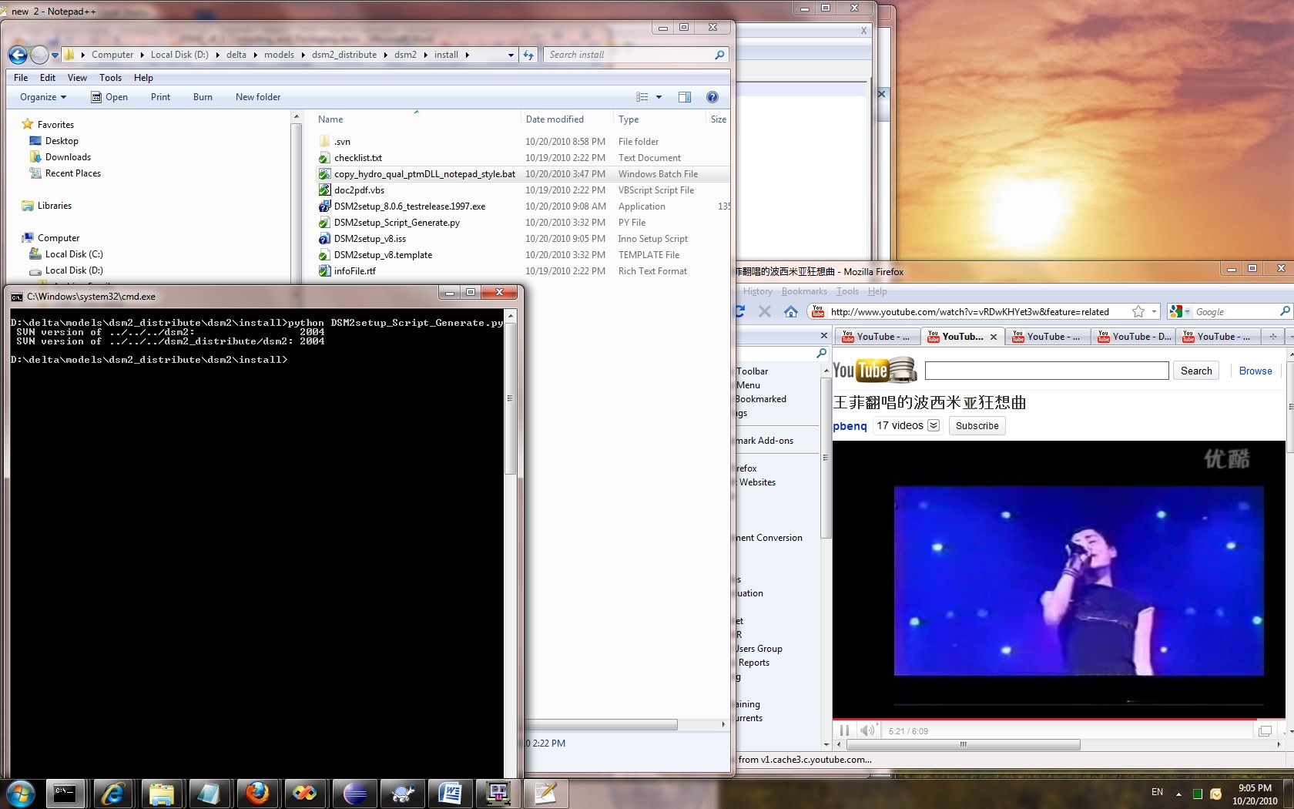
Figure 6

- Create DSM2 installation file:

Run “DSM2setup_v8.iss” with Inno Setup Compiler v5.2.3
The installation file named “DSM2setup_8.X.Xrelease.XXXX.exe” will be created in the same folder, i.e., “D:\delta\models\dsm2_distribute\dsm2\install”
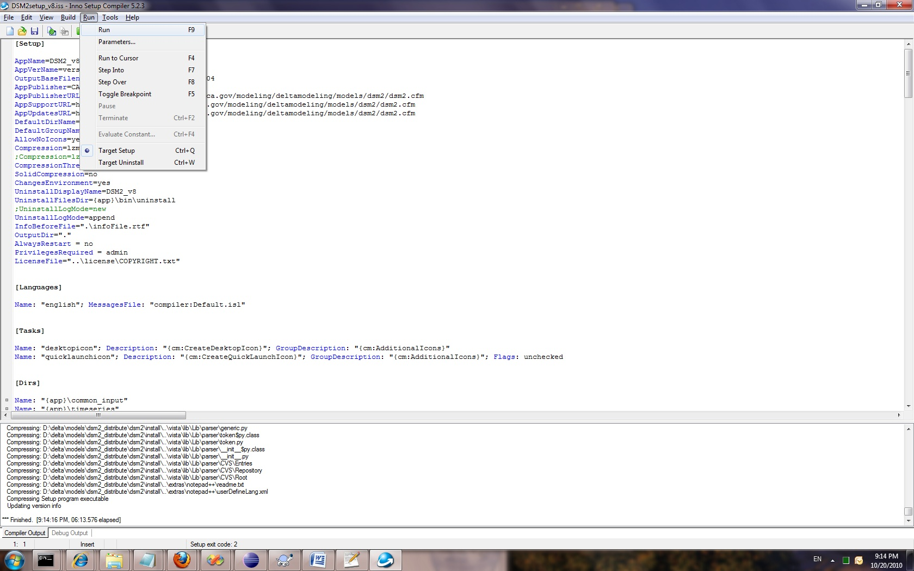
Figure 7

- Quick-test installer:

Test installation on clean machine. Run historical hydro, qual_ec and ptm.

- SVN Tag and version increment:

Create SVN release tag for both “dsm2” and “dsm2_distribute” folders. (See Figure 5).
Immediately increment DSM2 version number in the following three files:

D:\delta\models\dsm2\src\common\version_generate.py
D:\delta\models\dsm2_distribute\dsm2\install\copy_hydro_qual_ptmDLL_notepad_style.bat
D:\delta\models\dsm2_distribute\dsm2\install\DSM2setup_Script_Generate.py

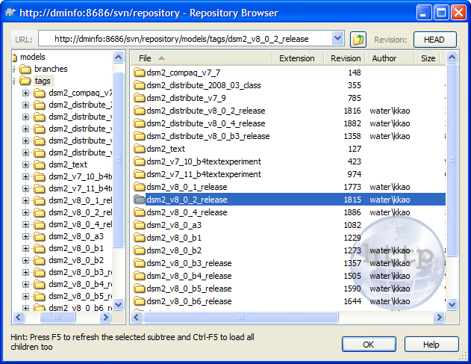
Figure 8

