Date: 3/16/2010

To: Jamie Anderson

From: Kevin Kao

Delta Modeling Section

Bay-Delta Office

Department of Water Resources

Subject : DSM2 version 8 compilation and packaging

This memo presents step-by-step instruction on compiling and packaging DSM2 version 8. Please note that DSM2 project folders may be reorganized and moved to open source server in the near future. Please consult with Nicky or Eli for more information.

**Required Software for DSM2_v8 compilation and Packaging**

1. Visual Studio 2008 sp1
2. Intel Fortran Compiler 11.0
3. Subversion <http://subversion.apache.org/packages.html>
4. Tortoise SVN <http://tortoisesvn.net/downloads>
5. Flex and Bison packages in Cygwin <http://www.cygwin.com/setup.exe>
6. Inno Setup Compiler v5.2.3 <http://files.jrsoftware.org/is/5/isetup-5.2.3.exe>
7. Python <http://www.python.org/download/>
8. Microsoft Office 2007

**Compiling DSM2_v8**

1. Checkout DSM2 project:
2. Checkout the following folders hosted on DWR SVN server and put them in the same directory, e.g., D:\delta\models\

<http://dminfo:8686/svn/repository/models/branches/dsm2_v8_0>

<http://dminfo:8686/svn/repository/models/branches/input_storage_v1_0>

<http://dminfo:8686/svn/repository/models/branches/oprule_v1_0>

<http://dminfo:8686/svn/repository/models/branches/dsm2_distribute_v8_0>

<http://dminfo:8686/svn/repository/models/trunk/third_party>

<http://dminfo:8686/svn/repository/models/trunk/lib>

1. Rename the folder “dsm2_v8_0” to “dsm2”, “input_storage_v1_0” to “input_storage”, “oprule_v1_0” to “oprule”, “dsm2_distribute_v8_0” to “dsm2_distribute”. See figure below.

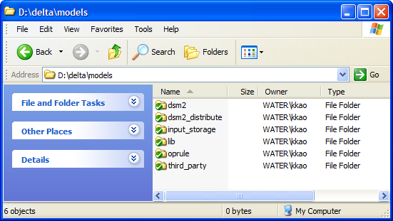

1. Compile Input_Storage library:

Use Visual Studio 2008 to open the following solution file and compile both Debug and Release versions. The compiled libraries will be automatically placed in the folder D:\delta\models\lib\

D:\delta\models\input_storage\build_vs2008\all\input_storage_all.sln

1. Compile Oprule library:

Use Visual Studio 2008 to open the following solution file and compile both Debug and Release versions. The compiled libraries will be automatically placed in the folder D:\delta\models\lib\

D:\delta\models\oprule\build_vs2008\OpRuleAll.sln

1. HEC DSS library:

HEC DSS libraries are precompiled and placed the lib folder. See figure below.

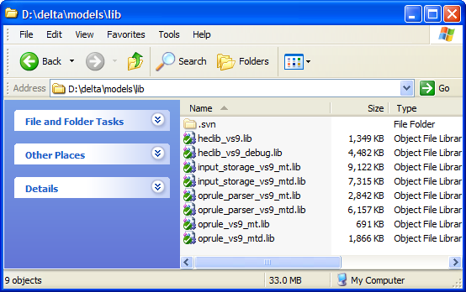

1. Compile DSM2:

Run “generate.py” in the folder “D:\delta\models\dsm2\src\input_storage”.

Open the following solution file with Visual Studio 2008 and compile.

D:\delta\models\dsm2\build_vs2008sp1_ivf110066\all

The release version of compiled binaries will be automatically placed in the folders:

D:\delta\models\dsm2\build_vs2008sp1_ivf110066\hydro\Release D:\delta\models\dsm2\build_vs2008sp1_ivf110066\qual\Release

D:\delta\models\dsm2\build_vs2008sp1_ivf110066\all\DLL\

**Packaging DSM2**

1. Generate tutorial PDF files:

Run “doc2pdf.vbs” in the folder “D:\delta\dsm2_distribute\dsm2\install\” to generate PDFs from tutorial word documents (Delete the old PDFs before run this script)

1. Copy compiled binaries to distribution folder:

Run “copy_hydro_qual_ptmDLL_notepad_style.bat” in the folder “D:\delta\models\dsm2_distribute\dsm2\install\”

1. Generate Inno Setup script:

Run “DSM2setup_Script_Generate.py ” in the folder “D:\delta\dsm2_distribute\dsm2\install\” to generate “DSM2setup_v8.iss”

1. Create DSM2 installation file:

Run “DSM2setup_v8.iss” with Inno Setup Compiler v5.2.3

The installation file named “DSM2setup_8.X.Xrelease.XXXX.exe” will be created in the same folder.