Date: 4/21/2010

To: Jamie Anderson

Cc: Prabhjot (Nicky) Sandhu, Tara Smith

From: Kevin Kao

Delta Modeling Section

Bay-Delta Office

Department of Water Resources

Date: 7/12/2010

Rev 1: Eli Ateljevich

Yu Zhou

Date: 10/20/2010

Rev 2: Yu Zhou (PTM compiling addition, before 8.0.6 release)

Date: 1/14/2013

Rev 3: Yu Zhou (Updates of SVN strategy, compiler, before 8.1.2 release)

Subject : DSM2 version 8 compilation and packaging assuming a minor (bug-fix) release

This memo presents step-by-step instruction on compiling and packaging DSM2 version 8 assuming a minor (bug-fix) release. Please note that DSM2 project may be reorganized and moved to an open-source server in the near future. Please consult with Nicky or Eli or Joey for more information.

**Required Software**

1. Visual Studio 2008
2. Intel Fortran Composer 2013
3. Subversion <http://subversion.apache.org/packages.html>
4. Tortoise SVN <http://tortoisesvn.net/downloads>
5. Flex and Bison packages in Cygwin <http://www.cygwin.com/setup.exe>

(make sure ../cywin/bin set in the environment path)

1. Inno Setup Compiler v5.2.3 <http://files.jrsoftware.org/is/5/isetup-5.2.3.exe>
2. Python <http://www.python.org/download/>
3. Java Development Kit <http://java.sun.com/javase/downloads/index.jsp>
4. Microsoft Office 2007
5. Apache ANT http://ant.apache.org/bindownload.cgi

Note: make sure all software have their binary, header, or library folder set in the environment variables.

**Visual Studio Configurations**

1. Start Visual Studio 2008, go to “Tools → Options → Projects and Solutions → VC++ Directories → Include Files” (See Figure 1)
2. Add paths to JDK include files (See Figure 2)
3. Go to the library files: “Tools → Options → Projects and Solutions → VC++ Directories → Library Files”. Add the fortran library location. This will be something like C:\Program Files (x86)\Intel\Compiler\11.1\065\lib\ia32. You should find a file ifconsol.lib in this directory.

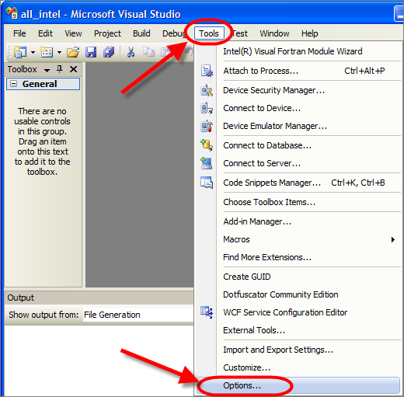

Figure

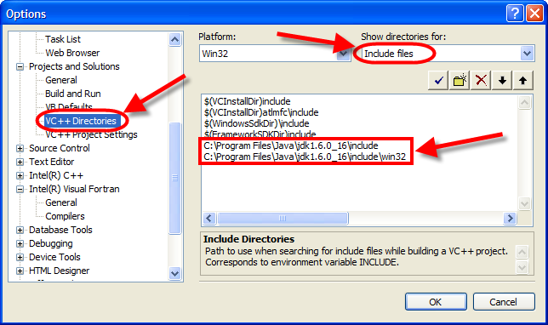

Figure

**DSM2 Versioning**

The latest DSM2 release version is 8.1.1 Subversion: 2146.

DSM2 is currently on the trunk. Its versioned is 8_1_*: the first two digits of DSM2 version; the 3rd digit is used for minor (bug-fix) releases. The subversion number is embedded automatically at compilation time. To modify or increment DSM2 version number, please confirm that the following 3 files are modified:

D:\delta\models\dsm2\src\common\version_generate.py

D:\delta\models\dsm2_distribute\dsm2\install copy_hydro_qual_ptmDLL_notepad_style.bat

D:\delta\models\dsm2_distribute\dsm2\install\DSM2setup_Script_Generate.py

*BDO is using an ‘unstable trunk’ branching strategy in SVN for DSM2 development.

*SVN categories: Trunk is for major development and bug fix; Branches are usually for separate and time-consuming studies on old versions; Tags are the records for all release versions.

*DSM2 version tag (the 3rd digit in the version number) is designed to use odd number for internal use, and even number for formal release

**Checkout DSM2 project**

1. Checkout the following folders hosted on DWR SVN server and put them in the same directory, e.g., D:\delta\models\

<http://dminfo:8686/svn/repository/models/trunk/dsm2>

<http://dminfo:8686/svn/repository/models/trunk/input_storage>

<http://dminfo:8686/svn/repository/models/trunk/oprule>

<http://dminfo:8686/svn/repository/models/trunk/dsm2_distribute>

<http://dminfo:8686/svn/repository/models/trunk/third_party>

<http://dminfo:8686/svn/repository/models/trunk/lib>

1. Confirm the check-out folders hierarchy and names as following (Figure 3)

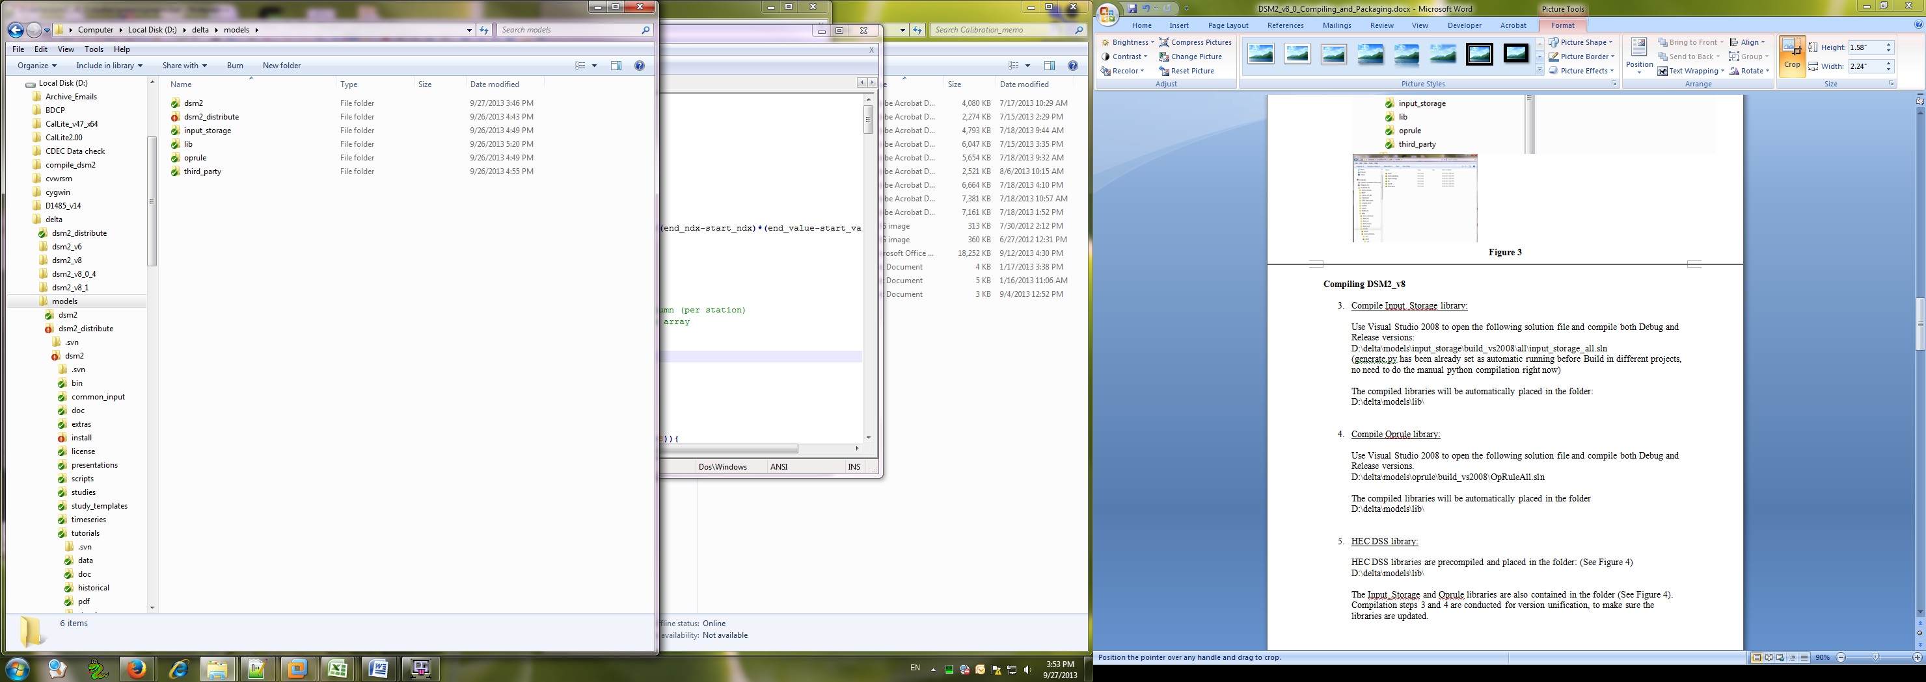

Figure

**Compiling DSM2_v8**

1. Compile Input_Storage library:

Use Visual Studio 2008 to open the following solution file and compile both Debug and Release versions:

D:\delta\models\input_storage\build_vs2008\all\input_storage_all.sln

(generate.py has been already set as automatic running before Build in different projects, no need to do the manual python compilation right now)

The compiled libraries will be automatically placed in the folder:

D:\delta\models\lib\

1. Compile Oprule library:

Use Visual Studio 2008 to open the following solution file and compile both Debug and Release versions.

D:\delta\models\oprule\build_vs2008\OpRuleAll.sln

The compiled libraries will be automatically placed in the folder

D:\delta\models\lib\

1. HEC DSS library:

HEC DSS libraries are precompiled and placed in the folder: (See Figure 4)

D:\delta\models\lib\

The Input_Storage and Oprule libraries are also contained in the folder (See Figure 4). Compilation steps 3 and 4 are conducted for version unification, to make sure the libraries are updated.

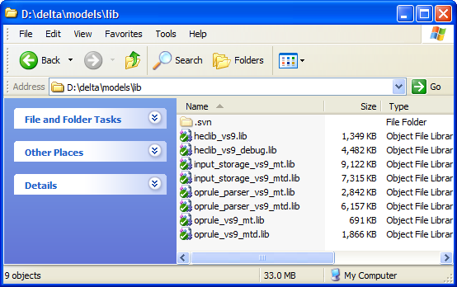

Figure

1. Compile DSM2:
2. Run “generate.py” in the folder “D:\delta\models\dsm2_v8_1\src\input_storage”, to generate 121 input storage files. (See Figure 5)

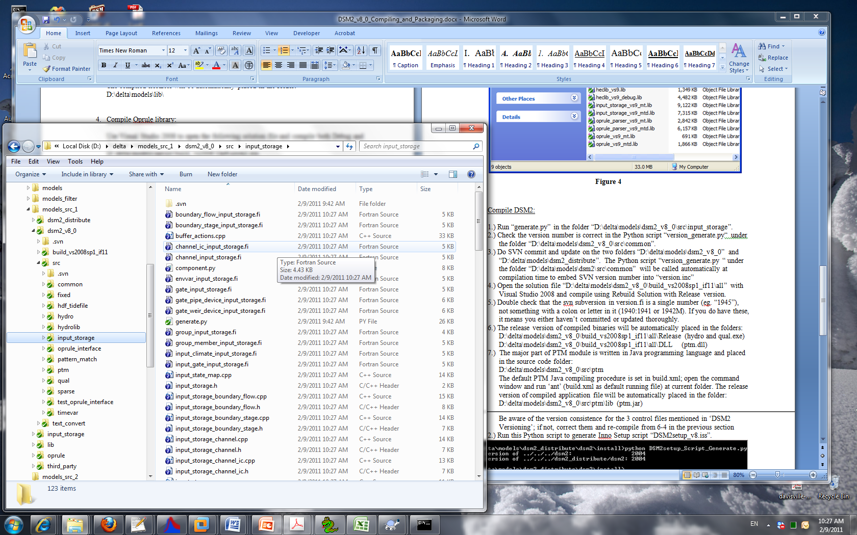

Figure

1. Check the version number is correct (8.1.*) in the Python script “version_generate.py“ under the folder “D:\delta\models\dsm2_v8_1\src\common”.
2. Do SVN commit and update on the two folders “D:\delta\models\dsm2_v8_1” and “D:\delta\models\dsm2_distribute”. The Python script “version_generate.py “ under the folder “D:\delta\models\dsm2\src\common” will be called automatically at compilation time to embed SVN version number into “version.inc”
3. Open the solution file “D:\delta\models\dsm2_v8_0\build_vs2008sp1_if11\all” with Visual Studio 2008 and compile using Rebuild Solution with Release version.
4. Double check that the svn subversion in version.fi is a single number (eg. “1945”), not something with a colon or letter in it (1940:1941 or 1942M). If you do have these, it means you either haven’t committed or updated thoroughly.
5. The release version of compiled binaries will be automatically placed in the folders:

D:\delta\models\dsm2_v8_1\build_vs2008sp1_if11\all\Release (hydro and qual.exe) D:\delta\models\dsm2_v8_1\build_vs2008sp1_if11\all\DLL (ptm.dll)

1. The major part of PTM module is written in Java programming language and placed in the source code folder:

D:\delta\models\dsm2_v8_1\src\ptm

The default PTM Java compiling procedure is set in build.xml; open the command window and run ‘ant’ (build.xml as default running file) at current folder. The release version of compiled application file will be automatically placed in the folder:

D:\delta\models\dsm2_v8_0\src\ptm\lib (ptm.jar)

**Packaging DSM2**

1. Generate tutorial PDF files:
2. Delete all PDF files in “D:\delta\models\dsm2_distribute\dsm2\tutorials\pdf”
3. Run “doc2pdf.vbs” in “D:\delta\models\dsm2_distribute\dsm2\install\” to generate PDFs from tutorial word documents.
4. Copy compiled binaries to distribution folder:
5. Check the DSM2 version and paths to the compiled binaries are correct in the batch file “copy_hydro_qual_ptmDLL_notepad_style.bat” in the folder “D:\delta\models\dsm2_distribute\dsm2\install\”

Be aware of the version consistence for the 3 control files mentioned in ‘DSM2 Versioning’; if not, correct them and re-compile from 6-4 in the previous section

1. Run the batch file “copy_hydro_qual_ptmDLL_notepad_style.bat”.

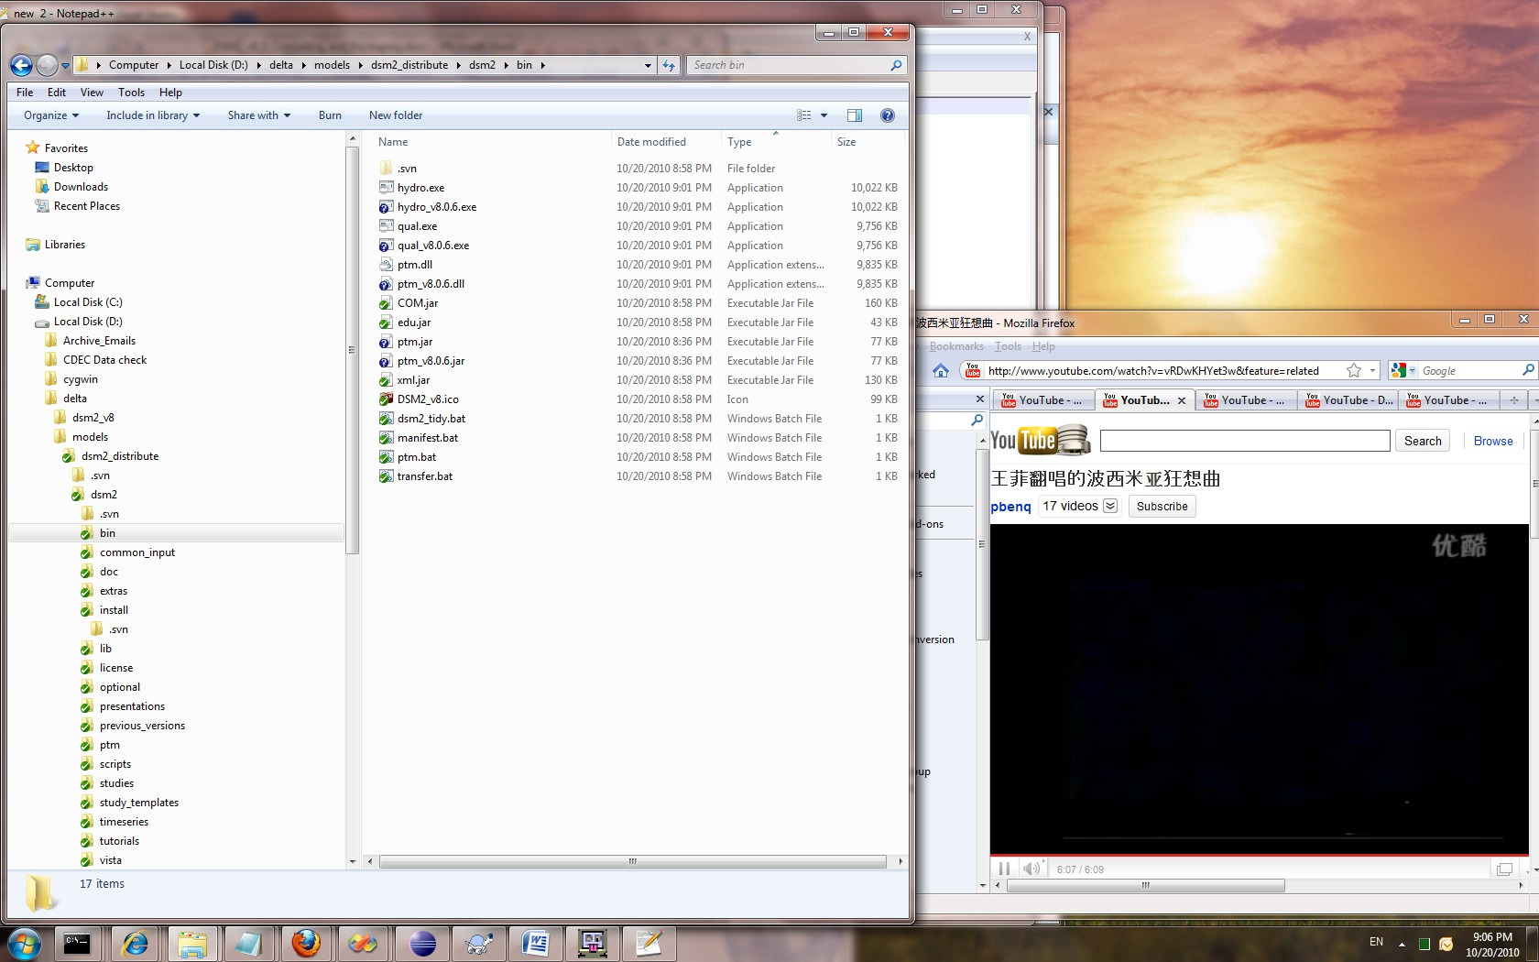

Figure

1. Generate packaging script:
2. Check the DSM2 version is correct in the Python script “DSM2setup_Script_Generate.py” in the folder “D:\delta\models\dsm2_distribute\dsm2\install\”.

Be aware of the version consistence for the 3 control files mentioned in ‘DSM2 Versioning’; if not, correct them and re-compile from 6-4 in the previous section

1. Run this Python script to generate Inno Setup script “DSM2setup_v8.iss”. (Figure 6)

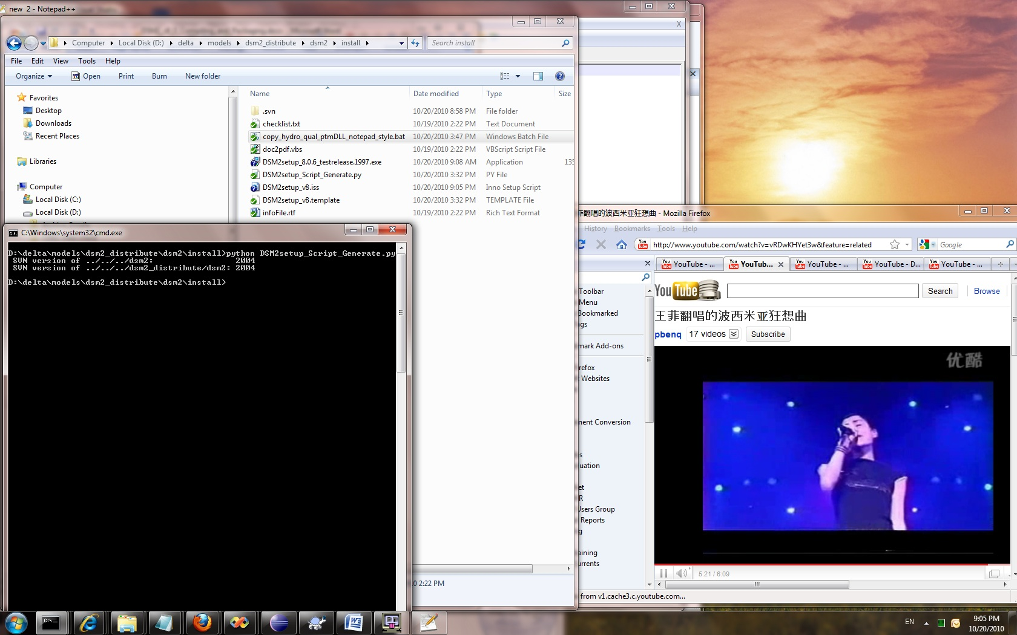

Figure

1. Create DSM2 installation file:

Run “DSM2setup_v8.iss” with Inno Setup Compiler v5.2.3

The installation file named “DSM2setup_8.X.Xrelease.XXXX.exe” will be created in the same folder, i.e., “D:\delta\models\dsm2_distribute\dsm2\install”

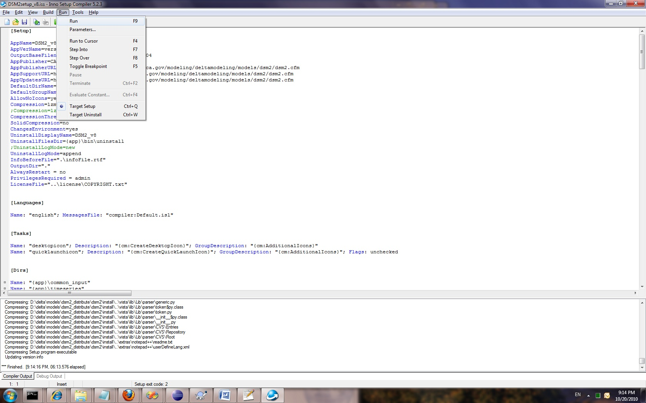

Figure

1. Quick-test installer:

Test installation on clean machine. Run historical hydro, qual_ec and ptm.

1. SVN Tag and version increment:

Create SVN release tag for both “dsm2” and “dsm2_distribute” folders. (See Figure 5).

Immediately increment DSM2 version number in the following three files:

D:\delta\models\dsm2\src\common\version_generate.py

D:\delta\models\dsm2_distribute\dsm2\install\copy_hydro_qual_ptmDLL_notepad_style.bat

D:\delta\models\dsm2_distribute\dsm2\install\DSM2setup_Script_Generate.py

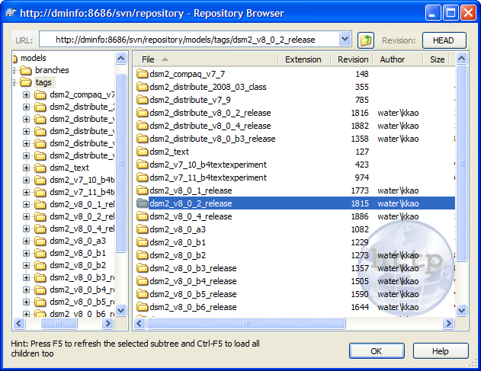

Figure