**DSM2_v8 installation instruction for Windows XP**

1. Right click "My Computer", select "Properties", select the tab "Advanced", click the button "Environment Variables".

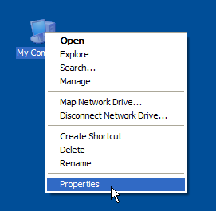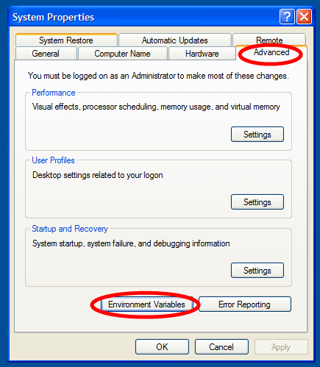

1. Delete DSM2 related values in variables "PATH" and "PYTHONPATH" under both categories "User variables for XXX" and "System variables". Then click “OK”.

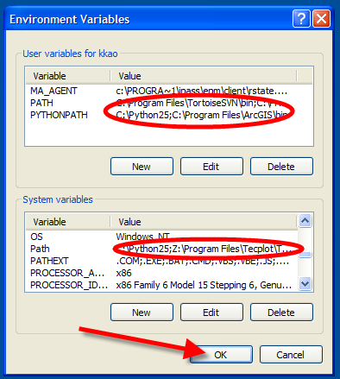

1. Run the installation file DSM2setup_8.0.2.exe.

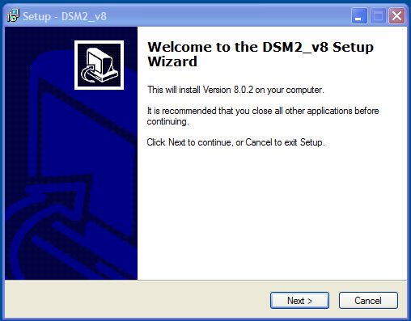

1. Logout your Windows account and then login.

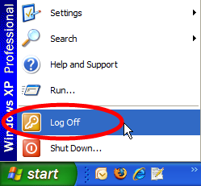

1. Download Notepad++ from here:

<http://superb-west.dl.sourceforge.net/sourceforge/notepad-plus/npp.5.4.2.Installer.exe>

1. Install Notepad++ with the option “Don’t use %APPDATA%”.

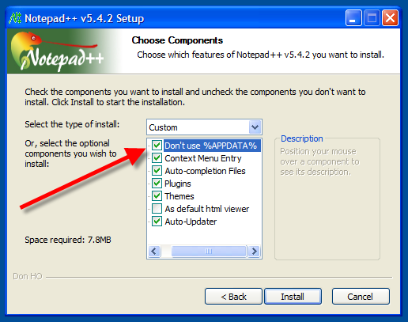

1. Copy the file “userDefineLang.xml” under “your dsm2_8 directory\ tools\notepad++ “(e.g., “D:\delta\dsm2\tools\notepad++ “ ) to your Notepad++ installation folder (e.g., “C:\Program Files\Notepad++”).