**DSM2_v8 installation instruction for Windows XP**

1. Right click "My Computer", select "Properties", select the tab "Advanced", and click the button "Environment Variables".

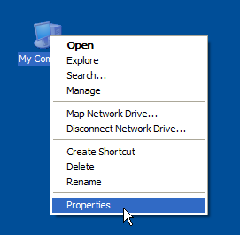

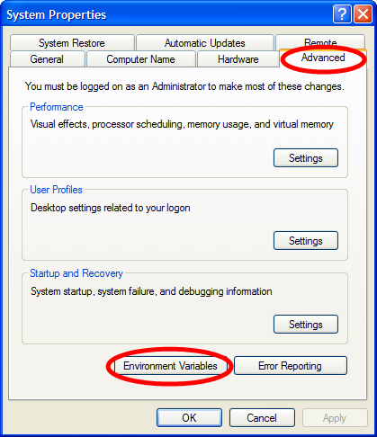

1. Delete DSM2 related values in variables "PATH" and “PYTHONPATH” under both categories "User variables for XXX" and "System variables". Then click “OK”.

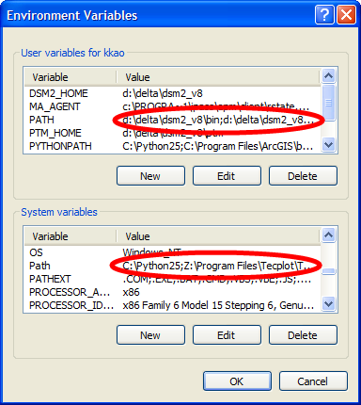

1. Run the installation file.

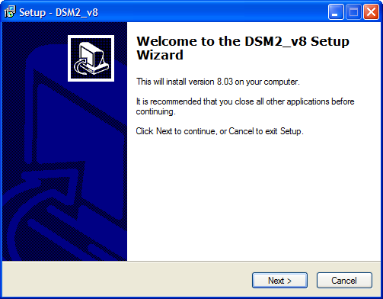

1. Logout your Windows account and then login.

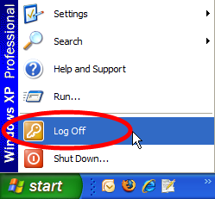

1. Download Notepad++ from here:

<http://superb-west.dl.sourceforge.net/sourceforge/notepad-plus/npp.5.4.2.Installer.exe>

1. Install Notepad++ with the option “Don’t use %APPDATA%”.

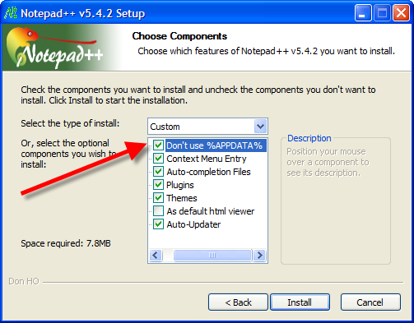

1. Copy the file “userDefineLang.xml” under “your dsm2_8 directory\extras\notepad++ “(e.g., “D:\delta\dsm2\extras\notepad++ “ ) to your Notepad++ installation folder (e.g., “C:\Program Files\Notepad++”).
2. When working with tables you will want the columns to line up, so it is useful if all the characters are the same width – this is known as monospace. Only a few fonts are monospace, including Courier New and Courier. Due to a quirk of notepad++, if you want monospace, you need to set the global default. The way to do this is to go to Settings->Style Configurator and edit Global Styles font to be Courier New.

