**Poindcloud maps:**

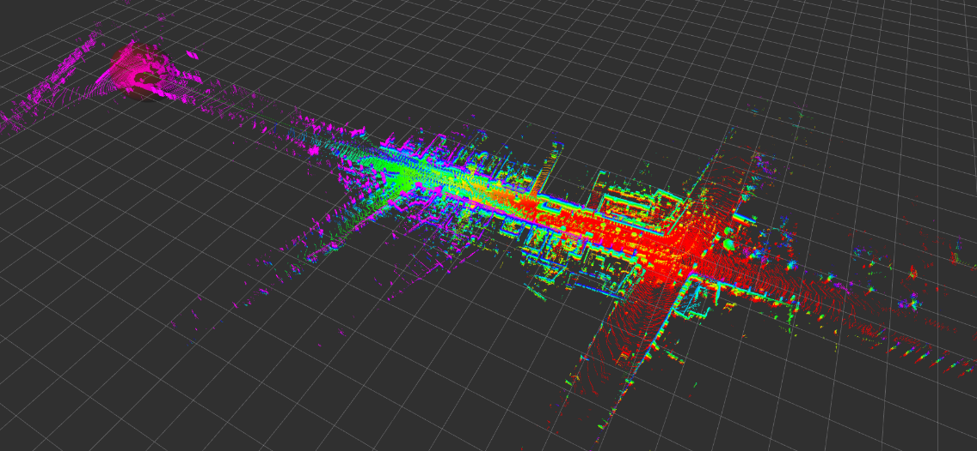

**Figure 1 hdl_graph_slam**

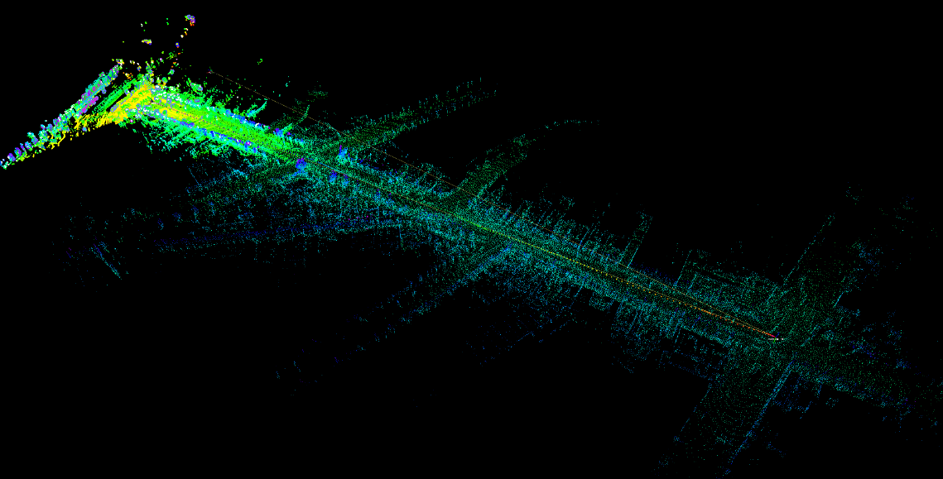

**Figure 2 LeGO_LOAM**

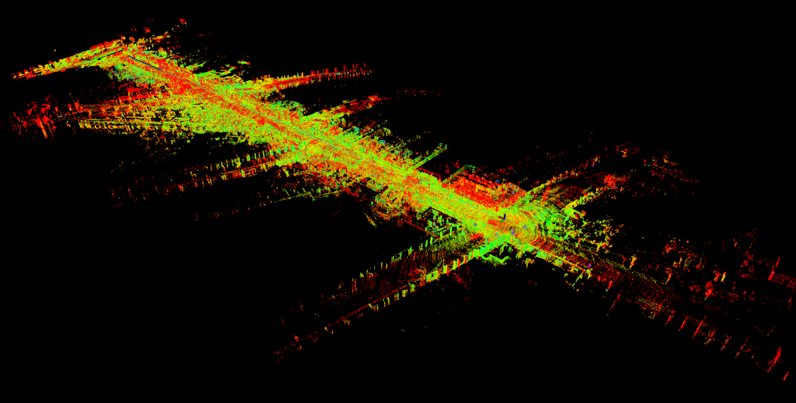

**Figure 3 LIO-SAM**

**Trajectory:**

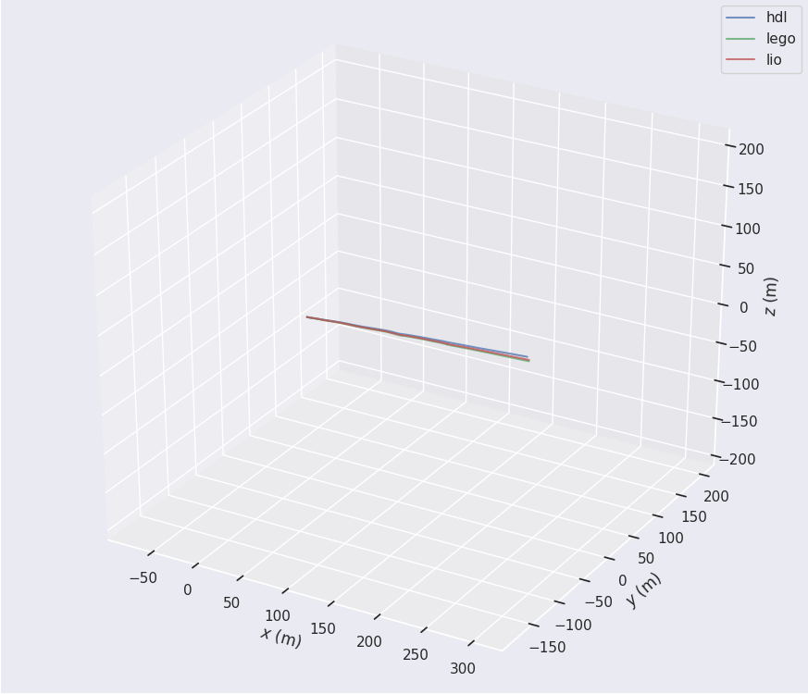

**Figure 4 Trajectories**

**Cpu and memory usages:**

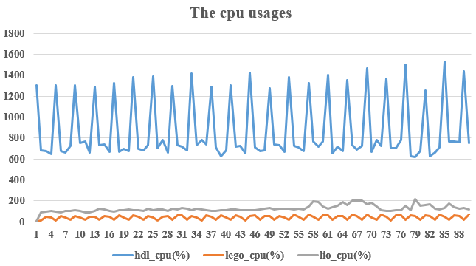

**Figure 5 The cpu usages**

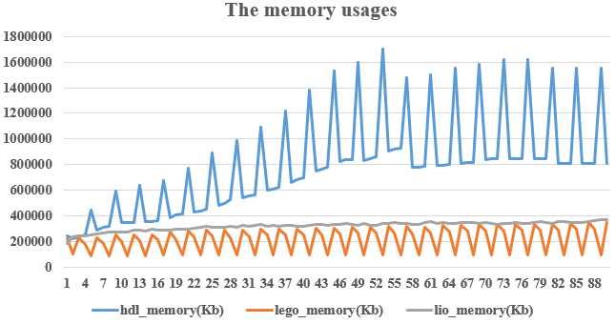

**Figure 6 The memory usages**