

University of Gloucestershire
Cyber Security BSc
Dissertation

An investigation into the timing side-channel vulnerabilities introduced through parallelism in Partial Homomorphic Encryption algorithms

By

Callum Liddell
2026

Supervisor: Joe Cox

Abstract
The use of Partial Homomorphic Encryption (PHE) has remained a prominent area of research interest due to its unique ability to perform computations directly on encrypted data, making it particularly suitable for privacy-sensitive applications, such as electronic voting (e-voting) systems. Current research predominantly focuses on enhancing computational performance through techniques like parallel processing, whilst largely overlooking the security implications these optimisations may introduce. Parallel execution exposes cryptographic implementations to timing side-channel vulnerabilities that do not exist in equivalent sequential implementations, yet no prior work has evaluated the decryption phase of parallel Paillier-based systems through a structured leakage assessment methodology. This research identifies and characterises three structural timing side-channel leakage vectors introduced by parallel Paillier decryption, adapts the established Test Vector Leakage Assessment methodology to a software timing context through candidate-identity partitioning, dual independent measurement metrics and N-Progressive monotonicity testing across three run counts to develop the CP-TVLA Framework. Lastly, three proactive implementation level countermeasures, ciphertext-blinding, synchronisation barrier, and constant-time padding, are implemented and evaluated against this framework. Applied to 150,000 decryption timing records across three system configurations, the CP-TVLA framework detected no statistically significant first-order candidate-distinguishable leakage in either the unprotected parallel or hardened secure system, with 0/20 within-system violations sustained across both measurement metrics at 10,000 measurement runs per candidate. The secure system carries a 9.3% mean computational overhead above the unprotected baseline, attributable primarily to ciphertext blinding.

Keywords: PHE, Paillier Cryptosystem, Timing Side-Channel, Parallel Processing, Electronic Voting, TVLA, Leakage Assessment, Ciphertext Blinding, Modular Exponentiation

Acknowledgements
To Marcus, Trey, George and Will, thank you for the absurd amount of laughs, mostly at Will’s expense. Joe, I’m sorry for the last three years, thank you for all your help in not only this dissertation, but throughout my entire degree, you may actually know what you’re talking about sometimes.
To my darling fiancée, thank you for your undying support, positivity and ego-inflating words, I do all of this for you.

Ethical Statement
I declare that this dissertation has been created by myself, and that it has not been submitted, in whole or in part, in a prior assignment or degree. The work presented is entirely my own, except where stated by citation and reference or acknowledgement.
I confirm that all the tables and figures used throughout this dissertation are my own works, or regenerations of another author’s work with a citation included.
I confirm that all the citations in this dissertation have been provided in the reference list and that they can all be accessed.
I confirm that all the tools, software and data used throughout this dissertation followed the terms and conditions detailed in licensing agreements and are within the bounds of the university code of conduct.
The university guideline for ethical approval has been followed within this dissertation.

Contents
Abstract 2
Acknowledgements 3
Ethical Statement 4
Table of Figures 7
Table of Tables 7
Chapter 1 – Introduction 8
1.1 Overview 8
1. 2 Problem Statement 8
1.3 Research Aim 8
1.4 Research Questions 9
1.5 Research Objectives 9
1.6 Scope 9
1.7 Conclusion 9
Chapter 2 – Literature Review 10
2.1 Homomorphic schemes 10
2.2 Performance Constraints 10
2.3 Optimisation Techniques 11
2.4 Parallelism 12
2.4.1 CPU and Thread Parallelism 13
2.4.2 CRT-Based Parallelism 14
2.4.3 GPU Parallelism 14
2.5 Side-Channel Attacks and Frameworks 14
2.6 Research Gap 15
Chapter 3 – Research Methodology 17
3.1 Literature Review Strategy 17
3.2 The TVLA Framework Adaptation 19
3.2.1 N-Progressive Monotonicity Testing 20
3.2.2 Cross-System Validation 20
3.3 Experimental Design 21
3.3.1 Implementation of framework 22
3.4 Proactive Countermeasure Design 23
3.5 Tools and Environment 24
Chapter 4 – Implementation 24
4.1 System Overview and Configuration 24
4.2 Cryptographic Foundations 25
4.3 Election Setup Pipeline 26
4.3.1 Homomorphic Aggregation 29
4.4 System 1: Sequential Decryption 31
4.5 System 2: Parallel Decryption 33
4.6 System 3: Secure Decryption 36
4.6.1 Threat Model 36
4.6.2 CM1: Ciphertext Blinding 36
4.6.3 CM2: Synchronisation Barrier 37
4.6.4 CM3: Constant-Time Padding 38
4.7 Measurement and Data Export 39
4.8 Python Analysis Script 39
4.8.1 Descriptive Statistical Analysis 39
4.8.2 TVLA Analysis 40
4.8.3 Output Generation 40
Chapter 5 – Testing and Results 41
5.1 Descriptive Statistics 41
5.1.1 Sequential 41
5.1.2 Parallel 42
5.1.3 Secure 42
5.2 Framework Validation: Cross-System TVLA 43
5.3 Within-System Candidate Distinguishability 44
5.4 N-Progressive Monotonicity Analysis 46
5.5 Countermeasure Overhead and Effectiveness 46
5.6 Discussions and limitations 47
Chapter 6 – Conclusion 48
References 50
Appendix A – GitHub Repository 55

Table of Figures
Figure 1: Parallelism Flowchart 13
Figure 2: Literature review flowchart 18
Figure 3: CP-TVLA Flowchart 21
Figure 4: Compile-time constants 25
Figure 5: Weighting function 25
Figure 6: Cold start function 27
Figure 7: Encrypt precinct function 28
Figure 8: Encrypt ballot function 29
Figure 9: Aggregate precinct function 30
Figure 10: Combine precinct function 30
Figure 11: Capture heap metrics 31
Figure 12: CM3 Padding deadline 31
Figure 13: QPC Timer 31
Figure 14: Sequential system 32
Figure 15: Wait group barrier 33
Figure 16: Parallel system start 34
Figure 17: Parallel system continued 35
Figure 18: Ciphertext-blinding (CM1) 37
Figure 19: Synchronisation barrier (CM2) 38
Figure 20: Constant-time padding (CM3) 39
Figure 21: Overhead statistic 47

Table of Tables
Table 1: Homomorphic schemes and security 10
Table 2: Literature review table 16
Table 3:Wall-Clock Duration (ns) N = 10,000 runs per candidate. CV = Coefficient of Variation. P99 = 99th Percentile 41
Table 4: Heap Allocations (Sequential only) 42
Table 5: CP-TVLA Cross-System Comparison All cross-system violations are architecturally expected and carry no security implications. 44
Table 6: CP-TVLA Within-System Comparison Results shown at N=10,000 runs per candidate. 45
Table 7: N-Progressive Monotonicity Analysis 46

Chapter 1 – Introduction

1.1 Overview
Homomorphic encryption enables computation on encrypted data, making it well-suited to privacy-critical applications such as electronic voting, where vote tallying must be performed without exposing individual ballots. The Paillier cryptosystem (Paillier, 1999), which supports additive homomorphism, has attracted significant adoption in this domain due to its strong semantic security and practical key sizes. As deployment scales up, parallel processing has become a primary optimisation strategy, enabling multiple ciphertexts to be decrypted concurrently across CPU Cores. However, the security implications of this parallelism, particularly with respect to timing side-channel vulnerabilities in the decryption phase, remains unexplored in literature.
This dissertation addresses that gap, as Chapter 2 reviews relevant literature on PHE schemes, optimisation techniques, parallelism in Paillier systems, assessment frameworks, and side-channel attacks. Chapter 3 develops the CP-TVLA evaluation framework, whilst Chapter 4 describes the implementation of three e-voting systems, which is evaluated in Chapter 5, where TVLA results are presented and interpreted. Finally, Chapter 6 concludes with a synthesis of findings, experiment limitations and directions for future work.

1. 2 Problem Statement
Current advancements in Partial Homomorphic Encryption have largely been driven by the need for greater computational efficiency and yet security considerations of optimisation methods, such as parallel processing, remain unexplored. As a result, existing implementations risk introducing novel attack vectors and compromising the integrity of encrypted data.

1.3 Research Aim
This research addresses the identified gap through a structured three-part approach. Firstly, a Paillier-based e-voting system is implemented in three configurations, sequential baseline, unprotected parallel and secure parallel, to expose and characterise timing side-channel leakage vectors introduced through parallelism. A Candidate-Partitioned TVLA based analytical framework is developed to evaluate leakage systematically, adapting a hardware-oriented methodology to a software timing context. Finally, three structural countermeasures targeting each identified leakage vector are proactively implemented and evaluated for both effectiveness in eliminating leakage and impact on computational overhead relative to an unprotected baseline.

1.4 Research Questions
RQ1: What timing-side channel vulnerabilities are introduced through parallel processing in the decryption phase of a Paillier-based e-voting system?
RQ2: How can a candidate partitioned TVLA framework be developed and applied to systematically evaluate side-channel leakage in parallel Paillier decryption?
RQ3: How effective are proactively applied countermeasures at eliminating timing side-channel vulnerabilities in the parallel decryption phase, and what is their computational overhead?

1.5 Research Objectives
RO1: To identify and characterise the structural timing side-channel vulnerabilities introduced by parallel processing in a Paillier-based e-voting system.
RO2: To develop and apply a TVLA framework combining candidate-partitioned Welch t-testing, dual independent timing metrics and progressive measurement runs to evaluate side-channel leakage in parallel homomorphic decryption.
RO3: To implement three proactive structural countermeasures targeting distinct leakage vectors in the parallel decryption phase, and to quantify their effectiveness and computational overhead relative to an unprotected baseline.

1.6 Scope
This research is limited to timing side-channel vulnerabilities in the decryption phase of a software Paillier implementation running on a Windows x86 platform. The evaluation methodology is designed to be generalisable to other parallel PHE schemes and privacy-preserving systems, but all empirical results are specific to the implementation described in Chapter 4. Power analysis, electromagnetic attacks and formal verification of zero-knowledge proofs are outside the scope of this project.

1.7 Conclusion
While advancements in Partial Homomorphic Encryption have significantly improved computational efficiency, security implications of parallel optimisation techniques remain unevaluated. This research addresses that gap by analysing the timing vulnerabilities introduced through parallel processing within the Paillier cryptosystem.

Chapter 2 – Literature Review

2.1 Homomorphic schemes
Partial Homomorphic Encryption (PHE) schemes represent the earliest, practical approach to performing computations on encrypted data, allowing for useful data processing without sacrificing confidentially, thereby reducing risk of data exposure and breaches. The RSA (Rivest et al. 1978a) cryptosystem was the first widely deployed encryption scheme to exhibit homomorphic properties, where ciphertext multiplication corresponds to plaintext multiplication after decryption. Whilst these properties were not an explicit design choice, Rivest et al. established the feasibility of computation on encrypted values and later proposed it as a solution to a sample application that would benefit from homomorphic operations (Rivest et al. 1978b). However, RSA is deterministic and therefore fails to achieve indistinguishability under chosen-plaintext attack (IND-CPA), making it vulnerable to ciphertext analysis. Subsequent schemes formalised and extended this concept, with ElGamal (1985) preserving multiplicative homomorphism whilst introducing probabilistic encryption based on the discrete logarithm problem, achieving indistinguishability under chosen-plaintext attack (IND-CPA) and thus a stronger secure posture against such attacks, though it does not achieve indistinguishability under chosen-ciphertext attack (IND-CCA), as its malleability permits ciphertext manipulation. Similarly, Paillier’s (1999) cryptosystem introduced additive homomorphism, enabling efficient and secure aggregation by allowing plaintext addition through ciphertext multiplication, differing fundamentally from both RSA and ElGamal in its algebraic structure. Like ElGamal, Paillier achieves IND-CPA security through its probabilistic encryption mechanism, but similarly does not satisfy IND-CCA security, as the homomorphic property itself implies ciphertext malleability. Schemes, security basis and indistinguishability guarantees are summarised in Table 1.
Table 1: Homomorphic schemes and security
Scheme | Homomorphism | Security Basis | IND-CPA | IND-CCA
RSA | Multiplicative | Factoring | Negative | Negative
ElGamal | Multiplicative | Discrete Log | Positive | Negative
Paillier | Additive | Decisional Composite Residuosity | Positive | Negative

2.2 Performance Constraints
Despite their theoretical utility, PHE schemes suffer from performance limitations that significantly restrict practical deployment. Research shows that whilst PHE provides strong theoretical security, its adoption in practical deployments requires careful coordination of hardware capabilities and bandwidth, due to the computational and memory demands of PHE at a structural level (Kupcova et al, 2025). These demands, such as large moduli and the underlying algebraic structure of the Decisional Composite Residuosity assumption, are what make Paillier suitable for ballot privacy, but are also the driving factors in computational cost. Findings by Munjal and Bhatia (2022) show that Paillier was slower in encryption, decryption, computation and key generation when compared to RSA, noting that storage overhead specifically, a key element in cloud computing, was significantly higher in Paillier.
The aforementioned constraints are further compounded by the scale of real-world e-voting deployments, where hierarchical aggregation, such as homomorphic addition of precinct-level ciphertexts into a national ciphertext, is utilised to reduce the number of required decryption operations. Whilst this approach significantly improves efficiency by limiting decryption to a constant number of operations, it does not eliminate computational cost but rather redistributes the burden from repeated decryption to large-scale ciphertext aggregation. Consequently, the growing computational demand has driven research towards optimisation strategies, most notably parallelism, which leverages multi-core architecture to reduce overall processing time. However, whilst such techniques provide meaningful improvements in throughput, as discussed in Chapter 2.4, they also introduce a class of implementation-level vulnerabilities that have been underexplored in performance focused research.

2.3 Optimisation Techniques
To address the computational overhead present in PHE schemes, literature has predominantly focused on algorithmic refinement. One such refinement is sliding-window exponentiation, evidenced by Ueno and Homma’s (2023) analysis of exponent-blinded RSA-CRT, which documents its widespread deployment in major cryptographic libraries such as GmuTLS, libgcrypt and mbedTLS, finding that modular multiplication can be substantially reduced through limited precomputation. This is further supported by Noma et al. (2017), who demonstrate that adaptive window selection can reduce exponentiation operations by up to 6% and that fixed-base exponentiation, as explored by Prots’ko et al. (2023), reduces execution time from approximately 442-500 µs to 297-336 µs for a 1024-bit moduli. Moreover, Montgomery multiplication, which addresses the inefficiencies of modular reduction by eliminating costly division operations was evaluated by Seo et al. (2020), who present an optimised Montgomery-based modular multiplication technique for microprocessors, evidencing a performance improvement for large integer arithmetic. Their work builds upon earlier contributions by Gouvea et al. (2012), who reported a 45% improvement in prime field multiplication through the use of an irregular non-adjacent form (NAF) representation, combined with precomputed lookup tables. Notably, Seo et al. observe that point addition and doubling chains may introduce vulnerability to timing attacks, as implemented in Gouvea’s approach. These findings are further supported by a comparative analysis of multi-precision multiplication techniques, such as Montgomery and Karatsuba, concluding that Montgomery offers a superior performance and more stable timing behaviour.
Recent survey literature further suggests a growing recognition that the substantial computational overhead of homomorphic encryption schemes necessitates targeted optimisation strategies. Xie et al. (2024) provide a comprehensive survey by systematically examining algorithmic, hardware and hybrid optimisation techniques in federated learning environments, whilst Yin et al. (2021) Liu et al. (2023), Yang et al. (2023), and Lyu et al. (2024) by contrast, largely position PHE as a privacy-enabling mechanism and offer limited discussions on optimisation techniques. Critically, these surveys do not examine the security implications introduced by efficiency driven optimisations.

2.4 Parallelism
Parallelism in homomorphic encryption arises primarily as a response to the increased computational overhead imposed by modular arithmetic, particularly modular exponentiation and multiplication which dominate encryption time and homomorphic operations. Optimisation techniques such as sliding-window exponentiation, the Chinese Remainder Theorem (CRT), and Montgomery multiplication enable the decomposition of large modular operations into smaller components that can be executed concurrently, thereby improving performance (Tandel et al., 2021). However, unlike parallelism in general purpose computing, where independent tasks are distributed to maximise throughput and resource utilisation, parallelism in homomorphic encryption is fundamentally constrained by the need to preserve the underlying algebraic structure of the scheme (Figure 1). Furthermore, whilst parallelisation yields significant performance gains, it also introduces potential security considerations, as increased structural complexity and concurrency may expand the attack surface. Consequently, efficiency improvements in homomorphic encryption must be considered alongside potential secure trade-offs.
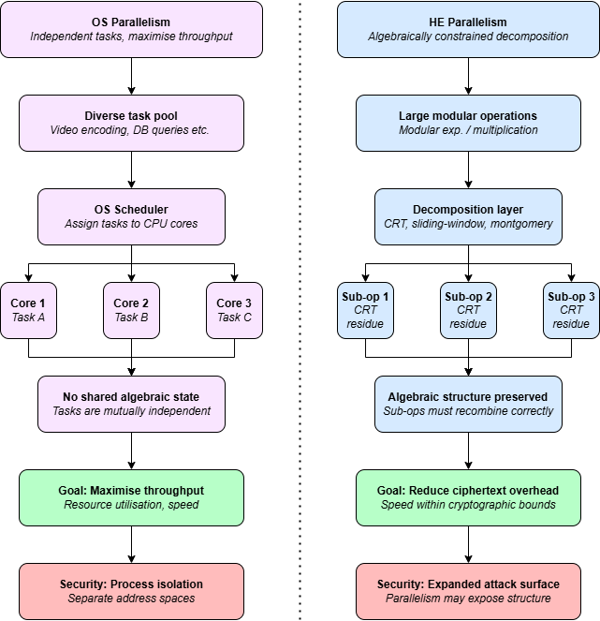
Figure 1: Parallelism Flowchart

2.4.1 CPU and Thread Parallelism
Thread-level parallelism on multi-core CPUs has been shown to dramatically improve Paillier encryption throughput, with optimised implementations increasing the rate of encryption from fewer than 500 operations per second for 2048-bit keys to 89,493 by Jost et al. (2025), highlighting the potential of concurrent execution for independent tasks. In application contexts such as electronic voting, the independence of individual votes makes parallelism particularly effective, Galymzhankyzy et al. (2024) demonstrate a 4.6x speedup ratio when compared to sequential operations and Kartik et al. (2024) show that parallel homomorphic aggregation can maintain correctness, confidentiality, and integrity of encrypted tallies. Collectively, these studies suggest that CPU-based parallelism is a practical and scalable approach for improving Paillier performance, but they neglect to provide an analysis on the security implications of parallel Paillier implementations.

2.4.2 CRT-Based Parallelism
Algorithmic restructuring using CRT enables intrinsic parallelism by splitting large modular exponentiations into smaller computations. Multi-prime CRT variants of Paillier achieve speedup ratios of 1.86 to 3.15x as the number of primes increase from two to four, demonstrating the efficiency of decomposing the problem space (Pan et al. 2025). Hardware-orientated methods have also further enhanced performance by combining CRT acceleration with Montgomery multiplication and structured modular reduction to improve computational efficiency and power performance (Feng et al., 2025). Similarly, Cai et al. (2019) achieved sub-nanosecond operation times using ASIC-based modular arithmetic units, showing that hardware-level parallelism can push Paillier encryption to extreme performance levels. These approaches, however, introduce side-channel vulnerabilities, necessitating mitigation strategies such as constant-time computation and power-balancing to preserve the security assumptions of the scheme, as noted by Feng et al.

2.4.3 GPU Parallelism
Massively parallel GPU architectures have been leveraged to accelerate Paillier encryption through the thousands of lightweight cores available on modern GPUs which allow independent modular arithmetic operations to be executed concurrently, resulting in significant speedups compared to CPU-based or distributed frameworks. Teng and Liu (2023) report a 90x speedup over sequential execution, which substantially exceeds the 27x improvement observed with MapReduce-based distributed CPU implementations. This body of work demonstrates that GPUs are particularly well-suited for workloads dominated by repeated modular operations, such as those required for large-scale homomorphic encryption and privacy-preserving applications.

2.5 Side-Channel Attacks and Frameworks
Whilst PHE schemes are commonly evaluated under IND-CPA and IND-CCA security models, these frameworks assume idealised adversarial conditions and therefore fail to capture vulnerabilities arising from physical implementations. In particular, they do not account for side-channel leakage, which has been more comprehensively addressed in hardware-oriented models such as that proposed by Standaert et al. (2009), whose framework emphasises leakage through physical channels like power consumption and electromagnetic radiation. However, such approaches are primarily suited to embedded systems and are less applicable to adversaries restricted to timing observations, which remain comparatively underexplored.
More broadly, the literature on side-channel attacks in homomorphic encryption is heavily concentrated on levelled and fully homomorphic encryption (LHE/FHE), with relatively limited attention given to PHE schemes. Across these works, there is a consistent recognition that vulnerabilities stem from data-dependent behaviour in core operations, rather than from inherent weaknesses in cryptographic design. For example, Ghaleb and Buchanan (2025) broad analysis categorising attacks into passive forms, such as Simple Power Analysis, and active techniques like fault injection, demonstrate that leakage arises during computation rather than from the encryption schemes themselves.
Although a range of countermeasures, such as constant-time implementations, masking, blinding, and shuffling are frequently proposed, their effectiveness remains contested. While these techniques aim to obscure exploitable patterns, Pace et al. (2025) showed that masking and shuffling can be bypassed through deep learning-based approaches when sufficient traces are available, enabling full key recovery. Similarly, commonly assumed defences assumed to provide meaningful protection have been shown to fail, with Aydin and Aysu (2022, 2024) and Aydin et al. (2022) presenting a series of attacks on Microsoft SEAL, recovering secret key coefficients with accuracies exceeding 98%. Lastly, work by Schmid et al. (2024) indicates that encrypting side-channel traces does not inherently mitigate risk, as encrypted traces can still be exploited to mount effective attacks.

2.6 Research Gap
Taken together, the existing literature demonstrates that parallel implementations can significantly improve performance, however, there is a lack of research examining how parallelised decryption affects resistance to timing side-channel attacks. In particular, there is no established or widely adopted framework for systematically evaluating timing leakage in this context. This reveals a clear gap in the current body of research, highlighting the need for a structured investigation into the security to efficiency trade off in parallel implementations of Paillier decryption. Table 2 highlights parallel implementations of PHE schemes, and whether the literature considers vulnerabilities introduced through parallelism.

Table 2: Literature review table
Author | Scheme | Optimisation | Parallel | Security Consideration
Pan et al. (2025) | CRT Paillier | Parallelised modular exp. | Yes | IND-CPA Only
Jost et al. (2025) | Paillier | Fixed base + thread parallelism | Yes | Cipher-text attacks only
Teng et al. (2023) | Paillier | GPU Parallelism | Yes | None
Cai et al. (2019) | Paillier | ASIC-based processor | Yes | Modular exp. Attacks only
Feng et al. (2025) | Paillier | CRT + Montgomery + Hardware | Yes | Hardware side-channel only
Galymzhankyzy et al. (2024) | Paillier | Parallelised voting enc. | Yes | Partial-parallelism risks
Kartik et al. (2024) | Paillier | Parallelised voting enc. | Yes | Future work only
Ueno and Homma (2023) | RSA | Sliding-window exponentiation | No | None
Seo et al. (2020) | RSA/ECC | Montgomery Multiplication | No | Timing vulnerability noted
Prots’Ko et al. (2023) | RSA | Fixed-base  Exponentiation | Yes | None
Gouvea et al. (2012) | ECC | NAF + Lookup tables | No | None

Chapter 3 – Research Methodology
This chapter describes the research methodology adopted to address the three research questions. The chapter is structured around four principal components, the literature review strategy that motivated the research design; the experimental design underpinning the three system implementations; the development and justification of the CP-TVLA evaluation framework; and the rational for the proactive countermeasure design.

3.1 Literature Review Strategy
The literature review (Figure 2) was conducted across IEEE Xplore, ACM Digital Library, ScienceDirect and ArXiv, with supplementary references to NIST cryptographic standards and original scheme specification papers. Sources were selected on the basis of relevance, accuracy and recency, with foundational works included where their contributions remain pertinent.
Search terms including PHE performance constraints, Paillier computational overhead, and timing-side channel homomorphic encryption were used to identify literature spanning PHE scheme specifications, performance constraints, optimisation techniques and evaluation frameworks. This body of work collectively established that the dominant computational cost of Paillier arises from modular exponentiation, that optimisation strategies such as CRT, sliding-window exponentiation, and parallelism are widely employed to address this, and that performance improvements are consistently reported without corresponding security analysis.
Formal security models such as IND-CPA and IND-CCA, whilst commonly applied, fail to capture vulnerabilities arising from physical implementations, and existing side-channel frameworks are oriented towards hardware emissions rather than timing observations. Furthermore, side-channel research in homomorphic encryption is predominantly concentrated on levelled and fully homomorphic schemes such as Brakerski/Fan-Vercauteran (BFV) and Cheon-Kim-Kim-Song (CKKS), with limited attention given to PHE, largely reflecting a broader academic shift towards more expressive schemes driven by their relevance to privacy-preserving machine learning and cloud computing. PHE is widely regarded as a mature primitive, and this perception has discouraged deeper, implementation-level scrutiny despite its prevalence in real-world deployments, resulting in a scarcity of literature directly informing this work.
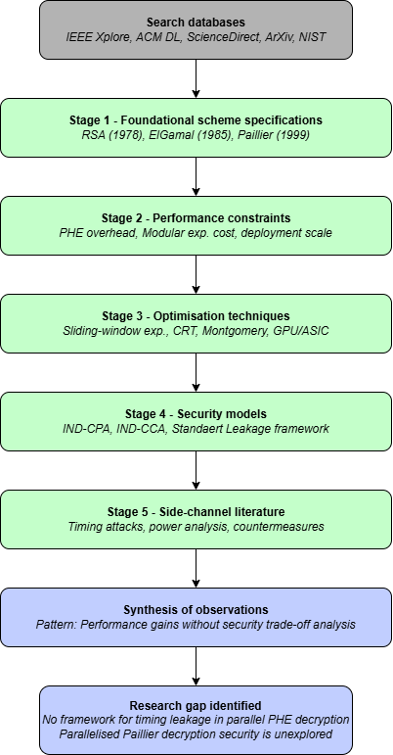
Figure 2: Literature review flowchart

3.2 The TVLA Framework Adaptation
The Test Vector Leakage Assessment (TVLA), as originally defined by Goodwill et al. (2011) and formalised in the TVLA Derived Test Requirements (Rambus, N.D), applies Welch’s t-test to compare fixed-input and random-input trace sets collected from hardware measurements, using a detection threshold of |t| > 4.5, corresponding to a false-positive rate of approximately 1 in 100,000 under the null hypothesis. The methodology has become a standard evaluation tool in hardware, but its direct application to a software timing context requires adaptation. The evaluation methodology must be grounded in the specific adversarial question under consideration, that is, what an attacker seeks to learn and from what observations (Standaert et al., 2009). In the standard TVLA setting, the adversarial question concerns whether a device leaks information as inputs vary between fixed and random values, whereas in the e-voting context of this research, that question does not apply, as the relevant threat is whether and adversary observing decryption timings can infer which candidate’s ciphertexts are being processed. The partitioning strategy must therefore reflect the threat model, rather than the input-variation assumption that underpins the conventional TVLA.
Traces are therefore partitioned by candidate identity in place of fixed versus random inputs, with each candidate producing a distinct group of timing records. Welch’s t-test is applied to all ten pairwise candidate comparisons within each system, and a violation, defined as |t| > 4.5, would indicate that an adversary observing decryption timing could statistically distinguish which candidate ciphertext is being decrypted. This adaptation maps directly to the threat model, where the attacker seeks to infer relative vote totals from timing profiles, rather than recover a cryptographic key from input-dependent leakage.
Two structurally independent timing measurements are captured simultaneously for each decryption call, measuring elapsed wall-clock time and processor computational work respectively. Environmental and system-level factors introduce significant measurement bias into timing evaluations, and such bias is commonplace across computing architectures (Mytkowicz et al., 2009). Within leakage detection specifically, environmental fluctuation is a recognised threat to the reliability of t-test based assessments, with changes to measurement design identified as the appropriate mitigation (Ding et al., 2016). The dual-metric instrumentation adopted here reflects that principle by capturing two structurally independent measurements simultaneously, environmental bias affecting one metric can be identified through divergence with the other, producing a more reliable basis for the Welch’s t-test than either metric could provide alone. Hardware performance counters, such as cache misses, were considered but would require platform-specific kernel interfaces and would introduce additional complexity with diminishing returns. The dual-metric design of the CP-TVLA therefore reflects the most practical balance between measurement independence and implementation feasibility within the constraints of this study. A visual representation of the CP-TVLA framework is evident in Figure 3.

3.2.1 N-Progressive Monotonicity Testing
The experiment is conducted at three measurement counts to test whether within-system t-statistics grow monotonically with an increasing N, which is the expected behaviour of a genuine leakage (Fei et al., 2014; Hajra and Mukhopadhyay, 2013). A true signal, representing a systematic difference in mean decryption times between candidate groups should become more reliably detectable as sample size increases. Conversely, a non-monotonic pattern, where the t-statistic peaks at an intermediate N and subsequently decreases, is the statistical signature of a fluctuation.
The monotonicity check is not part of the original TVLA specification and represents an original methodological contribution of this work that provides evidence of a null results reliability in a way that a single-N evaluation fundamentally cannot.

3.2.2 Cross-System Validation
Cross-system comparisons are also evaluated under the same Welch’s t-test and threshold, and whilst not security-critical and are expected to flag violations due to architectural differences, their purpose is to validate the measurement framework is functioning correctly and is sensitive enough to detect large known differences between systems. A framework that failed to detect these gross differences would lack credibility for the much subtler within-system candidate comparisons that are the focus of this research. Additionally, these comparisons allow for the computational cost of each architectural layer to be quantified, enabling the calculation of mean overhead for the secure implementation.

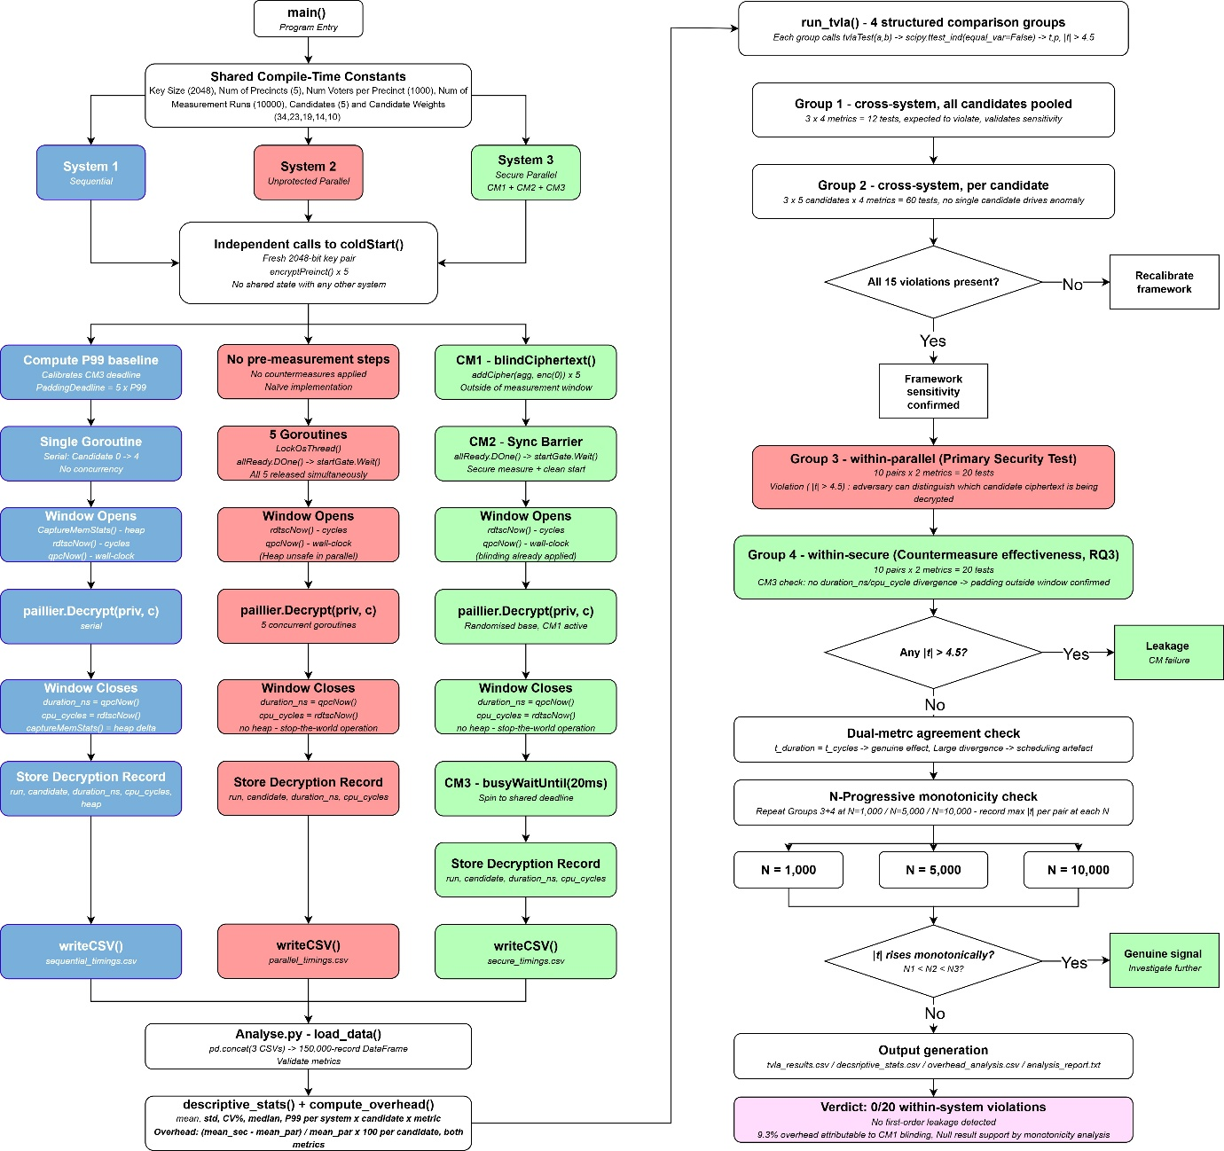
Figure 3: CP-TVLA Flowchart

3.3 Experimental Design
The three systems are consecutively executed within a single Go executable. The sequential system decrypts all five candidate ciphertexts serially within a single goroutine, the unprotected parallel system decrypts all five ciphertexts concurrently without countermeasures, and the hardened secure system extends the parallel architecture with three implementation-level countermeasures. This deliberate progression enables the sequential system to provide a baseline free from concurrent interference, whilst the unprotected parallel system exposes the structural leakage vectors that parallelism introduces, and the hardened secure system demonstrates both the effectiveness of countermeasures and their contribution to computational overhead.
Prior to empirical measurement, a structural analysis of the parallel system was conducted to identify potential timing side-channel leakage vectors. Three such vectors were identified, and countermeasures were proactively implemented in System 3 to address them before measurement began.
Each system performs an independent coldStart(), generating a fresh 2048-bit Paillier key pair and re-encrypting the entire election dataset before measurement commences. This ensures that warm cache state cannot propagate between systems, and that measured timings reflect the architectural properties of each system, rather than shared process artefacts. Full system specifications are provided via the GitHub link in Appendix A.

3.3.1 Implementation of framework
The main implementation is written in Go (Version 1.21) and was chosen for the lightweight goroutine model and language-native concurrency that maps directly to the parallel decryption architecture under evaluation, allowing all five candidate ciphertexts to be decrypted concurrently. Critically, Go exposes runtime.LockOSThread(), which pins a goroutine to a dedicated OS thread, enabling the deterministic thread assignment required for clean synchronisation barrier behaviour and reproducible timing measurements (Go, 2026a). Python implementations would face significant constraints in this context, as the CPython Global Interpreter Lock (GIL) ensures that only one thread executes Python bytecode at a time, meaning that the five concurrent decryption goroutines this architecture requires could not be replicated using Python threads without serialising the cryptographic operations parallelism is intended to expose (Python, 2026a). A multiprocessing approach would avoid GIL constraints but would introduce inter-process communication overhead and prevent the shared-memory synchronisation barrier that CM2 depends upon. Notably, Python 3.13 introduces an experimental free-threaded build via PEP 703 (Python, 2026b ) that disables the GIL, which would in principle support this architecture, however, this remains experimental and its timing behaviour under concurrent cryptographic workloads is underexplored in literature, making it unsuitable as a measurement platform.
Go additionally provides direct access to Windows QueryPerformanceCounter via syscall bindings and exposes runtime.ReadMemStats() for heap allocation profiling in the sequential system (Go, 2026b), both necessary for the dual-metric instrumentation described in Section 3.3.2. The statistical analysis pipeline is implemented in Python 3.12 using Pandas, NumPy and SciPy, exploiting the complementary strengths of each language, with Go for high-throughput concurrent execution and Python for flexible statistical computational and visualisation.

3.4 Proactive Countermeasure Design
A key finding from the literature is that the absence of detected leakage under specific experimental conditions does not constitute a security guarantee (Ronen et al., 2019; Jancar et al., 2022; Standaert, 2018). Countermeasures are therefore designed proactively based on structural analysis of the parallel implementation, rather than reactively in response to observed t-test violations. This approach reflects the principle that mitigations addressing only measured leakage may leave systems vulnerable to attack surfaces beyond the sensitivity of the evaluation methodology, and that security arguments should rest on structural properties rather than empirical null results.
Three distinct leakage vectors were identified within the parallel Paillier decryption architecture. Input-dependent timing variation is mitigated through ciphertext blinding (CM1), which randomises the base of the modular exponentiation, scheduling state divergence is addressed by a synchronisation barrier (CM2), which holds all goroutines at a common gate until each is ready. Completion-time ordering observable to a network adversary is addressed by constant-time padding, which requires each goroutine to busy-wait until a shared deadline is reached, calibrated at 5 times the 99th percentile sequential decryption time.
RQ3 is addressed through a comparative analysis between the unprotected parallel system, and the hardened secure system, which incorporates these countermeasures. Effectiveness is defined as the absence of statistically significant timing leakage under the CP-TVLA framework, determined using Welch’s t-test with a |t| > 4.5 threshold across all candidate partitions, and validated through N-Progressive monotonicity testing to distinguish genuine signals from statistical fluctuations.
Computational overhead is defined as the percentage increase in mean decryption time relative to the unprotected parallel baseline, measured across both duration_ns and cpu_cycles. This dual-metric design enables differentiation between true computational cost and artefacts arising from system-level effects, while also allowing the contribution of individual countermeasures to be inferred. Together, this framework enables a structured evaluation of the security to performance trade-offs in proactive countermeasure design.

3.5 Tools and Environment
Table 3 describes the tools, version, and purpose of tools utilised for implementation.
Table 3: Tools and environment
Type | Tool | Version | Purpose
Language | Go | 1.21 | Implementation of three e-voting systems
Language | Python | 3.12 | TVLA Analysis, statistical computation and reporting
Library | Go-go-gadget-paillier | -- | Paillier cryptographic primitives
Library | Pandas / NumPy | 2.x | CSV ingestion and statistical analysis
IDE | VS Code | 1.90 | Development environment
OS | Windows 11 | -- | Host platform (QPC timer dependency)

Chapter 4 – Implementation
This chapter details the Paillier-based e-voting system developed to evaluate timing side-channel vulnerabilities. The implementation is grounded in the additively homomorphic properties of the Paillier cryptosystem (Paillier, 1999), and the security analysis is framed around the timing side-channel threats characterised in Chapter 3.4.

4.1 System Overview and Configuration
The election consists of five candidates competing across five independently tallied precincts, each recording 1,000 votes, providing a total electorate of 5,000 voters. Core parameters, such as 2048-bit Paillier key size, number of precincts, voters per precinct and measurement runs are defined as compile-time constants (Figure 4), with each system performing 10,000 measurement runs over the decryption phase, yielding 50,000 timing records per system.

$$Number ofcandidates x number of runs=total records for analysis$$

Candidates vote probabilities are defined by integer weights that sum to 100, acting as percentile probabilities, sampled using Go’s cryptographically secure random number generator crypto/rand (Figure 5), reflecting best practice for any system in which unpredictability must be preserved (Turan et al., 2018). This process ensures the election produces realistic, non-uniform votes, similar to a real-world election, without introducing deterministic bias.
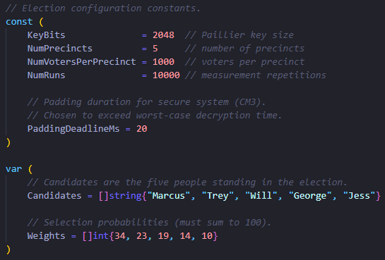
Figure 4: Compile-time constants
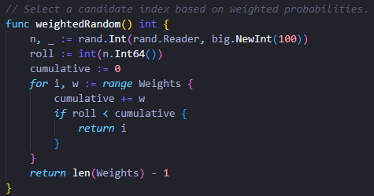
Figure 5: Weighting function

4.2 Cryptographic Foundations
The Paillier cryptosystem is a public-key scheme whose defining property is additive homomorphism. Given two ciphertexts $Enc\left(v_{1}\right)$ and $Enc\left(v_{2}\right)$produced under the same public key, their product modulo $N^{2}$ decrypts to the plaintext sum $v_{1}+ v_{2})$. Formally:

$$Enc\left(v_{1}\right) × Enc\left(v_{2}\right) mod N^{2} =Enc(v_{1}+ v_{2})$$

This property is essential, as it allows for vote tallying to be performed entirely within the encrypted domain, with no single individual ballot ever decrypted during aggregation, which is deferred until the national ciphertext is formed. The implementation uses go-go-gadget-paillier (Roasbeef, 2016), providing key generation, encryption, decryption, and the addCipher homomorphic addition. Each ballot uses 1-of-k (one-hot) encoding, in which the ballot is represented as a vector of k ciphertexts corresponding to k candidates, with the slot for the chosen candidate encrypted as the value 1, with other slots encrypted as 0 (Chillotti et al., 2016). Paillier’s semantic security under the Decisional Composite Residuosity assumption ensures that two encryptions of the same plaintext are computationally indistinguishable, preserving ballot privacy and ensuring that ballots cast for the same candidate cannot be linked to one another and that an observer intercepting ciphertexts gains no information about underlying votes.

$$Ballot=\left[ Enc\left(0\right), Enc\left(1\right), Enc\left(0\right), Enc\left(0\right), Enc\left(0\right) \right]$$
$$^ Selected Candidate$$

4.3 Election Setup Pipeline
Each system commences with an independent call to coldStart(), which generates a fresh key pair and runs the full setup procedure (Figure 6). Voter choices are sampled and recorded as ground truth for later verification, encryption is then parallelised across all available CPU cores using a worker pool pattern (Go by Example, 2026), where voter indices are pushed into a buffered channel, and runtime.NumCPU() goroutines drain the channel concurrently, each calling encryptBallot() (Figure 7, 8). Public key encryption is a well-established and researched cryptographic principle and is not the subject of this experiment or analysis, therefore, parallelising the encryption process is utilised only as an optimisation technique to reduce setup time.
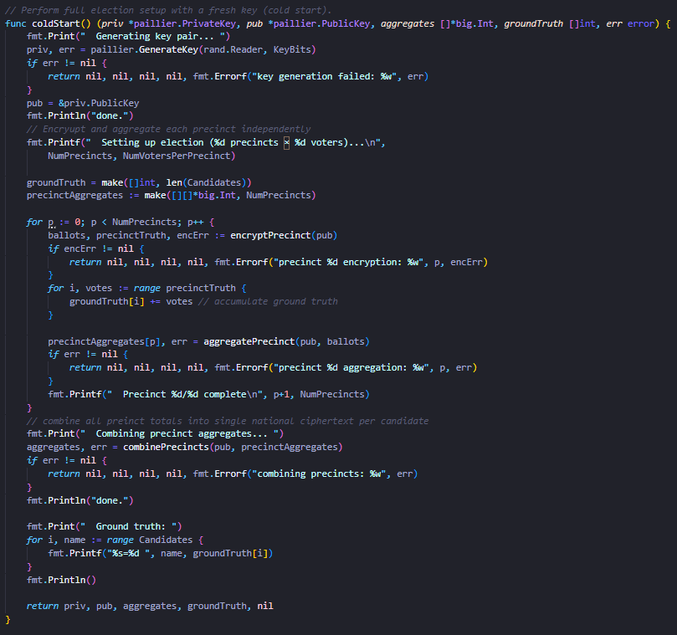
Figure 6: Cold start function
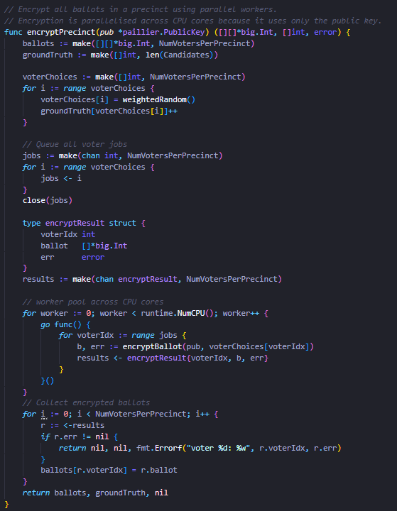
Figure 7: Encrypt precinct function
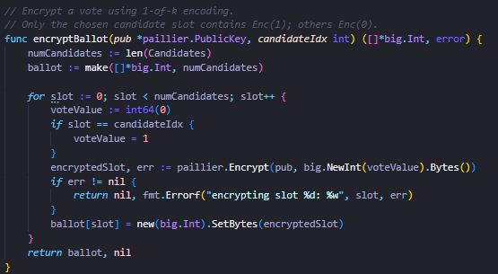
Figure 8: Encrypt ballot function

4.3.1 Homomorphic Aggregation
Once all the ballots are encrypted for a precinct, aggregatePrecinct() computes a per-candidate running total through iterative homomorphic addition (Figure 9), with each candidate’s running total initialised to Enc(0), and for every ballot in the precinct, the encrypted slot for each candidate is added to the running total using Paillier.AddCipher(). Once all precincts are complete, combinePrecincts() applies the same operation across the five precinct-level aggregates to produce a national ciphertext per-candidate (Figure 10).
The two-stage architecture mirrors the structure of real-world voting deployments where ballot boxes are tallied locally before being combined at a central counting authority (Baltz et al., 2022). This approach preserves privacy, as if a precinct-level aggregate is compromised, no individual vote can be recovered without the private key.

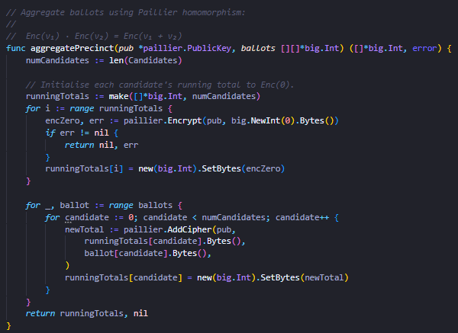
Figure 9: Aggregate precinct function

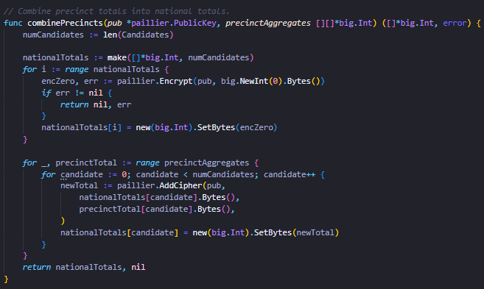
Figure 10: Combine precinct function

4.4 System 1: Sequential Decryption
The sequential system serves as the baseline measurement configuration, where all five candidate ciphertexts are decrypted serially within a single goroutine, isolating the cost of a single Paillier decryption operation without parallel interference introducing timing data variation (Figure 14). Heap allocation metrics are captured using runtime.ReadMemStats(), where memory statistics are taken immediately before and after each call to Paillier.Decrypt() (Figure 11). The number of allocated bytes during the decryption operation is calculated through the difference between Malloc and TotalAlloc, feasible only in the sequential system as it is a stop-the-world operation that pauses goroutines, providing a snapshot infeasible in the parallel routines as multiple invocations across goroutines would produce mutually interfering results.
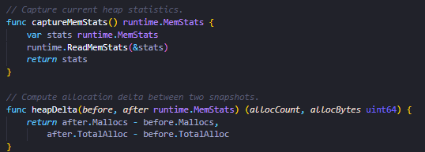
Figure 11: Capture heap metrics
The 99th percentile of sequential per-candidate decryption duration is computed and used to calibrate the constant-time padding deadline (CM3) in System 3, set to five times the 99th percentile to comfortably exceed worst-case concurrent execution time. Additionally, wall-clock time is captured using qpcNow(), which calls QueryPerformanceCounter (QPC) at approximately1 µs resolution (Figure 13), rather than time.Now(), at 500 µs resolution in Windows which is too coarse for the CP-TVLA at the microsecond scale (Microsoft, 2026b).
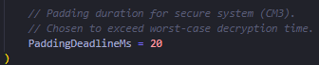
Figure 12: CM3 Padding deadline
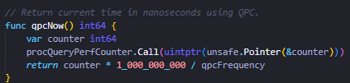
Figure 13: QPC Timer
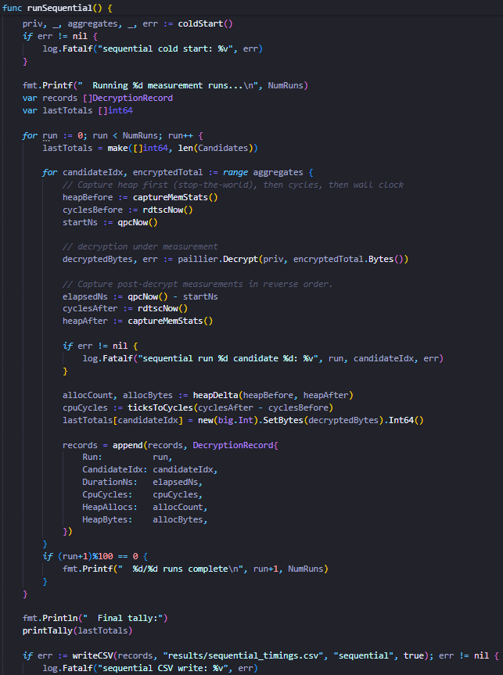
Figure 14: Sequential system

4.5 System 2: Parallel Decryption
The parallel system (Figure 16, 17) decrypts all five ciphertexts simultaneously, with one goroutine per candidate using a dedicated OS thread via runtime.LockOSThread() before decryption commences (Go, 2026a). Without pinning, Go’s cooperative scheduler cannot preempt the computationally intensive decryption loop, causing goroutines to compete for threads. With pinning, each goroutine is guaranteed a dedicated thread and, on a machine with sufficient cores, runs concurrently on a separate physical core. A sync.WaitGroup barrier holds all goroutines at a common gate until pinned and ready, then releases them simultaneously (Figure 15). This barrier is also present in this system to ensure clean comparative measurements, as without it, launch-order differences may introduce timing bias.
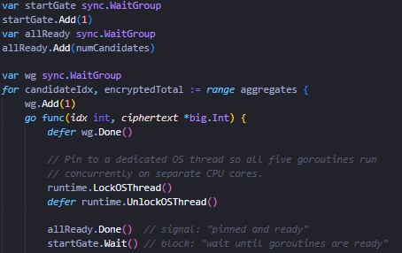
Figure 15: Wait group barrier

The parallel system applies no implementation-level countermeasures and is intended to represent a naïve performance-oriented implementation without adequate security analysis. This is consistent with developer behaviour documented in literature, evidencing that developers are concerned about timing-attacks, but security analysis tools were not utilised to ensure systems are constant-time, leading to potentially vulnerable implementations (Jancar et al., 2022).
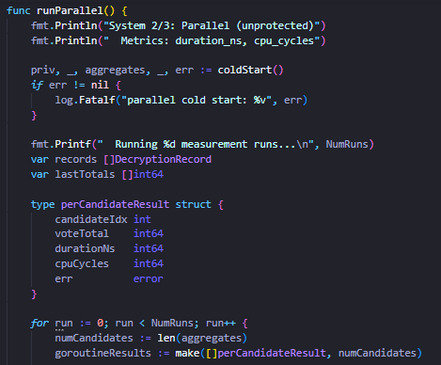
Figure 16: Parallel system start

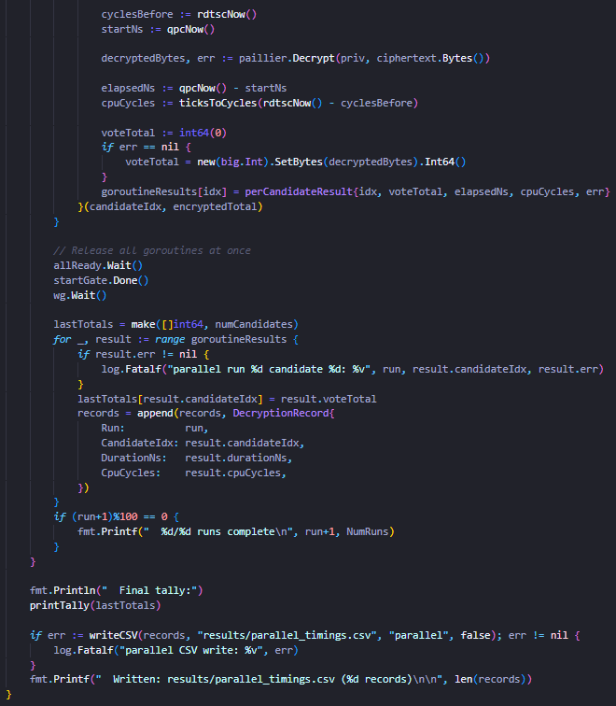
Figure 17: Parallel system continued

4.6 System 3: Secure Decryption
The secure systems extends the previous parallel architecture with three proactive countermeasures, each targeting a distinct leakage vector identified through structural analysis. As established in Chapter 3.4, countermeasures are applied before empirical leakage, as the absence of detected leakage does not constitute a security guarantee. This is demonstrated by Ronen et al. (2019), who showed through TLS implementation analysis that seven out of nine systems remained vulnerable to side-channel attacks, as mitigations addressed only observed leakage.
Together, these countermeasures represent a layered approach to side-channel defence, a strategy that aims to stay ahead of the arms-race between side-channel attacks and defences as noted by Lou et al. (2021), who expect unknown vulnerabilities still exist in modern implementations.

4.6.1 Threat Model
The secure system assumes that an adversary is incapable of directly modifying computation but capable of measuring elapsed time between the start and end decryption, without requiring physical access to a machine, supported by GE et al. (2018) who demonstrate that timing information is recoverable through shared resources such as CPU caches and branch predictors, accessible to co-resident processes. In a networked deployment, like an e-voting system, the same information is also recoverable from timing response messages or from the arrival order of decrypted results. The objective of the three countermeasures is to ensure that the observed timing profile of the five goroutines reveals no information about relative computational cost, and in turn the ciphertext content of each decryption operation.

4.6.2 CM1: Ciphertext Blinding
Ciphertext blinding addresses the input-dependent timing leakage that arises from modular exponentiation at the core of decryption, where computing $cλ mod N^{2}$ involves repeated modular squaring and multiplications, whose execution time depends on the bit pattern for the base value c. Standard implementations that utilise sliding-window or left-to-right binary methods to reduce multiplication counts have been demonstrated to leak key-dependent information through cache access patterns by Bernstein et al. (2017), as the set of pre-computed values accessed depends on the specific bits of the exponent and base. Furthermore, Cabrera Aldaya et al. (2019) confirmed the exploitability of dependent timing by recovering RSA private keys in a single trace by exploiting input access patterns of binary GCD algorithm using cache-timing attacks.
Ciphertext blinding eliminates this leakage by homomorphically adding a fresh encryption of zero to each aggregate ciphertext before decryption, replacing the fixed ciphertext with independently random values on each run. This method breaks the fixed relationship between candidate ciphertexts and decryption time, as the input to the modular exponentiation changes unpredictably between runs. This implementation is the Paillier equivalent of RSA multiplicative blinding, which Brumley and Tuveri (2011) identify as a necessary step in timing-safe RSA, and which OpenSSL enables by default (OpenSSL, 2025).
Implemented serially to all five aggregate ciphertexts before goroutine launch using the blindCiphertext() function, the blinding is performed outside the measurement window to ensure that the computational cost does not appear in recorded decryption timings, therefore not affecting the comparison between the systems (Figure 18).

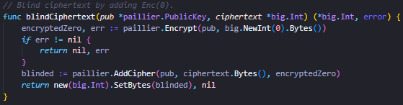
Figure 18: Ciphertext-blinding (CM1)

4.6.3 CM2: Synchronisation Barrier
The second leakage vector arises from the conditions surrounding decryption. When goroutines are launched sequentially in a for loop the first goroutine begins executing before the last has been created, meaning each goroutine enters decryption from a different CPU cache and branch predictor state, producing timing variations. Pereida Garcia and Brumley (2017) showed that a constant-time ECDSA scalar multiplication leaked key-dependent timing, as surrounding code was not itself constant-time. To resolve this, a synchronisation barrier was implemented to hold all goroutines at a startGate until each goroutine has signalled readiness via allReady, ensuring all five goroutines begin decryption from the same simultaneous scheduling position. Each goroutine is pinned to a dedicated OS thread, essential to the barrier’s success, as without it, goroutines could migrate to different threads, reintroducing the scheduling divergence the barrier eliminates.
The synchronisation barrier is present in System 2 to ensure clean comparative timing measurements, whereas in System 3 it also serves the additional role of a proactive security measure (Figure 19).
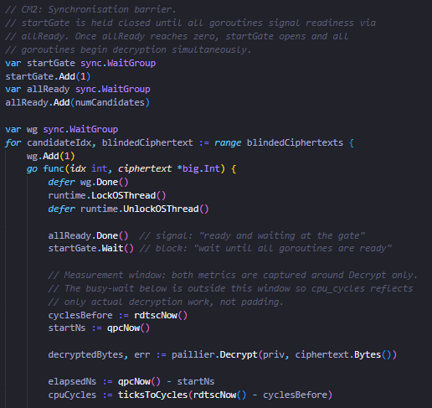
Figure 19: Synchronisation barrier (CM2)

4.6.4 CM3: Constant-Time Padding
The final countermeasure combats completion time leakage from information revealed by the order and spacing in which goroutines finish decryption. Even with the aforementioned countermeasures, goroutine decryption is completed at different times due to cache misses, pipeline stalls and frequency fluctuations. As noted by Van Goethem et al. (2020) an adversary could collect a series of measurements and infer secret information through statistical analysis, in this context, using per-candidate completion time differences to predict ballot outcomes. Constant-time padding eliminates this by requiring every goroutine to busy-wait after Paillier.Decrypt() returns, until a shared 20ms deadline, calibrated as five times the 99th percentile per-candidate decryption time of the sequential system (Figure 20). Whilst the busy-wait executes after the measurement window closes, duration_ns is inflated for all candidates equally, but cpu_cycles remains unaffected, reinforcing the need for dual-independent metrics in timing-attack analysis.
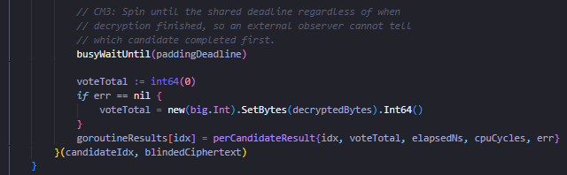
Figure 20: Constant-time padding (CM3)

4.7 Measurement and Data Export
The decryption timing for each system follows a consistent methodology, where wall-clock time is sampled using qpcNow() immediately before and after Paillier.Decrypt() to produce a nanosecond elapsed duration. The measurement of heap allocations in the sequential system are taken at the same two points, and measurements are accumulated across all runs and candidates into a slice of DecryptionRecord structs, each carrying run index, candidate index, nanosecond duration, and additionally, heap allocation metrics for the sequential system. Once the measurement phase is concluded, the records are serialised to a CSV file, enabling the combined loading in the subsequent Python analysis script. The CSV format was chosen specifically for its simplicity and compatibility with Pandas and NumPy libraries used in the analysis pipeline below.

4.8 Python Analysis Script
The Python analysis script ingests the three CSV files produces by the Go implementation, loads the three CSV files into a combined data frame, and validates the data to ensure that all metric columns are present. The python file is structured into three logical stages, comprising of descriptive statistical analysis, TVLA comparison and output generation.

4.8.1 Descriptive Statistical Analysis
Descriptive statistics are computed by descriptive_stats(), which iterates over every system, candidate, and available metric to compute the mean, standard deviation, coefficient of variation (CV) and median, returning the data frame that populates descriptive_stats.csv. The CV is particularly informative for comparing measurement noise across the three systems, as it normalised standard deviation by the mean, allowing the proportional spread of timing distributions to be compared, despite the different mean durations of each system.

4.8.2 TVLA Analysis
The TVLA analysis is implemented by runTVLA(), which structures all comparisons into for groups, each corresponding to the four CP-TVLA framework components. Each individual comparison is delegated to tvlaTest(), which calls scipy.stats.ttest_ind() to perform a Welch’s t-test. The equal_var=False parameter of this function is essential as the t-test assumes equal variance, which is false in this instance as the three systems have different variance by design. The returned t-statistic is then evaluated against the |t| > 4.5 TVLA threshold, with the Boolean leakage flag and p-value both stored for reporting.
The four comparison groups are cross-system with all candidates pooled, testing each of the three system pairs across all four metrics; cross-system per candidate, repeating the same pairs for each candidate individually to confirm that no single candidate drives anomalous cross-system results; within-parallel, testing all ten candidate pairings for duration_ns and cpu_cycle independently as the primary security test for RQ1; and within-secure, applying the same ten pairings to the secure system to evaluate countermeasure effectiveness for RQ3. Results within each group are sorted by absolute t-statistic in descending order, ensuring that the largest potential variations are presented first in both the CSV output and text report.

4.8.3 Output Generation
All TVLA results are exported to tvla_results.csv alongside the descriptive statistics CSV. A structured text report (analysis_report.txt) is written containing the full comparison tables grouped by metric and scope. Visualisations are generated using matplotlib and seaborn and written to a results/plots directory, including TVLA bar charts with the |t| > 4.5 TVLA threshold marked, box plots comparing duration distributions across candidates and systems, coefficients of variation charts and CPU cycles versus wall-clock scatter plots whose divergence patterns reveals the relative contribution of scheduling noise versus genuine computational variation in each system.

Chapter 5 – Testing and Results
This chapter presents and interprets the results of the CP-TVLA framework applied to 150,000 decryption timing records across the three systems at N = 10,000 measurement runs per candidate. The |t| > 4.5 detection is applied, corresponding with criteria specified by Goodwill et al. (2011) and the TVLA Derived Test Requirements.

5.1 Descriptive Statistics
Table 4 presents the descriptive statistics for duration_ns across all three systems at N = 10,000 runs per candidate. The cpu_cycles are structurally identical, with CV values agreeing to within 0.03 percentage points of their duration_ns counterparts in every case. The full cpu_cycles tables are accessible via the GitHub link in Appendix A, and unless otherwise stated, observations made below apply equally to both metrics.
Table 4:Wall-Clock Duration (ns)
N = 10,000 runs per candidate. CV = Coefficient of Variation. P99 = 99th Percentile
System | Candidate | Mean | Std | CV% | Median | P99
Sequential | Marcus | 2559335.11 | 204181.90 | 7.98 | 2543550.00 | 3145521.00
 | Trey | 2562043.68 | 202351.25 | 7.90 | 2546800.00 | 3156301.00
 | Will | 2559331.48 | 203147.91 | 7.94 | 2543900.00 | 3129708.00
 | George | 2561376.91 | 204385.60 | 7.98 | 2543700.00 | 3124874.00
 | Jess | 2558668.37 | 205815.85 | 8.04 | 2541500.00 | 3134372.00
Parallel | Marcus | 2707532.71 | 450592.48 | 16.64 | 2555000.00 | 4021018.00
 | Trey | 2714588.78 | 457828.51 | 16.87 | 2554850.00 | 4112502.00
 | Will | 2705979.28 | 447376.78 | 16.53 | 2548700.00 | 4025611.00
 | George | 2708933.38 | 453212.29 | 16.73 | 2552700.00 | 4046836.00
 | Jess | 2717239.94 | 458998.37 | 16.89 | 2562250.00 | 4100926.00
Secure | Marcus | 2969432.30 | 564604.25 | 19.01 | 2804450.00 | 4735049.00
 | Trey | 2961607.98 | 559015.95 | 18.88 | 2797000.00 | 4700424.00
 | Will | 2963265.15 | 567978.57 | 19.17 | 2793850.00 | 4797136.00
 | George | 2970438.43 | 568303.86 | 19.13 | 2804950.00 | 4732621.00
 | Jess | 2955038.43 | 566876.02 | 19.18 | 2786900.00 | 4793702.00

5.1.1 Sequential
Within the sequential system, mean decryption times are tightly clustered between 2,558,668 ns (Jess) and 2,562,044 ns (Trey), a total inter-candidate spread of just 3.4 µs, with CVs ranging narrowly from 7.90% to 8.04%. This baseline CV represents the intrinsic timing variability of Paillier decryption in isolation, free from concurrent interference and serving as the reference point against which elevated variance in the parallel and secure systems can be attributed to the parallel execution model rather than underlying cryptographic operations.
Table 5: Heap Allocations (Sequential only)
System | Candidate | Mean(allocs) | Std | CV (%) | Median | Mean (bytes) | CV (%)
Sequential | Marcus | 77.03 | 0.25 | 0.32 | 77 | 29,852 | 0.84
 | Trey | 77.03 | 0.25 | 0.33 | 77 | 29,852 | 0.84
 | Will | 77.03 | 0.26 | 0.34 | 77 | 29,854 | 0.87
 | George | 77.03 | 0.25 | 0.33 | 77 | 29,853 | 0.86
 | Jess | 77.03 | 0.26 | 0.34 | 77 | 29,852 | 0.85

The heap allocation (Table 5) is near-deterministic at a median of 77 allocations per decryption call across all five candidates (CV <0.34%), with a corresponding heap byte allocation of approximately 29,852 bytes (CV <0.87%). The near-zero inter-candidate spread in both metrics’ rules out a heap-timing side-channel in which garbage collector pauses create candidate-correlated execution delays, since a candidate consistently allocating more memory would be statistically distinguishable through collection-induced pauses.

5.1.2 Parallel
The parallel system shows a substantially elevated CV of 16.53-16.89%, approximately double the sequential baseline, reflecting cache contention, pipeline interference and OS scheduling introduced by the five goroutines executing concurrently on shared hardware. Importantly, this variance increase is uniform across all candidates, as no single candidate exhibits a substantially higher or lower CV, indicating that the noise sources are symmetric and balanced across goroutines, rather than tied to any candidate-specific property.
Despite this elevated variance, the five candidate means span only 11.3 µs, from Will at 2,705,979 ns to Jess at 2,717,240 ns. This inter-candidate difference is roughly two orders of magnitude smaller than the per-candidate standard deviation of approximately 450,000-459,000 ns, meaning candidate discrimination from timing alone is statistically very difficult at these run counts. The mean overhead relative to the sequential baseline is approximately 5.8%, with P99 values rising to 4,021,018-4,112,502 ns, a P99-to-mean ratio of 1.51 compared to 1.23 in the sequential system, reflecting occasional scheduling delays introduced by the concurrent execution environment.

5.1.3 Secure
Mean decryption times range from 2,955,038 ns (Jess) to 2,970,438 ns (George), an inter-candidate spread of 15.4 µs, which whilst slightly wider than the parallel system’s 11.3 µs remains well within the within-candidate standard deviation of approximately 559,000-568,000 ns. The mean overhead relative to the unprotected parallel baseline is 9.3%, attributable primarily to ciphertext blinding (CM1), with the synchronisation barrier (CM2) contributing negligible overhead, and the constant-time padding (CM3) executing after the measurement window closes and therefore does not affect the recorded metrics.
CVs range from 18.88% to 19.27%, a modest increase above the parallel system. This is expected, as blinding randomises the modular exponentiation base on every run, disrupting any residual cache reuse that would otherwise stabilise repeated identical computations. Critically, this CV increase is uniform across all five candidates, as a candidate-specific CV outlier would indicate that a countermeasure has inadvertently introduced candidate-correlated variance, the absence of such outlier provides evidence that none of the three countermeasures introduced a new candidate-distinguishable timing pattern, a finding confirmed statistically by the within-secure TVLA results in Section 5.3

5.2 Framework Validation: Cross-System TVLA
This section presents the results of the cross-system comparison used to validate that the framework correctly detects known architectural differences between systems, establishing its sensitivity as a positive control before it is applied to the security-critical within-system test. Table 6 presents the cross-system TVLA results across all three system pairs, pooled and per candidate.
Table 6: CP-TVLA Cross-System Comparison
All cross-system violations are architecturally expected and carry no security implications.
Red = |t| > 4.5
Green = |t| < 4.5
Comparison | Scope | |t| (duration_ns) | |t| (cpu_cycles)
ALL CANDIDATES POOLED
Sequential vs Secure | Pooled | 150.23 | 150.41
Parallel vs Secure | Pooled | 78.08 | 78.43
Sequential vs Parallel | Pooled | 67.75 | 67.86
PER CANDIDATE
Sequential vs Secure | Marcus | 68.31 | 68.45
Sequential vs Secure | George | 67.73 | 67.75
Sequential vs Secure | Trey | 67.21 | 67.24
Sequential vs Secure | Will | 66.96 | 67.08
Sequential vs Secure | Jess | 65.72 | 65.83
Parallel vs Secure | Marcus | 36.26 | 36.37
Parallel vs Secure | George | 35.98 | 36.14
Parallel vs Secure | Will | 35.59 | 35.72
Parallel vs Secure | Trey | 34.19 | 34.35
Parallel vs Secure | Jess | 32.60 | 32.81
Sequential vs Parallel | Jess | 31.52 | 31.56
Sequential vs Parallel | Trey | 30.48 | 30.51
Sequential vs Parallel | Marcus | 29.96 | 30.04
Sequential vs Parallel | Will | 29.85 | 29.88
Sequential vs Parallel | George | 29.68 | 29.74

All six pooled comparisons substantially exceed the |t| > 4.5 threshold, with the largest t-statistic being at |t| = 150.23 (duration_ns) and |t| = 150.41 (cpu_cycles) for sequential vs secure. The agreement of both metrics to within 0.4 units confirms that detected differences reflect genuine computational divergence, rather than scheduling noise. These violations are architecturally expected and carry no security implications, as the three systems are structurally different by design. However, a framework that failed to detect these gross, known differences, would lack the sensitivity required for the far subtler within-system comparisons. The consistent detection across both metrics for all fifteen per-candidate comparisons confirms the framework is functioning as intended.

5.3 Within-System Candidate Distinguishability
The security-critical test is whether any candidate-pair within a system produces a |t| > 4.5, which would indicate that an adversary observing decryption timing could statistically distinguish which candidate’s ciphertext is being processed, a direct timing side-channel against ballot privacy. Table 7 presents all twenty within-system pairwise comparisons for both the parallel and secure systems across both metrics at N = 10,000 runs per candidate.
Table 7: CP-TVLA Within-System Comparison
Results shown at N=10,000 runs per candidate.
Red = |t| > 4.5
Green = |t| < 4.5
System | Candidate-Pair | |t| (duration_ns) | |t|  (cpu_cycles) | Metric agreement | P-value
Within-
Parallel | Will vs Jess | 1.757 | 1.755 | 0.002 | 0.079
 | Marcus vs Jess | 1.509 | 1.464 | 0.045 | 0.131
 | Trey vs Will | 1.345 | 1.349 | 0.004 | 0.179
 | George vs Jess | 1.288 | 1.264 | 0.024 | 0.198
 | Marcus vs Trey | 1.098 | 1.059 | 0.039 | 0.272
 | Trey vs George | 0.878 | 0.860 | 0.018 | 0.380
 | Will vs George | 0.464 | 0.486 | 0.022 | 0.643
 | Trey vs Jess | 0.409 | 0.403 | 0.006 | 0.683
 | Marcus vs Will | 0.245 | 0.299 | 0.043 | 0.807
 | Marcus vs George | 0.219 | 0.197 | 0.022 | 0.827
Within-
Secure | George vs Jess | 1.919 | 1.960 | 0.041 | 0.055
 | Marcus vs Jess | 1.799 | 1.711 | 0.088 | 0.072
 | Trey vs George | 1.108 | 1.168 | 0.060 | 0.268
 | Will vs Jess | 1.025 | 0.922 | 0.103 | 0.306
 | Marcus vs Trey | 0.985 | 0.912 | 0.073 | 0.325
 | Will vs George | 0.893 | 1.042 | 0.149 | 0.372
 | Trey vs Jess | 0.825 | 0.807 | 0.018 | 0.409
 | Marcus vs Will | 0.770 | 0.786 | 0.016 | 0.441
 | Trey vs Will | 0.208 | 0.121 | 0.087 | 0.835
 | Marcus vs George | 0.126 | 0.261 | 0.135 | 0.900

All 20 within-parallel comparison fall below the detection threshold for both metrics, with the maximum observed value of |t| = 1.757 (Will vs Jess, duration_ns), with the corresponding cpu_cycles statistic of 1.755 agreeing to three decimal places. The convergence of both metrics indicates that this small elevation reflects genuine computational variation well below the detection threshold, rather than a measurement artefact as previously discussed in section 3.2.2. The associated 0.079 p-value confirms the result would arise by chance approximately 8% of the time, providing no grounds for a leakage determination.
All 20 within-secure comparisons are similarly below the threshold, with the largest t-statistic of |t| > 1.919 (George vs Jess, duration_ns), with the corresponding cpu_cycles value of 1.960. The close agreement between both metrics here is particularly important, as it confirms that the constant-time padding (CM3), which busy-waits after the measurement window closes and is expected to inflate duration_ns but not cpu_cycles, has not introduced a candidate-correlated distortion into the wall-clock channel. The 0/20 violation rate is therefore sustained across both metrics and both systems, with no evidence of first-order candidate-distinguishable leakage at this run count.

5.4 N-Progressive Monotonicity Analysis
Table 8 presents the progression of maximum within-system t-statistics across the three run counts, demonstrating the framework’s N-progressive monotonicity test.
Table 8: N-Progressive Monotonicity Analysis
System | Candidate Pair | N = 1,000 | N = 5,000 | N = 10,000 | Monotonic?
Parallel | Will vs Jess | 0.956 | 2.047 | 1.757 | No
Secure | George vs Jess | 1.605 | 2.956 | 1.919 | No

The within-parallel maximum rose from 0.956 at 1,000 runs to 2.047 at 5,000 runs, then fell to 1.757 at 10,000 runs. The within-secure maximum similarly peaked at 2.956 at 5,000 runs before falling to 1.919 at 10,000 runs. In both cases, the non-monotonic pattern identifies the 5,000-run peak as a fluctuation rather than an emerging signal, a distinction that a single-N evaluation at 5,000 runs would have been unable to make, potentially prompting further investigation had the progression not been available.
The monotonicity check provides evidence of the null result’s reliability that a single-N evaluation cannot. The detection horizon at 10,000 runs is approximately 29 µs, calculated as $4.5 x \sqrt{2 }×(σ \sqrt{N})$, with an actual mean spread of 11.3 µs between candidates, the actual result lies well below this horizon, meaning the test cannot resolve the existing inter-candidate differences at this run count, confirming that the differences are genuinely small relative to measurement noise.

5.5 Countermeasure Overhead and Effectiveness
The three countermeasures add approximately 9.34% mean overhead to the unprotected parallel baseline, attributable primarily to ciphertext blinding (CM1), which introduces a fresh Paillier encryption operation per candidate per run. The synchronisation barrier (CM2) and thread pinning contribute negligible additional overhead, as both were already present in the unprotected parallel system and their cost is absorbed into the existing parallel architecture. The constant-time padding (CM3) adds latency that is observable in total goroutine wall time but does not appear in either duration_ns or cpu_cycles as recorded, since the busy-wait executes after the measurement window closes. The dual-metric design is directly useful here, as divergence expected between duration_ns and cpu_cycles if CM3 were inflating the measurement window is not observed, confirming the padding is operating outside the measurement window as intended.
On effectiveness, the within-secure t-statistics are comparable to the within-parallel results across all three run counts, with both systems producing a 0/20 violation rate at N = 10,000. None of the countermeasures inadvertently introduce new candidate-distinguishable timing patterns, as evidenced by the uniform CV distribution across candidates in the secure system. The 9.34% overhead is modest, relative to the structural security guarantees the countermeasures provide and is well-characterised across both metrics and all run counts (Figure 21).
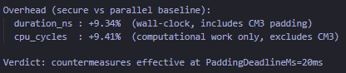
Figure 21: Overhead statistic

5.6 Discussions and limitations
The primary result of this evaluation is a 0/20 within-system violation rate in both the parallel and secure systems, sustained across all three run counts and both independent metrics. Taken together with the N-Progressive monotonicity analysis, which identifies the intermediate peaks as sampling fluctuations, this provides reliable evidence that no first-order candidate-distinguishable timing leakage is detectable under the conditions of this evaluation.
However, a null TVLA result should not be interpreted as a proof of security, Standaert (2018) demonstrated that implementations can pass a Welch’s t-test whilst remaining vulnerable to higher-order or multivariate attacks that exploit variance or covariance rather than differences in mean. The CP-TVLA framework as applied here only detects first-order leakage, and leakage that manifests in the second statistical moment, or in the joint distribution of duration_ns and cpu_cycles, would not necessarily be detected. A more comprehensive evaluation would apply higher-order TVLA variants and multivariate leakage assessments as described by Durvaux and Standaert (2016).
A further limitation is that the detection horizon at N = 10,000 runs is approximately 29 µs, the framework therefore cannot resolve whether this spread represents a true latent signal or purely random variation and can only confirm that if any such signal does exist, it lies below the detection threshold at this measurement budget. This does not undermine the validity of the result, but it does bind the strength of the security claim to this specific experimental environment.
Finally, all empirical results are specific to the hardware, operating system, and runtime environment, and should not be extrapolated to other platforms without independent evaluation. These limitations collectively motivate the proactive countermeasure design adopted in this work, as the security argument can be grounded in the structural properties of the hardened implementation rather than the absence of detected leakage.

Chapter 6 – Conclusion
This dissertation investigated the timing side-channel vulnerabilities introduced through parallel processing in a Paillier-based e-voting system, developed a candidate-partitioned TVLA framework for systematic evaluation, and proactively implemented and evaluated three structural countermeasures, addressing the research gap identified in Chapter 2.6.
Addressing RQ1, three structural timing side-channel vulnerabilities were identified, being input-dependent timing from ciphertext bit-pattern variation, scheduling state divergence from staggered goroutine launch, and completion time ordering detectable to a network adversary. These leakage vectors are structural to any unprotected parallel homomorphic implementation and are not specific to Paillier or the Go runtime. Empirically, no statistically detectable first-order candidate-distinguishable leakage was found at any run count, tested with a 0/20 violation rate sustained across both metrics and both the unprotected and hardened systems.
Addressing RQ2, the CP-TVLA framework was developed and validated, comprising candidate-identity partitioning, dual independent metrics capturing wall-clock time and CPU cycle counts, and N-progressive monotonicity testing across three run counts. The monotonicity analysis was particularly informative, correctly distinguishing the 5,000-run of |t| > 2.956 as a fluctuation rather than a genuine signal, a distinction that a single-N evaluation would have missed.
Addressing RQ3, the three countermeasures, ciphertext blinding, synchronisation barrier, and constant-time padding, collectively eliminated candidate-distinguishable leakage without introducing novel candidate-correlated patterns, carrying a 9.3% mean overhead above the unprotected parallel baseline, attributable to per-run blinding encryption. The proactive structural design approach is consistent with best practice established in literature (Ronen et al., 2019) and represents a deliberate response to the principle that null TVLA results under controlled conditions cannot guarantee deployment-scale security.
Future work should seek to extend the evaluation to higher-order TVLA variants, investigate behaviour at larger observation budgets and apply the CP-TVLA protocol to other parallel partial homomorphic implementations, such as CRT-Accelerated Paillier and ElGamal-based schemes. Furthermore, the candidate-partitioned methodology generalises naturally to other privacy-preserving systems employing parallel homomorphic decryption, such as federated learning or encrypted medical record processing, where the partitioning strategy can be redefined around participant or record identity to reflect the adversarial question of each deployment context.

References
Aydin, F. and Aysu, A. (2022) “Exposing Side-Channel Leakage of SEAL Homomorphic Encryption Library”. In proceedings of the 2022 Workshop on Attacks and Solutions in Hardware Security, pp. 95-100. Available at: https://doi.org/10.1145/3560834.35638
Aydin, F., Aysu, A. (2024). “Leaking secrets in homomorphic encryption with side-channel attacks”. J Cryptogr Eng 14, 241–251. Available at: https://doi.org/10.1007/s13389-023-00340-2.
Aydin, F., Karabulut, E., Potluri, S., Alkim, E. and Aysu, A. (2022) “RevEAL: single-trace side-channel leakage of the SEAL homomorphic encryption library”. In proceedings of the 2022 Conference & Exhibition on Design, Automation & Test in Europe, pp. 1527-1532. Available at: RevEAL | Proceedings of the 2022 Conference & Exhibition on Design, Automation & Test in Europe
Baltz, S., Agadjanian, A., Chin, D., Curiel, J., DeLuca, K., Dunham, J., Miranda, J., Phillips, C.H., Uhlman, A., Wimpy, C., Zarate, M. and Stewart, C. (2022). “American Election Results at the Precinct Level”. Available at: https://doi.org/10.1038/s41597-022-01745-0
Bernstein, D. J., Breitner, J., Genkin, D., Bruinderink, L. G., Heninger, N., Lange, T., Van Vredendaal, C. and Yarom, Y. (2017). “Sliding Right into Disaster: Left-to-Right Sliding Windows Leak”. Cryptographic Hardware and Embedded Systems – CHES 2017, Volume 10529, pp. 556-576. Available at: https://doi.org/10.1007/978-3-319-66787-4_27
Brumley, B.B. and Tuveri, N. (2011). “Remote Timing Attacks Are Still Practical”. Computer Security – ESORICS 2011, vol 6879. Springer, Berlin, Heidelberg. https://doi.org/10.1007/978-3-642-23822-2_20
Cabrera Aldaya, A. Pereida García, C., Alvarez Tapia, L. M., and Brumley, B. B. (2019) ‘Cache-Timing Attacks on RSA Key Generation’. IACR Transactions on Cryptographic Hardware and Embedded Systems, Volume 2019, Issue 4, pp 213-242. Available at: https://doi.org/10.13154/tches.v2019.i4.213-242
Cai, C., Awano, H. and Ikeda, M. (2019). “High-Speed ASCI Implementation of Paillier Cryptosystem with Homomorphism”. In proceedings of the 2019 IEEE 13th International Conference on ASIC (ASICON), Chongqing, China. Available at: 10.1109/ASICON47005.2019.8983588
Chillotti, I., Gama, N., Georgieva, M., Izabachène, M. (2016). “A Homomorphic LWE Based E-voting Scheme.”. Available at: https://doi.org/10.1007/978-3-319-29360-8_16
Ding, A. A., Chen, C. and Eisenbarth, T. (2016). “Simpler, Faster, and More Robust T-test Based Leakage Detection”. Available at: https://doi.org/10.1007/978-3-319-43283-0_10
ElGamal, T. (1985) “A public key cryptosystem and a signature scheme based on discrete logarithms”. IEEE Transactions on Information Theory, Volume 31, Issue 5). Available at: 10.1109/TIT.1985.1057074
Fei, Y., Ding, A., Lao, J. and Zhang, L. (2014). “A Statistics-based Fundamental Model for Side-channel Attack Analysis”. Available at: https://eprint.iacr.org/2014/152
Feng, J., Zhang X., Zilic, Z., Hae, Q. and Wang, J. (2025) “An Efficient Paillier Homomorphic Encryption Circuit with Operational CRT Acceleration for IoT”. IEEE Internet of Things Journal, Volume 12, Issue 22. Available at: 10.1109/JIOT.2025.3603982
Galymzhankyzy, Z., Rinatov, I., Abdiraman, A. and Unaybaev, S. (2024). “Optimizing E-Voting Systems: Integration of Paillier Cryptosystem and Parallel Processing for Enhanced Security and Efficiency”. In proceedings of the 2024 IEEE AITU: Digital Degeneration, Astana, Kazakhstan. Available at: 10.1109/IEEECONF61558.2024.10585388
Garcia, C. P. and Brumley, B. B. (2017). “Constant Time Callees with Variable-Time Callers”. In proceedings of the 26th USENIX Security Symposium, Vancouver, BC, Canada. Available at: Constant-Time Callees with Variable-Time Callers | USENIX
Ge, Q., Yarom, Y., Cock, D. and Heiser, G. (2018). “A survey of microarchitectural timing attacks and countermeasures on contemporary hardware”. J Cryptogr Eng 8, 1–27. Available at: https://doi.org/10.1007/s13389-016-0141-6
Ghaleb, B. and Buchanan, W. (2025). “Side Channel Analysis in Homomorphic Encryption”. Available at: https://ia.cr/2025/867
Go (2026a). "LockOSThread". Available at: https://pkg.go.dev/runtime#LockOSThread (Accessed: 9th February).
Go (2026b) “ReadMemStats”. Available at: runtime package - runtime - Go Packages (Accessed: 12th February).
Go By Example (2026). “Go By Example: Worker Pools”. Available at: Go by Example: Worker Pools (Accessed: 27th February 2026).
Goodwill, G., Jun, B., Jaffe, J., and Rohatgi, P. (2011). “A testing methodology for side channel resistance validation”. Available at: https://api.semanticscholar.org/CorpusID:16852899
Gouvêa, C.P.L., Oliveira, L.B. & López, J. Efficient software implementation of public-key cryptography on sensor networks using the MSP430X microcontroller. J Cryptogr Eng 2, 19–29 (2012). Available at: https://doi.org/10.1007/s13389-012-0029-z
Hajra, S. and Mukhopadhyay, D. (2013). “SNR to Success Rate: Reaching the Limit of Non-Profiling DPA”. Available at: https://ia.cr/2013/865
Jancar, J., Fourne, M., Braga, D. D. A., Sabt, M., Schwabe, P. and Barthe, G. (2022). “’They’re not that hard to mitigate’: What Cryptographic Library Developers Think About Timing Attacks”. In proceedings of the 2022 IEEE Symposium on Security and Privacy (SP), San Francisco, CA, USA. Available at: 10.1109/SP46214.2022.9833713
Jost, C., Lam, H.T., Maximov, A., & Smeets, B.J. (2025). Encryption Performance Improvements of the Paillier Cryptosystem. IACR Cryptol. ePrint Arch., 864. Available at: https://api.semanticscholar.org/CorpusID:14294131
Kartik, R., Reddy, V. P. K., Sandeep, P., Verma, R. K. and C.R, K. (2024) “Secure Electronic voting protocol with Partial Homomorphic Encryption with Paillier algorithm”. In proceedings of the 2024 International Conference on Intelligent Computing and Emerging Communication Technologies (ICEC), Guntur, India. Available at: 10.1109/ICEC59683.2024.10837117
Kupcova. E., Pleva, M., Khavan, V. and Drutarovsky, M. (2025) “A Comparative Study of Partially, Somewhat, and Fully Homomorphic Encryption in Modern Cryptographic Libraries”. Available at: https://doi.org/10.3390/electronics14234753
Liu, Y. Kang, Y., Zou, T., Pu, Y., He. Y., Ye, X., Ouyang, Y., Zhang, Y-Q. and Yang, Q. (2022) “Vertical Federated Learning: Concepts, Advances and Challenges”. Available at:
https://doi.org/10.48550/arXiv.2211.12814
Lou, X., Zhang, T., Jiang, J. and Zhang, Y. (2021) “A survey of Microarchitectural Side-channel Vulnerabilities, Attacks, and Defenses in Cryptography”. ACM Computing Surveys (CSUR), Volume 54, Issue 6, pp. 1-37. Available at: https://doi.org/10.1145/3456629
Lyu, L., Yu, H., Ma, X., Chen, C., Sun, L. and Zhao, J. (2024). “Privacy and Robustness in Federated Learning: Attacks and Defenses”. IEEE Transactions on Neural Networks and Learning Systems, Volume 34, Issue 7. Available at: 10.1109/TNNLS.2022.3216981
Microsoft (2026) “QueryPerformanceCounter function (profileapi.h)”. Available at: QueryPerformanceCounter function - Win32 apps | Microsoft Learn (Accessed: 19th February 2026).
Microsoft (2026b). “Acquiring high-resolution time stamps”. Available at: Acquiring high-resolution time stamps - Win32 apps | Microsoft Learn (Accessed: 19th February 2026).
Munjal, K. and Bhatia, R. (2022). “Analysing RSA and PAILLIER Homomorphic Property for Security in Cloud”. Available at: https://doi.org/10.1016/j.procs.2022.12.027
Mytkowicz, T., Diwan, A., Hauswirth, M. and Sweeney, P. F. (2009). “Producing wrong data without doing anything obviously wrong!”. Available at: https://doi.org/10.1145/1508284.1508275
Noma, A. M. et al. (2017) “Iterative sliding window method for shorter number of operations in modular exponentiation and scalar multiplication”, Cogent Engineering, 4(1).Available at: 10.1080/23311916.2017.1304499
OpenSSL (2025) “RSA_blinding_on”. Available at: RSA_blinding_on - OpenSSL Documentation (Accessed: 17th February 2026).
Pace, P., Pelletier, H. and Vaudenay, S. (2025) “Hybrid Homomorphic Encryption Resistance to Side-Channel Attacks”. In proceedings of the First International Conference, CASCADE 2025, Saint-Etienne, France, April 2-4. Available at: https://doi.org/10.1007/978-3-032-01405-4_10
Paillier, P. (1999). “Public-Key Cryptosystems Based on Composite Degree Residuosity Classes”. Available at: https://doi.org/10.1007/3-540-48910-X_16
Pan, S., Liu, Y., Hu, X. and Zhu, J. (2025) “Research on Crt-Based Paillier Encryption Optimization Methods”. In proceedings of the 2025 18th International Congress on Image and Signal Processing, BioMedical Engineering and Informatics (CISP-BMEI), Qingdao, China. Available at: 10.1109/CISP-BMEI68103.2025.11259311
Prots'ko, I., Gryshchuk, A. and Riznyk, V. (2023). “Efficient Multithreading Computation of Modular Exponentiation with Pre-computation of Residues for Fixed-base”. Computer Modelling and Intelligent Systems. 3392. 224-234. Available at: 10.32782/cmis/3392-19.
Python (2026a) “Glossary”. Available at: Glossary — Python 3.14.4 documentation (Accessed: 11th February 2026).
Python (2026b) “PEP 703 – Making the Global Interpreter Lock Optional in CPython”. Available at: PEP 703 – Making the Global Interpreter Lock Optional in CPython | peps.python.org (Accessed: 3rd May).
Rambus (No Date) “Test Vector Leakage Assessment (TVLA) Derived Test Requirements (DTS) with AES”. Available at: TVLA-DTR-with-AES.pdf
Rivest, R. L., Adleman, L. and Dertouzos, L. M. (1978b). “On Data Banks and Privacy Homomorphisms”. Available at: rivest-adleman-dertouzos.pdf
Rivest, R.L., Shamir, A. and Adleman, L. (1978a). “A Method for obtaining digital signatures and public-key cryptosystems”. Published in Communications of the ACM, 21(2), pp. 120-126. Available at: https://doi.org/10.1145/359340.359342
Roasbeef (2016) ‘Go-Go-Gadget-Paillier’. Available at: https://github.com/roasbeef/go-go-gadget-paillier (Accessed: 15th January 2026).
Ronen, E., Gillham, R., Genkin, D., Shamir, A., Wong, D. and Yarom, Y. (2019). “The 9 Lives of Bleichenbacher’s CAT: New Cache Attacks on TLS Implementations”. IEEE Symposium on Security and Privacy, San Francisco, CA, USA. Available at: 10.1109/SP.2019.00062
Schmid, F., Mukherjee, S., Picek, S., Stottinger, M., De-Santis, F. and Rechberger, C. (2024) “Towards Private Deep Learning-Based Side-Channel Analysis Using Homomorphic Encryption: Opportunities and Limitations”. 15th International Workshop, COSADE 2024, Gardanne, France, April 9-10. Available at: https://doi.org/10.1007/978-3-031-57543-3_8
Seo. H., An, K., Kwon, H. and Hu, Z. (2020). “Montgomery Multiplication for Public Key Cryptography on MSP430X.” ACM Transactions on Embedded Computing Systems (TECS), Volume 10, Issue 3. Article No. 20, pp. 1-15. Available at: https://doi.org/10.1145/338791
Standaert, F-X. (2018) “How (Not) to Use Welch’s T-Test in Side-Channel Security Evaluations”. Available at: 10.1007/978-3-030-15462-2_5
Durvaux, F. and Standaert, F-X. (2016) “From Improved Leakage Detection to the Detection of Points of Interests in Leakage Traces”. Available at: 10.1007/978-3-662-49890-3_10
Standaert, X-F., Malkin, T. and Yung, M. (2009). “A Unified Framework for the Analysis of Side-Channel Key Recovery Attacks. Available at: https://doi.org/10.1007/978-3-642-01001-9_26
Tandel, P., Shubhrant, A. and Sohani, M. (2021). “Modified Fully Homomorphic Encryption based on Parallel Processing in Cloud Computing”. International Journal of Scientific research in Computer Science, Engineering and Information Technology, Volume 7, Issue 2, pp. 250-262. Available at: International Journal of Scientific Research in Computer Science, Engineering and Information Technology
Teng, Y. and Liu, C. (2023) “Research on GPU-Based Parallel Processing for the Paillier Algorithm”. In proceedings of the 2023 International Conference on Blockchain Technology and Information Security (ICBCTIS), Xi’an, China. Available at: 10.1109/ICBCTIS59921.2023.00023
Turan, M. S., Barker, E., Kelsey, J., McKay, K., Baish, M. and Boyle, M. (2018). “Recommendation for the Entropy Sources Used for Random Bit Generation”. Available at: https://doi.org/10.6028/NIST.SP.800-90B
Ueno, R. and Homma, N. (2023). “How Secure is Exponent-Blinded RSA-CRT with Sliding-Window Exponentiation?”. IACR Transactions on Cryptographic Hardware and Embedded Systems, 2023(2), 241-269. Available at: https://doi.org/10.46586/tches.v2023.i2.241-269
Van Goethem, T., Popper, C., Joosen, W. and Vanhoef, M. (2020). “Timeless Timing Attacks: Exploiting Concurrency to Leak Secrets over Remote Connections”. Available at: https://www.usenix.org/conference/usenixsecurity20/presentation/van-goethem
Xie, Q., Jiang, S., Jiang, L., Huang, Y., Zhao, Z., and Khan, S. (2024) “Efficiency Optimization Techniques in Privacy-Preserving Federated Learning With Homomorphic Encryption: A Brief Survey”. IEEE Internet of Things Journal, Volume 11, Issue 14. Available at: 10.1109/JIOT.2024.3382875
Yang, L, Chai, D., Zhang, J., Jin, Y., Wang, L., Liu, H., Tian, H., Xu, Q. and Chen, K. (2023) “A Survey on Vertical Federated Learning: From a Layered Perspective”. Available at: https://doi.org/10.48550/arXiv.2304.01829
Yin, X. Zhu, Y. and Hu, J. (2021). “A Comprehensive Survey of Privacy-preserving Federated Learning: A Taxonomy, Review and Future Directions”. ACM Computing Surveys (CSUR), Volume 54, Issue 6. Available at: https://doi.org/10.1145/3460427

Appendix A – GitHub Repository
CAL-LUM/Timing-Side-Channel-Vulnerabilities-in-Parallel-Partial-Homomorphic-Encryption-

