**SOP for DCE MSOT Single Wavelength Data Analysis on MATLAB**

**DCE_MSOT_SingleWavelength_M2022b_20230524**

**Authors:** Shreya Goel, Grace Isakson, Katerina Kotrotsou, Alia Khaled

**Last modified b**y: Alia Khaled    **Last modified on:** 2023-05-24

The code analyzes Single Wavelength DCE MSOT Data acquired on iThera Invision and reconstructed on ViewMSOT software.

**Components Needed: s**

1. Main code: run_MSOT_nonneg.m
2. Sub-codes: run_DCE_MSOT_RECON.m
3. Other codes: Negative_pixel_count.m ; Voxel_count.m ; ROI_modification.m
4. Folder titled: DCE_MSOT_SingleWavelength_M2022b_20230524
5. Data exported from ViewMSOT after reconstruction and spectral unmixing.

**Important:** Store all the above components into a single folder.

**Note:** This version runs on Matlab 2022b

**Procedure:**

**DCE MSOT Data Analysis**

1. The user will be prompted to select the folder containing the DCE data.

NOTE: Please select the main scan folder and not the RECONs subfolder at this step.

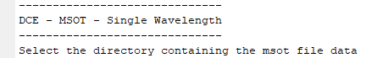

1. The command window will display the name of the scan. If correct, press Y to continue. If wrong, press N to re-select the correct scan.

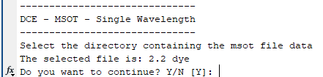

1. Next, select the folder to save the analyzed data.
2. Enter the number of chromophores when prompted (the number of chromophores selected when spectrally unmixing). The prompt will say ‘Select chromophore for segmentation.’



NOTE: The number of chromophores should be “1” for Single Wavelength DCE MSOT

1. In the image pop-up, trace the tumor or desired region.

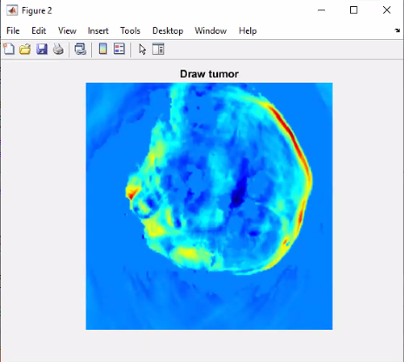

Here is an example of a Tumor ROI:

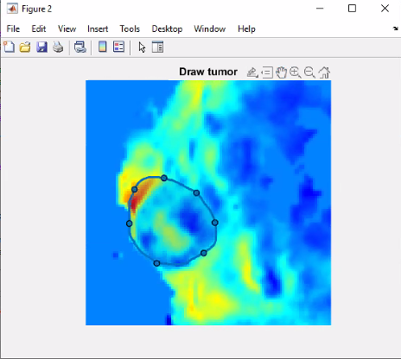

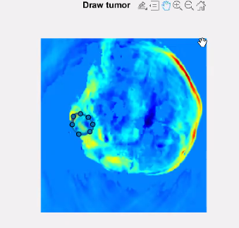

1. If satisfied with the ROI, press Y in the command window. If you are not satisfied, enter N and redraw the ROI, then press Y if you are satisfied.
2. Next, the program will first try to find the AIF automatically using the DBSCAN clustering technique. A figure with DBSCAN clusters will appear.

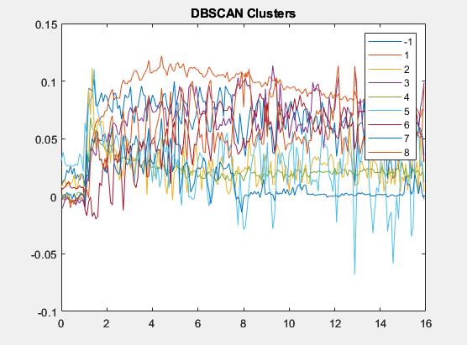

1. Click on individual curves to investigate them and see which curve resembles the correct AIF curve.

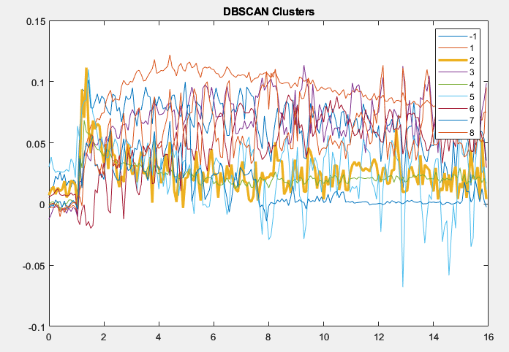

1. Once you identify a good candidate, write its number in front of the prompt ‘Choose an AIF cluster:’



NOTE: if the chosen curve is labeled “-1” please enter “0” in response to the prompt.

1. Next, two figures will appear, one with the automatic AIF ROI overlaid on the original image, and the other shows the AIF curve from this ROI.

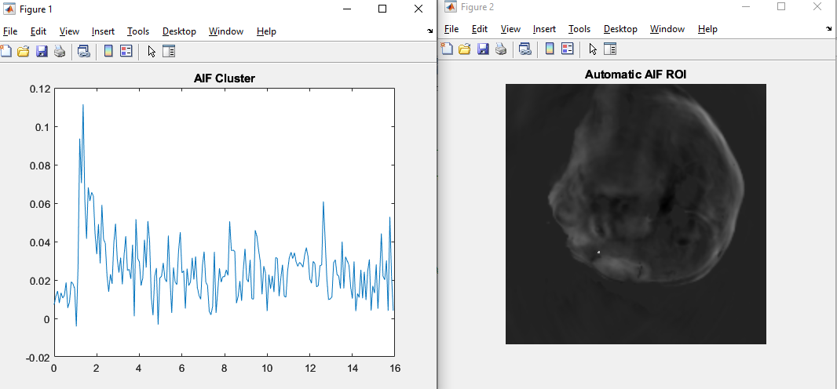

1. If you are satisfied with the Automatic ROI, answer “Y” to the prompt ‘Are you satisfied with the Automatic AIF ROI?’



1. If you are NOT satisfied with the Automatic ROI, answer “N” to start the manual AIF ROI selection process.



1. In the next pop-up, carefully trace the location of the AIF.

NOTE: If you dislike the slice chosen for tracing the AIF, you can change it by opening run_DCE_MSOT_RECON and editing ref_anat = I(:,:,50); at line 329. Change the 50 at the end to a different number to change the slice, although it is recommended to keep the slice in the middle of the scan. If you want to change the slice because the data is corrupted, it is better to not use that data set at all.

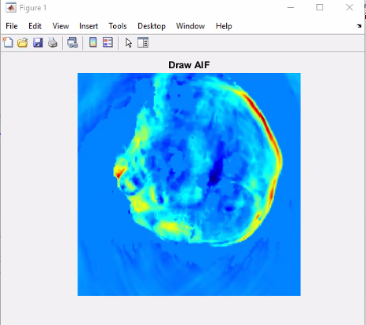

Here is an example of an AIF ROI:

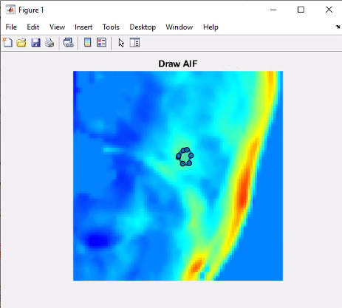

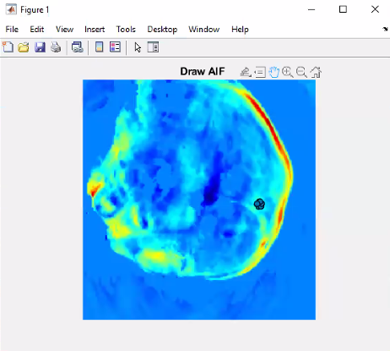

1. The program will then show the AIF curve from selected AIF ROI.

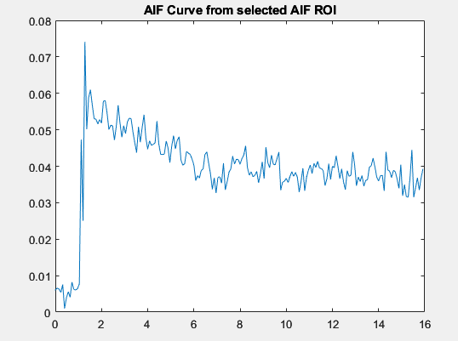

1. If you are satisfied with the ROI and the curve, answer “Y” to the prompt ‘Are you satisfied with the AIF ROI?’



1. If you are NOT satisfied with the ROI and the curve, answer “N” and you will get another chance to choose a different ROI and see the corresponding curve. Repeat this process until you are satisfied with the AIF ROI, then answer ‘Y’ to proceed.

**Changing the Color Maps Interactively**

Sometimes the default colormap is not helpful in determining the ROIs. Having the ability to change them interactively during the runtime can be a great help. Here is how to do it:

1. From the figure, select Edit > colormap…

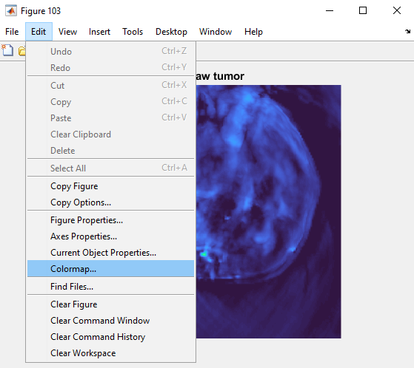

1. The “Colormap Editor” box will appear. You can change the Colormap from the “Select Colormap” dropdown menu. Here the chosen colormap is “Turbo”.

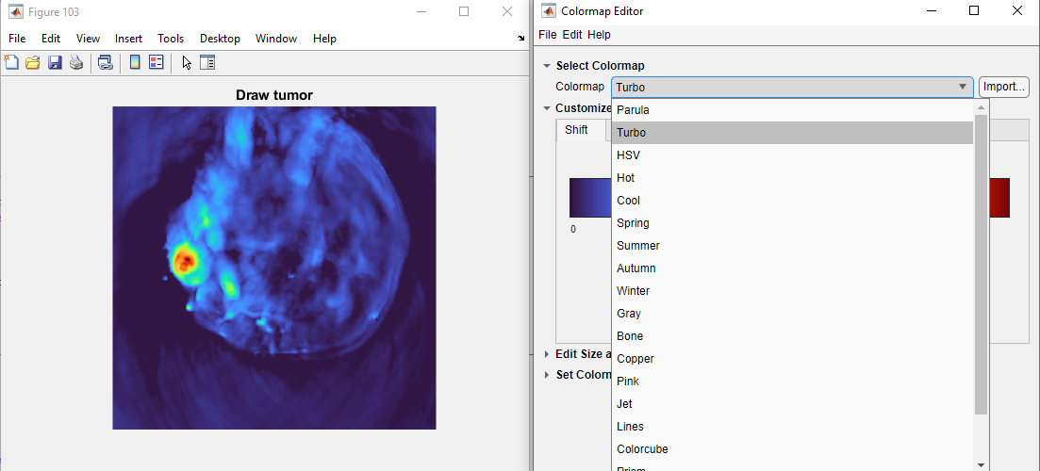

1. Choose different colormaps until you find the one that you are satisfied with, then close the “Colormap Editor” box.

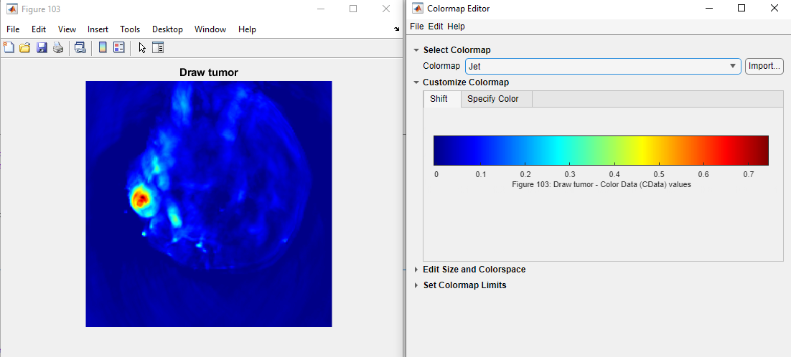

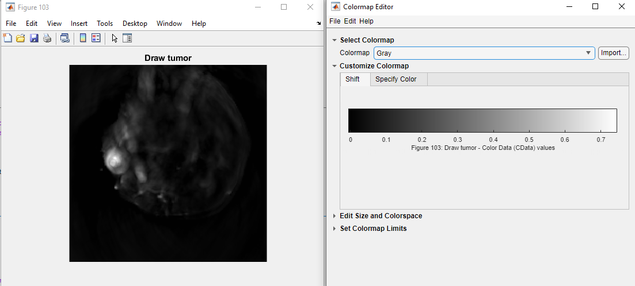

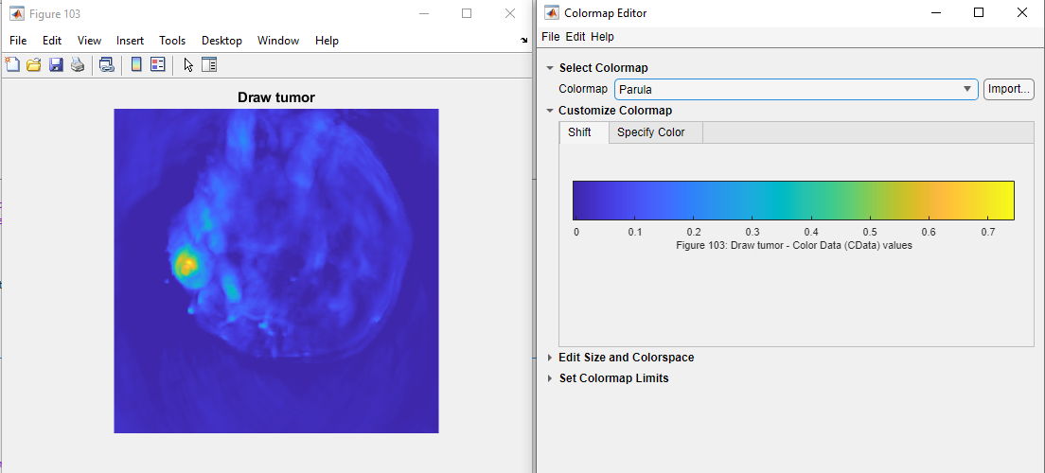

1. Now you can continue with selecting the ROI.

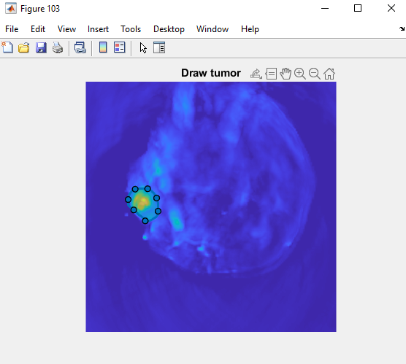

**Storage of Analyzed data**

Analyzed DCE data folder will be appended with the term “DCE_MSOT_RECON”.



**Visualization of Analyzed data**: **DCE-MSOT**

1. To load analyzed DCE data, go to the browser bar and select DCE_MSOT_RECON folder.
2. In the command window, enter clear all.
3. The current folder tab is now populated with analyzed DCE-MSOT data which includes:

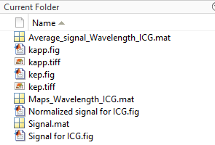

1. Average_signal_Wavelength_ICG.mat: Double click on this to view the tabulated values of Kapp and kep for the tumor ROI. The kinetic parameters are tabulated in 3 ways:

*Kapp_avg*: Average of kapp calculated for each pixel.

*Kapp_avg_signal*: Single kapp value calculate after averaging the signals for the entire tumor

*Kapp_nz: kapp_avg* calculated with only non-zero pixel values.

Similarly, kep values can be displayed.

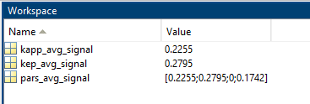

1. Kapp.fig: Displays the Kapp_avg map superimposed on grayscale image.

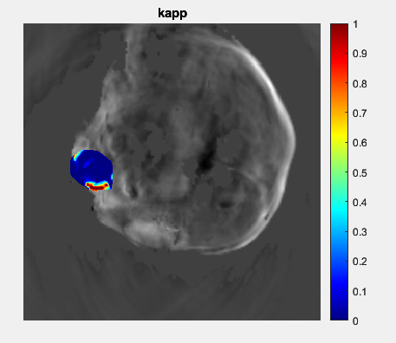

1. Kep.fig: Displays the kep_avg map superimposed on grayscale image.

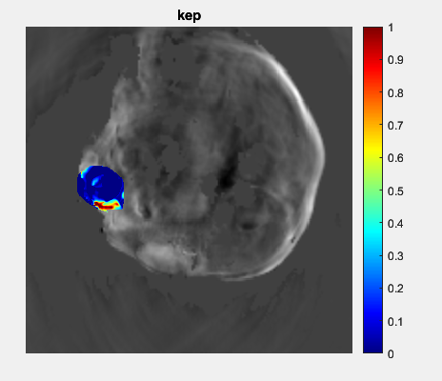

1. Maps_Wavelength_ICG.mat: This needs to be loaded to visualize other Kapp or kep maps. After loading this matrix, use the “overlap code” (included separately) to display the desired parameter.

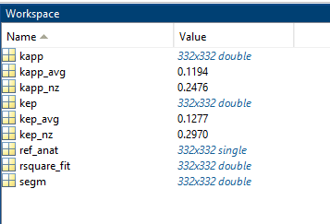

1. Signal for ICG.fig: Denotes the average signal of ICG over time in the ROIs.

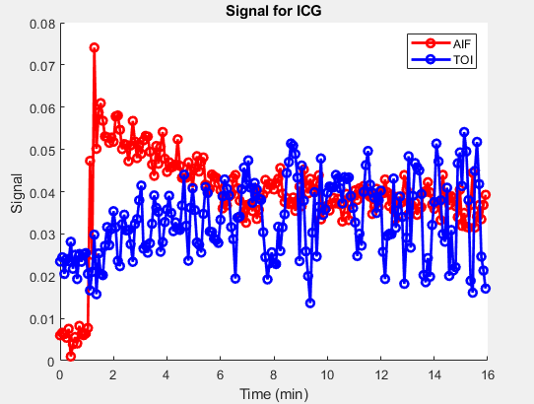

1. Normalized signal for ICG.fig: Denotes the average signal of ICG over time in the ROIs, normalized to maximum signal.

