**SOP for OE/DCE MSOT Data Analysis on MATLAB**

**OE_DCE_MSOT_Code_20221128**

**Authors:** Shreya Goel, Grace Isakson, Katerina Kotrotsou, Alia Khaled

**Last modified b**y: Alia Khaled  **Last modified on:** 2022-11-30

The code analyzes both OE and DCE MSOT Data acquired on iThera Invision and reconstructed on ViewMSOT software.

**Components Needed:**

1. Main code: run_MSOT_nonneg.m
2. Sub-codes: run_DCE_MSOT_MSP.m ; run_OE_MSOT_AK_nonneg.m
3. Other codes: Negative_pixel_count.m ; Voxel_count.m ; ROI_modification.m
4. Folder titled: com.itheramedical.msotlib_beta_rev723_20221128_M2022b
5. Data exported from ViewMSOT after reconstruction and spectral unmixing.

**Important:** Store all the above components into a single folder.

**Note:** This version runs on Matlab 2022

**Procedure:**

1. Double click on run_MSOT_nonneg.m to launch the program

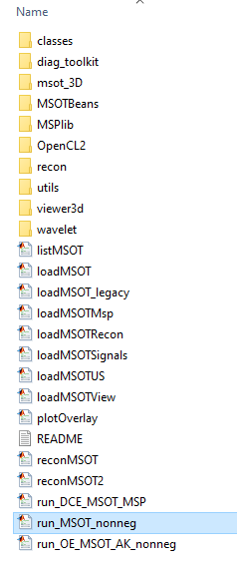

1. The code may throw an error that run_OE_MSOT_AK_nonneg is not found in the current folder or on the MATLAB path. To avoid this, type addpath then put the file location in quotes (e.g. addpath 'C:\Users\GIsakson\Documents\Non negative analysis') before running the code.
2. Click the “Run” button on the top.

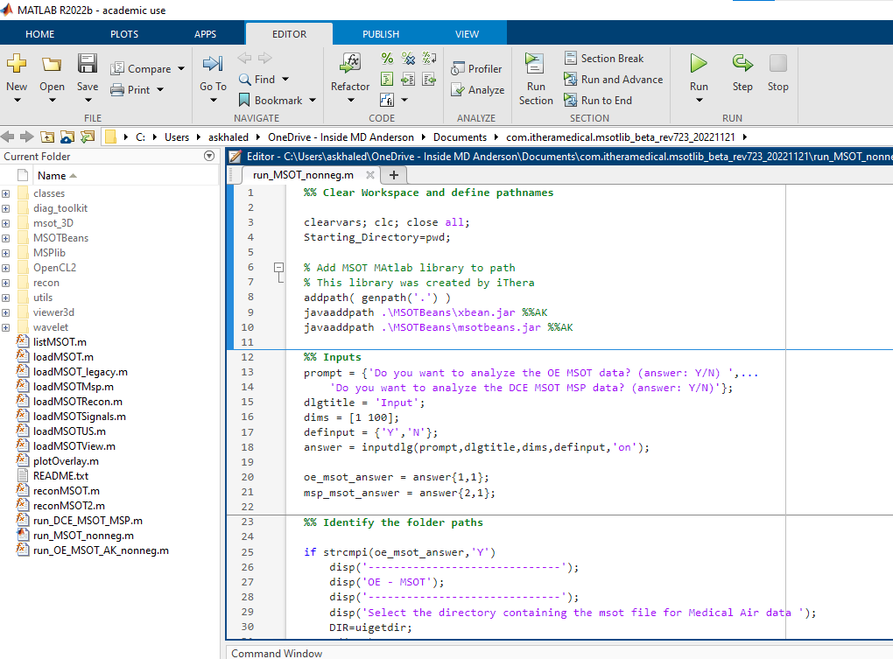

1. In the Input prompt indicate the types of analysis to perform by typing Y/N. Click OK.

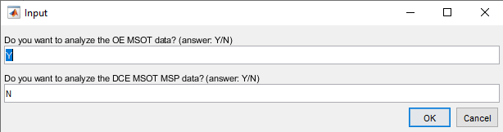

1. The code first performs OE MSOT analysis. In the pop-up window, select the folder containing the msot file for Medical Air data.
2. The command window will display the name of the scan. If correct, press Y to continue. If wrong, press N to re-select the correct scan.

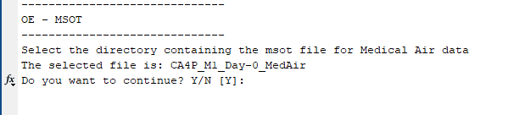

1. Next, select the folder containing the msot file for 100 % O2 data.

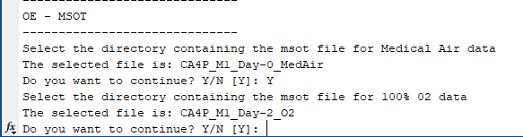

1. Select the folder to save the analyzed data.

NOTE: You may get an error saying that run_OE_MSOT_AK_nonneg is not found in the current folder or on the MATLAB path after this step. Click on the underlined phrase ‘add its folder to the MATLAB path’ and rerun the program to resolve this issue.

1. A grayscale image of the scan will pop up. Trace the tumor or desired region.

NOTE: You can zoom in by clicking on the magnifying glass with the plus sign just above the upper right-hand corner of the image. Click on the magnifying glass again to go back to the mode to draw the ROI. This also works when drawing an ROI for the AIF and muscle later.

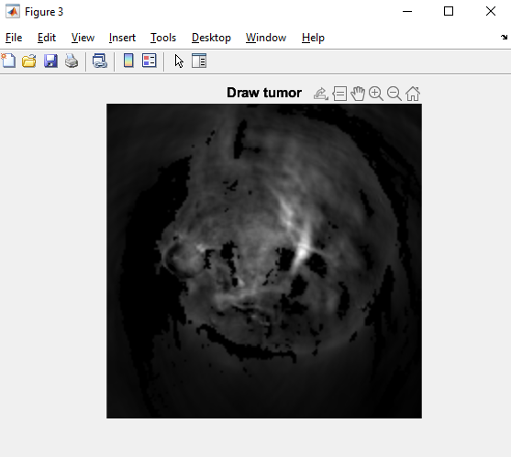

1. The command window will show the message: Are you satisfied with the ROI? Y/N [Y]:

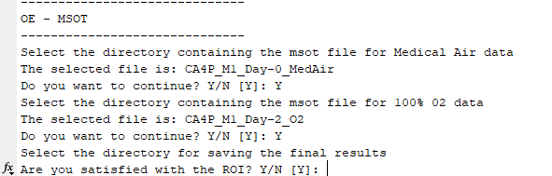

1. The user has the option to redraw the ROI as many times as needed.
2. Once you press Y, the code will run to perform the OE analysis and automatically save the data in the directory defined by the user.
3. If DCE MSOT analysis was selected, the code will automatically move to this step. The user will be prompted to select the folder containing the DCE data.

NOTE: Please select the main scan folder and not the MSP subfolder at this step.

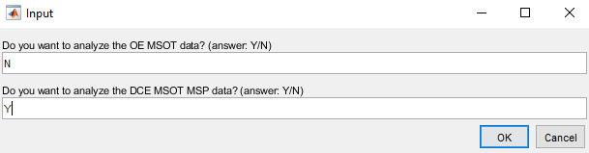

1. The command window will display the name of the scan. If correct, press Y to continue. If wrong, press N to re-select the correct scan.

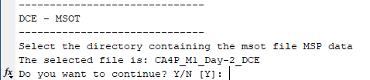

1. Next, select the folder to save the analyzed data.
2. Enter the number of chromophores when prompted (the number of chromophores selected when spectrally unmixing). The prompt will say ‘Select chromophore for segmentation.’



NOTE: The number of chromophores should be “3” for DCE MSOT (to unmix for 3 chromophores/components: Hb, HbO2 and ICG)

1. In the image pop-up, carefully trace the location of the AIF.

NOTE: If you dislike the slice chosen for tracing the AIF, you can change it by opening run_DCE_MSOT_MSP and editing ref_anat = I(:,:,50); at line 79. Change the 50 at the end to a different number to change the slice, although it is recommended to keep the slice in the middle of the scan. If you want to change the slice because the data is corrupted, it is better to not use that data set at all.

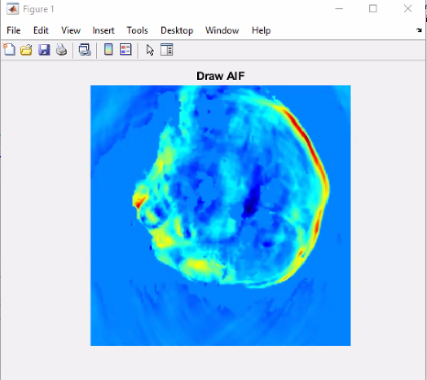

Here is an example of an AIF ROI:

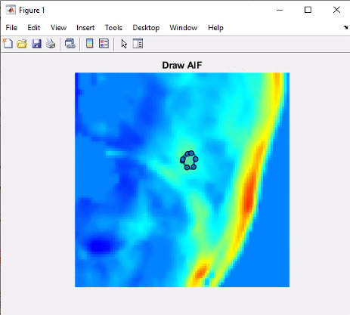

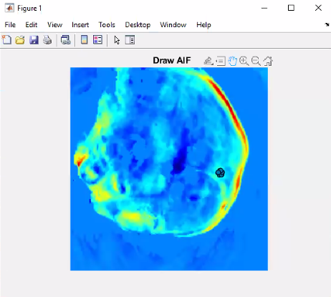

1. In the next pop-up, trace the tumor or desired region.

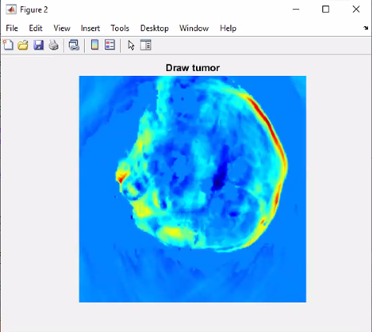

Here is an example of a Tumor ROI:

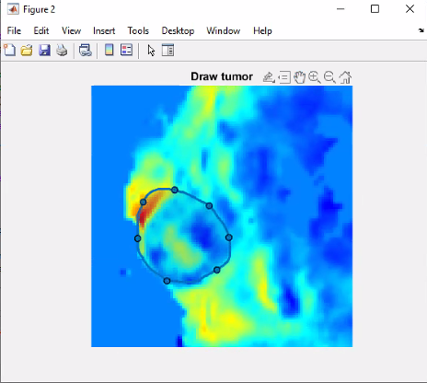

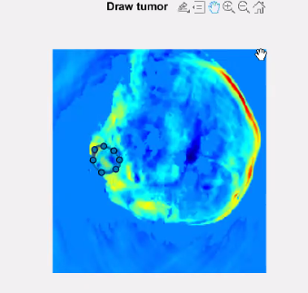

1. In the next pop-up, trace the ROI for muscle, if needed. This is not crucial and will not influence the analysis of DCE-MSOT data.

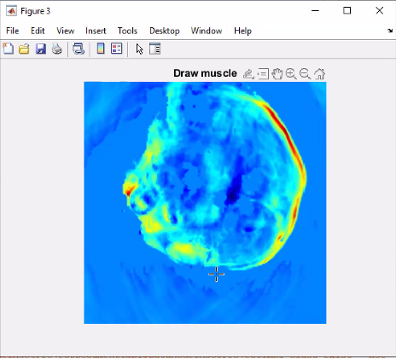

Here is an example of a Muscle ROI:

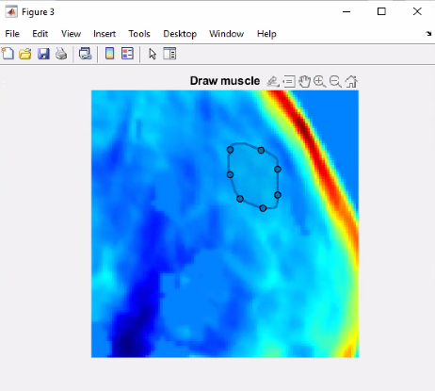

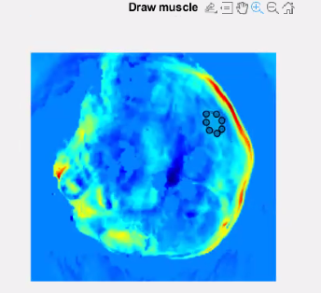

1. If satisfied with the ROIs, press Y in the command window. If you are not satisfied, enter N and redraw the ROIs, then press Y if you are satisfied.

**Storage of Analyzed data**

Analyzed OE-MSOT data is stored in two separate folders, one each for medical air and 100% O2 data. The 100% O2 folder also contains information for the ΔsO2 parameter.

The names of the folders will be extracted from the scan names (defined by the user in ViewMSOT software during data reconstruction) appended with the term “OE_MSOT_MSP.

Similarly, the DCE data folder will be appended with the term “DCE_MSOT_MSP.

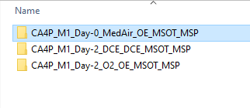

**Visualization of Analyzed data**: **OE-MSOT**

1. At the end of the scan, the “current folder” tab on the left will be automatically populated with the analyzed DCE-MSOT data.

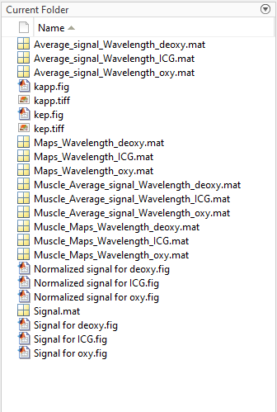

1. To visualize the OE-MSOT data, go to the browser bar and select medair_OE_MSOT_MSP folder.

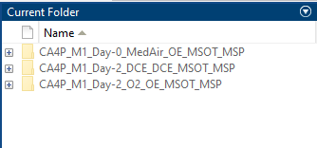

1. The current folder tab is now populated with analyzed Medair data which includes:

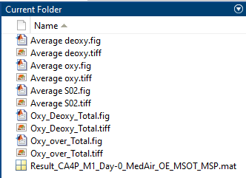

1. Maps of oxyhemoglobin (Average oxy.fig), deoxyhemoglobin (Average deoxy.fig), and %sO2 at medical air (Average sO2.fig).

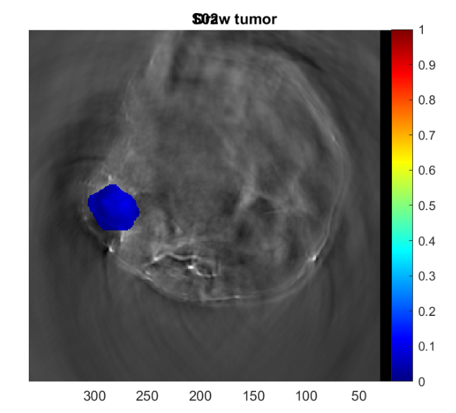

Average oxy

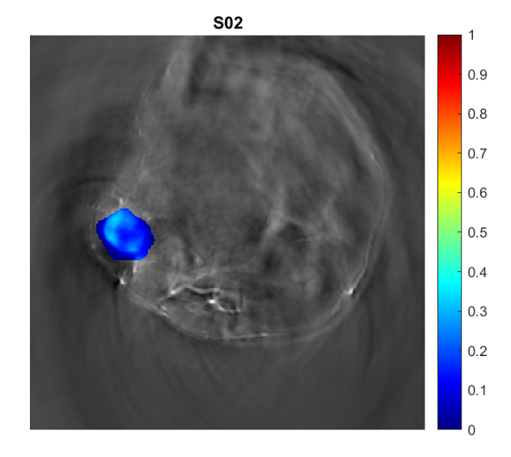

Average deoxy

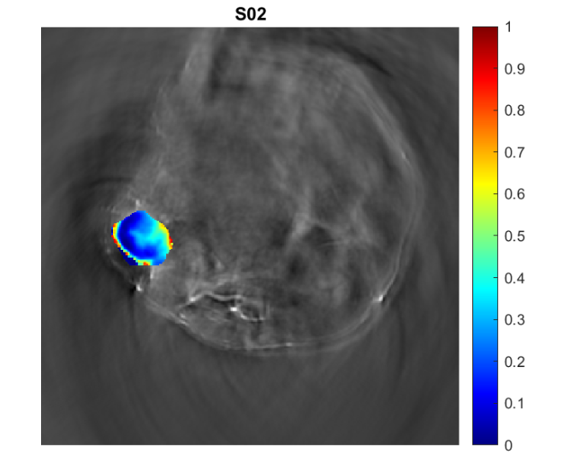

Average SO2

1. Signal vs time graph is displayed in the figure titled: Oxy_Deoxy_Total.fig

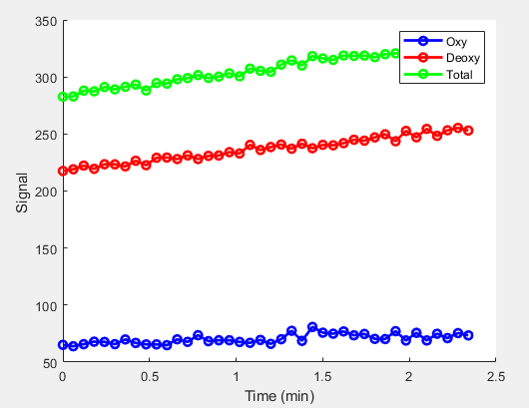

1. %sO2 vs time graph is displayed in the figure titled: Oxy_over_Total.fig.

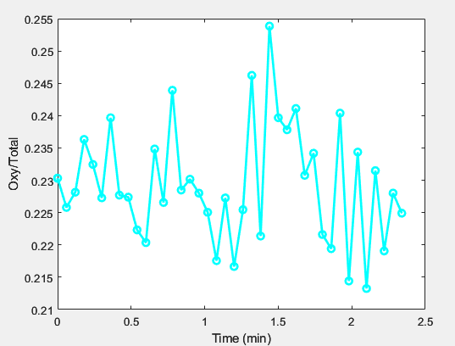

1. In the command window, enter clear all. This clears the workspace.
2. To load the tabulated values for %sO2, double click on folder titled: Result_... in the current folder tab.
3. The workspace will be populated with the metrics.

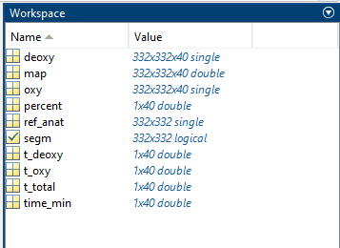

1. The folder titled “percent” shows the average %sO2 calculated at every time-point during the medical air scan. These values can be averaged further to evaluate %sO2(medair).
2. Similarly, the folders: t_deoxy, t_oxy and t_total represent the average signals for Hb, HbO2 and THb at every time-point in the ROI.
3. The folder time_min indicates the timestamps of each image.
4. To load the data acquired under 100% O2, repeat step 2, and select O2_OE_MSOT_MSP folder.

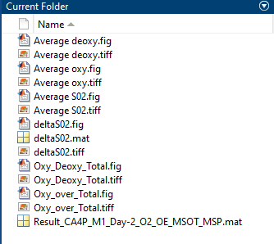

1. In the command window, enter clear all.
2. To load the tabulated values, double click on folder titled: Result_... in the current folder tab.
3. Analyzed data will be loaded and accessed as described above.

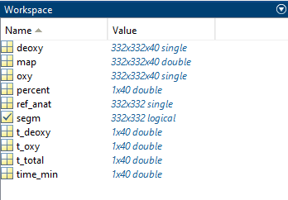

1. Additional ΔsO2 parameter is also included here, denoted as deltaSO2.fig.

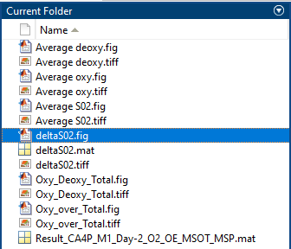

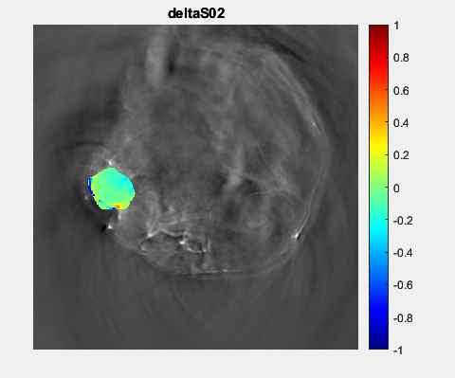

1. To extract the tabulated ΔsO2 value, double click on deltaSO2.mat folder.

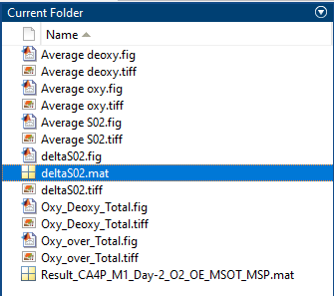

1. Parameter named delta_avg in the workspace indicates the tabulated average value of ΔsO2.

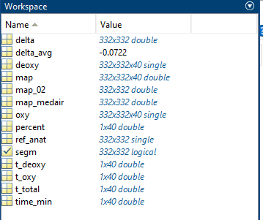

**Visualization of Analyzed data**: **DCE-MSOT**

1. To load analyzed DCE data, repeat step 2 from “OE-MSOT”. Select DCE_MSOT_MSP.
2. In the command window, enter clear all.
3. The current folder tab is now populated with analyzed DCE-MSOTdata which includes:

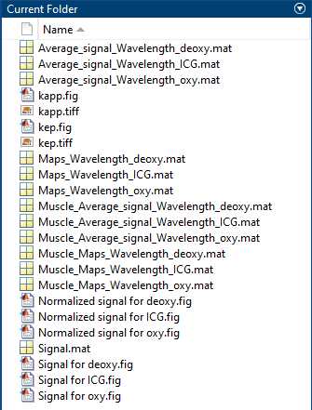

1. Average_signal_Wavelength_ICG.mat: Double click on this to view the tabulated values of Kapp and kep for the tumor ROI. The kinetic parameters are tabulated in 3 ways:

*Kapp_avg*: Average of kapp calculated for each pixel.

*Kapp_avg_signal*: Single kapp value calculate after averaging the signals for the entire tumor

*Kapp_nz: kapp_avg* calculated with only non-zero pixel values.

Similarly, kep values can be displayed.

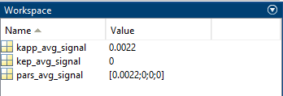

1. Kapp.fig: Displays the Kapp_avg map superimposed on grayscale image.

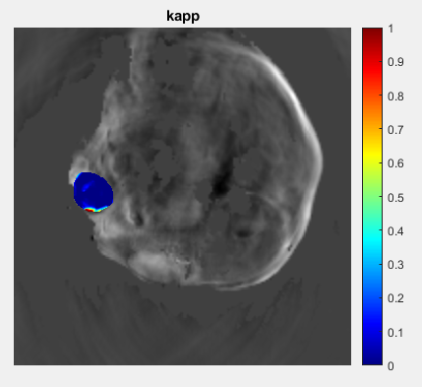

1. Kep.fig: Displays the kep_avg map superimposed on grayscale image.

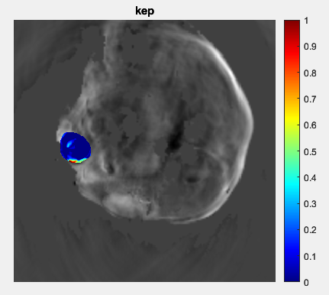

1. Maps_Wavelength_ICG.mat: This needs to be loaded to visualize other Kapp or kep maps. After loading this matrix, use the “overlap code” (included separately) to display the desired parameter.

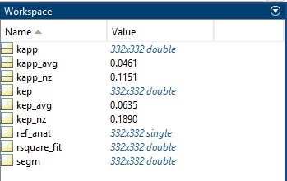

1. Muscle_Average_signal_Wavelength_ICG.mat and Muscle_Maps_Wavelength_ICG.mat : Display parameters for muscle ROIs.
2. Normalized signal for ICG.fig: Denotes the average signal of ICG over time in the three ROIs, normalized to maximum signal.

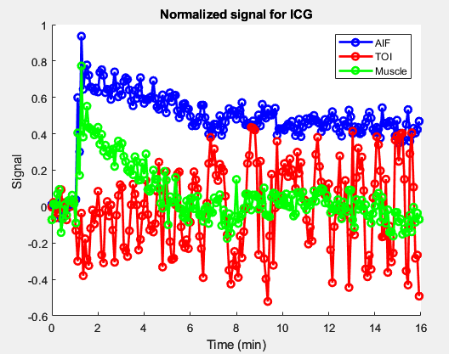

1. Signal for ICG.fig: Denotes the average signal of ICG over time in the three ROIs.

