**SOP for AcidoCEST MRI Analysis on MATLAB**

**acidoCEST_MRI_20230308**

**Authors:** Renee Chin, Alia Khaled

**Last modified b**y: Alia Khaled    **Last modified on:** 2023-03-08

1. **Locate Files**
   1. If necessary, download acquisition files. Identify the RARE1, cestFISP_Pre, and cestFISP_Post scans based on the “E_” number. The number of files in the DICOM folder ([numbered folder] -> pdata -> 1 -> dicom) will reflect the scan:

|  |  |
| --- | --- |
| Scan | Number of files in the DICOM folder |
| Localizer | 3 |
| RARE24 | 24 |
| RARE1 | 1 |
| cestFISP_Pre | 176 |
| cestFISTP_Post | 264 |

1. **Process Data**
   1. Open the MatLab by double-clicking “acidoCEST_Pagel4_ChemicalData_20220104_FinalVer”
   2. Ensure the “acidoCEST_Pagel4_20230308.m” tab is selected, then click “Run” on the top bar
   3. Select the folder containing all of the scans (i.e. the folder containing folders labeled “1”, “2”, “3”, etc.)

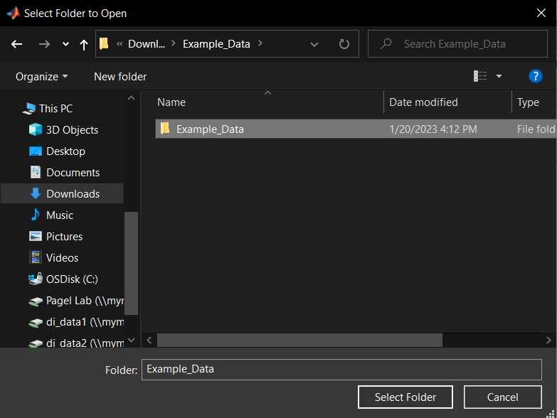

* 1. Input the folder number or scan number (“E_”, these numbers are the same) correspondingly:
     1. Anatomical Scan: RARE 1 (I.e. input “3” if this scan is E3 or in folder labeled “3”)
     2. Anatomical Slice for CEST: “1”
     3. Pre-Injection Scan: cestFISP_Pre (I.e. input “4” if this scan is E4 or in folder labeled “4”)
     4. Post-Injection Scan: cestFISP_Post (I.e. input “5” if this scan is E5 or in folder labeled “5”)

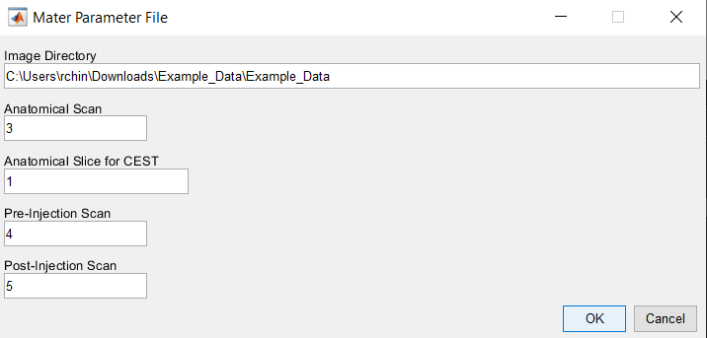

* 1. Circle the tumor, then click “Yes” when completed

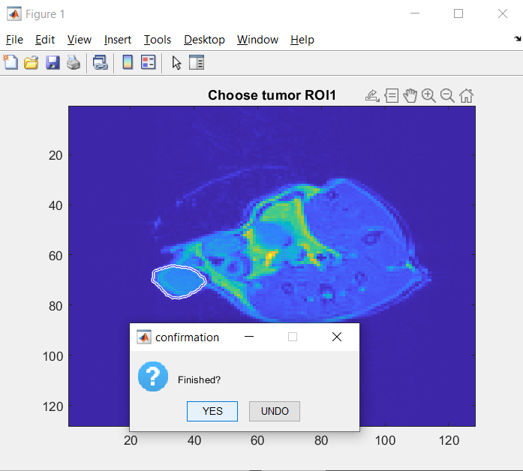

* 1. Circle an area around the corners of the scan for the noise without including the mouse. Ideally the area will be a little larger than the tumor. Click “Yes” when completed.

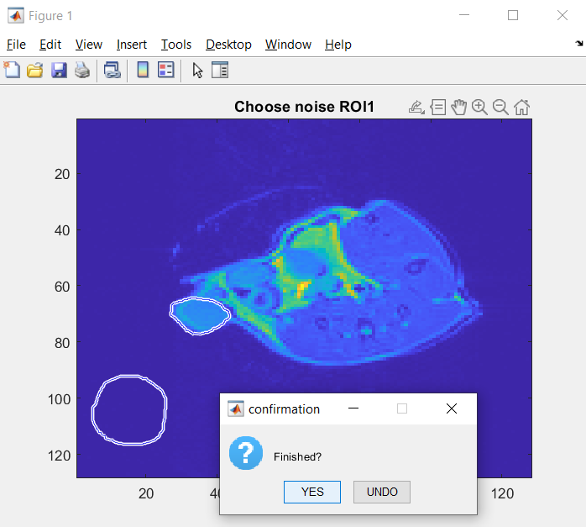

* 1. Select a folder to store results
  2. Allow the program to run. When the run is complete, “>>” will appear to the right of the “fx” input underneath the Command Window, and “Busy” will disappear from the bottom left corner of the screen.

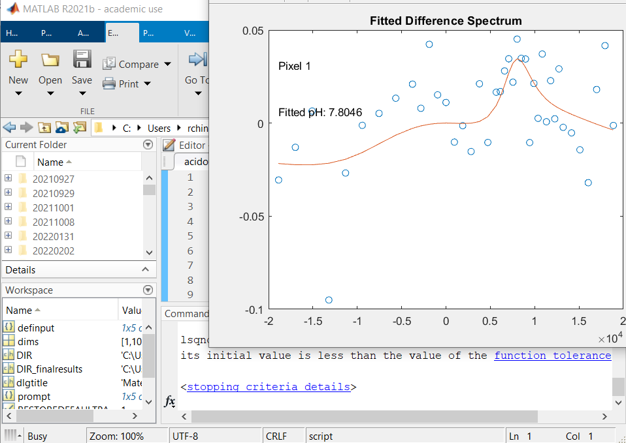

* 1. When run is complete, the average pH before and after thresholding as well as the total number of pixels in the tumor ROI will appear in the command window.

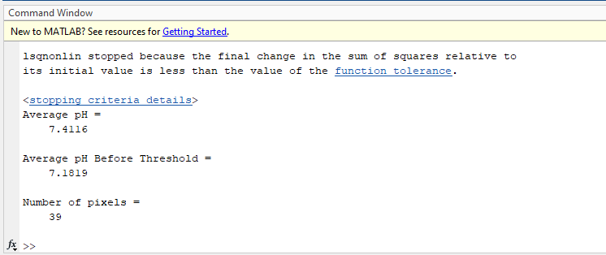

* 1. Figures with pH maps before and after thresholding will appear as well.

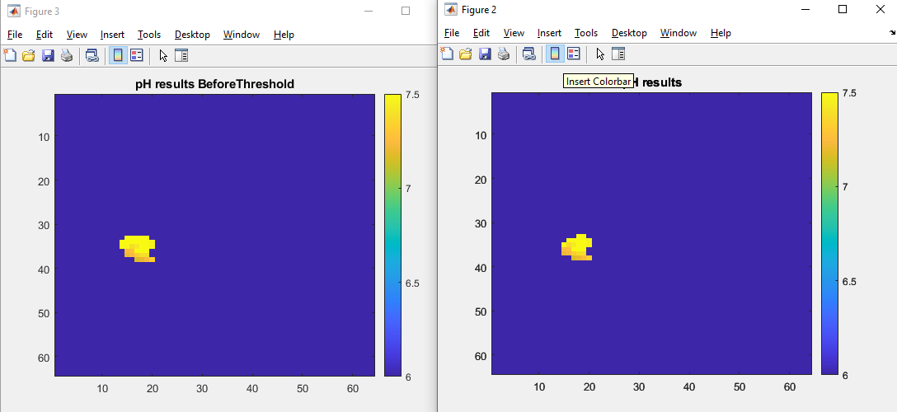

* 1. Figures with pH maps before and after thresholding overlaid on the anatomical image will appear on screen and saved in the output folder as MATLAB figures and TIFF Images.

