Usermanual for engineers

How to prepare 3D scan and generate mould for ear bolus

Contents

About this manual 2

Cropping the 3D scan 2

Making the bolus mould 3

Prepare model for printing 3

About this manual  
This user manual is for engineers making a mould for an ear bolus. This manual will explain how to prepare the raw 3D scan, make the mould and what software to use for it.

It is recommended to follow the manual to get the best results.

# Cropping the 3D scan

1. Download the 3D scanning of the patient on the R-drive on your Region H computer.
2. Import the OBJ.file into meshmixer
3. Use the **inspector** tool in **analysis**. Use the smooth fill mode. Remember to press **“autorepair all”.**
4. Crop the model. Crop out the ear but leave some on the sides. The cropping can be done in two ways.
   1. Use the **select tool** and select the ear and some surroundings (**orange is selected**). Then press **“i” to invert** the selection and then press **“x” to delete**.
   2. Use the select tool to draw a line across the model where you want to cut it. You must start the line outside the model. After “i” can be used to invert and “x” to delete.
5. Use the **inspector** tool again. Use the **smooth fill mode**. Remember to press **“autorepair all”**
6. Use the **“make solid” tool** in **edit**. You want to use the **“accurate”** solid type. **Press update and accept**.
7. If you need to cut more off the model just follow the steps from step 3 again.
8. Go to **edit** and use **“align”**. Source should be **“basepoint”**, destination **“world origin/Y-up”** and transformation **“translate and rotate”**.
9. When the 3D model looks like this you need to save it as an STL file.

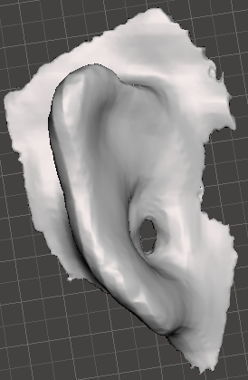

!! Important to have it as an STL file and not overwr ite the original OBJ file !!

# Making the bolus mould

1. Open the EarTemplate.scad in OpenSCAD.
2. Import the solid 3D model into OpenSCAD. If you drag and drop the STL file remember to remove **<import()>.**
3. Write the patient’s CPR number and separate each number with space without special signs.
4. Follow the steps in the script until the mould looks like this:

**It is important the ear is rotated this way and that there is NO HOLES between the ear and the base plate.**

1. Placing the **small (grey) cylinder** is important it is placed on the **highest/tallest** point of the ear. If the small (grey) cylinder is not visible, try changing the z-axis. It should look like the picture underneath.

1. Save the finished mould as an STL file

The mould is now ready for printing.

# Prepare model for printing

1. Print the mould using a **Prusa i3 MK3S** printer
2. Use PLA filament on the printer
3. Import the STL file into PrusaSlicer
4. Make sure the settings are as the picture
5. Only 5 % infill.
6. Make sure to wash the printer bed before starting the print. Use warm water and soap
7. Graphical user interface, text, application, email

   Description automatically generatedExport the gcode to a SD card
8. Put SD card into a Prusa i3 MK3S printer
9. Start the print.