CADENCE: Causal Drift Attribution and Cost-Constrained Retraining for Continually Deployed Machine-Learning Systems
Gona Lalith  Dept. of CSE, LPU  Phagwara, India  gonalalith2005@gmail.com | Ankita Maji  Dept. of CSE, LPU  Phagwara, India  ankitamaji7033@gmail.com | Nihar Kanakam  Dept. of CSE, LPU  Phagwara, India  niharkanakam@gmail.com
Quaise Mallick  Dept. of CSE, LPU  Phagwara, India  quaisemallick.wha@gmail.com | Shailaja Singh  Dept. of CSE, LPU  Phagwara, India  sshailaja2004@gmail.com | Jasmeen Khatun  Dept. of CSE, LPU  Phagwara, India  jasmeenkhatun536@gmail.com
Dr. Ravin Kumar
School of CSE, LPU
Punjab, India
ravinpal2009@gmail.com
Abstract—Deployed machine-learning models degrade as data distributions drift, yet the dominant maintenance policies—periodic and drift-triggered full retraining—answer only when to retrain, never which part of the model failed or how much of it to repair. This chapter presents CADENCE, a closed-loop framework that reframes model maintenance as minimum-cost repair under a performance constraint. CADENCE (i) builds a causal drift-attribution graph (CDAG) over external input features and internal activation clusters; (ii) scores per-node responsibility with a graph neural network and predicts each candidate repair's benefit with a learned counterfactual surrogate; and (iii) selects a minimal, cost- and service-level-agreement (SLA)-constrained retraining scope, executed as an EWC-regularized partial or full retrain with shadow/canary validation and rollback. Under a pre-registered evaluation protocol in which negative results are reported as first-class findings, learned attribution beats a Population-Stability-Index baseline on contested synthetic drift (mean reciprocal rank 0.10→0.41, AUROC 0.67→0.91; p<0.001, n=10); targeted partial retraining cuts Split-MNIST forgetting from 39.5% to near zero against a fair replay baseline (p<0.001, n=10); and on real electricity-market drift the policy saves 69.1% of retraining compute for a 1.66-point F1 cost. We are equally explicit about the operating envelope: the framework is net-positive only above a measured retrain-cost break-even, graph construction scales as ≈O(n^2.6), and a learned policy is competitive-but-not-superior to a greedy rule at a three-action scale. The chapter details the concepts, theory, applications, case illustrations, limitations, and future directions of diagnosis-driven model repair.
Keywords—concept drift; causal attribution; graph neural networks; constrained reinforcement learning; continual learning; catastrophic forgetting; cost-aware retraining; counterfactual surrogate; MLOps; model maintenance.
I. INTRODUCTION
A machine-learning model that is accurate on the day it is deployed does not stay accurate. As the serving data-generating process drifts—customers change behaviour, fraud tactics evolve, sensors age, markets move—predictive quality erodes, and the bulk of the effort of a production ML system is spent after first training rather than before it [16], [43]. Two maintenance policies dominate practice, and both are blunt. Periodic (calendar) retraining refits every model on a fixed cadence regardless of whether anything has changed, paying compute—and, at scale, non-trivial energy—on models that have not degraded. Reactive retraining waits until a downstream metric visibly drops and then retrains the whole model from scratch, paying both for the window of degraded predictions and for a full from-scratch refit.
Neither policy reasons about whether, where, or how much a model needs to change. A covariate shift confined to a single input feature and a wholesale concept change demand very different responses, yet both trigger the same expensive full retrain. Worse, a naive full retrain can induce catastrophic forgetting [1] of sub-populations or tasks the model previously served well. Prevailing production drift monitors compound the problem: they are correlational, raising an alarm when an input distribution shifts but unable to state whether that shift is responsible for the degradation, or which internal part of the model it actually broke.
This chapter argues that the right unit of decision is minimum-cost repair under a performance constraint: given a degradation, attribute it across the combined input–model system, estimate the benefit of a candidate repair before performing it, and execute the smallest intervention that restores service within a service-level agreement (SLA). This reframes model maintenance from a scheduling question (“when to retrain”) into a causal-attribution problem feeding a constrained sequential decision (“which subnetwork to repair, and by how much”). We instantiate the idea as CADENCE—Causal Attribution-Driven Efficient Continual rEtraining—a single closed loop over attribution, counterfactual benefit prediction, and cost-constrained scope selection.
Contributions and roadmap. This chapter (1) develops the conceptual and theoretical foundations of diagnosis-driven maintenance (Sections II–IV); (2) details the CADENCE architecture, its unified attribution graph, counterfactual surrogate, and constrained decision (Section III); (3) situates the framework within contemporary MLOps and continual-learning practice (Section V); (4) surveys practical applications (Section VI); (5) presents measured case illustrations across synthetic, real, and cross-model drift (Section VII); and (6) reports the limitations and future directions honestly (Sections VIII–IX). A distinguishing methodological commitment is pre-registration [32]: Stage-1 policy-health gates and Stage-2 verdicts were fixed in a signed document before the confirmatory runs, so that negative results are reported as first-class findings rather than being quietly discarded.
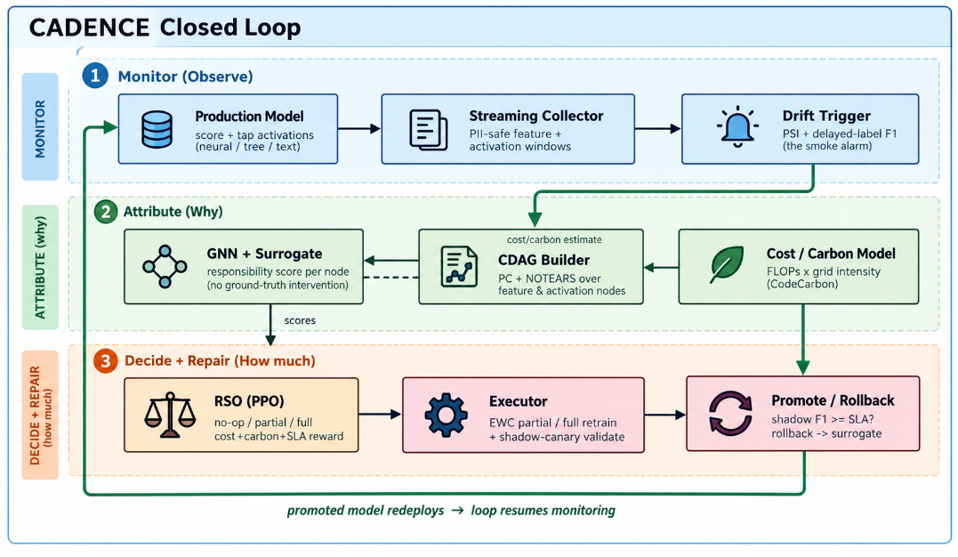
Fig. 1. The CADENCE closed loop: monitor → attribute (CDAG + GNN + counterfactual surrogate) → decide (cost-constrained scope) → repair (EWC partial/full + shadow validation) → redeploy.
II. CONCEPTUAL BACKGROUND AND THEORETICAL FOUNDATIONS
Concept drift. Concept drift is the change over time in the joint distribution of inputs X and targets Y that a deployed model was trained on. It is classically decomposed into covariate shift (the input distribution P(X) changes), prior-probability shift (the class balance P(Y) changes), and concept shift (the conditional P(Y|X) changes). Only the last necessarily requires the model's decision boundary to move, yet all three can trigger the same alarm; distinguishing them is central to deciding how to repair. Concept drift and its adaptation have been surveyed comprehensively [14] and re-reviewed for the deep-learning era [37].
Drift detection. Error-rate detectors such as DDM established the trigger-on-degradation pattern [9], and windowing detectors such as ADWIN adapt the reference window online [10]; distributional monitors such as the Population Stability Index (PSI) and dataset-shift tests raise alarms when inputs move [38], within the general framing of dataset shift [12]. These answer whether the input moved, not why the model degraded. CADENCE uses a PSI-plus-delayed-label trigger only as a gate; the diagnostic work happens after the alarm.
Causal structure discovery. Constraint-based structure learning matured with the PC algorithm, which recovers a graph skeleton from conditional-independence tests [7], within the broader interventional framework of causal inference [11], [27]. Continuous, differentiable structure learning was later made possible by NOTEARS, which casts acyclicity as a smooth constraint [35]; reviews of graphical [36] and time-series [39] causal discovery survey the wider landscape. CADENCE combines a PC-style skeleton with a NOTEARS-style continuous relaxation to build its attribution graph, while explicitly declining to claim identification of a unique causal graph—the graph is used as a structured inductive bias for an attribution ranking, not as a recovered ground truth.
Graph representation learning. Message-passing graph neural networks—inductive GraphSAGE [21], the graph convolutional network (GCN) [23], the general message-passing formulation [20], and graph attention [34]—learn node embeddings by aggregating evidence over a neighbourhood. Because responsibility is propagated through the graph, a node can be implicated even when no single edge from it to the performance node survives in the recovered skeleton.
Continual learning and catastrophic forgetting. Catastrophic interference in connectionist networks was identified early [1], [5]. Modern remedies include elastic weight consolidation (EWC), which anchors parameters important to prior tasks via a Fisher-information penalty [24], synaptic intelligence [31], gradient-episodic memory (GEM) [25], and exemplar-replay methods such as iCaRL [28]; the field is surveyed in [42]. CADENCE uses an EWC-regularized partial retrain as its repair mechanism, so adaptation to new drift does not erase previously served competence.
Constrained sequential decision-making. Choosing a maintenance action under an explicit budget and SLA is naturally a constrained Markov decision process (CMDP) [4], solved here by a Lagrangian dual [2] that adapts a penalty to the realized constraint-violation rate. The policy is interchangeable: a proximal-policy-optimization (PPO) agent [29]—built on generalized advantage estimation [17] and the policy-gradient foundations of [33]—implemented via Stable-Baselines3 [41], a constrained-policy-optimization alternative [18], a contextual bandit, or a transparent greedy rule.
Production reality. The operational burden of ML was crystallized as hidden technical debt [16] and catalogued as concrete deployment challenges [43]. CADENCE is designed as an MLOps component: it reaches the deployed model only through a narrow adapter and emits machine-readable telemetry for governance and audit. Figures 2 and 3 give the context and process-level data-flow views of this component.
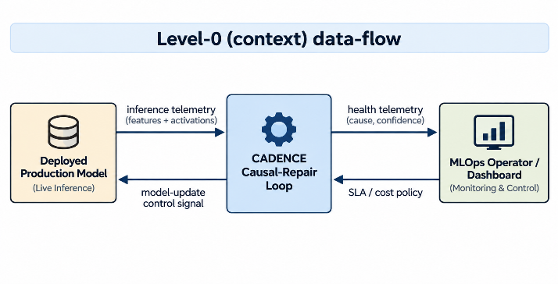
Fig. 2. Level-0 (context) data-flow: the CADENCE loop sits between the deployed model and the operator, consuming inference telemetry and an SLA/cost policy and returning a model-update control signal and health telemetry.
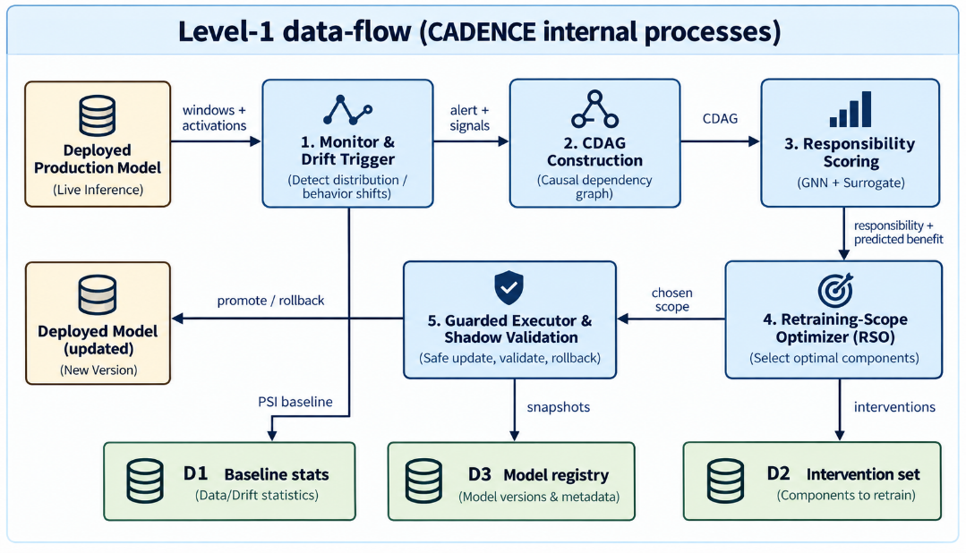
Fig. 3. Level-1 data-flow: monitor-and-trigger, CDAG construction, responsibility scoring, the retraining-scope optimizer, and a guarded executor, with baseline-statistics, model-registry, and intervention-sandbox stores.
III. MAJOR CONCEPTS AND DIMENSIONS
CADENCE is a closed loop of nine cooperating components. Figure 4 shows the loop with reference numerals; the deployed model (100) is reached only through an adapter interface (105) exposing score, activation-tap, partial-fit, full-fit, and snapshot/restore operations. The remaining components realize the four conceptual dimensions of diagnosis-driven repair: attribution, benefit prediction, constrained decision, and forgetting-safe execution.
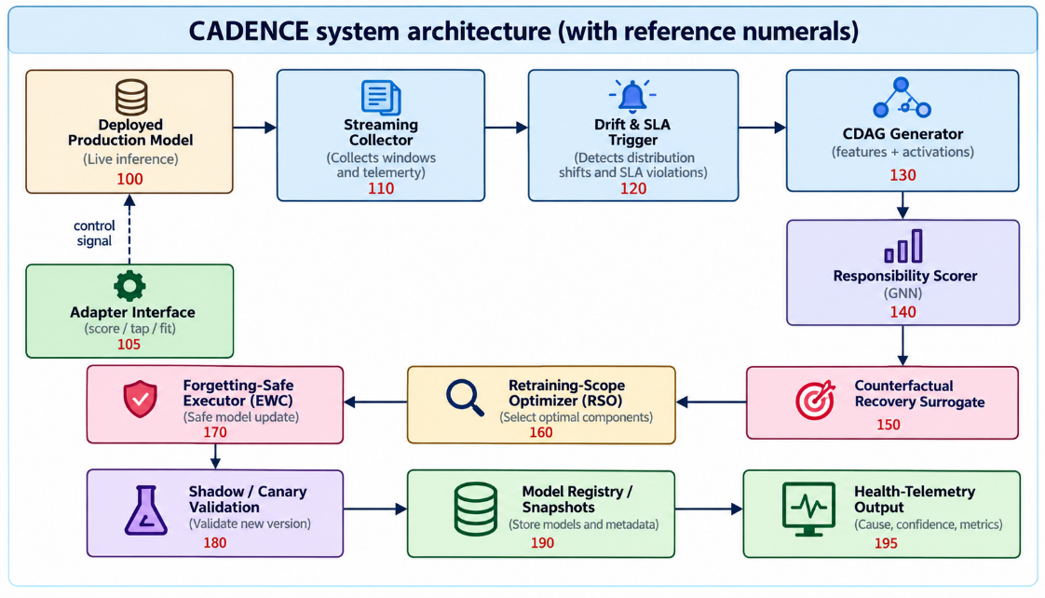
Fig. 4. Reference-numeral architecture: streaming collector (110), drift/SLA trigger (120), CDAG generator (130), responsibility scorer (140), counterfactual recovery surrogate (150), retraining-scope optimizer (160), forgetting-constrained executor (170), shadow/canary validation (180), model registry (190) and health-telemetry output (195).
A. The unified Causal Drift-Attribution Graph (CDAG)
On a trigger, the CDAG generator forms a single graph whose node set unifies three kinds of nodes: external feature nodes (210) summarizing input statistics, internal model-state nodes (220) derived from clustered per-layer activations of the deployed model, and a performance node (230). A skeleton is estimated by a constraint-based conditional-independence procedure [7]; edge weights (240) by a continuous acyclicity-regularized relaxation [35], masked by the skeleton. Spanning both the data and the model's own internal state is what lets CADENCE ask not only which feature moved but which internal component broke.
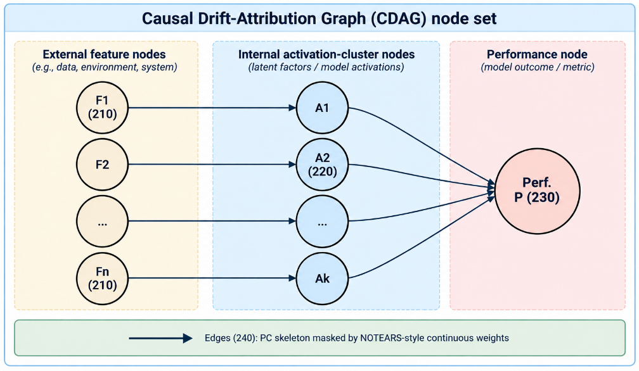
Fig. 5. The CDAG node set: external feature nodes (210), internal activation-cluster nodes (220), the performance node (230), and inferred weighted directed edges (240).
B. Responsibility scoring and the counterfactual recovery surrogate
A graph message-passing model ingests the CDAG and produces, per node, an embedding ei and a non-negative responsibility ri. For a candidate node i, the recovery of repairing it is the improvement of its post-repair performance over the current performance, where post-repair performance is defined as an expectation under a simulated repair intervention:
$$R_{i} = P_{i} - P_{cur} , P_{i} = E[ F1( Y | do( repair i ) ) ]$$
Running a real retrain for every candidate node at decision time would be prohibitive. Instead, a learned surrogate predicts each candidate's post-repair performance in a single forward pass from the node embedding and a context vector of the current performance and a severity estimate; the predicted recovery is obtained by subtraction. Only the predicted recovery and the responsibility feed the decision:
$${\hat{P}}_{i} = g_{θ}( e_{i} , [ P_{cur} , sev ] ) , {\hat{R}}_{i} = {\hat{P}}_{i} - P_{cur}$$
The surrogate is trained jointly with the GNN on an intervention sandbox populated offline by injecting drift, performing a candidate repair, and recording the measured post-repair performance. Because the recoveries for all candidate nodes are obtained by one forward pass, the surrogate amortizes hypothesis evaluation across the whole graph—this is what makes responsibility-and-recovery-coupled scope selection tractable online.
C. Node → subnetwork mapping
An attributed node is mapped to a concrete, retrainable parameter set by a mapping Φ: an internal activation-cluster node maps to the layer from which it was tapped; a feature node maps to the input-facing layer; several jointly responsible nodes map to the union of their scopes. Where a node has no independently retrainable component, or the union spans essentially the whole model, the mapping escalates to a full retrain.
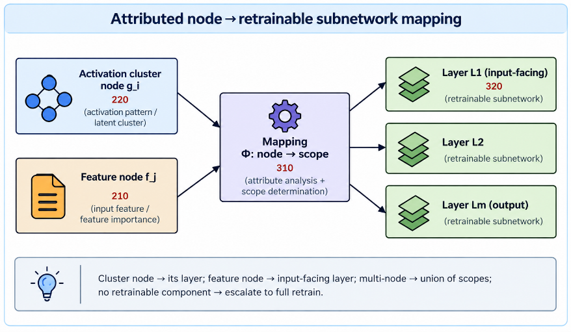
Fig. 6. Mapping Φ from an attributed node (feature node 210 or activation-cluster node 220) to a retrainable subnetwork/layer of the deployed model.
D. The cost- and SLA-constrained scope decision
Scope selection over the action space {no-op, partial, full} is a constrained MDP. The target node maximizes the product of responsibility and predicted recovery; the partial action's expected change is that node's predicted recovery. Among the actions whose predicted post-repair performance meets the SLA (“predicted-feasible”), the optimizer selects the one of least estimated compute cost, ranked by an objective J and governed by a dual variable that adapts to the realized violation rate:
$$i^{*} = {argmax}_{i} ( r_{i} · {\hat{R}}_{i} )$$
$$J(a) = E[ ΔF1(a) ] - w·C(a) - λ·max( 0 , SLA - F1(a) )$$
$$λ ← clip( λ + η( \bar{v} - δ ) , 0 , λ_{max} )$$
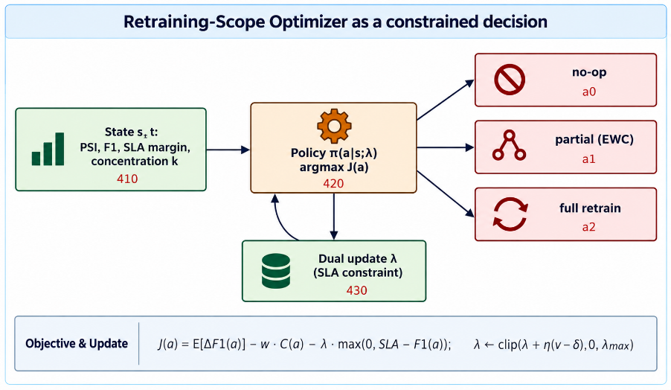
Fig. 7. The retraining-scope optimizer as a constrained decision: it ranks {no-op, partial, full} by the objective J and enforces the SLA through a dual-variable update.
E. Forgetting-constrained execution, validation and telemetry
For a partial retrain the executor updates only the mapped parameter set and freezes the rest, adding an EWC penalty that anchors parameters important to prior competence, weighted by the diagonal Fisher information Fj:
$$Loss = L_{task} + λ_{ewc} \sum_{j}{F_{j} {( θ_{j} - θ_{j}^{*} )}^{2}}$$
An attribution-concentration guard κ escalates to a full retrain when responsibility is diffuse rather than concentrated:
$$κ = \frac{\max_{i} r_{i}}{\sum_{i}{r_{i}}}$$
Every candidate model is validated in a shadow/canary path isolated from live serving; if it meets the SLA it is promoted to the model registry, otherwise the prior snapshot is restored. The realized post-repair performance is fed back to recalibrate the surrogate, and a machine-readable telemetry record—attributed cause, concentration, chosen action, predicted and realized recovery, and compute expended—is emitted for governance and audit.
IV. RELEVANT THEORIES AND MODELS
CADENCE is an integration of several mature theories, each mapped onto a concrete component. Making these mappings explicit clarifies both what is borrowed and where the novelty lies—in the interaction of the pieces, not in any one of them.
- Interventional causal reasoning. The recovery target is defined with the do-operator: the post-repair performance is the expected metric under a simulated repair intervention. CADENCE does not claim to identify a unique causal graph; it uses causal structure as an inductive bias and grades real-drift outcomes empirically.
- Constraint-based and continuous structure learning. The PC algorithm [7] supplies the skeleton; a NOTEARS-style continuous relaxation [35] supplies masked edge weights—combining a discrete independence test with a differentiable acyclicity objective.
- Graph message passing. GraphSAGE [21] and GCN [23] provide the readout that turns the graph into per-node embeddings and responsibilities, propagating blame through neighbourhoods.
- Elastic weight consolidation and Fisher information. EWC [24] provides the forgetting constraint; the diagonal Fisher information estimates per-parameter importance for prior tasks.
- Constrained MDPs and Lagrangian duality. The scope decision is a CMDP; a projected dual-ascent update adapts the SLA penalty to the realized violation rate, giving a controllable operating point along the cost/quality curve.
- Policy optimization. PPO [29] via Stable-Baselines3 [41] is one interchangeable optimizer; a greedy rule and a contextual bandit are others. Section VII reports that PPO is not superior to the greedy rule at the three-action scale studied—an honest, pre-registered negative.
- Feature attribution, contrasted. Shapley-value attribution [26] and axiomatic integrated gradients [30] explain individual predictions of a fixed model; CADENCE instead attributes the degradation of the model under drift and predicts the benefit of repairing it—a different question with a different object.
V. CONTEMPORARY PERSPECTIVES AND RECENT DEVELOPMENTS
Contemporary MLOps practice increasingly treats monitoring, drift detection, and retraining as first-class production concerns rather than afterthoughts [16], [43], operationalized in production ML platforms such as TFX [19]. Three currents are especially relevant. First, drift detection has broadened from error-rate detectors [9] to distribution-level and representation-level shift tests [38], and has been re-surveyed for deep models [37]; the open gap is that detection remains correlational. Second, continual learning has produced a mature toolbox for updating models without forgetting—EWC [24], GEM [25], and the methods catalogued in [42]—but these supply update mechanisms, not a policy for whether, where, and how much to update. Third, the reproducibility and pre-registration movement [32] has begun to reshape empirical ML, motivating CADENCE's commitment to fixing hypotheses and gates before analysis.
CADENCE's position is to couple diagnosis to repair scope: an attribution graph over external and internal state, a learned estimate of each repair's benefit, and a cost-constrained choice of how much to retrain. It does not claim novelty from the components individually; Table 1 makes the system-level distinction falsifiable by marking, for each representative prior family, whether a capability is a designed, first-class feature.
TABLE 1. Capability comparison against representative prior families. A mark denotes a designed, first-class capability.
Method family | Drift | Attrib. | Internal state | Counterf. benefit | Scope + Cost/SLA
Drift detection [9], [38] | ✓ | ✗ | ✗ | ✗ | ✗
Causal discovery [7], [35] | ✗ | ✓ | ✗ | varies | ✗
Continual learning [24], [25] | ✗ | ✗ | ✗ | ✗ | partial
Feature attribution [26] | ✗ | ✗ | ✗ | ✗ | ✗
Triggered full retrain | ✓ | ✗ | ✗ | ✗ | timing only
CADENCE (this work) | ✓ | ✓ | ✓ | ✓ | ✓

VI. PRACTICAL APPLICATIONS
Because CADENCE reaches the deployed model only through a narrow, model-agnostic adapter, the identical attribution-decision-repair loop applies wherever a model is served continuously under drift. High-value settings include: financial fraud detection, where fraud tactics shift adversarially and full nightly retrains are costly; credit-risk and loan-default scoring, where regulatory auditability of every model change is required; recommendation and click-through prediction, where behaviour drifts continuously; customer-churn prediction; and physiological-signal or sensor monitoring on edge and wearable devices, where compute and energy budgets are tight.
Three properties make the framework practically deployable. (1) Selective, cheaper repair: confining the update to a mapped subnetwork reduces the parameter-update and floating-point cost of an adaptation relative to a whole-model retrain, subject to the break-even discussed in Section VIII. (2) Reversible, non-disruptive change: shadow/canary validation and snapshot promotion/rollback mean a corrective update never interrupts or degrades the live serving path. (3) Governance and audit: the machine-readable telemetry record turns every maintenance decision into an inspectable artifact—attributed cause, concentration, action, predicted vs realized recovery, and compute spent—supporting compliance workflows. The runtime decision pipeline that produces these records is shown in Figure 8.
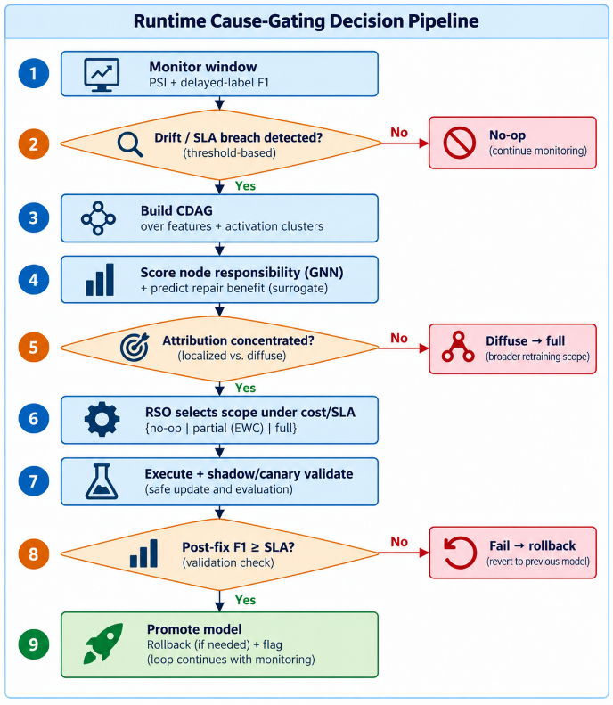
Fig. 8. Runtime cause-gating decision pipeline: monitor → trigger → CDAG → responsibility + predicted recovery → concentration test → constrained scope decision → guarded repair → promote/rollback → telemetry.
VII. EXAMPLES AND CASE ILLUSTRATIONS
All results below are measured under the pre-registered protocol, over multiple seeds with paired Wilcoxon tests and bootstrap confidence intervals; every value is regenerated from a versioned ledger (dataset, seeds, configuration, hardware) and none is hand-entered. Synthetic drift with a known root cause is injected into a Credit-Card-Fraud MLP; real drift uses the Elec2 electricity-market stream [6]; cross-model generality uses a LightGBM gradient-boosted-tree ensemble [22] (Give-Me-Some-Credit) and a TF-IDF/logistic-regression text model (Yelp); forgetting uses Split-MNIST [3]; models and baselines use scikit-learn [13] and gradient-boosted trees in the tradition of random forests [8]; optimization uses Adam [15].
A. Case 1 — Attribution beats correlation on contested drift (H1)
Reporting the easy and hard subsets separately (pooling dilutes the effect, because PSI is already saturated on easy scenarios), on the contested subset the CDAG+GNN scorer lifts mean reciprocal rank from 0.097 to 0.412 and AUROC from 0.672 to 0.905 (p<0.001 versus PSI, n=10). Against stronger baselines the GNN dominates on AUROC (0.91) over input-gradient and permutation attribution, while a counterfactual-permutation baseline is competitive on top-1/MRR—so the GNN's clean, consistent win is ranking quality, honestly reported (Table 2).
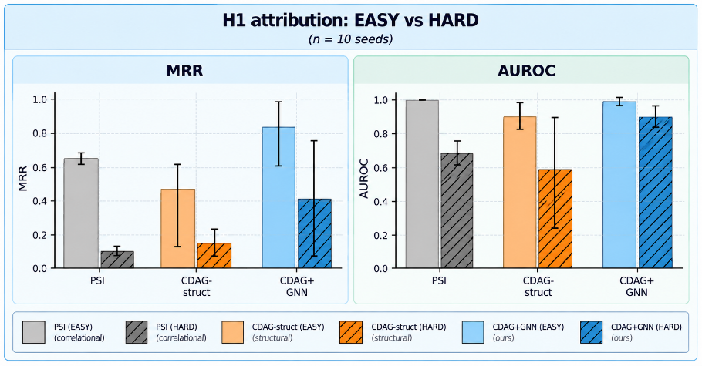
Fig. 9. H1 (n=10). Solid bars: EASY (PSI-saturated) subset; hatched bars: HARD (contested) subset. On HARD the CDAG+GNN beats both baselines on MRR and AUROC (p<0.001 vs PSI).
TABLE 2. H1 on the HARD (contested) subset (mean; n=10). p: paired Wilcoxon (GNN greater) on AUROC.
Scorer | top-1 | MRR | AUROC | p vs GNN
PSI | 0.00 | 0.097 | 0.672 | <0.001
Input-gradient | 0.00 | 0.268 | 0.517 | 0.032
Permutation | 0.50 | 0.517 | 0.293 | <0.001
CDAG+GNN (ours) | 0.30 | 0.450 | 0.910 | —

B. Case 2 — The counterfactual surrogate calibrates and amortizes
Trained jointly with the GNN on sandbox interventions, the surrogate is well-calibrated on held-out data (R²=0.888, mean absolute error 0.036) and reaches R²≈0.9 from roughly 50–100 interventions—evidence that it amortizes hypothesis evaluation rather than memorizing. Its failure mode is reported honestly: on a mechanism-held-out test (train on covariate drift, test on unseen concept drift) the in-distribution MAE is 0.004 but the out-of-distribution MAE is 0.55, so cross-mechanism generalization is an open problem; an unrecoverable-drift guard halts fruitless repair when successive attempts fail.
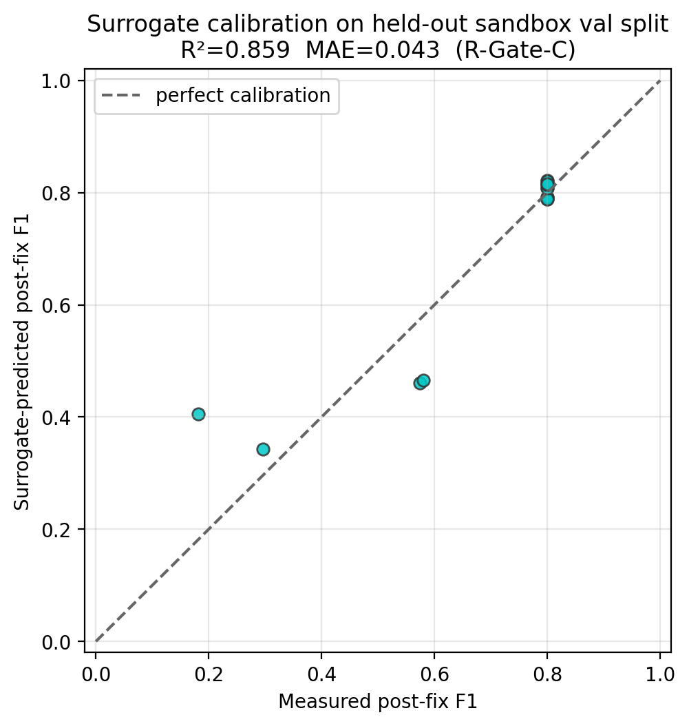
Fig. 10. Counterfactual surrogate calibration: surrogate-predicted vs. measured post-repair F1 on a held-out sandbox split. Points clustering on the diagonal indicate good calibration; the full-validation fit reported in the text is R²=0.888 (MAE 0.036).
C. Case 3 — Cost-constrained repair on real drift (H2)
On Elec2 the stream degrades from a training F1 of 0.84 to an un-adapted 0.43—a genuine 41-point, leakage-checked drift. Against a reactive-full baseline, CADENCE saves 69.1% of retraining compute for a 1.66-point F1 gap (95% CI [−0.025, −0.009])—a point on the cost/F1 Pareto frontier (Figure 11). A reduced learned-policy Stage-2 (3 seeds; a documented pre-registration amendment; the full 10×30k run pending) strengthens this: on the two recoverable contested scenarios the learned scope selector Pareto-dominates PSI-full-retrain (+0.02 and +0.09 F1 at 66% lower compute), while on an unrecoverable tail-flip all strategies fail equally. At n=3 the paired test is underpowered (p=0.25); we therefore report H2 as PRACTICAL, not strict-dominance.
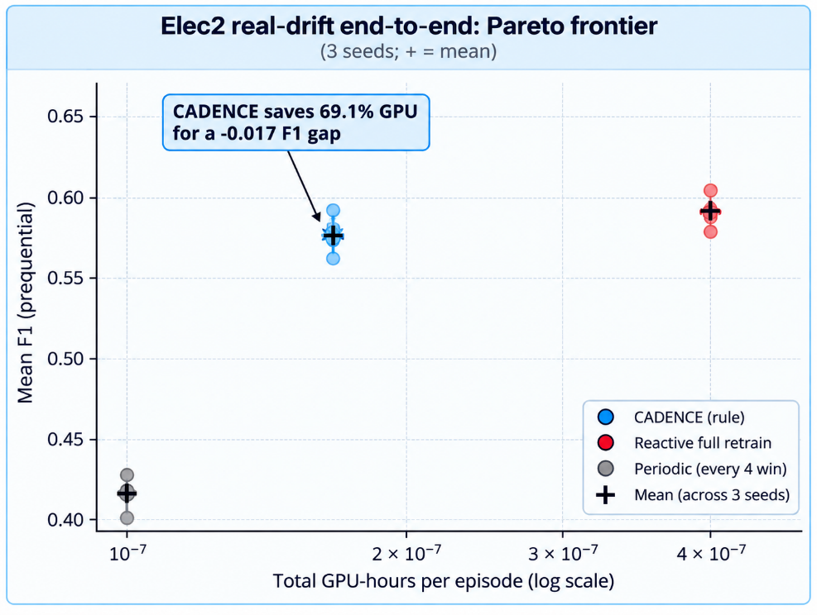
Fig. 11. Elec2 real-drift Pareto frontier (n=3): CADENCE sits on the cost/F1 frontier, saving 69.1% GPU-hours vs reactive-full for a −0.017 F1 gap.
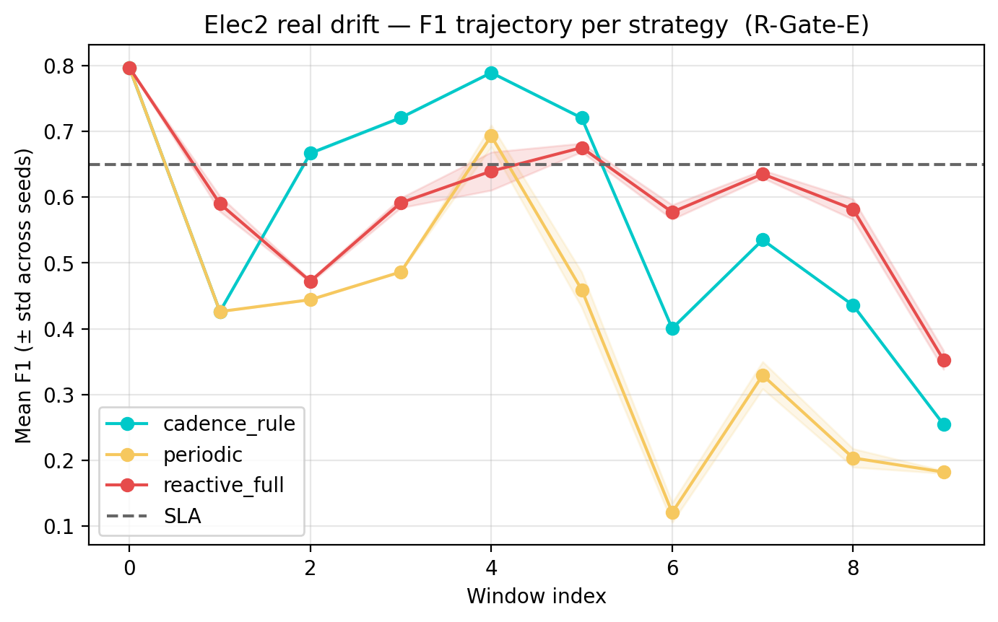
Fig. 12. Elec2 prequential F1 across the stream: the deployed model degrades under drift and is restored by cost-constrained repair.
D. Case 4 — Targeted partial retraining reduces forgetting (H3)
On Split-MNIST (disjoint digit tasks) an EWC-regularized partial retrain preserves the prior task almost perfectly (forgetting −0.03) while a naive full retrain loses 39.5%; even against a fair full-with-replay baseline, partial retraining wins (paired Wilcoxon p<0.001, n=10; Table 3). Honestly, an isolation ablation shows that CDAG-guided layer targeting is tied with random/gradient targeting on forgetting for this benchmark: the win here is EWC's, not causal layer selection's—an important negative that bounds the claim.
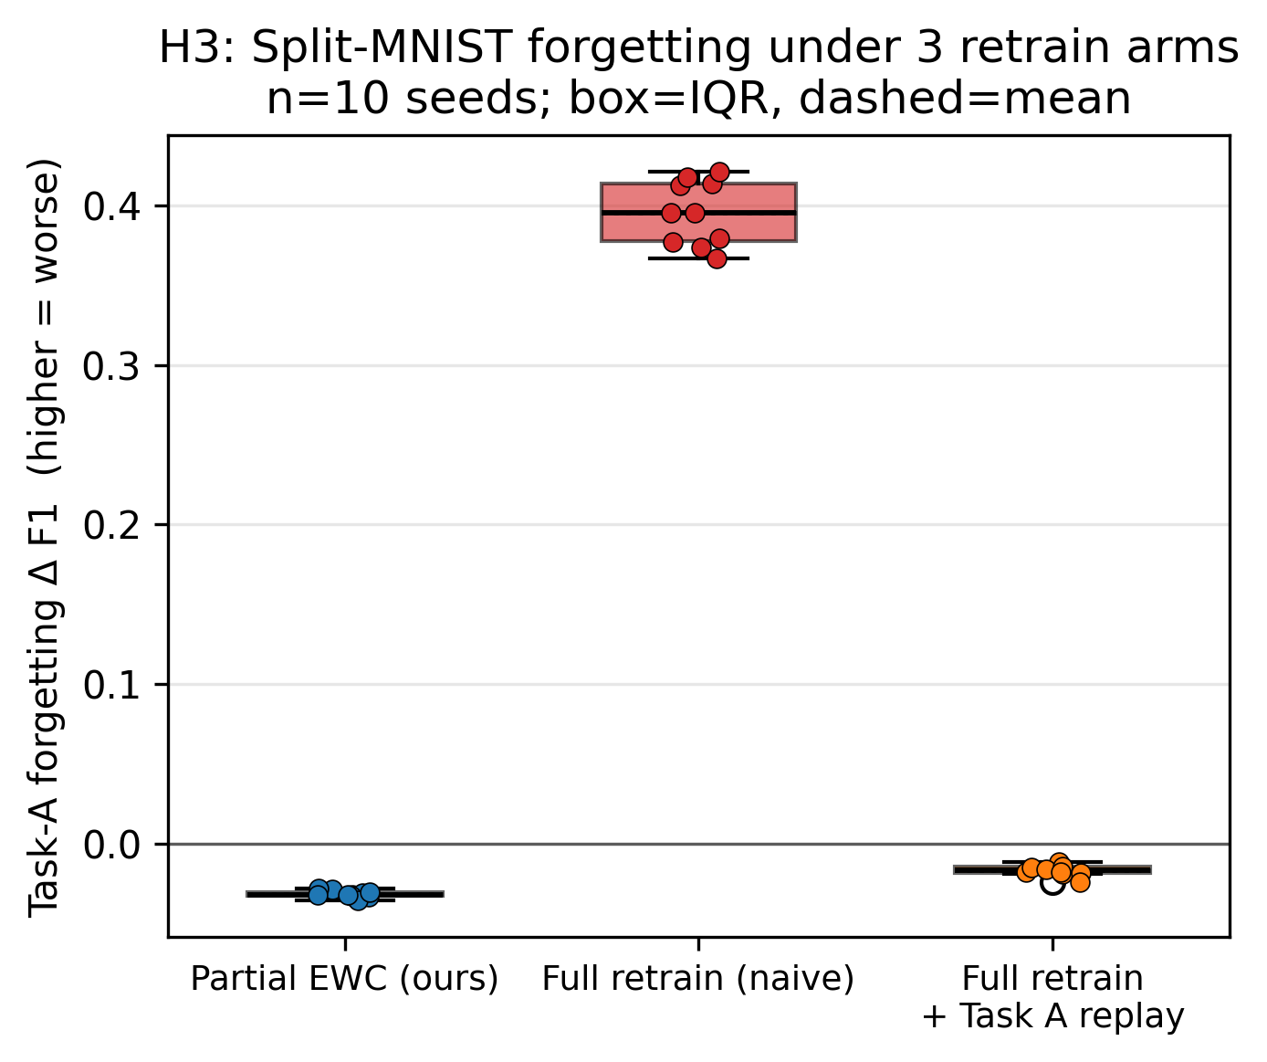
Fig. 13. H3 Split-MNIST (n=10): partial-EWC preserves Task A (median ≈ −0.03) versus naive-full loss ≈ 0.40; p<0.001.
TABLE 3. H3 forgetting on Split-MNIST (n=10; lower is better, negative = gain).
Retrain arm | Task-A forget | Task-B F1 | p vs ours
Naive full (no replay) | +0.395 | 0.990 | <0.001
Full + replay (fair) | −0.017 | 0.979 | <0.001
Partial + EWC (ours) | −0.032 | 0.802 | —

E. Case 5 — Cross-model generality and robustness
The identical loop runs over a neural MLP, a LightGBM ensemble, and a TF-IDF/logistic-regression text model; the architecture is model-agnostic, while the partial-repair mechanism requires internal layers (tree and linear adapters fall back to a full retrain by contract). On tree models at a realistic SLA, CADENCE still sits on the Pareto frontier (≈50% compute saved for a 0.007 F1 cost; Figure 14). Robustness probes show attribution quality degrading gracefully as a random fraction of CDAG edges is dropped—a proxy for missing activation samples (Figure 15)—and the PSI trigger separates undrifted from drifted streams, though with the expected false-alarm/true-alert trade-off (Figure 16).
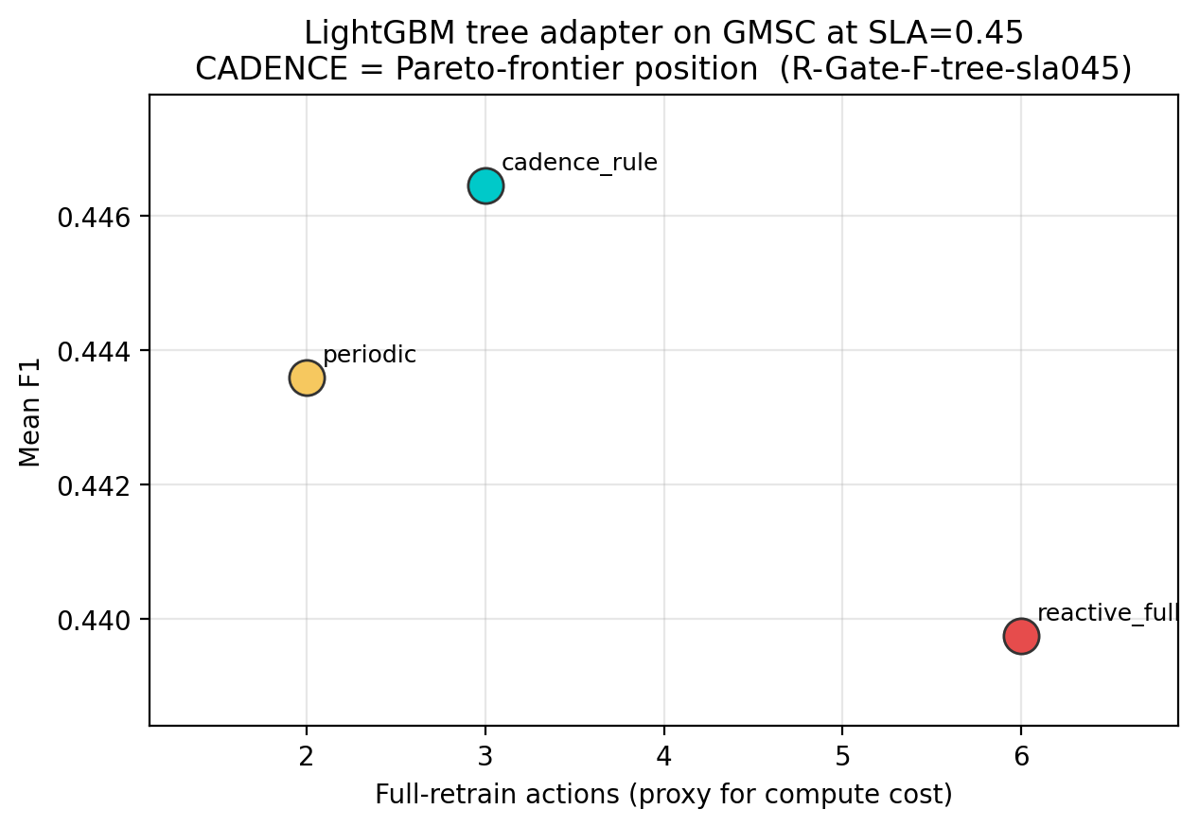
Fig. 14. Cross-model generality: the LightGBM tree adapter still lands on the cost/F1 Pareto frontier (≈50% compute saved for a 0.007 F1 cost).
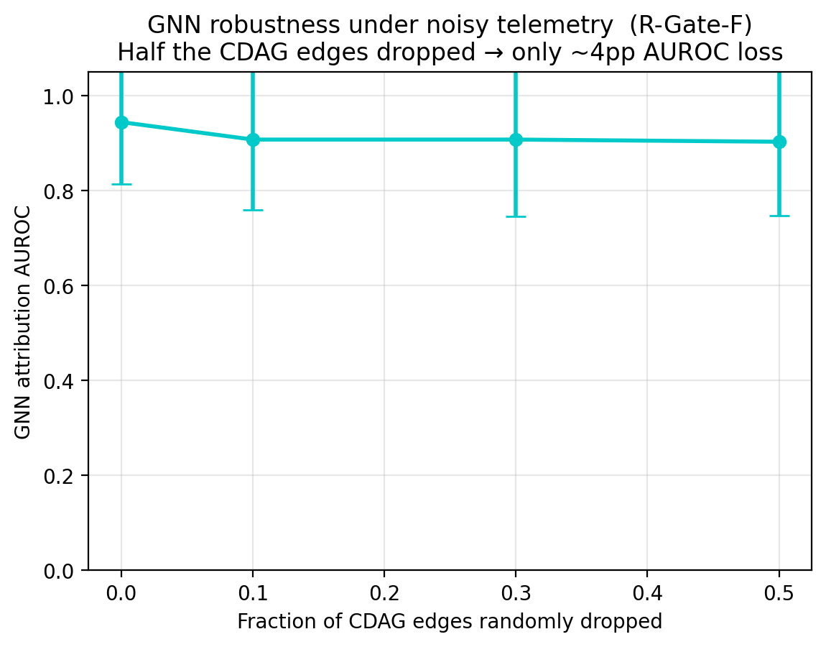
Fig. 15. Robustness: attribution AUROC as a random fraction of CDAG edges is zeroed (drop fraction 0.0→0.5), a proxy for missing activation samples.
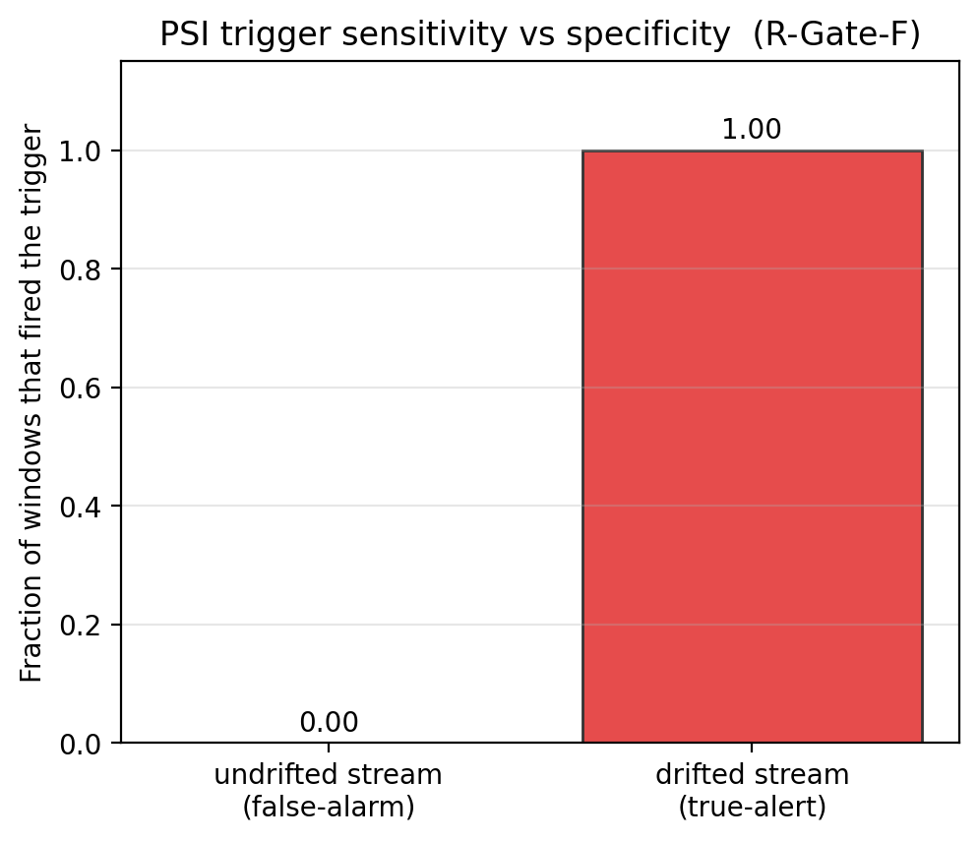
Fig. 16. Trigger behaviour: PSI firing on undrifted versus drifted streams—the false-alarm versus true-alert trade-off that gates the diagnostic loop.
F. Case 6 — System analysis and honest boundaries
Four measured system findings bound the claims and are reported as first-class results. Overhead: accounting for CADENCE's own monitoring, CDAG construction, GNN and policy cost, the net saving is positive only above a measured retrain-cost break-even of ≈1.3 s, so the headline figure is a retraining-compute saving rather than an end-to-end one. Scalability: CDAG construction scales as ≈O(n^2.6) (0.30 s, 5.2 s and 127 s at 30, 100 and 300 nodes respectively), so the graph is built only on a trigger and the node count is capped. Policy necessity: evaluated against no-op, always-partial, always-full and a greedy rule on the same environment and reward, a PPO policy is competitive but not superior (p=0.29 versus the greedy rule), so we do not claim reinforcement learning is necessary at a three-action scale. Diffuse cause: as one to ten features co-drift, the attribution-concentration κ falls monotonically from 0.94 to 0.61, correctly signalling when to escalate from a partial to a full retrain. A pre-registered Stage-1 diagnostic (seven of eight policy-health gates passed) confirms the learned policy is non-collapsed, exploring and constraint-satisfying — the substrate on which the confirmatory runs stand.
VIII. CHALLENGES AND LIMITATIONS
The framework's boundaries are stated as first-class findings rather than hidden. (1) Causal validity is demonstrated on synthetic drift only; on real drift the attribution is graded on outcome, and cross-mechanism surrogate transfer fails (OOD MAE 0.55). (2) H2's strict-dominance form awaits the pre-registered n≥10 learned-policy run; at present it is a reproducible practical Pareto win at n=3. (3) Two measured negatives bound the claims at the current three-action scale: a PPO policy is competitive but not superior to a greedy rule (p=0.29), and CDAG-guided layer targeting is tied with random targeting on Split-MNIST forgetting (EWC does the work). (4) Graph construction scales as ≈O(n^2.6) (0.30/5.2/127 s at 30/100/300 nodes), so the CDAG is built only on a trigger and the node count is capped. (5) The net saving is positive only above a measured retrain-cost break-even (≈1.3 s); the headline is therefore a retraining-compute saving, and carbon numbers are model-derived rather than hardware-measured, though the training-energy footprint that compute-frugal repair targets is well documented [40]. None of these undermine the established H1, H3, surrogate-calibration, robustness, or generality results; they define the operating envelope within which diagnosis-driven repair is the right tool.
IX. FUTURE DIRECTIONS
- Complete the pre-registered n≥10, 30k-step learned-policy Stage-2 to convert the practical H2 win into a strict-dominance result, or to falsify it.
- Improve cross-mechanism generalization of the counterfactual surrogate, e.g., via mechanism-aware features, meta-learning across drift types, or explicit uncertainty that widens out of distribution.
- Scale attribution beyond ~100 nodes with sparse or approximate structure discovery and incremental graph updates, lifting the O(n^2.6) construction wall.
- Test whether reinforcement learning becomes necessary at larger, richer action spaces (continuous or hierarchical scope, per-layer learning rates, replay ratios) where a greedy rule is no longer sufficient.
- Extend the partial-repair mechanism to transformer and large-language-model components (per-head or per-block scopes) and to additional continual-learning penalties beyond EWC.
- Replace model-derived carbon with hardware-measured energy, and drive automated governance, alerting, and compliance-audit workflows directly from the telemetry stream.
X. CONCLUSION
CADENCE reframes model maintenance from “when to retrain” to “minimum-cost repair under a performance constraint,” instantiated as one closed loop over external-and-internal attribution, counterfactual benefit prediction, and cost-constrained scope selection, executed under a forgetting constraint with reversible, audited deployment. The core is established with pre-registered, reproducible evidence: learned attribution beats correlation where the problem is hard (p<0.001); targeted partial retraining eliminates forgetting on a multi-task benchmark against a fair baseline (p<0.001); and the counterfactual surrogate is well-calibrated. We are equally explicit about the frontier—the cost saving is a reproducible practical Pareto win whose strict form is pending, and neither PPO superiority nor causal layer targeting is established at this scale. Strong claims where the evidence is strong, and published protocols where it is not: this separation is what makes diagnosis-driven model repair both defensible and deployable.
REFERENCES
[1] M. McCloskey and N. J. Cohen, “Catastrophic interference in connectionist networks: The sequential learning problem,” Psychology of Learning and Motivation, vol. 24, pp. 109–165, 1989.
[2] D. P. Bertsekas, Constrained Optimization and Lagrange Multiplier Methods. Belmont, MA: Athena Scientific, 1996.
[3] Y. LeCun, L. Bottou, Y. Bengio, and P. Haffner, “Gradient-based learning applied to document recognition,” Proc. IEEE, vol. 86, no. 11, pp. 2278–2324, 1998.
[4] E. Altman, Constrained Markov Decision Processes. Boca Raton, FL: CRC Press, 1999.
[5] R. M. French, “Catastrophic forgetting in connectionist networks,” Trends in Cognitive Sciences, vol. 3, no. 4, pp. 128–135, 1999.
[6] M. Harries, “SPLICE-2 comparative evaluation: Electricity pricing,” Univ. New South Wales, Tech. Rep., 1999.
[7] P. Spirtes, C. Glymour, and R. Scheines, Causation, Prediction, and Search, 2nd ed. Cambridge, MA: MIT Press, 2000.
[8] L. Breiman, “Random forests,” Machine Learning, vol. 45, no. 1, pp. 5–32, 2001.
[9] J. Gama, P. Medas, G. Castillo, and P. Rodrigues, “Learning with drift detection,” in Brazilian Symp. Artif. Intell. (SBIA), 2004, pp. 286–295.
[10] A. Bifet and R. Gavaldà, “Learning from time-changing data with adaptive windowing,” in SIAM Int. Conf. Data Mining (SDM), 2007.
[11] J. Pearl, Causality: Models, Reasoning, and Inference, 2nd ed. Cambridge, U.K.: Cambridge Univ. Press, 2009.
[12] J. Quiñonero-Candela, M. Sugiyama, A. Schwaighofer, and N. D. Lawrence, Eds., Dataset Shift in Machine Learning. Cambridge, MA: MIT Press, 2009.
[13] F. Pedregosa et al., “Scikit-learn: Machine learning in Python,” J. Mach. Learn. Res., vol. 12, pp. 2825–2830, 2011.
[14] J. Gama, I. Žliobaitė, A. Bifet, M. Pechenizkiy, and A. Bouchachia, “A survey on concept drift adaptation,” ACM Comput. Surv., vol. 46, no. 4, pp. 1–37, 2014.
[15] D. P. Kingma and J. Ba, “Adam: A method for stochastic optimization,” in Int. Conf. Learn. Represent. (ICLR), 2015.
[16] D. Sculley et al., “Hidden technical debt in machine learning systems,” in Adv. Neural Inf. Process. Syst. (NeurIPS), 2015.
[17] J. Schulman, P. Moritz, S. Levine, M. Jordan, and P. Abbeel, “High-dimensional continuous control using generalized advantage estimation,” in Int. Conf. Learn. Represent. (ICLR), 2016.
[18] J. Achiam, D. Held, A. Tamar, and P. Abbeel, “Constrained policy optimization,” in Int. Conf. Mach. Learn. (ICML), 2017.
[19] D. Baylor et al., “TFX: A TensorFlow-based production-scale machine learning platform,” in ACM SIGKDD Int. Conf. Knowl. Discovery Data Mining (KDD), 2017.
[20] J. Gilmer, S. S. Schoenholz, P. F. Riley, O. Vinyals, and G. E. Dahl, “Neural message passing for quantum chemistry,” in Int. Conf. Mach. Learn. (ICML), 2017.
[21] W. L. Hamilton, R. Ying, and J. Leskovec, “Inductive representation learning on large graphs,” in NeurIPS, 2017.
[22] G. Ke et al., “LightGBM: A highly efficient gradient boosting decision tree,” in NeurIPS, 2017.
[23] T. N. Kipf and M. Welling, “Semi-supervised classification with graph convolutional networks,” in ICLR, 2017.
[24] J. Kirkpatrick et al., “Overcoming catastrophic forgetting in neural networks,” Proc. Natl. Acad. Sci., vol. 114, no. 13, pp. 3521–3526, 2017.
[25] D. Lopez-Paz and M. Ranzato, “Gradient episodic memory for continual learning,” in NeurIPS, 2017.
[26] S. M. Lundberg and S.-I. Lee, “A unified approach to interpreting model predictions,” in NeurIPS, 2017.
[27] J. Peters, D. Janzing, and B. Schölkopf, Elements of Causal Inference: Foundations and Learning Algorithms. Cambridge, MA: MIT Press, 2017.
[28] S.-A. Rebuffi, A. Kolesnikov, G. Sperl, and C. H. Lampert, “iCaRL: Incremental classifier and representation learning,” in IEEE Conf. Comput. Vis. Pattern Recognit. (CVPR), 2017.
[29] J. Schulman, F. Wolski, P. Dhariwal, A. Radford, and O. Klimov, “Proximal policy optimization algorithms,” arXiv:1707.06347, 2017.
[30] M. Sundararajan, A. Taly, and Q. Yan, “Axiomatic attribution for deep networks,” in Int. Conf. Mach. Learn. (ICML), 2017.
[31] F. Zenke, B. Poole, and S. Ganguli, “Continual learning through synaptic intelligence,” in Int. Conf. Mach. Learn. (ICML), 2017.
[32] B. A. Nosek, C. R. Ebersole, A. C. DeHaven, and D. T. Mellor, “The preregistration revolution,” Proc. Natl. Acad. Sci., vol. 115, no. 11, pp. 2600–2606, 2018.
[33] R. S. Sutton and A. G. Barto, Reinforcement Learning: An Introduction, 2nd ed. Cambridge, MA: MIT Press, 2018.
[34] P. Veličković, G. Cucurull, A. Casanova, A. Romero, P. Liò, and Y. Bengio, “Graph attention networks,” in Int. Conf. Learn. Represent. (ICLR), 2018.
[35] X. Zheng, B. Aragam, P. Ravikumar, and E. P. Xing, “DAGs with NO TEARS: Continuous optimization for structure learning,” in NeurIPS, 2018.
[36] C. Glymour, K. Zhang, and P. Spirtes, “Review of causal discovery methods based on graphical models,” Frontiers in Genetics, vol. 10, p. 524, 2019.
[37] J. Lu, A. Liu, F. Dong, F. Gu, J. Gama, and G. Zhang, “Learning under concept drift: A review,” IEEE Trans. Knowl. Data Eng., vol. 31, no. 12, pp. 2346–2363, 2019.
[38] S. Rabanser, S. Günnemann, and Z. C. Lipton, “Failing loudly: An empirical study of methods for detecting dataset shift,” in NeurIPS, 2019.
[39] J. Runge, P. Nowack, M. Kretschmer, S. Flaxman, and D. Sejdinovic, “Detecting and quantifying causal associations in large nonlinear time series datasets,” Science Advances, vol. 5, no. 11, 2019.
[40] E. Strubell, A. Ganesh, and A. McCallum, “Energy and policy considerations for deep learning in NLP,” in Annu. Meeting Assoc. Comput. Linguistics (ACL), 2019.
[41] A. Raffin et al., “Stable-Baselines3: Reliable reinforcement learning implementations,” J. Mach. Learn. Res., vol. 22, no. 268, pp. 1–8, 2021.
[42] M. De Lange et al., “A continual learning survey: Defying forgetting in classification tasks,” IEEE Trans. Pattern Anal. Mach. Intell., vol. 44, no. 7, pp. 3366–3385, 2022.
[43] A. Paleyes, R.-G. Urma, and N. D. Lawrence, “Challenges in deploying machine learning: A survey of case studies,” ACM Comput. Surv., vol. 55, no. 6, pp. 1–29, 2022.

